Queries on project collection:

1.Query to retrieve all employee data who works on Reorganization project.

db.project.aggregate([{$match:{ Projectname:"Reorganization"}},{$group:{_id:"$Employee"}}])

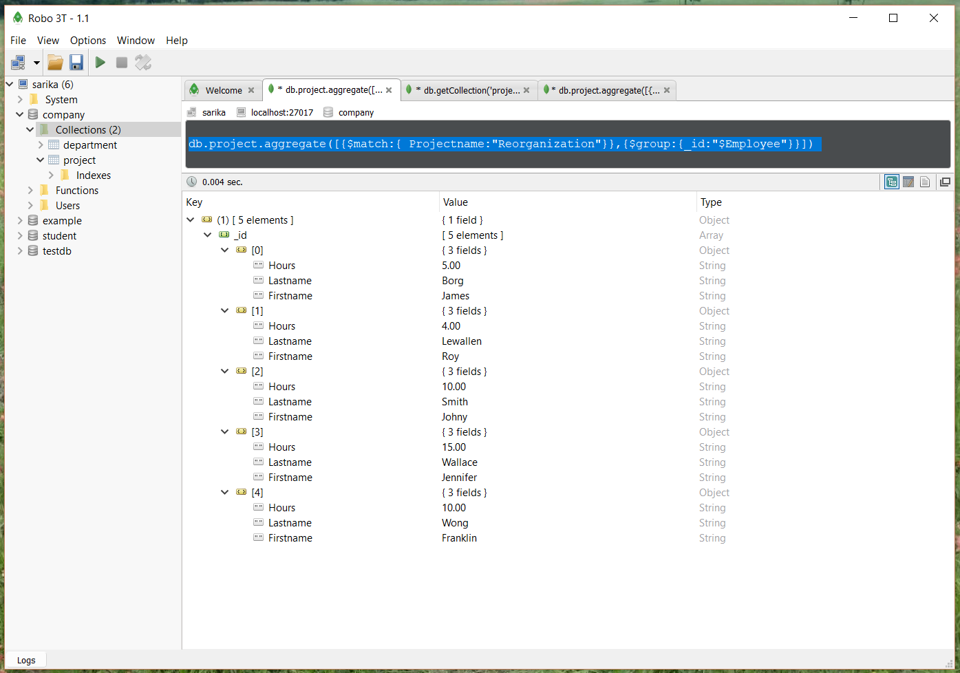

2. Query to get number of records of “software” department.

db.getCollection('project').find({"Department":"Software"}).count()

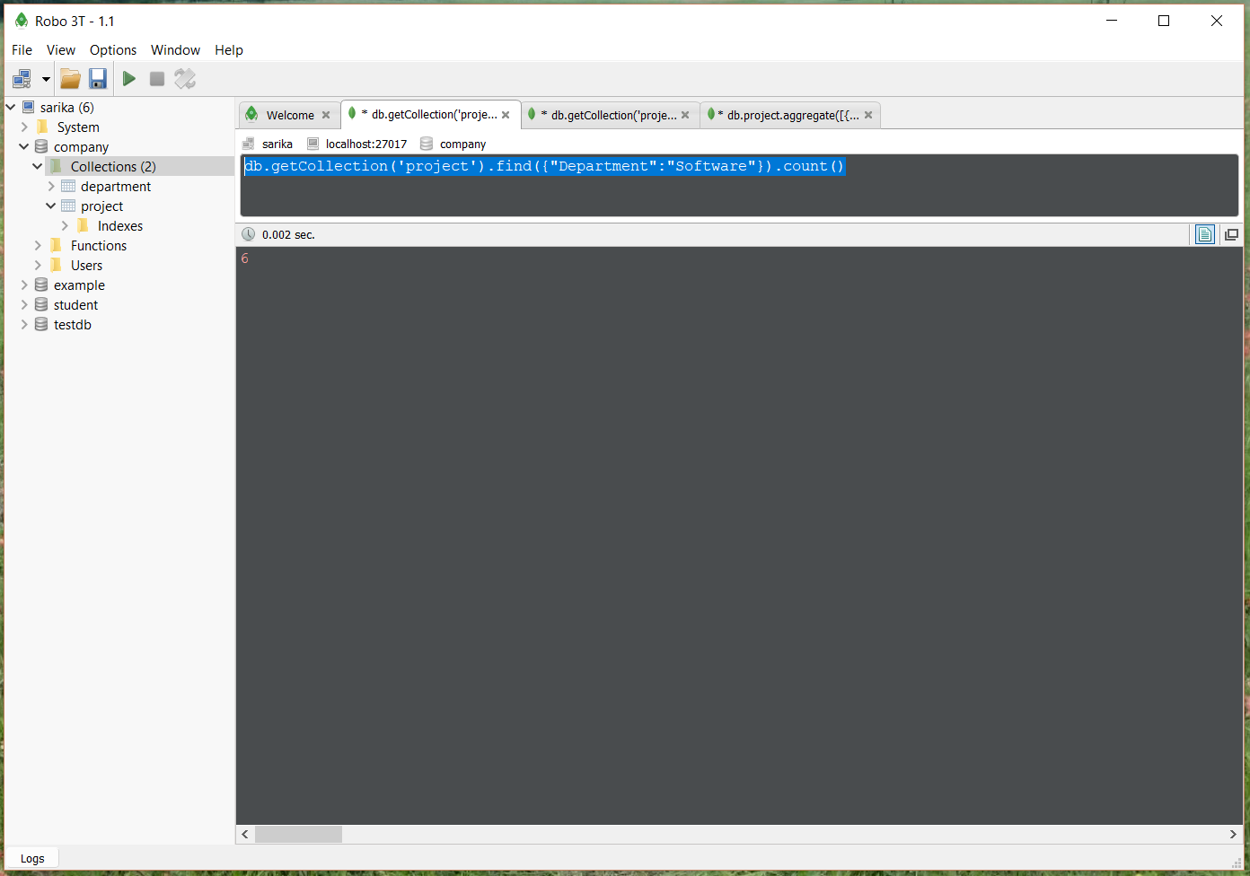

3.Query to retrieve the records where Department is "HR" or Projectname is “DatabaseSystems"

db.project.find( { $or: [ { Department: "HR" }, { Projectname: "DatabaseSystems" } ] } )

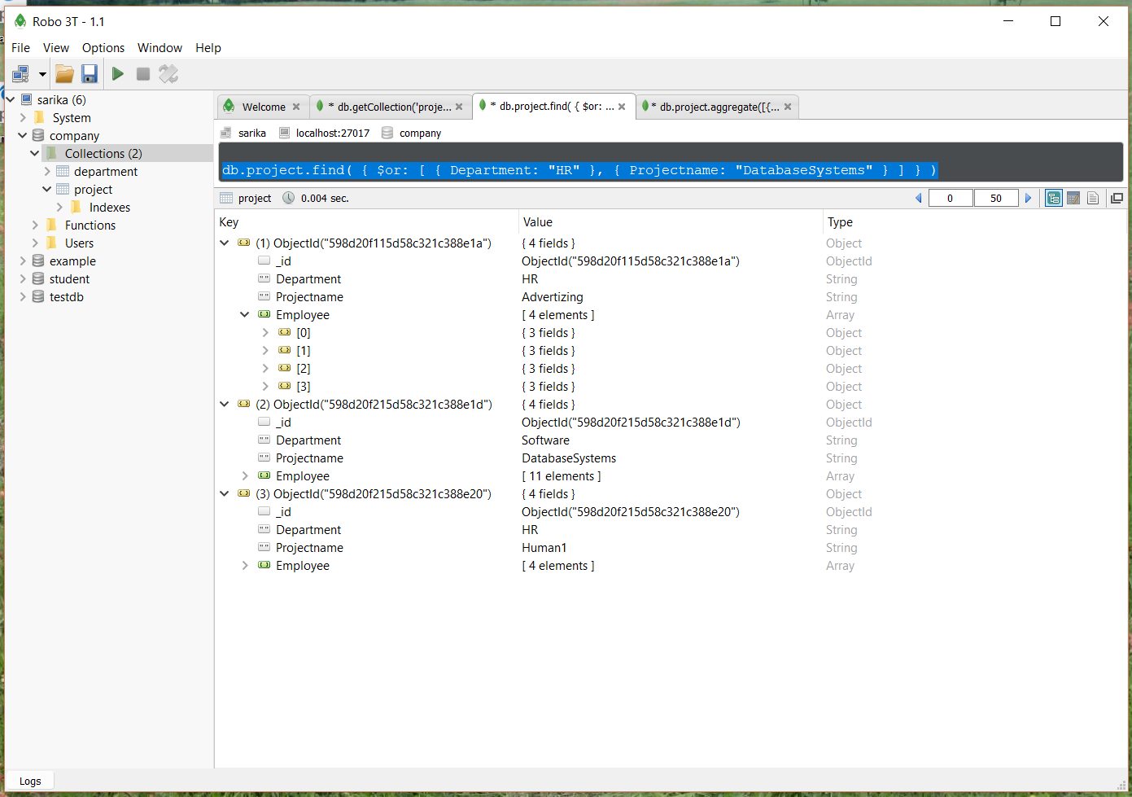

Queries on department collection:

1.Query to retrieve all records for Houston location.

db.getCollection('department').find({"Location.Locname":"Houston"})

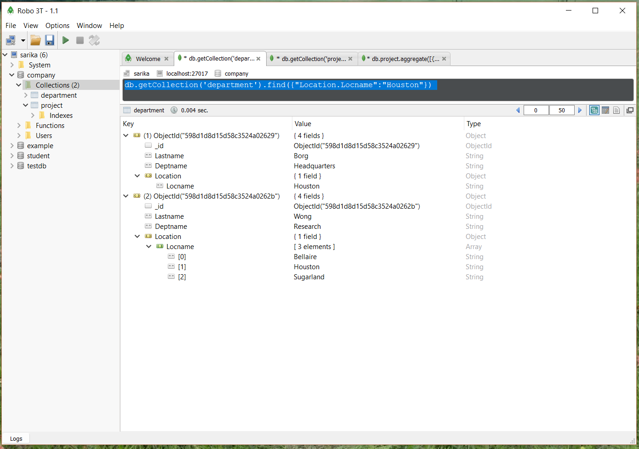

2.Query to retrieve the distinct last name of employee working in software department.

db.department.distinct( "Lastname", { Deptname: "Software" } )

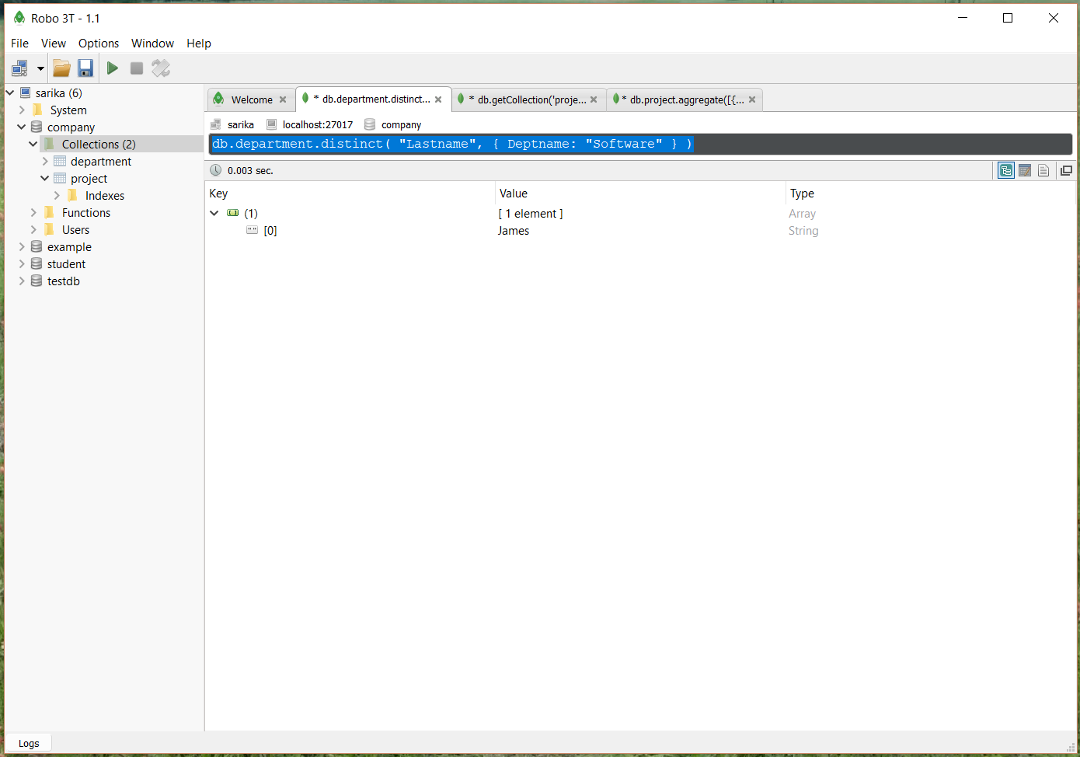

3.Query to get total size of department collection in bytes.

db.getCollection('department').totalSize()

