

**A project Report on**

**DEMO TOUR WEBSITE USING AUTOMATION TOOL SELENIUM WEBDRIVER WITH JAVA.**

**By**

**Sarika Nazare**

**Batch-EON (2021-5218)**

**Under the Guidance of,**

**Priyanka Desle**

**(Technical Trainer)**

**EduBridge India Pvt. Ltd.**

**Introduction:**

This Project aims to do overall testing like functional testing, GUI testing on Demo tour website to check quality of application using selenium web driver. It helps to improve quality of website and saves time for manually doing this testing.

In this project our main focus is to test the vacations Module and Hotels module. A tourism website is usually seeking to appeal to a broad audience and often has a wealth of information to share with that audience. Finding the best design for your requirements means picking you battles .

**Software Requirements:**

Operating System: Windows 10

Browser: Latest version of Google Chrome

Platform: Eclipse IDE

Automation Tool and Language: Selenium WebDriver, Java

Files: JDK, Selenium Jar files, Common IO file

1. **DEMO TOUR MODULE**

**TC01:** Launch the browser and Demo tour website

**Selenium WebDriver Test Script:**

WebDriver d = **new** ChromeDriver();

d.manage().window().maximize();

d.get("http://demo.guru99.com/test/newtours/index.php");

Thread.*sleep*(3000);

DemoTourTesting demo = **new** DemoTourTesting();

demo.demoTour(w);

demo.selenium(w);

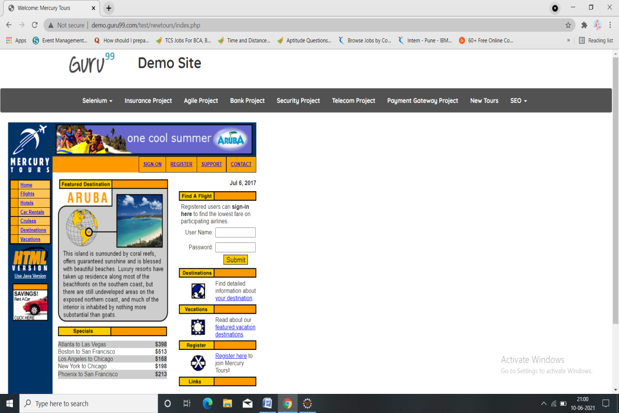

**TC02:** To verify the functionality of Demo Tour

**Selenium WebDriver Test Script:**

d.findElement(By.xpath("//body/cclink[1]/main[1]/div[2]/section[1]/div[2]/a[1]/div[1]")).click();

**TC03:** To verify and display the URL of Current page of browser.

**Selenium WebDriver Test Script:**

d.getCurrentUrl();

System.***out***.println("Current URL IS:" + d.getCurrentUrl());

**TC04:** To verify and display the Title of the current page.

**Selenium WebDriver Test Script:**

d.getTitle();

System.***out***.println("Title of page is:" + d.getTitle());

**TC05:** To verify the functionality of Register button from dropdown

**Selenium WebDriver Test Script:**

w.findElement(By.*linkText*("REGISTER")).click();

w.findElement(By.*name*("firstName")).sendKeys("Sarika");

w.findElement(By.*name*("lastName")).sendKeys("Nazare");

w.findElement(By.*name*("phone")).sendKeys("8788836324");

w.findElement(By.*name*("userName")).sendKeys("sarikanazare610@gmail.com");

w.findElement(By.*name*("address1")).sendKeys("Kothrud");

w.findElement(By.*name*("city")).sendKeys("Pune");

w.findElement(By.*name*("state")).sendKeys("maharastra");

w.findElement(By.*name*("postalCode")).sendKeys("400088"); // dropdown

w.findElement(By.*name*("country")).click();

**TC06:** To verify the functionality of login button

**Selenium WebDriver Test Script:**

w.findElement(By.*linkText*("sign-in")).click();

w.findElement(By.*name*("userName")).sendKeys("sarikanazare610@gmail.com");

w.findElement(By.*name*("password")).sendKeys("123456");

w.findElement(By.*name*("submit")).click();

**TC07:** To verify the functionality of sign off ,support and contact us.

**Selenium WebDriver Test Script:**

w.findElement(By.*linkText*("SIGN-OFF")).click();

w.findElement(By.*linkText*("SUPPORT")).click();

w.findElement(By.*xpath*("/html[1]/body[1]/div[2]/table[1]/tbody[1]/tr[1]/td[2]/table[1]/tbody[1]/tr[4]/td[1]/table[1]/tbody[1]/tr[1]/td[2]/table[1]/tbody[1]/tr[4]/td[1]/a[1]/img[1]")).click();

w.findElement(By.*linkText*("CONTACT")).click();

w.findElement(By.*xpath*("//tbody/tr[4]/td[1]/a[1]/img[1]"));

**TC08:** To verify the functionality of insurance login

w.findElement(By.*id*("email")).sendKeys("ashwinikusalkar1996@gmail.com");

w.findElement(By.*id*("password")).sendKeys("12345");

w.findElement(By.*xpath*("//*[@id=\"login-form\"]/div[3]/input")).click();

**Selenium WebDriver Test Script:**

**TC09:** To verify the edit button

**Selenium WebDriver Test Script:**

w.findElement(By.*linkText*("Edit Profile")).click();

w.findElement(By.*id*("user_title")).click();

Select title = **new** Select(w.findElement(By.*id*("user_title")));

title.selectByIndex(3);

**TC10:** To verify the functionality of Insurance_request_quotation

**Selenium WebDriver Test Script:**

w.findElement(By.*xpath*("//a[@id='ui-id-2']")).click();

w.findElement(By.*id*("quotation_breakdowncover")).click();

Select bw = **new** Select(w.findElement(By.*id*("quotation_breakdowncover")));

bw.selectByValue("3");

**TC11:** To verify and accesing the link

.

**Selenium WebDriver Test Script:**

Thread.*sleep*(2000);

w.findElement(By.*xpath*("//*[@id=\"navbar-brand-centered\"]/ul/li[1]/a")).click();

w.findElement(By.*xpath*("//*[@id=\"navbar-brand-centered\"]/ul/li[1]/ul/li[4]/a")).click();

w.findElement(By.*xpath*("/html/body/a[1]")).click();

w.navigate().back();

**TC12:** To verify the functionality of Features by clicking on delete customer form

**Selenium WebDriver Test Script:**

Thread.*sleep*(2000);

w.findElement(By.*xpath*("//*[@id=\"navbar-brand-centered\"]/ul/li[1]/a")).click();

w.findElement(By.*linkText*("Delete Customer Form")).click();

w.findElement(By.*name*("cusid")).sendKeys("1");

w.findElement(By.*xpath*("/html/body/form/table/tbody/tr[3]/td[2]/input[1]")).click();

Alert alert = w.switchTo().alert();

alert.accept();

alert.accept();

w.findElement(By.*xpath*("/html/body/form")).click();

w.navigate().back();

**TC13:** To verify the functionality of DOB

**Selenium WebDriver Test Script:**

Thread.*sleep*(2000);

w.findElement(By.*xpath*("//*[@id=\"navbar-brand-centered\"]/ul/li[1]/a")).click();

w.findElement(By.*linkText*("Selenium DatePicker Demo")).click();

WebElement datetime = w.findElement(By.*xpath*("//body/form[1]/input[1]"));

datetime.sendKeys("05/06/2021");

datetime.sendKeys(Keys.***TAB***);

datetime.sendKeys("0345AM");

w.findElement(By.*xpath*("//body/form[1]/input[2]")).click();

w.navigate().back();

**TC14:** To verify the functionality of plan type by selecting Webelement on which drag and drop operation needs to be performed

**Selenium WebDriver Test Script:**

WebElement from = w.findElement(By.*xpath*("//*[@id=\"credit2\"]/a"));

WebElement to = w.findElement(By.*xpath*("//*[@id=\"bank\"]/li"));

**Selenium WebDriver Test Script:**

TakesScreenshot t=(TakesScreenshot)d;

File scr=t.getScreenshotAs(OutputType.***FILE***);

Files.*copy*(scr, **new** File ("C:\\Users\\Ashok\\Pictures\\Saved Pictures\\picture.png"));

**TC16:** To verify the functionality of scroll down and scroll up of the displayed page.

**Selenium WebDriver Test Script:**

JavascriptExecutor js =(JavascriptExecutor)d;

js.executeScript("window.scrollTo(0, document.body.scrollHeight)");

Thread.*sleep*(2000);

js.executeScript("window.scrollTo(document.body.scrollHeight, 0)");

**TC17:** To verify and display the number of links available on page.

**Selenium WebDriver Test Script:**

List<WebElement> Links= d.findElements(By.*tagName*("a"));

**int** Total_links=Links.size();

System.***out***.println("Total links are:" + Total_links);

**TC18:** To verify and display the number of buttons available on page.

**Selenium WebDriver Test Script:**

List<WebElement> button= d.findElements(By.*tagName*("input"));

**int** Total_buttons=button.size();

System.***out***.println("Total buttons are:" + Total_buttons);

**TC19:** To verify the navigation to go back to previous page.

**Selenium WebDriver Test Script:**

d.navigate().back();

**TC20:** To verify that browser is able to close.

**Selenium WebDriver Test Script:**

d.close();