1. **What is Cloud.?**

The cloud refers to servers that are accessed over the Internet, and the software and databases that run on those servers. Cloud servers are located in data centres all over the world. By using cloud computing, users and companies don't have to manage physical servers themselves or run software applications on their own machines.

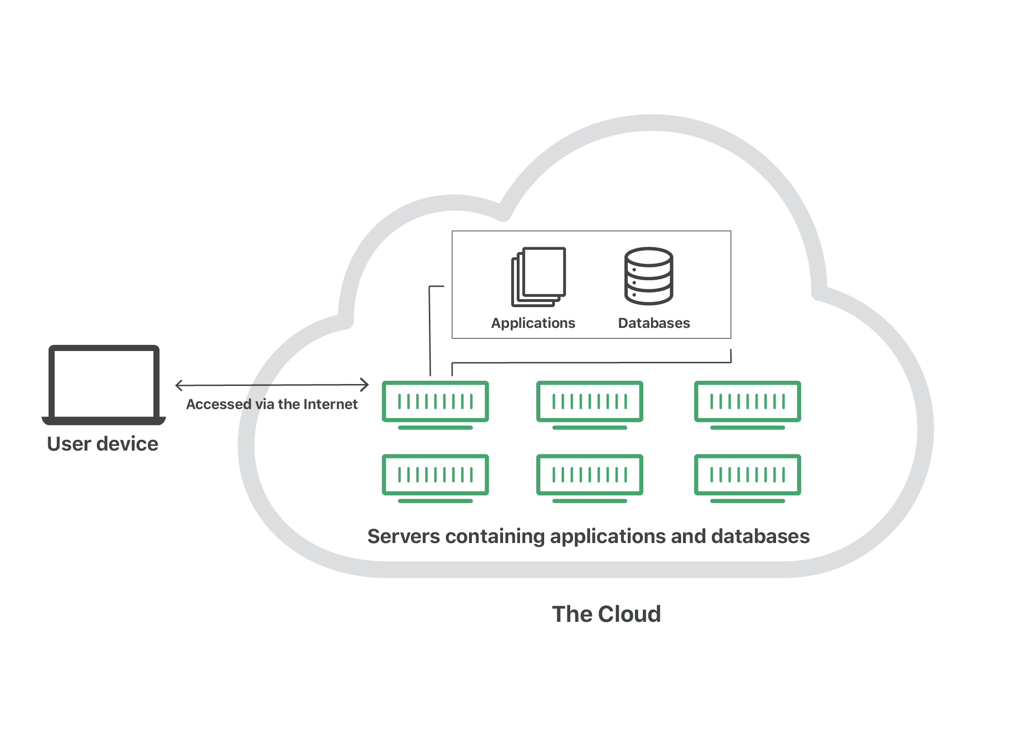

1. **What are Advantages of Cloud.?**
2. Less Costs
3. Availability
4. Flexibility in Capacity
5. All Over Functioning
6. Automated Updates on Software
7. Security
8. Carbon Footprint
9. Enhanced Collaboration
10. Control on the Documents
11. Easily Manageable
12. **What are Different Types of Cloud**
13. Public
14. Private
15. Hybrid
16. Community
17. **What is an EC-2**

Amazon Elastic Compute Cloud is a part of Amazon.com's cloud-computing platform, Amazon Web Services, that allows users to rent virtual computers on which to run their own computer applications.