1) Write a query that will give you all orders for more than Rs. 1,000.

**Ans :- select * from ORDERS where AMT > 1000;**

2) Write a query that will give you the names and cities of all salespeople in London with a commission above .10.

**Ans :- select SNAME, CITY from SALESPEOPLE where CITY = ‘London’ and COMM > .10;**

3) Write a query on the Customers table whose output will exclude all customers with a rating <= 100, unless they are located in Rome.

**Ans :- select * from CUSTOMERS where RATING > 100 and**

**CITY = ‘Rome’;**

4) What will be the output from the following query?

Select * from Orders

where (amt < 1000 OR

NOT (odate = ‘1990-10-03’

AND cnum > 2003));

**Ans :-**

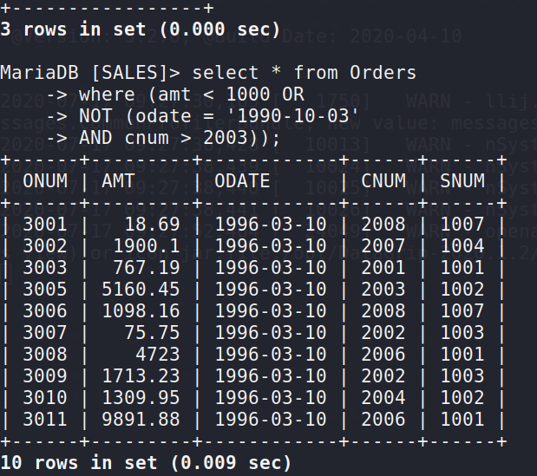

5) What will be the output of the following query? Select * from Orders where NOT ((odate = ‘1990-10-03’ OR snum >1006) AND amt >= 1500);

**Ans :-**

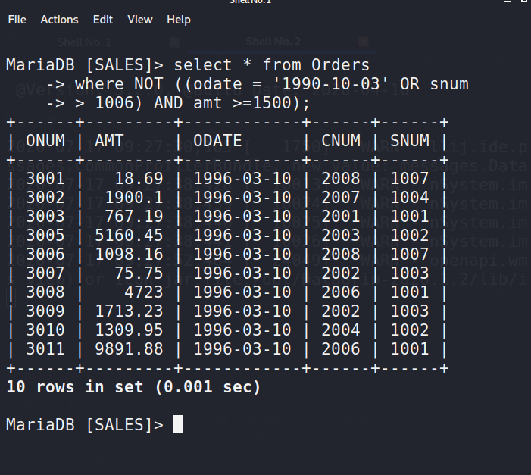

6) What is a simpler way to write this query? Select snum, sname, city, comm From Salespeople where (comm > .12 OR comm

**Ans :- select * from SALESPEOPLE where (COMM > 0.12 OR COMM < 0.14);**