AI Chatbot & Interview Copilot Platform
Complete Product Architecture & Development Bible
Version 2.0 • Finalized Product Blueprint

System Architecture
Shared RAG infrastructure powers both Chatbot and Interview Copilot modes.
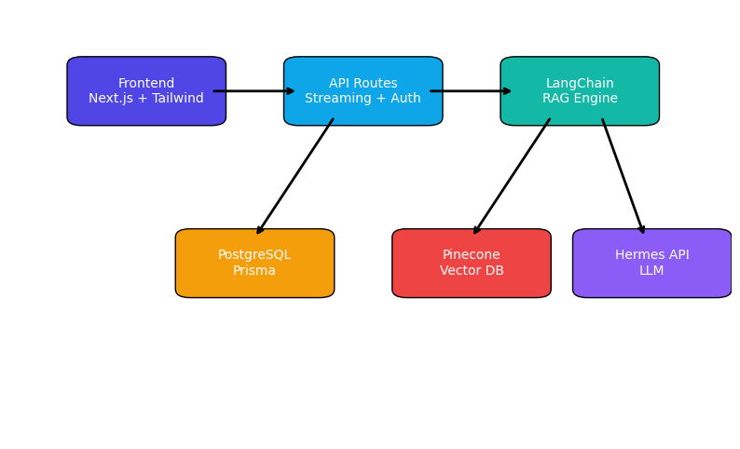

RAG Pipeline Flow
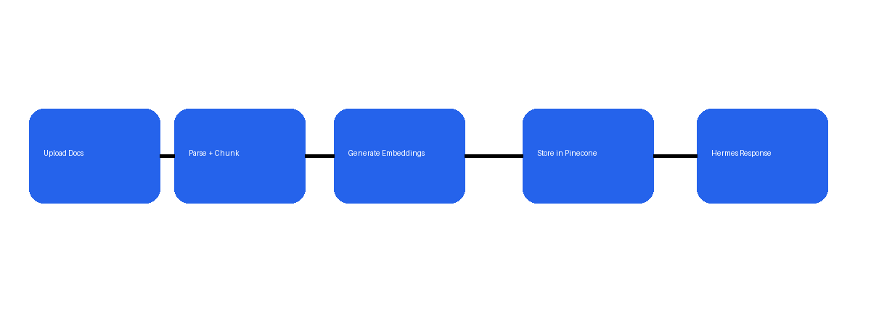

Core Product
- Chatbot mode for grounded document Q&A
- Interview Copilot mode using resume and job descriptions
- Shared vector search and streaming architecture

Sidebar Layout
- New Chat
- Chatbot
- Interview Copilot
- Previous Chats
- Edit Bot
- Settings

Tech Stack
- Next.js App Router
- Tailwind CSS
- NextAuth
- Prisma + PostgreSQL
- LangChain
- Pinecone
- Hermes API

Security
- Server-side API keys only
- Protected API routes
- Ownership validation
- Markdown sanitization

Database Models
Model | Purpose | Key Fields
User | Authentication | id, email, name
Bot | Bot configuration | type, prompt, temperature
Document | Knowledge base | filename, chunks
Conversation | Chat history | title, botId
Message | Stored messages | role, content

Development Roadmap
- Phase 1 — Authentication + Dashboard
- Phase 2 — Streaming Chat UI
- Phase 3 — RAG + Vector Search
- Phase 4 — Interview Copilot
- Phase 5 — Bot Builder
- Phase 6 — Deployment + Polish

Final Product Vision
Build a premium AI platform that combines ChatGPT-style UX, grounded document intelligence, and interview assistance powered by shared RAG systems and customizable prompts.

