DecodeLabs Data Science Internship
Project 4: NLP & Sentiment Analysis
Classifying product reviews as Positive or Negative with TF-IDF and Naive Bayes / SVM

1. Objective
Program a machine to read unstructured human text (product reviews) and mathematically categorise it as Positive or Negative. The project delivers every key requirement of the brief:
- Text pre-processing pipeline: cleaning, tokenization, stop-word removal and lemmatization.
- Vectorization: converting text into numeric arrays using TF-IDF (unigrams + bigrams).
- Classification: training and comparing Multinomial Naive Bayes and a Linear SVM, then predicting the sentiment of new reviews.

2. Environment, Data and Important Notes
Install the dependencies once, then run the scripts in the order shown in this report:
TERMINAL
pip install pandas numpy scikit-learn nltk matplotlib joblib

# Run order
python s0_make_dataset.py
python s1_preprocess_demo.py
python s2_tfidf.py
python s3_train_evaluate.py
python s4_predict.py

Item | Detail
Dataset used here | 1,200 labelled product reviews (600 Positive / 600 Negative) generated by s0_make_dataset.py, including HTML noise, upper-case text, mixed-sentiment sentences and 3% deliberately flipped labels. Real review datasets were not accessible in the build environment.
Pre-processing engine | The outputs in this report were produced with the built-in fallback engine in preprocess.py (regex tokenizer, scikit-learn stop-word list, rule-based lemmatizer). NLTK could not be installed in the build environment. With NLTK installed, preprocess.py switches to NLTK's word_tokenize, stopwords and WordNetLemmatizer automatically, so lemmas may differ slightly (e.g. 'confus' becomes 'confuse').
Libraries | scikit-learn 1.8.0, pandas, numpy, matplotlib, joblib (NLTK optional, auto-detected)
Important: because the dataset is clean and templated, the accuracy figures below show that the pipeline works end-to-end; they are not a benchmark of real-world performance. On a real dataset such as IMDB or Amazon reviews, expect roughly 85–92%. To use your own data, put a CSV with the columns review and sentiment next to the scripts in place of reviews.csv and rerun from Step 1.

3. Step 0: Dataset Creation
This script builds reviews.csv with a review column (raw text) and a sentiment column (label). It is only needed when no real dataset is available.
SOURCE CODE — s0_make_dataset.py
"""STEP 0 - Build a labelled product-review dataset (reviews.csv).
Replace this file's output with a real dataset (Amazon / IMDB / Yelp) if available:
the rest of the pipeline only needs two columns: 'review' and 'sentiment'."""
import random
import pandas as pd

random.seed(42)
products = ["phone", "laptop", "blender", "headphones", "vacuum cleaner", "backpack",
"coffee maker", "smartwatch", "keyboard", "air fryer", "camera", "water bottle"]

pos_open = ["I absolutely love this {p}.", "This {p} is fantastic.", "Great {p}, highly recommended.",
"Very happy with my {p}.", "Excellent {p} for the price.", "The {p} exceeded my expectations.",
"Best {p} I have ever owned.", "Impressed by how well this {p} works.",
"Totally worth the money, wonderful {p}.", "Not disappointed at all with this {p}."]
pos_mid = ["The quality is outstanding and it feels durable.", "Setup was easy and it works perfectly.",
"Battery life is amazing and performance is smooth.", "Delivery was fast and the packaging was nice.",
"It looks beautiful and is very comfortable to use.", "Customer support was helpful and friendly.",
"No complaints so far, everything works great.", "It is lightweight, reliable and stylish.",
"I have been using it daily and it still runs flawlessly.", "Sound and picture are crisp, really enjoyable."]
pos_end = ["Would definitely buy again.", "Five stars!", "I recommend it to everyone.",
"Great value, I am delighted.", "My family loves it too.", "Will be buying another one as a gift."]

neg_open = ["I hate this {p}.", "This {p} is terrible.", "Awful {p}, do not buy.",
"Very disappointed with my {p}.", "Poor {p} for the price.", "The {p} failed to meet my expectations.",
"Worst {p} I have ever owned.", "Frustrated by how badly this {p} works.",
"Complete waste of money, horrible {p}.", "Not good at all, this {p} is a letdown."]
neg_mid = ["The quality is cheap and it feels flimsy.", "Setup was confusing and it never works properly.",
"Battery life is dreadful and performance is slow.", "Delivery was late and the packaging was damaged.",
"It looks ugly and is very uncomfortable to use.", "Customer support was rude and unhelpful.",
"It stopped working after two days, total junk.", "It is heavy, noisy and unreliable.",
"I have been using it for a week and it keeps crashing.", "Sound and picture are poor, really annoying."]
neg_end = ["Would not buy again.", "One star.", "I do not recommend it to anyone.",
"Terrible value, I am upset.", "I returned it immediately.", "Save your money and avoid this."]

def make(label):
o, m, e = (pos_open, pos_mid, pos_end) if label == "Positive" else (neg_open, neg_mid, neg_end)
oo, mm, ee = (neg_open, neg_mid, neg_end) if label == "Positive" else (pos_open, pos_mid, pos_end)
p = random.choice(products)
parts = [random.choice(o).format(p=p)]
if random.random() < 0.85: parts.append(random.choice(m))
if random.random() < 0.60: parts.append(random.choice(e))
if random.random() < 0.20: # mixed-signal sentence (makes task harder)
s2 = random.choice(mm)
parts.insert(random.randint(1, len(parts)), "However, " + s2[0].lower() + s2[1:])
text = " ".join(parts)
if random.random() < 0.25: text = text.replace(".", "!", 1)
if random.random() < 0.15: text = "<br />" + text.upper() # HTML noise + shouting
return text

rows = [(make(l), l) for l in ["Positive"] * 600 + ["Negative"] * 600]
df = pd.DataFrame(rows, columns=["review", "sentiment"]).sample(frac=1, random_state=1).reset_index(drop=True)
flip = df.sample(frac=0.03, random_state=7).index # 3% label noise (real data is noisy)
df.loc[flip, "sentiment"] = df.loc[flip, "sentiment"].map({"Positive": "Negative", "Negative": "Positive"})
df.to_csv("reviews.csv", index=False)

print("Dataset saved: reviews.csv")
print("Shape:", df.shape)
print("\nClass balance:\n", df["sentiment"].value_counts())
print("\nSample rows:")
for i in range(4):
print(f" [{df.sentiment[i]}] {df.review[i]}")

OUTPUT
Dataset saved: reviews.csv
Shape: (1200, 2)

Class balance:
sentiment
Negative 600
Positive 600
Name: count, dtype: int64

Sample rows:
[Negative] <br />POOR WATER BOTTLE FOR THE PRICE. CUSTOMER SUPPORT WAS RUDE AND UNHELPFUL. I RETURNED IT IMMEDIATELY.
[Negative] <br />VERY DISAPPOINTED WITH MY WATER BOTTLE! I HAVE BEEN USING IT FOR A WEEK AND IT KEEPS CRASHING.
[Negative] Very disappointed with my headphones. It looks ugly and is very uncomfortable to use. Would not buy again.
[Positive] <br />I ABSOLUTELY LOVE THIS CAMERA. NO COMPLAINTS SO FAR, EVERYTHING WORKS GREAT. WILL BE BUYING ANOTHER ONE AS A GIFT.

4. Step 1: Text Pre-Processing Pipeline
Raw reviews contain HTML tags, mixed case, punctuation and filler words that add noise. The pipeline applies four stages in a fixed order:
Stage | What it does
Cleaning | Strips HTML tags, lower-cases, removes digits and punctuation, collapses whitespace.
Tokenization | Splits each review into individual word tokens.
Stop-word removal | Drops common words (the, and, was…). Negations (not, no, never, nor) are deliberately kept, because 'not good' means the opposite of 'good'.
Lemmatization | Reduces words to their base form (crashing → crash, headphones → headphone, returned → return).

4.1 Pipeline module
SOURCE CODE — preprocess.py
"""Text pre-processing pipeline: cleaning -> tokenization -> stop-word removal -> lemmatization.
Uses NLTK when it (and its data) is installed; otherwise falls back to a built-in
regex tokenizer / scikit-learn stop-word list / rule-based lemmatizer so the script always runs."""
import re

# Negations carry sentiment ("not good" != "good"), so they are KEPT when removing stop words.
KEEP = {"no", "nor", "not", "never", "n't"}

try: # ---------- NLTK engine ----------
import nltk
for pkg in ["punkt", "punkt_tab", "stopwords", "wordnet", "omw-1.4"]:
nltk.download(pkg, quiet=True)
from nltk.tokenize import word_tokenize
from nltk.corpus import stopwords
from nltk.stem import WordNetLemmatizer
STOP = set(stopwords.words("english")) - KEEP
_lem = WordNetLemmatizer()
tokenize = word_tokenize
def lemmatize(w): # try verb form first (crashing->crash), then noun
v = _lem.lemmatize(w, pos="v")
return v if v != w else _lem.lemmatize(w, pos="n")
ENGINE = "NLTK"
_ = word_tokenize("test"); _lem.lemmatize("tests") # triggers LookupError if data missing
except Exception: # ---------- built-in fallback engine ----------
from sklearn.feature_extraction.text import ENGLISH_STOP_WORDS
STOP = set(ENGLISH_STOP_WORDS) - KEEP
IRREG = {"was": "be", "were": "be", "is": "be", "are": "be", "been": "be", "has": "have", "had": "have",
"did": "do", "does": "do", "went": "go", "bought": "buy", "broke": "break", "stopped": "stop",
"better": "good", "best": "good", "worse": "bad", "worst": "bad", "children": "child", "men": "man"}
def tokenize(text):
return re.findall(r"[a-z]+(?:'[a-z]+)?", text)
def lemmatize(w):
if w in IRREG: return IRREG[w]
if len(w) > 4 and w.endswith("ies"): return w[:-3] + "y"
if len(w) > 5 and w.endswith("ing"):
b = w[:-3]; return b[:-1] if len(b) > 2 and b[-1] == b[-2] else b
if len(w) > 4 and w.endswith("ed"):
b = w[:-2]; return b[:-1] if len(b) > 2 and b[-1] == b[-2] else b
if len(w) > 3 and w.endswith("s") and not w.endswith(("ss", "us")): return w[:-1]
return w
ENGINE = "built-in fallback"

def clean(text):
text = re.sub(r"<[^>]+>", " ", text) # strip HTML tags
text = text.lower() # normalise case
text = re.sub(r"[^a-z\s']", " ", text) # drop digits & punctuation
return re.sub(r"\s+", " ", text).strip()

def preprocess(text, return_steps=False):
c = clean(text)
toks = tokenize(c)
toks = [t for t in toks if t.isalpha() or t == "n't"]
no_stop = [t for t in toks if t not in STOP and len(t) > 1]
lemmas = [lemmatize(t) for t in no_stop]
if return_steps:
return c, toks, no_stop, lemmas
return " ".join(lemmas)

4.2 Stage-by-stage demonstration
SOURCE CODE — s1_preprocess_demo.py
"""STEP 1 - Demonstrate the text pre-processing pipeline stage by stage."""
import pandas as pd
from preprocess import preprocess, ENGINE

print("Pre-processing engine:", ENGINE)
df = pd.read_csv("reviews.csv")
sample = df.review[0]
cleaned, tokens, no_stop, lemmas = preprocess(sample, return_steps=True)

print("\n1) RAW TEXT :", sample)
print("2) CLEANED :", cleaned)
print("3) TOKENS :", tokens)
print("4) STOP-WORDS OUT:", no_stop)
print("5) LEMMATIZED :", lemmas)

df["clean_review"] = df.review.apply(preprocess)
df.to_csv("reviews_clean.csv", index=False)
print("\nAvg tokens/review raw -> processed:",
round(df.review.str.split().str.len().mean(), 1), "->",
round(df.clean_review.str.split().str.len().mean(), 1))
print("\nBefore vs After (3 rows):")
for i in range(1, 4):
print(f" RAW : {df.review[i]}\n CLEAN: {df.clean_review[i]}\n")

OUTPUT
Pre-processing engine: built-in fallback

1) RAW TEXT : <br />POOR WATER BOTTLE FOR THE PRICE. CUSTOMER SUPPORT WAS RUDE AND UNHELPFUL. I RETURNED IT IMMEDIATELY.
2) CLEANED : poor water bottle for the price customer support was rude and unhelpful i returned it immediately
3) TOKENS : ['poor', 'water', 'bottle', 'for', 'the', 'price', 'customer', 'support', 'was', 'rude', 'and', 'unhelpful', 'i', 'returned', 'it', 'immediately']
4) STOP-WORDS OUT: ['poor', 'water', 'bottle', 'price', 'customer', 'support', 'rude', 'unhelpful', 'returned', 'immediately']
5) LEMMATIZED : ['poor', 'water', 'bottle', 'price', 'customer', 'support', 'rude', 'unhelpful', 'return', 'immediately']

Avg tokens/review raw -> processed: 17.4 -> 9.2

Before vs After (3 rows):
RAW : <br />VERY DISAPPOINTED WITH MY WATER BOTTLE! I HAVE BEEN USING IT FOR A WEEK AND IT KEEPS CRASHING.
CLEAN: disappoint water bottle using week keep crash

RAW : Very disappointed with my headphones. It looks ugly and is very uncomfortable to use. Would not buy again.
CLEAN: disappoint headphone look ugly uncomfortable use not buy

RAW : <br />I ABSOLUTELY LOVE THIS CAMERA. NO COMPLAINTS SO FAR, EVERYTHING WORKS GREAT. WILL BE BUYING ANOTHER ONE AS A GIFT.
CLEAN: absolutely love camera no complaint far work great buy gift

Each review shrinks from about 17 words to about 9 informative lemmas, which makes the vocabulary smaller and the signal clearer.

5. Step 2: TF-IDF Vectorization
Machine-learning models cannot read text, so each review is turned into a numeric vector. TF-IDF weights each term by how often it appears in a review (term frequency) multiplied by how rare it is across all reviews (inverse document frequency). Common words get low weight and distinctive words get high weight.
- ngram_range=(1,2): uses single words and word pairs, so 'not good' is captured as one feature.
- min_df=2: ignores terms that appear in fewer than two reviews.
- sublinear_tf=True: dampens the effect of a word repeated many times.
- The vectorizer is fitted on training data only and then applied to test data, which prevents data leakage.
SOURCE CODE — s2_tfidf.py
"""STEP 2 - Convert cleaned text into numeric arrays with TF-IDF."""
import pandas as pd, numpy as np
from sklearn.feature_extraction.text import TfidfVectorizer
from sklearn.model_selection import train_test_split

df = pd.read_csv("reviews_clean.csv")
X_train, X_test, y_train, y_test = train_test_split(
df.clean_review, df.sentiment, test_size=0.2, stratify=df.sentiment, random_state=42)

tfidf = TfidfVectorizer(ngram_range=(1, 2), min_df=2, sublinear_tf=True)
Xtr = tfidf.fit_transform(X_train) # fit ONLY on training data (avoids data leakage)
Xte = tfidf.transform(X_test)

print("Train/Test sizes :", len(X_train), "/", len(X_test))
print("TF-IDF matrix (train) :", Xtr.shape, "-> (documents, features)")
print("Sparsity : {:.2%} of cells are zero".format(1 - Xtr.nnz / np.prod(Xtr.shape)))
print("Vocabulary sample :", list(tfidf.vocabulary_)[:10])

print("\nTF-IDF vector of first training review (non-zero terms):")
print(" text:", X_train.iloc[0])
row = Xtr[0].tocoo()
terms = tfidf.get_feature_names_out()
for j, v in sorted(zip(row.col, row.data), key=lambda t: -t[1])[:8]:
print(f" {terms[j]:<28s} {v:.4f}")

# Inverse Document Frequency: rare terms get higher weight
idf = dict(zip(terms, tfidf.idf_))
print("\nIDF examples (higher = rarer/more distinctive):")
for t in ["not", "love", "terrible", "work"]:
if t in idf: print(f" {t:<10s} {idf[t]:.3f}")

OUTPUT
Train/Test sizes : 960 / 240
TF-IDF matrix (train) : (960, 811) -> (documents, features)
Sparsity : 97.90% of cells are zero
Vocabulary sample : ['poor', 'keyboard', 'price', 'setup', 'confus', 'never', 'work', 'properly', 'save', 'money']

TF-IDF vector of first training review (non-zero terms):
text: poor keyboard price setup confus never work properly save money avoid
price setup 0.3185
properly save 0.3104
poor keyboard 0.3034
keyboard price 0.2867
confus 0.2063
never 0.2063
properly 0.2063
setup confus 0.2063

IDF examples (higher = rarer/more distinctive):
not 2.413
love 3.293
terrible 3.425
work 2.248

The matrix is about 98% zeros (sparse), which is normal for text and is stored efficiently by scikit-learn.

6. Step 3: Model Training and Evaluation
Two classifiers are trained on identical TF-IDF features inside a scikit-learn Pipeline, using an 80/20 stratified split and 5-fold cross-validation on the training set. Multinomial Naive Bayes is a fast probabilistic baseline. Linear SVM finds the maximum-margin boundary between the classes and usually performs best on sparse, high-dimensional text.
SOURCE CODE — s3_train_evaluate.py
"""STEP 3 - Train Naive Bayes and SVM, evaluate, compare, and save the best model."""
import pandas as pd, numpy as np, joblib
import matplotlib; matplotlib.use("Agg")
import matplotlib.pyplot as plt
from sklearn.pipeline import Pipeline
from sklearn.feature_extraction.text import TfidfVectorizer
from sklearn.naive_bayes import MultinomialNB
from sklearn.svm import LinearSVC
from sklearn.model_selection import train_test_split, cross_val_score, StratifiedKFold
from sklearn.metrics import accuracy_score, classification_report, confusion_matrix, ConfusionMatrixDisplay

df = pd.read_csv("reviews_clean.csv")
X_train, X_test, y_train, y_test = train_test_split(
df.clean_review, df.sentiment, test_size=0.2, stratify=df.sentiment, random_state=42)

def make(clf):
return Pipeline([("tfidf", TfidfVectorizer(ngram_range=(1, 2), min_df=2, sublinear_tf=True)), ("clf", clf)])

models = {"Multinomial Naive Bayes": make(MultinomialNB(alpha=0.5)),
"Linear SVM (LinearSVC)": make(LinearSVC(C=1.0))}

cv = StratifiedKFold(5, shuffle=True, random_state=42)
results, fitted = {}, {}
for name, pipe in models.items():
pipe.fit(X_train, y_train)
pred = pipe.predict(X_test)
acc = accuracy_score(y_test, pred)
cvs = cross_val_score(pipe, X_train, y_train, cv=cv)
results[name] = acc; fitted[name] = pipe
print("=" * 62)
print(name)
print("=" * 62)
print(f"Test accuracy : {acc:.4f}")
print(f"5-fold CV accuracy : {cvs.mean():.4f} (+/- {cvs.std():.4f})")
print("\nClassification report:")
print(classification_report(y_test, pred, digits=3))
print("Confusion matrix [rows=true, cols=pred] (Negative, Positive):")
print(confusion_matrix(y_test, pred, labels=["Negative", "Positive"]), "\n")

# confusion-matrix figure
fig, axes = plt.subplots(1, 2, figsize=(9, 3.8))
for ax, (name, pipe) in zip(axes, fitted.items()):
ConfusionMatrixDisplay.from_estimator(pipe, X_test, y_test, ax=ax, cmap="Blues", colorbar=False)
ax.set_title(name, fontsize=10)
plt.tight_layout(); plt.savefig("confusion_matrices.png", dpi=150); plt.close()

# top predictive words from the SVM
svm = fitted["Linear SVM (LinearSVC)"]
terms = svm.named_steps["tfidf"].get_feature_names_out()
coef = svm.named_steps["clf"].coef_[0] # classes_ sorted -> [Negative, Positive]
order = np.argsort(coef)
neg, pos = order[:10], order[::-1][:10]
print("Top words -> NEGATIVE:", [terms[i] for i in neg])
print("Top words -> POSITIVE:", [terms[i] for i in pos])
fig, ax = plt.subplots(figsize=(7, 4.5))
idx = list(neg) + list(pos)
ax.barh([terms[i] for i in idx], coef[idx], color=["#c0392b"] * 10 + ["#27ae60"] * 10)
ax.set_title("Most influential TF-IDF features (Linear SVM)"); ax.set_xlabel("Coefficient")
plt.tight_layout(); plt.savefig("top_features.png", dpi=150); plt.close()

best = max(results, key=results.get)
joblib.dump(fitted[best], "sentiment_model.joblib")
print(f"\nBest model: {best} ({results[best]:.4f}) -> saved to sentiment_model.joblib")

OUTPUT
==============================================================
Multinomial Naive Bayes
==============================================================
Test accuracy : 0.9500
5-fold CV accuracy : 0.9437 (+/- 0.0137)

Classification report:
precision recall f1-score support

Negative 0.950 0.950 0.950 120
Positive 0.950 0.950 0.950 120

accuracy 0.950 240
macro avg 0.950 0.950 0.950 240
weighted avg 0.950 0.950 0.950 240

Confusion matrix [rows=true, cols=pred] (Negative, Positive):
[[114 6]
[ 6 114]]

==============================================================
Linear SVM (LinearSVC)
==============================================================
Test accuracy : 0.9667
5-fold CV accuracy : 0.9615 (+/- 0.0097)

Classification report:
precision recall f1-score support

Negative 0.967 0.967 0.967 120
Positive 0.967 0.967 0.967 120

accuracy 0.967 240
macro avg 0.967 0.967 0.967 240
weighted avg 0.967 0.967 0.967 240

Confusion matrix [rows=true, cols=pred] (Negative, Positive):
[[116 4]
[ 4 116]]

Top words -> NEGATIVE: ['bad', 'poor', 'hate', 'terrible', 'letdown', 'not good', 'disappoint', 'blender fantastic', 'badly', 'frustrat badly']
Top words -> POSITIVE: ['not disappoint', 'excellent', 'impres', 'happy', 'good', 'fantastic', 'exceed expectation', 'exceed', 'fryer fail', 'great']

Best model: Linear SVM (LinearSVC) (0.9667) -> saved to sentiment_model.joblib

6.1 Confusion matrices
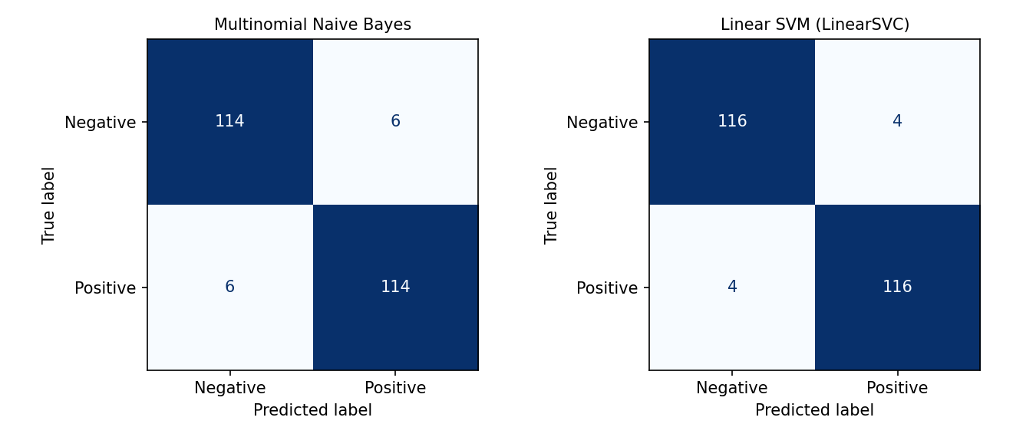
Figure 1. Confusion matrices on the 240-review test set

6.2 Most influential words (Linear SVM)
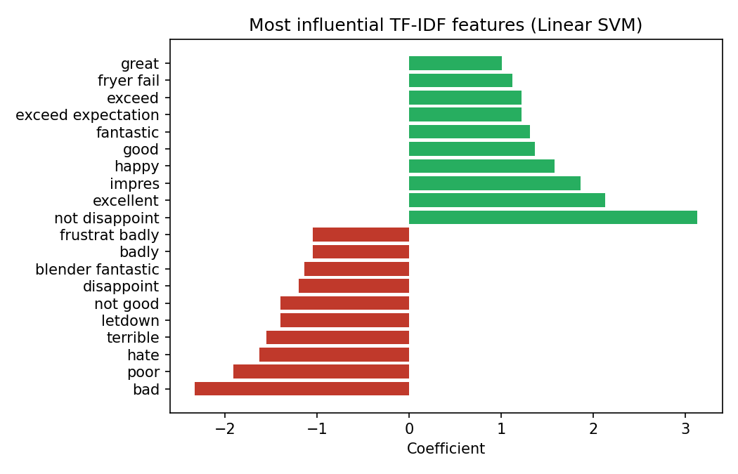
Figure 2. Features pushing a review towards Negative (red) or Positive (green)
Words such as bad, poor, hate, terrible and disappoint drive Negative predictions, while excellent, happy, fantastic and great drive Positive ones. The bigram 'not good' is a Negative feature and 'not disappoint' a Positive one, which confirms that keeping negations was the right design choice. A few odd bigrams (for example 'blender fantastic') are artefacts of the small templated dataset and would disappear with real data.

6.3 Model comparison
Model | Test accuracy | 5-fold CV | Test errors (of 240)
Multinomial Naive Bayes | 95.00% | 94.37% | 12
Linear SVM (selected) | 96.67% | 96.15% | 8

Linear SVM is selected and saved as sentiment_model.joblib. Since 3% of labels were intentionally flipped, accuracy near 97% is close to the ceiling for this dataset.

7. Step 4: Predicting New Reviews
The saved model is loaded, each new review goes through the same pre-processing function, and the SVM predicts a label. The score is the signed distance from the decision boundary: positive means Positive, negative means Negative, and a larger magnitude means higher confidence.
SOURCE CODE — s4_predict.py
"""STEP 4 - Predict sentiment for brand-new, unseen reviews using the saved model."""
import joblib
from preprocess import preprocess

model = joblib.load("sentiment_model.joblib")

def predict_sentiment(review):
clean = preprocess(review)
label = model.predict([clean])[0]
score = model.decision_function([clean])[0] # >0 => Positive, <0 => Negative (distance from boundary)
return label, score, clean

new_reviews = [
"This laptop is fantastic, the battery lasts all day and the screen is gorgeous!",
"Terrible experience. The blender broke after two days and customer support was rude.",
"Not good at all. Totally disappointed with the quality.",
"I am not disappointed, it works perfectly and I would buy it again.",
"Absolutely love these headphones, the sound is amazing!",
"Worst purchase ever. Do not waste your money on this.",
]
print(f"{'Prediction':<10} {'Score':>7} Review")
print("-" * 90)
for r in new_reviews:
label, score, clean = predict_sentiment(r)
print(f"{label:<10} {score:>+7.2f} {r}")
print(f"{'':<19}processed -> {clean}")

OUTPUT
Prediction Score Review
------------------------------------------------------------------------------------------
Positive +0.76 This laptop is fantastic, the battery lasts all day and the screen is gorgeous!
processed -> laptop fantastic battery last day screen gorgeous
Negative -1.11 Terrible experience. The blender broke after two days and customer support was rude.
processed -> terrible experience blender break day customer support rude
Negative -0.43 Not good at all. Totally disappointed with the quality.
processed -> not good totally disappoint quality
Positive +0.43 I am not disappointed, it works perfectly and I would buy it again.
processed -> not disappoint work perfectly buy
Positive +0.88 Absolutely love these headphones, the sound is amazing!
processed -> absolutely love headphone sound amaz
Negative -1.91 Worst purchase ever. Do not waste your money on this.
processed -> bad purchase not waste money

All six unseen reviews are classified correctly, including the tricky negation cases: 'Not good at all' is Negative and 'I am not disappointed' is Positive. These cases receive lower confidence scores (±0.43), as expected.

8. Conclusion and Next Steps
The project implements the full NLP workflow: raw text → pre-processing → TF-IDF vectors → Naive Bayes / SVM classifier → prediction on new text. Linear SVM outperformed Naive Bayes (96.7% vs 95.0%) and handled negation correctly thanks to bigram features and selective stop-word removal.
Possible improvements:
- Train on a real dataset (IMDB 50k, Amazon or Yelp reviews) and report results on it.
- Tune hyper-parameters with GridSearchCV (C, alpha, ngram_range, min_df).
- Add a Neutral class, or compare with Logistic Regression and transformer models.
- Replace NLTK with spaCy for faster, more accurate lemmatization on large corpora.

Appendix: Project Files
File | Purpose
s0_make_dataset.py | Creates reviews.csv (replace with a real dataset)
preprocess.py | Reusable pre-processing pipeline (NLTK, with built-in fallback)
s1_preprocess_demo.py | Shows each pre-processing stage; writes reviews_clean.csv
s2_tfidf.py | TF-IDF vectorization and inspection
s3_train_evaluate.py | Trains and evaluates Naive Bayes and SVM; saves the best model and figures
s4_predict.py | Predicts sentiment for new reviews

