# Run Length Encoding (RLE) Compression program:

|  |
| --- |
| #include<iostream>  #include<string>  #include<fstream>  using namespace std;  streampos filesize(const string& filepath)  {  ifstream file(filepath, ios::binary | ios::ate);  return file.tellg();  }  int main()  {  ofstream outfile;  outfile.open("File_1.txt");  if (outfile.is_open())  {  outfile << "AAABBBCCCDDDEEEFFFF";  outfile.close();  }  else  {  cerr << "Cannot open file to write";  return 1;  }  streampos o_filesize = filesize("File_1.txt");  if(o_filesize<=-1)  {  cout << "Cannot be able to get the correct size of the file ";  return 1;  }  else  {  cout << "Orignal size: " << o_filesize<<" byters\n";  }  ifstream readfile;  readfile.open("File_1.txt");  ofstream com_file;  com_file.open("compressed.txt");    if (readfile.is_open() || com_file.is_open())  {  char curr_char, pre_char;  int count = 0;  readfile.get(pre_char);  count = 1;  while (readfile.get(curr_char))  {  if (pre_char == curr_char)  {  count++;  }  else  {  com_file << pre_char << count;  pre_char = curr_char;  count = 1;  }  }  com_file << pre_char << count;  readfile.close();  com_file.close();  }  else  {  cerr << "Cannot open file!";  return 1;  }  streampos com_filesize = filesize("Compressed.txt");  if (com_filesize == -1) {  cerr << "Error getting size of the compressed file!" << endl;  return 1;  }  else {  cout << "Compressed file size: " << com_filesize << " bytes" << endl;  }  return 0;  } |

# Screenshorts of the program:

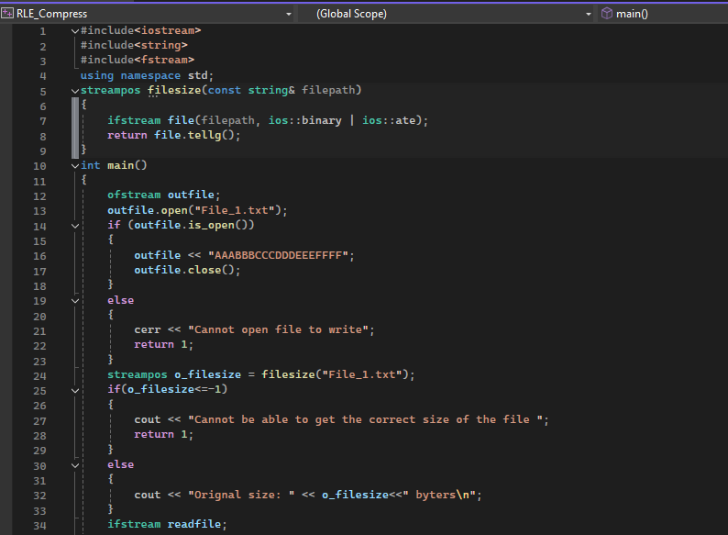

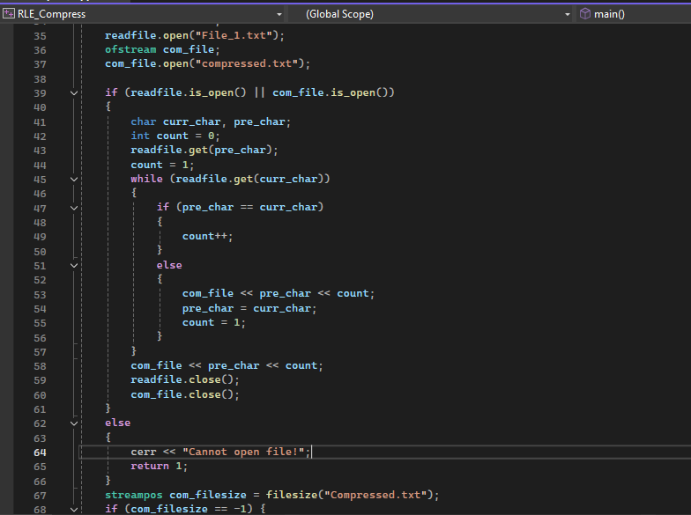

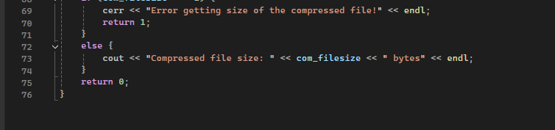

# Output:

Reduction in File size:

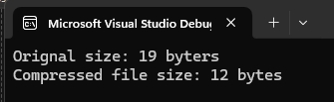

# File Before Compression:

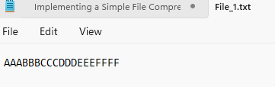

# File After Compression:

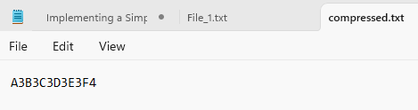

# Explanation:

In this program I used RLE algorithm to implement the file compression, RLE basically works by reading the file and counting the repetitions of alphabets in that file and it then indicate the alphabet and the number of times it repeated instead of writing all the repetitions in the compressed file… it is a basic concept of understanding how compression works/