Summary of Changes

P- 20

Networking Team Documents

Peer Team Feedback:
After receiving feedback from other teams during the integration review, two key features were identified as missing from our current system: a Turn Timer and a Content Filter System. Both were essential to improving fairness, gameplay flow, and creating a safer environment for players. We’ve now implemented both features and ensured they integrate cleanly into our existing system architecture.
- Turn Timer Functionality
The feedback pointed out the lack of a mechanism to handle players who go idle or take too long to make a move. To address this, we implemented a TurnTimer class that monitors each player's turn duration. The timer starts at the beginning of a player's turn and counts down. If the player fails to act within the allowed time, the system flags a timeout and simulates disconnection from the game session. In addition to managing timeout scenarios, the timer includes the ability to:
• Pause during unexpected issues like disconnection.
• Resume when the player reconnects.
• Reset upon successful turn completion.
• Notify the player when only 10 seconds remain on the clock.
This change improves the pacing of the game and prevents stalling, which is especially important in a real-time or competitive setting.
- Content Filter
Another suggestion was to handle inappropriate language in the in-game chat. As a solution, we extended the ChatManager to include a content filter that checks all incoming messages against a curated list of offensive words. If a message contains any of these terms, it is automatically rejected and not added to the chat history. The player is warned via a console message. This ensures the chat system promotes respectful communication and discourages toxic behavior. The list of inappropriate words was sourced from an open-source project and adapted to cover a wide range of offensive terms. Although reporting functionality is not yet fully implemented, the system can easily be extended to flag users or notify moderators when inappropriate messages are blocked.
Use Case Diagram:

Following is the annotated diagram received from Iteration 2 feedback:
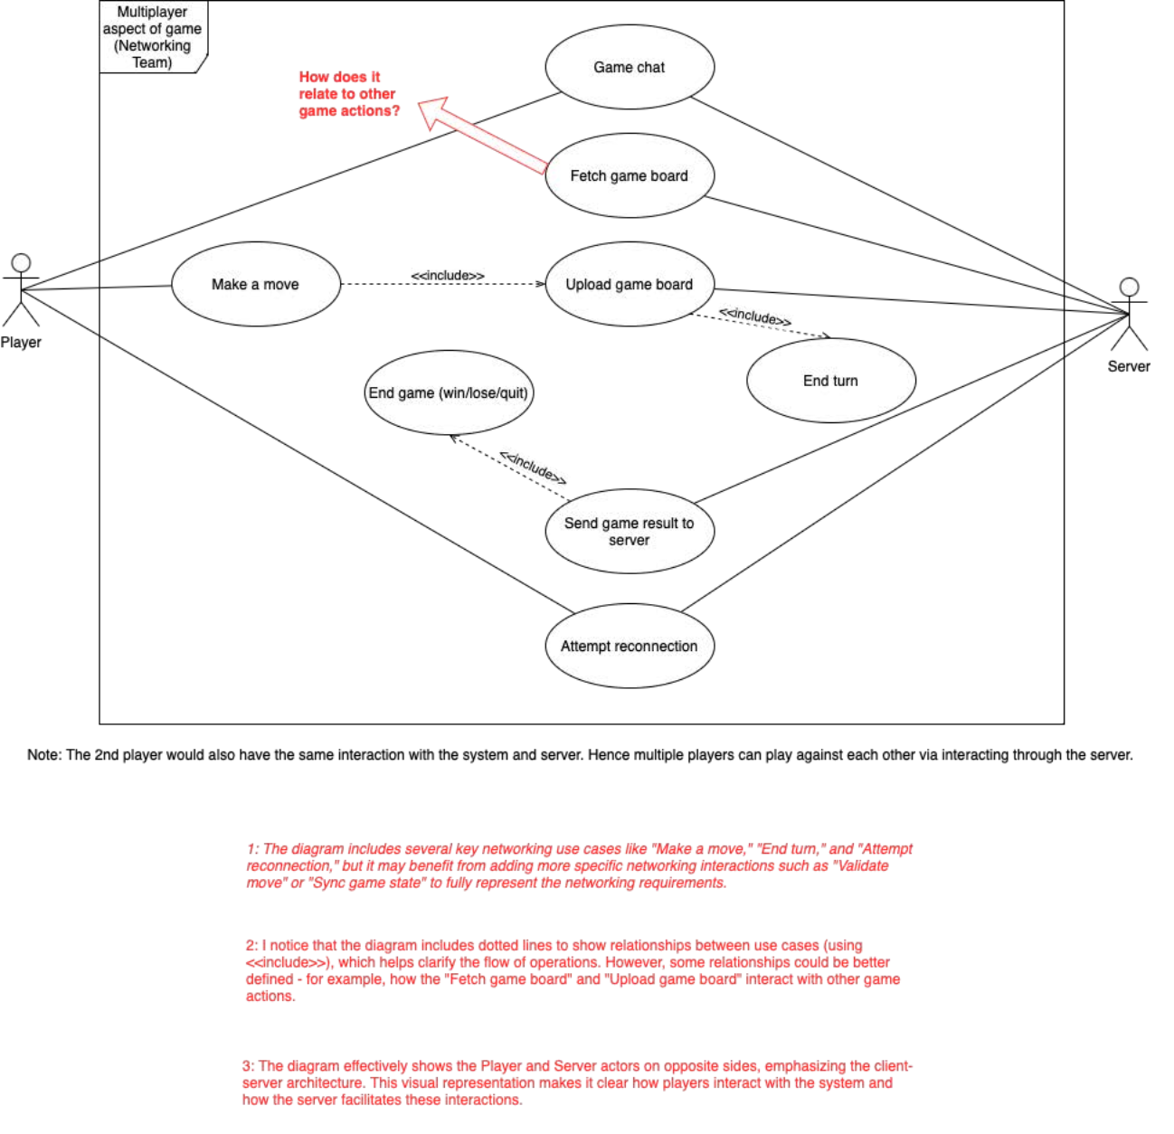

Updated Diagram:
Addressing feedback comment 1: In our project, move validation is done by Game Logic Team and occurs when “Make a move” use case is called (added as a note in updated diagram). “Sync game state” is performed by “Fetch game board” and “Upload game board” use cases.
Addressing feedback comment 2: Added an <<include>> relation from “Fetch game board” to “Make a move” to show that a move is only made after updated game board is fetched from server. Similarly, “upload game board” occurs after a move is made and then the turn ends.
Addressing feedback from the other (2nd) team: Added an extend relation from “Make a move” to “End game”, so that when a player does not make a move, the game automatically ends.
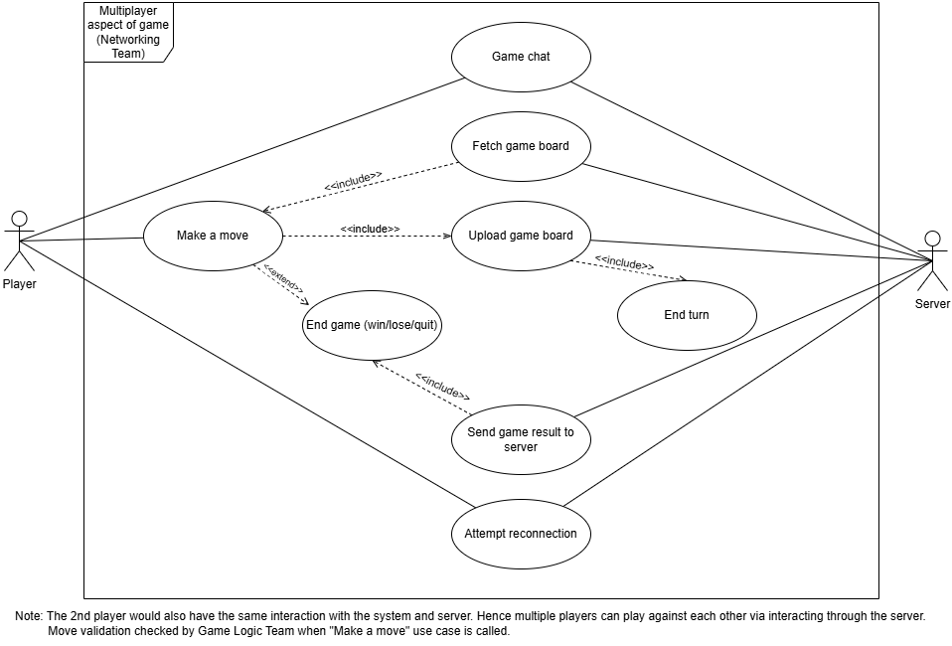

Structure Diagram:

Following is the annotated diagram received from Iteration 2 feedback:
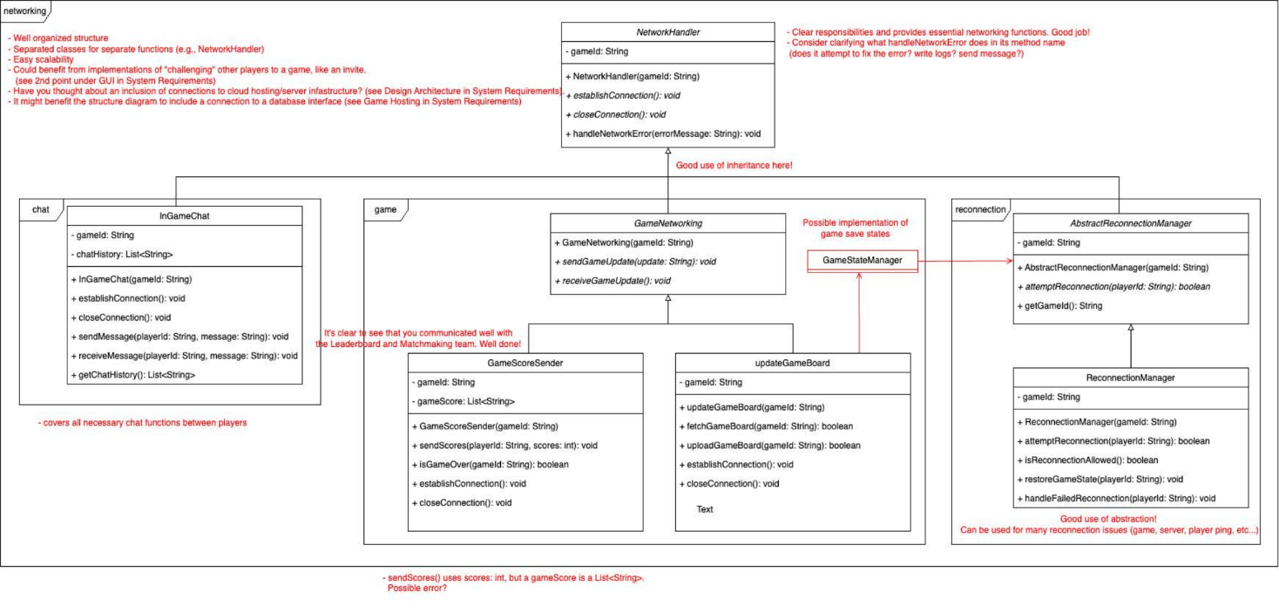

Updated Diagram:

First of all, new classes have been added that weren’t created during iteration 2.
As highlighted in the feedback and project requirements, a game server class has been added which acts as a stub.
A GameState class has been added in the reconnection package as per the feedback.
A note has been added which clarifies what NetworkHandler function is.
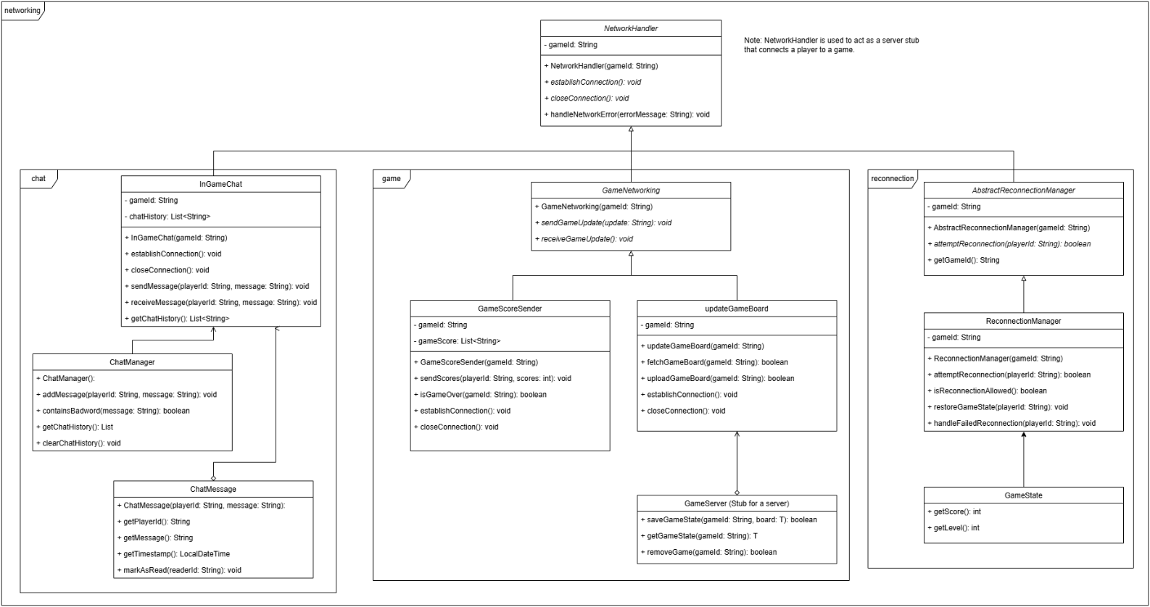

Another version of the updated structure diagram is the following which focuses on the newly added Turn Timer functionality:
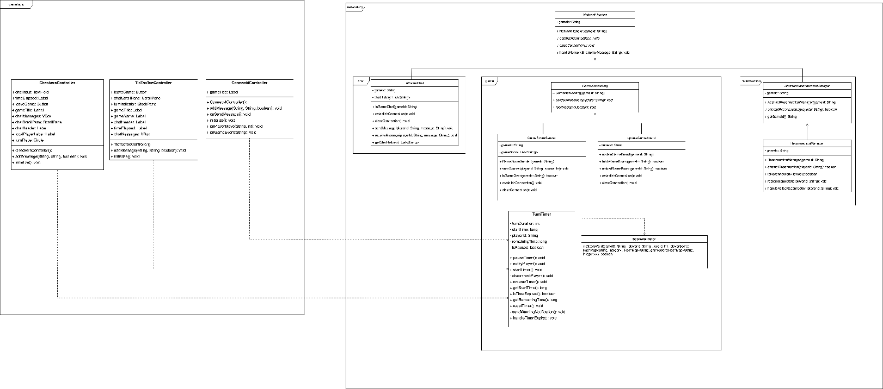

Sequence Diagram:
Following is a new sequence diagram created:
