Comments: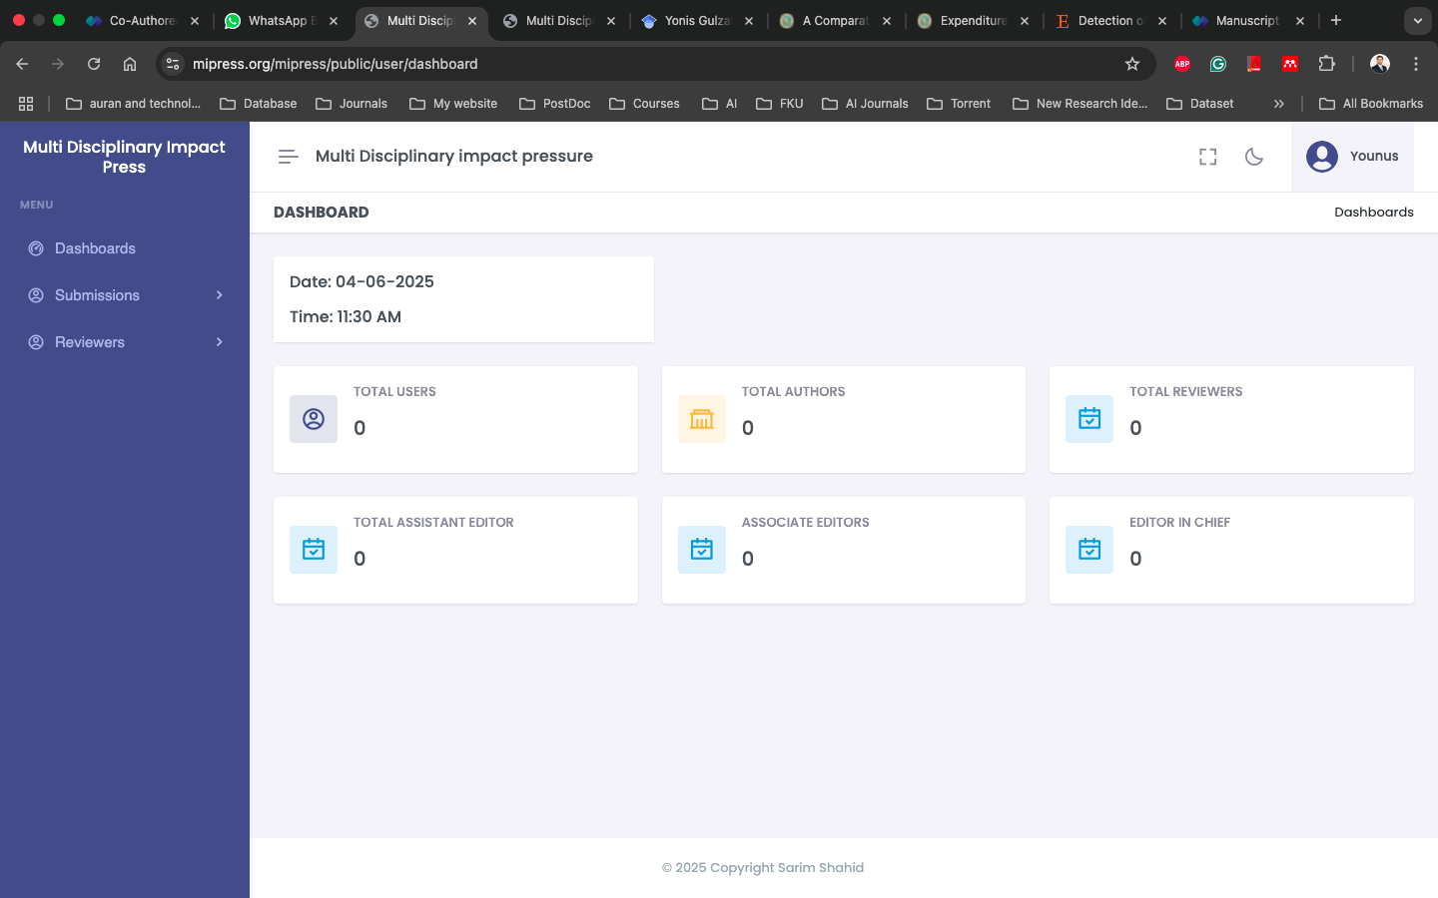

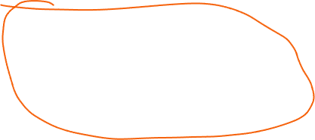

* For the author remove the dashboard option, when they login just simply show the papers they have submitted, if none then show like that
* When we login as user it shows dashboard, which is coming form admin. I think user dashboard should not be same as admin
* when entering abstract it say abstract should be of 255 characters, it should take at least 300 words not characters.
* When entering keywords: if there is no semi colon in the text it doesn’t take as keyword.
* Also when entering keywords, it should be first Entered First Shown but It is like First entered Last Shown
* Any issue I see that when file is greater than 2mb it does get uploaded
* Another issue once we enter the first page details of form submission, it should be saved as draft. Means we shall be later on able to continue later on where we have left

Author information:

* When we reach to author information page we see there are 4 authors motioned for which we need to enter the details. If there is only 2 authors and we delete rest of the ones. But then we want to add one more author. It keep the previous counting.
* Like: first 4 authors are there, and I deleted 2. So remaining are two, but then when I want to add new author. Its count shows 5 whereas it should be only 3.
* Title in author page should be predefined like Mr. Ms. Dr. Prof.
* Middle name should be optional
* Add one more text book as country, separate from affiliationA screenshot of a computer

  Description automatically generated



Also u can see the

Reviewer page:

* It shows author details rather reviewer details 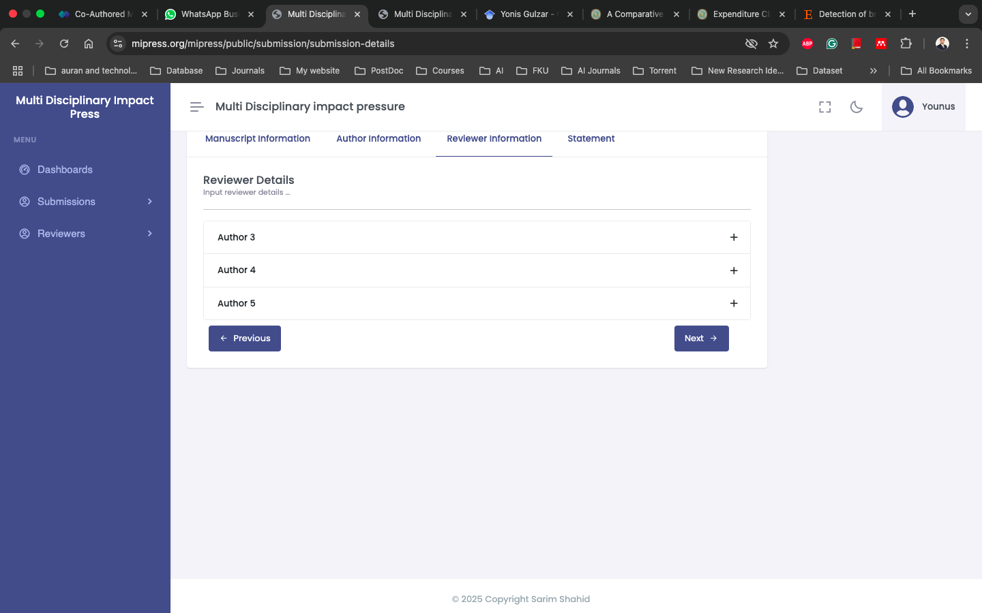

User profile

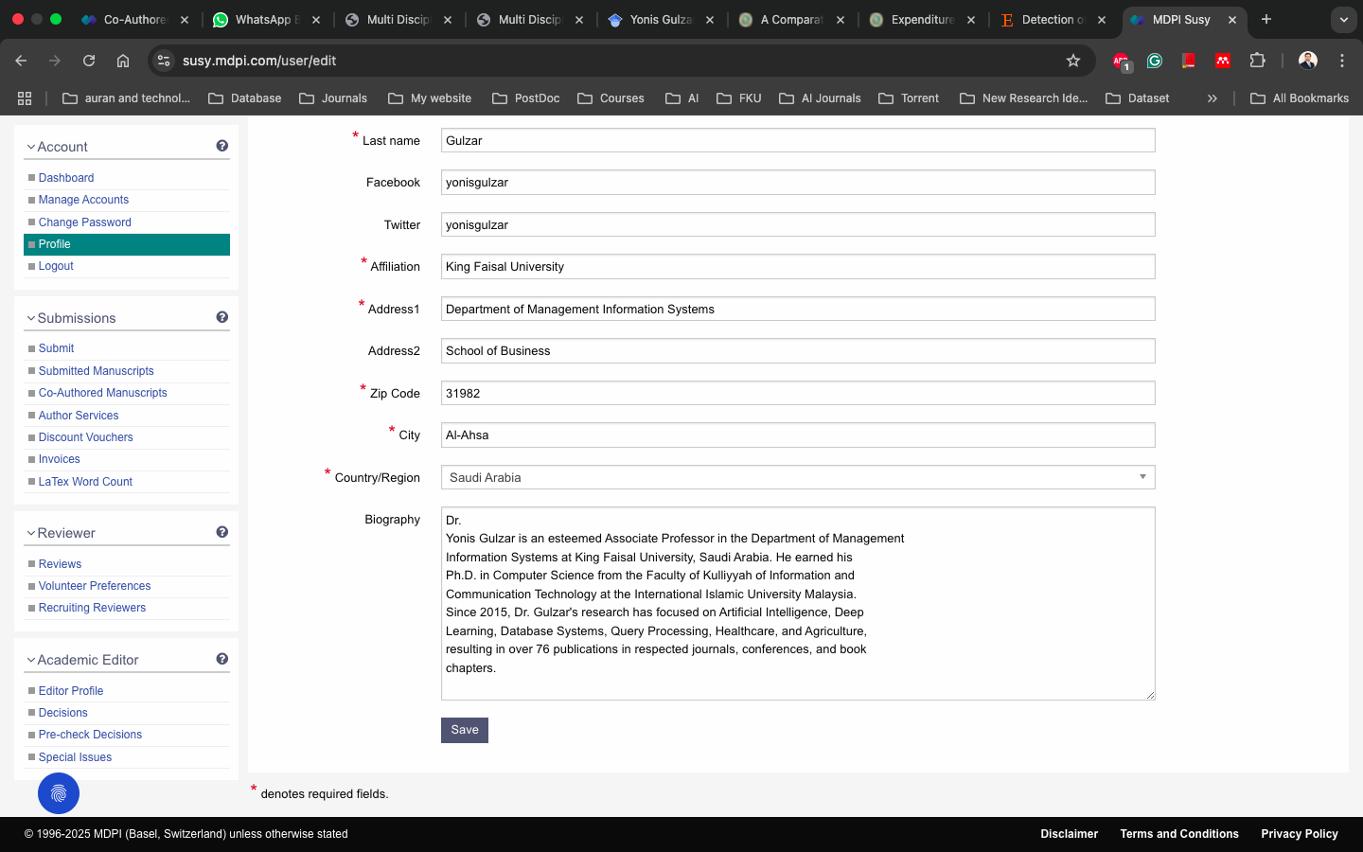

This is the under going but not submitted window

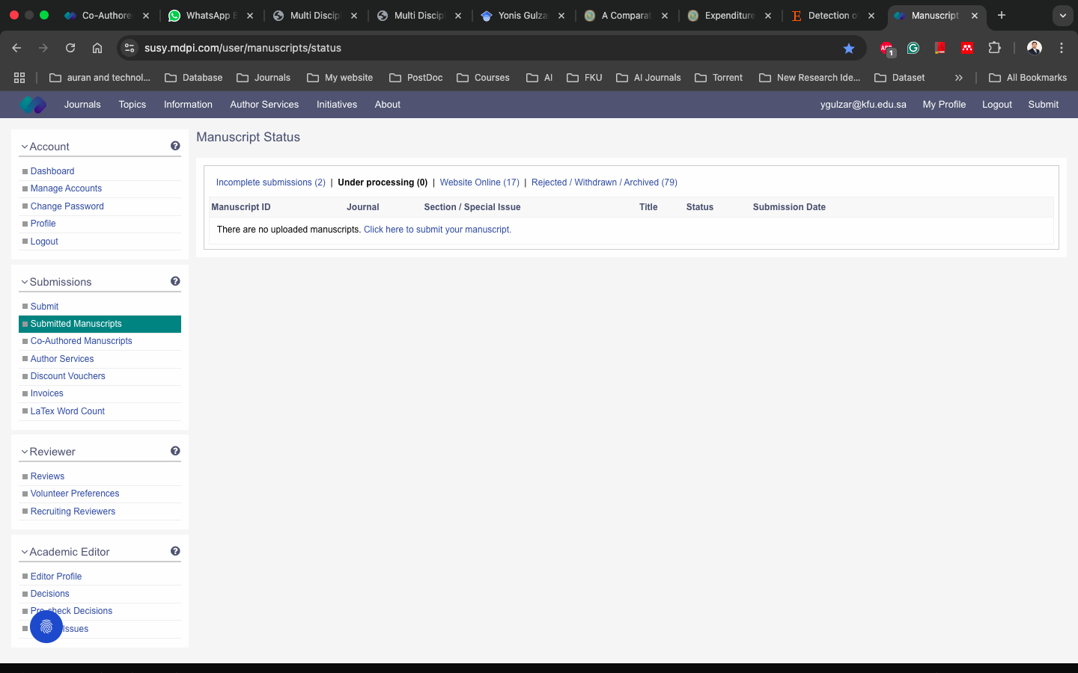



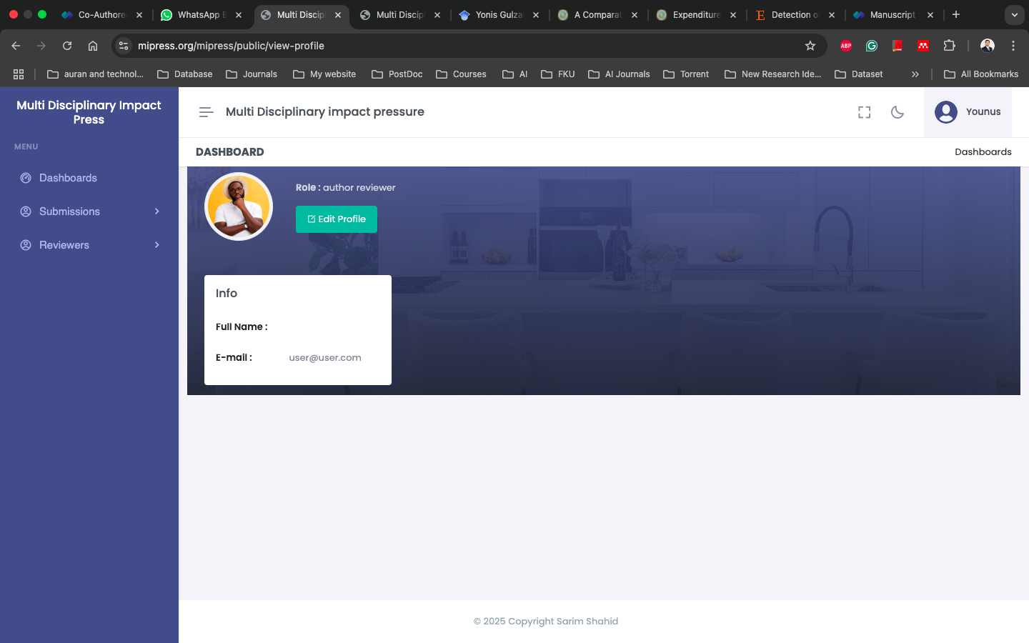



I think there is no need to mention the role here. avoid such details showing to user