- For the author remove the dashboard option, when they login just simply show the papers they have submitted, if none then show like that

- When we login as user it shows dashboard, which is coming form admin. I think user dashboard should not be same as admin

Explanation:

No its not coming from admin its a different dashboard for users only but I will remove that so user can only interact with manuscript submissions

- when entering abstract it say abstract should be of 255 characters, it should take at least 300 words not characters.

Noted / will take care of this

- Also when entering keywords, it should be first Entered First Shown but It is like First entered Last Shown

Explanation:

The order doesnt really matter as long as the keywords entered by user remain same and in database it will be saved in the same order user typed.

i know it wont make different but usually in manuscript the order of keywords show the area of research

- Any issue I see that when file is greater than 2mb it does get uploaded

Explanation:

This step is taken to keep the app lightweight you must mention a limit if u have in mind mention it (2mb,5mb,100mb etc) until 1 gb becuase 1gb word file is a very very rare case and it will take too much space.

Okay got it but usually manuscript files are not that large but if they contain good quality of figures they may go upto 10 to 20 mb, if we keep limit of 15 mb will that be good? And wont impact the speed?

- Another issue once we enter the first page details of form submission, it should be saved as draft. Means we shall be later on able to continue later on where we have left

Explanation:Noted| This tab will be included

all the steps once going to the next page should be auto saved, dont use new button, just once the user presses the next and if there is no error in the page, auto save it and if user exits without submitting the paper, show it in incomplete submission option

- Title in author page should be predefined like Mr. Ms. Dr. Prof.

What do you mean by this do you want a select option in title just like journal and article_type or you want this(Mr. Ms. Dr. Prof.) in placeholder explain please.

See the screenshot

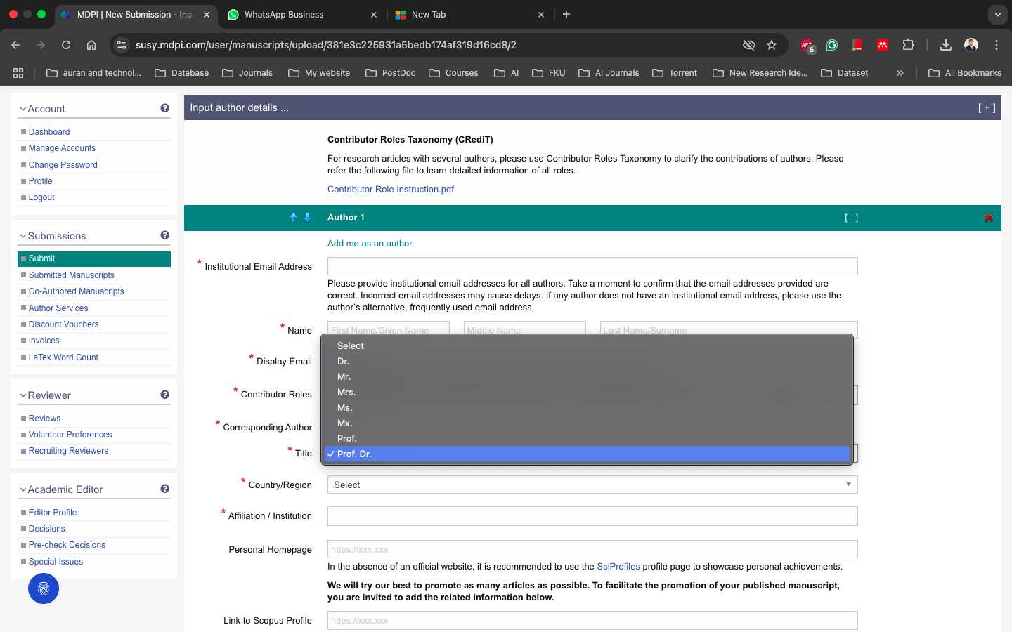

- Middle name should be optional

I have keep everything required uptil now just for development purpose later on I will make it optional in next update probably.

Okay

-Add one more text book as country, separate from affiliation

I will recommend a select box for country.

Yes please that is much better, get it from the country box

- It shows author details rather reviewer details

It's my mistake will fix it

Okay

- User profile

You want user profile exactly like this screenshot shared in excel and label in one line input in another?

Yes do that, make the profile like that

- I think there is no need to mention the role here. avoid such details showing to user

Will remove that

Okay good