**Submission process**

**Manuscript details (u can make these pages separate to make it more organized like what MDPI is doing example is as follows **

1. **Select Journal \***
2. **Upload** the file in .word *
3. **Article type** *( Research, Review, Short Communications, Case Studies, Perspective / Opinion, Methodology, Editorials)
   1. These types will be predefined, author must choose one of these.
4. **title** *
5. **Abstract \***
6. **Keywords**: *, separate them with semicolons

Then add author details, ask for author details

(First Author)

1. **Email** *,
2. **Title** (Dr, Prof., Mr, Ms), *
3. **First Name** *, **Middle Name**, **Last Name** *
4. **Affiliation**\* ( Ask for complete affiliation as in this format (Department, College, University name, City, Postcode, Country))
5. **Check Box** This is a corresponding author (optional)

(Second Author)

1. **Email** *,
2. **Title** (Dr, Prof., Mr, Ms),
3. **First Name** *, **Middle Name**, **Last Name** *
4. **Affiliation**\* ( Ask for complete affiliation as in this format (Department, College, University name, City, Postcode, Country))
5. **Check Box** This is a corresponding author (optional)

Depends upon how many authors, manuscript contains as many as authors (in order) author must add

Reviewer Details   
Ask for 3 reviewer details

1. **Email id** *, (maybe design it in a way that if this email id is already in the database you can fetch the first name, last name and affiliation from the database so author doesn’t need to add manually) if it is not then he will add following details
2. **First Name** *,
3. **Last Name**\*,
4. **Affiliation** *(university name is enough)

Statement

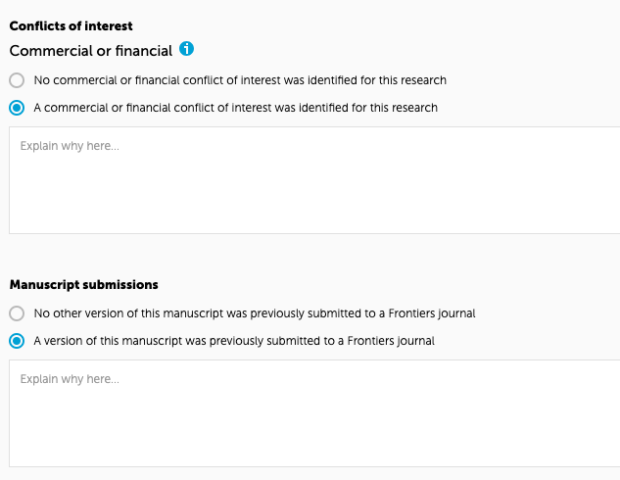



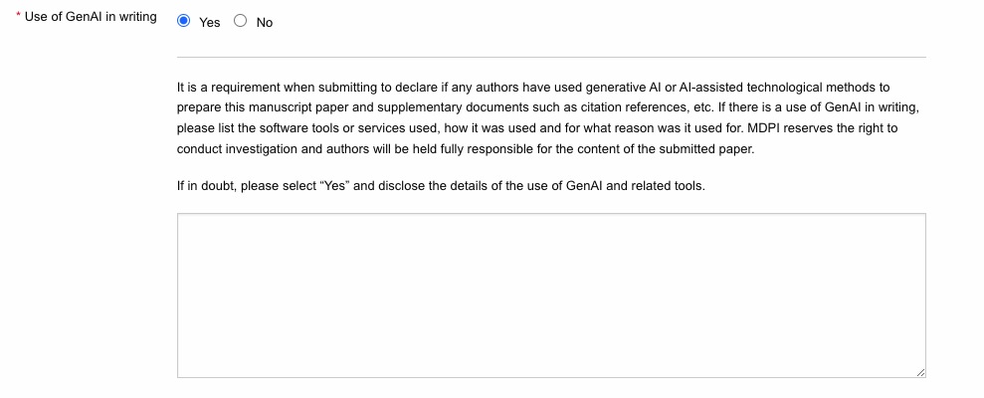

**Data availability statements**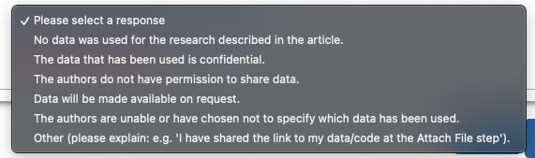

**Submit**