1. Number of auto policy sold this year under different state by each agent, and the change of the number sold

select AUTO.agentname, AUTO.state, AUTO.n_state, AUTO1.n_state1,

(coalesce(AUTO.n_state,0) - coalesce(AUTO1.n_state1,0)) as change

from

(select AAC.agentname, AAC.state, count(AAC.state) as n_state from

(select temp.agentname, substr(temp.clientaddress,instr(temp.clientaddress,',',-1)+1) as state

from

(select * from agent

left join autopolicy on autopolicy.agent_agentid = agent.agentid

left join client on autopolicy.client_clientid = client.clientid) temp

where temp.autopolicyno is not null

and temp.autopolicydate between '01/01/2017' and '12/31/2017') AAC

group by AAC.agentname, AAC.state) AUTO

full join (select AAC1.agentname, AAC1.state1, count(AAC1.state1) as n_state1 from

(select temp1.agentname, substr(temp1.clientaddress,instr(temp1.clientaddress,',',-1)+1) as state1

from

(select * from agent

left join autopolicy on autopolicy.agent_agentid = agent.agentid

left join client on autopolicy.client_clientid = client.clientid) temp1

where temp1.autopolicyno is not null

and temp1.autopolicydate between '01/01/2016' and '12/31/2016') AAC1

group by AAC1.agentname, AAC1.state1) AUTO1

on AUTO1.agentname = AUTO.agentname

order by change desc

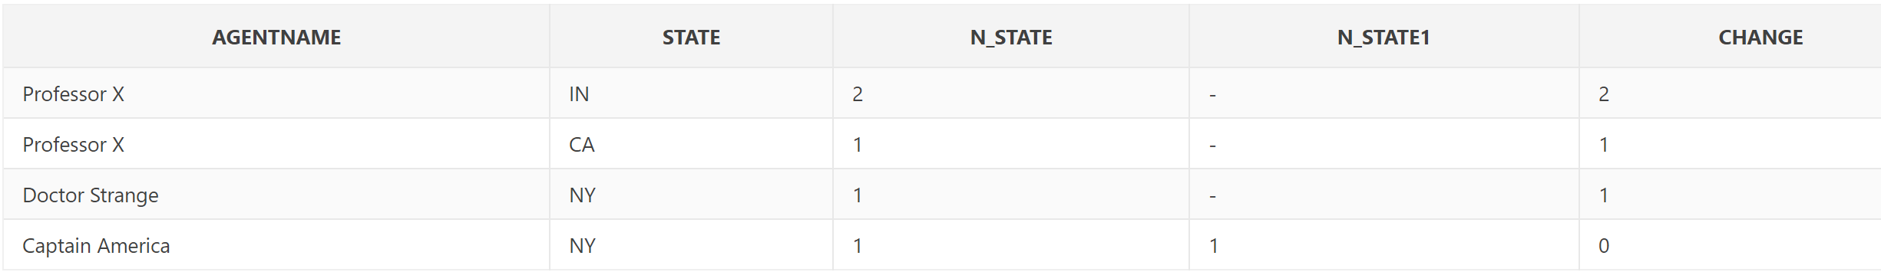

4. Market situation analysis of the insurance company

select insuranceconame, state, sum_auto_amt, sum_life_amt, total_amt, n_client, total_n_policy, round((total_n_policy / n_client),2) as realization from

(select insuranceconame, state, sum_auto_amt, sum_life_amt, (sum_auto_amt+sum_life_amt) as total_amt, n_client, (n_autopolicy+n_lifepolicy) as total_n_policy from

(select insuranceconame, state, sum(coalesce(autopolicydamageamt,0)) as sum_auto_amt, sum(coalesce(lifepolicyamount,0)) as sum_life_amt, count(distinct clientid) as n_client, count(autopolicyno) as n_autopolicy, count(lifepolicyno) as n_lifepolicy

from

(select insuranceconame, substr(clientaddress,instr(clientaddress,',',-1)+1) as state, autopolicyno, autopolicydamageamt, lifepolicyno, lifepolicyamount, clientid from

(((select * from

(select * from insurancecompany

left join invoice on insurancecompany.insuranceconame = invoice.company_insuranceconame) TEMP

where TEMP.invoiceno is not null)

left join client on client_clientid = client.clientid)

left join autopolicy on autopolicy_autopolicyno = autopolicy.autopolicyno)

left join lifepolicy on lifepolicy_lifepolicyno = lifepolicy.lifepolicyno)

group by insuranceconame, state)

order by total_amt desc)

order by realization desc