Large-scale electronic calculations using the NEMO3D program

Marek Korkusinski

1. The system and general simulation settings.
The system I considered was a single, dome-shaped quantum dot on a wetting layer. The wetting layer thickness was 1 unit cell; the diameter of the dot was 32 unit cells, and its height (above the wetting layer) was 3 unit cells. The dot material was InAs, and the barrier material was GaAs.
The first step of the procedure was the calculation of strain using the Keating model. The strain box was 200 x 200 x 100 unit cells (113.06 x 113.06 x 56.53 nm) and contained 32 million atoms. The QD was positioned in its center. I saved the fully converged displacement data and read this file in each subsequent electronic calculation.
All electronic calculations employed the sp3d5s* tight-binding model with spin (20 bands). I considered seven decks, varying in the number of atoms. Details on the size of my electronic domains are gathered in the table below.

Deck number | Domain dimensions (in unit cells) | Number of atoms
1 | 42 x 40 x 20 | 268 800
2 | 62 x 60 x 30 | 892 800
3 | 78 x 80 x 40 | 1 996 800
4 | 98 x 100 x 50 | 3 920 000
5 | 118 x 120 x 60 | 6 796 800
6 | 158 x 160 x 80 | 16 179 200
7 | 174 x 172 x 88 | 21 069 312

In each case the domain was built around the quantum dot so that the QD was in its center. The electronic calculation employed the Lanczos diagonalization algorithm set to retrieve 4 lowest confined states in the conduction band, and 4 highest confined states in the valence band (i.e., the ground and three lowest excited states both for the electron and the hole). I set the maximal number of Lanczos iterations to 8 000, but convergence was acheved typically after 3 000 iterations (this number was almost the same for all the domains, plus minus 100).

2. Eigenenergies and eigenvectors.

As mentioned before, each simulation was set to retrieve the ground and three lowest excited states for the electron and the hole. The energies I obtained for each domain are:
a) Electrons

Deck no. | Energy (eV)
1 | 1.32526 | 1.36846 | 1.36889 | 1.41118 | 1.41385 | 1.41571
2 | 1.32517 | 1.36736 | 1.36778 | 1.40330 | 1.40715
3 | 1.32517 | 1.36728 | 1.36770 | 1.40045
4 | 1.32517 | 1.36728 | 1.36769 | 1.39920
5 | 1.32517 | 1.36728 | 1.36769 | 1.39867
6 | 1.32517 | 1.36728 | 1.36769 | 1.39832
7 | 1.32517 | 1.36728 | 1.36769 | 1.39829

The figure below shows the electronic energies as a function of the number of atoms in the system.

b) Holes

Deck no. | Energy (eV)
1 | 0.15359 | 0.17379 | 0.17424 | 0.19695
2 | 0.15392 | 0.17394 | 0.17443 | 0.19703
3 | 0.15392 | 0.17394 | 0.17443 | 0.19703
4 | 0.15392 | 0.17394 | 0.17443 | 0.19703
5 | 0.15392 | 0.17394 | 0.17443 | 0.19703
6 | 0.15392 | 0.17394 | 0.17443 | 0.19703
7 | 0.15392 | 0.17394 | 0.17443 | 0.19703

The figure below shows the hole energies as a function of the number of atoms in the system.

In the case of holes, the energies obtained with the smallest decks are slightly different from those obtained with other decks. The difference is usually no larger than 0.35 meV. The first deck gives energies that are lower on the absolute scale, but higher from the point of view of the holes. That most likely means that the smallest domain is too small to contain the entire wave function of the hole, while each larger domain appears to be of sufficient size to obtain a result unperturbed by the existence of domain walls.
In the case of electrons the problem seems to be much more pronounced. While the ground state of the electron appears to have converged already in the second domain (i.e., for 892 800 atoms), the third excited state does not seem to be fully converged even in the largest domain (the 21 million one). The energies as a function of the number of electrons appear to exhibit an exponential behavior, and the corrections due to the increase of the domain become smaller than 0.5 meV already for the deck number 5 (with 6 796 800 atoms). Also note that in the case of the first two domains the program returned not only the four lowest energies requested, but also some additional states. The reason for this behavior is not known to me.
To make sure that the states found by the program are indeed the same states for each domain, I looked at the symmetry of the respective wave functions in various domains. In the figure below I present the probability density slices taken in a horizontal plane cutting the quantum dot in 1/3 of its height (i.e., 1 unit cell above the wetting layer). I prepared these slices for three input decks: number 1 (with 268 800 atoms), number 5 (with 6 796 800 atoms) and number 7 (with 21 069 312 atoms).

Orbital | Deck 1 | Deck 5 | Deck 7
Electron GS | 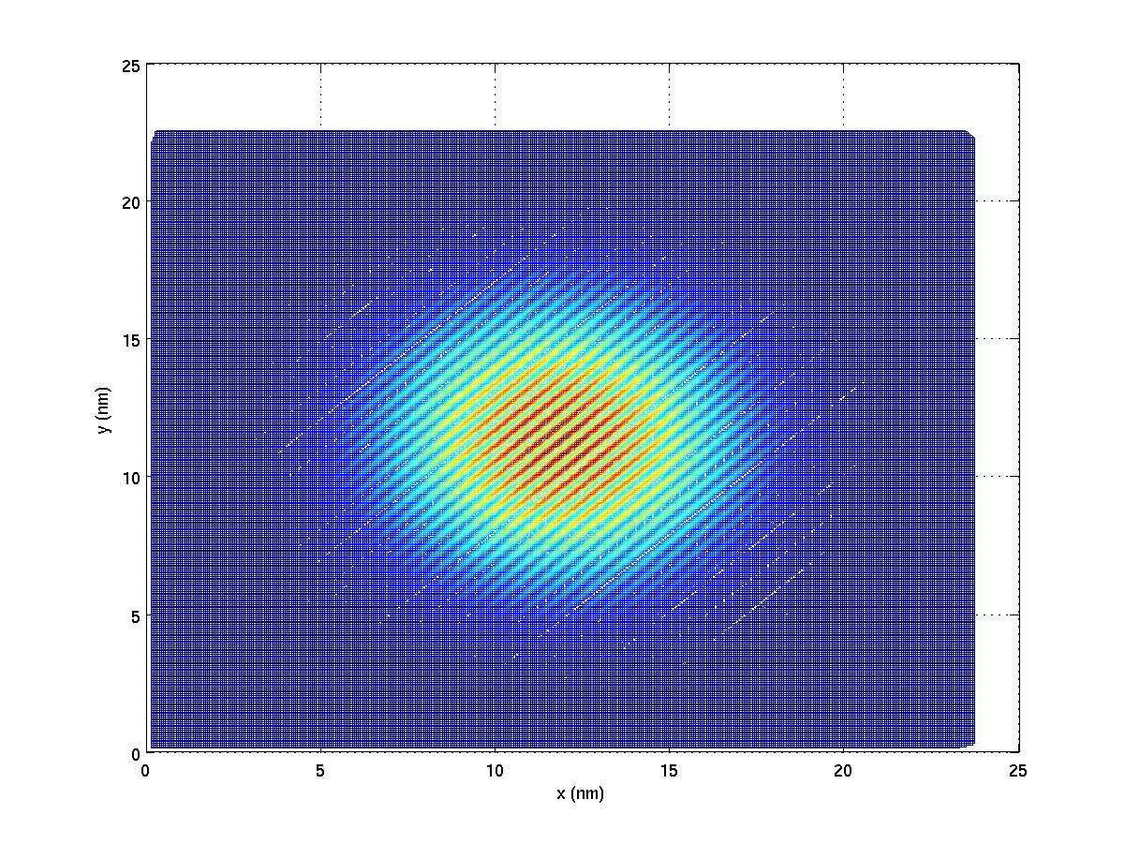 | 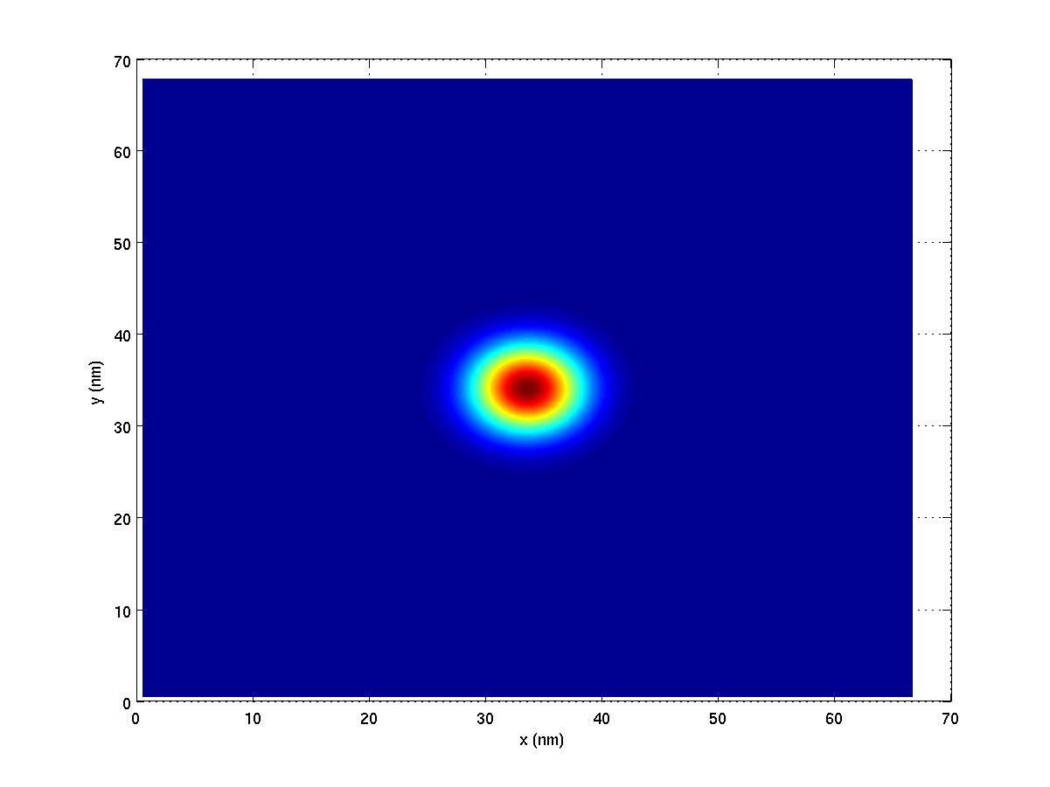 | 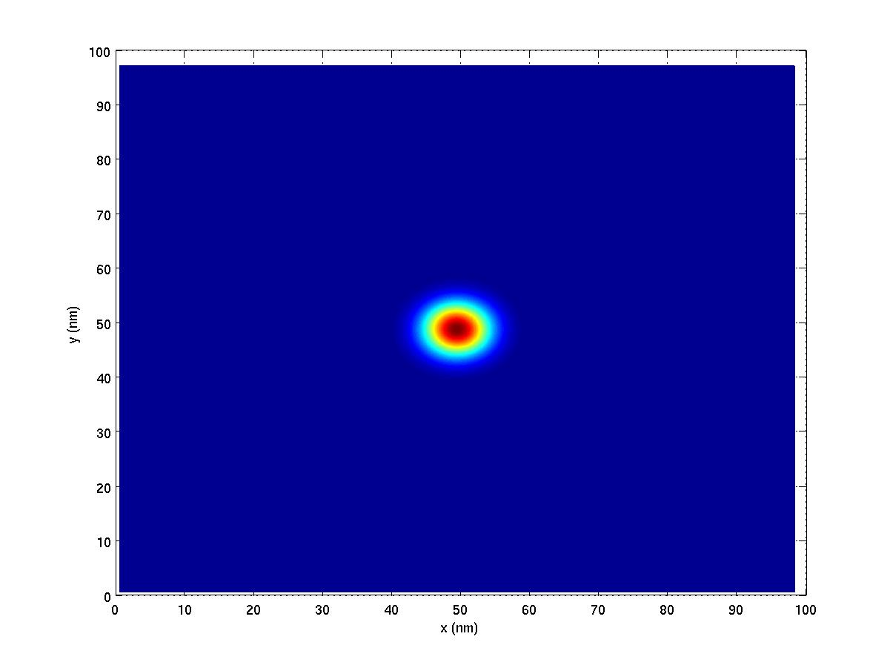
Electron 1ES | 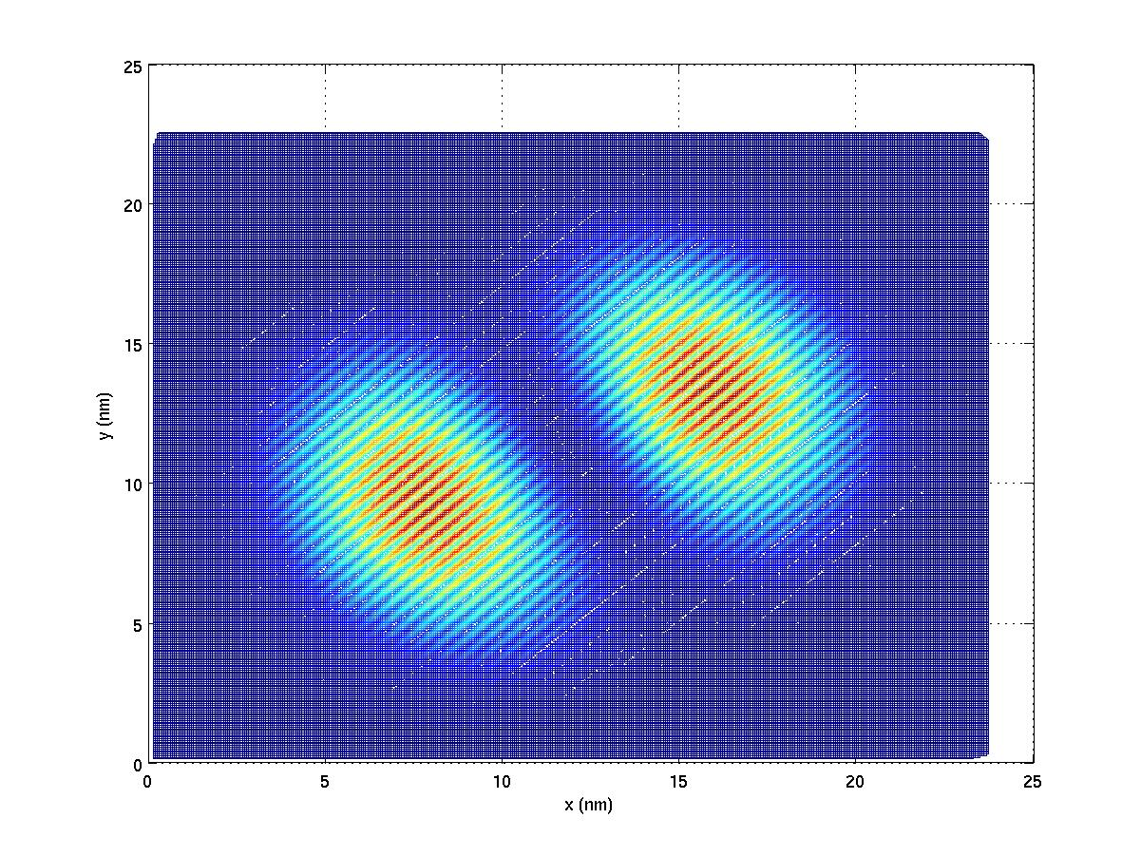 | 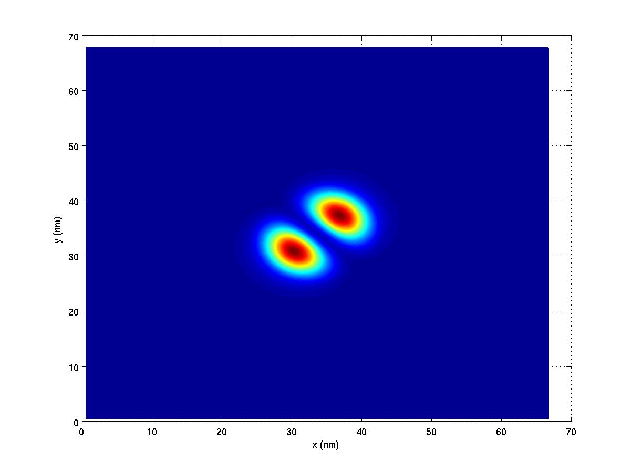 | 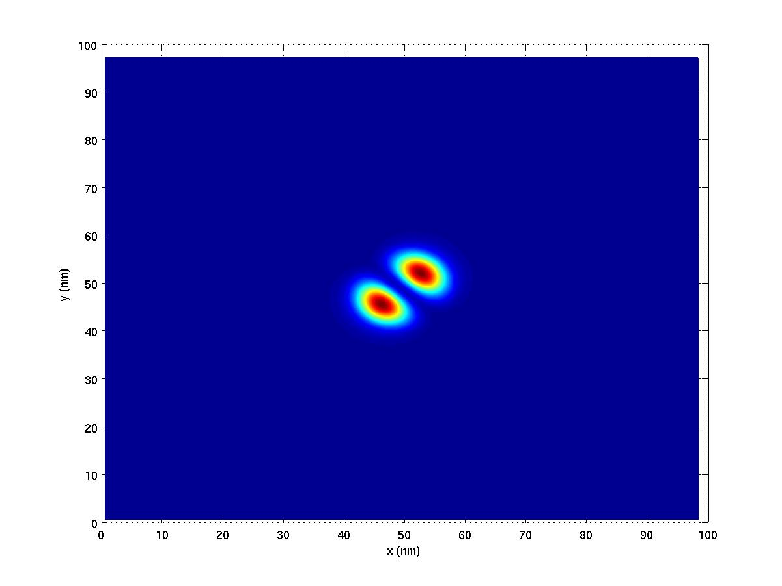
Electron 2ES | 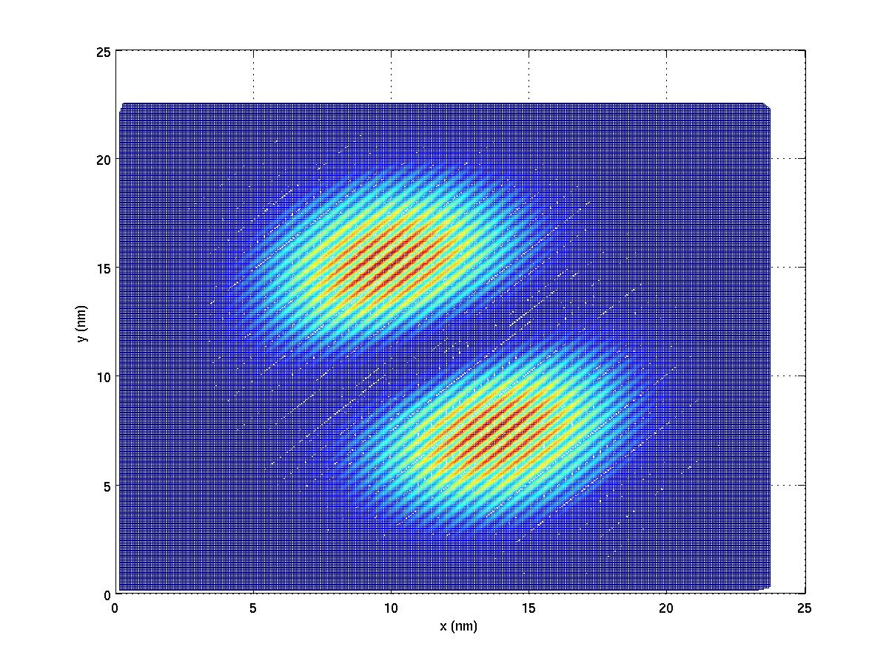 | 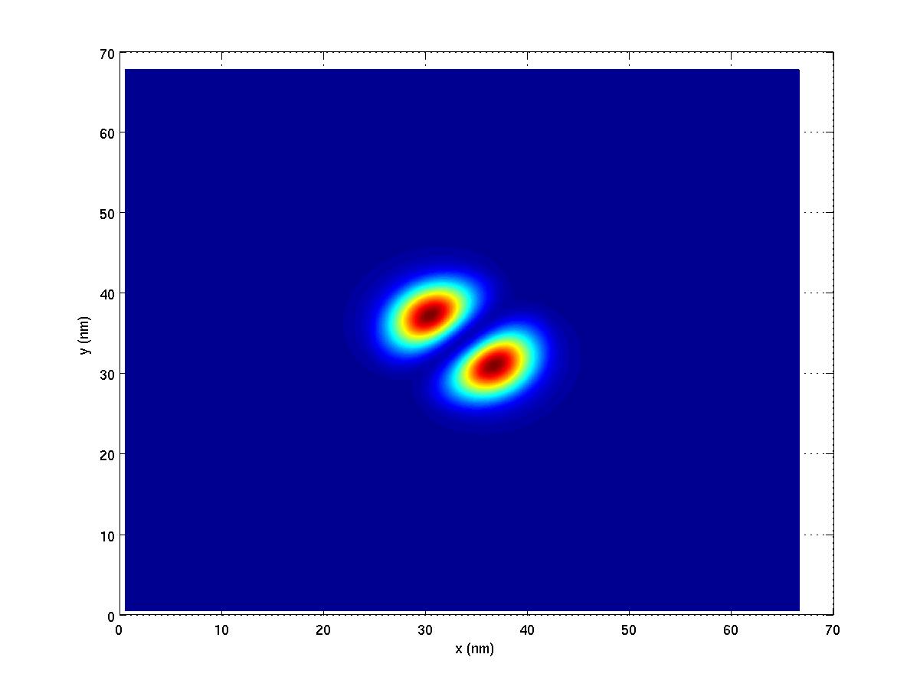 | 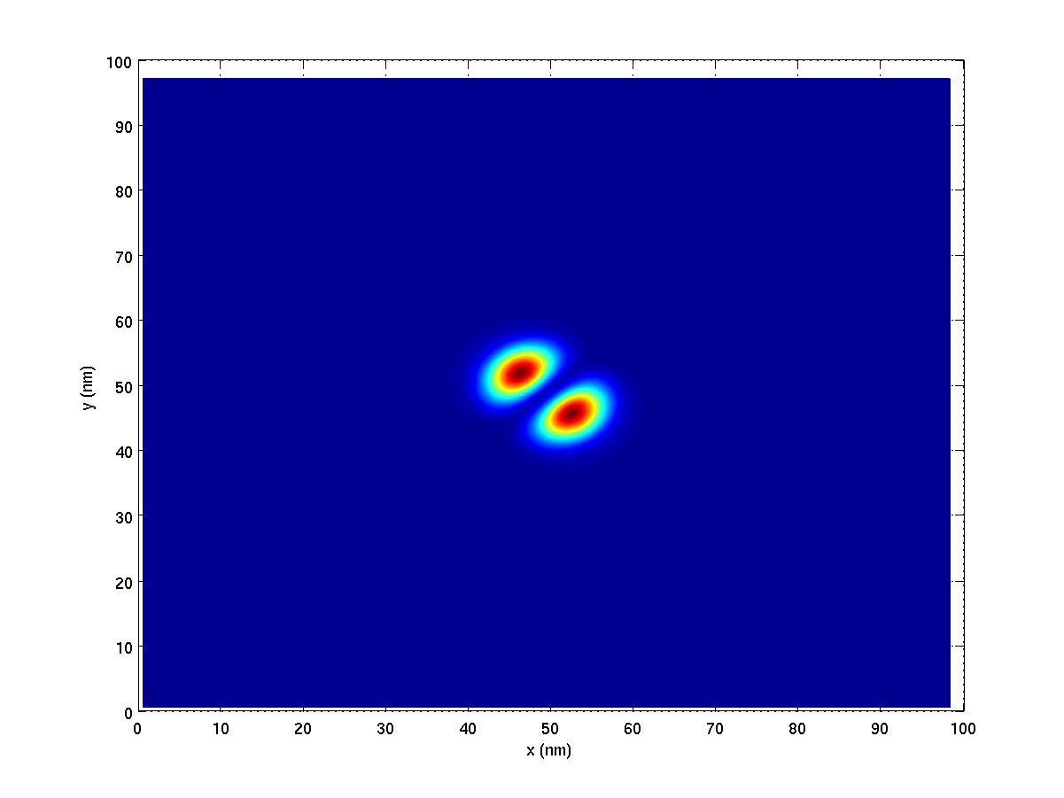
Electron 3ES | 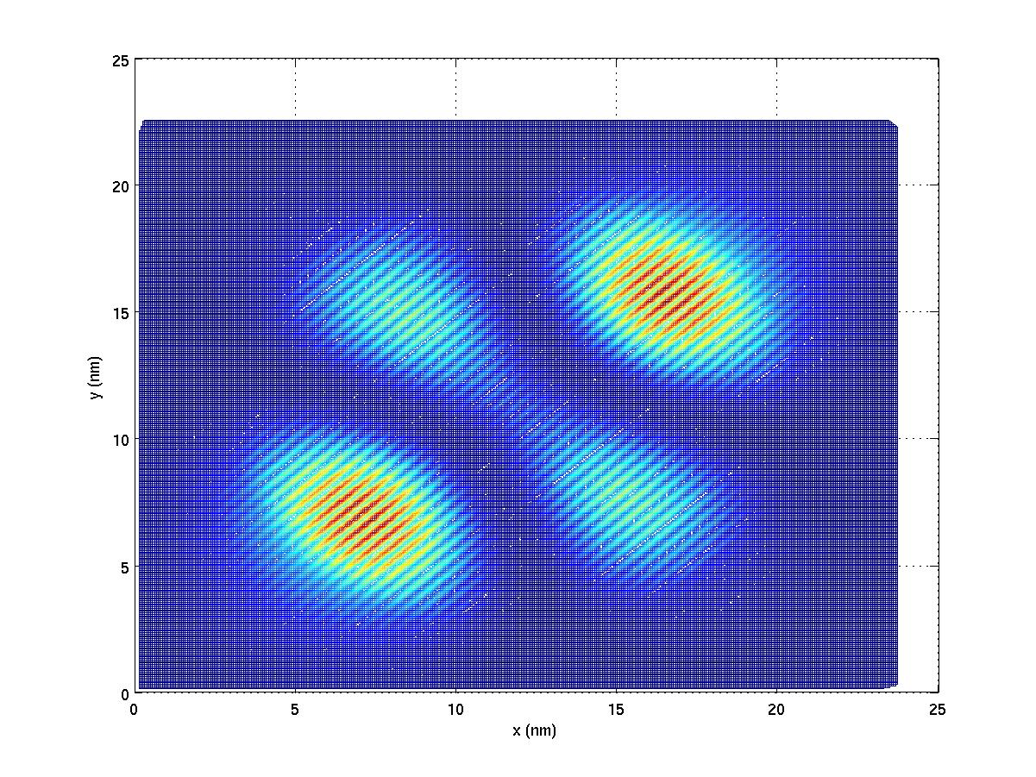 | 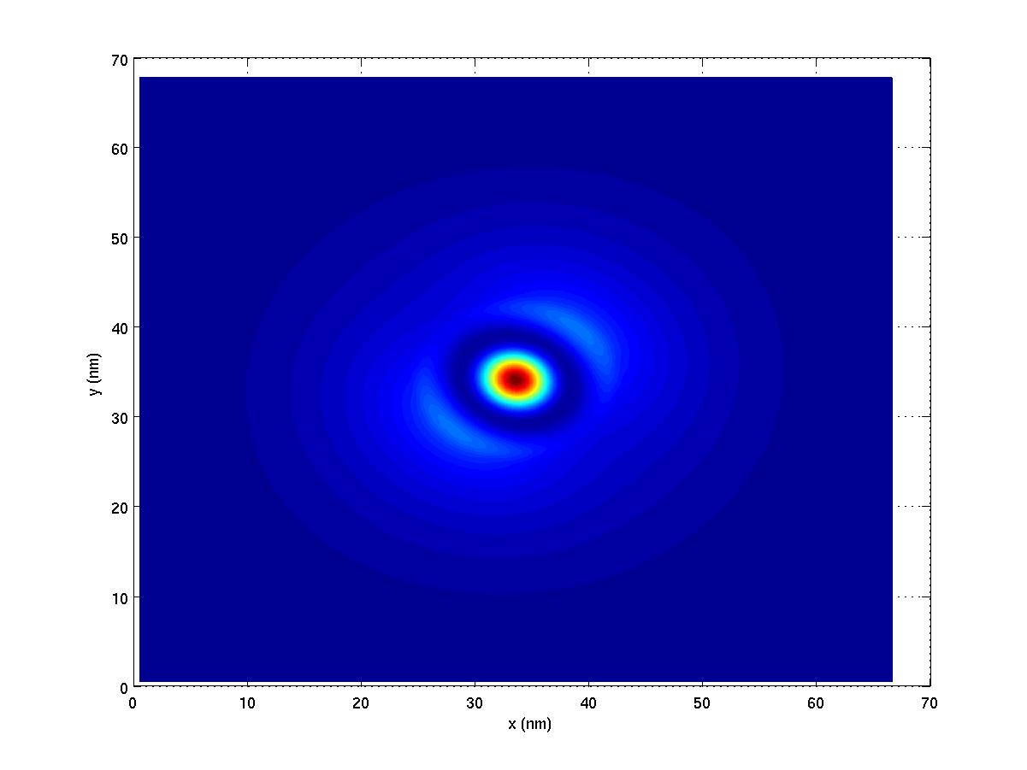 | 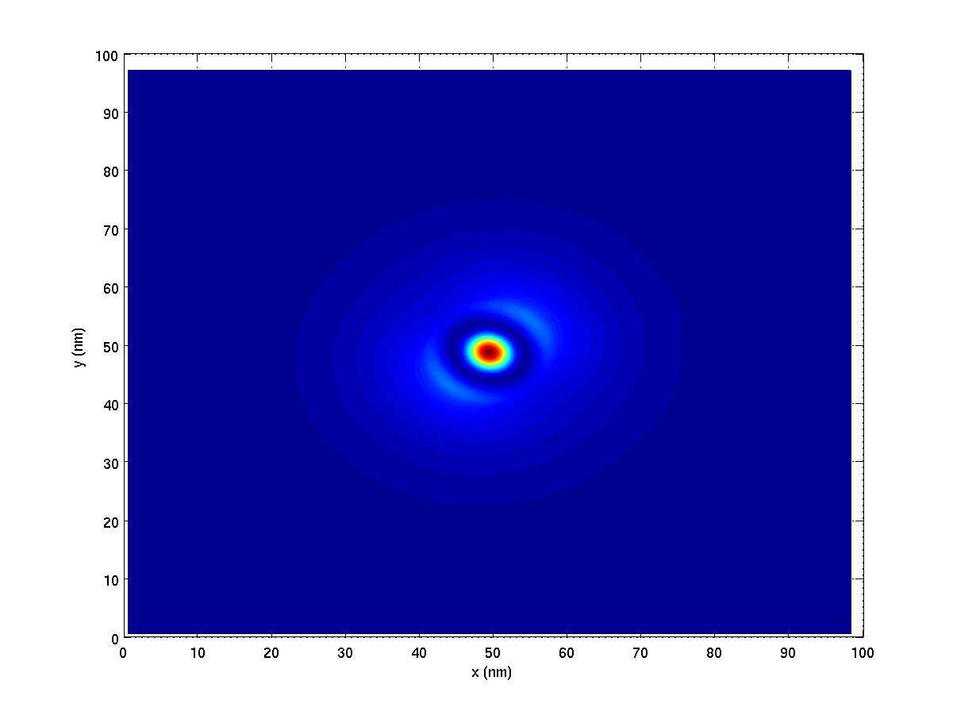
Hole GS | 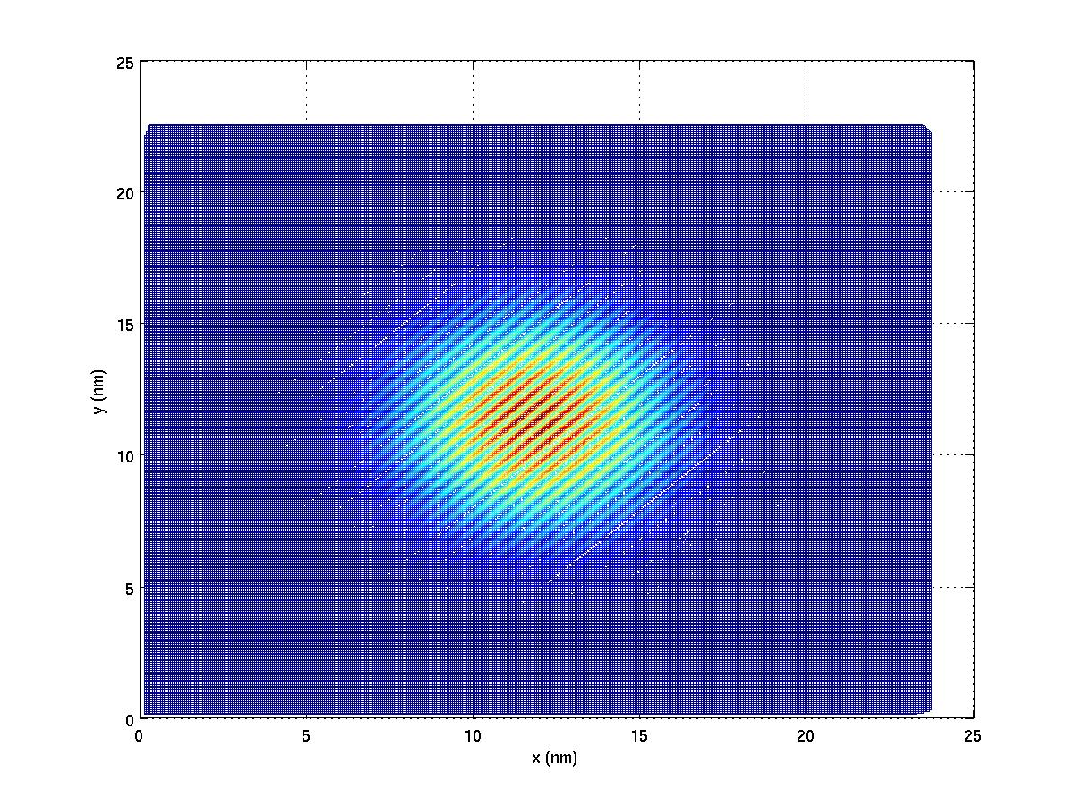 | 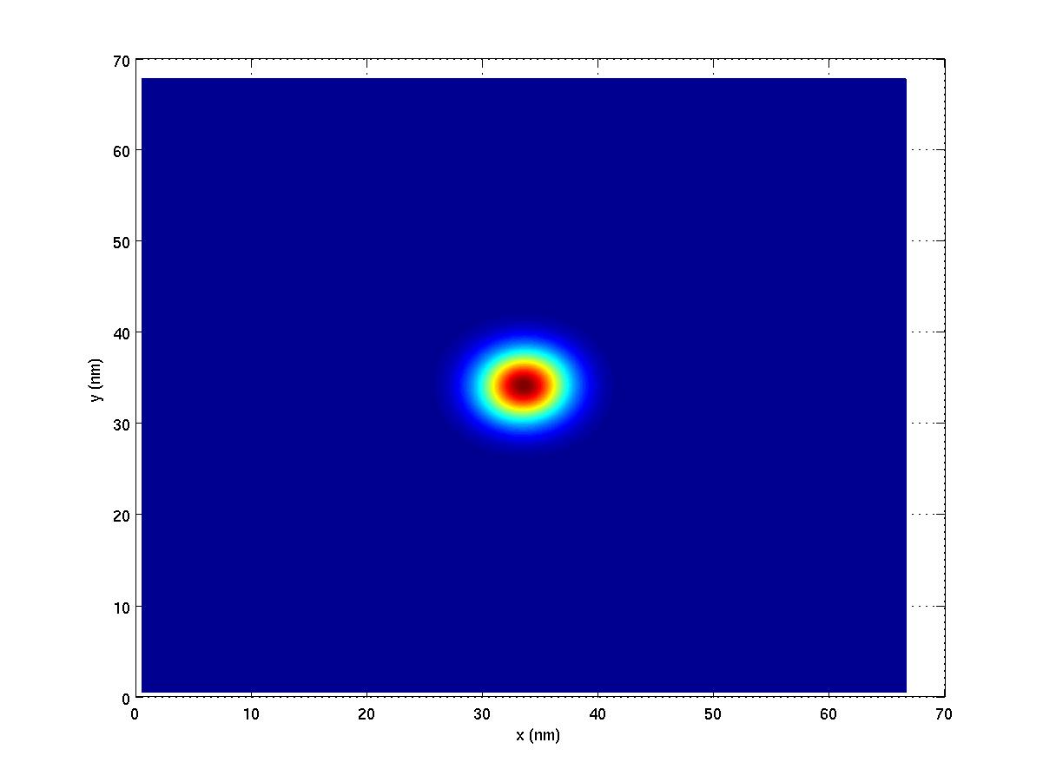 | 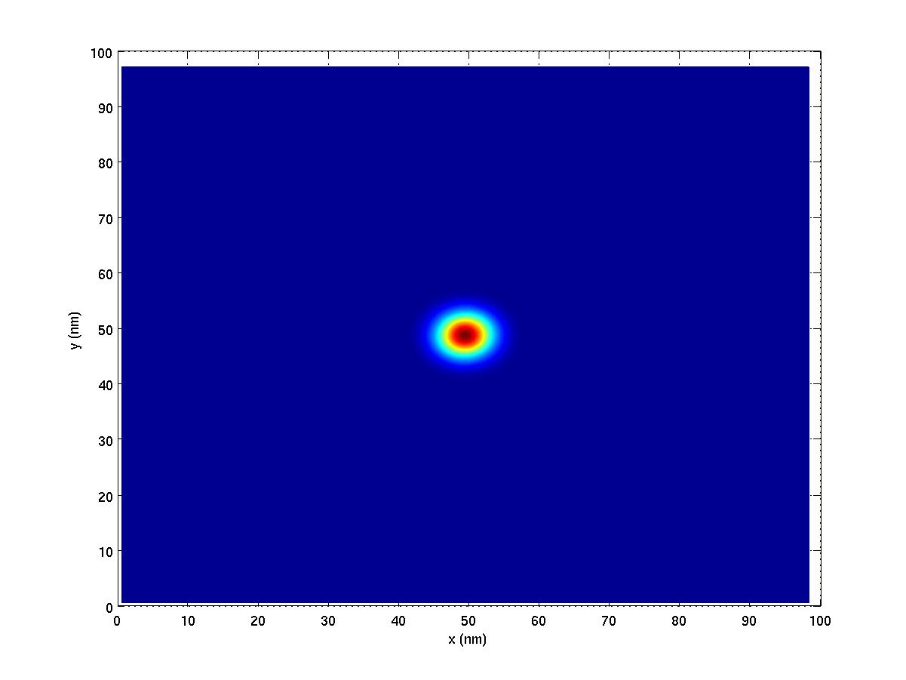
Hole 1ES | 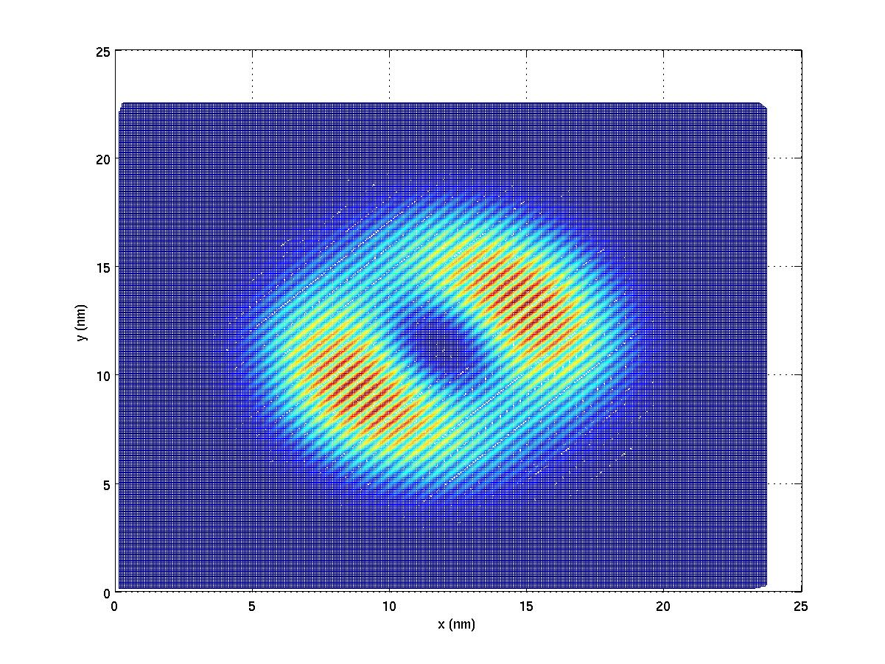 | 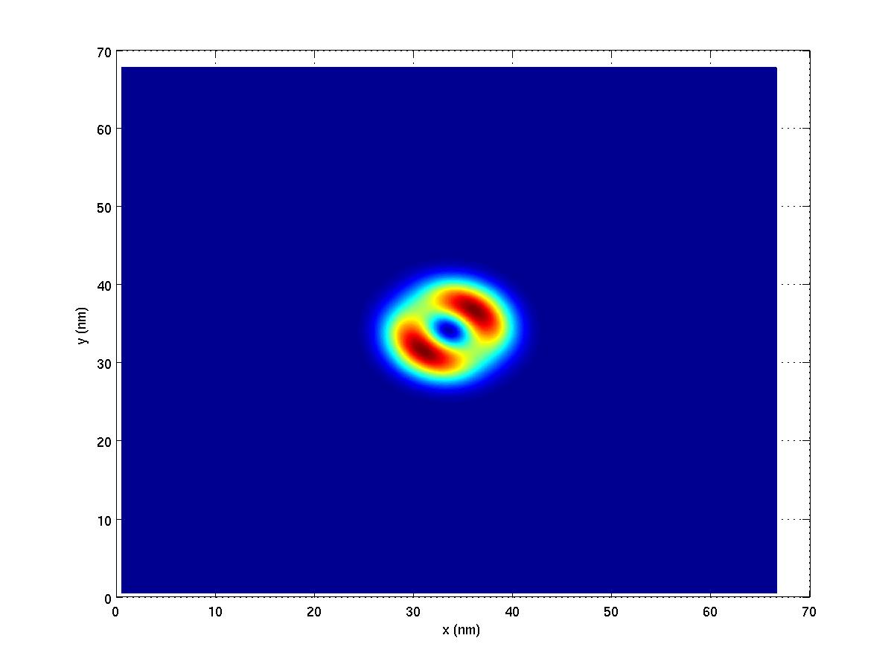 | 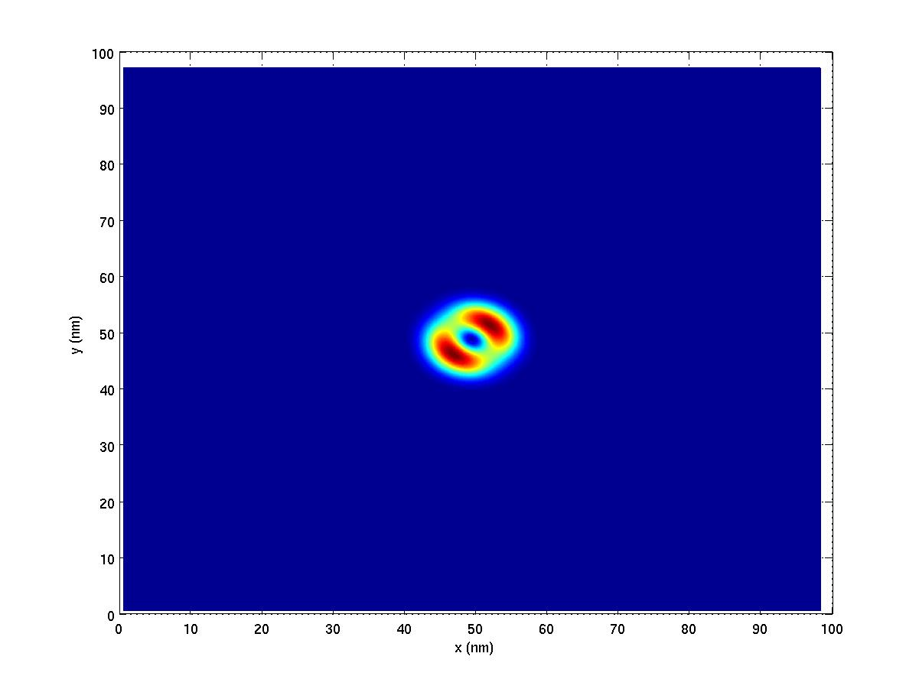
Hole 2ES | 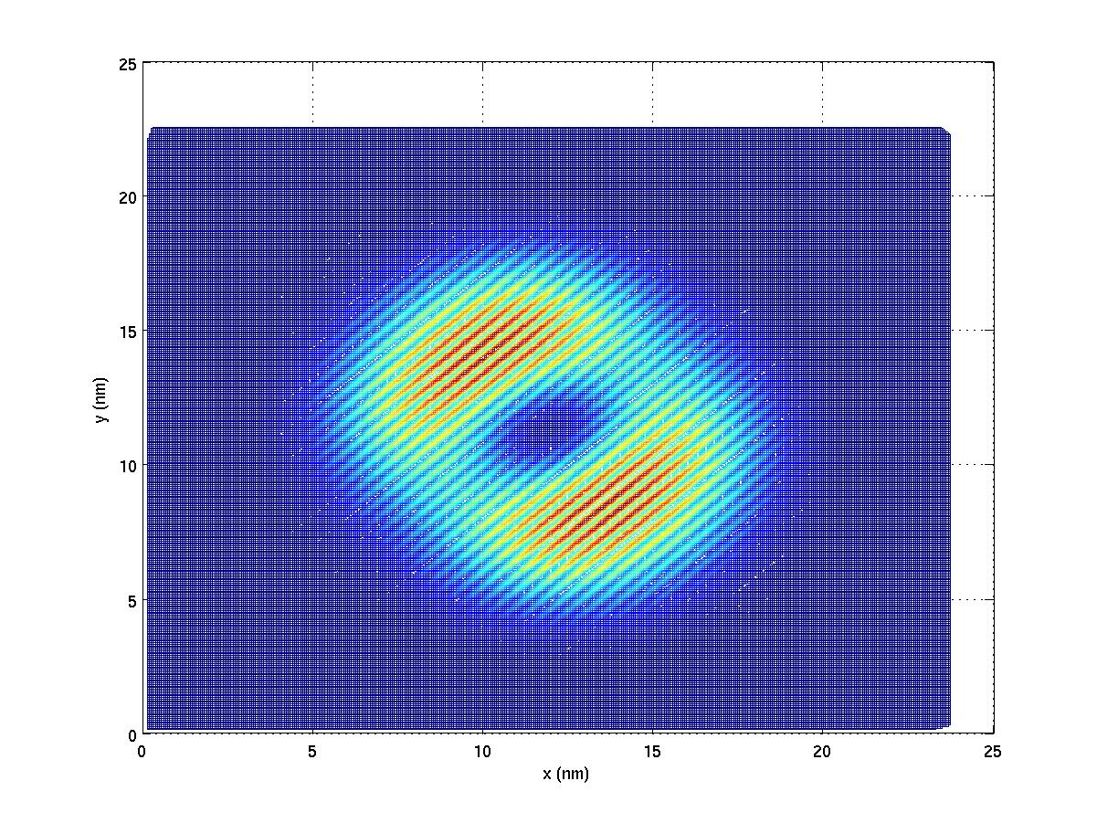 | 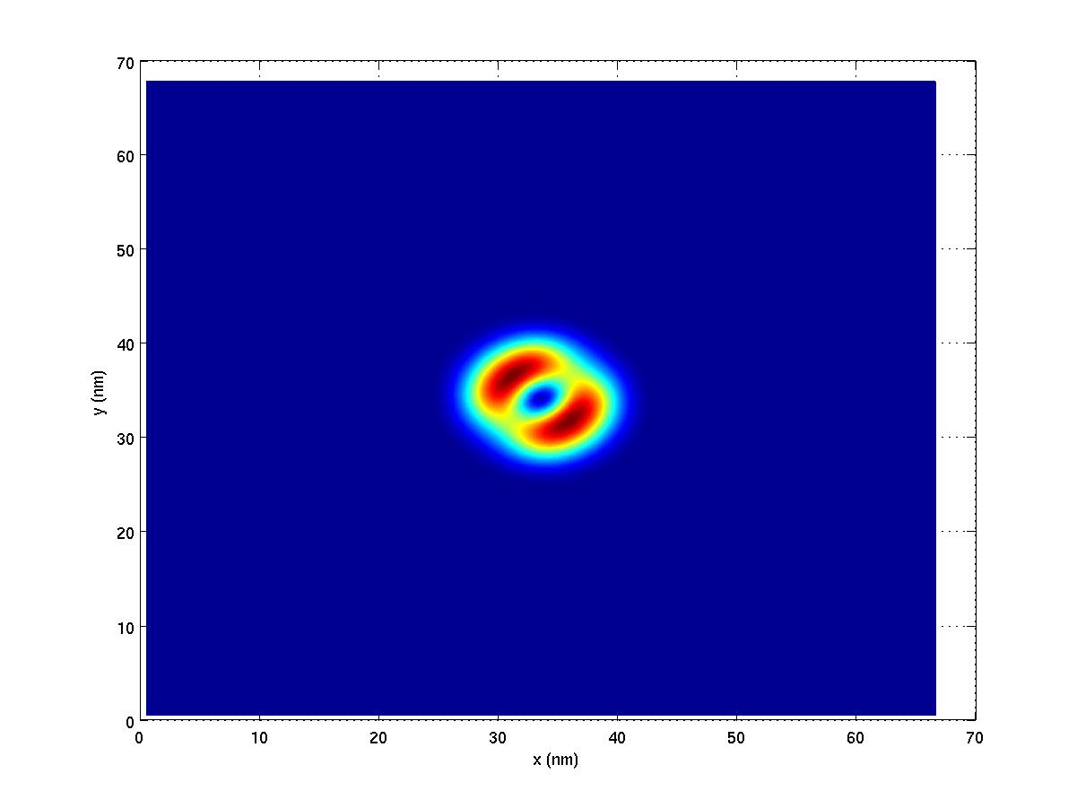 | 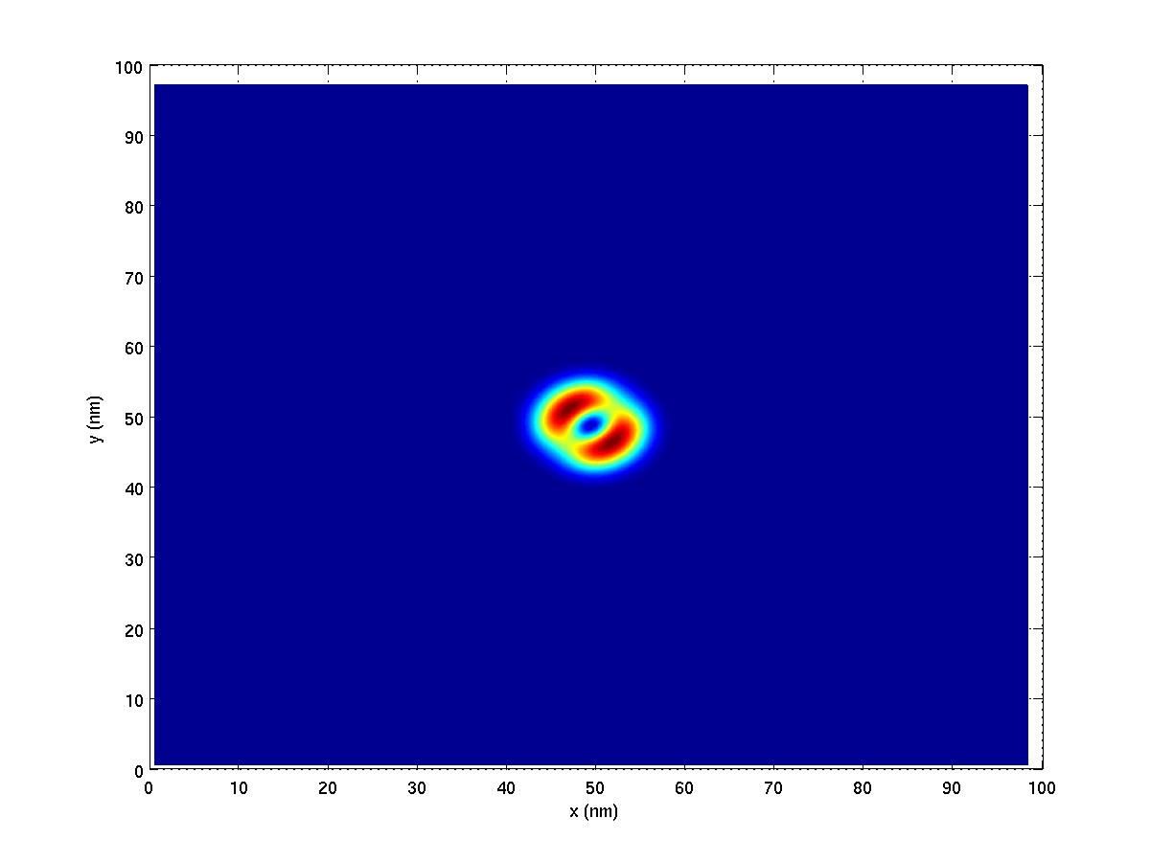
Hole 3ES | 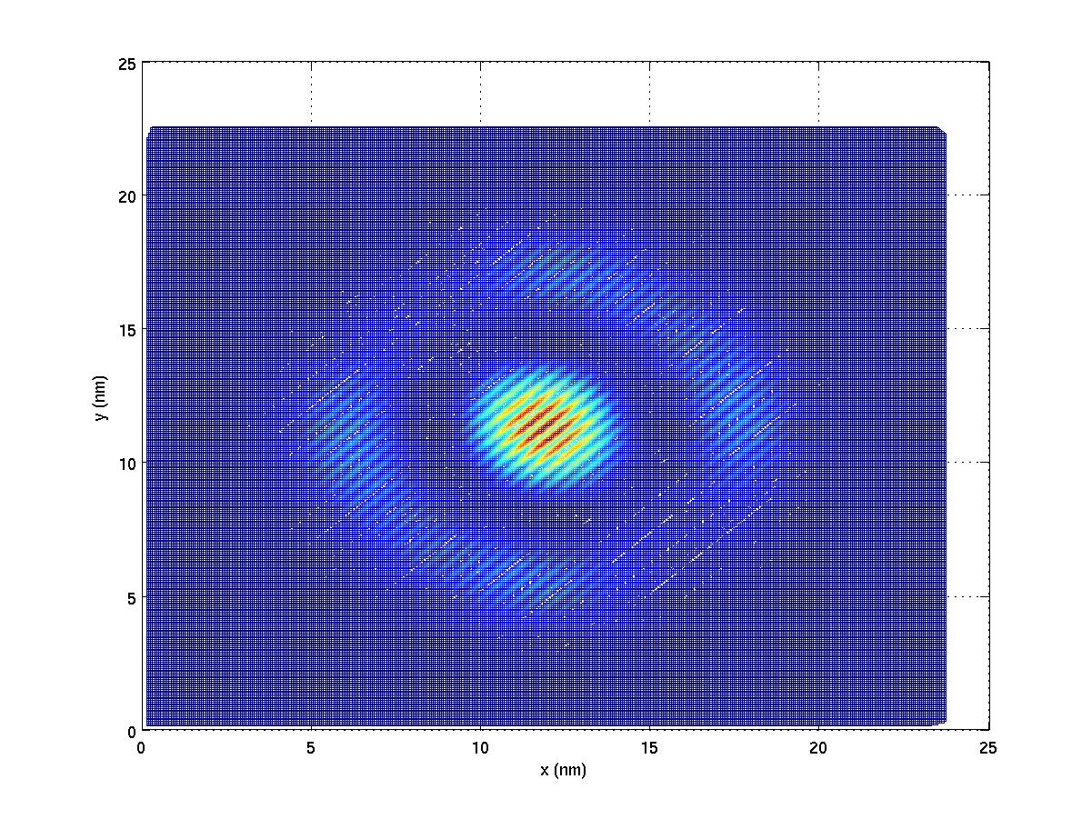 | 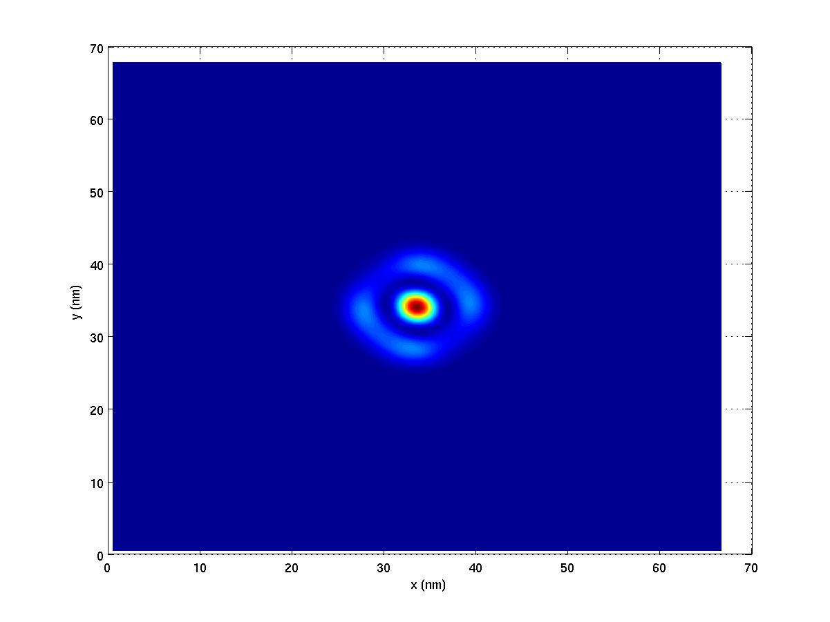 | 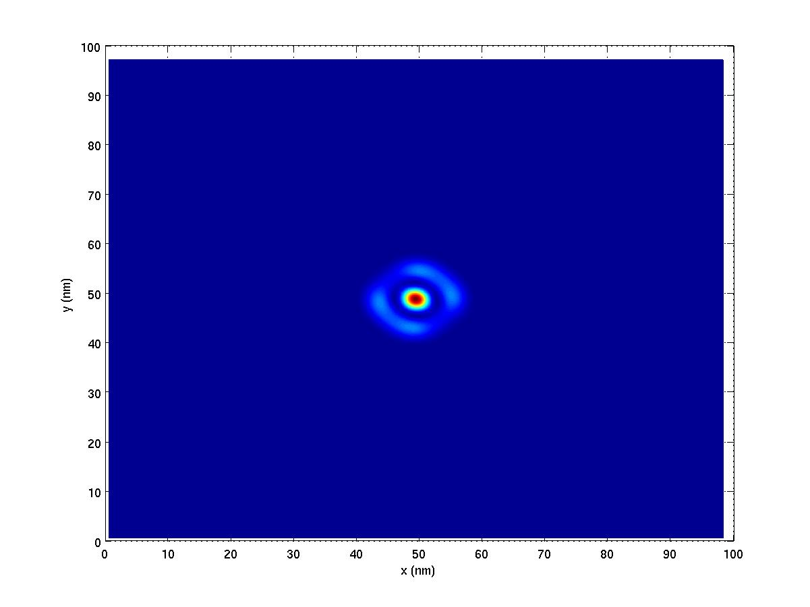

Note that the 3rd excited state of the electron indeed penetrates deeply into the barrier material. This state shows a significant difference in probability distribution in the smallest domain as compared to the two larger domains, which further confirms my previous statement that the first computational domain is too small for the computation of this state.

3. Performance analysis.

All calculations have been done on the NCSA TeraGrid cluster, using the high memory nodes. Decks 1 – 6 were run on 32 CPUs, while the biggest 7th deck was run on 64 CPUs. Here is the breakdown of total execution time for each deck.

Deck number | Number of atoms | Total execution time  hh:mm:ss
1 | 268 800 | 00:44:09
2 | 892 800 | 01:15:11
3 | 1 996 800 | 02:26:51
4 | 3 920 000 | 04:34:54
5 | 6 796 800 | 08:48:56
6 | 16 179 200 | 18:27:36

The calculation with the deck number 7 took 11:52:09. I set it apart form all others, since it was done on 64 CPUs.
The figure below shows the total computational time versus the number of atoms.

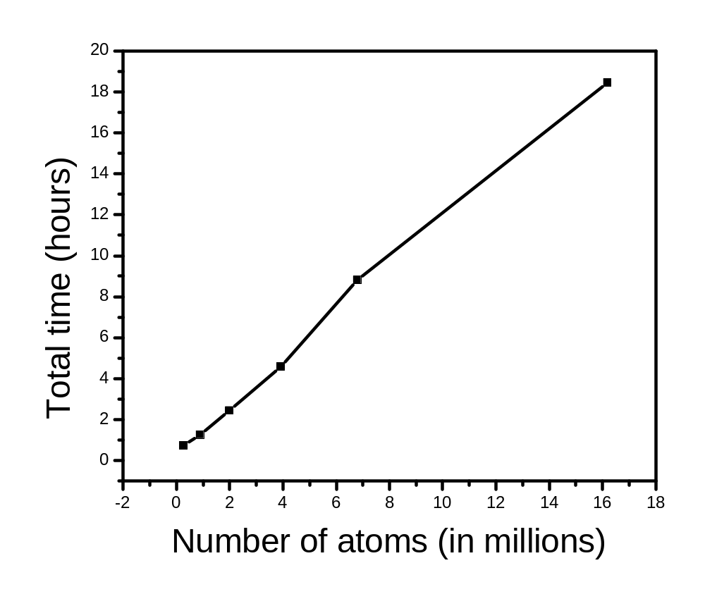

The comparison of computational time for different decks is reasonable, since each of these calculations took a similar number of iterations to converge. Slight differences in the actual number of iterations from deck to deck might be responsible for any irregularities on the above graph.

4. Outlook

From my observation of node capacity on TeraGrid while the largest deck was running, I expect that a 32-million electronic calculation is achievable on 64 CPUs. It should be completed within the preset 24-hour window. The only problem is the hard drive space: for the 21-million system, storing each full eigenvector (that is, the actual wave function, not the probability density) required more than 2.5 GB. The amount of available hard drive space might then become an issue if we actually want to store the eigenvectors for further processing (for example, to postprocess them or to use them in many-body calculations).

