**Objective Questions:**

1.What is the distribution of account balances across different regions?

**Distribution of Account Balances Across Different Regions:**

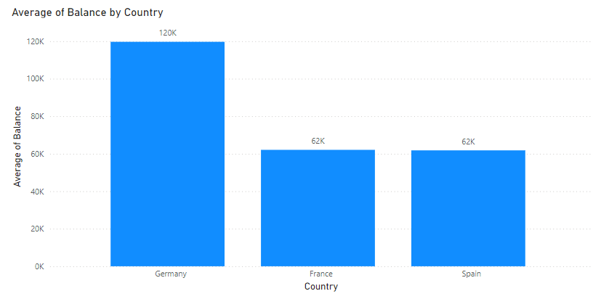

**Findings**:

* Germany: 120,000
* France: 62,000
* Spain: 62,000

2.Identify the top 5 customers with the highest Estimated Salary in the last quarter of the year. (SQL)

**Top 5 Customers with the Highest Estimated Salary in the Last Quarter:**

**Code:**

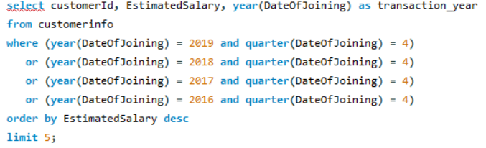

**Result:**

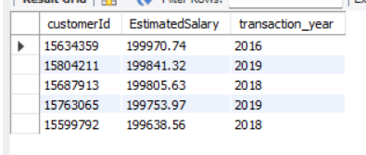

**Findings**:

1. Customer ID: 15599792 - Estimated Salary: 199,638.56 (Year: 2018)
2. Customer ID: 15634359 - Estimated Salary: 199,970.74 (Year: 2016)
3. Customer ID: 15687913 - Estimated Salary: 199,805.63 (Year: 2018)
4. Customer ID: 15763065 - Estimated Salary: 199,753.97 (Year: 2019)
5. Customer ID: 15804211 - Estimated Salary: 199,841.32 (Year: 2019)

3. Calculate the average number of products used by customers who have a credit card. (SQL)

**Average Number of Products Used by Customers with a Credit Card**

**Code:**

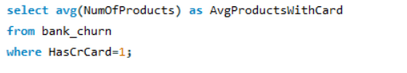

**Result**:

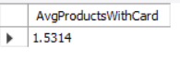

**Findings**:

Average Number of Products: 1.534

4.Determine the churn rate by gender for the most recent year in the dataset.

**Churn Rate by Gender for the Most Recent Year:**

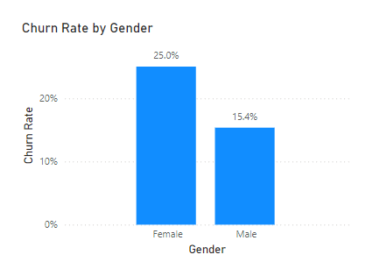

The most recent year in the dataset is **2019**:

**Findings**:

* Female Churn Rate: 25%
* Male Churn Rate: 15.4%

5.Compare the average credit score of customers who have exited and those who remain. (SQL)

**Comparison of Average Credit Scores Between Exited and Retained Customers:**

**Code:**



**Result**:

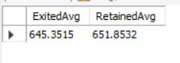

**Findings**:

* Exited Customers: Average Credit Score: 645.3515
* Retained Customers: Average Credit Score: 651.8532

1. Which gender has a higher average estimated salary, and how does it relate to the number of active accounts? (SQL)

**Average Estimated Salary by Gender and Its Relation to the Number of Active Accounts:**

**Code:**

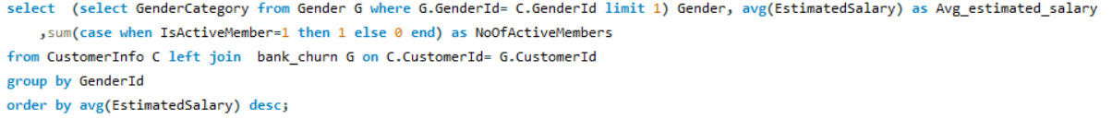

**Result:**

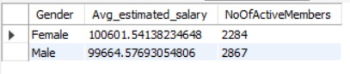

**Findings:**

* Female:
  + Average Estimated Salary: 100,601.54
  + Number of Active Accounts: 2,284
* Male:
  + Average Estimated Salary: 99,664.58
  + Number of Active Accounts: 2,867

1. Segment the customers based on their credit score and identify the segment with the highest exit rate. (SQL)

### Customer Segmentation Based on Credit Score and Exit Rates:

### Code:

### 

### Result:



**Segmentation Criteria**:

* **Poor**: Credit Score ≤ 599
* **Low**: Credit Score 600 - 700
* **Fair**: Credit Score 701 - 749
* **Good**: Credit Score 750 - 799
* **Excellent**: Credit Score ≥ 800

**Findings**:

* **Segment: Poor**
  + **Number of Exited Customers**: 660
  + **Total Customers in Segment**: 3,034
  + **Exit Rate**: 21.8%

8. Find out which geographic region has the highest number of active customers with a tenure greater than 5 years. (SQL)

### Geographic Region with the Highest Number of Active Customers with Tenure Greater Than 5 Years:

### Code:

### Result:



**Findings**:

* **Geographic Region**: France
  + **Description**: France has the highest number of active customers who have a tenure greater than 5 years.

9.What is the impact of having a credit card on customer churn, based on the available?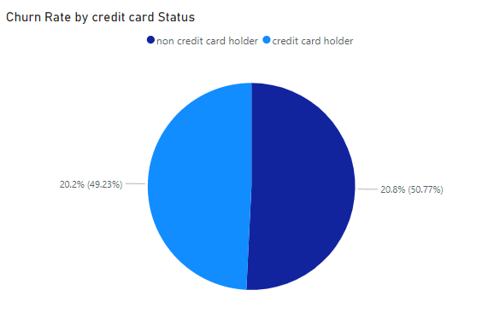

**Graph Analysis**:

The above pie chart shows the impact of having a credit card on customer churn

10.For customers who have exited, what is the most common number of products they have used?

### Most Common Number of Products Used by Exited Customers:

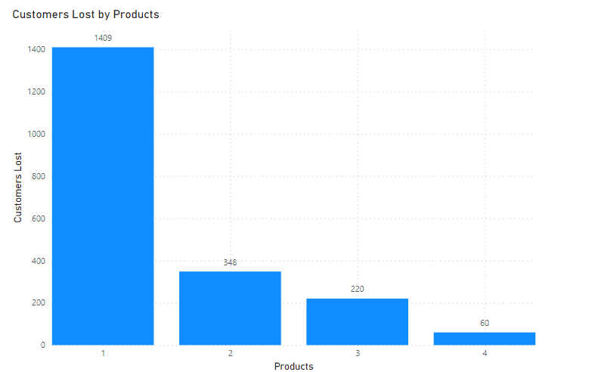

**Findings**:

* **1 Product**: 1,409 exited customers
* **2 Products**: 348 exited customers
* **3 Products**: 220 exited customers
* **4 Products**: 60 exited customers

The most common number of products used by customers who have exited is **1 product**.

11.Examine the trend of customers joining over time and identify any seasonal patterns (yearly or monthly). Prepare the data through SQL and then visualize it.

**Code:**

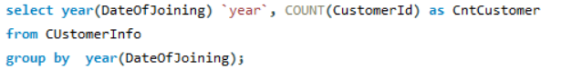

**Result:**

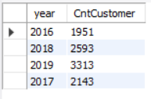

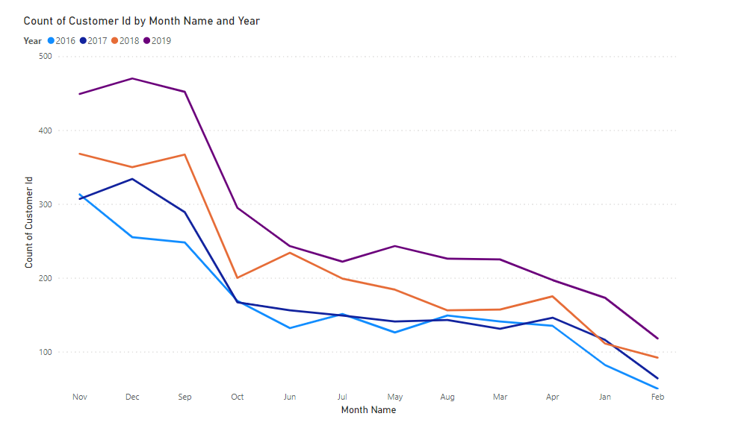

**Findings**:

* **Year 2016**: 1,951 customers joined
* **Year 2017**: 2,143 customers joined
* **Year 2018**: 2,593 customers joined
* **Year 2019**: 3,313 customers joined

**Seasonal Patterns**:

* Monthly variations can be observed, with typically higher customer joinings in certain months. Ref- Graph 2

12. Analyze the relationship between the number of products and the account balance for customers who have exited.

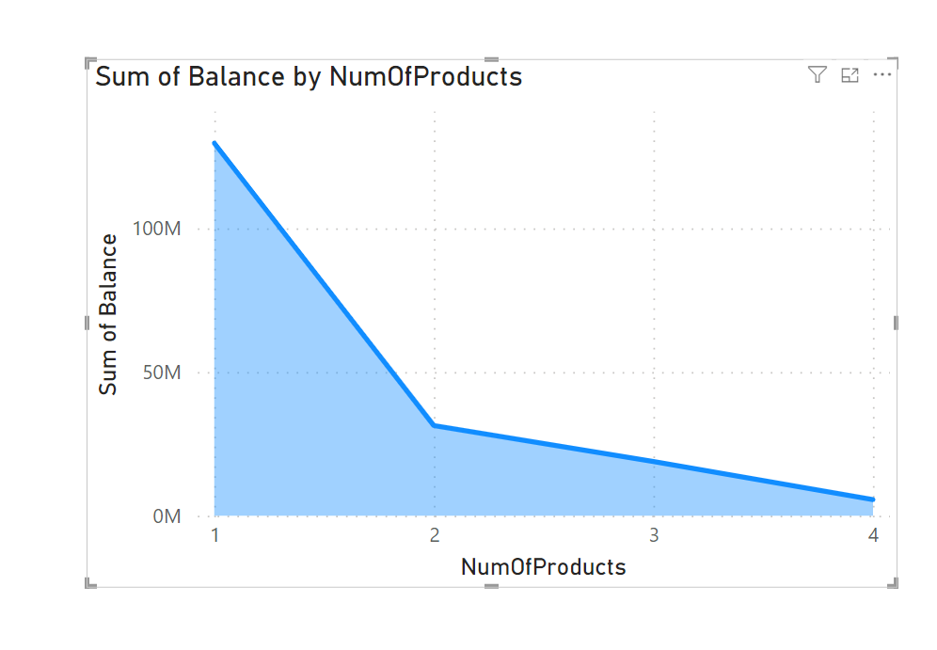

**Graph Analysis**:

The above graph shows relationship between the number of products and the account balance for customers who have exited.

13. Identify any potential outliers in terms of balance among customers who have remained with the bank.

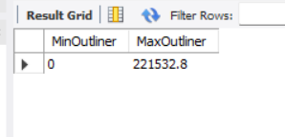

### Identification of Potential Outliers in Balance Among Customers Who Have Remained:

**Findings**:

* The balance among customers who have remained with the bank ranges from 0 to 221,523.8
* Outliers may be identified by examining balances significantly higher or lower than the average or median balance within this range.

14. How many different tables are given in the dataset, out of these tables which table only consists of categorical variables?

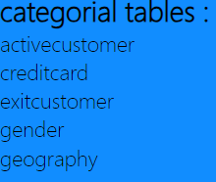

15. Using SQL, write a query to find out the gender-wise average income of males and females in each geography id. Also, rank the gender according to the average value. (SQL)

**Code:**

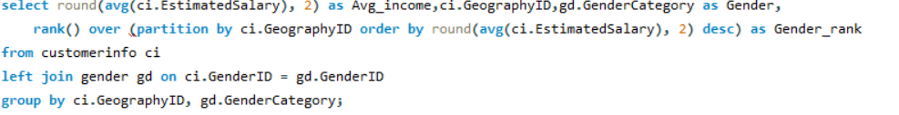

**Result:**

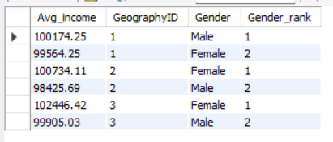

**Geography ID 1:**

* **Male**:
  + Average Income: 100,174.25 (Rank 1)
* **Female**:
  + Average Income: 99,564.25 (Rank 2)

**Geography ID 2:**

* **Female**:
  + Average Income: 100,734.11 (Rank 1)
* **Male**:
  + Average Income: 98,425.69 (Rank 2)

**Geography ID 3:**

* **Female**:
  + Average Income: 102,446.42 (Rank 1)
* **Male**:
  + Average Income: 99,905.03 (Rank 2)

16. Using SQL, write a query to find out the average tenure of the people who have exited in each age bracket (18-30, 30-50, 50+).

Code:

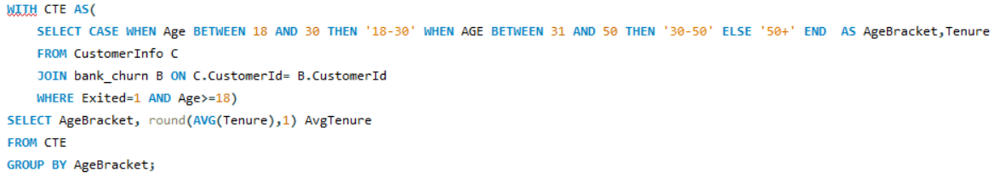

Result:

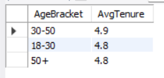

### Average Tenure of Exited Customers by Age Bracket

**Age Bracket 18-30**:

* Average Tenure: 4.8 years

**Age Bracket 30-50**:

* Average Tenure: 4.9 years

**Age Bracket 50+**:

* Average Tenure: 4.8 years

17. Is there any direct correlation between salary and the balance of the customers? And is it different for people who have exited or not?

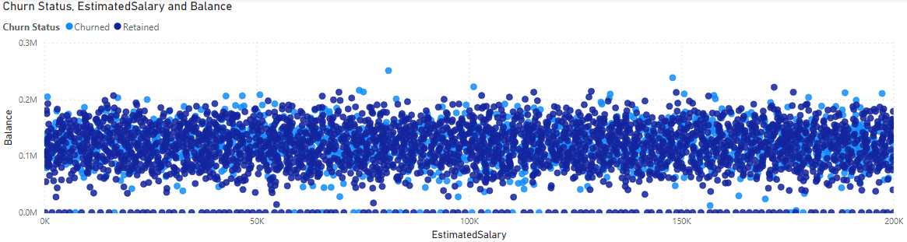

**Findings:**

NO

18. Is there any correlation between the salary and the Credit score of customers?

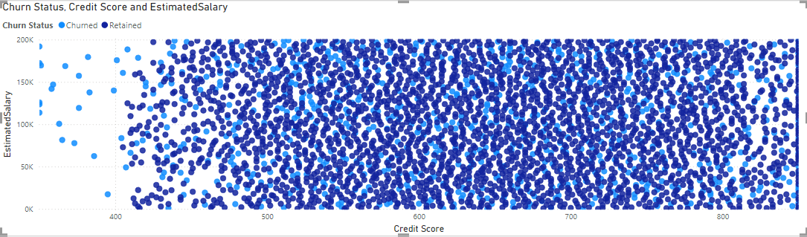

**Findings:**

Credit score under 400 are subjected to highest churn rate and in that respective credit score bucket as estimated salary increases the churn rate also increased.

**Method -2**



-excel

19. Rank each bucket of credit score as per the number of customers who have churned the bank.

**Code:**

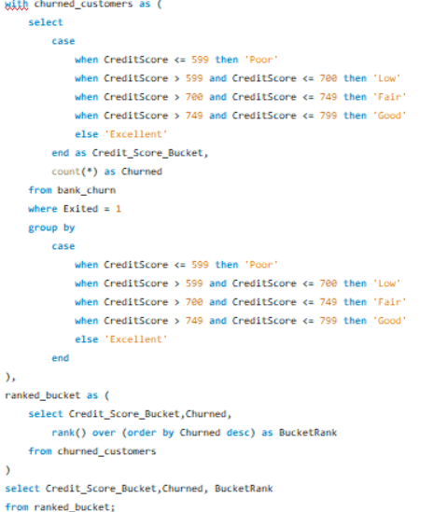

**Result:**

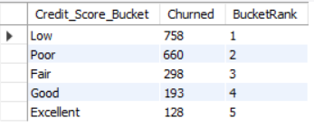

**Segmentation Criteria**:

* + **Poor**: Credit Score ≤ 599, Number of Customers Churned: 758
  + **Low**: Credit Score 600 – 700, Number of Customers Churned: 660
  + **Fair**: Credit Score 701 – 749, Number of Customers Churned: 193
  + **Good**: Credit Score 750 – 799, Number of Customers Churned: 193
  + **Excellent**: Credit Score ≥ 800 Number of Customers Churned: 128

Top of Form

Bottom of Form

20. According to the age buckets find the number of customers who have a credit card. Also retrieve those buckets that have lesser than average number of credit cards per bucket.

**Code:**

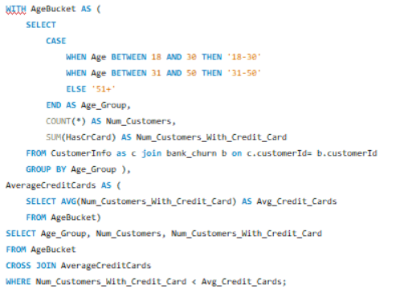

**Result:**

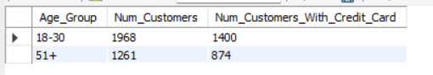

### Findings:

**Age Bracket 18-30**:

* Number of Customers with Credit Cards: 1,400

**Age Bracket 51+**:

* Number of Customers with Credit Cards: 874

**Buckets with Fewer Credit Cards than Average**:

* Age Bracket 51+: 874 credit cards (Less than average)

21. Rank the Locations as per the number of people who have churned the bank and average balance of the customers.

### Ranking Locations by Churned Customers and Average Balance:

### Code:

### 

### Result:

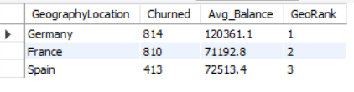

1. **Germany**:
   * Number of Customers Churned: 814
   * Average Balance: 120,361.10
2. **France**:
   * Number of Customers Churned: 810
   * Average Balance: 71,192.80
3. **Spain**:
   * Number of Customers Churned: 413
   * Average Balance: 72,513.40

22. As we can see that the “CustomerInfo” table has the CustomerID and Surname, now if we have to join it with a table where the primary key is also a combination of CustomerID and Surname, come up with a column where the format is “CustomerID_Surname”.

**Code:**



**Result:**

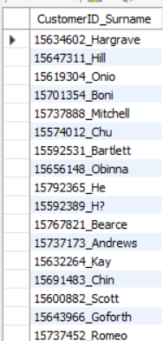

23. Without using “Join”, can we get the “ExitCategory” from ExitCustomers table to Bank_Churn table? If yes do this using SQL.

**Code:**

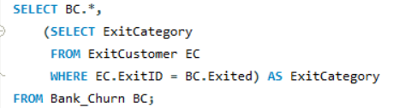

24. Were there any missing values in the data, using which tool did you replace them and what are the ways to handle them?

Given dataset is consistent and had no missing values so data preprocessing is not required

25. Write the query to get the customer IDs, their last name, and whether they are active or not for the customers whose surname ends with “on”.

**Code:**

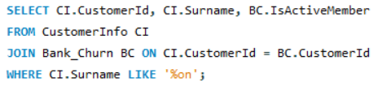

**Subjective Question**

1. Customer Behavior Analysis: What patterns can be observed in the spending habits of long-term customers compared to new customers, and what might these patterns suggest about customer loyalty?

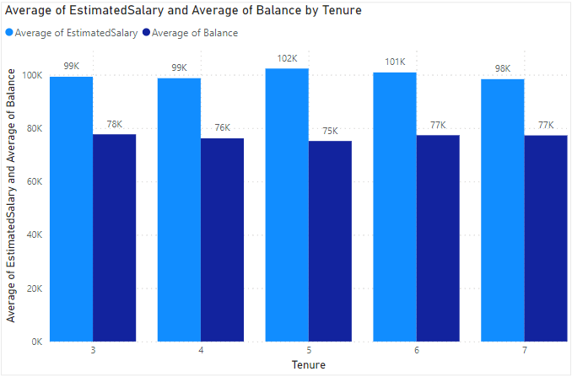

**Analysis**:

The average estimated salary indicates customers' income levels, while the average balance reflects the remaining amount in their accounts after expenditures. These characteristics provide insights into customer spending behaviors. However, there appears to be no definite pattern in the spending habits of both new and long-term customers, as their account balances are relatively similar. This suggests that other factors, such as customer engagement and satisfaction, might play a more significant role in loyalty.

2. Product Affinity Study: Which bank products or services are most commonly used together, and how might this influence cross-selling strategies?

**Analysis**:

The dataset includes the number of products purchased by each customer but lacks descriptions of the products and their interrelationships. This limitation makes it impossible to conduct a detailed product affinity study. Therefore, identifying effective cross-selling strategies based on the existing data is not feasible.

3. Geographic Market Trends: How do economic indicators in different geographic regions correlate with the number of active accounts and customer churn rates?

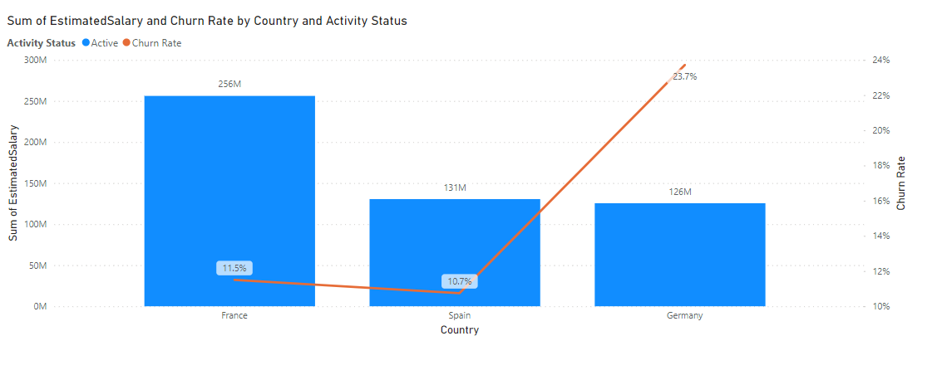

**Analysis**:

The correlation between economic indicators in various regions and the number of active accounts and churn rates can vary significantly. For instance, while Spain and Germany may have similar estimated salaries and active account numbers, Germany's high churn rate suggests that other factors may have a more substantial impact on customer behavior.

4.Risk Management Assessment: Based on customer profiles, which demographic segments appear to pose the highest financial risk to the bank, and why?

**Demographic segments:**

Gender

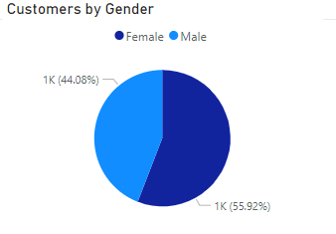

Age

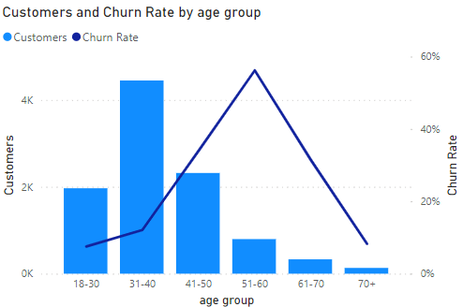

Country

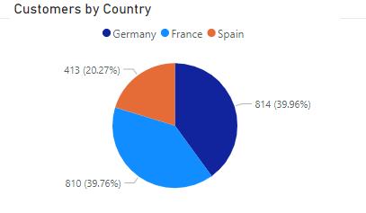

Financials

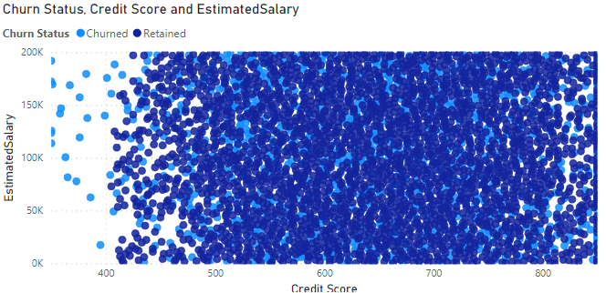

**Analysis**:

* **Gender**: Females exhibit a higher likelihood of churning.
* **Age Group**: Individuals aged 50-60 show the highest churn rates.
* **Credit Score**: Customers with poor credit scores are more prone to churning.
* **Location**: Notably, customers in Germany and France experience significant churn rates.
* **Financials**: Regardless of salary and balance, individuals with poor credit scores tend to churn.

5.Customer Tenure Value Forecast: How would you use the available data to model and predict the lifetime (tenure) value in the bank of different customer segments?

**Analysis**: This ia an attempt to visualize

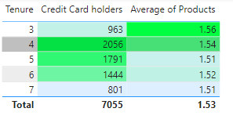

But,

CLV=(Revenue from Customer−Cost to Serve Customer)×Expected Duration of Relationship

However, due to the lack of adequate information like revenue from each customer and cost to serve them, a comprehensive customer tenure value forecast is not possible.

6.Marketing Campaign Effectiveness: How could you assess the impact of marketing campaigns on customer retention and acquisition within the dataset? What extra information would you need to solve this?

**Analysis**:

To effectively assess the impact of marketing campaigns on customer retention and acquisition, essential metrics such as the cost of marketing campaigns, conversion rate, churn rate, return on investment, and acquisition rate before and after the campaigns are required. While the dataset provides churn rate data, it is insufficient to evaluate the complete impact of marketing campaigns without additional information.

7.Customer Exit Reasons Exploration: Can you identify common characteristics or trends among customers who have exited that could explain their reasons for leaving?

**Analysis**:

* **Gender**: Females exhibit a higher likelihood of churning.
* **Age Group**: Individuals aged 50-60 demonstrate the highest churn rates.
* **Credit Score**: Customers with poor credit scores are more prone to churning.
* **Location**: Notably, customers in Germany and France experience significant churn rates.
* **Activity**: Inactive members top the list in terms of churn rates.

While these trends are common characteristics associated with customer exit, the dataset does not include specific reasons for leaving, such as customer feedback and surveys. Without these additional insights, it is challenging to accurately determine the reasons why customers are leaving.

8. Are 'Tenure', 'NumOfProducts', 'IsActiveMember', and 'EstimatedSalary' important for predicting if a customer will leave the bank?

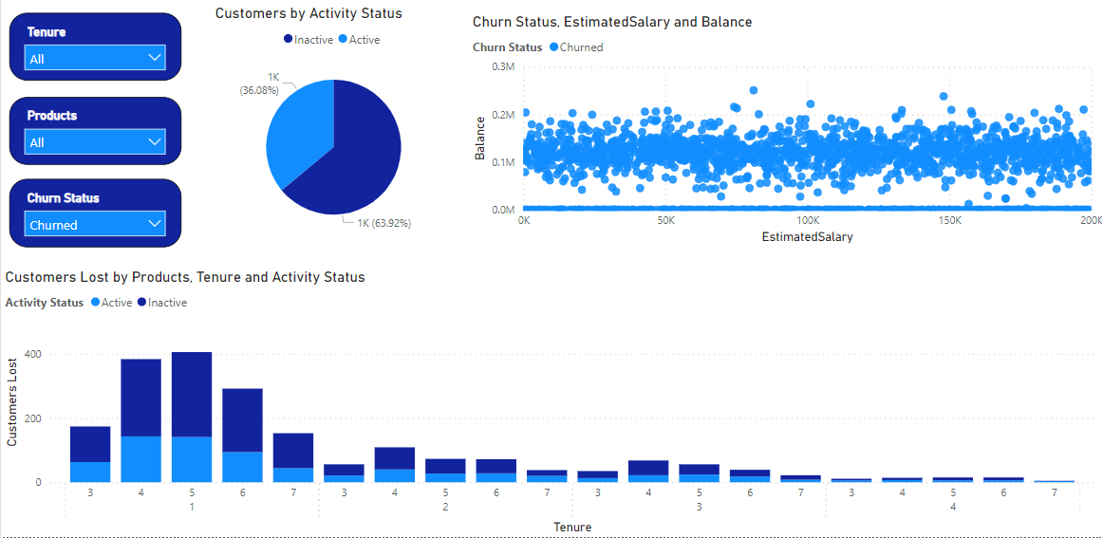

**Analysis**:

To determine the importance of these factors, a detailed predictive analysis using machine learning techniques would be necessary. These variables are typically included in churn prediction models, but their relative importance can only be ascertained through rigorous data analysis.

9.Utilize SQL queries to segment customers based on demographics and account details.

10. How can we create a conditional formatting setup to visually highlight customers at risk of churn and to evaluate the impact of credit card rewards on customer retention?

**Visually highlighting customers at risk of churn:**

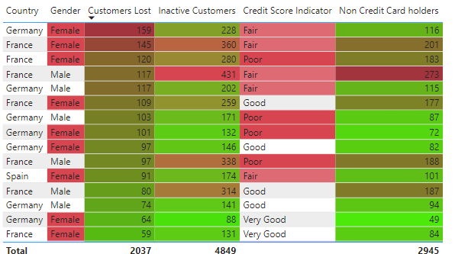

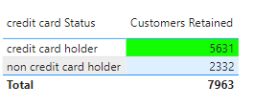

**Impact Evaluation**:

To evaluate the impact of credit card rewards on retention, discrete data on reward programs and their usage would be necessary. Analyzing the before-and-after effects of reward distribution on customer retention could provide insights into the effectiveness of these programs.

11. What is the current churn rate per year and overall as well in the bank? Can you suggest some insights to the bank about which kind of customers are more likely to churn and what different strategies can be used to decrease the churn rate?

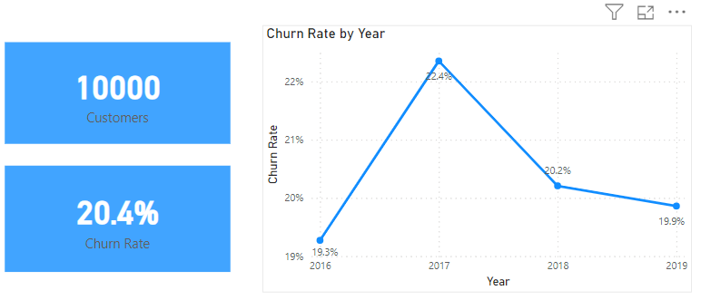

**Analysis**:

After conducting in-depth analysis, it has been observed that females, individuals aged 50-60, and inactive customers, particularly those in Germany and France, are experiencing significant churn rates. To address these issues effectively, the following strategies can be implemented:

**Targeted Marketing Campaigns for Female Customers**:

Conduct surveys to understand the preferences of female customers better. Develop marketing campaigns tailored to resonate with them, emphasizing features or benefits that cater to their specific needs and interests.

**Specialized Advisory Services for Individuals Aged 50-60**:

Offer specialized advisory services and retirement planning workshops tailored to the needs of individuals aged 50-60. Provide options such as guaranteed income streams or long-term savings plans to address their financial concerns effectively.

**Reactivation Campaigns for Inactive Customers**:

Implement targeted reactivation campaigns to reconnect with inactive customers. Offer discounts on fees and complement them with exclusive rewards to incentivize their return and reignite their interest in the products or services.

**Extra Budget Allocation for Marketing in Germany and France**:

Allocate additional budget for marketing efforts in Germany and France to address the high churn rates effectively. Identify the root causes of churn in these markets and take necessary steps to rectify them.

12. Create a dashboard incorporating all the KPIs and visualization-related metrics. Use a slicer in order to assist in selection in the dashboard.

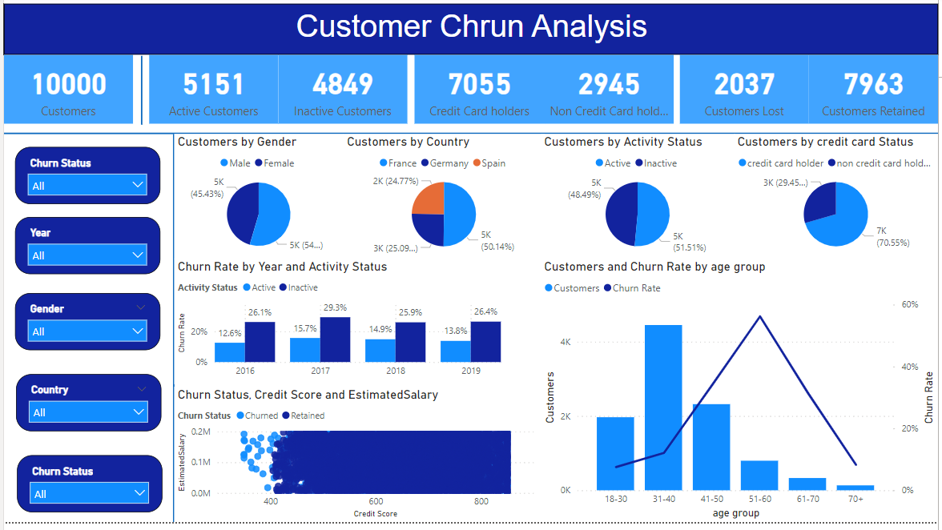

13. How would you approach this problem, if the objective and subjective questions weren't given?

**Analysis**:

In real-time, there isn't always a subjective or objective label attached to questions. The approach should be systematic:

* **Understanding the Problem Statement**: Clearly define the problem and understanding the requirements.
* **Formulating a Problem-Solving Approach**: Develop a structured approach to tackle the problem.
* **Using Appropriate Tools**: Selecting and utilizing the appropriate tools and techniques to solve the problem effectively.

14.In the “Bank_Churn” table how can you modify the name of the “HasCrCard” column to “Has_creditcard”?

SQL

ALTER TABLE Bank_Churn

RENAME COLUMN HasCrCard TO Has_creditcard;

Power BI

Slect Transform Data , locate HasCrCard coloumn header in Bank_Churn table

Right click to choose rename from the menu and change it to Has_creditcard