**Objective Questions**:

1. In analyzing the hospital dataset with Power BI, ensure data cleaning to address inconsistencies and missing values before further analysis.

With "Data" view in Power Bi, Inspected the dataset for inconsistencies, such as:

* + - Missing values
    - Duplicate records
    - Incorrect data types

Performed Data Cleaning,

With Power Query Editor in Power Bi,

* Removed Duplicate Records
* Handled Missing Values
* Corrected Data Types

1. **Assess the Average Waiting Time:** Analyse the patient wait times to identify the average duration a patient spends before receiving care.

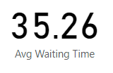

**Finding**: average waiting time before receiving treatment is 35.26 minutes

1. **Visits by Department Referral:** Calculate the total number of visits to each department based on referrals to understand which departments are most frequently visited.

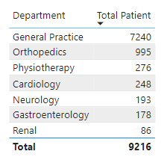

1. **Patient Visits by Age Group:** Segregate patient visits according to different age groups to see which demographics utilize healthcare services the most.

s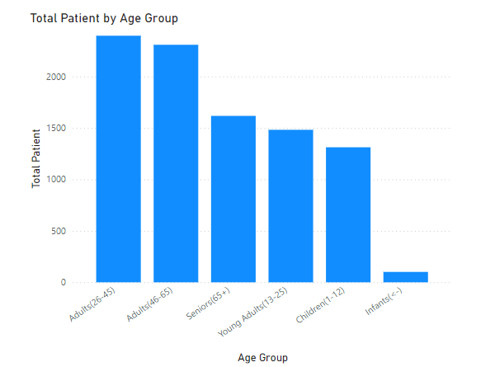

**Segregation:**

Infants(<1year), children(1-12years),young adults(13-25years),adults(26-45years),adults(46-65years),seniors(65+)

**Findings**: According to different age groups, patients between 26-45 are utilize healthcare services the most.

1. **Average Satisfaction by Demographics:** Determine the relationship between patient satisfaction scores, their age groups, and racial backgrounds to pinpoint areas for improvement in patient experience.

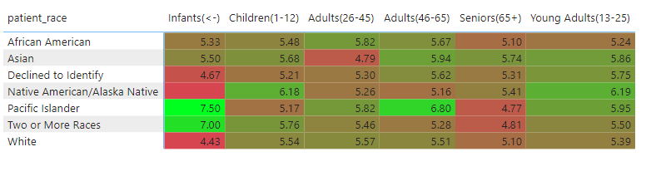

**Recommendation:** where cells are red are the pinpointed areas patient experience is to be improved.

1. The hospital's managing director seeks to evaluate the **revenue of each department** to understand how much revenue is generated by each.

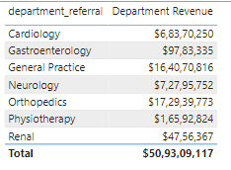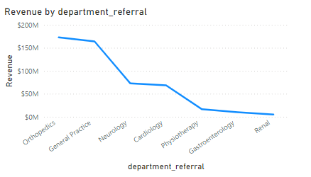

1. Is there any relation between the number of visits and the Gender of the patients?

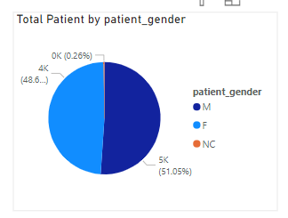

Finding : No significant relationship between number of visits and the Gender of the patients

1. Which department is charging the highest appointment fees in general? 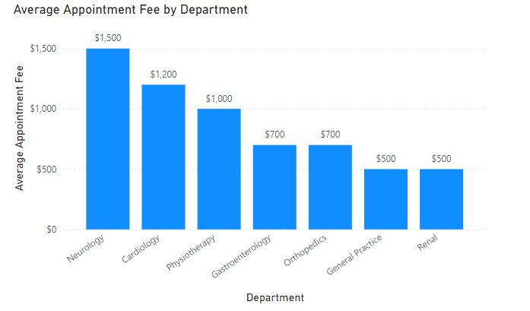

Finging : Neurology is charging highest appointment fee: $1500

**Subjective Questions:**

1. **What is the relation between patient wait time and satisfaction scores?**

The relation between patient wait time and satisfaction scores can provide valuable insights into the patient experience and overall satisfaction with healthcare services. Generally, shorter wait times are associated with higher satisfaction scores

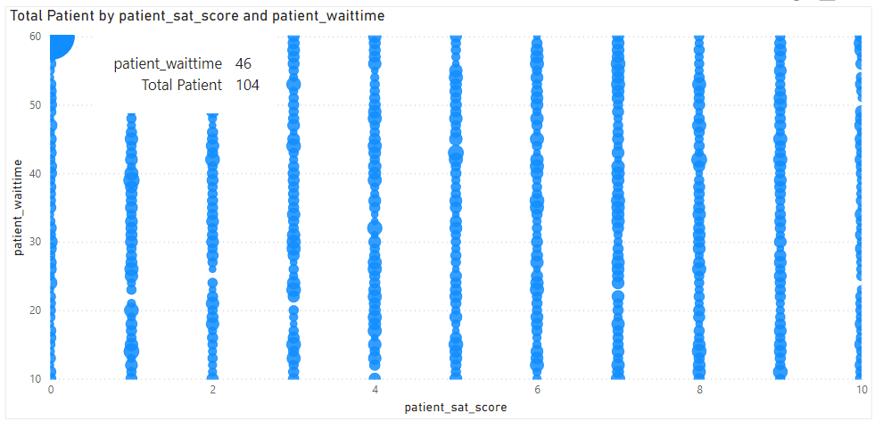

Patients satisfaction score at around waiting time 46 min before treatment is 0, this mean there is direct corelation between satisfaction score and wait time.

**2. How do patient demographics affect the frequency of visits to different departments?**

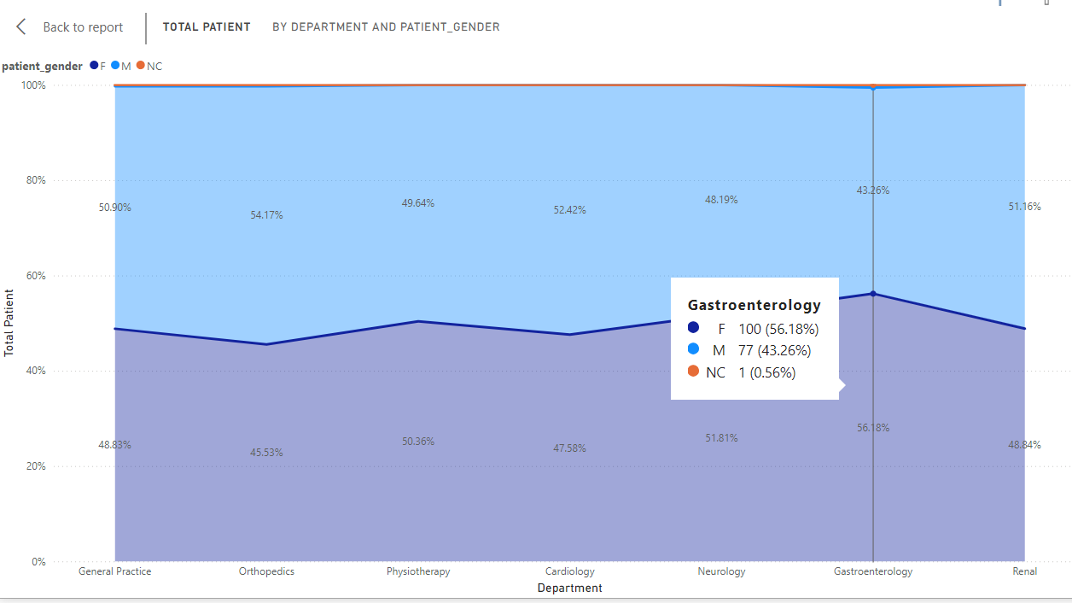

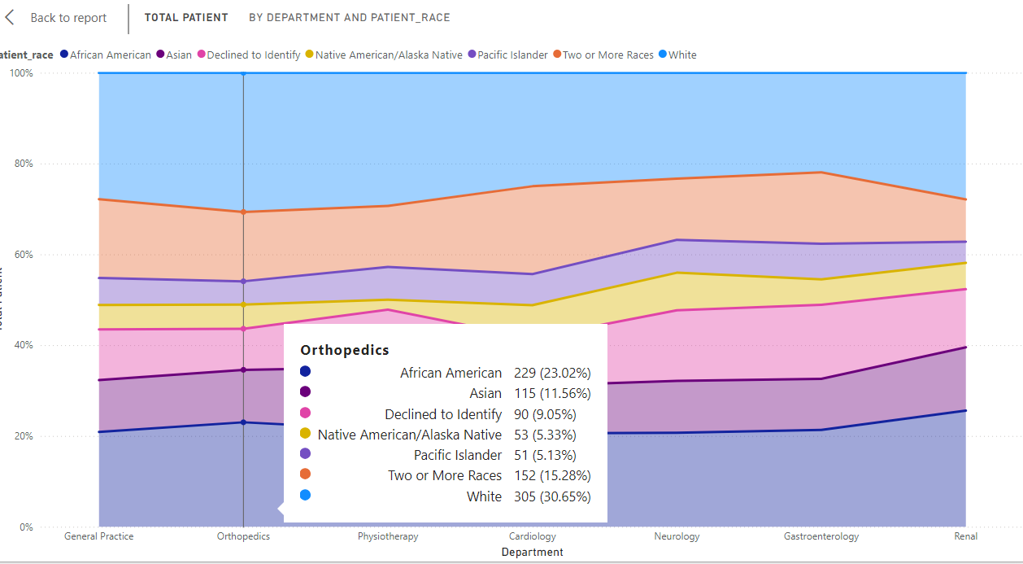

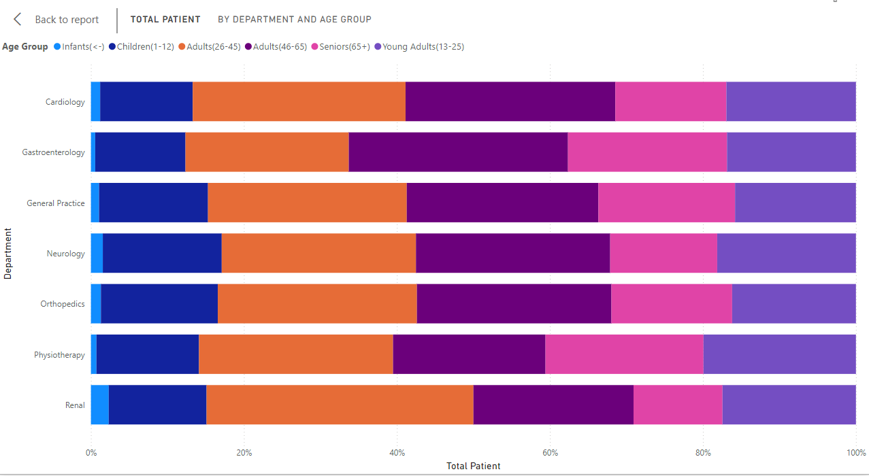

**Demographics Impact findings:**

* **Race**: White Patients tend to have more orthopaedic issues.
* **Age**:

Adults (26-45): More likely to experience renal-related issues.  
Adults (46-65): More prone to gastroenterology-related issues.

* **Gender**: Female Patients show a slightly higher frequency of gastroenterology-related issues.

**3. Is there a noticeable trend in the volume of patient visits throughout the year?**

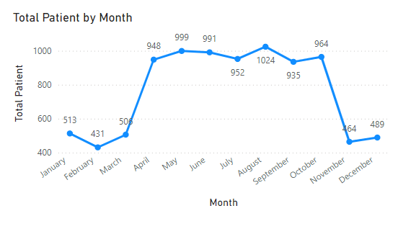

Yes, there is a noticeable trend in the volume of patient visits throughout the year. Specifically, there is a significant increase in patient volume from April to October. This suggests that the hospital experiences higher demand for healthcare services during these months.

**4. Which age groups report the highest and lowest satisfaction scores?** 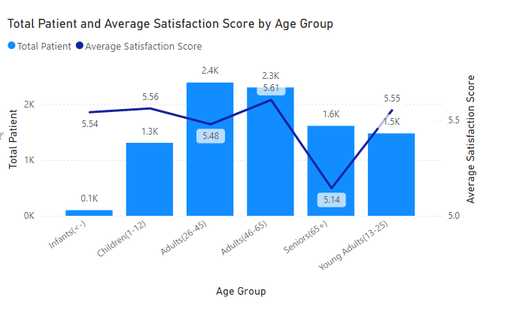

Highest Satisfaction: Adults aged 46-65 report the highest average satisfaction score, with an average of 5.61.

Lowest Satisfaction: Seniors aged 65 and older report the lowest average satisfaction score, with an average of 5.14.

**5. The hospital management intends to offer discounts to patients.**

**Recommendation:**

* **Medical Need:** Prioritize discounts for patients with critical conditions or expensive treatments to alleviate financial burden.
* **Income Level:** Provide higher discounts to lower-income patients to promote equity.
* **Other Strategies:** Include membership, referral discounts, package deals, flexible payments, and senior citizen discounts.

**6. The hospital has a budget to hire 2-3 new doctors.**

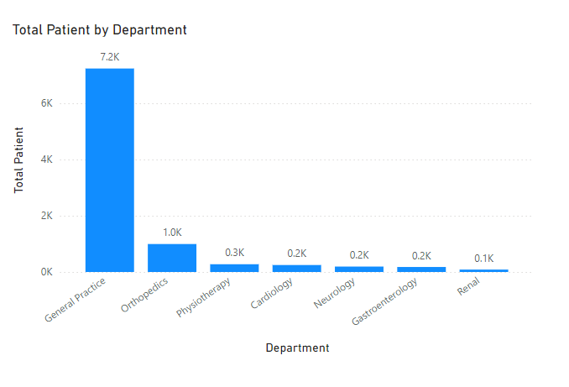

Analysis:  
Data analysis reveals that the General Practice department experiences significantly higher patient visit volumes compared to other departments. This indicates a high demand for services in this area.

Recommendation: Hire 2-3 new doctors specifically for the General Practice department to improve patient care and reduce wait times.

**7. Is the hospital profitable?**

While the dataset provides insights into revenue influx, a comprehensive analysis of profitability requires consideration of various expenses (salaries, facility maintenance, utilities, insurance and administrative costs) and investments (capital investments in equipment, technology and infrastructure). The dataset is insufficient to definitively determine profitability.

1. **Any Department for which the waiting time is oddly large?**

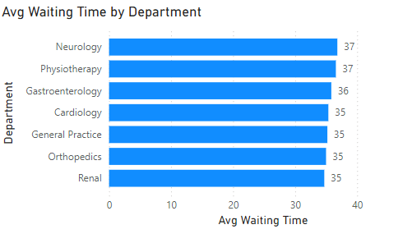

**Findings:** The graph indicates that waiting times across departments are generally consistent, there doesn't appear to be any department for which the waiting time is unusually large compared to others.

1. **Come up with strategies to provide discounts to the patients.**

**Strategies:**

**Income-Based Discounts**: more discounts for under deserved

**Senior Citizen Discounts:** ensuring elderly people receive necessary care.

**Flexible Payment Plans:** Offer instalment plans to manage costs.

**Insurance Partnership Discounts:** Partner with insurance companies to make healthcare more affordable

**First-Time Visit Discounts:** Attracts new patients

**Referral Discounts:** increases patient numbers through word-of-mouth referrals

**Package Services:** Provides cost savings for patients needing multiple treatments or services

**Existing patient discounts**: Helps in retinting existing customers.