# MLOps Iris Classification – End to End Pipeline

**Group No: 70**

|  |  |  |
| --- | --- | --- |
| **Name** | **ID** | **Contribution(%)** |
| Dhiman Kundu | 2023ac05129 | 100 |
| Rina Gupta | 2023ac05028 | 100 |
| Sarit Ghosh | 2023ac05131 | 100 |
| Soumen Choudhury | 2023ac05143 | 100 |

## Assignment Tasks

This project implements a comprehensive MLOps implementation for Iris flower classification with automated training, monitoring, and deployment capabilities addressing the following assignment requirements:

### Part 1: Repository and Data Versioning (4 marks)

* **GitHub Repository**: Complete project hosted on GitHub with clean structure

<https://github.com/SaritGhoshBits25/MLOps_Assignment_Group70>

* **Docker Hub Repository**:

<https://hub.docker.com/repository/docker/wp1412011989/iris-api/general>

* **Data Loading & Preprocessing**: Automated data preprocessing pipeline (`src/data_preprocessing.py`)

**Directory Structure**: Well-organized project structure with separate directories for source code, data, models, tests, and monitoring

├── src/ # Source code  
│ ├── api.py # FastAPI application with monitoring  
│ ├── train.py # Model training with MLflow  
│ ├── data_preprocessing.py # Data preprocessing pipeline  
│ ├── database.py # Database operations and logging  
│ └── retrain_pipeline.py # Automated retraining pipeline  
├── data/ # Dataset files  
│ ├── iris_raw.csv # Raw iris dataset  
│ ├── iris_train.csv # Training data  
│ └── iris_test.csv # Test data  
├── models/ # Trained model artifacts  
├── tests/ # Test suite  
├── monitoring/ # Monitoring configuration  
│ └── prometheus.yml # Prometheus configuration  
├── .github/workflows/ # CI/CD pipeline  
│ └── ci-cd.yml # GitHub Actions workflow  
├── Dockerfile # Container configuration  
├── docker-compose.yml # Multi-service orchestration  
└── requirements.txt # Python dependencies

**Data Version Control (DVC)**:

This project uses DVC for data versioning and pipeline management. DVC tracks data files and ensures reproducible data processing workflows.

* **Data tracking**: Raw iris dataset (`data/iris_raw.csv`)
* **Pipeline**: Automated data preprocessing pipeline
* **Remote storage**: Local remote for data versioning

DVC Files Structure

├── .dvc/  
│ └── config # DVC configuration  
├── data/  
│ ├── .gitignore # Git ignores data files  
│ ├── iris_raw.csv.dvc # DVC tracks raw data  
│ ├── iris_train.csv # Generated by pipeline  
│ └── iris_test.csv # Generated by pipeline  
├── dvc.yaml # Pipeline definition

### Part 2: Model Development & Experiment Tracking (6 marks)

**Multiple Models**: Implementation of classification models:

* Logistic Regression
* Random Forest
* Support Vector Machine (SVM)

**Model Information:**

* **Dataset**: Iris flower classification
* **Features**: Sepal length/width, Petal length/width
* **Classes**: Setosa, Versicolor, Virginica
* **Models**: Logistic Regression, Random Forest, SVM
* **Evaluation**: Accuracy, Precision, Recall, F1-score

**MLflow Integration**:

* Experiment tracking with parameters and metrics (`src/train.py`)
* Model versioning and artifact storage
* Model registry for best model selection

Following directories are created by MLflow under mlruns/<experiment-id>/<run-id>/:

* params/: model hyperparameters
* metrics/: performance metrics
* artifacts/: saved models
* tags/: metadata like model name or author

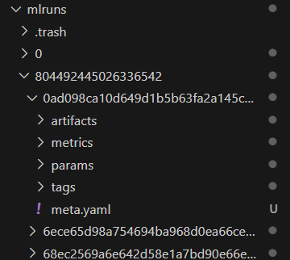

* MLflow UI accessible at `**http://localhost:5000**`

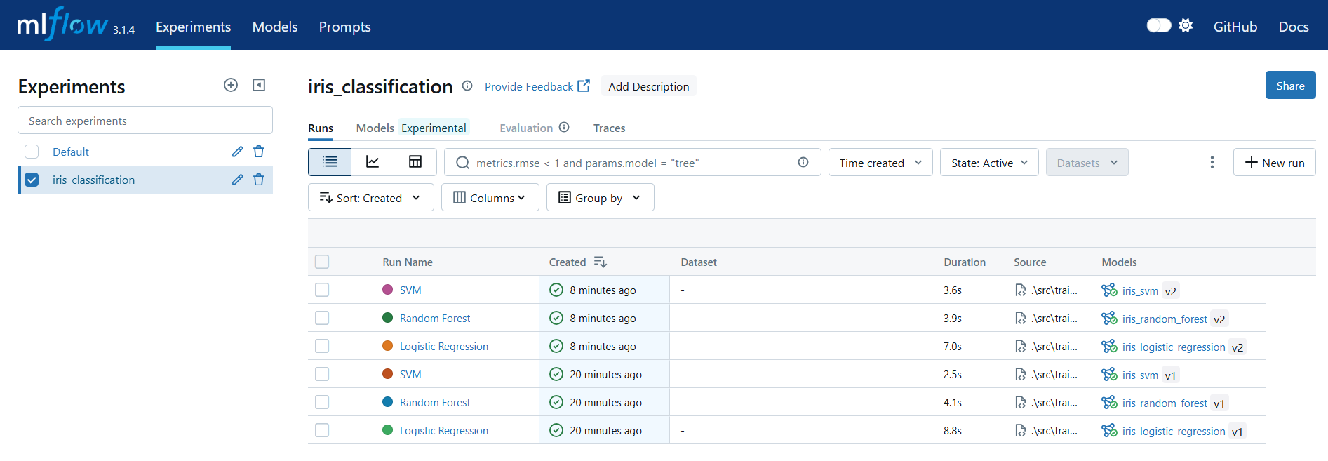

* **Model Selection**: Automated best model selection based on performance metrics

### Part 3: API & Docker Packaging (4 marks)

**FastAPI Implementation**: High-performance REST API (`src/api.py`) with:

* Automatic API documentation with Swagger UI
* GET / - API information and status
* GET /health - Health check endpoint
* POST /predict - Make predictions single predictions
* POST /predict/batch - Batch predictions for batch predictions
* GET /model/info - Current model information
* GET /metrics - Prometheus metrics
* POST /retrain-trigger – Retrain Model

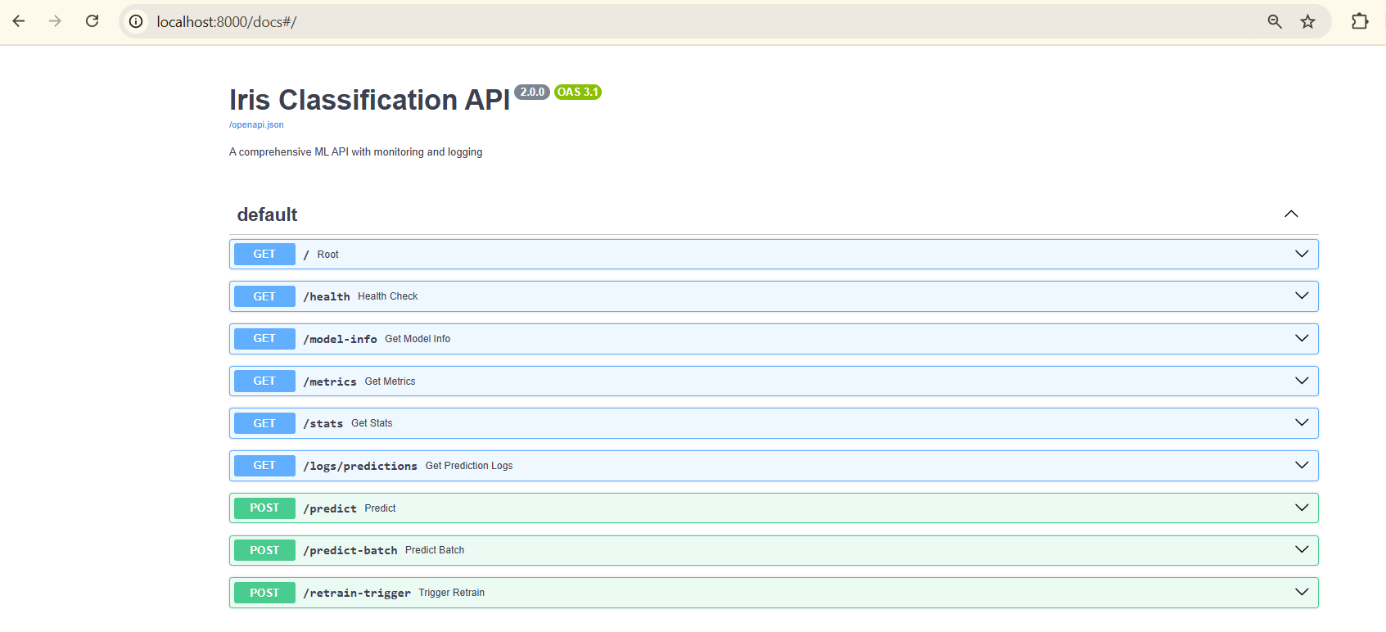

**Pydantic** schemas are used for request validation.

**Docker Containerization**: This is fully containerized using Docker.

* Multi-stage Dockerfile for optimized images
* Docker Compose orchestration (`docker-compose.yml`)
* Health checks and restart policies
* Build and run with Docker Compose

**docker-compose up –build**

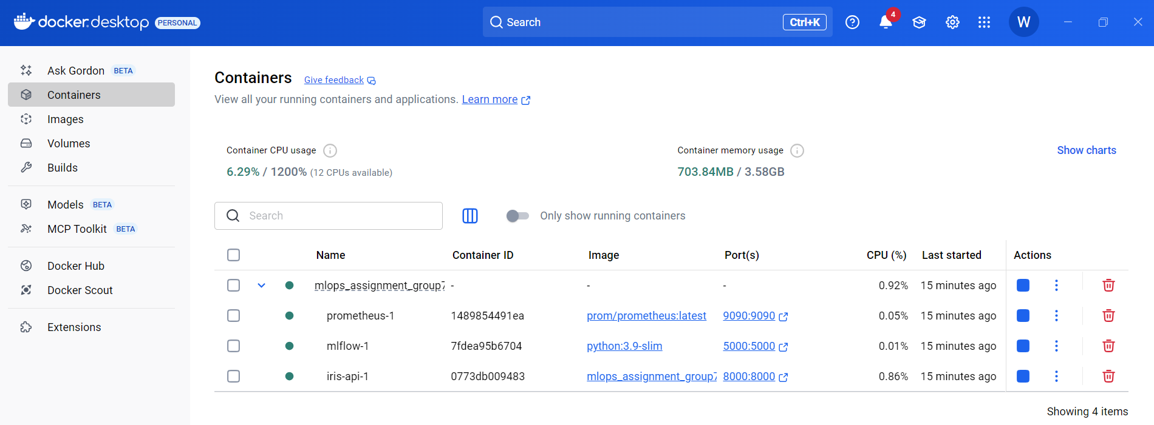

This will start:

* Iris API: http://localhost:8000
* Prometheus: http://localhost:9090
* MLflow: http://localhost:5000
* **JSON Input/Output**: Structured JSON request/response format with validation

### Part 4: CI/CD with GitHub Actions (6 marks)

* **Automated Pipeline** (`.github/workflows/ci-cd.yml`):
* **Testing Stage**: Code linting, unit tests, and API health verification
* **Build Stage**: Docker image building and container testing
* **Deploy Stage**: Automated deployment with health monitoring
* **Code Quality**: Automated linting and testing on every push
* **Docker Hub Integration**: Automated image building and registry push
* **Deployment**: Local deployment with shell scripts and docker run commands

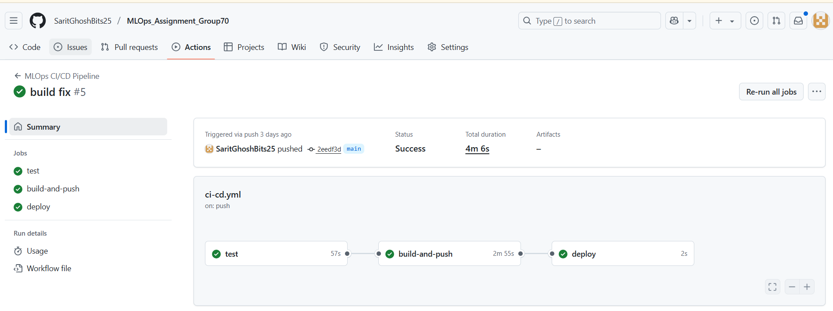

### Part 5: Logging and Monitoring (4 marks)

**Comprehensive Logging**:

* API logs: logs/api.log

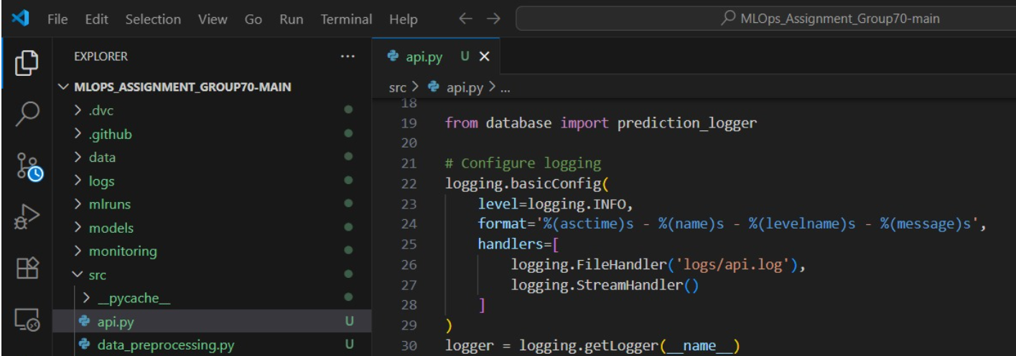

* Container logs: docker-compose logs <service-name>
* MLflow logs: Available in MLflow UI

All predictions are logged to SQLite database for persistence storage with (`src/database.py`):

* Prediction ID and timestamp
* Input features and predictions
* Model version and confidence scores
* Request metadata

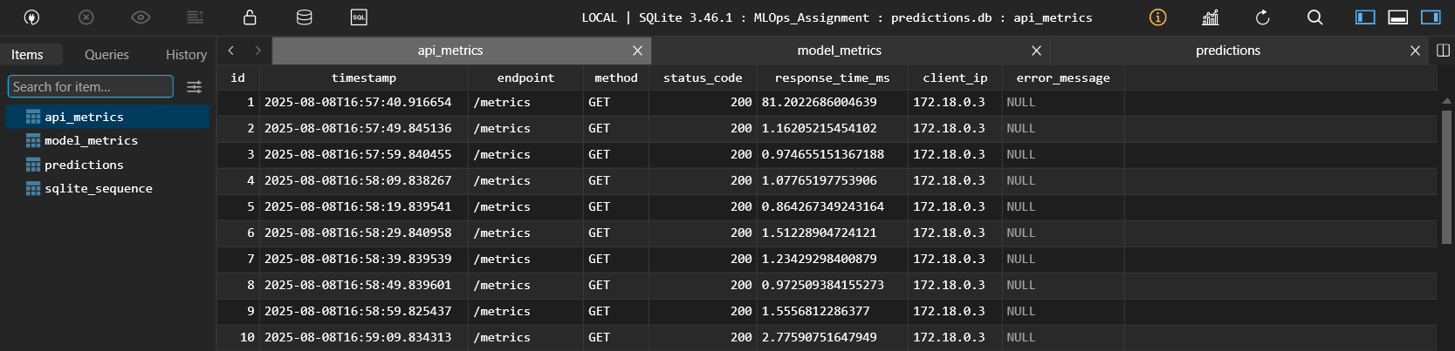

**Monitoring Integration**:

* Prometheus metrics endpoint (`/metrics`)
* Custom metrics for predictions, latency, and model performance
* Prometheus configuration (`monitoring/prometheus.yml`)

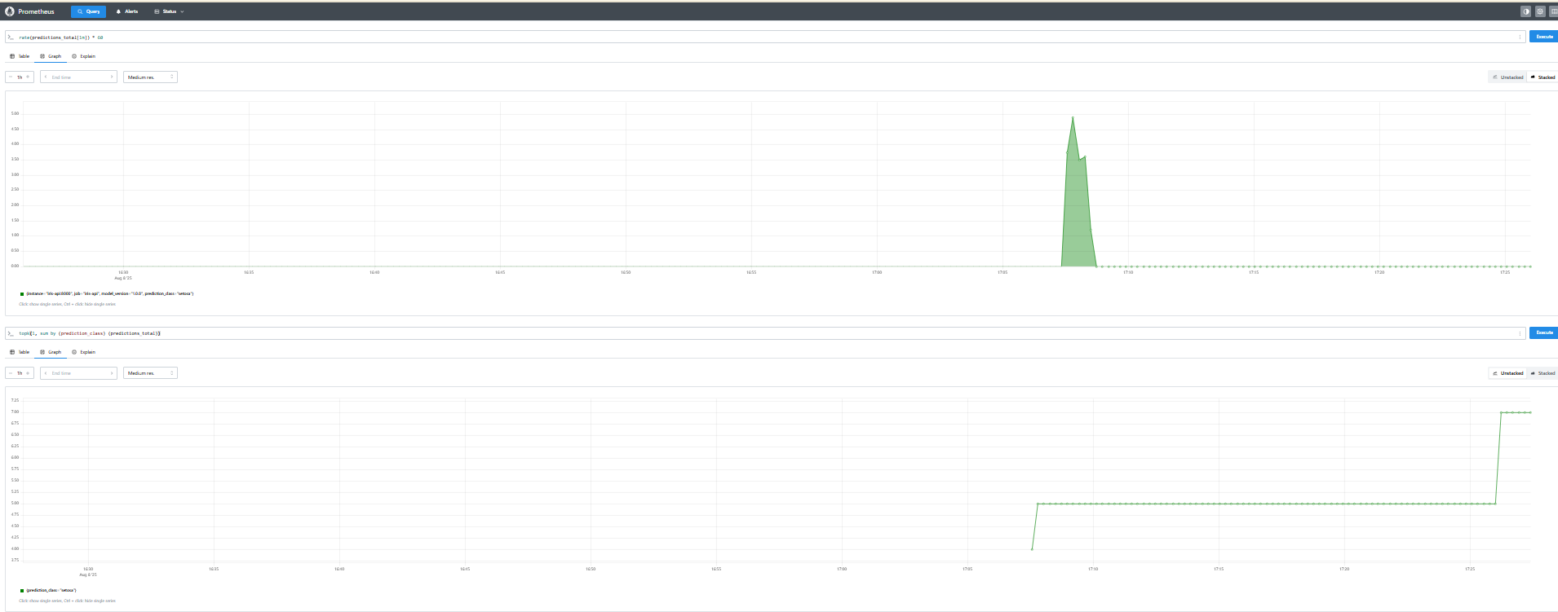

**Health Monitoring**: Dedicated health check endpoints for system status

### Part 6: Summary + Demo (2 marks)

* **Architecture Documentation**: Comprehensive summary with system architecture
* **Demo Preparation**: Complete setup instructions and API usage examples
* **Video Walkthrough**: Ready-to-demonstrate solution with all components integrated

### Bonus Features (4 marks)

**Input Validation**:

* Pydantic models for request/response validation
* Schema-based input validation with error handling

**Prometheus Integration**:

* Full Prometheus monitoring setup
* Custom metrics dashboard ready
* Real-time performance monitoring

**Model Retraining via API**:

The ‘/retrain’ endpoint supports:

* Automated retraining pipeline (`src/retrain_pipeline.py`)
* Performance-based retraining triggers
* Continuous model improvement workflow
* Retraining the best model
* Logging it to MLflow
* Saving the new model to registry