**MONGODB(NOSQL) Hands On**

**Name :- Sarita Paliwal**   
**Roll no:- 2401146**   
**Div:-B**

**Create a database called Inventory.**   
**EASY QUESTIONS**

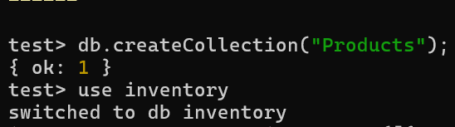

**Q1.Create a collection called Products with attributes: ProductID, Name, Category, Stock, and Price. use Inventory**   
**Q2.Insert 10 product documents into the Products collection.**

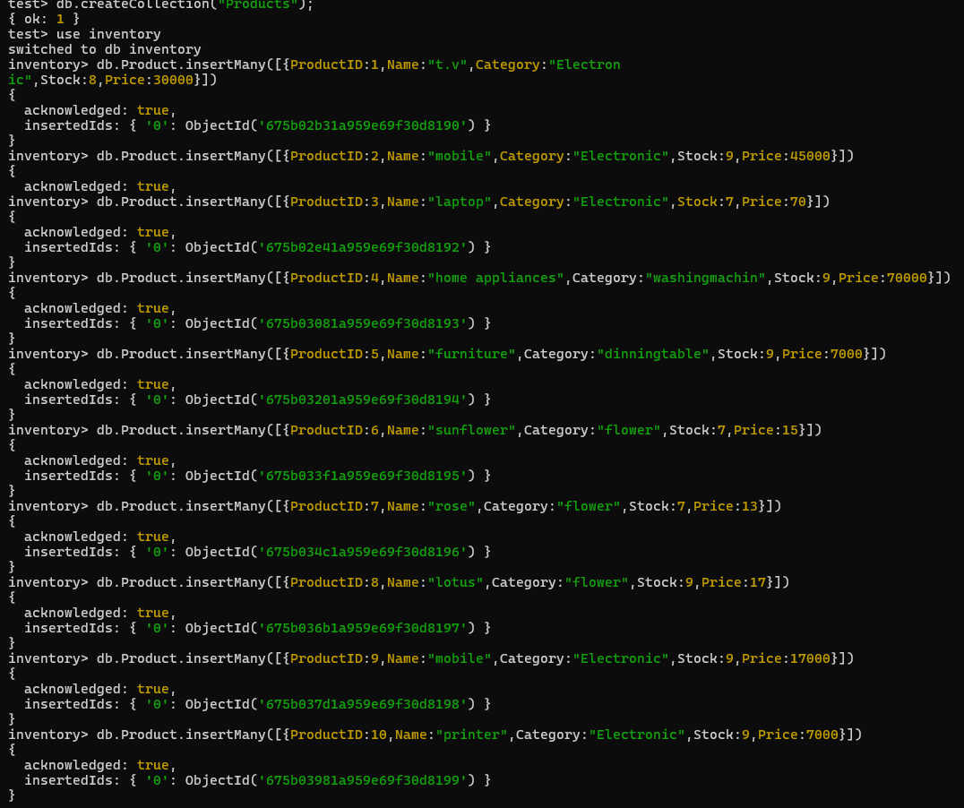

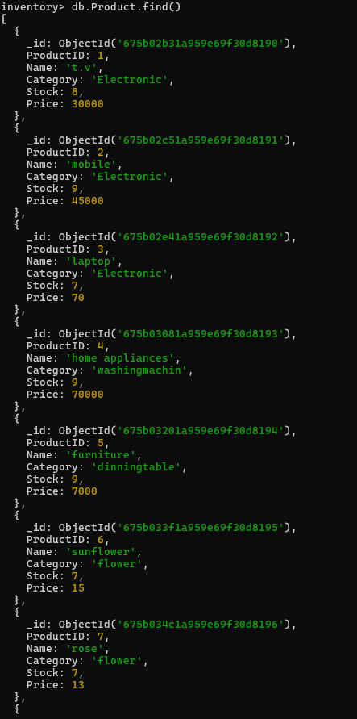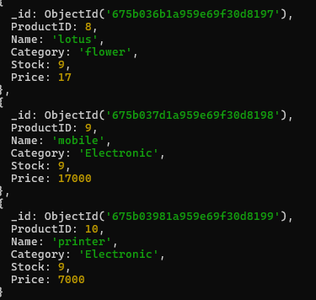

**Q3.Retrieve all products with stock greater than 10.**

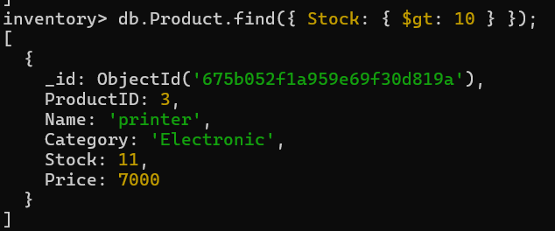

**Q4.Find all products from the 'Electronics' category.**

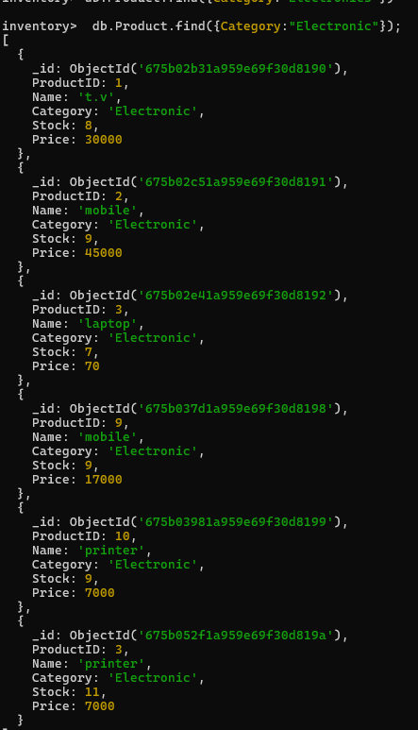

**Q5.Update the price of the product with ProductID 7 to 19.99.**

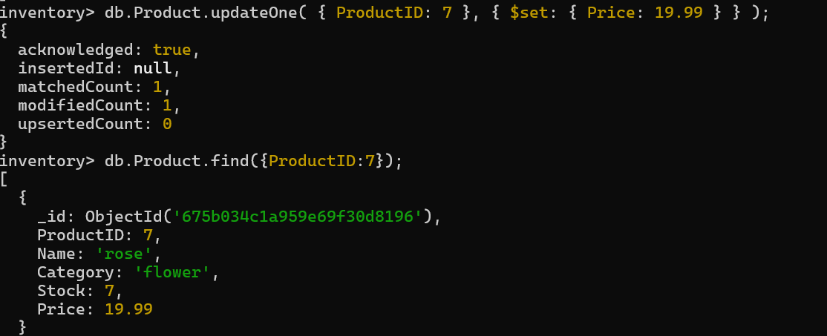

**Q6.Delete the product with ProductID 2**



**Q7.Count how many products are in stock.**



**Q8.Sort products by Price in descending order**

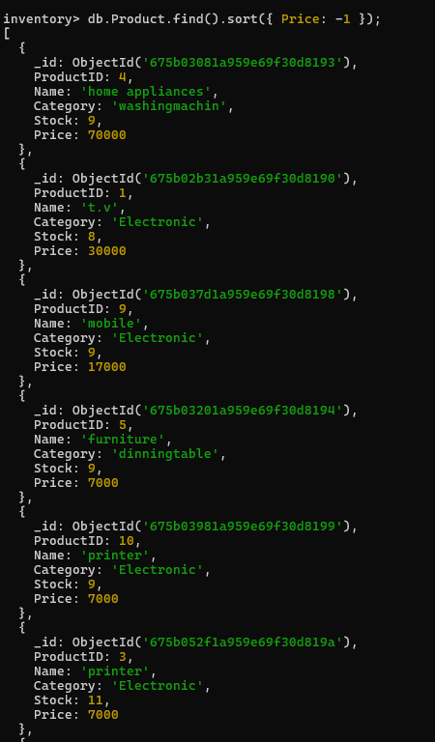

**Q9.Find products whose price is either 10 or 15.**

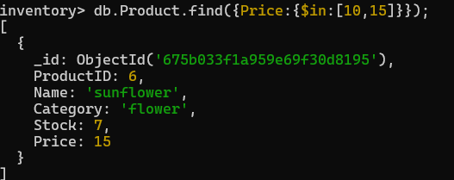

**Hard Questions**   
**Q1.Retrieve products whose Category is 'Home Appliances' and Stock is greater than 30.**

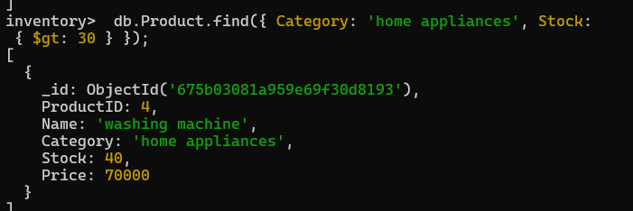

**Q2.Update the Category of the product with ProductID 4 to 'Furniture'.**

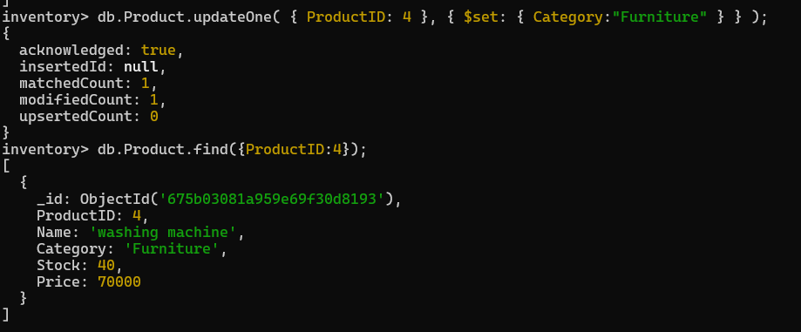

**Q3.Use $nin to find exclude products with stock 10, 15 units.**

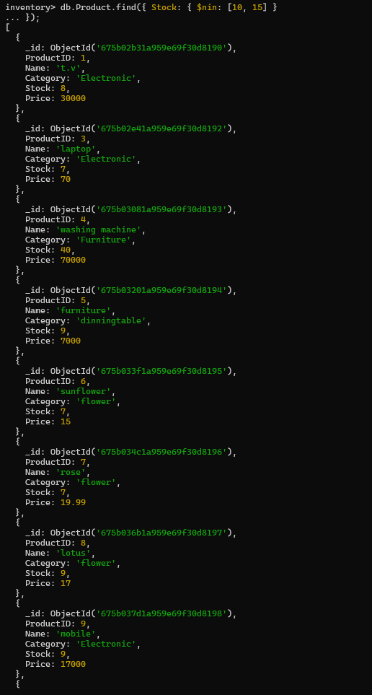

**Q4.Find products with Stock less than 5 and Price greater than 10.**

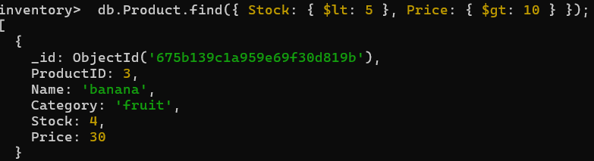

**Q5.Find products with a Name containing the character 'c'.**

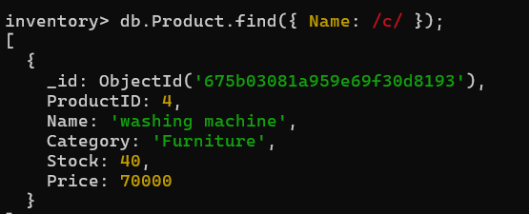

**Q6.Retrieve the first 5 products, skipping the first 2 documents**

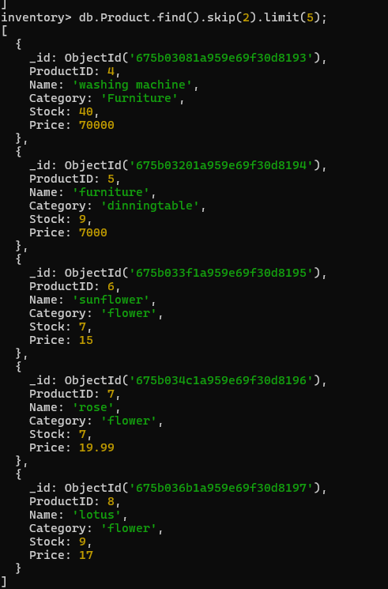

**Q7.Delete all products with stock equal to 0.**

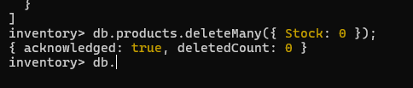

**2. Banking System Easy Questions**

**Q1. Create a database called Bank.**

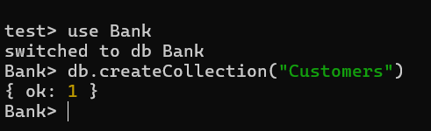

**Q2. Create a collection called Customers with attributes: CustomerID, Name,**

**AccountBalance, and AccountType.**

**Q3. Insert 10 documents representing customer information.**

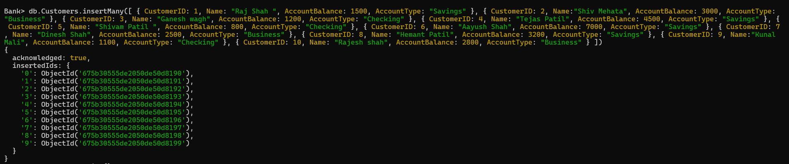

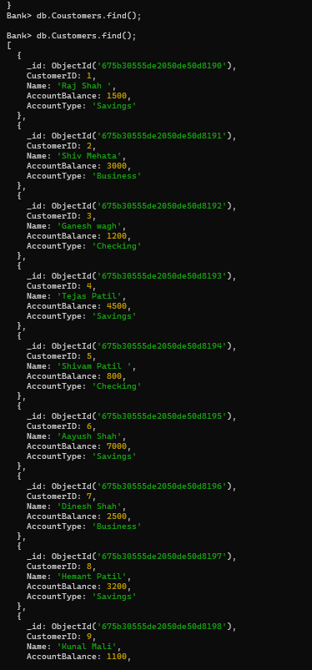

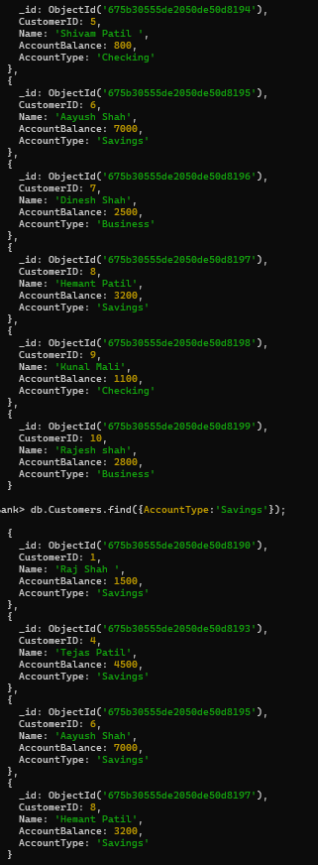

**Q4. Find all customers with AccountType 'Savings'.**

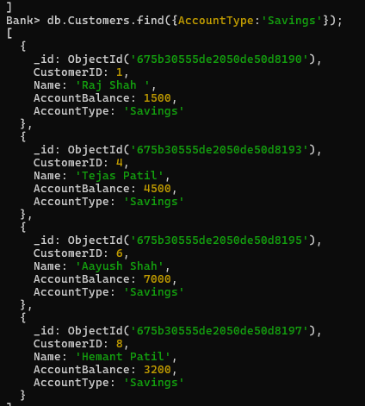

**Q5.Update the AccountBalance of the customer with CustomerID 4 to 5000.**

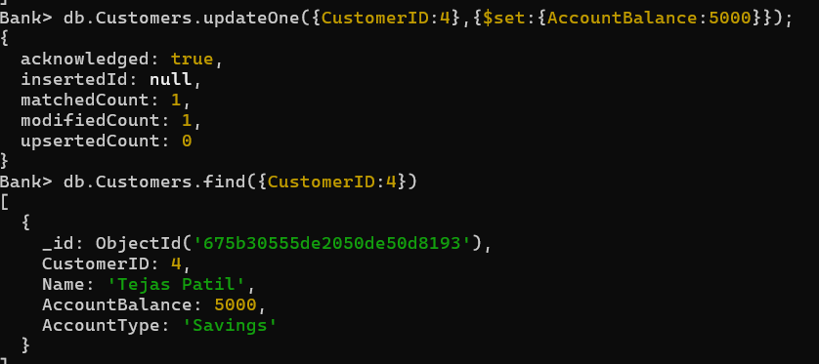

**Q6.Delete the customer with CustomerID 2.**



**Q7.Count the number of customers with an AccountBalance greater than 1000.**



**Q8.Sort customers by AccountBalance in ascending order.**

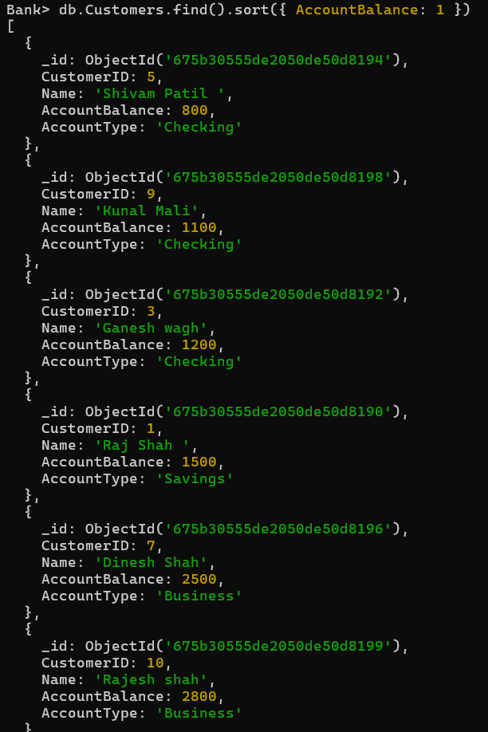

**Q9.Find customers whose AccountType is either 'Checking' or 'Business'.**

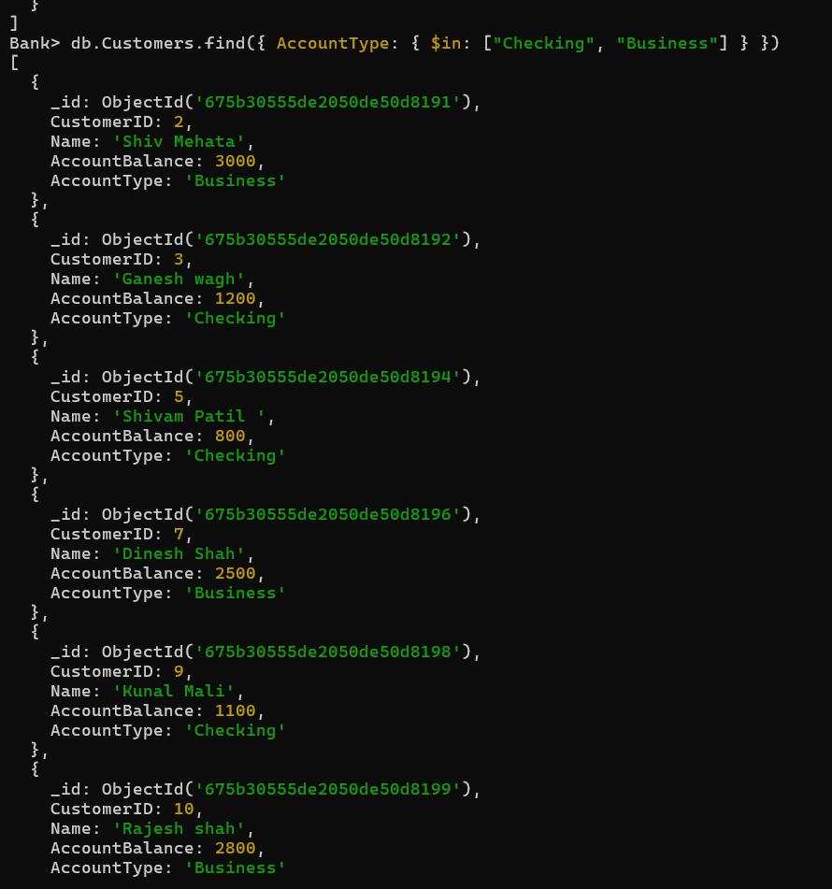

**Q10.Find customers with an AccountBalance between 2000 and 5000.**

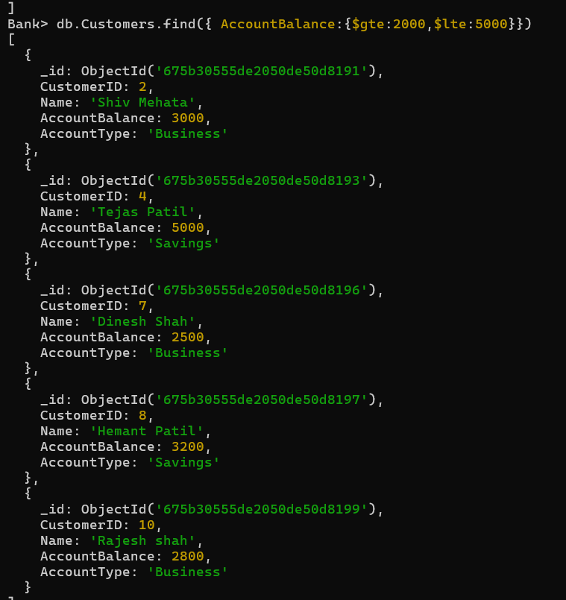

**Hard Questions**   
**Q1.Update the AccountBalance of all customers with AccountType 'Savings' by 1000.**

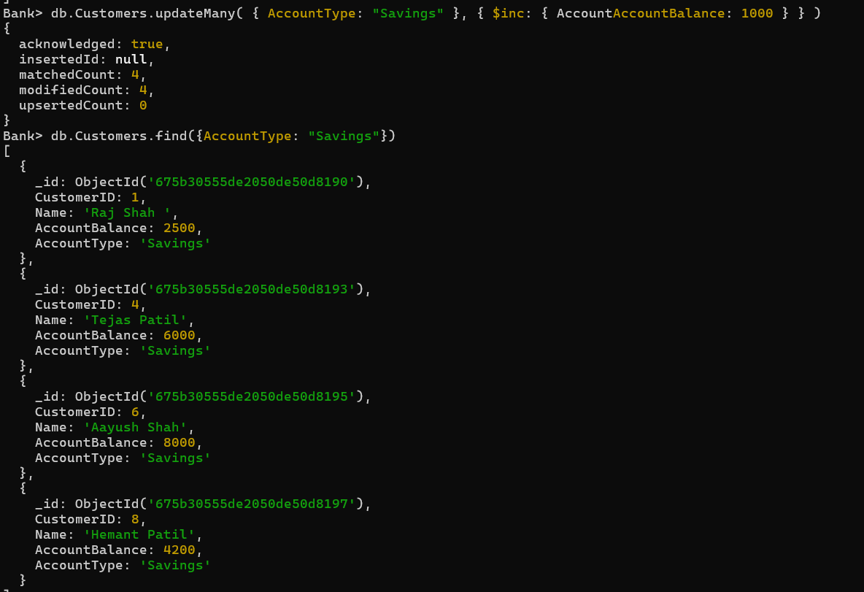

**Q2.Retrieve customers with an AccountBalance greater than 5000.**

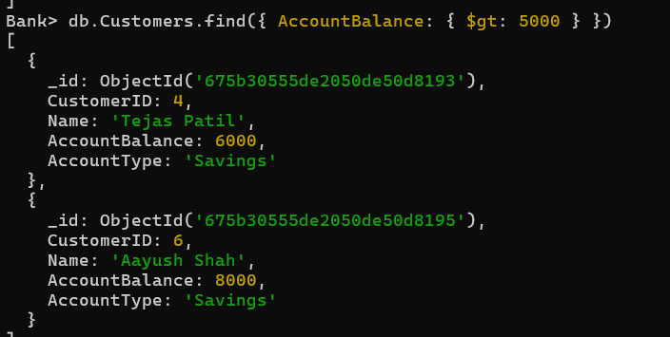

**Q3.Find customers with AccountType 'Checking' and AccountBalance less than 1000.**

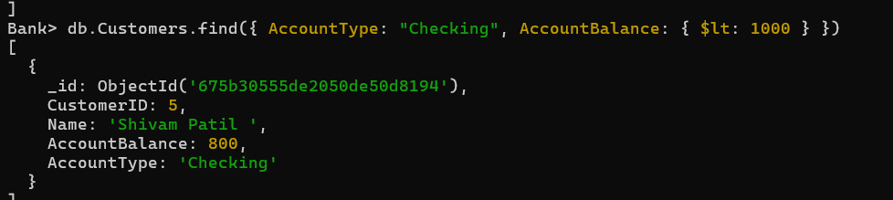

**Q4.Use $in to find customers with AccountType either 'Business' or 'Checking'.**

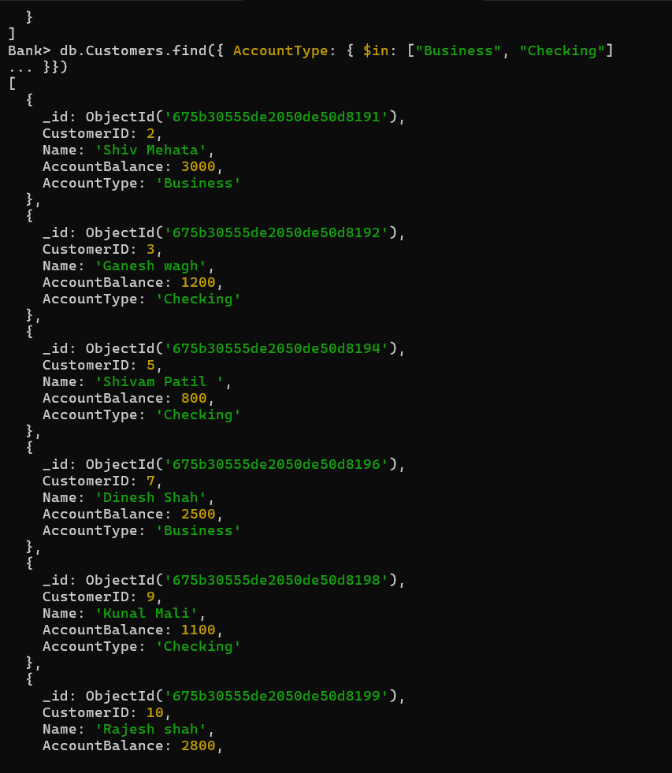

**Q5.Find customers whose AccountBalance is between 3000 and 7000.**

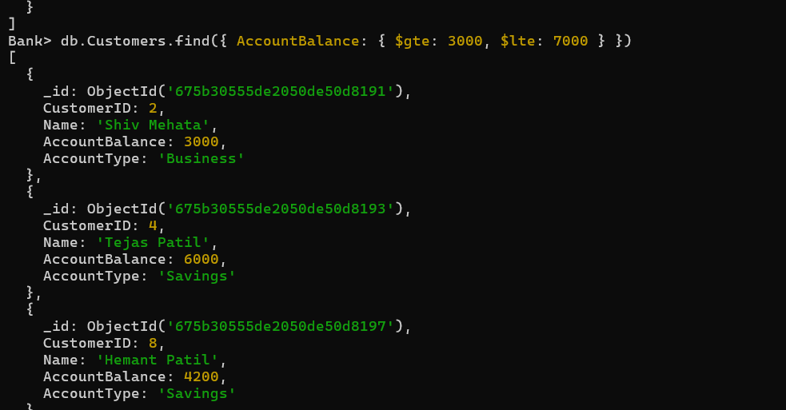

**Q6.Find all customers with AccountBalance less than 1000 and update it to 1500. 7. Delete all the customers .**

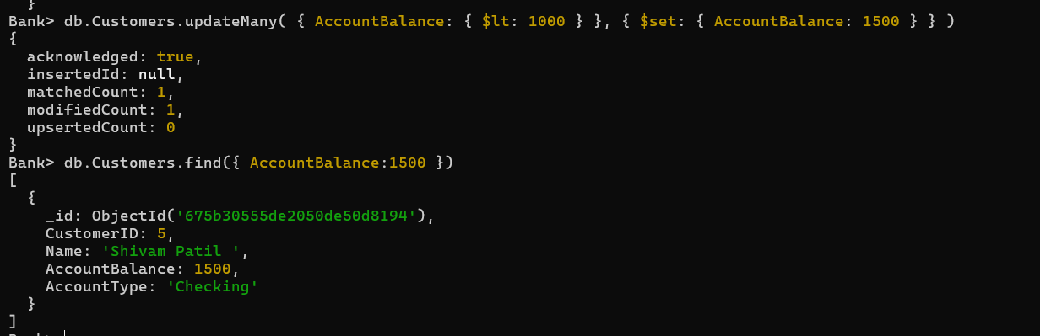

**3. Book and Author Database**

**Easy Questions**

**Q1.Create a database called "Library".**

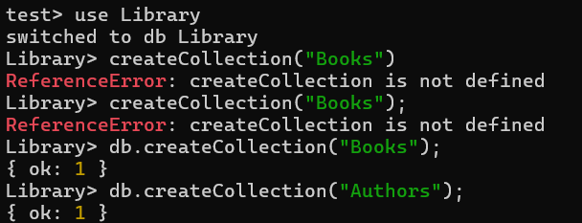

**Q2.Create a collection called "Books" with attributes: BookID, Title, AuthorID, Genre, PublishedYear, and Pages.**

**Q3.Create a collection called "Authors" with attributes: AuthorID, Name, DateOfBirth, Nationality.**

**Q4. Insert 5 books into the "Books" collection.**

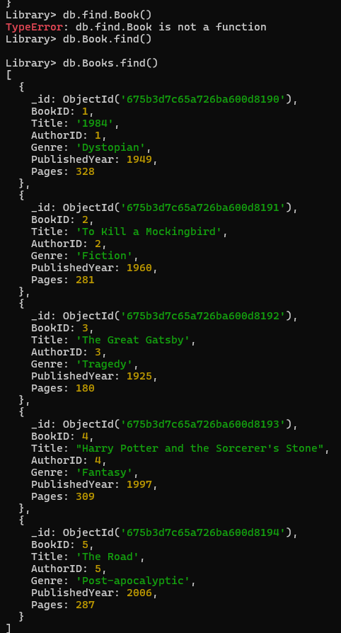

**Q5.Insert 3 authors into the "Authors" collection.**

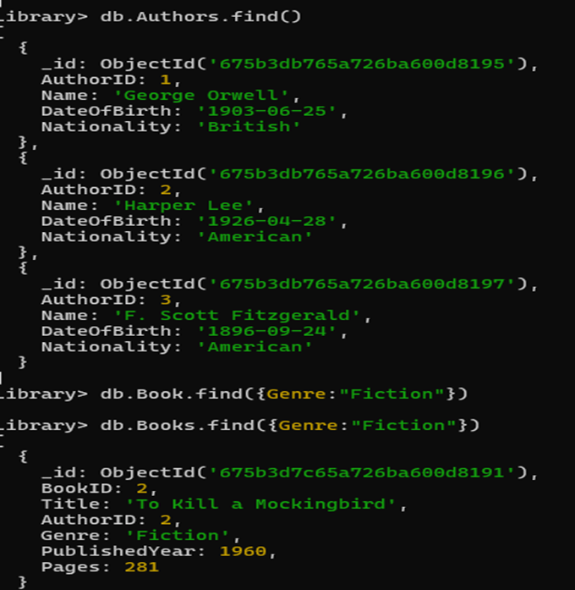

**Q6.Find all books with the Genre "Fiction".**

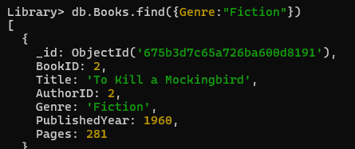

**Q7.Find all books authored by an author with the Name "J.K. Rowling".**

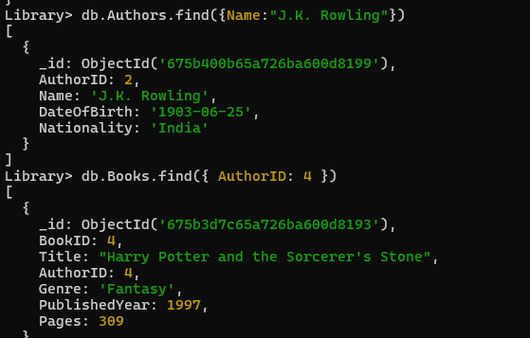

**Q8.Update the PublishedYear of the book with BookID 3 to 2022.**

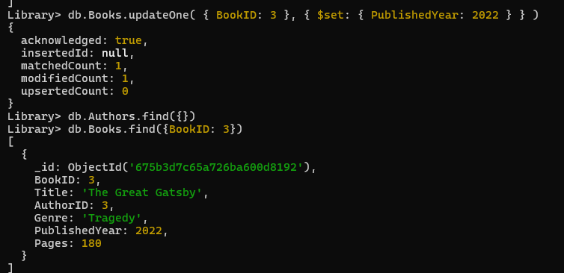

**Q9.Delete the book with BookID 2.**



**Q10.Count how many books belong to the “Science Fiction” genre.**



**Hard Questions**   
**Q1.Find books published between the years 2000 and 2010.**

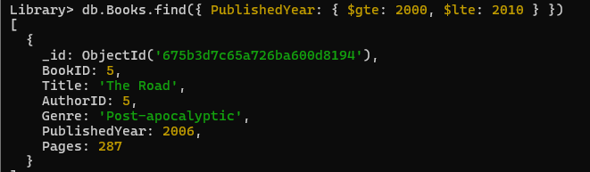

**Q2.Use $in to find books that belong to the genres "Thriller", "Romance", or "Adventure".**



**Q3.Retrieve the first 3 books, skipping the first 2 documents.**

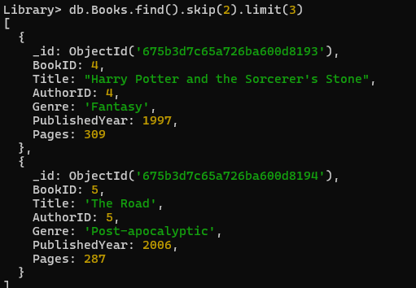

**Q4.Find all books written by authors born after 1980.**



**Q5.Sort books by Title in alphabetical order.**

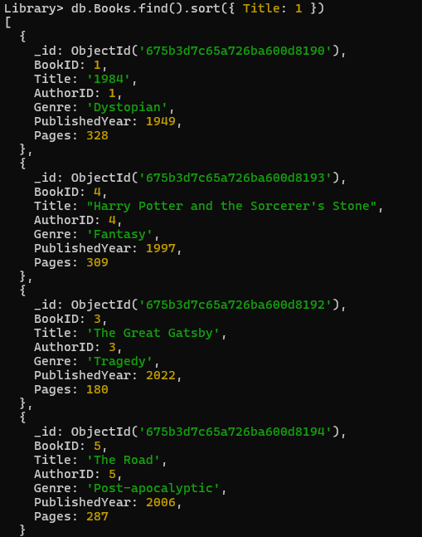

**Q6.Group books by Genre and find the average Published Year for each genre.**

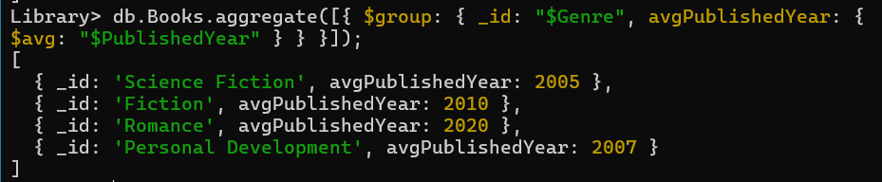

**Q7.Find all books whose Title contains the word "Harry Potter".**

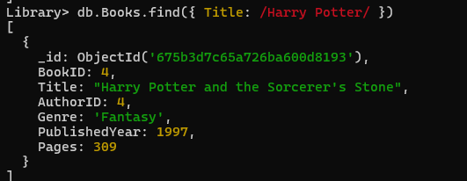

**Q8.Find all authors who have written books in the "Horror" genre.**

