

**IT21 - Java Programming**

**Practical Assignments 3**

**A.Y 2024-25**

**1.You have developed an e-commerce website for your client. The maximum no of units of a single prodcut that one user can add to the cart is 5. If the user adds more than 5 units of a single product, then your application is expected to throw,**   
**MaximumProductsLimitExceededException. Write a custom exception class to achieve this.**

→**MaxProdLimitedException.java**   
**package** pkgtablet;   
**publicclass**MaxProdLimitExceededException**extends** Exception {   
**public** MaxProdLimitExceededException(String message) {   
**super**(message);   
}   
}   
→**ShoppingCart.java**   
**package** pkgProducts;   
**import** pkgtablet.MaxProdLimitExceededException;   
**publicclass** ShoppingCart {   
**privatestaticfinalint*MAX_PRODUCT_LIMIT***=5;   
**publicvoid** addProductToCart(**int** quantity)**throws** MaxProdLimitExceededException {   
**if**(quantity>***MAX_PRODUCT_LIMIT***) {   
**thrownew** MaxProdLimitExceededException(   
"You cannot add more than "+***MAX_PRODUCT_LIMIT***+" units of a single product to cart." );   
}   
//Logic to add product to cart   
System.***out***.println(quantity+" units added to the cart.");   
}   
}   
→**ECommerceApp.java**   
package pkgProducts;   
import java.util.Scanner;   
import pkgtablet.MaxProdLimitExceededException;   
public class ECommerceApp {   
public static void main(String[] args) {   
Scanner scanner=new Scanner(System.in);   
ShoppingCart cart=new ShoppingCart();   
try {   
System.out.println("Enter number of units you want to add to the cart:");



int units=scanner.nextInt();   
cart.addProductToCart(units);   
}catch(MaxProdLimitExceededException e) {   
System.out.println("Error: "+e.getMessage());//Handles custom exception }finally {   
scanner.close();   
}   
}   
}

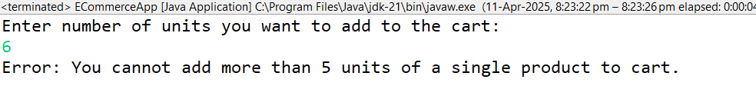

**2.The manufacturing of your medical company has very strict standards of product specifications. After each pill /tablet is ready, it is weighed. If the weight of the tablet exceeds the allowed limit, TabletWeightExceededException is raised. Using exception handling in Java, write the program to achieve the above business requirement.**

→**Tablet.java**   
**package** pkgtablet;   
**publicclass** Tablet {   
**private** String name;   
**privatedouble** weight;   
**privatestaticfinaldouble*MAX_WEIGHT***=500.0;   
**public** Tablet(String name,**double** weight) **throws** TabletWeigthExceededException{ **if**(weight>***MAX_WEIGHT***) {   
**thrownew** TabletWeigthExceededException("Error: "+name+" exceeds the maximum allowed weight of "+***MAX_WEIGHT***+" mg.");   
}   
**this**.name=name;   
**this**.weight=weight;   
System.***out***.println("Tablet "+name+" with weight "+weight+" mg is approved.");   
}   
**public** String getName() {   
**return** name;   
}   
**publicdouble** getWeight() {   
**return** weight;   
}   
}   
→**TabletDemo.java**   
**package** pkgtablet;   
**import** java.util.*;   
**publicclass** TabletDemo {   
**publicstaticvoid** main(String[] args) {   
Scanner scanner=**new** Scanner(System.***in***);   
**try** {   
System.***out***.println("Enter name of Tablet:");



String name=scanner.nextLine();   
System.***out***.println("Enter weight of tablet:");   
**double** weight=scanner.nextDouble();   
Tablet tablet1=**new** Tablet(name,weight);   
//Tablet tablet2=new Tablet("Dolo",500.0);   
//Tablet tablet3=new Tablet("Aspirin",520.0);//This will throw exception }   
**catch**(TabletWeigthExceededException e) {   
System.***out***.println(e.getMessage());   
}   
}   
}   
→**TabletWeigthExceededException.java**   
**package** pkgtablet;   
**publicclass**TabletWeigthExceededException**extends** Exception{ **public** TabletWeigthExceededException(String message) {   
**super**(message);   
}   
}

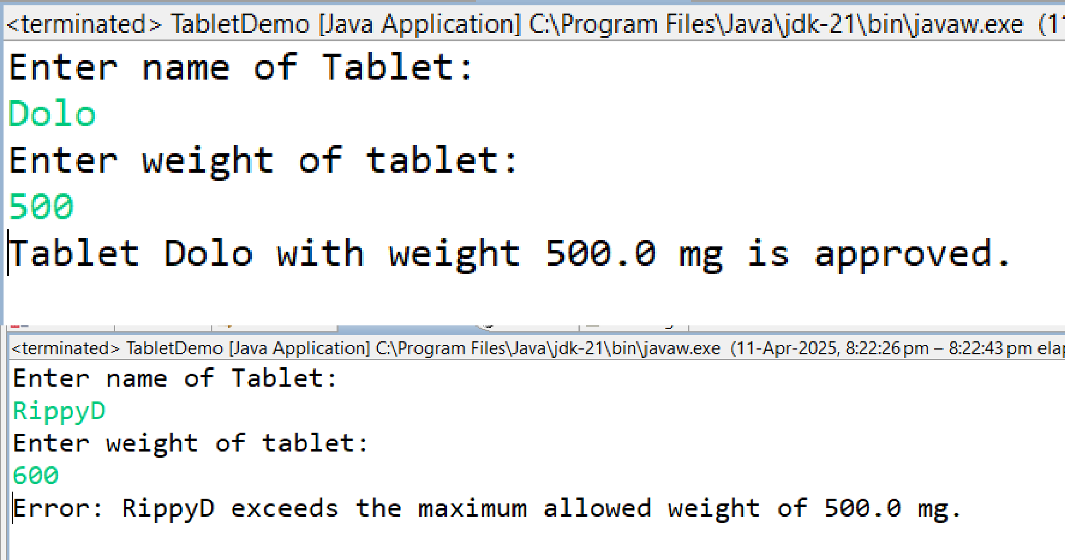

**3.When the battery of your mobile phone is less than 20%, the system should generate, LowBatteryException to alert the user to start charging the device. If the battery goes lower than 10 then the system should raise InsufficientChargeException and put the unit on power saver mode. Using exception handling in Java, write the program to achieve the above business requirement.**

→**InsufficientCharge.java**   
**package** pkgBattery;   
**publicclass**InsufficientCharge**extends** Exception { **public** InsufficientCharge(String message) {   
**super**(message);



}   
}   
→**LowBattery.java**   
**package** pkgBattery;   
**publicclass**LowBattery **extends** Exception {   
**public** LowBattery(String message) {   
**super**(message);   
}   
}   
→**MobilePhone.java**   
**package** pkgBattery;   
**publicclass** MobilePhone {   
**privateint** batteryLevel;   
**public** MobilePhone(**int** batteryLevel) **throws** LowBattery,InsufficientCharge {   
**this**.batteryLevel=batteryLevel;   
**if**(batteryLevel<10) {   
**thrownew** InsufficientCharge("Battery critically low (" + batteryLevel + "%)! Switching to Power Saver Mode.");   
}**elseif**(batteryLevel<20) {   
**thrownew** LowBattery("Battery low (" + batteryLevel + "%)! Please charge soon."); }**else** {   
System.***out***.println("No need to charge!");   
}   
}   
**publicint** getBatteryLevel() {   
**return** batteryLevel;   
}   
}   
→**MobilePhoneDemo.java**   
**package** pkgBattery;   
**import** java.util.*;   
**publicclass** MobilePhoneDemo {   
**publicstaticvoid** main(String[] args) {   
Scanner scanner=**new** Scanner(System.***in***);   
**try** {   
System.***out***.println("Enter charging of your phone:");   
Integer batteryLevel=scanner.nextInt();   
MobilePhone phone=**new** MobilePhone(batteryLevel);   
}   
**catch**(LowBattery e) {   
System.***out***.println("Warning: "+e.getMessage());   
}**catch**(InsufficientCharge e) {   
System.***out***.println("Critical: "+e.getMessage());   
}   
}   
}



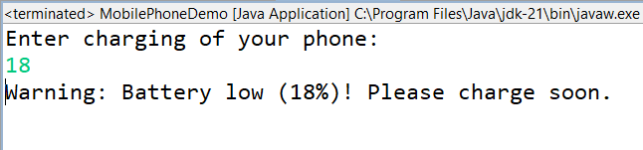

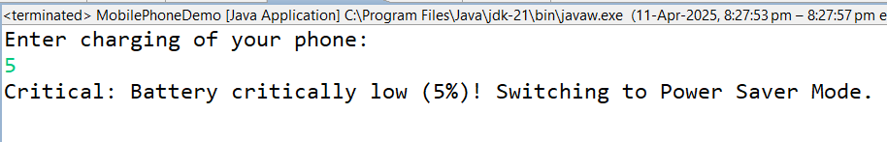

**4.You are writing an app for taking names of the volunteers for Cultural Committee of your Institute. According to the guidelines only 15 members are allowed in the committee.**

**Using your app, take the names of the interested candidates till the number reaches 15.**

**Once the threshold is crossed, display a message, “No more candidates allowed as**   
**volunteers. Thank you”. Use ArrayList to achieve the above given business logic. Hint : You will have to keep checking the size of the arraylist.**

**5.Once the above list of volunteers is finalized, each volunteer needs to pick a historical character as his/her badge icon. Using your app, take the name of the historical character from the volunteers and store them for future uses. Also, no two characters should be the same. In case the character is already in the list, ask the volunteer to enter some other character. Use ArrayList to achieve the above given requirement. Hint : You will have to check if the element is already contained inside the list.**

→**CulturalComittee.java**   
**package** pkgCulturalComittee;   
**import** java.util.*;   
**publicclass** CulturalComittee   
{   
Scanner scanner=**new** Scanner(System.***in***);   
ArrayList<String> volunteers=**new** ArrayList<String>();   
HashMap<String,String> assignedCharacters=**new** HashMap<>();   
//to add name of volunteers to arraylist   
**public** ArrayList<String> addElementsToCollection() {   
**while**(volunteers.size()<15)   
{   
System.***out***.println("Enter volunteer name:");   
String name=scanner.nextLine();   
volunteers.add(name);   
System.***out***.println(name+" has been added to the committee.");   
}   
System.***out***.println("No more candidates allowed as volunteers.Thank You."); **return** volunteers;   
}



//to add historical character to hashmap   
**public** HashMap<String,String> addHistoricalCharacter()   
{   
**for**(String volunteer:volunteers) {   
String character;   
**while**(**true**)   
{   
System.***out***.println(volunteer +":-Enter your Historical Characeter:");   
character=scanner.nextLine();   
//check if character is already assigned   
**if**(!assignedCharacters.containsValue(character)) {   
assignedCharacters.put(volunteer, character);   
**break**;   
}**else** {   
System.***out***.println("This character is already taken.Please choose another one."); }   
}   
}   
**return** assignedCharacters;   
}   
//Display final list   
**publicvoid** displayList() {   
System.***out***.println("\nFinal List of Volunteers and their Historical Characters:"); **for**(String volunteer:assignedCharacters.keySet()) {   
System.***out***.println(volunteer+"->"+assignedCharacters.get(volunteer));   
}   
scanner.close();   
}   
}   
→**CulturalCommitteeDemo.java**   
**package** pkgCulturalComittee;   
**import**java.util.*;   
**publicclass** CulturalCommitteeDemo {   
**publicstaticvoid** main(String[] args) {   
CulturalComittee cc=**new** CulturalComittee();   
cc.addElementsToCollection();   
cc.addHistoricalCharacter();   
cc.displayList();   
}   
}



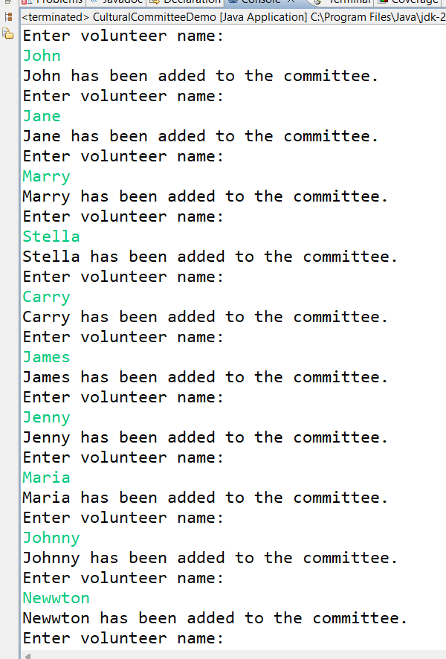



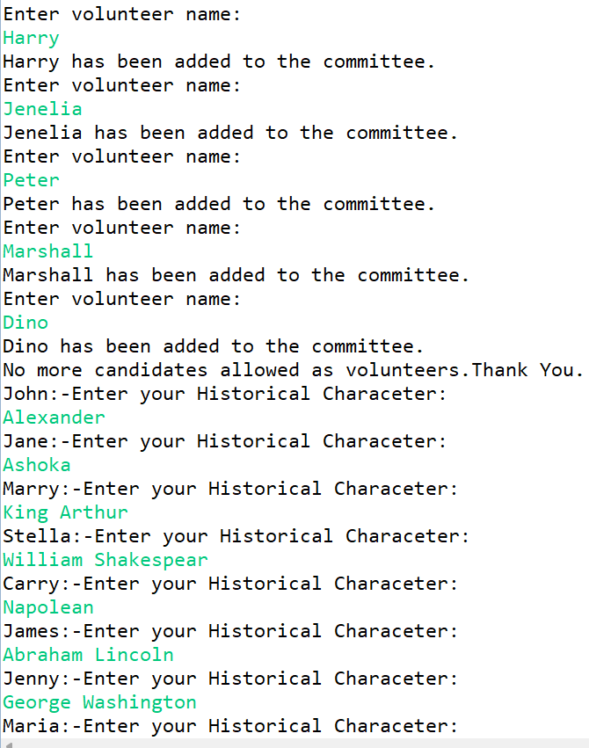



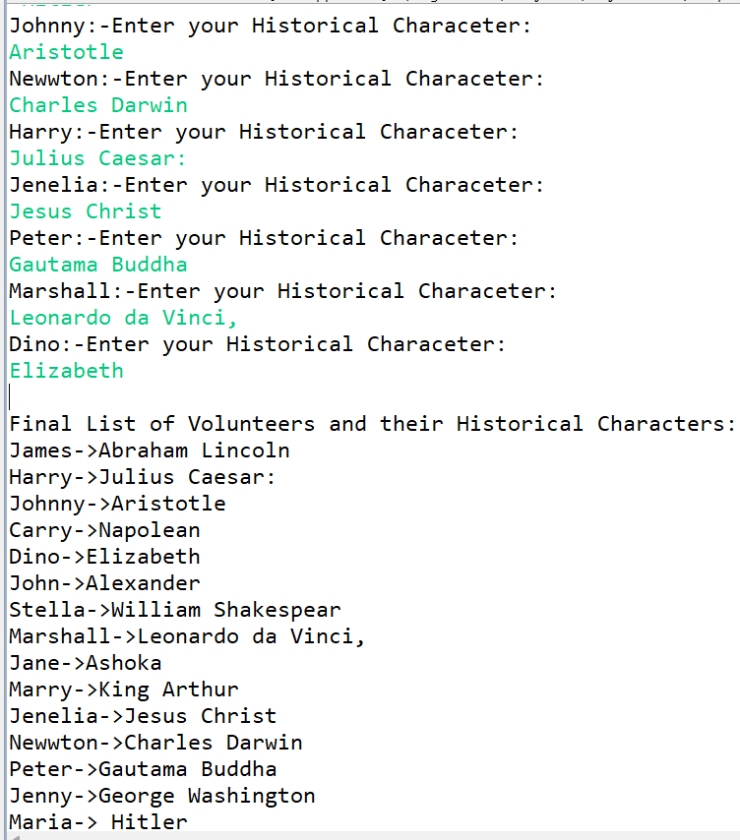

**6.The placement cell of your Institute has asked you to share the name of one technology which you are expert in. Using an app, take this from 15 students. The cell then wants you to give a technology count based on the input. For ex, how many students chose Java, how many chose Python, how many entered MERN, etc. Demonstrate the use of ArrayList to achieve this .Hint : You will need to sort the arraylist and then count the individual elements pertaining to a given technology.**

→**Technology.java**   
package pkgPlacement;   
import java.util.ArrayList;



import java.util.Collections;   
import java.util.Scanner;   
public class Technology {   
Scanner sc=new Scanner(System.in);   
ArrayList<String> technologies=new ArrayList<>();   
public void collectTechnology() {   
//Collecting technology choices from 15 students   
System.out.println("Enter technology each student is an expert in:");   
for (int i=0;i<15;i++) {   
System.out.println("Student "+(i+1)+": ");   
String tech=sc.nextLine().trim();   
technologies.add(tech);   
}   
}   
public void sort() {   
System.out.println("List after sorting:-");   
Collections.sort(technologies);   
System.out.println(technologies);   
}   
public void count() {   
System.out.println("\nTechnology Count:");   
int count=1;   
for(int i=1;i<technologies.size();i++) {   
if(technologies.get(i).equals(technologies.get(i-1))) {   
count++;   
}else {   
System.out.println(technologies.get(i-1)+"->"+count);   
count=1;   
}   
}   
System.out.println(technologies.get(technologies.size()-1)+"->"+count);//Print last element }   
public void countAgain() {   
System.out.println("\nTechnology Count:");   
ArrayList<String> counted=new ArrayList<>();   
for(String tech:technologies) {   
if(!counted.contains(tech)){//if technology is not counted yet   
int count=0;   
counted.add(tech);   
System.out.println(tech+": "+count);   
//count occurrences of technology in list   
for(String t:technologies) {   
if(t.equals(tech)) {   
count++;   
}   
}   
}



}   
}   
}   
→**TechnologyDemo.java**   
**package** pkgPlacement;   
**publicclass** TechnologyDemo {   
**publicstaticvoid** main(String[] args) {   
Technology techno=**new** Technology();   
techno.collectTechnology();   
techno.sort();   
techno.count();   
techno.countAgain();   
}



}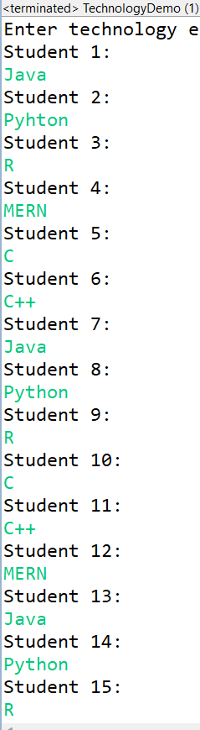



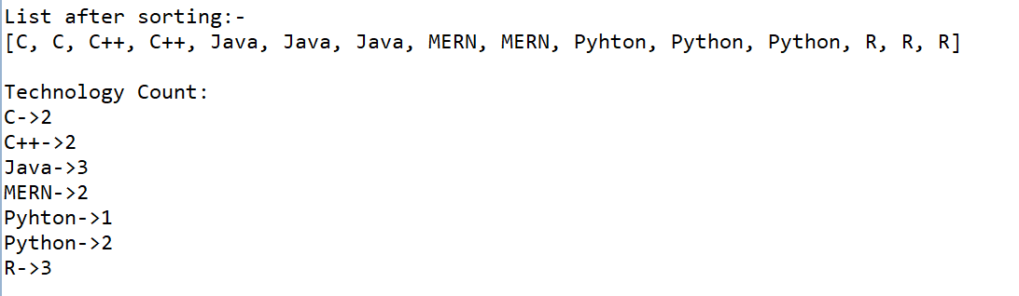

**7.For the recently held HR meet, the CR and LR of division A and B marked the attendance for their respective classes in separate lists. The TPO cell wants a**   
**consolidated list of FYMCA students who were present for the event. Write a program using ArrayList to mark division wise attendance first and then give the consolidated list.Hint : You will need to add the arraylists to get the final one.**

→**HRMeetAttendance.java**   
**package** pkgPlacement;   
**import** java.util.ArrayList;   
**publicclass** HRMeetAttendance {   
ArrayList<String> divA=**new** ArrayList<>();   
ArrayList<String> divB=**new** ArrayList<>();   
ArrayList<String> consolidatedList=**new** ArrayList<>(); **publicvoid** markAttendance() {   
//Mark attendance for Div A   
divA.add("Student1");   
divA.add("Student2");   
divA.add("Student3");   
System.***out***.println("Attendance of DivA students:-"+divA); //Mark attendance for Div B   
divB.add("Student4");   
divB.add("Student5");   
divB.add("Student6");   
System.***out***.println("Attendance of DivB students:-"+divB); }   
**publicvoid** consolidatedList() {   
consolidatedList.addAll(divA);   
consolidatedList.addAll(divB);   
}   
**publicvoid** display() {   
System.***out***.println("Consolidated Attendance List:");   
**for**(String student:consolidatedList) {   
System.***out***.println(student);   
}   
}   
}   
→**HRMeetAttendanceDemo.java**   
**package** pkgPlacement;



**publicclass** HRMeetAttendanceDemo {   
**publicstaticvoid** main(String[] args) {   
HRMeetAttendance hr=**new** HRMeetAttendance(); hr.markAttendance();   
hr.consolidatedList();   
hr.display();   
}   
}

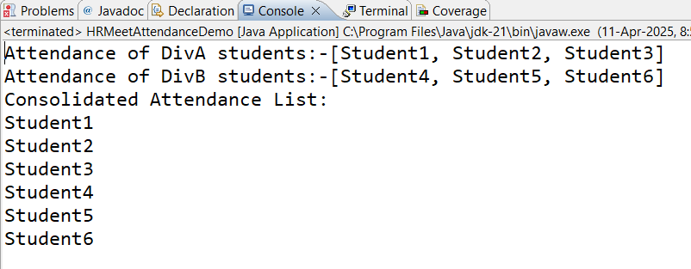

**8.Sports cell of the Institute needs to choose its core team from those students who**   
**participated in the recently held sports events. For this, the sports coordinator has decided to consider the participants of Football and Cricket. Only those players who participated in BOTH these games will be considered for the core team. Using ArrayList, write a Java program which will take the names of the students participating in Football and Cricket.**

**Find the common names in these two events and put them into a third list, called, SportsCoreTeam.Hint : You will need to compare the two arraylists to get the third one** →**SportsCoreTeam.java**   
package pkgSports;   
import java.util.ArrayList;   
import java.util.Scanner;   
public class SportsCoreTeam {   
ArrayList<String> footballplayers=new ArrayList<>();   
ArrayList<String> cricketplayers=new ArrayList<>();   
ArrayList<String> sportscoreteam=new ArrayList<>();   
Scanner sc=new Scanner(System.in);   
public void collectNames() {   
System.out.println("Enter names of students who participated in Football!");   
for(int i=0;i<5;i++) {   
String fname=sc.nextLine();   
footballplayers.add(fname);   
}   
System.out.println("Enter names of students who participated in Cricket!");   
for(int i=0;i<5;i++) {   
String cname=sc.nextLine();   
cricketplayers.add(cname);   
}



}   
public void makeCoreTeam() {   
for(String player:footballplayers) {   
if(cricketplayers.contains(player)) {   
sportscoreteam.add(player);   
}   
}   
System.out.println("Sports Core Team members are:-"+sportscoreteam); }   
}   
→**SportsCoreTeamDemo.java**   
**package** pkgSports;   
**publicclass** SportsCoreTeamDemo {   
**publicstaticvoid** main(String[] args) {   
SportsCoreTeam spc=**new** SportsCoreTeam();   
spc.collectNames();   
spc.makeCoreTeam();   
}   
}

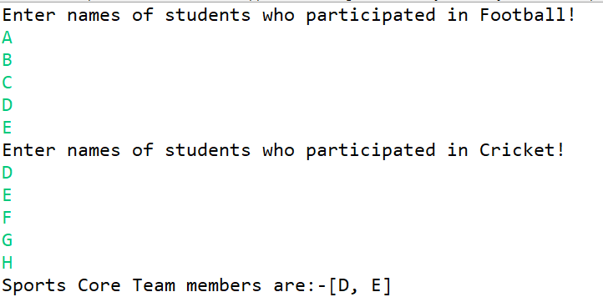

**9.The top three scorers in the coding competition will be given a certificate and trophy by the Coding Club. Using Vector, take the final scores (out of 100) of the participating coders and find the top three using only the max() function available in Collections. Hint : There is no need to sort the vector.**

→**CodingCompetition.java**   
package pkgCodingClub;   
import java.util.Collections;   
import java.util.Scanner;   
import java.util.Vector;   
public class CodingCompetition {   
Vector<Integer> scores=new Vector<>();



Scanner sc=new Scanner(System.in);   
public void addDetails() {   
System.out.println("Enter number of parcticipant coders:");   
int totalno=sc.nextInt();   
for(int i=0;i<totalno;i++) {   
System.out.println("Enter final scores for "+(i+1)+" participant"+"(out of 100):-");   
int finalscores=sc.nextInt();   
scores.add(finalscores);   
}   
}   
public void topthreescores() {   
if(scores.size()<3) {   
System.out.println("Not enough participants to determine top three");   
}   
else {   
//firstMax   
int firstMax=Collections.max(scores);   
scores.remove((Integer)firstMax);//Integer is used because without it will remove element at the given index not the value   
//secondmax   
int secondmax=Collections.max(scores);   
scores.remove((Integer)secondmax);   
//thirdmax   
int thirdmax=Collections.max(scores);   
System.out.println("Top three scores are:-");   
System.out.println("First is:-"+firstMax);   
System.out.println("Second is:-"+secondmax);   
System.out.println("Third is:-"+thirdmax);   
}   
}   
}   
→**CodingCompetitionDemo.java**   
**package** pkgCodingClub;   
**publicclass** CodingCompetitionDemo {   
**publicstaticvoid** main(String[] args) {   
CodingCompetition cc=**new** CodingCompetition();   
cc.addDetails();   
cc.topthreescores();   
}   
}



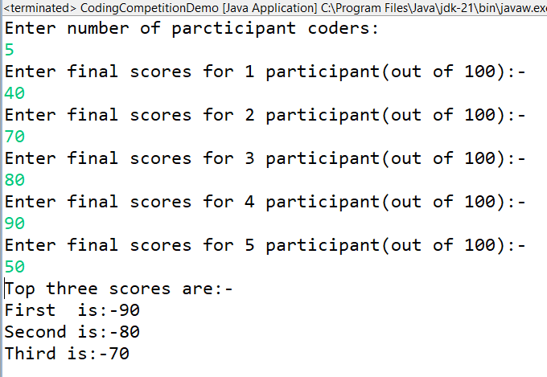

**10.KKR and MumbaiIndians are going to play the kickstart match of this year’s IPL season. Using Vector, you have taken the names of the players in each team and are displaying the same. But there is a last minute change in the batting line up of KKR. In place of QuintonDeKock, the team will send Anukul Roy at two down position. Make this change in their batting line up and display the new order.Hint : You need to get the original element and set it with the new one.**

→**KKR.java**   
**package** pkgIPL;   
**import** java.util.Vector;   
**publicclass** KKR {   
Vector<String> KKRplayers=**new** Vector<>();   
**publicvoid** addnames() {   
KKRplayers.add("Shubhman Gill");   
KKRplayers.add("Venkatesh Iyer");   
KKRplayers.add("Nitish Rana");   
KKRplayers.add("Quinton De Kock");   
KKRplayers.add("Andre Russell");   
KKRplayers.add("Eoin Morgan");   
KKRplayers.add("Dinesh Kartik");   
KKRplayers.add("PatCummins");   
KKRplayers.add("Sunil Narine");   
KKRplayers.add("Varun Chakravarthy");   
KKRplayers.add("Shivam Mavi");   
}   
**publicvoid** displayOriginal() {



System.***out***.println("Original KKR Batting Lineup:"); **for**(String p:KKRplayers) {   
System.***out***.println(p);   
}   
}   
**publicvoid** replace() {   
**int** pos=3;//index for quintonde kock   
KKRplayers.set(pos, "Ankul Roy");   
}   
**publicvoid** displayUpdated() {   
System.***out***.println("\nUpdated KKR Batting Lineup"); **for**(String p:KKRplayers) {   
System.***out***.println(p);   
}   
}   
}   
→**KKRdemo.java**   
**package** pkgIPL;   
**publicclass** KKRdemo {   
**publicstaticvoid** main(String[] args) {   
KKR kkrteam=**new** KKR();   
kkrteam.addnames();   
kkrteam.displayOriginal();   
kkrteam.replace();   
kkrteam.displayUpdated();   
}   
}



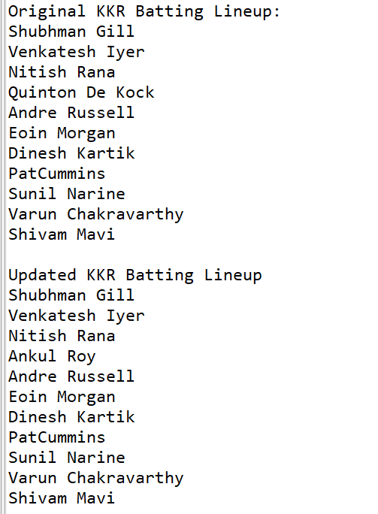

**11.In the e-commerce portal designed by you, the customer adds products to the shopping cart. Use a vector to hold the objects of Product class. At the time of billing, access each product object and read its price. Add the cost of all the products and display the bill total.**

**If the cart is empty, show a message, “Can we help you in finding what you were looking for?” and end the billing process.Hint : You will need a Product class and its objects. You will also need to check if the vector holding the cart is empty or not?**

→**ProductClass.java**   
**package** pkgEcom;   
**publicclass** ProductClass {   
String name;



**int** price;   
**public** ProductClass(String name,**int** price){   
**this**.name=name;   
**this**.price=price;   
}   
**publicvoid** displayProduct() {   
System.***out***.println("Product name:- "+name);   
System.***out***.println("Price:- "+price);   
}   
}   
→**ShoppingCart.java**   
**package** pkgEcom;   
**import** java.util.Vector;   
**publicclass** ShoppingCart {   
Vector<ProductClass> cart=**new** Vector<>();   
**publicvoid** addProducts(ProductClass product) {   
cart.add(product);   
System.***out***.println("Product added succesfuly!");   
}   
**publicvoid** displayCart() {   
**if**(cart.isEmpty()) {   
System.***out***.println("Your cart is empty!");   
}   
**else** {   
System.***out***.println("Your cart contains:");   
**for**(ProductClass product:cart) {   
System.***out***.println("Products name:- "+product.name);   
System.***out***.println("Products Price:- "+product.price);   
}   
}   
}   
**publicvoid** checkout() {   
**int** totalBill=0;   
**if**(cart.isEmpty()) {   
System.***out***.println("Can we help you in finding what you were looking for?"); **return**;//ends billing process   
}   
**else** {   
System.***out***.println("Billing Details:-");   
**for**(ProductClass product:cart) {   
System.***out***.println("Product:- "+product.name+"| Product price:- "+product.price); totalBill+=product.price;   
}   
System.***out***.println("Total Bill Amount :-"+totalBill);   
}   
}   
}   
→**ProductClassDemo.java**



**package** pkgEcom;   
**import** java.util.Scanner;   
**publicclass** ProductClassDemo {   
**publicstaticvoid** main(String[] args) {   
ShoppingCart shopcart=**new** ShoppingCart();   
Scanner sc=**new** Scanner(System.***in***);   
**while**(**true**) {   
System.***out***.println("\nE-commerce Shopping Cart");   
System.***out***.println("1.Add Product to Cart");   
System.***out***.println("2.View Cart");   
System.***out***.println("3.Checkout");   
System.***out***.println("4.Exit");   
System.***out***.println("Enter your choice");   
**int** choice=sc.nextInt();   
sc.nextLine();   
**switch**(choice) {   
**case** 1:   
//Add products to cart   
System.***out***.println("Enter product name: ");   
String name=sc.nextLine();   
System.***out***.println("Enter product price: ");   
**int** price=sc.nextInt();   
sc.nextLine();   
ProductClass product=**new** ProductClass(name,price);   
shopcart.addProducts(product);   
**break**;   
**case** 2:   
//View cart   
shopcart.displayCart();   
**break**;   
**case** 3:   
//Checkout Process   
shopcart.checkout();   
sc.close();   
**return**;//end program after checkout   
**case** 4:   
//Exit application   
System.***out***.println("Thank you for visiting !Have a great day."); sc.close();   
**return**;   
**default**:   
System.***out***.println("Invalid choice!Please try again.");   
}   
}   
}   
}



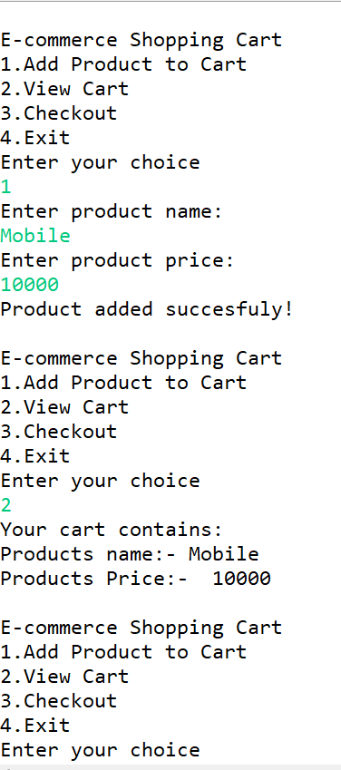



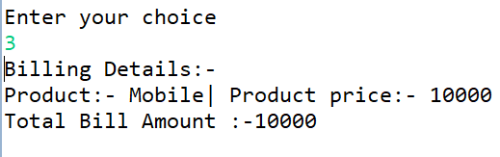

**12.During the Marathon event the organisers maintained a list to hold the details of the finishers. Once the marathon got over, they displayed the details of the first runner to finish the marathon and the last one to finish the same. Write an app having the objects of MarathonRunner class in to a vector list, finishers. Display the details of the runner who comes first and of the who comes last. MarathonRunner class has the properties, name, badgeNbr, startTime and endTime. Hint : You will need to check the first and last element in the vector.**

→**MarathonRunner.java**   
package pkgMarathon;   
import java.util.Scanner;   
import java.util.Vector;   
public class MarathonRunner {   
String name;   
int badgeNbr;   
double startTime;   
double endTime;   
Scanner sc = new Scanner(System.in);   
Vector<MarathonRunner> finishers = new Vector<>();   
// Constructor   
public MarathonRunner(String name, int badgeNbr, double startTime, double endTime) { this.name = name;   
this.badgeNbr = badgeNbr;   
this.startTime = startTime;   
this.endTime = endTime;   
}   
//Default Constructor   
public MarathonRunner() {   
}   
// Method to calculate total time taken   
public double getTotalTime() {   
return endTime - startTime;   
}   
// Accept runner details   
public void acceptDetails() {   
System.out.print("Enter the number of runners who finished the marathon: ");   
int totalRunners = sc.nextInt();   
sc.nextLine(); // Consume newline   
for (int i = 0; i < totalRunners; i++) {   
System.out.println("\nEnter details for Runner " + (i + 1) + ":");



System.out.print("Name: ");   
String name = sc.nextLine();   
System.out.print("Badge Number: ");   
int badgeNbr = sc.nextInt();   
sc.nextLine(); // Consume newline   
System.out.print("Start Time: ");   
double startTime = sc.nextDouble();   
sc.nextLine(); // Consume newline   
System.out.print("End Time: ");   
double endTime = sc.nextDouble();   
sc.nextLine(); // Consume newline   
// Validate that End Time > Start Time   
if (endTime < startTime) {   
System.out.println("Error: End Time must be greater than Start Time. Please re-enter details."); i--; // Retry current iteration   
continue;   
}   
//Add runner to vector   
finishers.add(new MarathonRunner(name,badgeNbr,startTime,endTime));   
}   
}   
// Display runner details   
public void displayRunnerDetails() {   
System.out.println("Name: " + name);   
System.out.println("Badge Number: " + badgeNbr);   
System.out.println("Start Time: " + startTime);   
System.out.println("End Time: " + endTime);   
System.out.println("Total Time Taken: " + getTotalTime() + " minutes\n");   
}   
// Display first and last finisher   
public void displayFirstLast() {   
if (finishers.isEmpty()) {   
System.out.println("No runners finished the marathon.");   
} else {   
System.out.println("\nFirst Finisher:");   
finishers.firstElement().displayRunnerDetails();   
System.out.println("Last Finisher:");   
finishers.lastElement().displayRunnerDetails();   
}   
}   
}   
→**MarathonDemo.java**   
**package** pkgMarathon;   
**publicclass** MarathonDemo {   
**publicstaticvoid** main(String[] args) {   
MarathonRunner runner=**new** MarathonRunner();   
runner.acceptDetails();   
runner.displayRunnerDetails();



runner.displayFirstLast();   
}   
}



