1. Write a Python program to convert kilometres to miles?

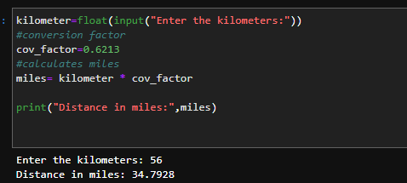

1. Write a Python program to convert Celsius to Fahrenheit?

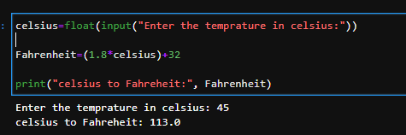

1. Write a Python program to display calendar?

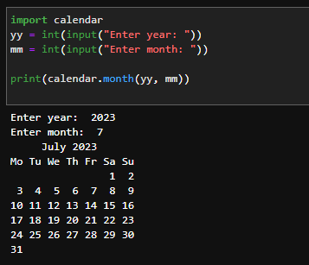

1. Write a Python program to solve quadratic equation?

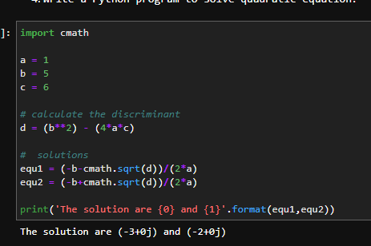

1. Write a Python program to swap two variables without temp variable?

