Date:

- Create a PL/SQL block that computes the sum of the salary of all the employees working in the particular department.

Query: DECLARE
s_sum employees.salary%type;
dept employees.salary%type;
BEGIN
SELECT department_id, sum(salary) into dept, s_sum from employees where department_id=100 group by department_id;
dbms_output.put_line (dept||" "|| s_sum);
END;

OUTPUT:
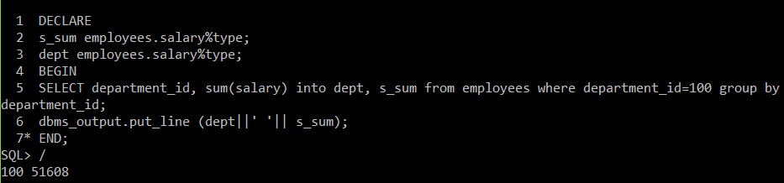

- Create a PL/SQL block that displays the employee name and the department name of that employee.
Query:
dept departments.department_name%type;
BEGIN
SELECT e.first_name, d.department_name into e_name, dept from employees e, departments d where
e.department_id= d.department_id and e.employee_id=100;
END;
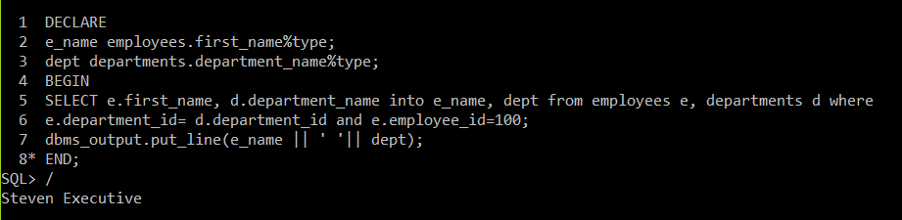

- Create a PL/SQL block that computes the bonus amount for a given employee based on the employee’s salary using employees table.
  - If the employee’s salary is less than $5000 display the bonus amount for the employee as 10% of the salary
Query:
DECLARE
bonus employees.salary%type;
sal employees.salary%type;
BEGIN
SELECT salary into sal from employees where employee_id=190;
if sal<5000 then
bonus := 0.1*sal;
dbms_output.put_line('salary less than 5000');
elsif sal between 5000 and 10000 then
bonus := 0.15*sal;
dbms_output.put_line('salary between 5000 and 10000');
else
bonus := 0.2*sal;
dbms_output.put_line('salary greater than 10000');
end if;
dbms_output.put_line(bonus);
END;

OUTPUT:
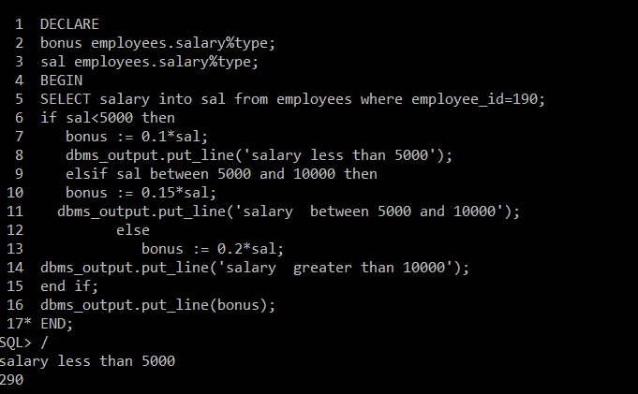
  - If employee’s salary is between $5000 and $10000 display the bonus amount for the employee as 15% of the salary

OUTPUT:
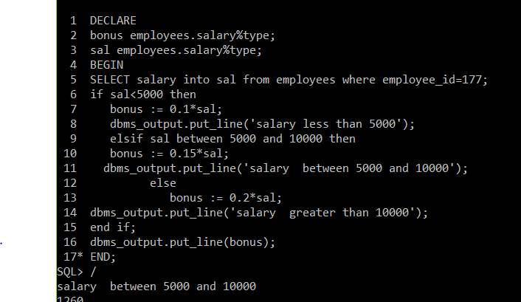

  - If employee’s salary exceeds $10000 display the bonus amount for the employee as 20% of the salary

OUTPUT:
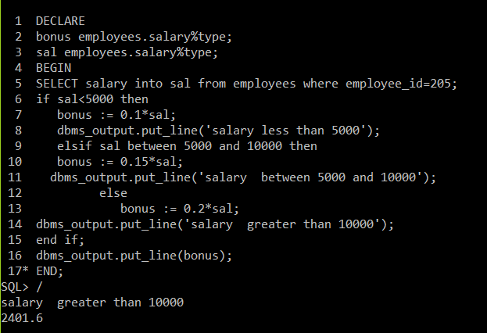
  - If employee’s salary is null display the bonus amount for the employee as 0.

Ans: No employee id with salary null.

