**ST.** XAVIER’S **COLLEGE**

**(Affiliated to Tribhuvan University)**

Maitighar, Kathmandu



**Advanced Database Management System**

**Lab Assignment #1**

**Submitted By**

**Aashish Paudel**

**7th SEM / 4th Year**

**014BSCIT002**

**Submitted To**

|  |  |
| --- | --- |
| **Signature** | **Remarks** |
| **Mr. Nitin Malla**  **Lecturer**  **Dept. of Computer Science** |  |  |

**Write the SQL statement for the following and show the table generated by that query also:**

1. If the salary is a monthly salary, list the names and annual salary of each employee.

Command:



Result:

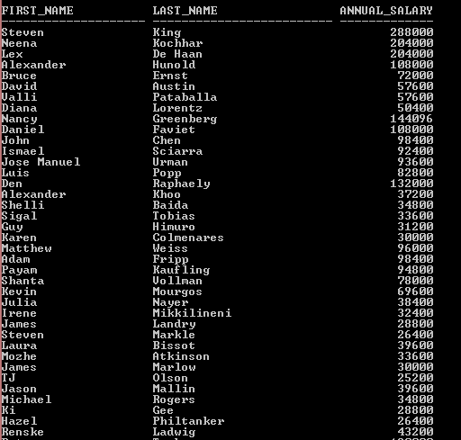

1. What would the SQL statement be to obtain the result –

EMPLOYEE ‘WORKS IN DEPARTMENT’ DEPTNO

-------------------------- -------------------------------------- --------------

7396-SMITH WORKS IN DEPARTMENT 20

Command:



Result:



1. If employees with a particular job are given commissions, list the names and annual income of each employee.

Command:



Result:

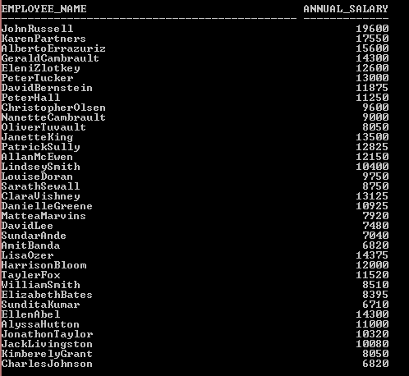

1. List the deptno in ascending order and within each deptno, sort the records in terms of the salary (highest salary first).

Command:



Result:

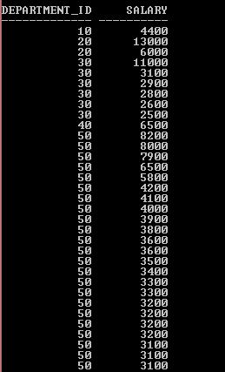

1. List the names, numbers, job and departments of all employees whose job_id contains CLERK.

Command:



Result:

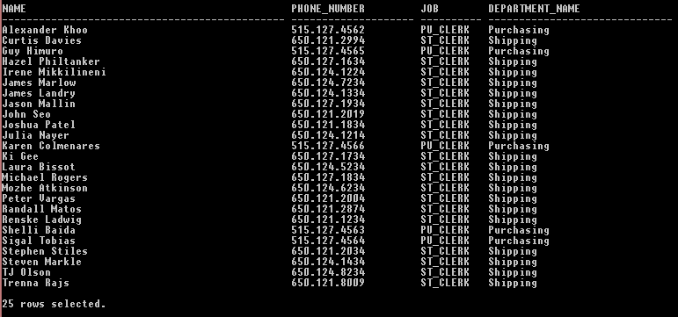

1. Find all clerks who earn between 500 and 20000.

Command:



Result:

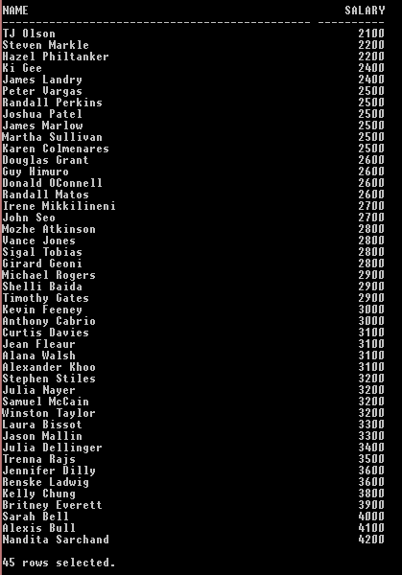

1. Find all employees whose manager is one of the three, i.e. with manager number 100, 200 or 205.

Command:



Result:

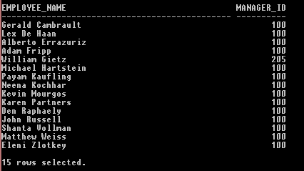

1. List employees whose names are exactly 4 characters in length.

Command:



Result:



1. List all managers and salesman with salaries over Rs. 5000.

Command:



Result:

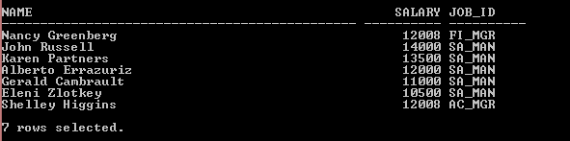

1. Display all employees who were hired during 1998.

Command:



Result:



But if hired date is 2002.



Result:



1. Calculate the average salary of all employees

Command:



Result:



1. Find the minimum salary earned by a clerk.

Command:



Result:



1. Find the number of employees in department 20.

Command:



Result:



1. Display the average monthly salary bill for each job type within each department. (group within group)

Command:



Result:

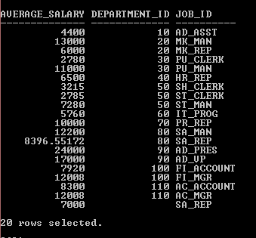

1. Display only those jobs where the maximum salary is greater than or equal to $3000.

Command:



Result:

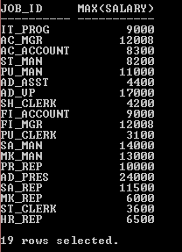

1. Find the minimum and maximum salary for each job type.

Command:



Result:

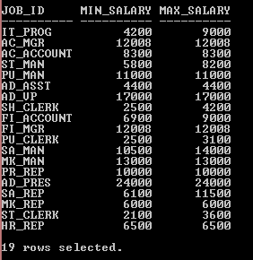

1. Evaluate each employee’s grade and display it together with his name and salary.

(Rule for joining tables:- minimum number of join conditions = number of tables to be joined minus one.)

Command:



Result:

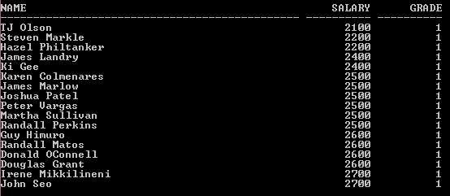

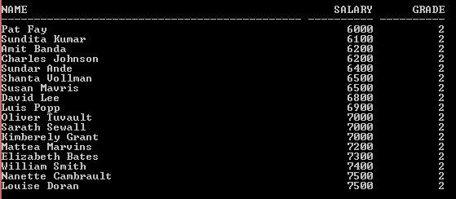

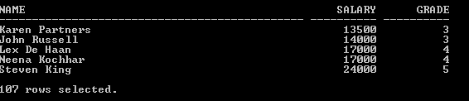

1. Display the name, location and dept name of employees whose salary is more than 1500 a month.

Command:



Result:

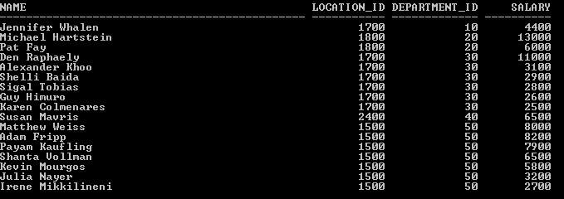

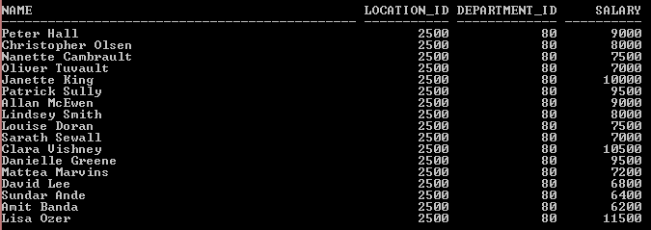

1. Show employees who belong to Grade 3.

Command:



Result:

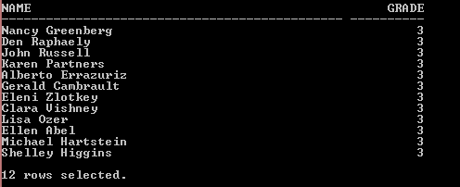

1. List the employee name, job, salary, grade and dept name for everyone in the company except clerks. Sort on salary, displaying the highest salary first.

Command:



Result:

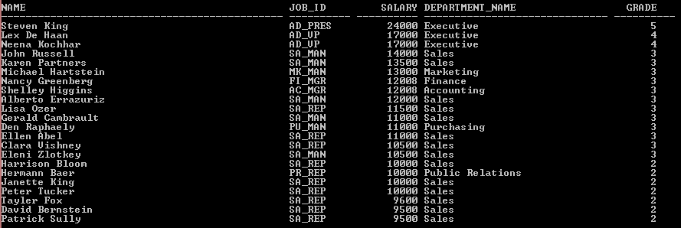

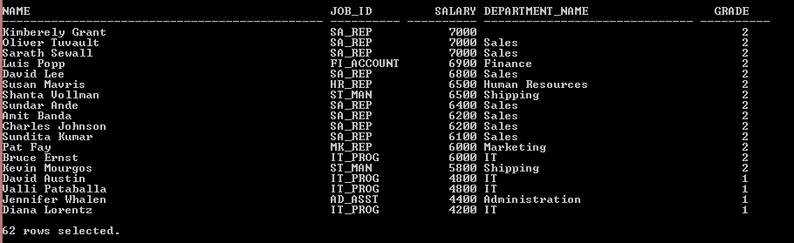

1. Display all employees who earn more than their managers.

Command:



Result:



1. List all employees by name and number along with their manager’s name and number.

Command:



Result:

