**ST. XAVIER’S COLLEGE**

**(Affiliated to Tribhuvan University)**

**Maitighar, Kathmandu**



**LAB ASSIGNMENTS**

**OF**

**“ADVANCED JAVA”**

**Submitted By**

**Sarita Karki**

**4th Year / 7th Semester**

**014BSCIT040**

**Submitted To**

|  |  |
| --- | --- |
| **Signature** | **Remarks** |
| **Mr. Bal Krishna Subedi**  **Lecturer**  **Dept. of Computer Science**  **Date: 03/27/2018** |  |  |

**WAP TO ILLUSTRATE INHERITANCE USING SUPER:**

**CLASS 1:**

package inheritance;

public class Super {

int i = 9;

void showA() {

System.out.println("The value of i is:" + i);

}

}

**CLASS 2:**

package inheritance;

class Sub extends Super{

int i=10;

int a=super.i;

void showB(){

System.out.println("Value of i is:" +i);

System.out.println("Super value of i is:" +a);

}

}

**MAIN CLASS:**

package inheritance;

public class Inheritance {

public static void main(String[] args) {

Super sup=new Super();

sup.showA();;

Sub next= new Sub();

next.showB();

}

}

**OUTPUT:**

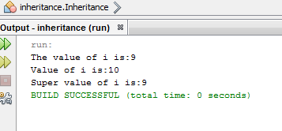

**WAP TO FIND THE CIRCUMFERENCE OF CIRCLE USING FINAL AND THIS**

**CLASS 1:**

package circumference;

public class Calculate {

final double pi=3.1415;

int r;

public Calculate(int r) {

this.r=r;

}

public void show(){

System.out.println("The circumference is:"+(2*pi*r));

}

}

**MAIN CLASS:**

package circumference;

public static void main(String[] args) {

Calculate cal=new Calculate(2);

cal.show();

}

}

**OUTPUT:**

