**ST. XAVIER’S COLLEGE**

**(Affiliated to Tribhuvan University)**

**Maitighar, Kathmandu**



**LAB ASSIGNMENTS**

**OF**

**“ADVANCED JAVA”**

**Submitted By**

**Sarita Karki**

**4th Year / 7th Semester**

**014BSCIT040**

**Submitted To**

|  |  |
| --- | --- |
| **Signature** | **Remarks** |
| **Mr. Bal Krishna Subedi**  **Lecturer**  **Dept. of Computer Science**  **Date: 03/25/2018** |  |  |

**WAP TO FIND THE FACTORIAL OF A NUMBER USING RECURSIVE FUNCTION**

**SOURCE CODE:**

package factorial;

import java.util.Scanner;

public class Factorial {

public static void main(String[] args) {

int fact=1;

int i;

Scanner sc= new Scanner(System.in);

System.out.println("Enter the number:");

int number= sc.nextInt();

for(i=1; i<=number; i++){

fact=i*fact;

}

System.out.println("The Factorial of the number is:"+fact);

}

}

**OUTPUT:**

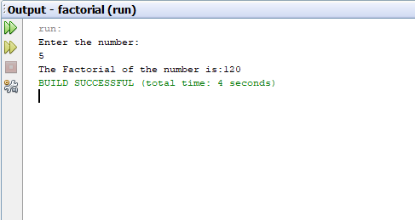

**WAP TO FIND THE VOLUME OF CYLINDER USING OBJECT PASSING:**

**SOURCE CODE:**

**MAIN CLASS:**

package objectpassing;

public class ObjectPassing {

public static void main(String[] args) {

Cylinder cyn= new Cylinder(2,3);

Cylinder one= new Cylinder(cyn);

System.out.println("Volume of the cylinder is:" +(one.volume()));

}

}

**REFERENCE CLASS:**

package objectpassing;

public class Cylinder {

double r;

double h;

double pi=3.1415;

public Cylinder(double radius, double height) {

r=radius;

h=height;

}

Cylinder (Cylinder ob){

r=ob.r;

h=ob.h;

}

double volume(){

return pi*r*r*h;

}

}

**OUTPUT:**

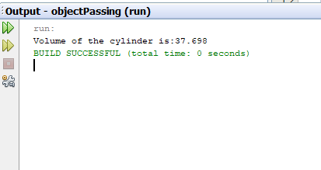

**WAP TO ILLUSTRATE STATIC METHOD/VARIABLES**

**SOURCE CODE:**

package staticmethod;

class Student {

int rollno;

String name;

static String college = "ASCOL";

Student8(int r, String n) {

rollno = r;

name = n;

}

static void change() {

college = "St.xavier's";

}

void display() {

System.out.println(rollno + " " + name + " " + college);

}

public static void main(String args[]) {

Student.change();

Student s1 = new Student8(111, "Sarita");

Student s2 = new Student8(222, "Soyesha");

s1.display();

s2.display();

}

}

**OUTPUT:**

