**ST. XAVIER’S COLLEGE**

**(Affiliated to Tribhuvan University)**

**Maitighar, Kathmandu**



**LAB ASSIGNMENTS**

**OF**

**“ADVANCED JAVA”**

**Submitted By**

**Sarita Karki**

**4th Year / 7th Semester**

**014BSCIT040**

**Submitted To**

|  |  |
| --- | --- |
| **Signature** | **Remarks** |
| **Mr. Bal Krishna Subedi**  **Lecturer**  **Dept. of Computer Science**  **Date: 03/22/2018** |  |  |

**WAP TO FIND THE VOLUME OF CUBE USING METHOD OVERLOADING**

**SOURCE CODE:**

package cubevolume;

public class Cube1{

public void volume1(int l){

System.out.println("The volume1 of cube is:" +(l*l*l));

}

public void volume1(double l){

System.out.println("The volume1 of cube is:" +(l*l*l));

}

}

public class CubeVolume {

public static void main(String[] args) {

Cube1 c= new Cube1();

c.volume1(2);

c.volume1(2.5);

}

}

OUTPUT:

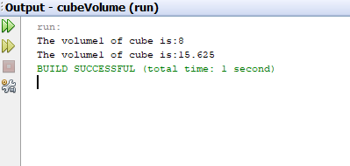

**WAP TO FIND THE SUM OF STRING/INT USING CONSTRUCTOR OVERLOADING**

**SOURCE CODE:**

package constructorovd;

public class overLoad {

public overLoad() {

System.out.println("no value");

}

public overLoad(int a , int b){

System.out.println("The sum is:" +(a+b));

}

public overLoad(String c , String d){

System.out.println("The sum is:" +(c+d));

}

}

**OUTPUT:**

