**ST. XAVIER’S COLLEGE**

**(Affiliated to Tribhuvan University)**

**Maitighar, Kathmandu**



**LAB ASSIGNMENTS**

**OF**

**“ADVANCED JAVA”**

**Submitted By**

**Sarita Karki**

**4th Year / 7th Semester**

**014BSCIT040**

**Submitted To**

|  |  |
| --- | --- |
| **Signature** | **Remarks** |
| **Mr. Bal Krishna Subedi**  **Lecturer**  **Dept. of Computer Science**  **Date: 04/3/2018** |  |  |

**WAP TO ILLUSTRATE EXCEPTION HANDLING USING ALL KEYWORDS TRU, CATCH, THROE, THROWS, FINALLY.**

SOURCE CODE:

package throwdemo;

public class ThrowDemo {

public static void main(String[] args) {

try{

int data=25/0;

System.out.println(data);

}

catch(NullPointerException e){System.out.println(e);}

finally{System.out.println("finally block is always executed");}

}

}

**OUTPUT:**

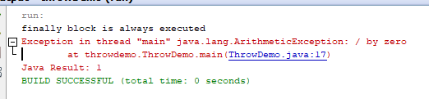

**Throw:**

package throwdemo;

import java.util.Scanner;

public class Throw {

static void validate(int rate){

if(rate<18)

throw new ArithmeticException("low rate");

else

System.out.println("welcome to store");

}

public static void main(String args[]){

Scanner sc= new Scanner(System.in);

System.out.println("Enter the rate");

int rate= sc.nextInt();

validate(rate);

}

}

**OUTPUT:**

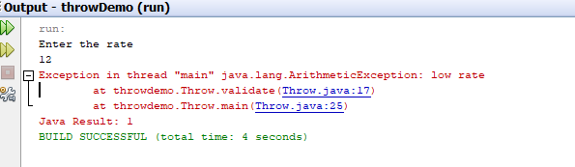

**THROWS:**

package throwdemo;

import java.io.*;

public class ThrowsDemo {

void method()throws IOException{

throw new IOException("device error");

}

}

class Testthrows4{

public static void main(String args[])throws IOException{//declare exception

ThrowsDemo m=new ThrowsDemo();

m.method();

System.out.println("normal flow...");

}

}

**Output:**

