**GIT ASSIGNMENTS**

1.Create a directory ‘project_dir’ & cd to ‘project_dir’

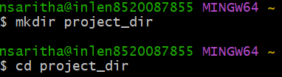

2.Initialize git version database.(git init)

3.Create a new file index.html



4.Check the git status. You should find index.html as untracked file.

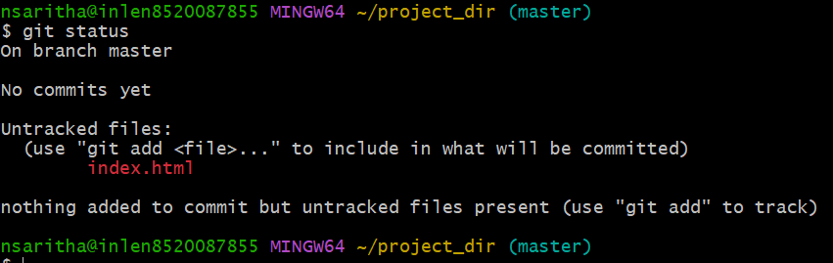

5.Stage the index.html file.



6.Commit index.html

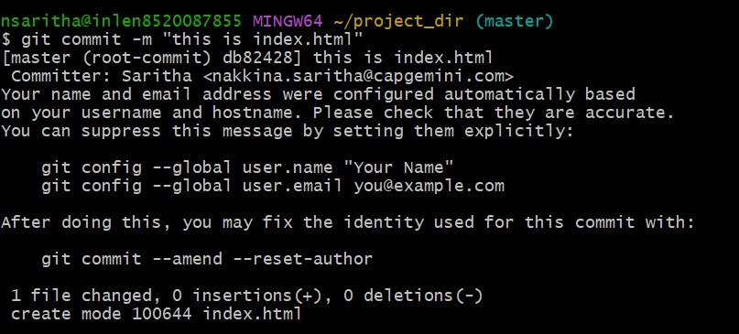

7.Make few changes in index.html & create a new file info.txt file.



8.Check git status. You should find index.html & info.txt file.

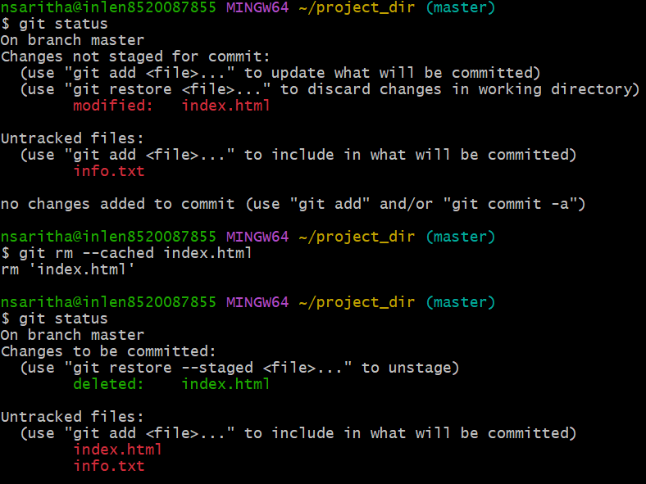

9.Configure GIT to ignore all txt files.



10.Again check the git status. You should find only index.html as untracked files.

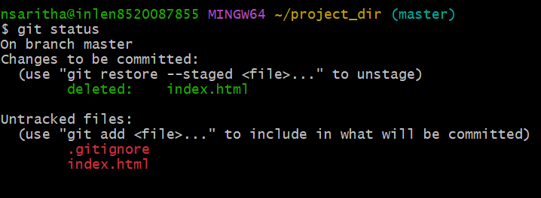

11.State & commit index.html

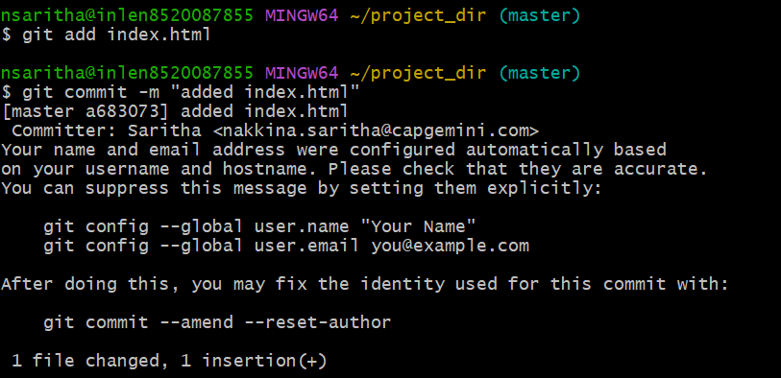

12.Log all your comments so far.

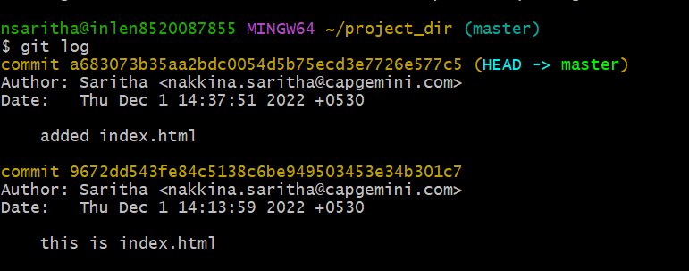

13.Make some changes in index.html

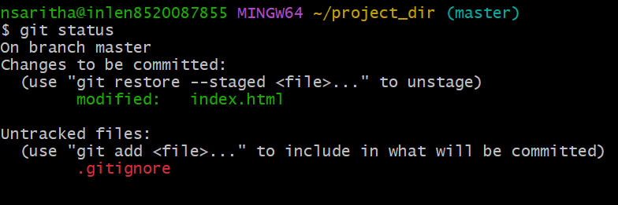

14.Revert the change made in the previous step using git command



15.Again change index.html

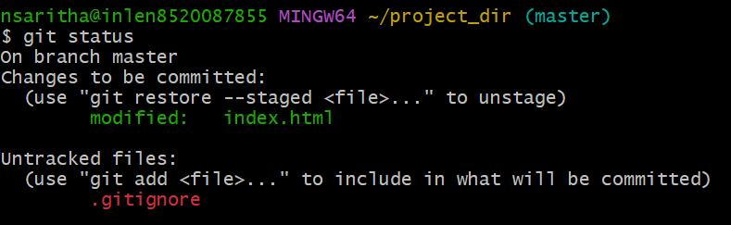

16.Stage index.html



17.Revert back the last stage

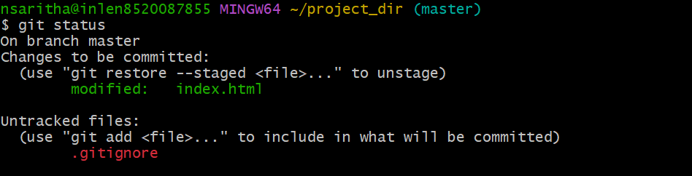

18.Rename ‘add’ command to ‘my-add’



19.using my_add command stage index.html again & commit the changes

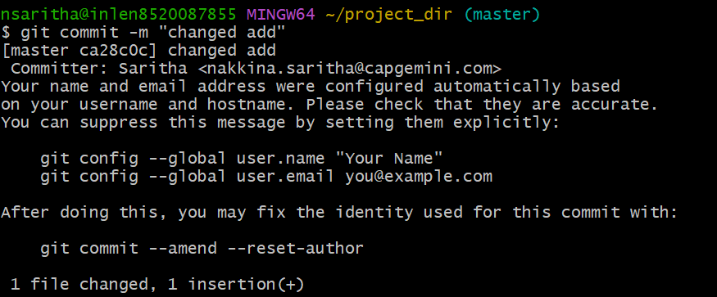

20.Revert the last commit

