Content
- Connect to VM via RDP
- Install IIS on VM
- Add inbound rule in VM (to allow incoming requests on port 80)
- Deploy web application to VM

- Connect to VM via RDP
When you create a VM from Azure portal, will create below components (You can find these component from “Resouces”) :
- Virtual Machine
- Public IP address
- Virtual Network (VNet)
- Hard disk
- Network Security Group (NSG) – is a set of rules that allow or deny traffic (acts as a firewall) based on source/destination IP, Port, Protocol etc.
- Network Interface (NIC) – it is provisioned(placed) to connect VM to Virtual Network
- Network watcher
Now, to connect to VM via (RDP – remote desktop),
->go to resources
->Click on VM created
->Launches VM page, where you can find “connect” option
-> click on “connect” option displays a page where you can “Native RDP ”
-> click on” download RDP file”, downloads the VM.
-> double click on it.
-> Open the RDP, where you have to enter username and password
- Install IIS on VM
  - Connect to VM via RDP
  - Go to start->server manager->Add roles and features
  - Turn on /off features ->server roles->select “Web Server IIS”, will install IIS
- Add inbound rule in VM
- Go to “Resources” in Azure portal
- Click on VM created
- Launches VM page, where you can find “Network settings” option
  - On click of it displays a page where you can see “Rule”
  - Expand Rule -> Network Security Group-> click on “create port rule”
  - Select -> inbound rule
  - displays a popup where you give port as 80 and select service as “http” or https
- Deploy ASP.Net web application to VM
Follow the steps below to deploy web application to VM:
- Install .Net run time in VM – From VM, download ASP.Net hosting bundle from internet and install it
- Bundle and make runnable version of the application -
- Copy the application build to IIS server
- Configure new website on IIS server

NOTE: Below are some of the differences you can find when creating and connecting to VM in Windows vs Linux:
Feature | Windows | Linux
Operating System | OS | Ubantu server
Connecting to VM | Via Remote desktop | 2 ways you can connect  1. Use Putty if it is installed in your machine  2.From VS Code ->-> go to Terminal ->new terminal-> type ssh <user name>@<VM public IP address> -> enter pwd
Web Server | IIS | Apache web server
Deploying application to VM  (First build the app in release mode and then copy it to VM via RDP ->Local resource | Copy and paste the release folder and assign it to IIS web site | Install “File Zilla” to copy files and run below commands from VS code terminal to deploy sample php application  sudo apt update  sudo apt install-php libapache2-mod-php

NOTE: Prior to publish .Net application, run below Bash command from terminal if you are using VS code
dotnet publish -c Release -o ./bin/Publish
Below is the method to publish .net application/ Services from Visual studio to Azure
Right click on the application-> Publish
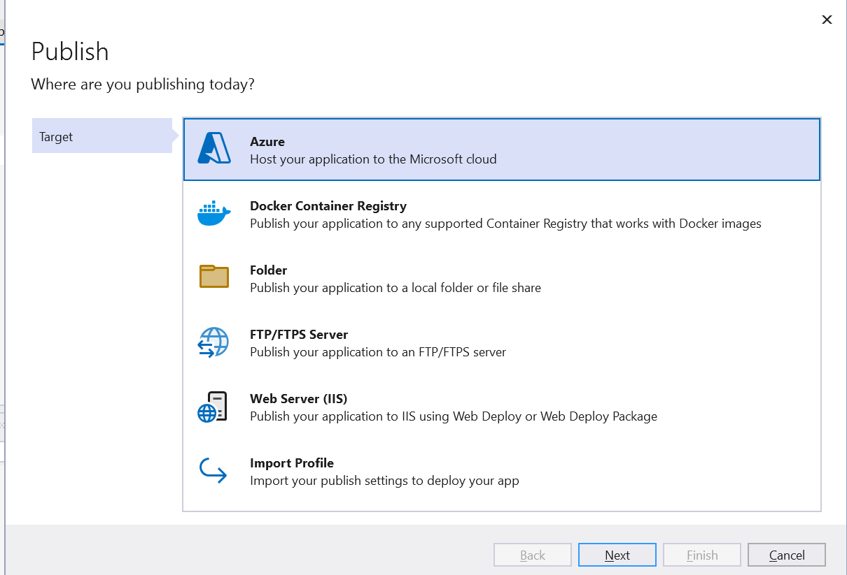
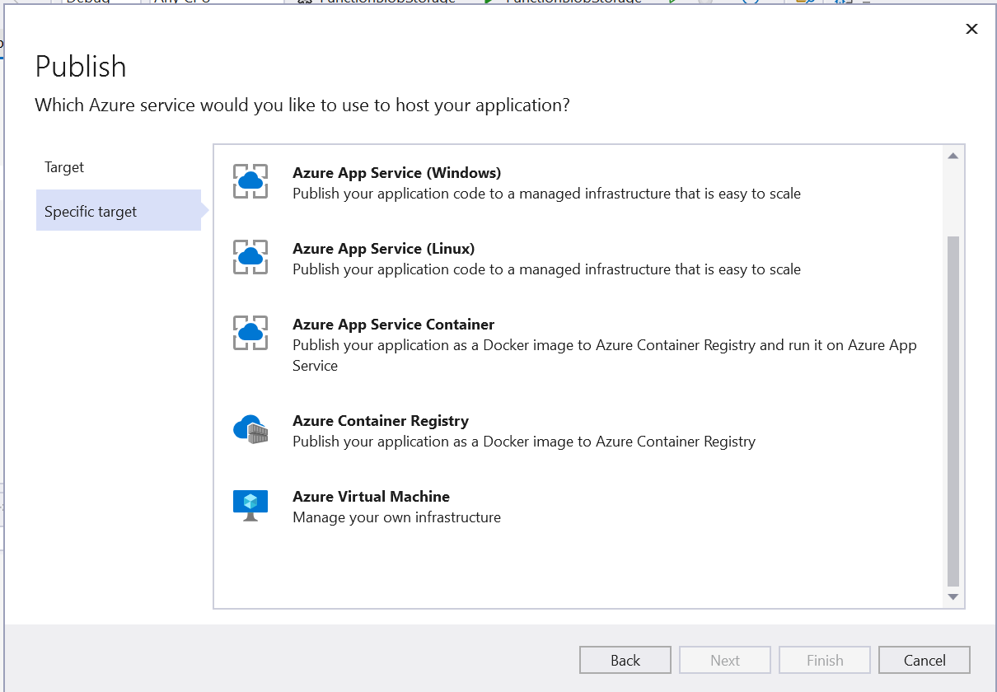

Select where you want to deploy
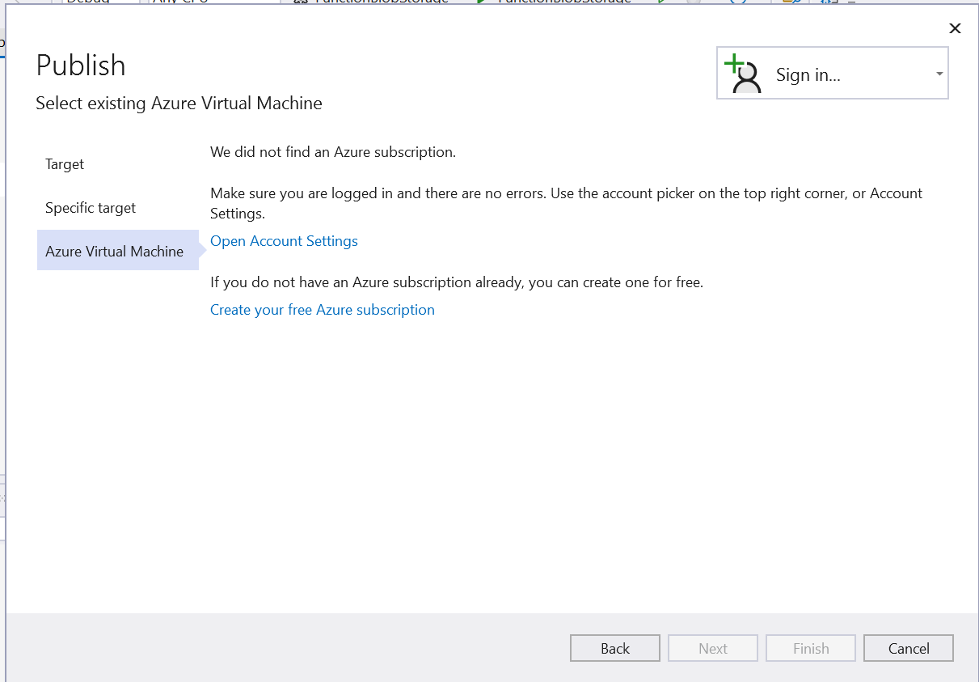
Login to Azure and it will deploy on selected destination

Publishing a .NET Application from Visual Studio (instead of VS Code)
When you use Visual Studio, you normally don’t run dotnet publish manually. Visual Studio does that for you behind the scenes.
✅ Option 1: Publish Using Visual Studio UI (Most Common)
🔹 Steps
- Open your project in Visual Studio
- Right-click the project → Publish
- Choose Folder (or IIS / Azure / VM depending on target)
- Select a folder path
- Click Publish
👉 Visual Studio internally runs:
dotnet publish -c Release -o <publish-folder>
✅ Option 2: Publish Profile (Recommended for Repeat Use)
Visual Studio creates a Publish Profile (.pubxml).
Benefits:
- Environment-specific settings
- Reusable
- Ideal for Azure VMs, IIS, App Services
You can later:
- Right-click project → Publish
- Choose the saved profile → Publish
Create publishing profile (.pubxml):
- Select release mode
- Right-click project → Publish will display as shown below
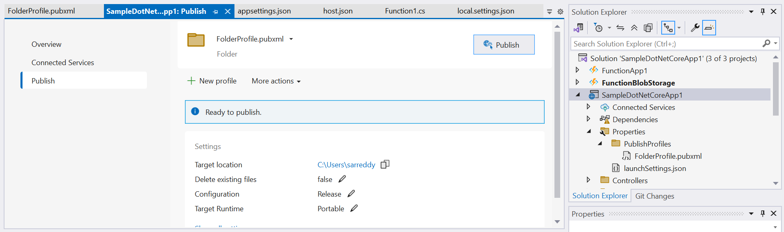
- Select folder location to save. pubxml file
- Below is sample . pubxml file present under properties folder, which has
  - Publish url, Mode of publish , Build configuration (release/debug) etc

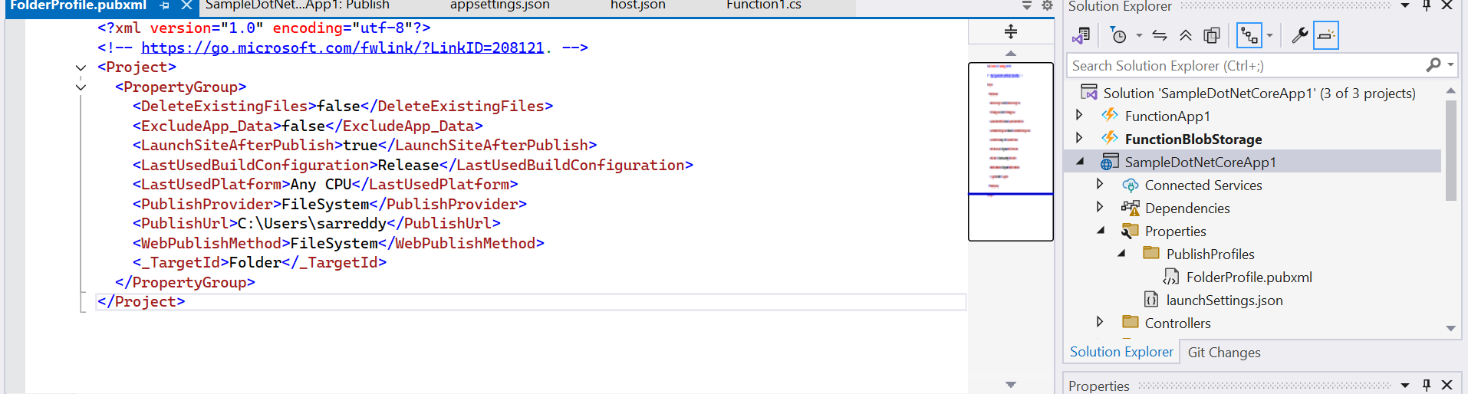
NOTE: Once it is published you can choose this file for deployment with publish option “ import profile”
✅ Option 3: Publish Directly to Azure (App Service / VM)
Visual Studio supports direct Azure publishing:
Steps:
- Right-click project → Publish
- Select Azure
- Choose:
  - Azure App Service
  - Azure Virtual Machine
- Sign in to Azure
- Select resource → Publish
Visual Studio:
- Builds the app
- Publishes
- Copies files
- Configures IIS (if VM)
✅ Option 4: Equivalent CLI Command (For Interview Answer)
If interviewer asks:
“What does Visual Studio do internally?”
You answer:
Visual Studio internally runs the dotnet publish command with the selected configuration and output folder.

