SAM (State - Action - Model)

Graphical user interface - set with 3 main building blocks - state, model and actions

- Actions triggered by events (like mousedown, mousemove etc) - role to translate an event into values for the model
- Model - responsible for the decision of accepting the values we got from actions
- If model accept the value, state function computes the state representation from the model and notify the the new application state, so that the view can display the state representation
- state function computes the next action predicate.
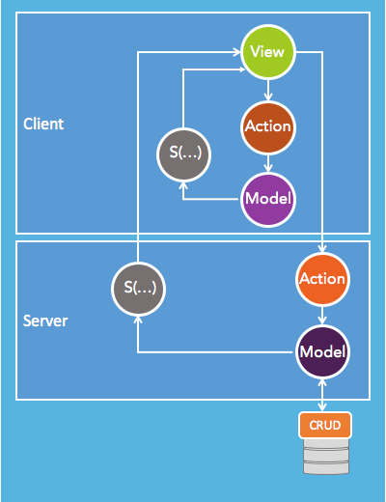

Eg :
Rendering count of mouse clicks :
- From View – when an event mouse click occurs, an action triggered, presents the model with new click.
- Model sets the flag for new mouse click
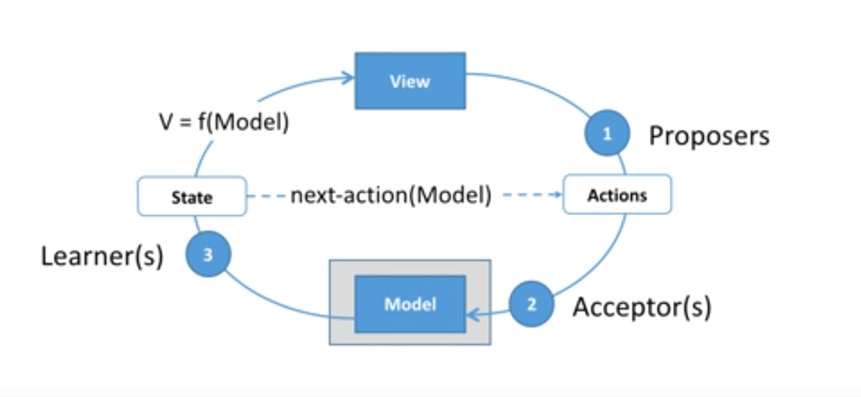
- State displays the state representation with incremented mouse click variable and displays its on view and waits for the new mouse click from view.

Swagger

Swagger is a set of open-source tools built around the OpenAPI Specification (API description format for REST APIs) that can help you design, build, document and consume REST APIs.

I personally feel like this is similar to apidoc which I used for creating API doc for our SoupedUp API for Leecare integration. (https://api.soupedup.com/docs/ using http://apidocjs.com/, sample run avoided there)

The major Swagger tools include:
- Swagger Editor – browser-based editor where you can write OpenAPI specs.
- Swagger UI – renders OpenAPI specs as interactive API documentation (like apidoc).
  - Swagger UI allows anyone — be it your development team or your end consumers — to visualize and interact with the API’s resources without having any of the implementation logic in place. It’s automatically generated from your Swagger specification, with the visual documentation making it easy for back end implementation and client side consumption.
- Swagger Codegen – generates server stubs and client libraries from an OpenAPI spec.
[An OpenAPI file(YAML or JSON) describes entire API : Available endpoints and operations , parameters for each operation, Authentication methods (like Oauth), General information.]

