POWER-BI(output):
Cumulative return(line_chart):
The chart is plotting the Price Ratio over time.
- Y-axis: Cumulative_Return_Ratio
- Calculation: Current Price / Initial Price
This calculation gives you the growth factor of an investment. For example, if the ratio is 1.5, it means the stock has grown by 50% since the start date. This is the standard way to compare stock performance on a single chart.

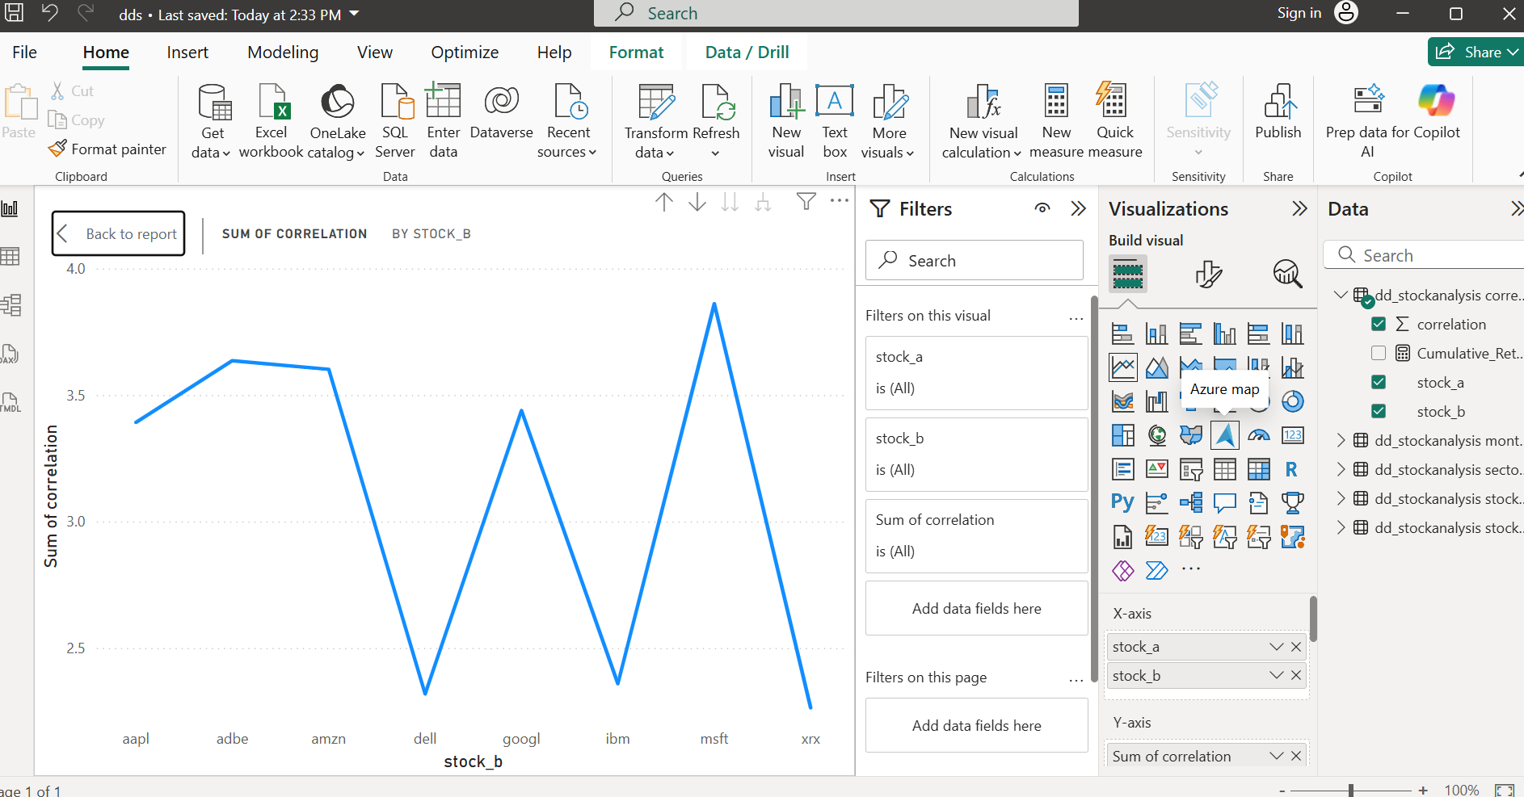

Correlation matrix:(heatmap)
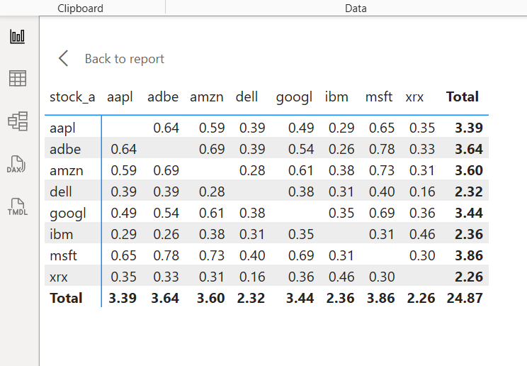

Volatility analysis:(Bar chart)
