Final Assignment

Of

Python

(ICT. ED 477)

Submitted To

Mr. Santosh Dahal

In Partial Fulfillment of the Requirements of the course

7th Semester

Submitted By: Sarjan Rai

Symbol No.: 77214026

T.U. Regd. No.: 9-2-214-63-2020

SUKUNA MULTIPLE CAMPUS

Sundarharaincha-12, Morang, Nepal

2081

Python Programming Lab Activities (7th Semester)
Instructions:
Lab 1: Python Programming Fundamentals
1.1 Installing Python and setting up the development environment (e.g., Anaconda, Jupyter Notebook).
1.2 Running a simple program using the command line or Jupyter Notebook.
Lab 2: Control Statements in Python
Lab 3: Lists, Tuples, Dictionaries, Sets, and Strings

Lab 4: Object-Oriented Programming with Python
4.1 Write programs to illustrate the object-oriented concept with simple examples.
Object-Oriented Programming (OOP) is a programming paradigm defined as a programming model that organizes code using the concept of objects. Objects represent real-world entities with attributes (state) and methods (behavior). This approach provides a structured way to design programs by encapsulating data and functionality within objects, promoting modularity, reusability, and scalability.
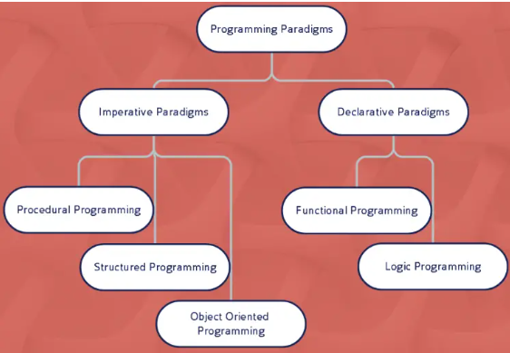

[What is a Programming Paradigm?
A programming paradigm is a fundamental approach or style of programming that provides a framework for organizing and structuring code. It influences how problems are solved by defining strategies for dividing tasks, managing data, implementing operations, and coordinating tasks.]
The OOPs concept focuses on writing the reusable code. It is a widespread technique to solve the problem by creating objects.
The main principles of OOP
Major principles of object-oriented programming system are given below.
- Class: A class in Python is a fundamental construct in object-oriented programming (OOP) that bundles data (attributes) and functionality (methods) into a single unit. It serves as a blueprint for creating objects, which are concrete instances of a class. Objects maintain their state using attributes and interact with the external environment or other objects through methods.

Classes support core OOP principles such as inheritance, polymorphism, encapsulation, and abstraction, enabling modular, scalable, and reusable code architectures. By defining classes, developers can model real-world entities and relationships, ensuring that code reflects logical and functional design.
In Python, a class is also a first-class object, meaning it can be passed as arguments, returned from functions, or assigned to variables. Python's class system is highly dynamic, offering features like:
Dynamic Nature: Python's class mechanism is highly dynamic. Classes are created at runtime, and their structure or behavior can be modified after creation. This dynamism enables flexibility in applications like metaprogramming and runtime type adjustments.
First-Class Objects: A Python class is itself a first-class object, meaning it can be assigned to variables, passed as arguments to functions, or returned from functions. This property enables high flexibility in code design and implementation.
Inheritance and Method Resolution Order (MRO): Python supports multiple inheritance, where a class can inherit attributes and methods from more than one parent class. The method resolution order (MRO) defines the order in which Python searches for methods or attributes in the class hierarchy.
Dunder Methods and Data Model Integration: Classes in Python incorporate special double underscore methods (dunder methods) like __init__, __str__, and __call__ that integrate seamlessly with Python's data model. These methods enable operator overloading, custom behavior, and integration with built-in features.
Scope and Namespace: Python classes define a new namespace — a mapping of names to objects. This namespace is local to the class and distinct from other namespaces like global or built-in. Namespaces are dynamically created and managed during the runtime of the program. The scope in Python determines the textual region of the program where a namespace is directly accessible.

Python organizes scopes in a hierarchical order:
The local scope of the current function or method.
The enclosing scope of outer functions, if applicable.
The global scope of the current module.
The built-in scope, which contains Python's built-in functions and objects.
By using statements like global and nonlocal, developers can explicitly control variable scope and binding behavior across these hierarchical levels.

Decorators and Metaclasses: Python supports the use of decorators for augmenting or modifying class functionality in a modular way. Additionally, metaclasses enable developers to define custom class creation behavior, making the language powerful for advanced use cases.
Key Features of Python Classes:
Object-Oriented Design: Classes enable inheritance, allowing new classes (derived classes) to build upon existing ones (base classes).
Attribute References: Access class attributes using obj.attribute.
Dynamic Typing: Classes and objects in Python allow arbitrary amounts and types of data, making them highly adaptable to various programming requirements.
Encapsulation and Attribute Access: Python enforces encapsulation by convention (e.g., prefixing attributes with _ or __ to suggest restricted access). However, attributes can be accessed or modified using getter and setter methods or properties.
Runtime Modification: Since classes are objects, developers can modify them at runtime by adding or removing attributes or methods, enhancing Python’s flexibility for prototyping
and runtime behavior adjustments.

Define a class using the ‘class’ keyword:
Example of a Python class and object:

class Vehicle:
def __init__(self, brand, model):
self.brand = brand
self.model = model
def display_info(self):
return f"{self.brand} {self.model}"

# Creating an object (instance) of the Vehicle class
car = Vehicle("Tesla", "Model S")
print(car.display_info()) # Output: Tesla Model S

- Objects
In Python, an object is an instance of a class that represents a real-world entity or concept. It is the concrete implementation of a class, which acts as a blueprint for defining the structure and behavior of objects. While a class is an abstract, logical entity, an object is a tangible, physical entity that occupies memory and holds data values.

Objects are created using the class they are derived from, typically by calling the class name like a function. This process, known as instantiation, allocates memory for the object and initializes it using the class's __init__ method (if defined). Once created, an object can store specific data (attributes) and perform tasks (methods) as defined by the class.

Key Characteristics of an Object

Instance of a Class: An object is an individual realization of a class. For example, if a class defines a template for a "Car," objects of this class might represent specific cars, such as a Toyota Corolla or a Honda Civic. Each object can have its unique attributes while sharing the same behavior.

Physical Entity: Unlike a class, which is only a logical construct, an object exists in memory and occupies space. It has a defined lifecycle from creation to deletion. Python’s memory management system, including garbage collection, handles the object's lifecycle.

Creation Process: In Python, objects are instantiated using the class name followed by parentheses. For example:
class Car:
def __init__(self, brand, model):
self.brand = brand
self.model = model
car1 = Car("Toyota", "Corolla") # Object of the class
Here, car1 is an object of the Car class, and its attributes brand and model are initialized during creation.

Multiple Objects: A single class can be used to create multiple objects, each representing unique data. For instance, while the Car class is a general template, car1 and car2 can represent different cars with unique attributes:
car2 = Car("Honda", "Civic")
print(car1.brand) # Outputs: Toyota
print(car2.brand) # Outputs: Honda

Objects Allocate Memory: Memory is allocated to an object only when it is created. This allocation stores the object’s attributes and enables it to perform the methods defined in its class. Once the object is no longer in use, Python’s garbage collector automatically reclaims the memory.
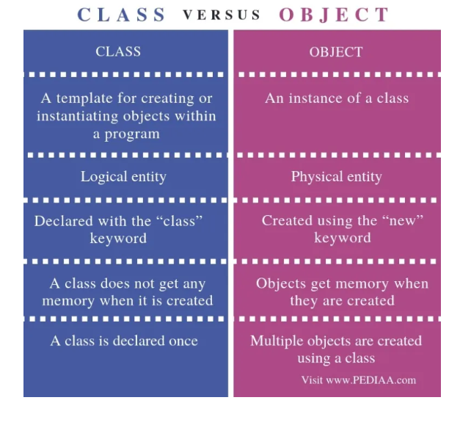

- Polymorphism
Definition:
Polymorphism in Python refers to the ability of an object, method, or operator to take on multiple forms or behaviors depending on the context in which it is used. In simpler terms, polymorphism allows us to perform the same action in various ways, enabling code flexibility and reusability.
Polymorphism is one of the four fundamental principles of Object-Oriented Programming (OOP), along with inheritance, encapsulation, and abstraction. The word "polymorphism" comes from the Greek terms "poly" (meaning many) and "morph" (meaning form), which together describe the concept of a single entity taking multiple forms. In Python, polymorphism enables a method or function to behave differently depending on the object or data type that calls it. This results in the ability to use the same interface for different data types, making the code more flexible, modular, and reusable.
Consider an example where a person, Manisha, acts differently based on her environment. At the office, she assumes the role of an employee, but at home, she takes on the role of a wife. In both contexts, she is the same person but exhibits different behaviors according to the situation. Similarly, polymorphism in OOP allows methods to perform different operations based on the type of the object that invokes them, making the method versatile and adaptable.
In essence, polymorphism is a feature in OOP that allows us to perform the same task in different ways. It enables methods and operators to behave in more than one form, offering benefits such as flexibility, reusability, and extensibility in our code. By leveraging polymorphism, we can execute different operations through the same method or operator, tailored to specific requirements or contexts.

Benefits of Polymorphism:
Polymorphism offers several advantages in object-oriented programming:

Flexibility: Code can be written to be more general and flexible, allowing new classes to be added without changing the existing codebase.

Reusability: Methods can be reused across different objects or data types, reducing redundancy in the code.

Extensibility: As the code evolves, new features can be added with minimal changes to the existing code, making it easier to extend the system.

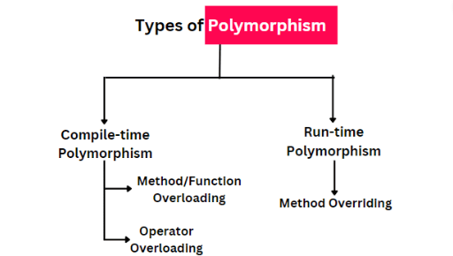

Types of Polymorphism in Python

Compile-time Polymorphism: This type of polymorphism is also known as static polymorphism. We can achieve or implement this type of polymorphism through function or method overloading and operator overloading.

Method overloading is an object-oriented programming feature by which we can implement polymorphism. In method overloading, we define multiple methods with the same name, but with a different type or number of arguments. But Python does not support the method overloading directly because two methods can’t have the same name in Python.
Although we can use this concept in Python, there is a simple implementation of method overloading inside a Python class.

class Calculator:
def add(self, a, b, c = 0):
return a + b + c
calc = Calculator()

result1 = calc.add(8, 4)
result2 = calc.add(9, 1, 6)

print(result1)
print(result2)

#Output:
12
16

Run-time Polymorphism: Method overriding is a concept of having the same method name in a derived class as in the base class. With inheritance and method overriding, we achieve the runtime polymorphism. In Python, method overriding occurs when a derived class offers a different implementation for a method that is already defined in its base class. This type of polymorphism is also referred to as dynamic polymorphism. We can achieve this type of polymorphism through inheritance and method overriding.

The purpose of method overriding is to change the behavior or functionality of the method based on the requirements of derived class. The behavior of a method is determined at runtime based on the actual type of object. It can differ for different instances of the derived classes, providing flexibility and adaptability in our code.

- Encapsulation
Definition:
Encapsulation is the process of wrapping up variables and methods into a single entity and it is one of the fundamental concepts in object-oriented programming (OOP). Encapsulation is a technique for hiding a class’ internal operations and exposing only the information required for external interactions. It enables the creation of objects with clearly defined behaviors and properties, enhancing their usability and security.
It restricts direct access to some of an object's components, making the object’s internal state hidden from the outside world. Access to these internal components is only allowed through a controlled interface, usually via public methods (getters and setters), ensuring better data protection and preventing accidental modification.
Encapsulation can be achieved by declaring the data members and methods of a class either as private or protected. But In Python, we don’t have direct access modifiers like public, private, and protected. We can achieve this by using single underscore “_” and double underscores “__”.
Public Member: In Python, public members are attributes or methods that are accessible from anywhere, both within the class and outside of it. These members are the default type of attributes or methods and do not have any access restrictions. To define public attributes or methods in a class, you simply create them without any prefix or special notation (such as underscores).
Public members are directly accessible from outside the class, meaning you can create instances of the class and access or modify these members as needed. Public members are typically used for attributes or methods that need to be accessed or modified by other classes, functions, or scripts. They provide flexibility in terms of how you can interact with the object and its data.
Private Member: A protected member refers to an attribute or method of a class that is meant to be accessed only within the class and its subclasses, but not from external code. The use of protected members follows a naming convention, not strict enforcement like in other languages. To define a protected member in python, we have to prefix the name of the member with an underscore (__) symbol.
Protected Member: Protected variables and methods are those that can be accessed within the class and its subclasses. In Python, protected variables and methods are declared by prefixing them with a single underscore (_).Unlike private members, protected members are accessible from outside the class, but this access is conventionally discouraged to maintain object integrity.
Why Encapsulation is Essential in Python

- Data Protection: Encapsulation acts as a guard for your data. It prevents direct access to certain attributes and methods, safeguarding them from accidental changes. This controlled access ensures that the integrity of your data is maintained, providing a secure environment for both developers and users.
- Information Hiding: Imagine having a box with a complex mechanism inside, but you only need to interact with the buttons on the outside. That's what encapsulation does — it hides the inner workings of a class and exposes only what's necessary. By limiting what the outside world can see and interact with, it reduces complexity and minimizes the risk of unintentional bugs or side effects.
- Flexibility and Maintainability: Encapsulation enhances flexibility in your code. It allows you to make changes to one part of your program without disturbing other components. This isolation between system components makes your code easier to maintain and update, improving long-term sustainability. Plus, encapsulation enables you to refactor, extend, and modify your code more easily without causing disruptions elsewhere.
- Code Reusability: One of the biggest benefits of encapsulation is its ability to promote code reusability. By designing self-contained, modular components, you create code that can be reused in different contexts without unnecessary duplication. This leads to cleaner, more efficient code that can be quickly integrated into other applications, making your work more productive and scalable.

- Inheritance
"The process by which a child class inherits the methods and attributes of a parent class is called inheritance.”
Inheritance is a mechanism that allows newly created classes, known as subclasses, to acquire the methods and attributes of an existing class, referred to as the superclass or parent class. This mechanism promotes code reusability by allowing the creation of new classes based on existing ones, eliminating the need to build them from scratch while maintaining and extending functionality.

It is one of the cornerstones of object-oriented programming (OOP), inheritance helps reduce the effort spent on rewriting repetitive logic, making the code easier to maintain and update.

To inherit a class we use the following syntax:

class SubClass(SuperClass):
#class_body

This concept finds widespread applications across various domains:

- Software Development: Crafting extensible frameworks and libraries.
- Web Development: Designing reusable components in Django or Flask.
- Data Science: Building modular pipelines using reusable base classes.
In Python, inheritance not only simplifies the development of new classes but also integrates seamlessly with the dynamic and flexible nature of the language. It is particularly powerful when combined with other OOP principles like encapsulation and polymorphism, enabling developers to create robust, maintainable, and highly extensible systems.
Important of Inheritance:
- Code Reusability: Avoid duplication by leveraging already defined methods and properties.
- Maintainability: Modify the superclass, and the changes propagate automatically to subclasses.
- Extensibility: Extend existing functionality without altering the superclass.
- Real-World Mapping: Models real-world relationships effectively, e.g., "Employee" and "Manager" classes.

Different types of inheritance

In Python, based upon the number of child and parent classes involved, there are five types of inheritance. The type of inheritance are listed below:
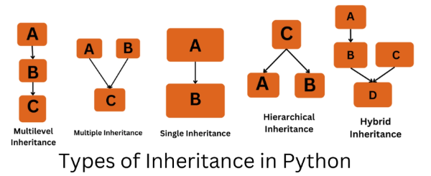
Multilevel Inheritance

Multiple Inheritance

Single Inheritance

Hierarchical Inheritance

Hybrid Inheritance

Types of Inheritance

- Single Inheritance: Single inheritance can be defined as an inheritance where a subclass or derived class inherits from a single superclass or parent class. In simple words, the derived class or subclass has only one direct parent class.
For Example
class ParentClass:
def display(self, name):
print(f"Hello, {name}")
class ChildClass(ParentClass):
pass
child = ChildClass()
child.display("Sarjan") #Output: Hello, Sarjan
- Multiple Inheritance: A class that inherits attributes and methods from more than one parent class called multiple inheritance. Syntax:
class ParentClass1:
# ParentClass1 attributes and methods

class ParentClass2:
# ParentClass2 attributes and methods

class ChildClass(ParentClass1, ParentClass2):
# ChildClass attributes and methods
Python supports multiple-class inheritance and can be defined as an inheritance where a subclass or child class inherits from more than one superclass. In short, multiple inheritance allow to have a subclass more than one direct parent class or superclass.

Note: There is a risk of using multiple inheritances because it can lead to uncertainty in the code and also cause a “Diamond Problem” where a subclass inherits certain conflicting methods from multiple parent classes.

- Multilevel Inheritance: Multi-level inheritance can be defined as where a subclass inherits from the single subclass and then another subclass inherits from the first subclass. By this, the second subclass can access all the attributes and methods from both the first subclass and the superclass.

Suppose three classes A, B, C. A is the superclass, B is the child class of A, C is the child class of B. In other words, we can say a chain of classes is called multilevel inheritance.

# Base class
class Animal:
def eat(self):
return "This animal eats."

def sleep(self):
return "This animal sleeps."

class Mammal(Animal):
def give_birth(self):
return "This mammal gives birth to live young."

class Dog(Mammal):
def bark(self):
return "Woof! Woof!"

my_dog = Dog()

print(my_dog.eat()) #Output: This animal eats.
print(my_dog.sleep()) #Output: This animal sleeps.
print(my_dog.give_birth()) #Output: This mammal gives birth to live young.
print(my_dog.bark()) #Output: Woof! Woof!

- Hierarchical Inheritance: Hierarchical inheritance is a type of inheritance in which a single base class is inherited by multiple derived classes. This structure allows each derived class to share the properties and methods of the base class, forming a tree-like hierarchy of classes.
Example of Hierarchical Inheritance:
class College:
def __init__(self, name):
self.name = name

def info(self):
print("\nDisplaying College Information")
print(f"College Name: {self.name}")

class Faculty(College):
def __init__(self, name, faculty_name, faculty_head, faculty_head_gender):
super().__init__(name)
self.faculty_name = faculty_name
self.faculty_head = faculty_head
self.faculty_head_gender = faculty_head_gender

def faculty_info(self):
pre = ""

if self.faculty_head_gender in ["Male", "male", "M", "m"]:
pre = "Mr."
elif self.faculty_head_gender in ["Female", "female", "F", "f"]:
pre = "Ms."
else:
pre = "Mr./Ms."
print(f"Faculty Name: {self.faculty_name}\nFaculty Head: {pre} {self.faculty_head}")

class Student(College):
def __init__(self, name, student_name, enrollment_year):
super().__init__(name)
self.student_name = student_name
self.enrollment_year = enrollment_year

def student_info(self):
print("\nDisplaying Student Information")
print(f"Student Name: {self.student_name}\nEnrollment Year: {self. Enrollment_year}")

faculty_member = Faculty("Sukuna Multiple Campus", "BICTE", "Santosh Dhahal", "Male")
student_member = Student("Sukuna Multiple Campus", "Sarjan Rai", 2077)

faculty_member.info()
faculty_member.faculty_info()
student_member.student_info()

#Output:
Displaying College Information
College Name: Sukuna Multiple Campus
Faculty Name: BICTE
Faculty Head: Mr. Santosh Dhahal

Displaying Student Information
Student Name: Sarjan Rai
Enrollment Year: 2077

- Hybrid Inheritance: Hybrid inheritance refers to a combination of two or more types of inheritance in object-oriented programming. This approach allows developers to create complex class structures that leverage the strengths of multiple inheritance types, such as single, multiple, multilevel, and hierarchical inheritance.

In Python, hybrid inheritance is supported, but it requires careful design and consideration to avoid complications such as the Diamond Problem, where ambiguity can arise from multiple inheritance paths.

The general syntax for hybrid inheritance is as follows:
class ParentClass1:
# ParentClass1 attributes and methods.

class ChildClass1(ParentClass1):
# ChildClass1 attributes and methods.

class ChildClass2(ParentClass1):
# ChildClass2 attributes and methods.

class ChildClass3(ParentClass1, ParentClass2):
# ChildClass3 attributes and methods.

- Abstraction
The process of handling complexity by hiding unnecessary details and internal implementation of a system from the user while providing only essential features or functionality is called abstraction. In other words, abstraction is a technique that conceals irrelevant or non-essential data, focusing on presenting only the critical information needed by the user. This approach not only simplifies the user experience but also enhances clarity in program design.
Abstraction enables developers to create systems with clean and intuitive interfaces by emphasizing essential behaviors. It promotes better code readability, maintainability, and reusability, allowing users to interact with objects or systems without worrying about intricate implementation details. This separation of concerns reduces programming complexity and boosts productivity.
The main intention of abstraction is to represent the high-level or essential features of an object without including background details, thereby improving the efficiency and effectiveness of an application. It helps developers concentrate on critical functionality while removing distractions caused by non-essential elements. By focusing on what is important, abstraction ensures streamlined design and a more efficient application development process.

Key Points
Abstraction focuses on what an object does instead of how it does it.
It allows us to define interfaces without implementing them directly.
Why Use Abstraction?
- Simplifies Code: Abstraction helps in managing complexity by breaking down the system into smaller, manageable parts.
- Enhances Code Maintenance: It makes the code easier to maintain and extend.
- Encourages Code Reusability: Abstraction allows for code reusability by defining common interfaces.
What is Abstract Class?
An abstract class is a class that cannot be instantiated and is meant to be subclassed. It serves as a blueprint for creating other classes and can contain abstract methods, which are declared without implementation. These abstract methods must be implemented by its subclasses, ensuring a consistent structure across related classes.
Additionally, an abstract class can include concrete methods with predefined behavior that its subclasses inherit, making it a foundational tool for achieving abstraction and polymorphism in object-oriented programming.
# Example of Abstract Method
from abc import ABC, abstractmethod
class Shape(ABC):
@abstractmethod
def area(self):
pass
class Rectangle(Shape):
def __init__(self, length, width):
self.length = length
self.width = width
def area(self):
return self.length * self.width
rect = Rectangle(5, 3)
print(f"Area of rectangle: {rect.area()}") #Output: Area of rectangle: 15
Key Characteristics of an Abstract Class:
- Cannot be Instantiated: You cannot create an object of an abstract class directly.
- Abstract Methods: An abstract class can contain abstract methods, which are declared without a body and must be implemented in derived classes.
- Concrete Methods: Along with abstract methods, it can also include concrete methods with implementations that can be inherited by subclasses.
- Inheritance: Abstract classes are intended to be extended by other classes, which then implement or override the abstract methods.

Why Use OOP?
Organized Code: Instead of writing a single large program, OOP lets you divide your program into small, manageable pieces.
Reusability: You can use existing code to build new functionalities.
Real-World Modeling: You can model entities like cars, books, or animals in your program.
Flexibility: Makes your code easier to maintain, debug, and extend.
The Need for OOP: In procedural programming, code grows unstructured as programs become larger. Imagine:
A program with numerous global variables and functions all mixed together.
Difficulties in ensuring variables are only accessed where needed.
Challenges in reusing code without unintended interference.
OOP resolves these challenges by grouping data (attributes) and behavior (methods) into classes and objects. It also emphasizes principles like encapsulation to control data access and enhance modularity.

4.2 Write programs to make use of the __init__ method to initialize objects.
The __init__ method in Python is a special method (also known as a constructor) that is automatically called when an object of a class is created. It is used to initialize the attributes of the object and set up its initial state.
Unlike regular methods, the __init__() method has double underscores (__) on both sides. Therefore, it is often called 'dunder init'. Python uses this method internally, meaning there is no need to call it explicitly.
Syntax:
def __init__(self, object_parameters...):
# Initialize the object
The ‘self’ is a reserved keyword in python which represents the instance of the class. The ‘self’ keyword allows easy access to the class methods and parameters for use in other methods of the class.
Constructors can very simply be understood as a special method that is called during the object initialization /creation. The constructor is usually defined as a function in the class definition that takes in the state parameters and creates an object with those user-defined parameters.
Key Points about the __init__ Method
- Automatic Invocation: It is automatically executed when an instance of the class is created.
- Initialization: Primarily used to initialize instance attributes of the class.
- Customizable: You can define parameters in the __init__ method to pass data during object creation.
- Special Syntax: The method name is always __init__ and is defined with def.
- Not Mandatory: A class doesn't require an __init__ method unless you need specific initialization logic.
- First Argument: The first parameter must be self, which refers to the instance being created.
Example of initializing objects:
class Car:
def __init__(self, make, model, year=2020, color="Black"):
self.make = make
self.model = model
self.year = year
self.color = color
if self.year < 1886:
raise ValueError("Year cannot be earlier than 1886.")
def display_info(self):
print(f"{self.year} {self.color} {self.make} {self.model}")

car1 = Car("Tesla", "Model S", 2023, "Red")
car2 = Car("Ford", "Mustang") # Uses default year and color

car1.display_info() # Output: 2023 Red Tesla Model S
car2.display_info() # Output: 2020 Black Ford Mustang

4.3 Write programs to apply different types of inheritance (single, multiple, hierarchical, multilevel).
#Displaying Single Inheritance:
class Item:
def __init__(self, title, author):
self.title = title
self.author = author
def display_info(self):
print(f"Title: {self.title}, Author: {self.author}")
class Book(Item):
book_count = 0
def __init__(self, title, author, genres, release_year, publisher):
super().__init__(title, author)
self.genres = genres if isinstance(genres, list) else [genres]
self.release_year = release_year
self.publisher = publisher
Book.book_count += 1
self.book_id = Book.book_count
def display_book_info(self):
genre_label = "Genre" if len(self.genres) == 1 else "Genres"
print(f"\nDisplaying The Book Information {self.book_id}")
print(f"Title: {self.title} by {self.author}, {genre_label}: {', '.join(self.genres)}")
print(f"Release Year: {self.release_year}, Publisher: {self.publisher}")
book1 = Book("Karnali Blues", "Buddhisagar", "Autobiographical Fiction", 2010, "Fine Print Publication")
book1.display_book_info()
book2 = Book("Palpasa Café", "Narayan Wagle", ["Fiction", "Drama"], 2005, "Sajha Prakashan")
book2.display_book_info()
# Multipel Inheritance
class CollegeFaculty:
def __init__(self, faculty_id, department):
self.faculty_id = faculty_id
self.department = department
def display_faculty_info(self):
print(f"Faculty ID: {self.faculty_id}, Department: {self.department}")
class Student:
def __init__(self, student_id, semester):
self.student_id = student_id
self.semester = semester
def display_student_info(self):
print(f"Student ID: {self.student_id}, Semester: {self.semester}")

class FacultyStudent(CollegeFaculty, Student):
def __init__(self, faculty_id, department, student_id, semester, courses):
CollegeFaculty.__init__(self, faculty_id, department)
Student.__init__(self, student_id, semester)
self.courses = courses
def display_faculty_student_info(self):
print(f"Courses: {', '.join(self.courses)}")
faculty_student = FacultyStudent("F101","BICTE", "4026", "Seventh",["Research Project", "Research in Educaiton", "Teaching Method", "Pyhon" , "Multimedia In Education"])

faculty_student.display_faculty_info() #Output: Faculty ID: F101, Department: BICTE
faculty_student.display_student_info() #Output: Student ID: 4026, Semester: Seventh
faculty_student.display_faculty_student_info() #Output: Courses: Research Project, Research in Educaiton, Teaching Method, Pyhon, Multimedia In Education
#Remaning Example of Inheritance are given in 4.1
4.4 Write programs to implement method overloading and overriding.
Method overloading is an object-oriented programming feature by which we can implement polymorphism. In method overloading, we define multiple methods with the same name, but with a different type or number of arguments. But Python does not support the method overloading directly because two methods can’t have the same name in Python.
Although we can use this concept in Python, there is a simple implementation of method overloading inside a Python class.

class Calculator:
def add(self, a, b, c = 0):
return a + b + c
calc = Calculator()

result1 = calc.add(8, 4
result2 = calc.add(9, 1, 6

print(result1) ) #Output: 12
print(result2) ) #Output: 16
Method overriding is a concept of having the same method name in a derived class as in the base class. In Python, method overriding occurs when a derived class offers a different implementation for a method that is already defined in its base class
The purpose of method overriding is to change the behavior or functionality of the method based on the requirements of derived class. The behavior of a method is determined at runtime based on the actual type of object. It can differ for different instances of the derived classes, providing flexibility and adaptability in our code.
Code Example:
class Notification:
def send(self, message):
raise NotImplementedError("This method must be overridden by subclasses")

class Email(Notification):
def send(self, message):
return f"Sending email: {message}"

class SMS(Notification):
def send(self, message):
return f"Sending SMS: {message}"
email = Email()#Creating object
sms = SMS()
print(email.send("Your order has been sent.")) # Sending email: Your order has been sent.
print(sms.send("Your package is on the way."))Sending SMS: Your package is on the way.

4.5 Write programs to elaborate polymorphism and data hiding concepts.
Concept of Polymorphism is given in 4.1 and program is given in 4.4
Data Hiding is refers to the practice of restricting access to certain details of an object’s data. It is a key concept in Object-Oriented Programming (OOP), where the internal object details, such as data members, are concealed from the outside world. Data hiding prevents direct access to the data from outside the class, providing security, reducing system complexity, and promoting better program maintenance.
It is a mechanism to hide the data of a class from the other classes or outside the world. In Python, we can achieve or implement data hiding using a double underscore (__) before the data attribute (i.e. variable) we want to hide.
Advantages of Data Hiding
- Separation of Irrelevant Data: Objects within a class are isolated from irrelevant or unnecessary data, ensuring that only essential information is exposed.
- Enhanced Security: By restricting access to confidential data, data hiding protects against unauthorized access, including from potential hackers.
- Prevents Accidental Data Linking: Data hiding prevents programmers from mistakenly linking to incorrect data. Errors are raised when such attempts are made, ensuring corrections can be easily identified.
- Encapsulation of Objects: Data hiding supports the encapsulation principle of OOP, where an object’s internal state is hidden from outside interference and only accessible through well-defined methods.
- Protection of Volatile Data: By hiding sensitive or volatile data from the public, the integrity of the data is maintained, reducing the risk of unwanted modifications.
- Restricted Access: Only specific, authorized users within an organization can access critical data, helping to ensure proper access control and maintain operational efficiency.
- Better System Operations: By isolating objects from irrelevant data streams, system operations become more streamlined and focused on essential tasks.
Disadvantages of Data Hiding
- Increased Code Complexity: Implementing data hiding often requires writing additional code to create access methods (getters and setters), which may increase the overall complexity.
- Reduced Performance: The encapsulation of data can lead to slower performance because the linkage between visible and hidden data is restricted, requiring more method calls for accessing or modifying hidden data.
- Lengthier Code: Data hiding sometimes forces programmers to write longer, more intricate code to manipulate hidden data, which may become cumbersome in complex systems.
- Challenges for Programmers: The added layer of abstraction can make it harder for programmers to understand or work with hidden data, leading to more time-consuming debugging or development.
class BankAccount:
def __init__(self, account_holder, balance=1000):
self.account_holder = account_holder
self.__balance = balance
def Account_info(self): return f"\nAccount Holder: {self.account_holder}, Balance: {self.__balance}"
def deposit(self, amount):
if amount > 0:
self.__balance += amount
print(f"Deposited ${amount}. New balance: ${self.__balance}")
else: print("Deposit amount must be positive.")
def withdraw(self, amount):
if amount > 0 and self.__balance >= amount:
self.__balance -= amount
print(f"Withdrew ${amount}. New balance: ${self.__balance}")
else: print("Insufficient funds or invalid amount.")
def get_balance(self): return self.__balance
account = BankAccount("Rahul Karti", 12000)
print(f"{account.Account_info()}\n")
account.deposit(500)
account.withdraw(200)
print(f"\nCurrent Balance: ${account.get_balance()}")
#Output:
Account Holder: Rahul Karti, Balance: 12000

Deposited $500. New balance: $12500
Withdrew $200. New balance: $12300

Current Balance: $12300
Lab 5: Function, Exception, and File Handling
- Function:
Functions are modular blocks of code designed to perform a specific task or return a result. They serve as fundamental building blocks in Python programming, enabling developers to organize their code into smaller, reusable components. This modular approach enhances code clarity, maintainability, and efficiency. This results in more readable code, easier debugging, and fewer typing errors.
The primary purpose of functions is to encapsulate repetitive tasks into a single unit. By defining a function, programmers avoid rewriting the same code for different inputs and can instead reuse the function through function calls. It efficiently eliminate code redundancy resulting overall improvements in development.
Functions in Python are created using the def keyword, followed by a function name and function parameters inside parentheses.
Syntax:
def function_name(parameters):
"""docstring"""
statements ............
return [expression]
The term "def" introduces the definition of a function and is followed by a function name and in parentheses a list of arguments. To execute the code inside a function, call it by its name, optionally passing required arguments. The function's block of code will run when invoked.

def say_hello(name):
"""It says hello with the name passed to the function"""
return f"Hello! {name}, how are you?"
print(say_hello("sarjan"))#Output: Hello! sarjan, how are you?
Key Benefits of Python Functions:
Modularity: Breaks down complex programs into manageable pieces.
Reusability: Eliminates the need to write the same code multiple times.
Readability: Improves the clarity and organization of code.
Maintainability: Simplifies debugging and future updates.
Encapsulation: Isolates functionality, promoting clean and efficient code.
Function on Python:
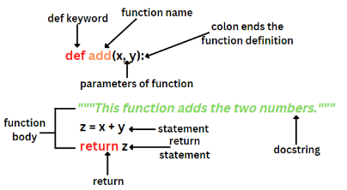

Types of Function in Python:
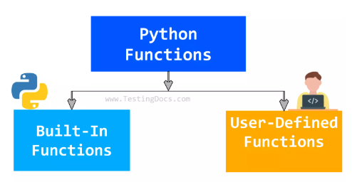

- Built-in Functions
- User-defined Functions
Built-in Functions: Built-in functions are a collection of pre-defined functions readily available for use without requiring the import of any external libraries. These functions provide essential functionality for performing common tasks, such as manipulating data types, handling input/output, and more. Python includes over 70 built-in functions, which are categorized and listed alphabetically for easy reference.

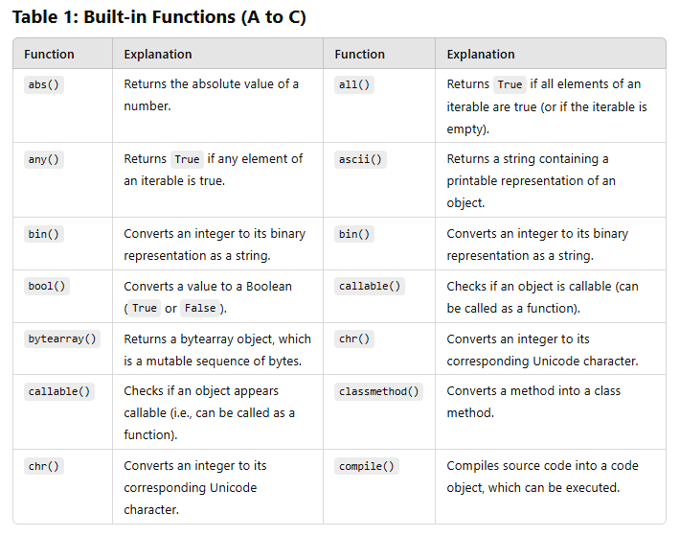
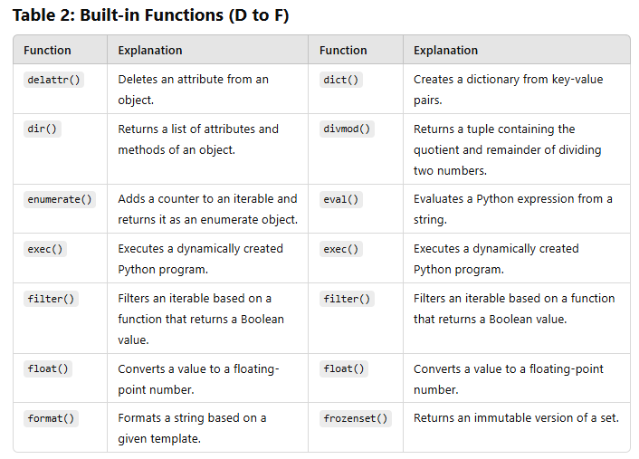
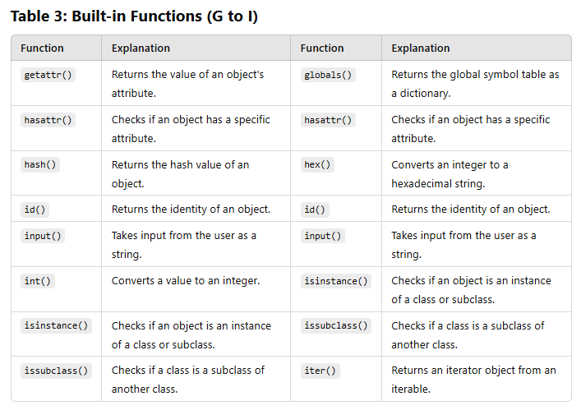
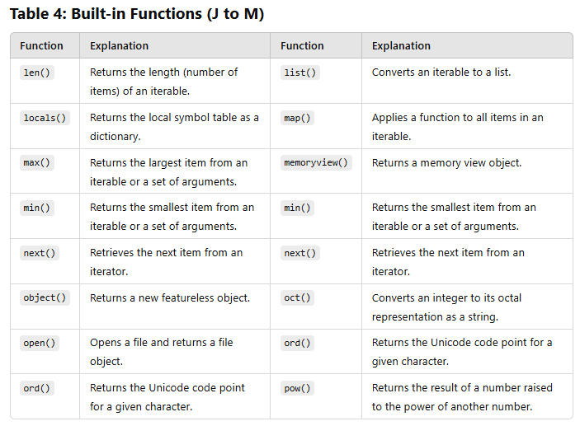
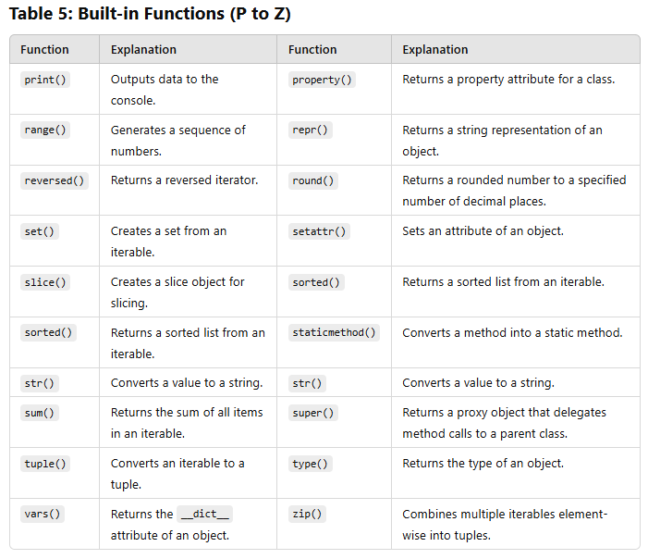

Key Characteristics of Built-in Functions:
- Predefined: These functions are included by default in the Python interpreter.
- No Need for Definition: They can be used directly without writing any additional code.
- Commonly Used: Built-in functions cover many common tasks such as mathematical operations, string manipulations, and type conversions.
User-defined Functions: A user-defined function is a function created by a programmer to perform a specific task or set of operations in a program. It encapsulate custom logic or operations tailored to specific requirements.
User-defined functions offer modular functionality by encapsulating reusable code in organized, self-contained blocks. They are specifically designed to address custom requirements, enhancing code readability, maintainability, and reducing redundancy

Advantages of User-Defined Functions:
- Tailored Solutions: User-defined functions allow developers to create precise solutions for specific problems. By encapsulating logic designed to meet unique requirements, they provide unmatched flexibility and adaptability in program design.
- Improved Modularity: Functions promote the division of a program into independent, smaller sections, each handling a specific task. This modularity simplifies the management of complex programs, making them easier to read, test, and debug.
- Enhanced Reusability: Functions encapsulate logic in a way that can be reused in different parts of the program or even across different projects. This eliminates duplication, reduces errors, and improves development efficiency.
- Code Maintenance and Scalability: User-defined functions streamline the process of updating and adapting code as requirements evolve. By centralizing logic into a single function, the need for duplicating code across multiple areas is eliminated. When changes or fixes are required, they can be made in one location, ensuring that the update is automatically applied wherever the function is used. This approach significantly improves scalability and maintainability, making it easier to manage complex systems and adapt them to future changes without introducing inconsistencies.
Code Example:
# mymath.py
greeting = "Namasker!"
class Userp:
def __init__(self, name):
self.name = name
def greet(self): return f"{self.name}, k xa khaber?"
# print_user.py
from mymath import Userp, greeting
print(greeting)
user_instance = Userp("Sarjan")
print(user_instance.greet())
#Output:
Namasker!
Sarjan, k xa khaber?
5.1 Write programs to divide work into functions.
Following code example will demonstrate the work division by creating different function with specific task.
def get_employee_details():
name = input("Enter employee name: ")
hours_worked = float(input("Enter hours worked: "))
hourly_rate = float(input("Enter hourly rate: "))
return name, hours_worked, hourly_rate
def calculate_pay(hours_worked, hourly_rate):
return hours_worked * hourly_rate
def display_payroll(name, total_pay):
print(f"Employee: {name}")
print(f"Total Pay: ${total_pay:.2f}")

def main():
name, hours_worked, hourly_rate = get_employee_details()
total_pay = calculate_pay(hours_worked, hourly_rate)
display_payroll(name, total_pay)

if __name__ == "__main__":
main()
#Output:
Enter employee name: Sarjan Rai
Enter hours worked: 7
Enter hourly rate: 100
Employee: Sarjan Rai
Total Pay: $700.00
5.2 Write different varieties of functions: functions with arguments, value-returning functions, and functions without arguments.
a. Simple function: A basic function that perform a simple printing task without taking any argument or return any value.
def demofunction():
print("Hello Function is called.")
df = demofunction() #Output: Hello Function is called.

b. Function without parameter and return type:
def demofunction():
return "This is Text Returned from Function."

print(demofunction()) #Output: This is Text Returned from Function.

c. Function without parameter, and no return type:
def sayhello(name):
print(f"{name} say hello")
sh = sayhello("Sarjan") #Output: Sarjan say hello

d. Function with multiple parameter, and return type:
def domath(a, b): return a + b
dm = domath(10, 20)
print(f"Total: {dm}") #Output: Total: 30
e. Function with multiple parameter, and no return type
def domath(a, b):
sum = a + b
print(f"Total: {sum}")
dm = domath(9, 7) # Output: Total: 16

f. Function with default value, and return type
def def_fun(name, salary = 22000):
return f"Employee Full Name: {name}\nMonthly Salary: {salary}\n"

print(def_fun("Sarjan Rai"))
print(def_fun("Ram Gautam", 32000))
# Output:
Employee Full Name: Sarjan Rai
Monthly Salary: 22000

Employee Full Name: Ram Gautam
Monthly Salary: 32000

g. Function with default value, and no return type
def def_fun(name = "Sarjan"): print(f"{name} is a studet.")

dfc = def_fun() #Output: Sarjan is a student.
dfc2 = def_fun("Bikash") #Output: Bikash is a student.

h. Lambda Function (Anonymous Function): A small, inline function defined using the lambda keyword.
add = lambda x, y: x + y
print("Total Value: ",add(3, 7)) # Output: Total Value: 10
- Function with Variable-Length Arguments: In Python, *args and **kwargs are special syntaxes that allow for flexible handling of function arguments.They provide powerful capabilities when it comes to dealing with variable-length argument lists.

- Understanding *args: The term “args” stands for “variable-length arguments” and is used to pass a non-keyworded, variable number of arguments to a function. The asterisk () before “args” allows a function to accept any number of positional arguments.
The arguments are passed as a tuple and these passed arguments make tuple inside the function with same name as the parameter excluding asterisk *.

- Understanding **kwargs: **kwargs stands for "keyword arguments" and allows a function to accept a variable number of named arguments dynamically. The double asterisks (**) in the function definition collect these arguments into a dictionary, where each key corresponds to the argument name, and its value represents the associated value. This flexible syntax enables passing additional named arguments to a function, making it versatile for handling varying inputs.

Key Points:
- Useful for handling named arguments that might vary in number.
- The arguments are stored as a dictionary, making them accessible by their keys.

- Combining *args and **kwargs: The true power of *args and **kwargs lies in their ability to be used together in the same function. This allows us to create highly flexible functions that can handle various types of arguments.
def example_function(*args, **kwargs):
print("Variable-length Arguments(*args): ")
for arg in args: print(arg)
print("Keyword Argument()**kwargs:")
for key, value in kwargs.items(): print(f"{key}: {value}")
example_function(1, 2, 3, 4, Name="Sarjan Rai", Age=30, Addresh = "Sundarharaicha-10, Morang", Reg_no = "9-2-214-60-2020")
#Output:
Variable-length Arguments(*args):
1
2
3
4
Keyword Argument()**kwargs:
Name: Sarjan Rai
Age: 30
Addresh: Sundarharaicha-10, Morang
Reg_no: 9-2-214-60-2020
j. Recursive Function
def factorial(n): if n == 0 or n == 1:
return 1
return n * factorial(n - 1)
print(factorial(5)) # Output: 120

k. Asynchronous Function
import asyncio
async def say_hello():
await asyncio.sleep(1)
print("Hello after 1 second!")
asyncio.run(say_hello())
l. Function with Type Hints
m. Nested Function
n. Higher-Order Function
What is File Handling?
File handling is a crucial component of programming, enabling applications to store, retrieve, and manipulate data in files. It involves creating, reading, writing, appending, and deleting files. Python provides powerful and easy-to-use tools for efficient file handling using the open() function as a primary gateway to interact with files.
Files store data either temporarily or permanently, offering a structured way to manage data on disk. Each file is identified by a unique filename.
Syntax:
with open("file_name", "mode") as file_object:
#Perform operation
File Modes in Python
When opening a file, we can specify different modes. Here’s a quick rundown:
‘r’ – Read mode
‘w’ – Write mode (also creates a new file if it doesn’t exist already)
‘a’ – Appending mode, adds new data to the end of the file (also creates a file if it doesn’t exist)
‘t’ – Text mode
‘b’ – Binary mode
‘+’ – Update mode, for both reading and writing
File Handling Operations
Following are fundamental file handling operations:
- Open a File: To open a file in Python, we use the built-in open() function. To open a file in Python, we use the open() function. The syntax of open() is as follows:
open(
file, # The pathname
mode=’r’, # The mode to open the file in
buffering=-1, # The buffering policy
encoding=None, # The encoding used for the file
errors=None, # How encoding/decoding errors are handled
newline=None, # How to identify new lines
closefd=True, # Whether to keep file descriptor open
opener=None # Using a custom opener
)

- Read a File: ‘read’ is a built-in method used to read a file’s contents. There are various methods available like read(), readline(), readlines().
Example:
read(): In Python, the read() method reads the content of the file and stores it into a string. Here is an example:
f = open('myfile.txt', 'r')
print(f.read())
f.close()
readline(): readline() reads a file line-by-line instead of pulling the content of the whole file at once. Consider this:
f = open('myfile.txt', 'r')
print(f.readline())
f.close()
readlines(): readlines() function reads all the lines at once and returns a list of strings, where each string is a line from the file.
f = open('myfile.txt', 'r')
print(f.readlines())
f.close()
- Write to a File: ‘write’ is a built-in method used for writing data to a file. There are two ways—write() and writelines(). ".writelines()" will write multiple lines to a file
Python provides write() function to write data into a file.
f = open('myfile.txt', 'w')
f.write('Hello, I am writing in .txt file!')
f.close()
- Appending to a file: Appending means adding new data at the end of a file. This doesn’t erase existing data.
Example:
f = open('myfile.txt', 'a')
f.write('\nThis is appended text.')
f.close()
- Close a File: After our work with the file is competent, we should close it using the close() method.
Advantages of File Handling
1. Data Storage and Persistence: One of the primary advantages of file handling is the ability to store data permanently. Unlike variables or in-memory structures that lose their data when the program terminates, files preserve information for future use. This makes files essential for saving user preferences, application configurations, and logs. Additionally, they enable the retrieval of data across multiple sessions, ensuring continuity in application behavior.
2. Data Sharing: Files allow seamless sharing of data between programs, systems, or users. For instance, a CSV file generated by one system can be read and processed by another, facilitating interoperability. File handling also supports common formats like JSON and XML, which are widely used for data exchange in web APIs and applications.
3. Large Data Management: Files are particularly useful for managing large datasets that cannot fit into a system’s memory. By storing data on disk, files enable applications to process and analyze substantial amounts of information incrementally. This capability is essential for tasks like handling database backups, log analysis, or processing multimedia files.
4. Backup and Recovery: Files play a vital role in backing up data, ensuring that critical information is not lost due to system crashes or application errors. Regular backups stored in files can be restored to recover data. This makes file handling an indispensable component of disaster recovery strategies.
5. Automation: With file handling, repetitive tasks such as merging files, generating reports, or monitoring system logs can be automated. Scripts can be written to handle such tasks efficiently, saving time and reducing manual intervention. For example, automatically appending data to a log file or generating daily sales reports are practical applications of file handling.
6. Logging and Monitoring: Files are commonly used for logging application activities or system events. This helps in debugging issues and monitoring performance over time. For instance, server logs stored in files can reveal patterns of user activity or highlight system bottlenecks, aiding in optimization and troubleshooting.
7. Wide Format Support: Python's file handling capabilities extend to various file formats, including text files, binary files, CSV, JSON, and XML. This flexibility allows developers to work with structured, semi-structured, and unstructured data efficiently, making it a versatile tool for diverse applications.

5.3 Write programs to store output in files.
import pandas as pd
import csv
student_data = [
["Student ID", "Name", "Age", "Roll No."],
[1, "Sarjan Rai", 24, 77214026],
[2, "Bikash Rai", 22, 77214004],
[2, "Parash Trital", 25, 772140016]
]
with open("student_data.csv", "w", newline="") as file:
writer = csv.writer(file)
writer.writerows(student_data)

df = pd.read_csv("student_data.csv") # Reading the CSV file into a pandas DataFrame
output = "Student Data from the CSV File:\n\n" + df.to_string(index=False, col_space=15)

with open("student_data_output.txt", "w") as file:
file.write(output)
print("Formatted output has been written to 'student_data_output.txt'")
#Output:
Formatted output has been written to 'student_data_output.txt'
Student_data_output.txt:
Student Data from the CSV File:

Student ID Name Age Roll No.
1 Sarjan Rai 24 77214026
2 Bikash Rai 22 77214004
2 Parash Trital 25 772140016
5.4 Write programs to read input from files.
import csv
def read_from_csv(file_name):
try:
with open(file_name, 'r') as file:
reader = csv.reader(file)
next(reader) # Skip the header row (first line)
print("Student Data from the CSV File:\n")
for row in reader:
print(f"Student ID: {row[0]}, Name: {row[1]}, Age: {row[2]}, Roll No.: {row[3]}")

except FileNotFoundError:
print(f"Error: The file '{file_name}' was not found.")

except IOError:
print(f"Error: An unexpected error occurred while reading the file '{file_name}'.")
except Exception as e:
print(f"An unexpected error occurred: {e}")

file_name =r'D:\Bicte\7th_SEM\Python(ICTEd477)\python\PY_Pritice\College_Pratice\unit 4\student_data.csv'
read_from_csv(file_name)
#Output:
Student Data from the CSV File:

Student ID: 1, Name: Sarjan Rai, Age: 24, Roll No.: 77214026
Student ID: 2, Name: Bikash Rai, Age: 22, Roll No.: 77214004
Student ID: 2, Name: Parash Trital, Age: 25, Roll No.: 772140016

What are Exceptions?
Exceptions are unusual events that occur during the execution of a program, interrupting the normal flow of control. These errors arise during runtime and are typically caused by issues that are difficult to anticipate during development, even if the syntax is correct.
Exceptions can be a result of both known errors (e.g., trying to divide by zero) and human errors (e.g., programming mistakes). While the code itself may be syntactically correct, runtime errors can still occur due to unexpected conditions such as invalid inputs, resource unavailability, or other unforeseen situations.
Exception Handling in Python
Exception handling is a critical mechanism in Python that allows developers to gracefully manage runtime errors, often referred to as exceptions. These exceptions can occur during the execution of a program, and they have the potential to interrupt or halt the normal flow of the application.
So Python provides a structured approach to handle those errors, preventing the program from crashing or behaving unpredictably. This ensures that the program can recover, continue, or fail gracefully with appropriate messaging.
Why Exception Handling is Important?
Every program has the possibility of encountering unforeseen errors due to a variety of reasons such as user input, file access issues, or network failures. Exception handling entails spotting potential error situations, responding appropriately when exceptions arise, and identifying possible error conditions before they disrupt the program. This allows the programmer to handle these situations gracefully, ensuring the program continues running smoothly or fails in a controlled manner.
Benefits of Exception Handling
- Error Control: Exception handling enables you to manage and control errors effectively, allowing the program to continue running or exit gracefully rather than crashing. This helps in creating robust applications that can handle edge cases.
- Improved Readability: By isolating error-handling code from the main logic of the program, exception handling improves code readability and maintainability.
- Graceful Program Exit: In situations where a program can't recover from an error, exception handling allows the programmer to define clean exit strategies, log errors, or provide detailed feedback to users.
- User-Friendly Responses: Instead of printing stack traces or cryptic error messages, exception handling allows you to give meaningful error messages that guide users to resolve issues (e.g., "Please enter a valid number").
- Flexibility in Error Handling: With specific except blocks, Python allows you to handle different types of errors differently. For example, you can treat a file not found error differently from a network timeout error.
The Structure of Exception Handling in Python: try, except, else, finally

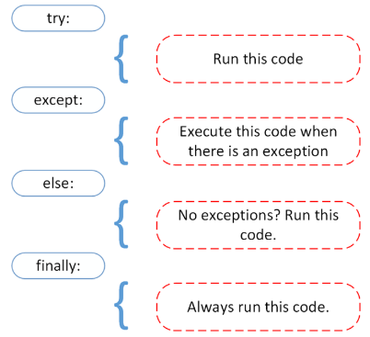

Python's exception handling system provides a structured way to catch and handle errors using specific keywords: try, except, else, and finally. These elements work together to ensure that the program can respond to errors, recover from them, and always clean up resources as needed.
Let's take a detailed look at each of these elements.
- try Block: The try block is used to wrap the code that might raise an exception. It contains the statements that are monitored for potential errors during execution. If an exception occurs inside the try block, Python stops executing the remaining code in that block and jumps to the corresponding except block.
Syntax:
try:
# code that may raise an exception
- except Block: The except block handles exceptions that are raised in the try block. It specifies the type of exceptions to catch, and the corresponding code to handle those exceptions. If no exception is raised, the except block is skipped.
Syntax:
try:
# code that may raise an exception
except <ExceptionType>:
# code to handle the exception
- else Block: The else block, if provided, is executed only if no exception occurs in the try block. It is typically used to run code that should only execute when no error has occurred, such as code that depends on the successful execution of the try block.
Syntax:
try:
# code that may raise an exception
except <ExceptionType>:
# code to handle the exception
else:
# code to execute if no exception occurs

- finally Block: The finally block is used to execute code that should run regardless of whether an exception occurs or not. This block is typically used for cleanup operations, such as closing files, releasing resources, or other tasks that must always happen. Even if an exception is raised or the program terminates abruptly, the code in the finally block will still be executed.
Syntax:
try:
# code that may raise an exception
except <ExceptionType>:
# code to handle the exception
else:
# code to execute if no exception occurs
finally:
# code to execute regardless of exception
5.5 Write programs to handle different types of exceptions using try, except, finally blocks.
Types of Exception Handling
- exception Exception: All built-in, non-system-exiting exceptions are derived from this class. All user-defined exceptions should also be derived from this class.
try:
raise Exception("This is a general exception.")
except Exception as e:
print(f"Caught Exception: {e}")
finally:
print("General exception handling complete.")
#Output:
Caught Exception: This is a general exception.
General exception handling complete.

- exception ArithmeticError: The base class for those built-in exceptions that are raised for various arithmetic errors: OverflowError, ZeroDivisionError, FloatingPointError.

- ZeroDivisionError
try:
result = 10 / 0 # Division by zero
except ZeroDivisionError as e:
print(f"ZeroDivisionError Caught: {e}")
finally:
print("ZeroDivisionError handling complete.")
#Output:
ZeroDivisionError Caught: division by zero
ZeroDivisionError handling complete.

- FloatingPointError
import numpy as np
try:

np.seterr(all='raise')
arr = np.array([1.0, 0.0])
result = 1.0 / arr

except FloatingPointError as e:
print(f"Caught FloatingPointError: {e}")
finally:
print("FloatingPointError handling complete.")

#Output:
Caught FloatingPointError: divide by zero encountered in true_divide
FloatingPointError handling complete.

- OverflowError
try:
import math
result = math.exp(1000) # Exponential function causing overflow
except OverflowError as e:
print(f"OverflowError Caught: {e}")
finally:
print("OverflowError handling complete.")

#Output:
OverflowError Caught: math range error
OverflowError handling complete.

- exception AssertionError: Raised when an assert statement fails.
def register_user(name, age):
try:
assert age >= 18, "Age must be 18 or above to register." # Assert that the age is 18 or above

print(f"Registration successful for {name}.")
return True

except AssertionError as e:
print(f"Registration failed: {e}")
return False

finally:
print("Registration attempt complete.\n")

print("Testing1:")
register_user("Sarjan Rai", 20)

print("Testing2:")
register_user("Prakash K.C.", 16)

#Output:

Testing1:
Testing1:
Registration successful for Sarjan Rai.
Registration attempt complete.

Testing2:
Registration failed: Age must be 18 or above to register.
Registration attempt complete.

- exception AttributeError: Raised when an attribute reference (see Attribute references) or assignment fails. (When an object does not support attribute references or attribute assignments at all, TypeError is raised.)
- exception ImportError: Raised when the import statement has troubles trying to load a module. Also raised when the “from list” in from ... import has a name that cannot be found.
- exception ModuleNotFoundError: A subclass of ImportError which is raised by import when a module could not be located. It is also raised when None is found in sys.modules.
- exception IndexError: Raised when a sequence subscript is out of range. (Slice indices are silently truncated to fall in the allowed range; if an index is not an integer, TypeError is raised.)
- exception KeyError: Raised when a mapping (dictionary) key is not found in the set of existing keys.
- exception NameError: Raised when a local or global name is not found. This applies only to unqualified names. The associated value is an error message that includes the name that could not be found. The name attribute can be set using a keyword-only argument to the constructor. When set it represent the name of the variable that was attempted to be accessed.

Lab 6: Database and GUI Programming
6.1 Write programs to establish a connection with a database (SQLite) and create or delete databases and tables.
import sqlite3
import os
def create_connection(db_name):
try:
conn = sqlite3.connect(db_name)
print(f"Connected to the database '{db_name}' successfully.")
return conn
except sqlite3.Error as e:
print(f"Error connecting to database: {e}")
return None

def create_table(conn):
try:
cursor = conn.cursor()
cursor.execute("""
CREATE TABLE IF NOT EXISTS students (
id INTEGER PRIMARY KEY AUTOINCREMENT,
name TEXT NOT NULL,
age INTEGER,
major TEXT
)
""")
conn.commit()
print("Table 'students' created successfully.")
except sqlite3.Error as e:
print(f"Error creating table: {e}")

def delete_table(conn):
try:
cursor = conn.cursor()
cursor.execute("DROP TABLE IF EXISTS students")
conn.commit()
print("Table 'students' deleted successfully.")
except sqlite3.Error as e:
print(f"Error deleting table: {e}")

def delete_database(db_name):
try:
if os.path.exists(db_name):
os.remove(db_name)
print(f"Database '{db_name}' deleted successfully.")
else:
print(f"Database '{db_name}' does not exist.")
except Exception as e:
print(f"Error deleting database: {e}")

def main():
db_name = "CollegeDatabase.db"
conn = create_connection(db_name)
if conn:
create_table(conn)

#To delete table created by object ‘conn’
# delete_table(conn)
conn.close()

print(f"Connection to the database '{db_name}' closed.")

# This will delete the ‘.db’ file
# delete_database(db_name)

if __name__ == "__main__":
main()

#Output:
Connected to the database 'CollegeDatabase.db' successfully.
Table 'students' created successfully.
Connection to the database 'CollegeDatabase.db' closed.

6.2 Write programs to store data in a database and manipulate the data.
import sqlite3
import os
def create_connection(db_name):
try:
conn = sqlite3.connect(db_name)
print(f"Connected to the database '{db_name}' successfully.")
return conn
except sqlite3.Error as e:
print(f"Error connecting to database: {e}")
return None

def create_table(conn):
try:
cursor = conn.cursor()
cursor.execute("""
CREATE TABLE IF NOT EXISTS students (
id INTEGER PRIMARY KEY AUTOINCREMENT,
name TEXT NOT NULL,
age INTEGER,
major TEXT
)
""")
conn.commit()
print("Table 'students' created successfully.")
except sqlite3.Error as e:
print(f"Error creating table: {e}")

def insert_data(conn):
try:
cursor = conn.cursor()
cursor.executemany("""
INSERT INTO students (name, age, major)
VALUES (?, ?, ?)
""", [
("Sarjan Rai", 24, "Computer Science"),
("Parash Trital", 25, "Electrical Engineering"),
("Bikash Rai", 22, "Mechanical Engineering"),
])
conn.commit()
print("Data inserted successfully into 'students' table.")
except sqlite3.Error as e:
print(f"Error inserting data: {e}")

def query_data(conn):
try:
cursor = conn.cursor()
cursor.execute("SELECT * FROM students")
rows = cursor.fetchall()
print("\nStudent Data:")
for row in rows:
print(row)
except sqlite3.Error as e:
print(f"Error querying data: {e}")

def update_data(conn):
try:
cursor = conn.cursor()
cursor.execute("""
UPDATE students
SET major = ?
WHERE name = ? AND major = ?
""", ("Civil Engineering", "Sarjan Rai", "Computer Science"))
conn.commit()
print("\nUpdated Sarjan Rai's major to Civil Engineering")
except sqlite3.Error as e:
print(f"Error updating data: {e}")
def delete_data(conn):
try:
cursor = conn.cursor()
cursor.execute("DELETE FROM students WHERE name = ?", ("Parash Trital",))
conn.commit()
print("\nDeleted student record for Parash Trital.")
except sqlite3.Error as e:
print(f"Error deleting data: {e}")
def delete_table(conn):
try:
cursor = conn.cursor()
cursor.execute("DROP TABLE IF EXISTS students")
conn.commit()
print("\nTable 'students' deleted successfully.")
except sqlite3.Error as e:
print(f"Error deleting table: {e}")
def delete_database(db_name):
try:
if os.path.exists(db_name):
os.remove(db_name)
print(f"\nDatabase '{db_name}' deleted successfully.")
else:
print(f"\nDatabase '{db_name}' does not exist.")
except Exception as e:
print(f"Error deleting database: {e}")

def main():
db_name = "CollegeDatabase.db"
conn = create_connection(db_name)
if conn:
create_table(conn)
insert_data(conn)
query_data(conn)
update_data(conn) # Update operation (will now update the existing record)
query_data(conn) # After update
delete_data(conn)
query_data(conn) # After deletion
# delete_table(conn)
conn.close()
print(f"Connection to the database '{db_name}' closed.")

delete_database(db_name)
if __name__ == "__main__":
main()

#Output:
Connected to the database 'CollegeDatabase.db' successfully.
Table 'students' created successfully.
Data inserted successfully into 'students' table.

Student Data:
(1, 'Sarjan Rai', 24, 'Computer Science')
(2, 'Parash Trital', 25, 'Electrical Engineering')
(3, 'Bikash Rai', 22, 'Mechanical Engineering')

Updated Sarjan Rai's major to Civil Engineering

Student Data:
(1, 'Sarjan Rai', 24, 'Civil Engineering')
(2, 'Parash Trital', 25, 'Electrical Engineering')
(3, 'Bikash Rai', 22, 'Mechanical Engineering')

Deleted student record for Parash Trital.

Student Data:
(1, 'Sarjan Rai', 24, 'Civil Engineering')
(3, 'Bikash Rai', 22, 'Mechanical Engineering')
Connection to the database 'CollegeDatabase.db' closed.

Database 'CollegeDatabase.db' deleted successfully.

  - Write programs to perform CRUD operations in the database.
Complete in 6.2 by Modifying data stored in database 'CollegeDatabase.db'
6.4 Write programs to create simple GUIs with widgets: label, text entry, radio buttons, and check
import tkinter as tk
from tkinter import messagebox

def submit_form():
name = entry_name.get()
age = entry_age.get()
gender = selected_gender.get()
hobbies = []

if var_reading.get():
hobbies.append("Reading")
if var_traveling.get():
hobbies.append("Traveling")
if var_sports.get():
hobbies.append("Sports")

if not name or not age or not gender:
messagebox.showerror("Input Error", "Please fill in all fields.")
return

result_message = f"Name: {name}\nAge: {age}\nGender: {gender}\nHobbies: {', '.join (hobbies)}"
messagebox.showinfo("Form Submitted", result_message)

entry_name.delete(0, tk.END)
entry_age.delete(0, tk.END)
var_reading.set(0)
var_traveling.set(0)
var_sports.set(0)
selected_gender.set("Male") # Reset to default gender

root = tk.Tk()
root.title("Simple GUI Form")
root.geometry("300x400")

label_name = tk.Label(root, text="Enter your Name:")
label_name.pack()

entry_name = tk.Entry(root)
entry_name.pack()

label_age = tk.Label(root, text="Enter your Age:")
label_age.pack()

entry_age = tk.Entry(root)
entry_age.pack()

label_gender = tk.Label(root, text="Select your Gender:")
label_gender.pack()

selected_gender = tk.StringVar()
selected_gender.set("Male") # Default value

radio_male = tk.Radiobutton(root, text="Male", variable=selected_gender, value="Male")
radio_female = tk.Radiobutton(root, text="Female", variable=selected_gender, value =
" Female")
radio_other = tk.Radiobutton(root, text="Other", variable=selected_gender, value="Other")

radio_male.pack()
radio_female.pack()
radio_other.pack()

label_hobbies = tk.Label(root, text="Select your Hobbies:")
label_hobbies.pack()

var_reading = tk.IntVar()
var_traveling = tk.IntVar()
var_sports = tk.IntVar()

checkbox_reading = tk.Checkbutton(root, text="Reading", variable=var_reading)
checkbox_traveling = tk.Checkbutton(root, text="Traveling", variable=var_traveling)
checkbox_sports = tk.Checkbutton(root, text="Sports", variable=var_sports)

checkbox_reading.pack()
checkbox_traveling.pack()
checkbox_sports.pack()

submit_button = tk.Button(root, text="Submit", command=submit_form)
submit_button.pack()

root.mainloop()
#Output:




