**LAB ASSIGNMENTS**

Name: Sarmad Ahmad

Registration No: SP20-BSE-084.

GitHub link:

<https://github.com/Sarmad-47/OOP-SP21>

**Lab activity 1**

package lab7_ac1;

public class EmployeeRecord {

private int emp_id;

private double salary;

public EmployeeRecord(int emp_id,double salary) {

this.emp_id=emp_id;

this.salary=salary;

}

public void setEmp_id(int id) {

emp_id = id;

}

public int getEmp_id() {

return emp_id;

}

public void setSalary(int sal) {

salary = sal;

}

public double getSalary() {

return salary;

}

}

package lab7_ac1;

public class Manager {

private String title ;

private double dues;

private EmployeeRecord emp;

private StudentRecord stu;

public Manager(String t, double d, EmployeeRecord e, StudentRecord s) {

title = t;

dues = d;

emp = e;

stu = s;

}

public void display(){

System.out.println("Title is: "+title);

System.out.println("Dues are: "+dues);

System.out.println("Employee record is under: ");

System.out.println("Employee id is: "+emp.getEmp_id());

System.out.println("Employee salary is: "+emp.getSalary());

System.out.println("Student record is as under: ");

System.out.println("Degree is : "+ stu.getDegree());

}

}

package lab7_ac1;

public class StudentRecord {

private String degree;

public StudentRecord(String degree) {

this.degree=degree;

}

public void setDegree(String deg) {

degree = deg;

}

public String getDegree() {

return degree;

}

}

package lab7_ac1;

public class Runner {

public static void main(String[] args) {

StudentRecord s= new StudentRecord("MBA");

EmployeeRecord e = new EmployeeRecord(111,50000);

Manager m1=new Manager("finance Manager",5000,e,s);

m1.display();

}

}

**Output**

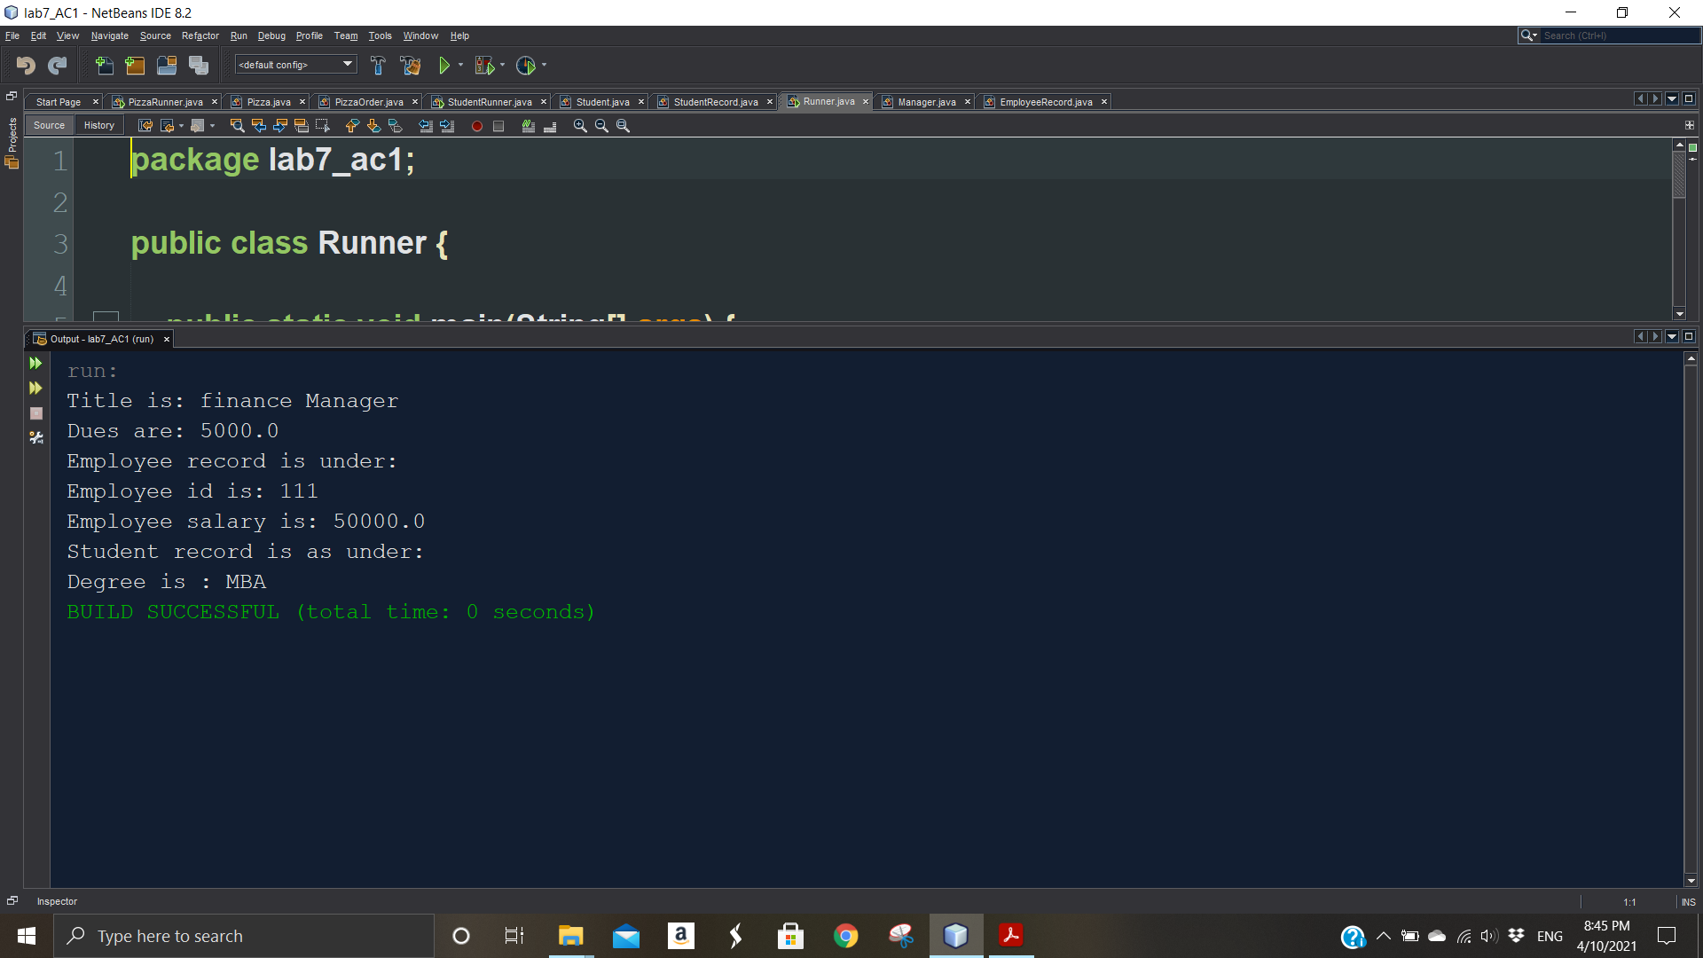

**Lab activity 2**

package lab7_ac2;

public class Date {

private int day;

private int month;

private int year;

public Date(int theMonth, int theDay, int theYear) {

day = checkday(theDay);

month = checkmonth(theMonth);

year = theYear;

}

private int checkmonth(int testMonth) {

if (testMonth > 0 && testMonth <= 12) {

return testMonth;

} else {

System.out.println("Invalid month " + testMonth + " set to 1");

return 1;

}

}

private int checkday(int testDay) {

int daysofmonth[]={0,31,28,31,30,31,30,31,31,30,31,30,31};

if (testDay > 0 && testDay <= daysofmonth[month]) {

return testDay;

} else if (month == 2 && testDay == 29 && (year % 400 == 0 || (year % 4 == 0 && year % 100 != 0))) {

return testDay;

} else {

System.out.println("Invalid date " + testDay + " set to 1");

}

return 1;

}

public int getDay() {

return day;

}

public int getMonth() {

return month;

}

public int getYear() {

return year;

}

public void display() {

System.out.println(day + " " + month + " " + year);

}

}

package lab7_ac2;

public class employee {

private String name;

private String fname;

private Date birthdate;

private Date hiredate;

employee() {

}

employee (String x, String y, Date birthofDate, Date dateofHire) {

name = x;

fname = y;

birthdate = birthofDate;

hiredate = dateofHire;

}

public void setname(String x) {

name = x;

}

public String getname() {

return name;

}

public void setfname(String x) {

fname = x;

}

public String getfname() {

return fname;

}

public void setbirthdate(Date b) {

birthdate = b;

}

public Date getbirthdate() {

return birthdate;

}

public void sethiredate(Date h) {

hiredate = h;

}

public Date gethiredate() {

return hiredate;

}

public void display() {

System.out.println("Name: " + name + " Father Name: " + fname);

birthdate.display();

hiredate.display();

}

}

package lab7_ac2;

public class Employrun {

public static void main(String[] args) {

Date b = new Date(1, 12, 1990);

Date h = new Date(5, 6, 2016);

employee e1 = new employee("xxx", "yyyy", b, h);

e1.display();

}

}

**Output**

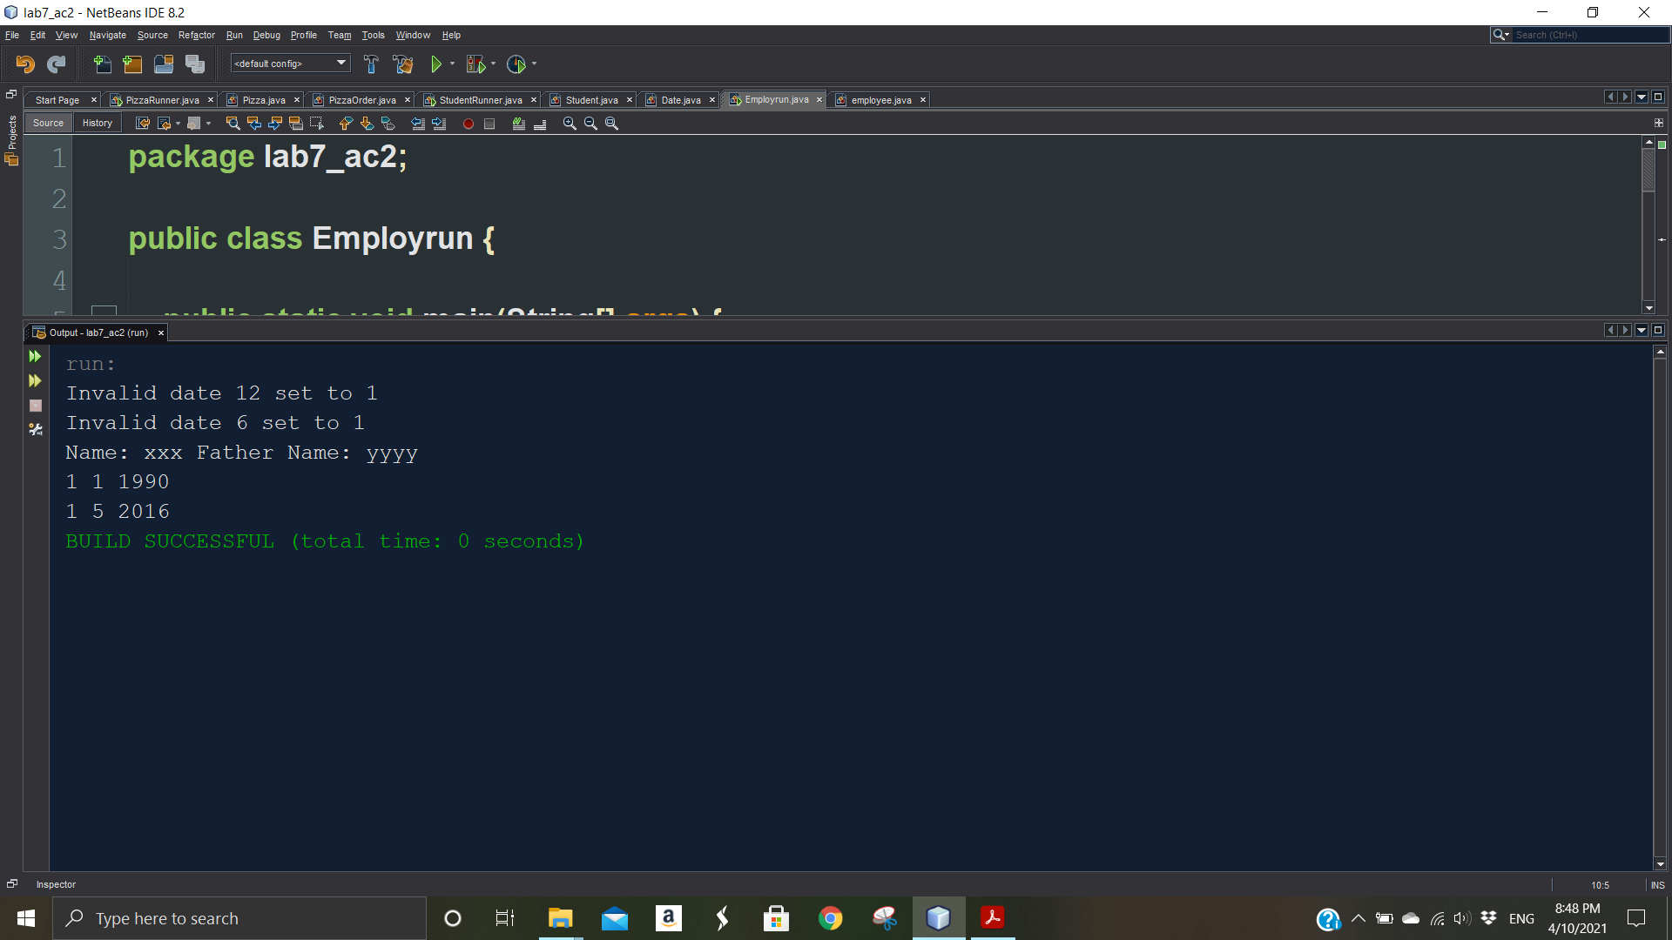

**Home Activity 1 & 2**

package lab7_hac1;

public class Address {

private int streetno;

private int houseno;

private String city;

private int postal_Code;

Address(int street,int house,String City,int code){

streetno=street;

houseno=house;

city=City;

postal_Code=code;

}

public int getStreetno() {

return streetno;

}

public void setStreetno(int streetno) {

this.streetno = streetno;

}

public int getHouseno() {

return houseno;

}

public void setHouseno(int houseno) {

this.houseno = houseno;

}

public String getCity() {

return city;

}

public void setCity(String city) {

this.city = city;

}

public int getPostal_Code() {

return postal_Code;

}

public void setPostal_Code(int postal_Code) {

this.postal_Code = postal_Code;

}

@Override

public String toString(){

return String.format("street No= [%d] , House no = [%d] , City = [%s] , Postal Code = [%d] ",streetno,houseno,city,postal_Code);

}

}

package lab7_hac1;

public class Book {

private Person author;

private String bookname;

private String publisher;

Book(Person author,String bookname,String publisher){

this.author=author;

this.bookname=bookname;

this.publisher=publisher;

}

@Override

public String toString(){

return String.format("Author = {%s} \nBook Name = [%s] \nPublisher of the book = [%s] ",author,bookname,publisher);

}

}

package lab7_hac1;

public class Person {

private Address address;

private String name;

private String contactno;

Person(String name, Address address,String contactno){

this.name=name;

this.address=address;

this.contactno=contactno;

}

@Override

public String toString(){

return String.format("Name = [%s] , Address = {%s} , Contact no = [%s] ",name,address,contactno);

}

}

package lab7_hac1;

public class PersonRunner {

public static void main(String[] args) {

/**

* person 1 address

*/

Address address1= new Address(77,854,"Islamabad",44410);

address1.setStreetno(51);

address1.setHouseno(208);

address1.setCity("Faisalabad");

address1.setPostal_Code(87951);

System.out.println("Street No: " +address1.getStreetno() );

System.out.println("House no: "+ address1.getHouseno() );

System.out.println("City: "+ address1.getCity());

System.out.println("Postal Code: "+address1.getPostal_Code() );

Person person1=new Person("Ali",address1,"0321440021");

System.out.println(address1.toString());

System.out.println(person1.toString());

/**

* person 2 address

*/

Address address2= new Address(12,210,"Islamabad",44480);

Person person2=new Person("Rashid",address2,"0320550047");

System.out.println(person2);

/**

* publisher and book name.

*/

Book book1=new Book(person1,"Broken Glass","Alain Mabanckou");

System.out.println(book1.toString());

Book book2=new Book(person2,"Harvest","Jim Crace");

System.out.println(book2);

}

}

**Output**

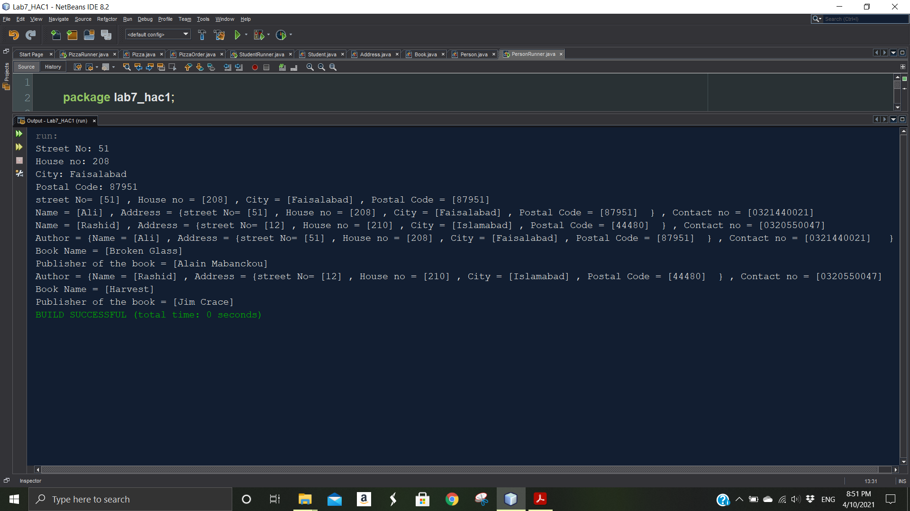

**Lab activity 3**

package lab7_ac3;

public class Line {

private Point startPoint;

private Point endPoint;

Line(Point startPoint, Point endPoint){

this.startPoint= startPoint;

this.endPoint= endPoint;

}

public double Length(){

return Math.sqrt(Math.pow(startPoint.getX()-endPoint.getX(), 2) + Math.pow(startPoint.getY()-endPoint.getY(), 2));

}

}

package lab7_ac3;

public class Point {

private double x;

private double y;

Point(int x,int y){

this.x= x;

this.y= y;

}

public double getX() {

return x;

}

public void setX(double x) {

this.x = x;

}

public double getY() {

return y;

}

public void setY(double y) {

this.y = y;

}

public void display(){

System.out.println("The x cordinate is: "+ x+"\t"+"The y cordinate is: "+y);

}

}

package lab7_ac3;

public class PointRunner {

public static void main(String[] args) {

Line line1=new Line(new Point(4,8),new Point(15,25));

System.out.printf("The length of the line 1 is : %.2f", line1.Length()).println();

Line line2= new Line(new Point(7,12),new Point(-11,-6));

System.out.printf("The length of the line 2 is : %.2f", line2.Length()).println();

}

}

**Output**

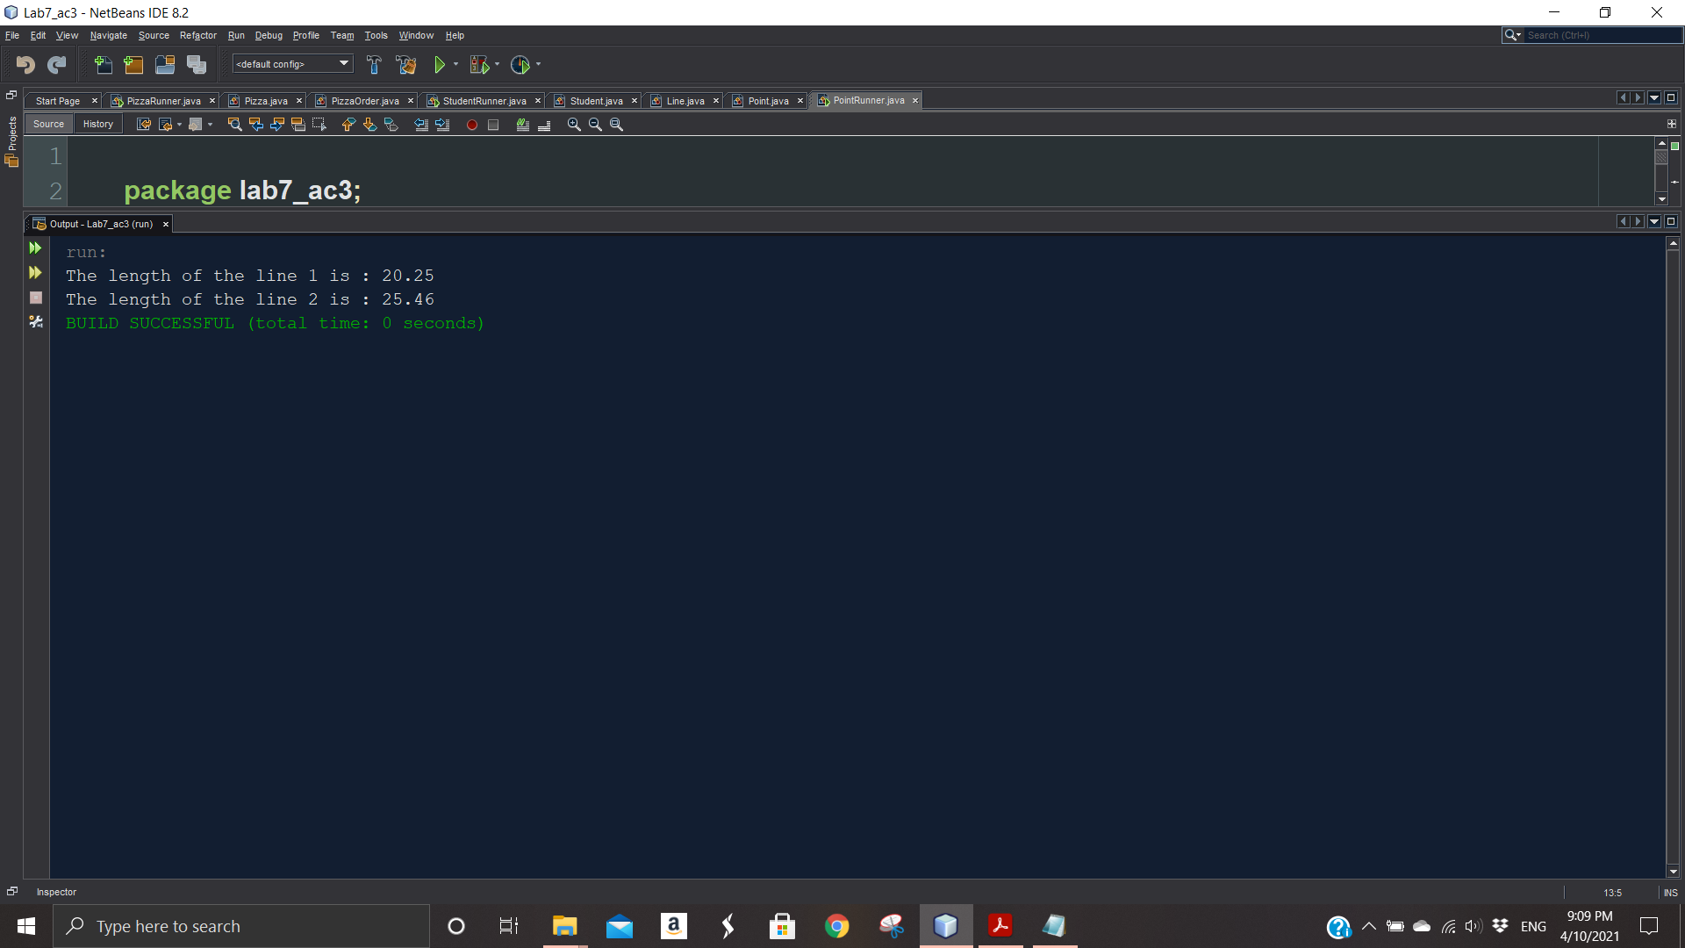

**Assignment**

package lab7_assignment1;

public class Pizza {

private String pizzasize;

private int cheesetoppings;

private int pepperoniToppings;

private int hamtoppings;

Pizza(){

}

Pizza(String pizzasize,int cheesetoppings, int pepperoniToppings,int hamtoppings){

this.pizzasize=pizzasize;

this.cheesetoppings=cheesetoppings;

this.pepperoniToppings=pepperoniToppings;

this.hamtoppings=hamtoppings;

}

/**

* @return the pizzasize

*/

public String getPizzasize() {

return pizzasize;

}

/**

* @param pizzasize the pizzasize to set

*/

public void setPizzasize(String pizzasize) {

this.pizzasize = pizzasize;

}

/**

* @return the cheesetoppings

*/

public int getCheesetoppings() {

return cheesetoppings;

}

/**

* @param cheesetoppings the cheesetoppings to set

*/

public void setCheesetoppings(int cheesetoppings) {

this.cheesetoppings = cheesetoppings;

}

/**

* @return the pepperoniToppings

*/

public int getPepperoniToppings() {

return pepperoniToppings;

}

/**

* @param pepperoniToppings the pepperoniToppings to set

*/

public void setPepperoniToppings(int pepperoniToppings) {

this.pepperoniToppings = pepperoniToppings;

}

/**

* @return the hamtoppings

*/

public int getHamtoppings() {

return hamtoppings;

}

/**

* @param hamtoppings the hamtoppings to set

*/

public void setHamtoppings(int hamtoppings) {

this.hamtoppings = hamtoppings;

}

public double calcCost(){

double pizza_Cost = 0;

if(this.pizzasize.equalsIgnoreCase("Small")){

pizza_Cost= 10 + (this.cheesetoppings*2) + (this.hamtoppings*2) + (this.pepperoniToppings*2);

}else if(this.pizzasize.equalsIgnoreCase("Medium")){

pizza_Cost =12 + (this.cheesetoppings*2) + (this.hamtoppings*2) + (this.pepperoniToppings*2) ;

} else if(this.pizzasize.equalsIgnoreCase("Large")){

pizza_Cost =14 + (this.cheesetoppings*2) + (this.hamtoppings*2) + (this.pepperoniToppings*2) ;

}

return pizza_Cost;

}

public String getDescription(){

return String.format("Pizza size = %s \nCheese Toppings = %d \nPepperoniToppings = %d \nHam Toppings = %d",pizzasize,cheesetoppings,pepperoniToppings,hamtoppings);

}

}

package lab7_assignment1;

public class PizzaOrder {

private Pizza pizza1, pizza2, pizza3;

PizzaOrder() {

this.pizza1 = new Pizza("small", 2, 4, 5);

this.pizza2 = new Pizza("Medium", 1, 1, 2);

this.pizza3 = new Pizza("large", 1, 5, 1);

}

public void calTotal() {

double sum = pizza1.calcCost() + pizza2.calcCost()+ pizza3.calcCost();

System.out.println(pizza1.getDescription());

System.out.println(pizza2.getDescription());

System.out.println(pizza3.getDescription());

System.out.println("There are total 3 pizza");

System.out.println("Total sum is: " + " $" + sum);

}

}

package lab7_assignment1;

public class PizzaRunner {

public static void main(String[] args) {

Pizza pizza1=new Pizza("Large",1,1,2);

System.out.println(pizza1.getDescription());

System.out.println("The total cost is: $"+pizza1.calcCost());

Pizza pizza2= new Pizza();

pizza2.setPizzasize("Medium");

pizza2.setCheesetoppings(2);

pizza2.setPepperoniToppings(4);

pizza2.setHamtoppings(2);

// System.out.println(pizza2.getDescription());

// System.out.println("The total cost is: $"+pizza2.calcCost());

System.out.println("\n");

PizzaOrder order=new PizzaOrder();

order.calTotal();

}

}

**Output**

