**Lab 8 Assignment**

Name: Sarmad Ahmad

Registration No: SP20-BSE-084

Q.1

1. Imagine a publishing company that markets both book and audio-cassette versions of its works. Create a class publication that stores the title and price of a publication. From this class derive two classes:

i. book, which adds a page count and

ii. tape, which adds a playing time in minutes.

Each of these three classes should have set() and get() functions and a display() function to display its data.

Write a main() program to test the book and tape class by creating instances of them, asking the user to fill in their data and then displaying the data with display*().*

**Code:**

package lab8_assignment1;

public class Book extends Publication {

private int pages;

public int getPages() {

return pages;

}

public void setPages(int pages) {

this.pages = pages;

}

@Override

public void Display(){

super.Display();

System.out.println("Pages = "+pages);

}

}

package lab8_assignment1;

public class Publication {

private String title;

private double price;

public String getTitle() {

return title;

}

public void setTitle(String title) {

this.title = title;

}

public double getPrice() {

return price;

}

public void setPrice(double price) {

this.price = price;

}

public void Display(){

System.out.println("Title = "+title+"\n"+"Price = $"+price);

}

}

package lab8_assignment1;

public class Tape extends Publication{

private int time;

public int getTime() {

return time;

}

public void setTime(int time) {

this.time = time;

}

@Override

public void Display(){

super.Display();

System.out.println("Time = "+time+" minutes");

}

}

package lab8_assignment1;

import java.util.Scanner;

public class PublishingRunner {

public static void main(String[] args) {

Scanner kb = new Scanner(System.in);

Book book = new Book();

Tape tape = new Tape();

System.out.print("Enter book title = ");

book.setTitle(kb.nextLine());

System.out.print("Price of the book = $");

book.setPrice(kb.nextDouble());

kb.nextLine();

System.out.print("Total pages = ");

book.setPages(kb.nextInt());

kb.nextLine();

System.out.print("\nEnter tape title: ");

tape.setTitle(kb.nextLine());

System.out.print("Price of the tape = $");

tape.setPrice(kb.nextDouble());

kb.nextLine();

System.out.print("Tape time = ");

tape.setTime(kb.nextInt());

System.out.println("\nBook Details:-");

book.Display();

System.out.println("\nTape Details:-");

tape.Display();

}

}

**Output:**

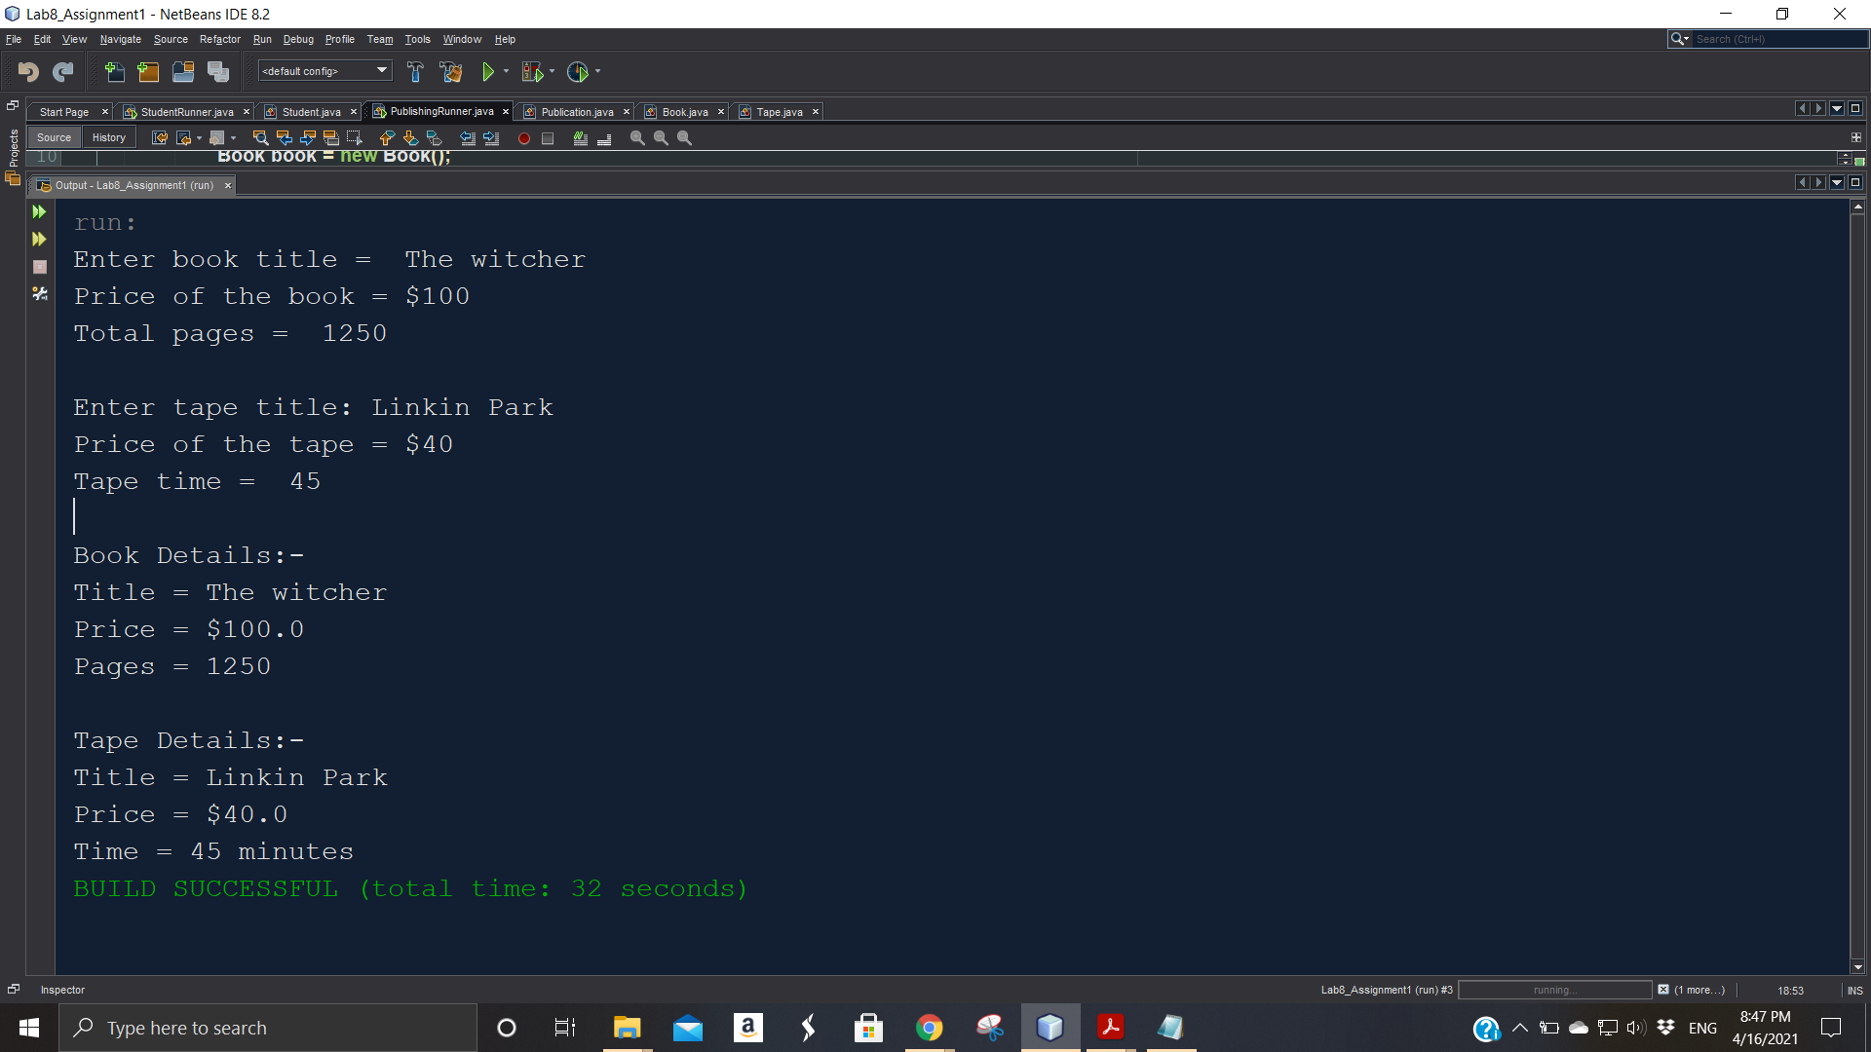

Q.2

Write a base class Computer that contains data members of wordsize(in bits), memorysize (in megabytes), storagesize (in megabytes) and speed (in megahertz). Derive a Laptop class that is a kind of computer but also specifies the object’s length, width, height, and weight. Member functions for both classes should include a default constructor, a constructor to inialize all components and a function to display data members.

**Code:**

package lab8_assignment2;

public class Computer {

private double wordSize;

private double memorySize;

private double storageSize;

private double speed;

Computer(){

wordSize=0;

memorySize=0;

storageSize=0;

speed=0;

}

Computer(double wordSize,double memorySize,double storageSize,double speed){

this.wordSize=wordSize;

this.memorySize=memorySize;

this.storageSize=storageSize;

this.speed=speed;

}

public double getWordSize() {

return wordSize;

}

public void setWordSize(double wordSize) {

this.wordSize = wordSize;

}

public double getMemorySize() {

return memorySize;

}

public void setMemorySize(double memorySize) {

this.memorySize = memorySize;

}

public double getStorageSize() {

return storageSize;

}

public void setStorageSize(double storageSize) {

this.storageSize = storageSize;

}

public double getSpeed() {

return speed;

}

public void setSpeed(double speed) {

this.speed = speed;

}

@Override

public String toString(){

return String.format("Word Size = %f bits \nMemory Size = %f megabytes \nStorage Size = %f megabytes \nSpeed = %f megahertz",wordSize,memorySize,storageSize,speed);

}

}

package lab8_assignment2;

public class Laptop extends Computer {

private double length;

private double width;

private double height;

private double weight;

Laptop(){

super();

length=0;

width=0;

height=0;

weight=0;

}

Laptop(double wordSize,double memorySize,double storageSize,double speed,double length,double width,double height,double weight){

super(wordSize,memorySize,storageSize,speed);

this.length=length;

this.width=width;

this.height=height;

this.weight=weight;

}

public double getLength() {

return length;

}

public void setLength(double length) {

this.length = length;

}

public double getWidth() {

return width;

}

public void setWidth(double width) {

this.width = width;

}

public double getHeight() {

return height;

}

public void setHeight(double height) {

this.height = height;

}

public double getWeight() {

return weight;

}

public void setWeight(double weight) {

this.weight = weight;

}

@Override

public String toString(){

return super.toString() + "\n"+ String.format("Length = %f \nWidth = %f \nHeight = %f \nWeight = %f", length,width,height,weight) ;

}

}

package lab8_assignment2;

public class ComputerRunner {

public static void main(String[] args) {

Computer computer=new Computer(64,1600,24000,30);

System.out.println("Computer details");

System.out.println(computer);

System.out.println("\n\n");

System.out.println("Laptop details");

Laptop laptop =new Laptop(64,3500,30000,20,16,8,8,4.5);

System.out.println(laptop);

}

}

**Output:**

