**OUTPUT OF EACH METHOD:**

1. 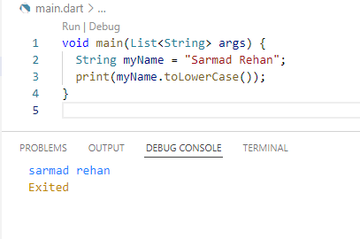**toLowerCase();**
2. **toUpperCase();**

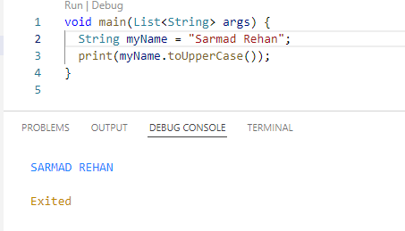

1. 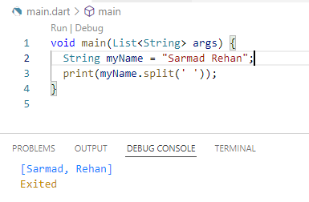**split();**
2. 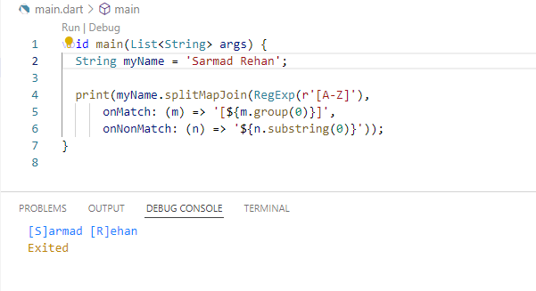**splitMapJoin();**
3. **substring();**

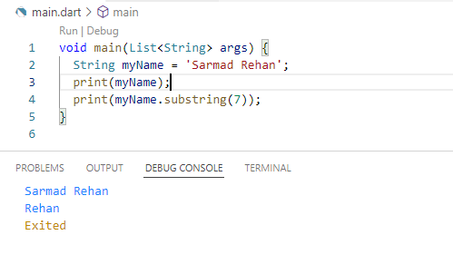

1. **startsWith();**

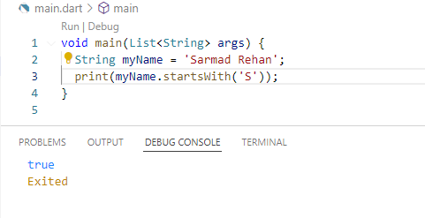

1. **endsWith();**

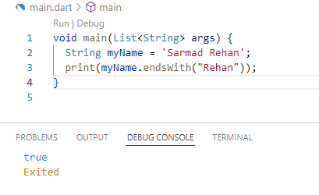

1. **contains();**

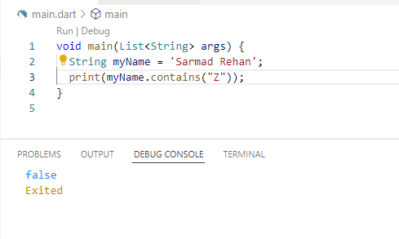

1. **compareTo();**

**NOTE**

// 1 indicates first input is less than second

// 0 indicates both inputs are equal

// -1 indicates second input is greater than first.

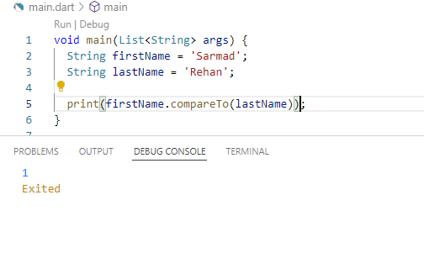

1. **codeUnitAt();**

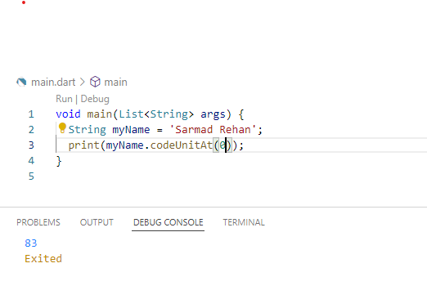

1. **indexOf();**

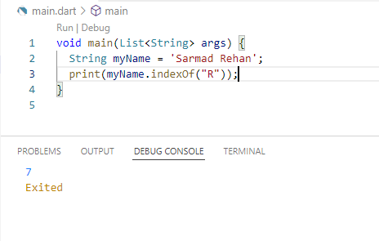

1. **lastIndexOf();**

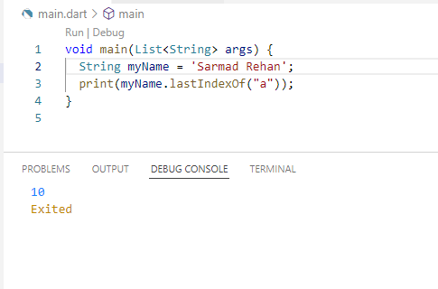

1. **replaceFirstMapped();**

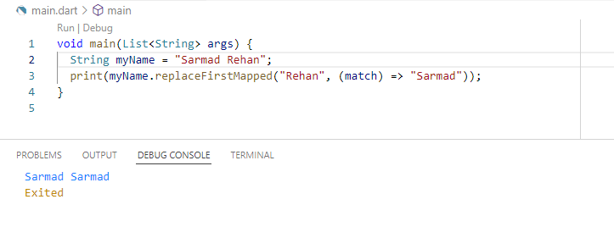

1. 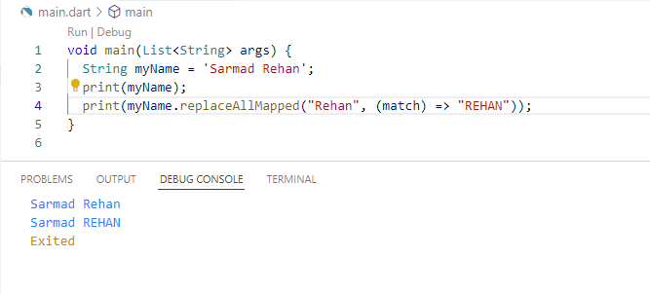**replaceAllMapped();**
2. 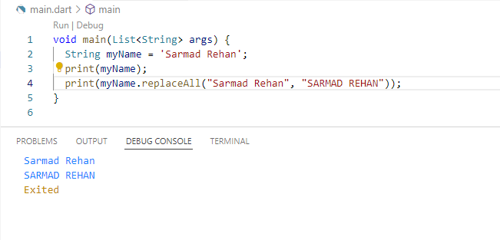**replaceAll();**
3. **replaceFirst();**

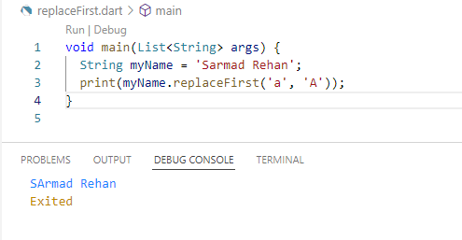

1. **replaceRange();**

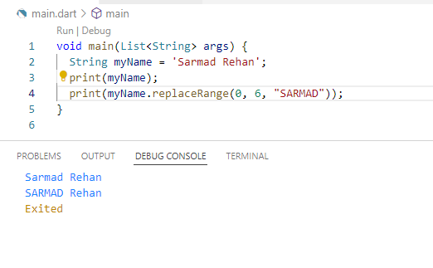

1. 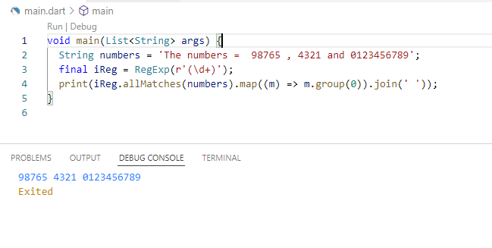**allMatches();**
2. 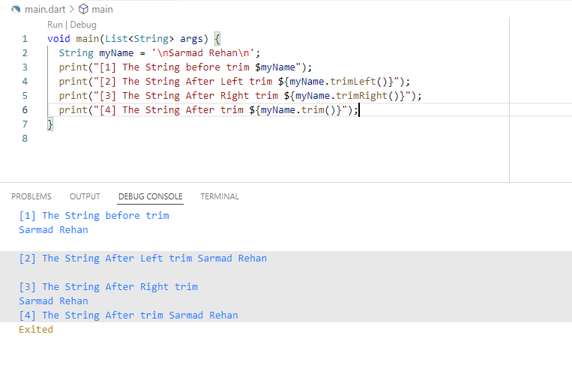**trimRight()****;**
3. **trimLeft();**
4. **trim();**
5. **padRight();**

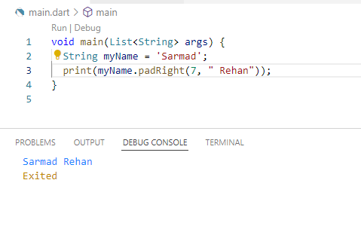

1. **padLeft();**

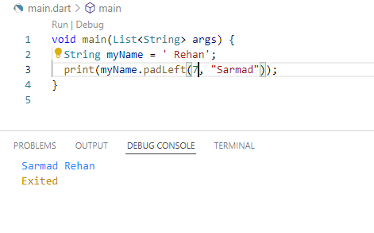

1. **matchAsPrefix();**

