SME Retail Intelligence
Full System Test Report
Release Verification Architecture and Visual Evidence
Prepared for Sarmad Ali
Tests completed 4 September 2026
Report finalized 9 September 2026
Repository Sme-Retail-Intelligence

Release result
Passed. All locally executable checks passed after the issues found during this audit were corrected.
This report records what was tested, what changed, how the services communicate, and which production checks remain dependent on external cloud accounts. It does not claim that Oracle Cloud, DuckDNS, Resend, Gemini, Groq, or YouTube were exercised without the required credentials.

Executive Summary
The platform is working in its local running form. The owner dashboard, staff workspace, API, worker, and PostgreSQL database start together through Docker Compose and report healthy status. Authenticated browser and API journeys returned live retail data, a seven day demand forecast, safe natural language answers, tenant scoped access, and completed background CSV processing.

Result at a Glance
Area | Verified result
FastAPI | 7 unit and regression tests passed
End to end API | 50 checks passed
Browser journeys | 14 screens captured without browser console errors
Security scans | No known Python dependency vulnerabilities and no reachable Go vulnerabilities
Frontend audits | 0 npm vulnerabilities in the Next.js and Angular applications
Containers | 5 of 5 application services healthy after a fresh rebuild and recreate
Kubernetes | 30 valid resources, 0 invalid, 0 errors, and 1 custom resource schema skipped
Database restore | Custom format backup restored into a temporary database and row counts matched
Service logs | No ERROR, FATAL, panic, or Traceback entries in the final ten minute window

Verdict
The repository is ready as a complete local portfolio project and release candidate. Production deployment cannot be marked complete until the owner supplies and authorizes the cloud, DNS, email, language model, and video accounts listed later in this report.

Architecture and Service Connections
Both web applications use the same authenticated API. FastAPI owns validation, permissions, forecasting, safe query approval, and request metrics. PostgreSQL is the system of record. The Go worker shares the database contract for queued imports and weekly digests. Optional providers sit behind clear interfaces, while Docker Compose and k3s supply the runtime layer.
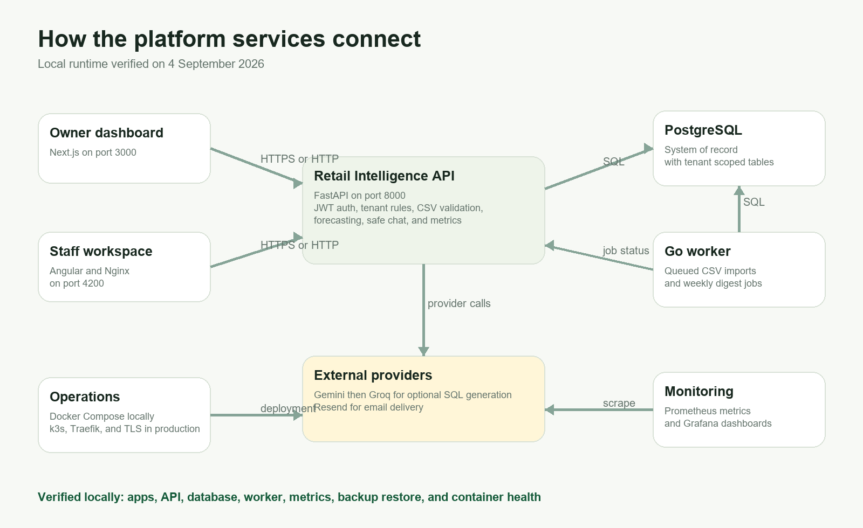
Figure 1. Architecture and verified service connections

Request Flow
- An owner or staff member signs in and receives a short lived JWT access token.
- The browser sends the token to FastAPI, which resolves the user and organization before reading or writing data.
- CSV uploads are validated and either processed immediately or stored as queued work for the Go service.
- Forecast requests read organization scoped sales history and return predictions, MAE, RMSE, model, and confidence metadata.
- Chat requests pass through question safety checks, SQL parsing, allowlists, tenant constraint injection, row limits, and a database timeout.

Detailed Test Matrix
ID | Check | Method | Result | State
T01 | API unit and regression tests | pytest | 7 passed | Pass
T02 | Go worker tests | go test | All packages passed | Pass
T03 | Python dependency audit | pip-audit | No known vulnerabilities | Pass
T04 | Go vulnerability scan | govulncheck | No reachable vulnerabilities | Pass
T05 | Owner production build | Next.js build | Compiled and prerendered | Pass
T06 | Staff production build | Angular build | 280.55 kB initial bundle | Pass
T07 | Frontend dependency audits | npm audit | 0 vulnerabilities in both apps | Pass
T08 | Container build and health | Docker Compose | All five services healthy | Pass
T09 | Authenticated system workflow | HTTP end to end suite | 50 checks passed | Pass
T10 | Browser workflow | Headless Chrome | 14 views completed | Pass
T11 | Kubernetes schema validation | kubeconform strict | 30 valid, 0 invalid, 0 errors | Pass
T12 | Database restore drill | pg_dump and pg_restore | 276 sales, 10 inventory, 10 users restored | Pass
T13 | Worker observability | Health and Prometheus | 1 import, 1 digest, 0 errors | Pass
T14 | Runtime log review | Docker logs | No final error patterns | Pass
The Kubernetes skipped item is a cert-manager custom resource whose schema is not bundled with the validator. It was intentionally accepted through the workflow's ignore missing schemas setting; no standard Kubernetes resource was skipped.

Security, Data, and Forecast Verification

Authentication and Tenant Boundaries
- Requests without a bearer token were denied with HTTP 401 and an invalid password was denied with HTTP 401.
- The demo owner could manage users and settings. A newly created staff user could review uploads but received HTTP 403 for owner only user and settings endpoints.
- A newly registered organization received an empty inventory response and could not see the demo organization's records.

CSV and Worker Processing
- A unique sales CSV entered the queue, the Go worker completed it, and the upload reported one processed row.
- Uploading the same content again returned the original upload ID with the duplicate flag, confirming idempotency.
- A CSV with incorrect column names was rejected with HTTP 422.

Forecast and Chat
- A seven day COFFEE-01 forecast returned seven predictions using simple exponential smoothing with high confidence, MAE 0.648, and RMSE 0.803.
- Inventory availability, low stock, sales by SKU, best movers, and reorder oriented questions all returned approved tenant scoped results.
- A request to drop the sales table and expose users was rejected and executed no query.

Dependency and Secret Review
- FastAPI, PyJWT, python-multipart, Starlette, pgx, and Go text dependencies were updated during the audit.
- The final Python, Go, Next.js, and Angular scans reported no known or reachable vulnerabilities at test time.
- The tracked repository contains environment templates only. Local credentials remain in the ignored .env file and were not included in the report or evidence.

Issues Found and Corrected
Issue | Correction
Low stock question classification | The wording 'low in stock' was being routed to general inventory. The deterministic rule and regression test now recognize the phrase.
Outdated dependencies | Python and Go packages with published advisories were upgraded, container toolchains were aligned, and the final scanners returned clean results.
Local hostname support | The API now accepts both localhost and 127.0.0.1 origins for the owner and staff development ports.
Staff root redirect | Nginx previously generated an absolute redirect that could lose port 4200. Relative redirects now preserve the correct local address.
Angular async rendering | Successful login requests did not update the visible view under Angular's zoneless behavior. RxJS callbacks now explicitly notify Angular to render.
Browser polish | Form autocomplete attributes and the staff favicon were added so the final browser journey runs without console errors or form advisories.

External Production Checks Still Required
The following items are implemented or documented but were not marked as passed because no production credentials or accounts were supplied for this verification run:
- Oracle Cloud ARM VM creation and the final k3s rollout
- DuckDNS updates and live Let's Encrypt certificate issuance or renewal
- Encrypted backup upload to OCI Object Storage
- Resend email delivery outside local worker execution
- Live Gemini and Groq provider calls beyond deterministic offline chat rules
- A public HTTPS URL and an unlisted YouTube walkthrough
These are deployment follow ups, not failures in the verified local application. Each one needs an account owner action or secret before it can be tested honestly.

Owner Sign In
The Next.js entry screen presents a focused owner login and explains the product without exposing any data before authentication.
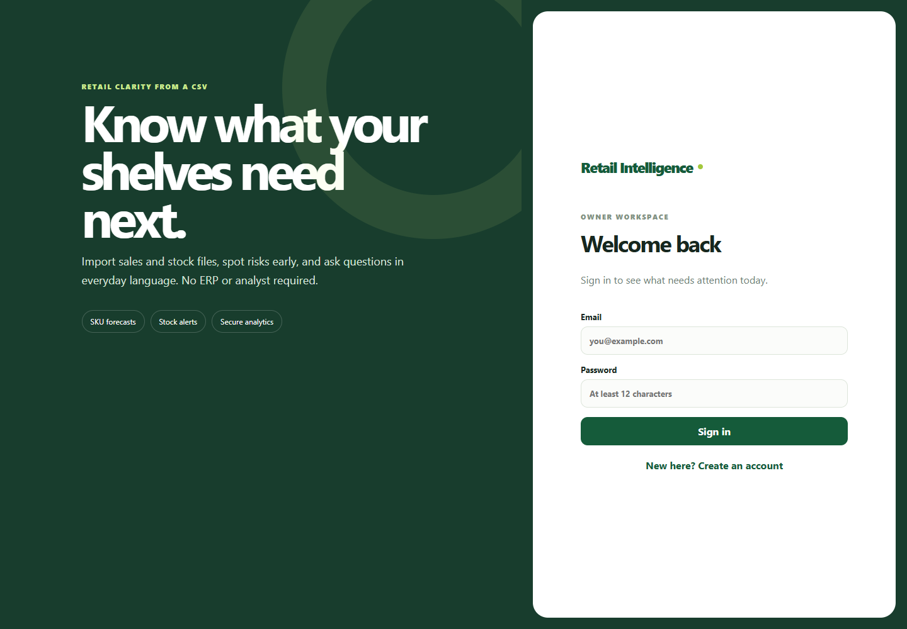
Figure 2. Owner Sign In

Owner Overview With Live Data
After authentication, the dashboard shows live organization scoped counts, sales momentum, reorder suggestions, and inventory status.
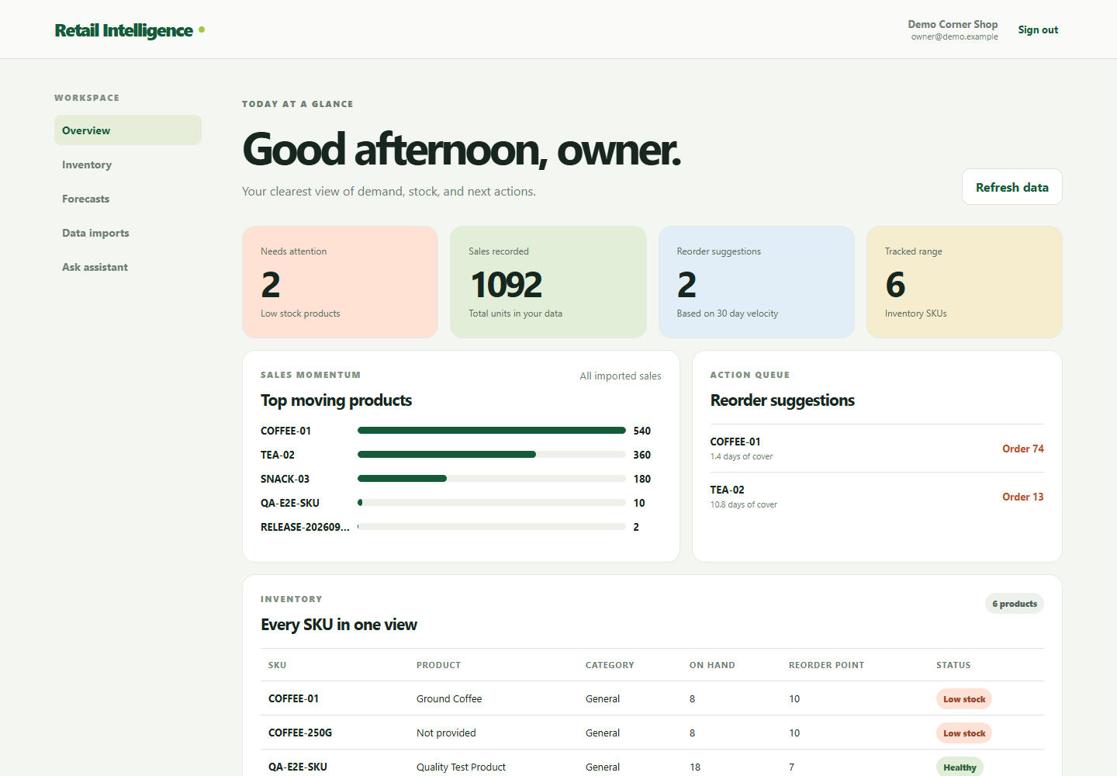
Figure 3. Owner Overview With Live Data

Inventory View
The inventory table lists six SKUs with on hand quantities, reorder points, and clear low stock or healthy status labels.
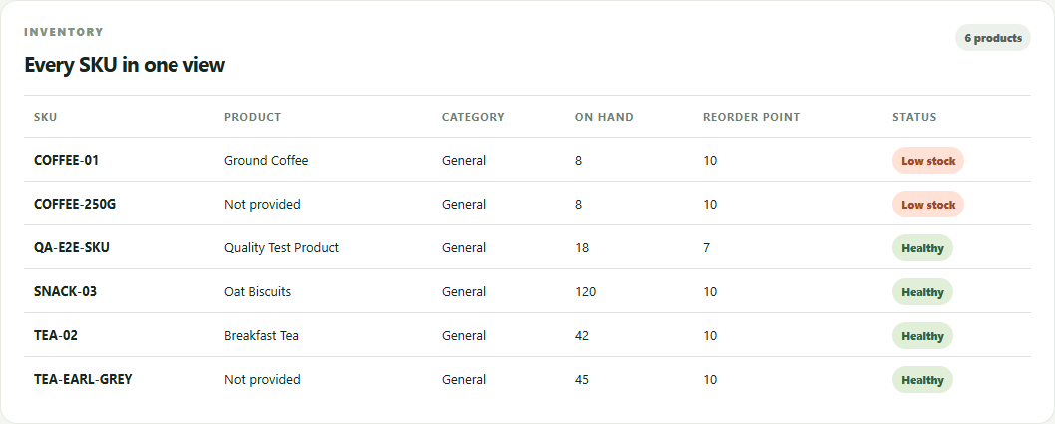
Figure 4. Inventory View

Demand Forecast
The seven day forecast displays its model, confidence, predicted units, MAE, RMSE, and daily bars.
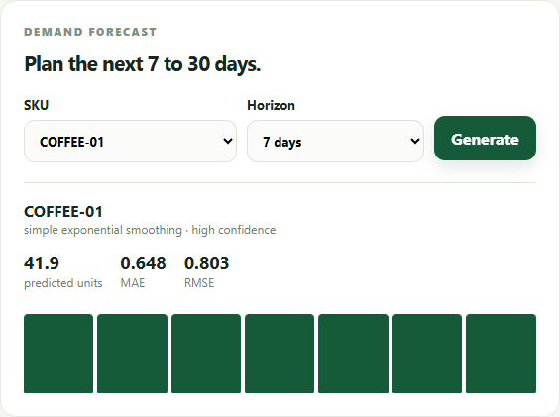
Figure 5. Demand Forecast

Secure Retail Assistant
The low stock wording regression test is visible here: two items are returned below their organization reorder points.
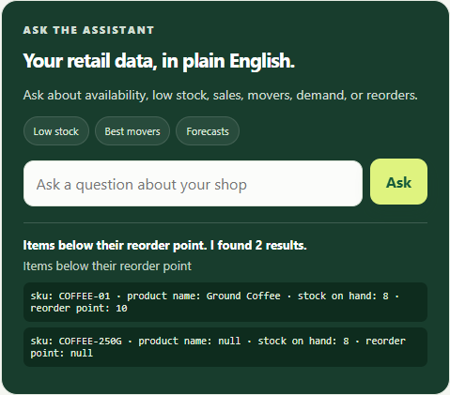
Figure 6. Secure Retail Assistant

CSV Import Entry
Owners can choose sales or inventory CSV files using the documented required column names.
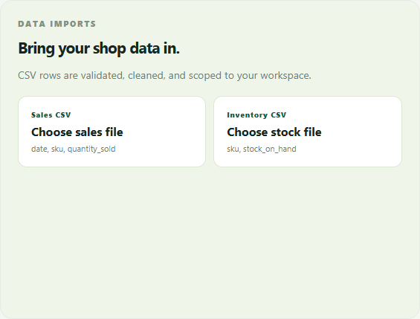
Figure 7. CSV Import Entry

Staff Sign In
The Angular staff workspace has its own clean sign in experience while using the same API and authentication contract.
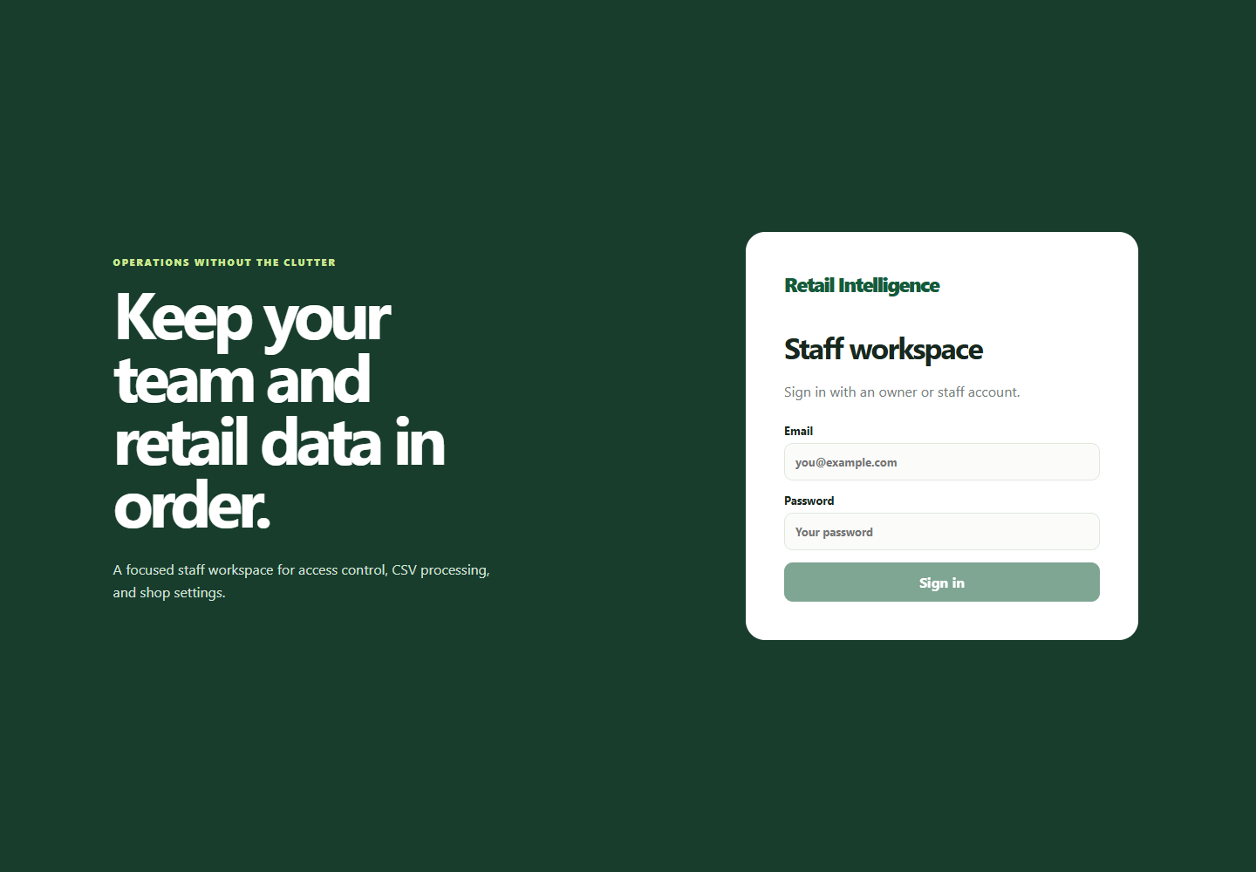
Figure 8. Staff Sign In

Staff Operations Overview
An owner in the staff workspace can create users, queue imports, review the team, and control operational settings.
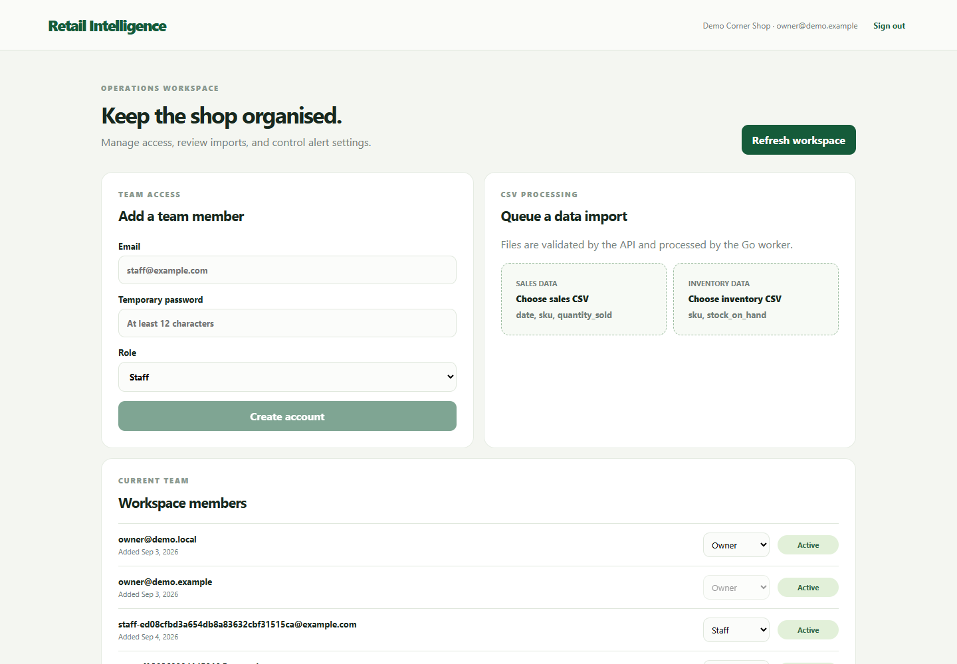
Figure 9. Staff Operations Overview

Workspace Members
The team view shows organization members, roles, and active state. The current owner account is protected from accidental self changes.
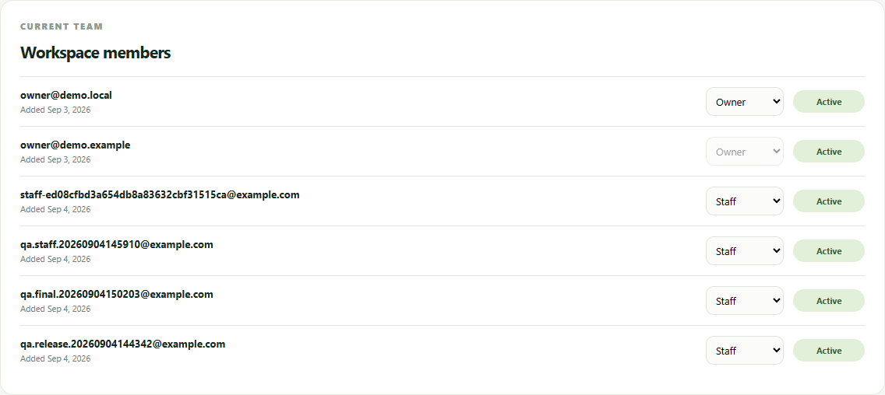
Figure 10. Workspace Members

Import Review
The latest worker processed file and earlier demo imports appear with completion status and processed row counts.
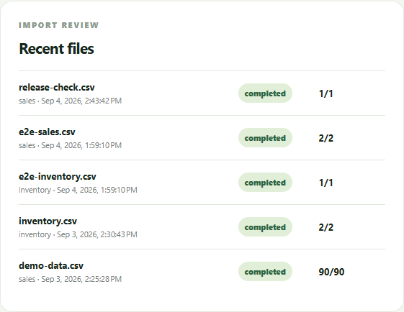
Figure 11. Import Review

Shop Settings
Owner settings control the low stock threshold, overstock day window, and weekly digest preference.
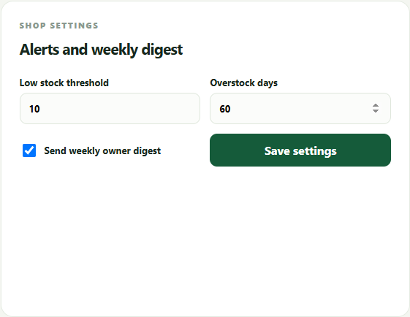
Figure 12. Shop Settings

Interactive API Documentation
FastAPI exposes an OpenAPI 3.1 interface with authentication, users, settings, uploads, analytics, forecasts, chat, health, and metrics routes.
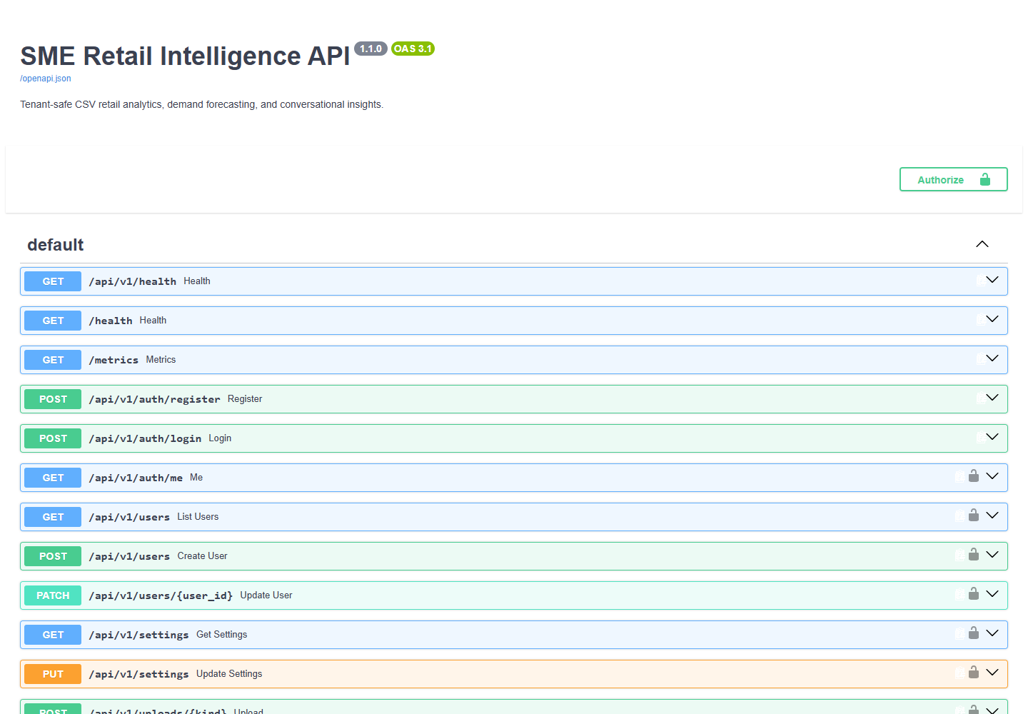
Figure 13. Interactive API Documentation

API Health Response
The public health route returned status ok and API version 1.1.0 after the final container rebuild.
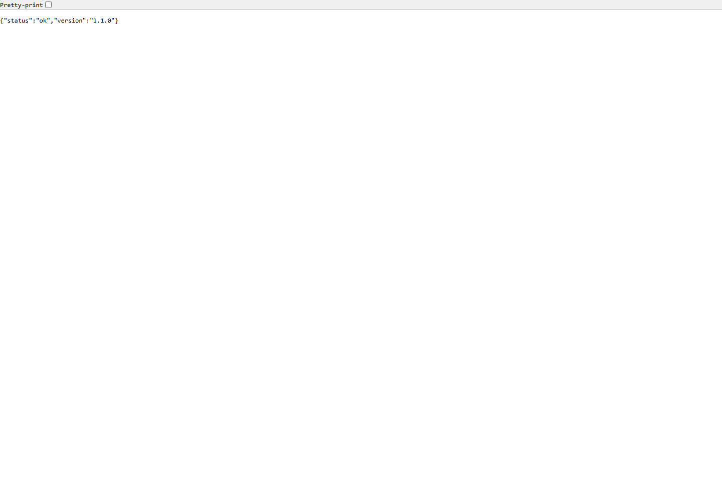
Figure 14. API Health Response

Prometheus Metrics
The metrics endpoint exports runtime values plus application counters for login, forecast, chat, upload, and registration outcomes.
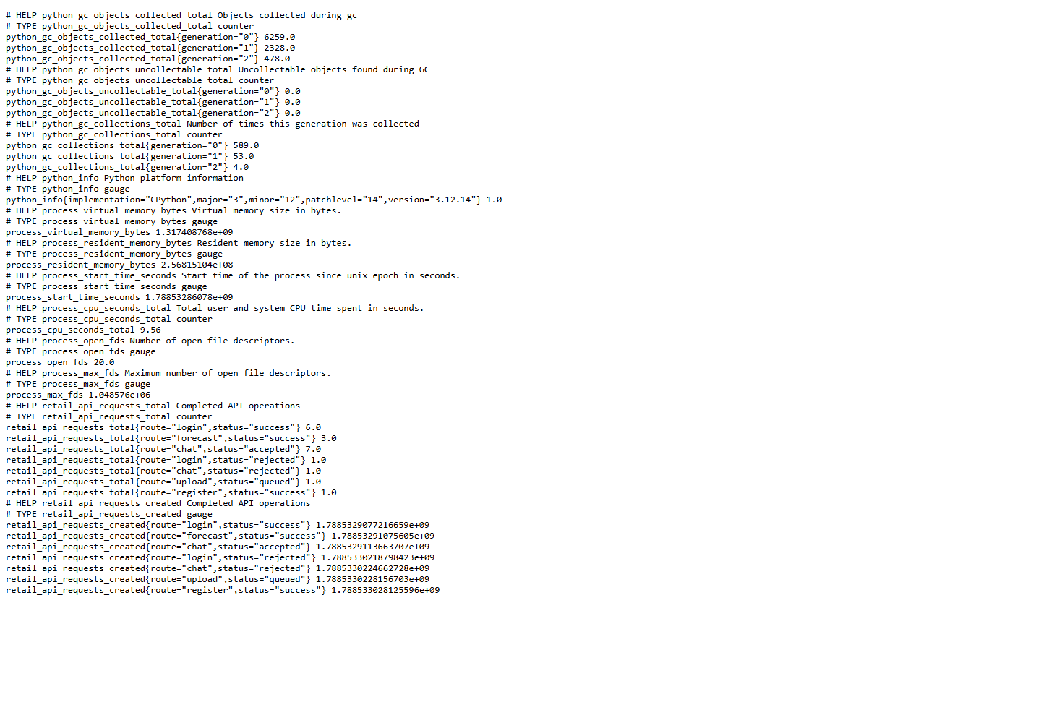
Figure 15. Prometheus Metrics

Final Release Checklist
Release item | State
Source builds | Complete
Automated tests | Complete
Dependency security scans | Complete
Authenticated browser and API journeys | Complete
Docker Compose startup and health | Complete
PostgreSQL backup and restore drill | Complete
Kubernetes schema validation | Complete
Visual evidence and report | Complete
Final GitHub commit and CI run | Performed after this report is generated
Oracle Cloud live deployment | Waiting for production accounts and secrets

Local release verification passed.

