A short example of your data to analyze:

| Sepal.Length | Sepal.Width | Petal.Length | Petal.Width | Species |
| --- | --- | --- | --- | --- |
| 5.1 | 3.5 | 1.4 | 0.2 | setosa |
| 4.9 | 3.0 | 1.4 | 0.2 | setosa |
| 4.7 | 3.2 | 1.3 | 0.2 | setosa |
| 4.6 | 3.1 | 1.5 | 0.2 | setosa |
| 5.0 | 3.6 | 1.4 | 0.2 | setosa |
| 5.4 | 3.9 | 1.7 | 0.4 | setosa |

Sepal.Length mean is: 5.84333333333333

Sepal.Length sd is: 0.828066127977863

Sepal.Length median is: 5.8

Bar Plot is:

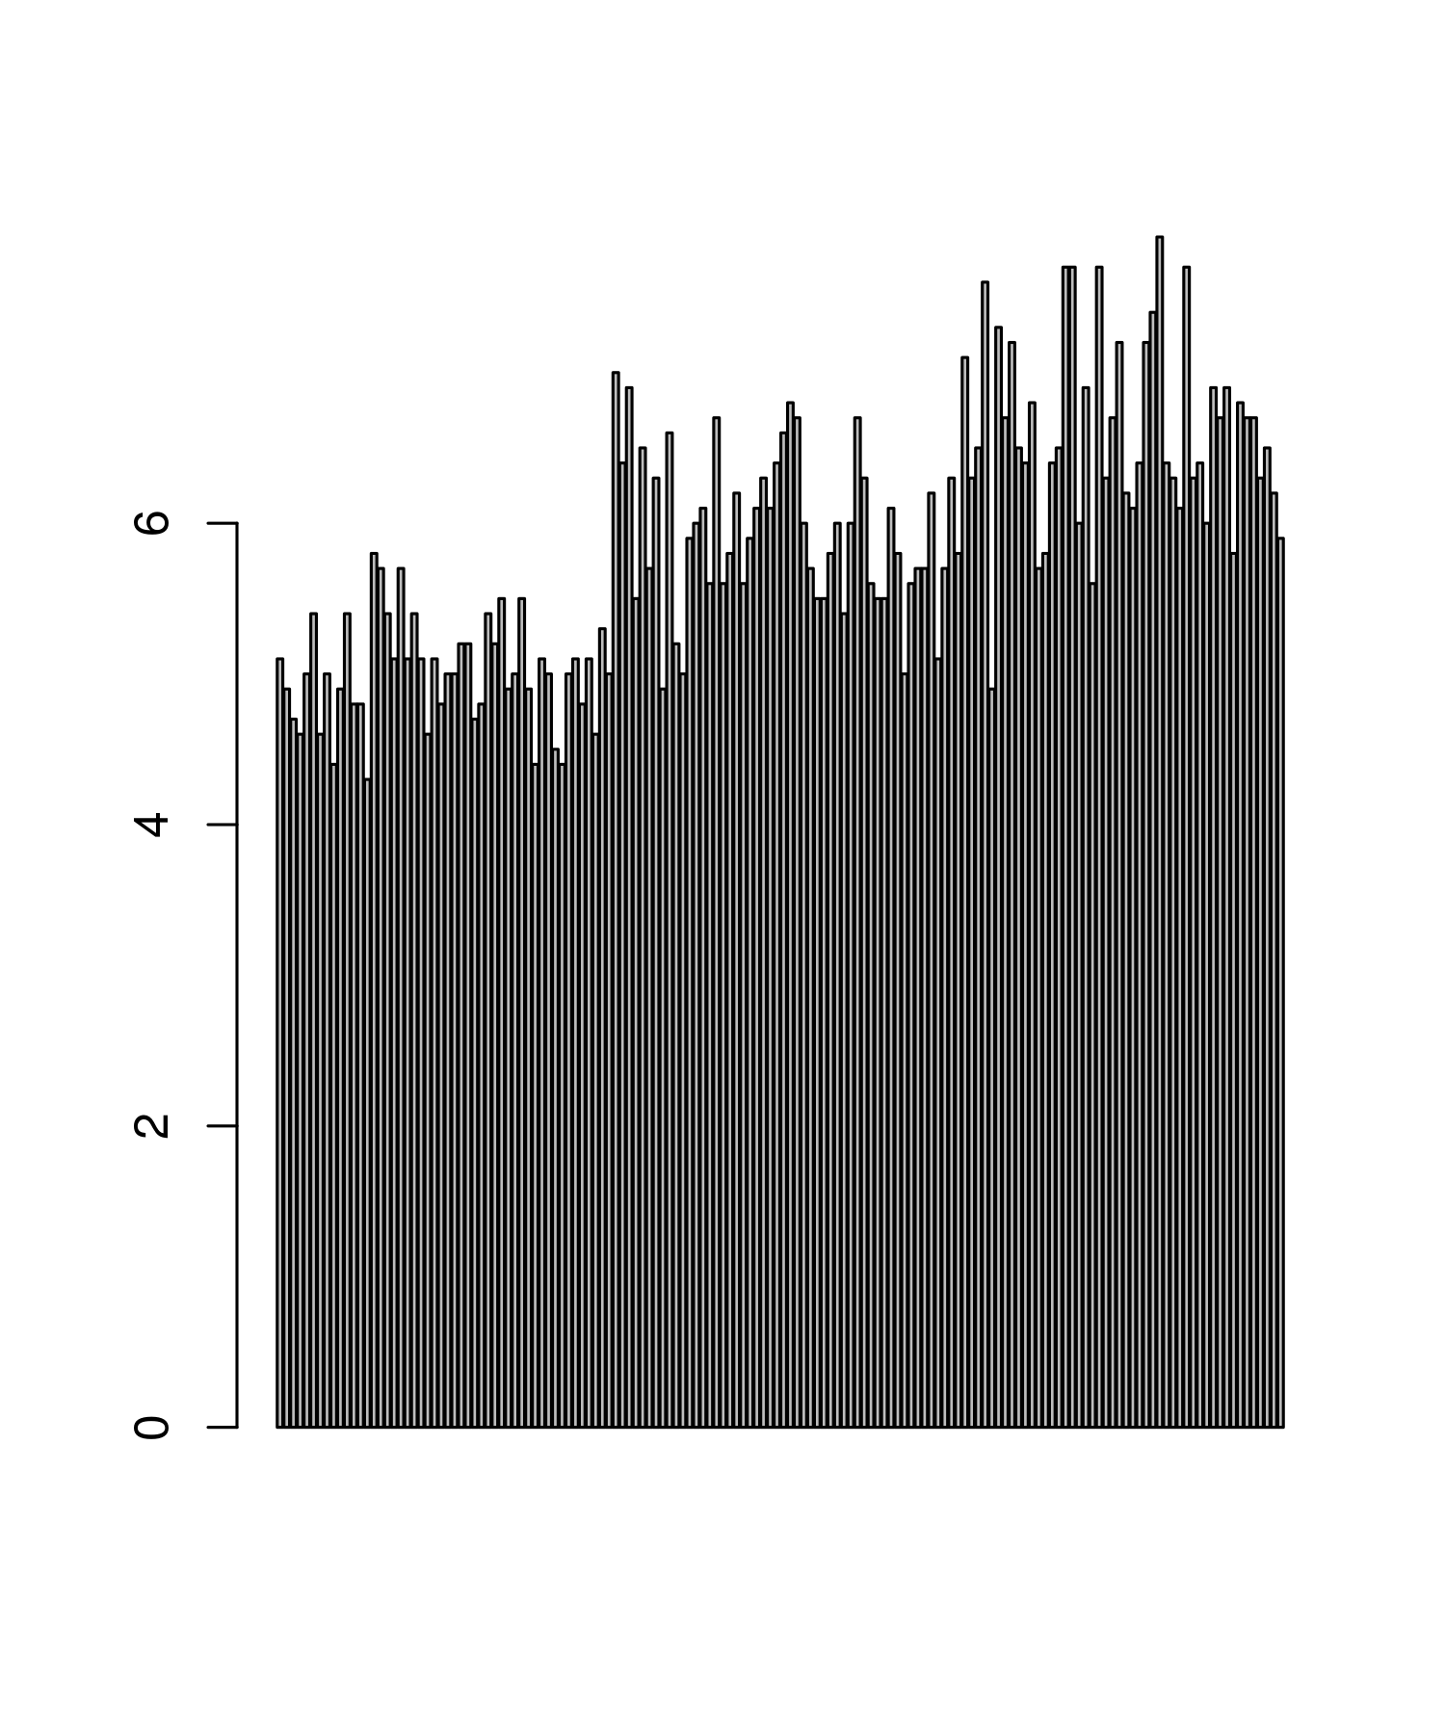

Box Plot is:

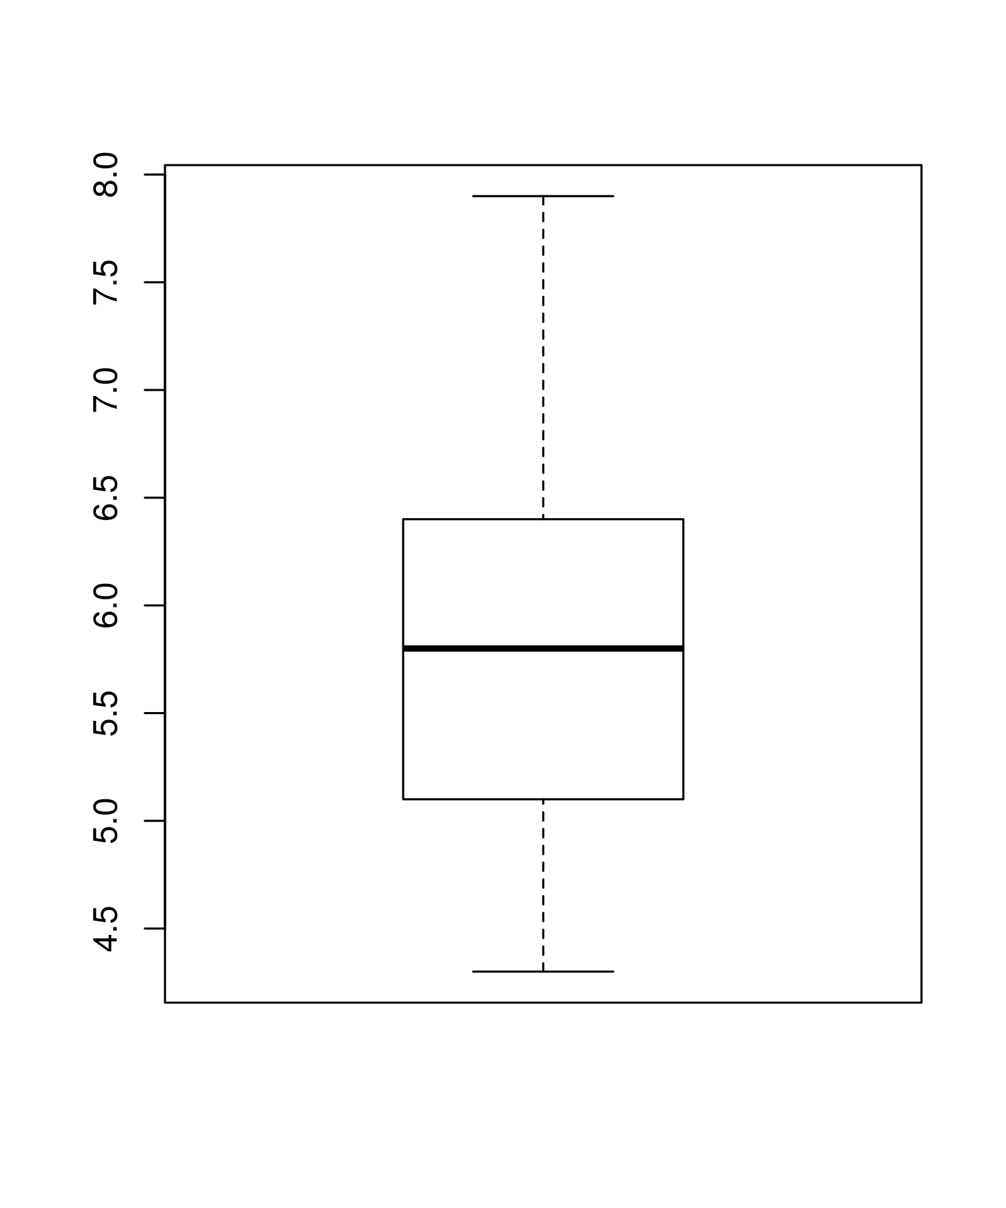

Scatter Plot is:

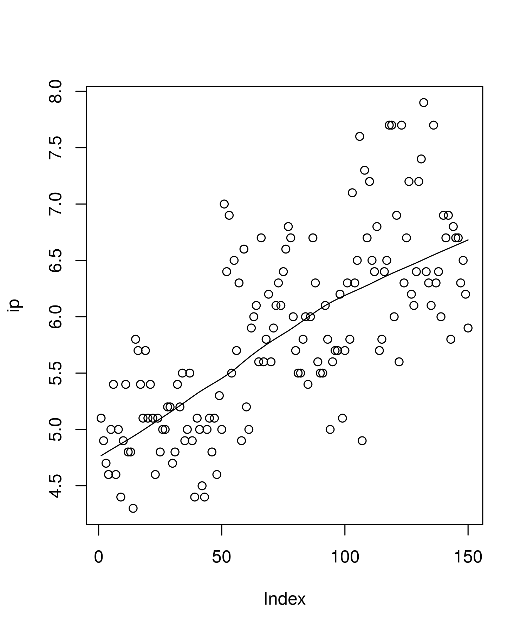

Sepal.Width mean is: 3.05733333333333

Sepal.Width sd is: 0.435866284936698

Sepal.Width median is: 3

Bar Plot is:

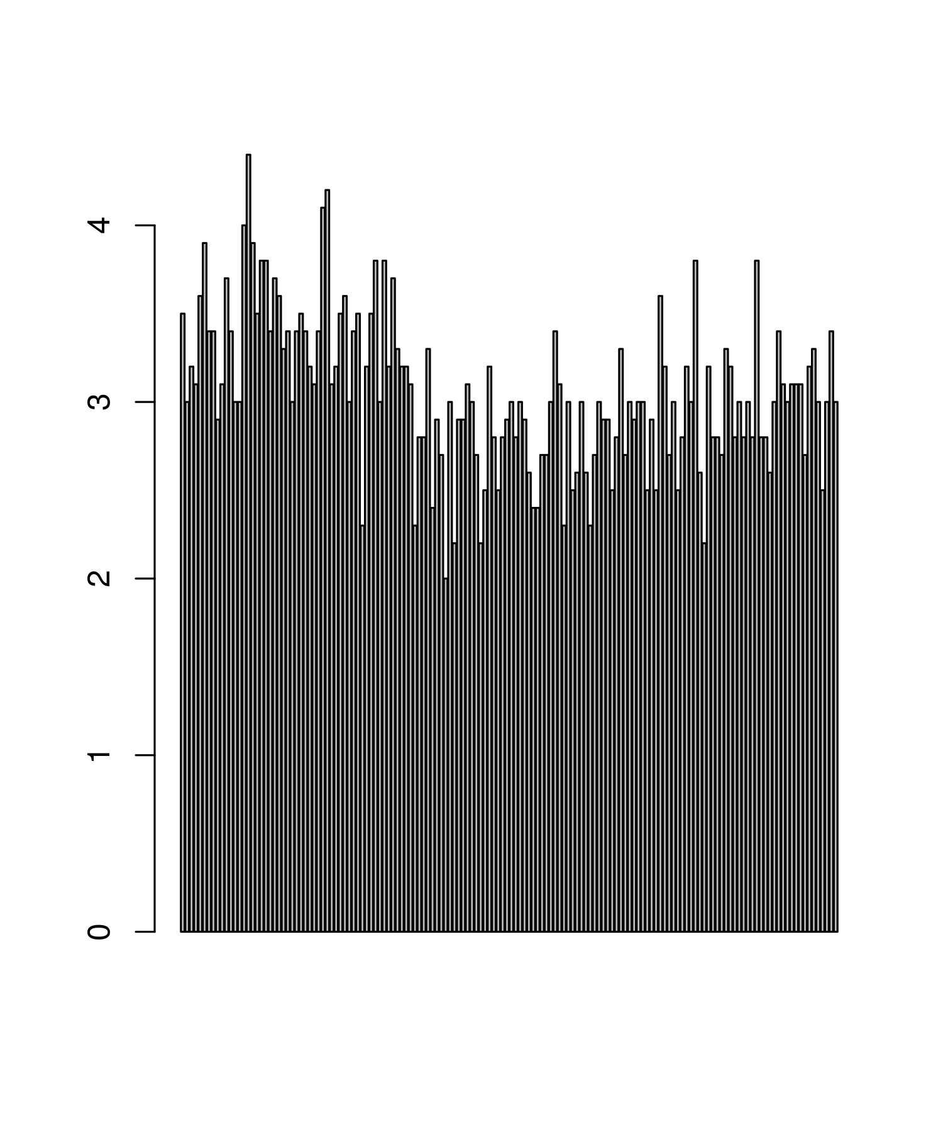

Box Plot is:

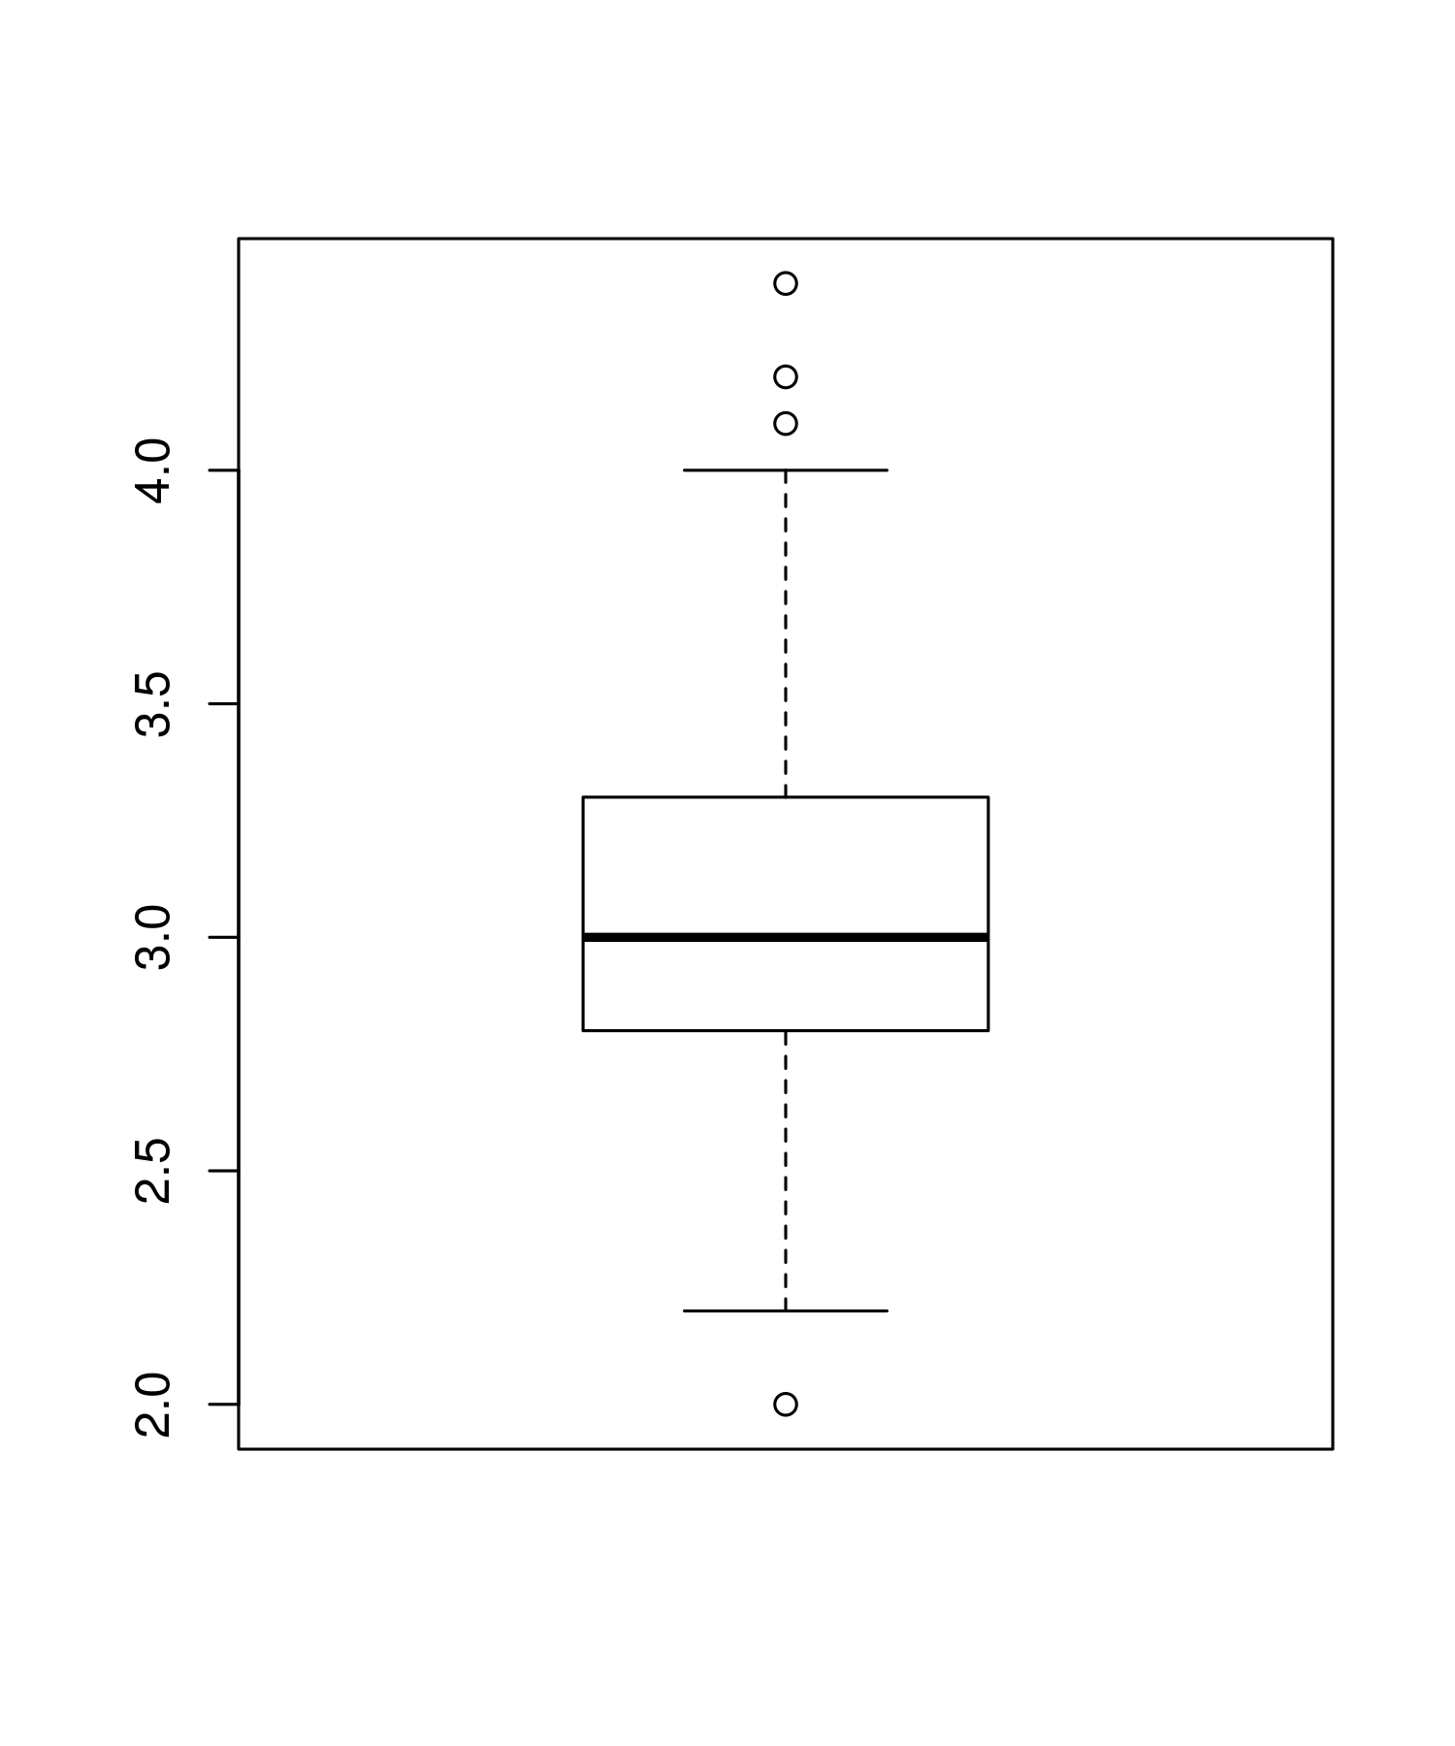

Scatter Plot is:

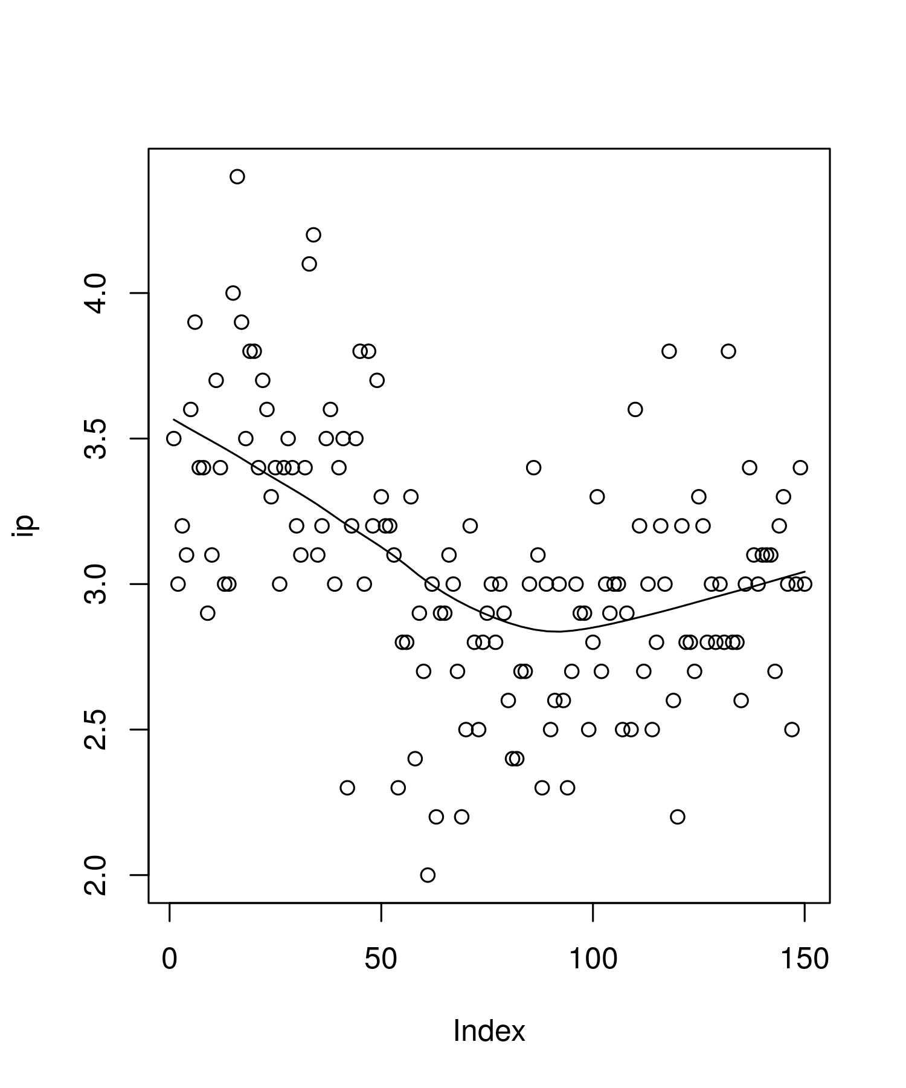

Petal.Length mean is: 3.758

Petal.Length sd is: 1.76529823325947

Petal.Length median is: 4.35

Bar Plot is:

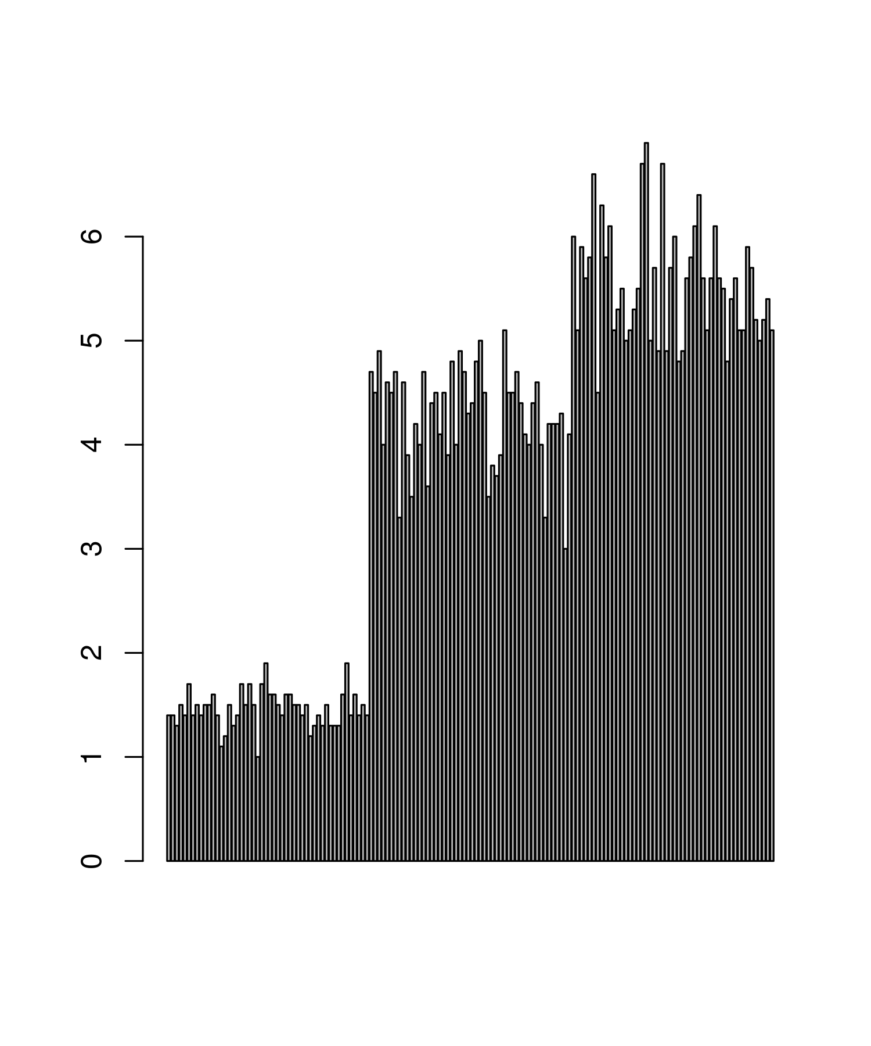

Box Plot is:

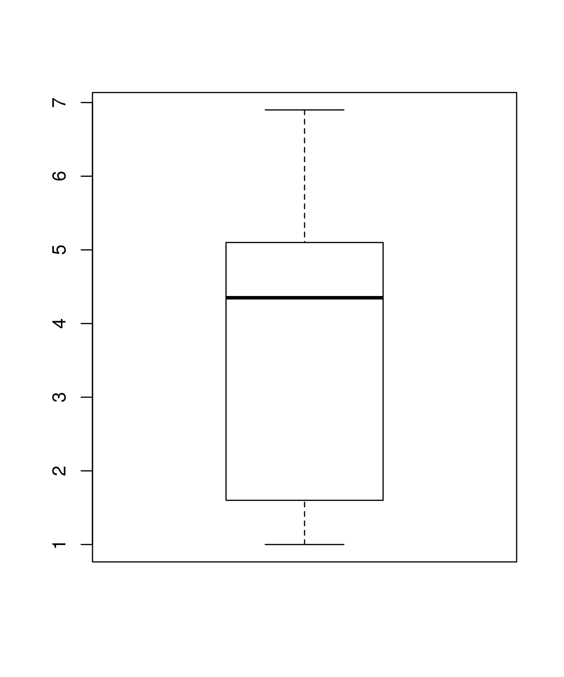

Scatter Plot is:

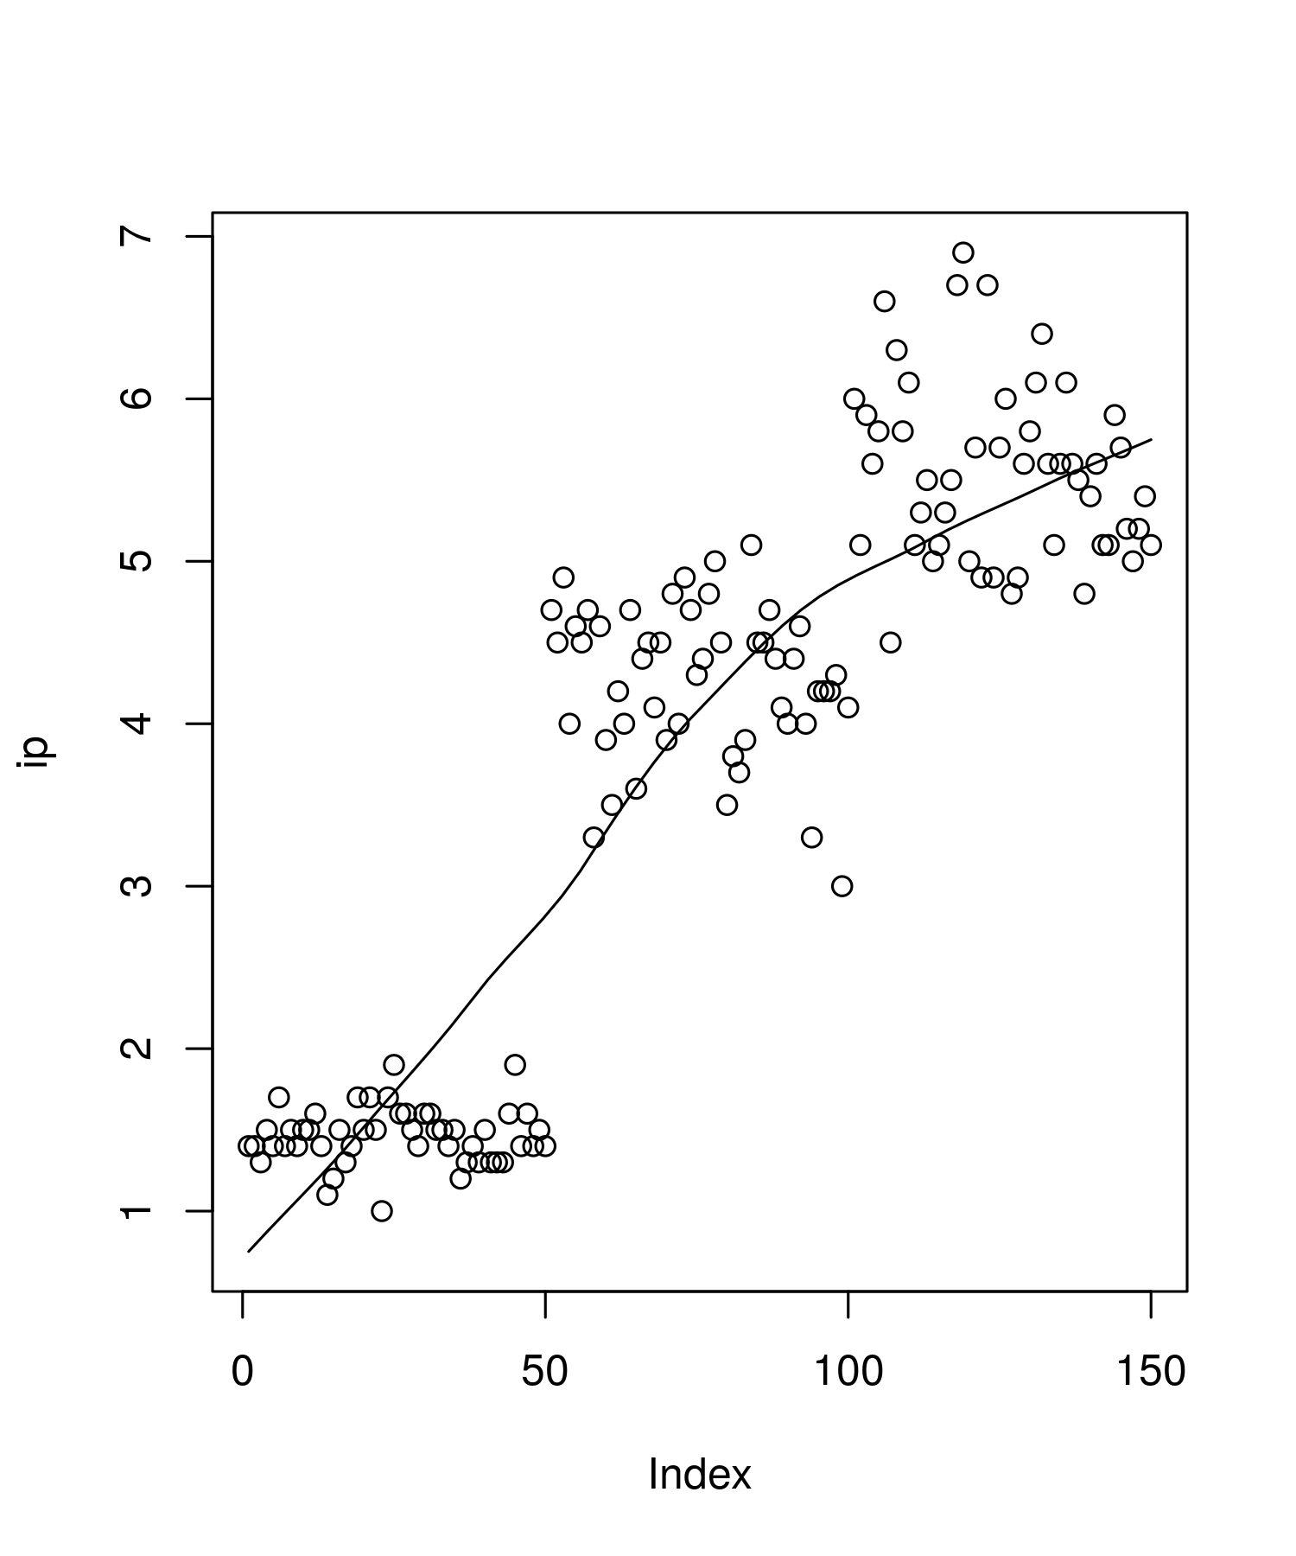

Petal.Width mean is: 1.19933333333333

Petal.Width sd is: 0.762237668960347

Petal.Width median is: 1.3

Bar Plot is:

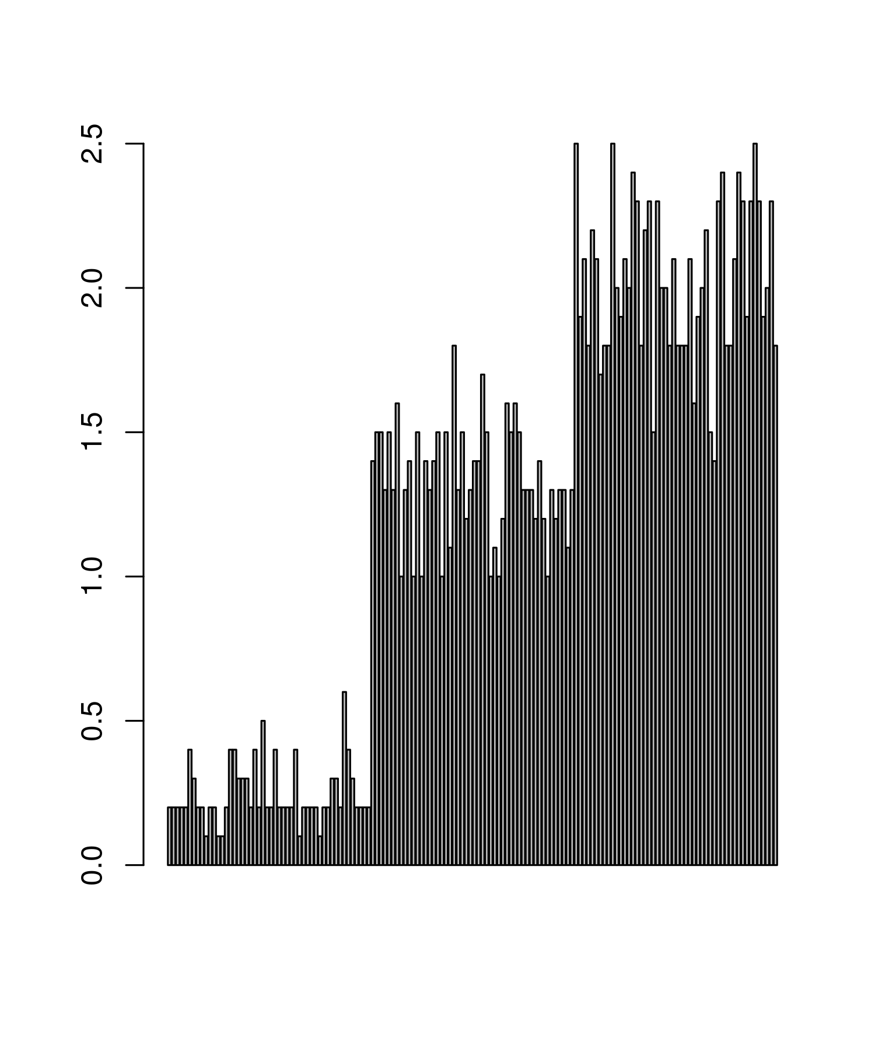

Box Plot is:

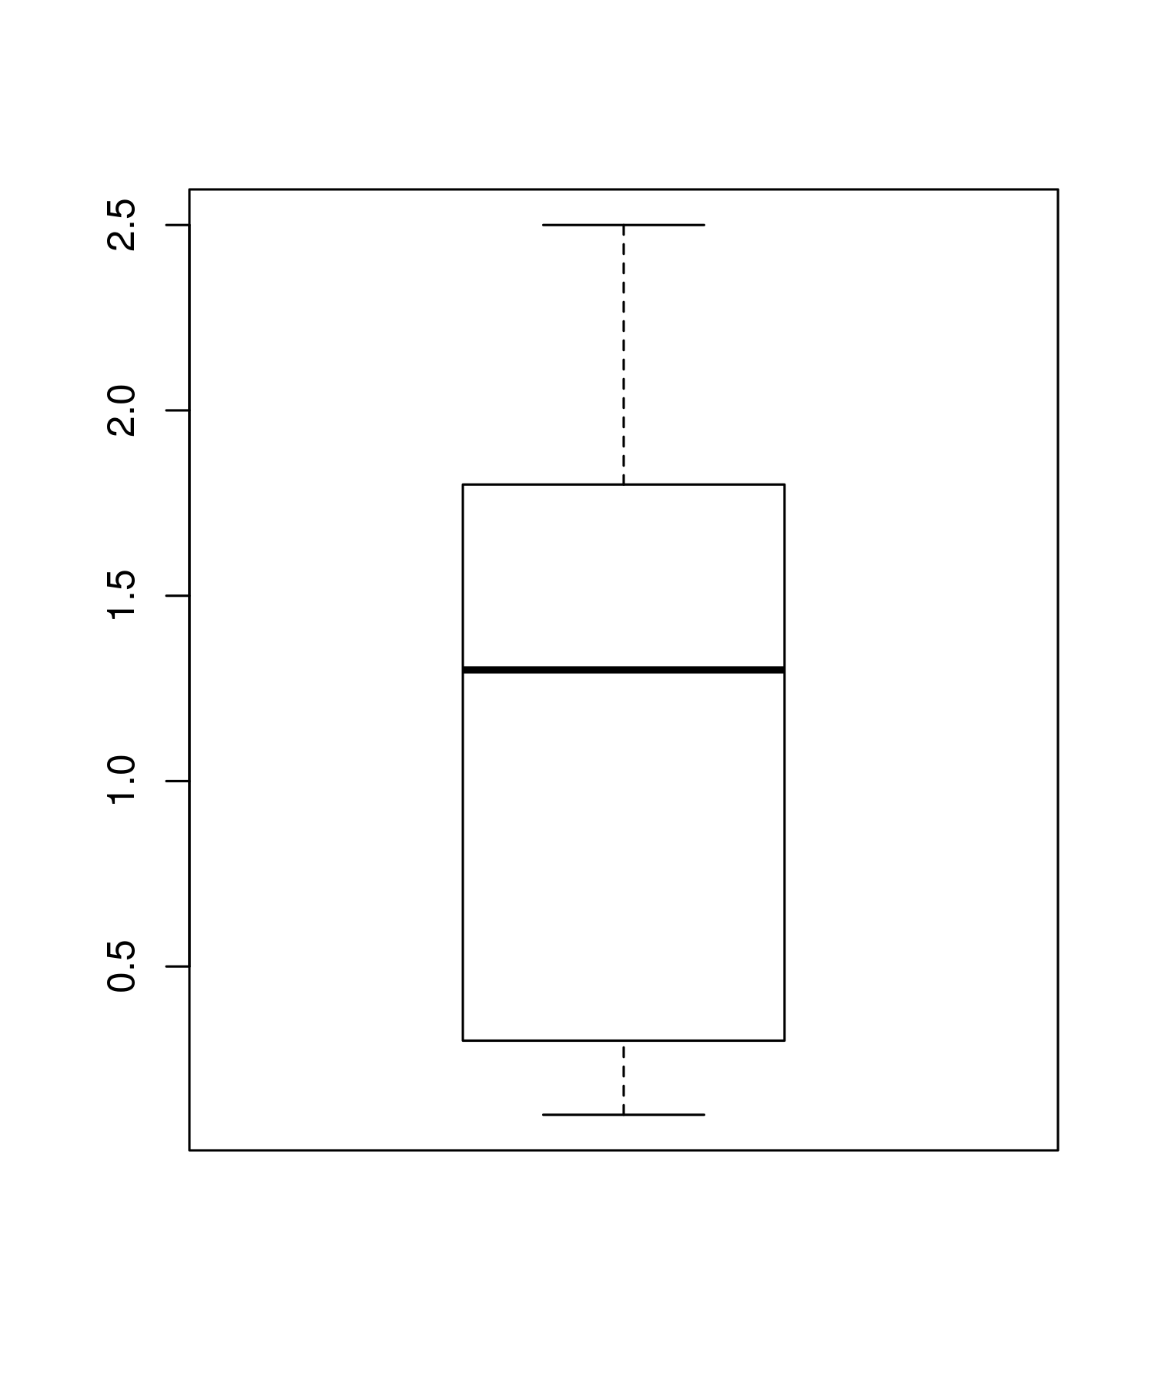

Scatter Plot is:

