S01 - DOM to Selenium Code-HW – OUTPUT
Changed to Model - openai/gpt-oss-120b

import org.openqa.selenium.By;
import org.openqa.selenium.WebDriver;
import org.openqa.selenium.WebElement;
import org.openqa.selenium.chrome.ChromeDriver;
import org.testng.annotations.AfterClass;
import org.testng.annotations.BeforeClass;
import org.testng.annotations.Test;

public class CreateLeadTest {

private WebDriver driver;

@BeforeClass
public void setUp() {
System.setProperty("webdriver.chrome.driver", "path/to/chromedriver");

driver = new ChromeDriver();
driver.manage().window().maximize();
driver.get("http://yourapplicationurl.com");
}

@Test
public void createLead() {

// Company Name
WebElement company = driver.findElement(By.name("companyName"));
company.sendKeys("Acme Corp");

// Last Name
WebElement lastName = driver.findElement(By.name("lastName"));
lastName.sendKeys("Doe");

// First Name
WebElement firstName = driver.findElement(By.name("firstName"));
firstName.sendKeys("John");

// Submit Button (avoiding numeric ID)
WebElement submit = driver.findElement(
By.cssSelector("input.smallSubmit[value='Create Lead']")
);

submit.click();
}

@AfterClass
public void tearDown() {

if (driver != null) {
driver.quit();
}
}
}

S02 - TextFromImage-Url-HW – Converting to base64

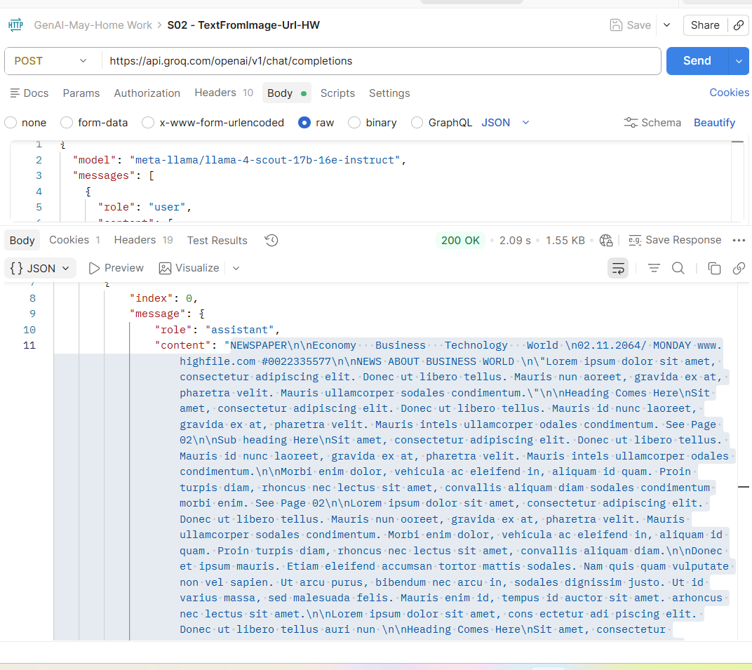

S02 - TextFromImage-Url-HW With Direct URL

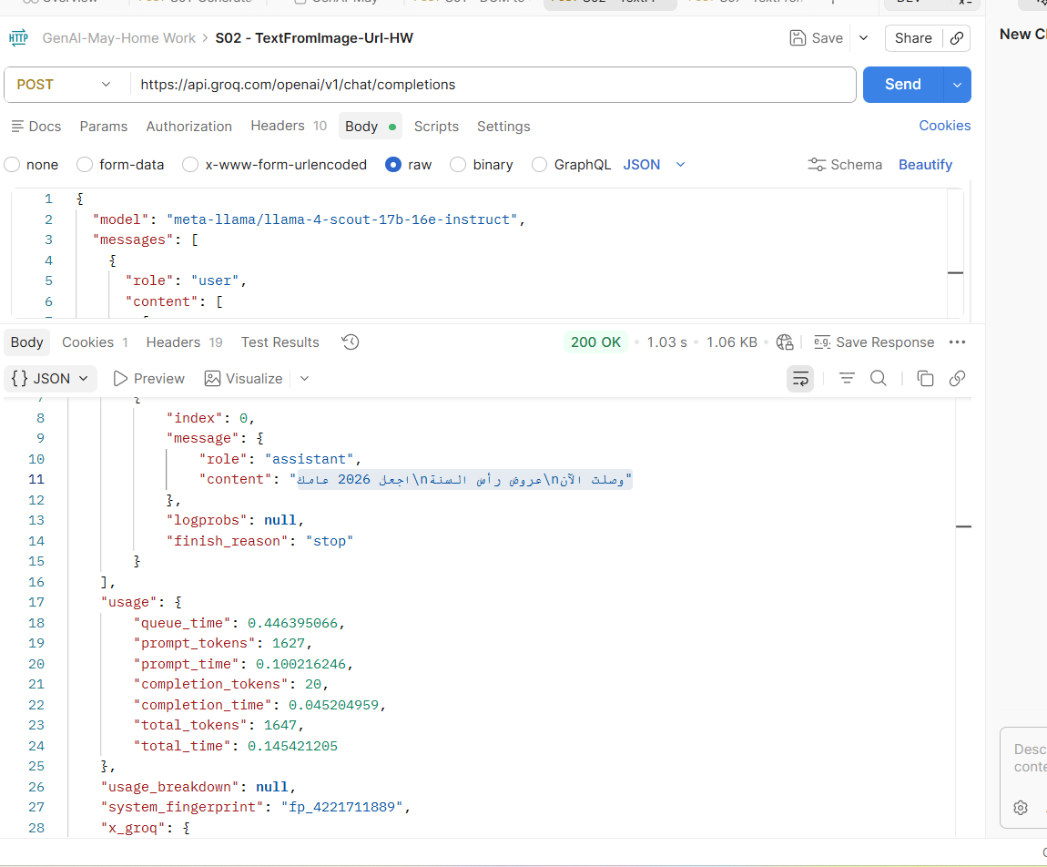

S03-WebSearch-HW

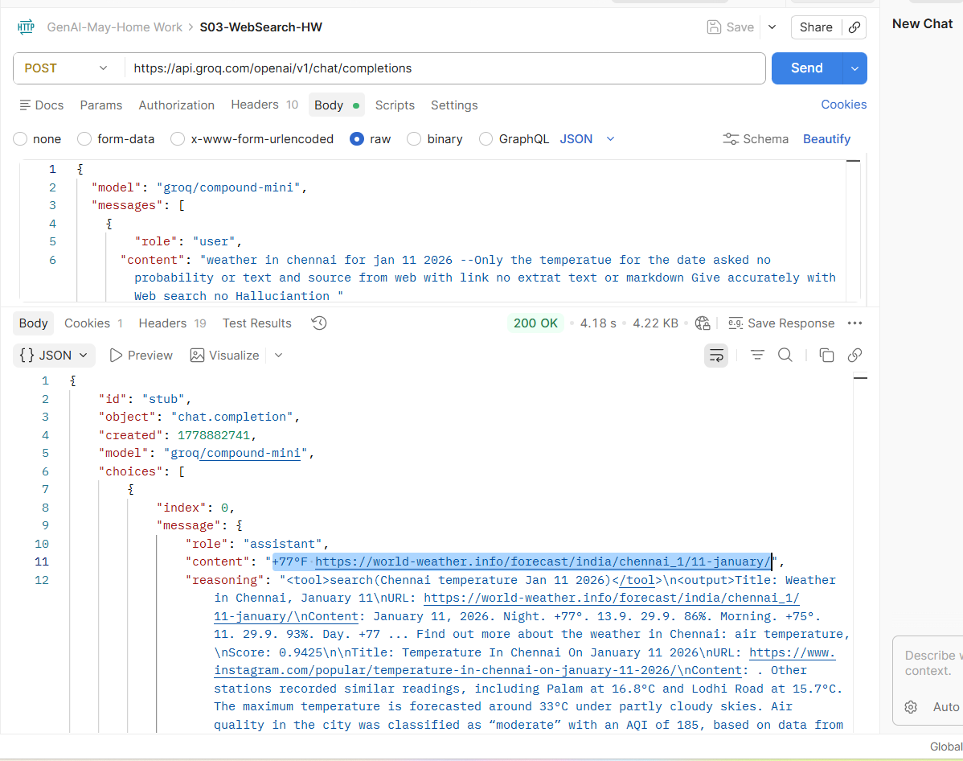

S04- MultiLingual-HW
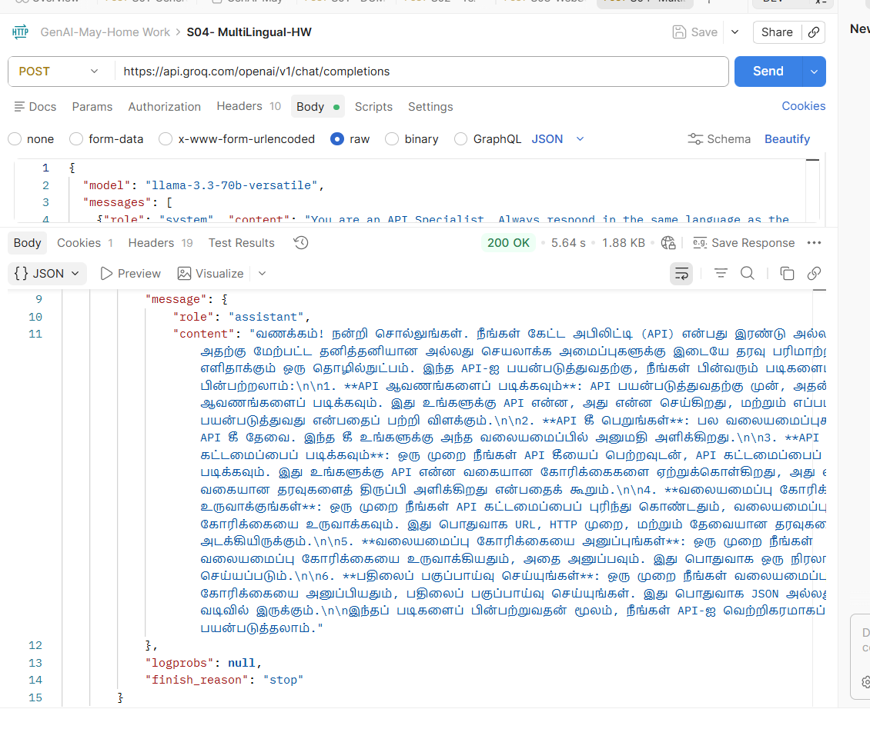
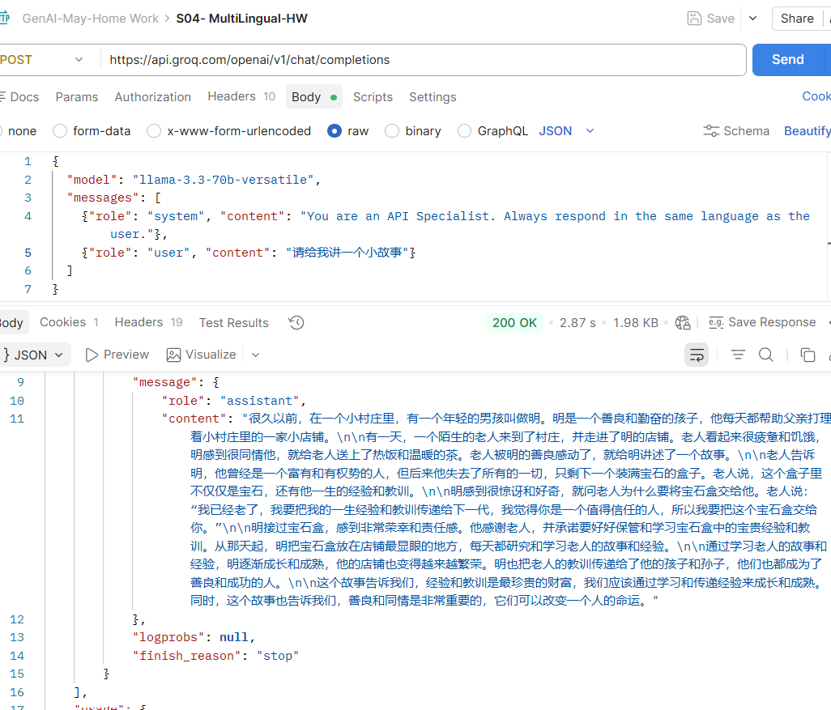
Translating to English with CHatgpt
