ITA0501-Computer Vision
1.Code:
import cv2
# Read the image
image = cv2.imread("image.jpg")
# Check whether image is loaded
if image is None:
("Error: Image not found!")
else:
# Convert image to grayscale
gray_image = cv2.cvtColor(image, cv2.COLOR_BGR2GRAY)
# Display original image
cv2.imshow("Original Image", image)
# Display grayscale image
cv2.imshow("Grayscale Image", gray_image)
# Save grayscale image
cv2.imwrite("gray_image.jpg", gray_image)
print ("Image read successfully.")
print ("Image converted to grayscale successfully.")
print ("Grayscale image saved successfully.")
# Wait and close
cv2.waitKey(0)
cv2.destroyAllWindows()
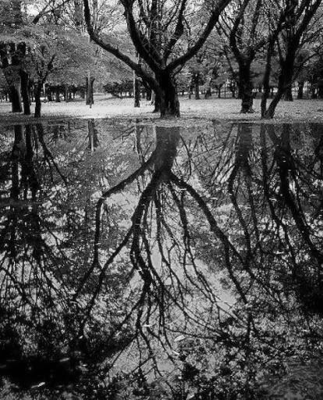
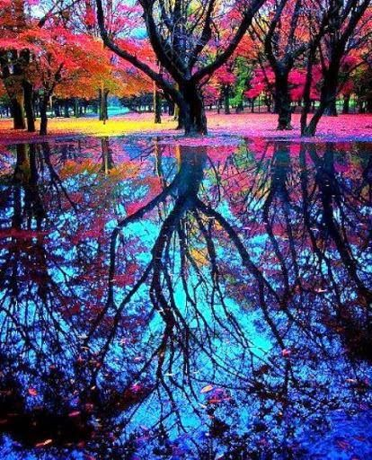
Input: Output:

