2.
Code:
import cv2
# Read the image
image = cv2.imread("image.jpg")
# Check image
if image is None:
print ("Error: Image not found!")
else:
# Apply Gaussian Blur
blurred image = cv2.GaussianBlur(image, (15, 15), 0)
# Display images
cv2.imshow("Original Image", image)
cv2.imshow("Gaussian Blurred Image", blurred_image)
# Save blurred image
cv2.imwrite("blurred_image.jpg", blurred image)
print ("Image read successfully.")
print ("Gaussian Blur applied successfully.")
print ("Blurred image saved successfully.")
cv2.waitKey(0)
cv2.destroyAllWindows()
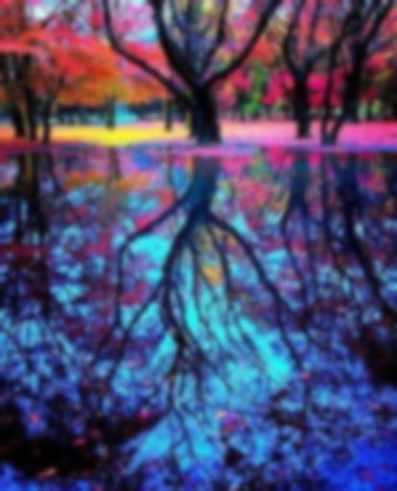
Input: Output:
