4.code
import cv2
# Read the image
image = cv2.imread("image.jpg")
# Check whether image is loaded
if image is None:
print ("Error: Image not found!")
else:
# Convert image to grayscale
gray_image = cv2.cvtColor(image, cv2.COLOR_BGR2GRAY)
# Apply histogram equalization
equalized_image = cv2.equalizeHist(gray_image)
# Display original grayscale image
cv2.imshow("Original Grayscale Image", gray_image)
# Display equalized image
cv2.imshow("Histogram Equalized Image", equalized_image)
# Save equalized image
cv2.imwrite("equalized_image.jpg", equalized_image)
print ("Image read successfully.")
print ("Histogram equalization applied successfully.")
print ("Equalized image saved successfully.")
cv2.waitKey(0)
cv2.destroyAllWindows()
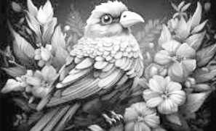
Input: Output:
