7.Code:
import cv2
from tkinter import Tk
from tkinter.filedialog import askopenfilename
# Open file selection window
Tk (). withdraw()
video_path = askopenfilename(
title="Select your video",
filetypes= [("Video Files", "*.mp4 *.avi *.mov *.mkv")]
)
# Open video
video = cv2.VideoCapture(video_path)
if not video. is Opened ():
print ("Error: Video could not be opened!")
else:
print ("Playing video in slow motion...")
# Slow Motion
while True:
ret, frame = video.read()
if not ret:
break
cv2.imshow("Slow Motion", frame)
if cv2.waitKey(100) & 0xFF == ord('q'):
break
video.release()
cv2.destroyAllWindows()
# Open video again
video = cv2.VideoCapture(video_path)

print("Playing video in fast motion...")
# Fast Motion
while True:
ret, frame = video.read()
if not ret:
break
cv2.imshow("Fast Motion", frame)
if cv2.waitKey(20) & 0xFF == ord('q'):
break
video.release()
cv2.destroyAllWindows()
print("Video processing completed.")
Input:
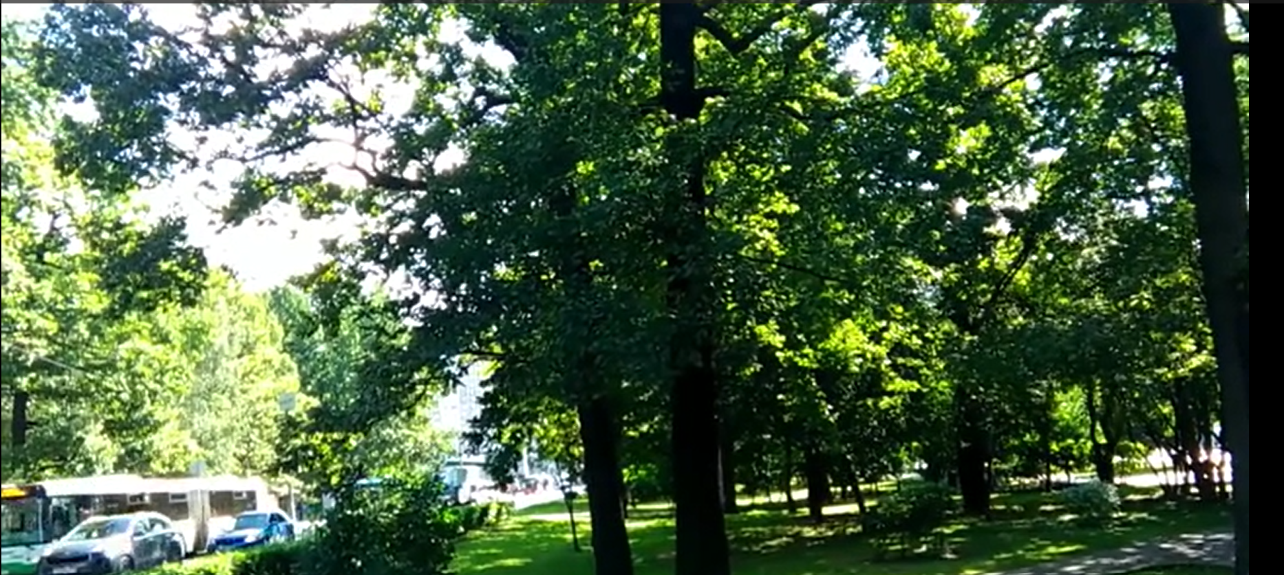
Output:
