ITA0501-Computer Vision

11. 180-Degree Rotation Clockwise
Aim
To perform a 180-degree clockwise rotation on the given image using OpenCV.
Algorithm
- Read the image.
- Rotate the image by 180 degrees.
- Display the original and rotated images.
- Save the rotated image.
Code
import cv2
image = cv2.imread("image.jpg")
if image is None:
print ("Error: Image not found!")
else:
rotated = cv2.rotate(image, cv2.ROTATE_180)
cv2.imshow("Original Image", image)
cv2.imshow("180 Degree Rotated Image", rotated)
cv2.imwrite("rotated_180.jpg", rotated)
print ("180 degree rotation completed.")
cv2.waitKey(0)
cv2.destroyAllWindows()

Input:
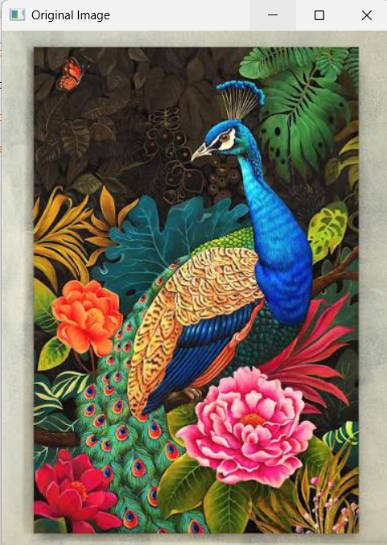
Output:
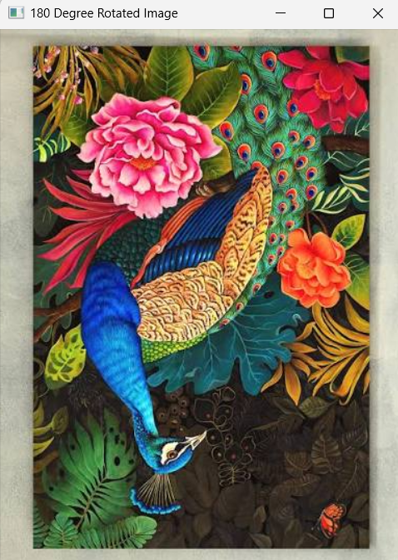
Result
Thus, the image was successfully rotated by 180 degrees using OpenCV.

12. 270-Degree Rotation Clockwise
Aim
To perform a 270-degree clockwise rotation on the given image using OpenCV.
Algorithm
- Read the image.
- Rotate the image by 270 degrees clockwise.
- Display the original and rotated images.
- Save the rotated image.
Code:
import cv2
image = cv2.imread("image.jpg")
if image is None:
print ("Error: Image not found!")
else:
rotated = cv2.rotate(image, cv2.ROTATE_90_COUNTERCLOCKWISE)
cv2.imshow("Original Image", image)
cv2.imshow("270 Degree Clockwise Image", rotated)
cv2.imwrite("rotated_270.jpg", rotated)
print ("270 degree clockwise rotation completed.")
cv2.waitKey(0)
cv2.destroyAllWindows()

Input:
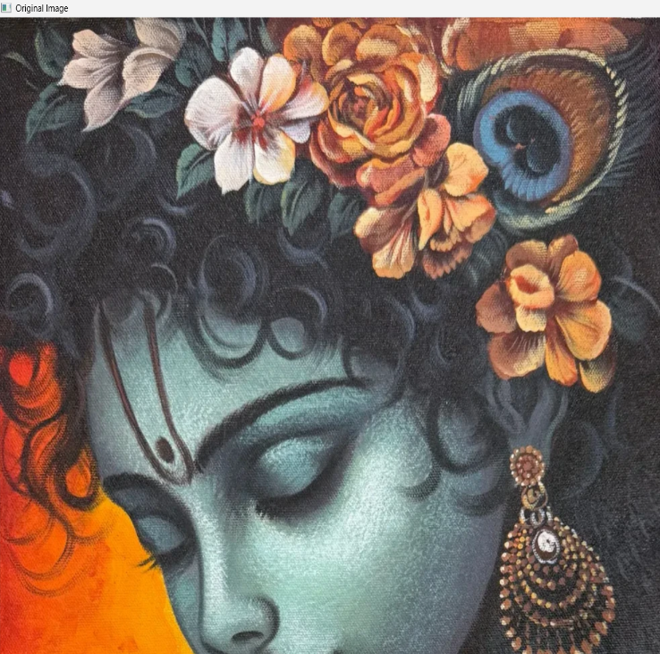

Output:
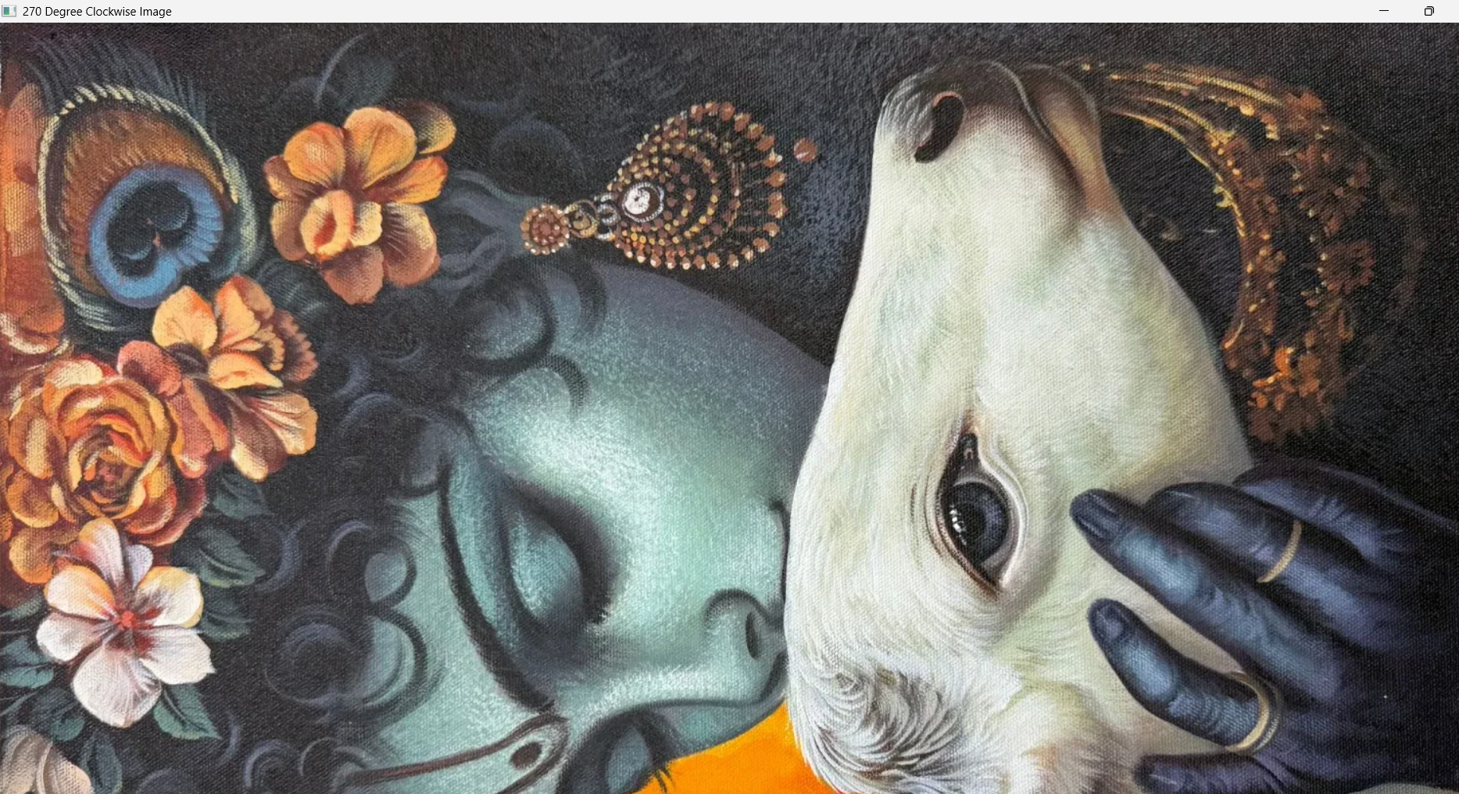

Result
Thus, the image was successfully rotated by 270 degrees clockwise using OpenCV.

13. Affine Transformation
Aim
To perform Affine Transformation on the given image using Python and OpenCV.
Algorithm
- Read the image.
- Select three points from the original image.
- Define three destination points.
- Create the affine transformation matrix.
- Apply the transformation.
- Display the original and transformed images.
Code:
import cv2
import numpy as np
image = cv2.imread("image.jpg")
if image is None:
print("Error: Image not found!")
else:
rows, cols = image.shape[:2]
points1 = np.float32([
[50, 50],
[200, 50],
[50, 200]
])
points2 = np.float32([
[10, 100],
[200, 50],
[100, 250]
])

matrix = cv2.getAffineTransform(points1, points2)
transformed = cv2.warpAffine(image, matrix, (cols, rows))
cv2.imshow("Original Image", image)
cv2.imshow("Affine Transformed Image", transformed)
cv2.imwrite("affine_image.jpg", transformed)
print("Affine transformation completed.")
cv2.waitKey(0)
cv2.destroyAllWindows()
Input:
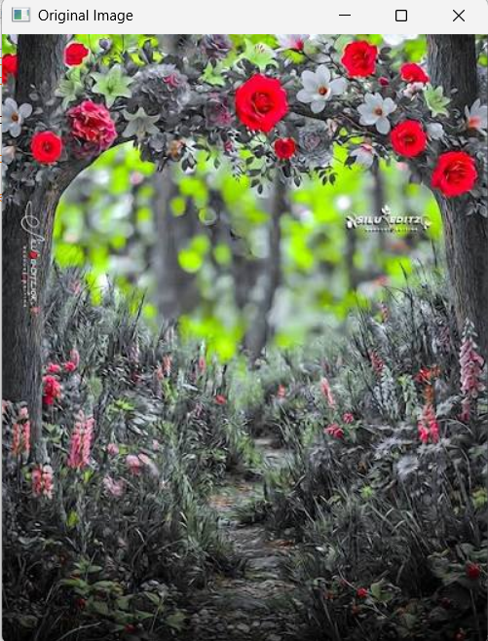

Output:
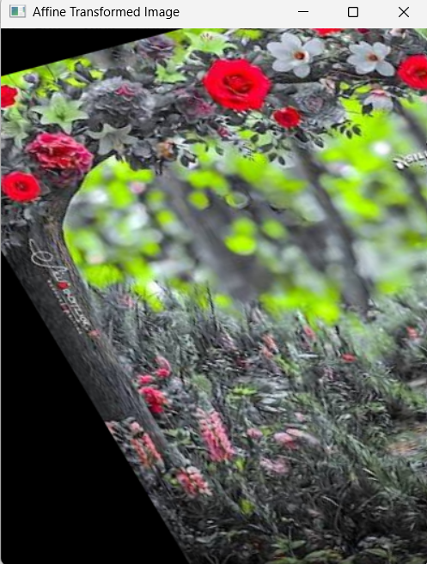
Result:
Thus, Affine Transformation was successfully performed using OpenCV.

14. Perspective Transformation
Aim
To perform Perspective Transformation on the given image using Python and OpenCV.
Algorithm
- Read the image.
- Select four points from the image.
- Define four destination points.
- Calculate the perspective transformation matrix.
- Apply the transformation.
- Display the transformed image.

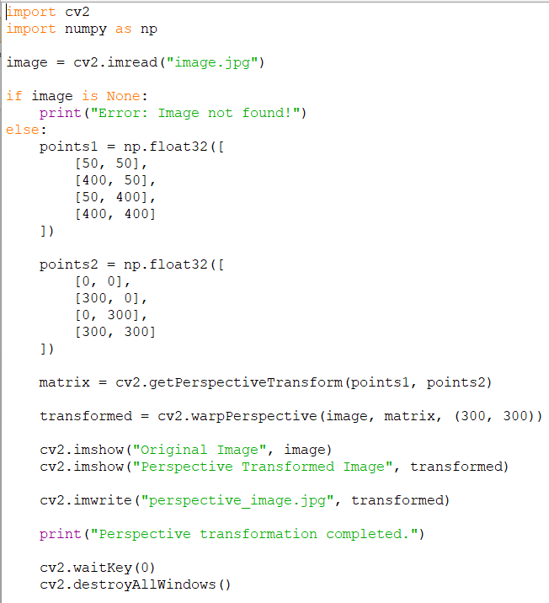
Code

Input:
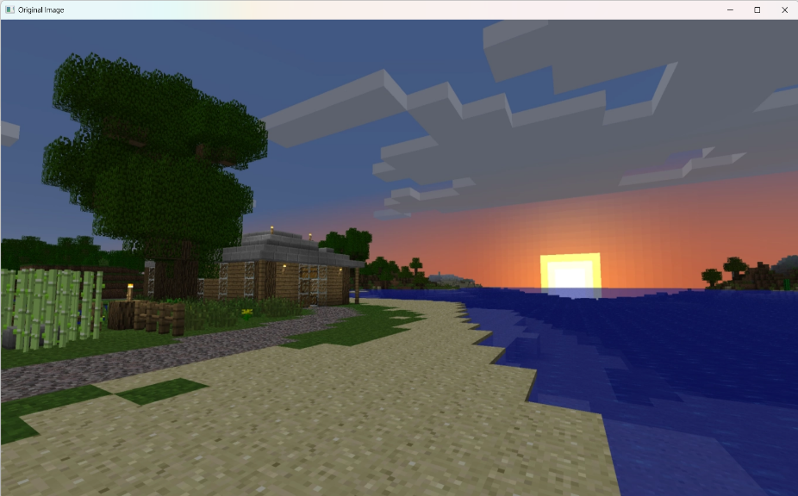

Output:
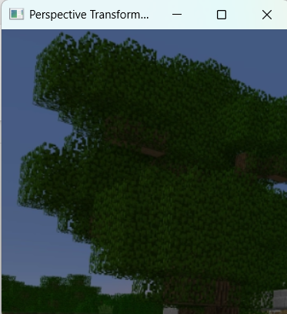
Result
Thus, Perspective Transformation was successfully performed using OpenCV.

15. Harris Corner Detection
Aim
To read an image in Python and detect corners using Harris Corner Detection.
Algorithm
- Read the image.
- Convert the image to grayscale.
- Apply Harris Corner Detection.
- Mark the detected corners.
- Display the result.
- Save the output image.

Code
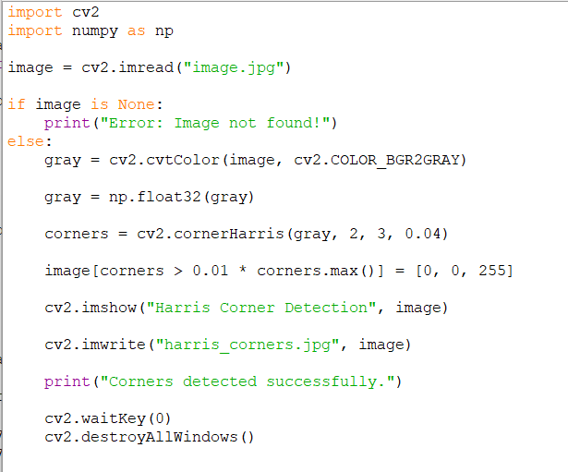
Input:

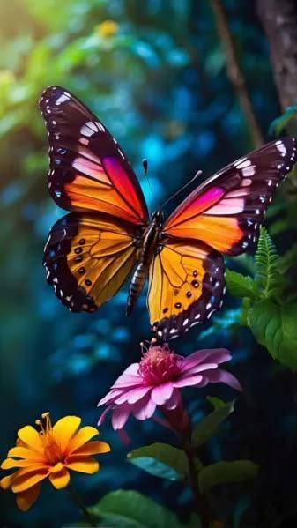
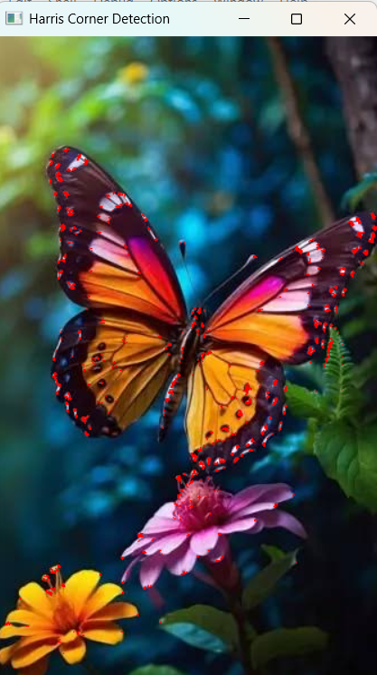
Output:

Result
Thus, the corners in the given image were successfully detected using Harris Corner Detection.

16. Sobel Algorithm
Aim: To apply the Sobel algorithm to filter an input image using OpenCV.
Algorithm:
- Read the input image.
- Convert it into grayscale.
- Apply Sobel filtering in X and Y directions.
- Display and save the output.
Code:
import cv2
image = cv2.imread("image.jpg")
if image is None:
print ("Image not found!")
else:
gray = cv2.cvtColor(image, cv2.COLOR_BGR2GRAY)
sx = cv2.Sobel(gray, cv2.CV_64F, 1, 0, ksize=3)
sy = cv2.Sobel(gray, cv2.CV_64F, 0, 1, ksize=3)
sobel = cv2.convertScaleAbs(cv2.addWeighted(
cv2.convertScaleAbs(sx), 0.5,
cv2.convertScaleAbs(sy), 0.5, 0
))
cv2.imshow("Original Image", image)
cv2.imshow("Sobel Image", sobel)
cv2.imwrite("sobel.jpg", sobel)
cv2.waitKey(0)
cv2.destroyAllWindows()

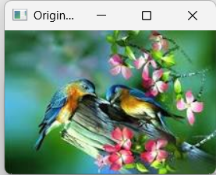
Input:

Output:
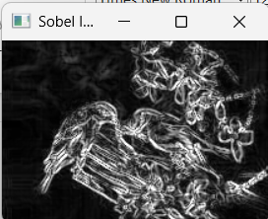
Result:
Thus, the Sobel algorithm was successfully implemented using OpenCV.
17. Image Watermarking
Aim: To insert a watermark into an original image using OpenCV.
Algorithm:
- Read the original image.
- Add watermark text to the image.
- Display the watermarked image.
- Save the output image.
Code:
import cv2
image = cv2.imread("image.jpg")
if image is None:
print("Image not found!")
else:
watermarked = image. Copy()
cv2.putText(watermarked, "SAMPLE",
(30, 60),
cv2.FONT_HERSHEY_SIMPLEX,
2, (255, 255, 255), 3)
cv2.imshow("Original Image", image)
cv2.imshow("Watermarked Image", watermarked)
cv2.imwrite("watermarked.jpg", watermarked)
cv2.waitKey(0)
cv2.destroyAllWindows()
Input:
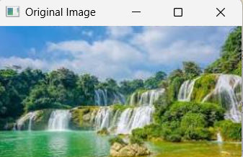
Output:
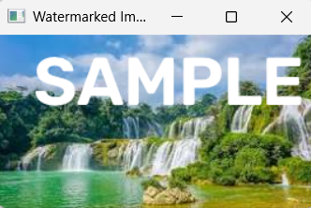
Result:
Thus, a watermark was successfully inserted into the original image using OpenCV.

18. Image Cropping, Copying and Pasting (ROI)
Aim: To crop, copy and paste a Region of Interest (ROI) from an image using OpenCV.
Algorithm:
- Read the input image.
- Select a rectangular region.
- Copy and paste the selected region.
- Display and save the result.
Code:
import cv2
image = cv2.imread("image.jpg")
if image is None:
print("Image not found!")
else:
height, width = image.shape[:2]
# Select ROI
roi = image[50:150, 50:150]
# Copy original image
result = image.copy()
# Resize ROI to fit the destination
roi = cv2.resize(roi, (100, 100))
# Paste ROI at a suitable position
x = max(0, width - 110)
y = max(0, height - 110)
result[y:y+100, x:x+100] = roi
cv2.imshow("Original Image", image)
cv2.imshow("Cropped ROI", roi)
cv2.imshow("Copy and Paste", result)
cv2.imwrite("roi.jpg", roi)
cv2.imwrite("roi_result.jpg", result)

print ("Cropping, copying and pasting completed.")
cv2.waitKey(0)
cv2.destroyAllWindows()
Input:
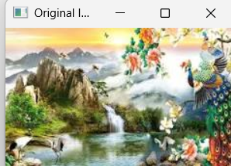
Output:
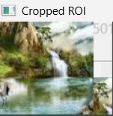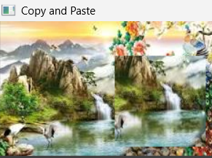
Result:
Thus, image cropping, copying and pasting were successfully performed using OpenCV.

19. Erosion Morphological Operation
Aim: To perform erosion on an image using OpenCV.
Algorithm:
- Read the image.
- Create a kernel.
- Apply erosion.
- Display and save the eroded image.

Code:
import cv2
import numpy as np
image = cv2.imread("shapes.png", 0)
if image is None:
print("Image not found!")
else:
kernel = np.ones((5, 5), np.uint8)
result = cv2.erode(image, kernel, iterations=1)
cv2.imshow("Original Image", image)
cv2.imshow("Eroded Image", result)
cv2.imwrite("erosion.jpg", result)
cv2.waitKey(0)
cv2.destroyAllWindows()
Input:
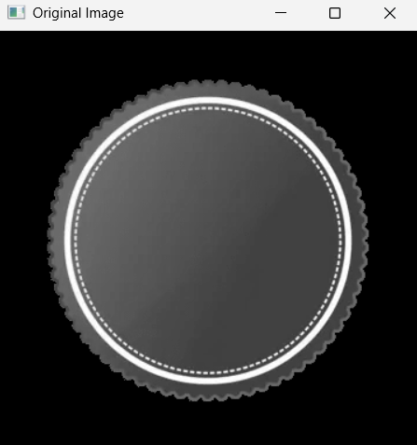
Output:
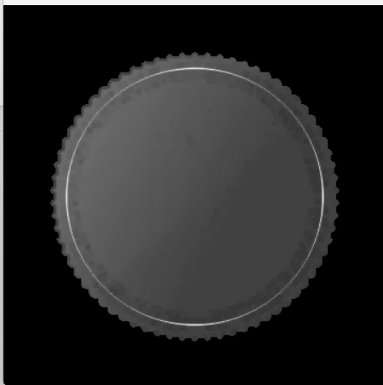
Result:
Thus, erosion was successfully performed using OpenCV.
20. Dilation Morphological Operation
Aim: To dilate the foreground regions of an image using OpenCV.
Algorithm:
- Read the image.
- Create a kernel.
- Apply dilation.
- Display and save the result.
Code:
import cv2
import NumPy as np
image = cv2.imread("shapes.png", 0)
if image is None:
print("Image not found!")
else:
kernel = np.ones((5, 5), np. uint8)
result = cv2.dilate(image, kernel, iterations=1)
cv2.imshow("Original Image", image)
cv2.imshow("Dilated Image", result)
cv2.imwrite("dilation.jpg", result)
cv2.waitKey(0)
cv2.destroyAllWindows()

Input:
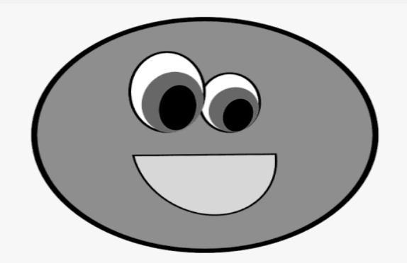

Output:
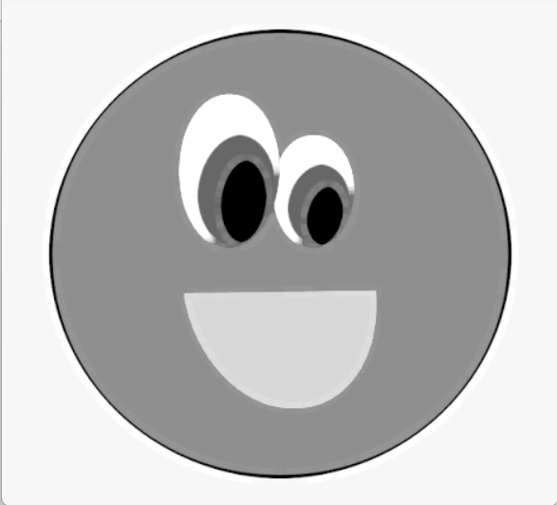
Result:
Thus, dilation was successfully performed using OpenCV.

