Network Security
First homework

Name: Sara Nikmehr
Std #: 40435091

Semester 1/ 1404-1405 (Fall 1404)
Instructor: Dr.Manavi
Homework #1: Wireshark & Protocol Analysis

Part 1: Build a Simple Login Server & Capture Username/Password

- Server Side

I create a simple server on a ubuntu machine using Golang and echo framework.
It serves an HTML login form and handles the POST request.
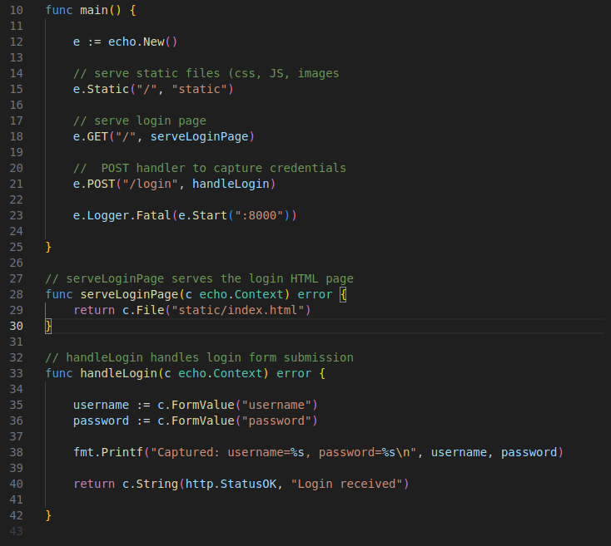
Echo sever listens on port 8000
And serves / (forms) and /login (POST handler)

I didn’t implement HTTPS.

Requirements:
You only need the Go compiler on your Linux system, which I’ve already uploaded to GitHub.

- Local Network

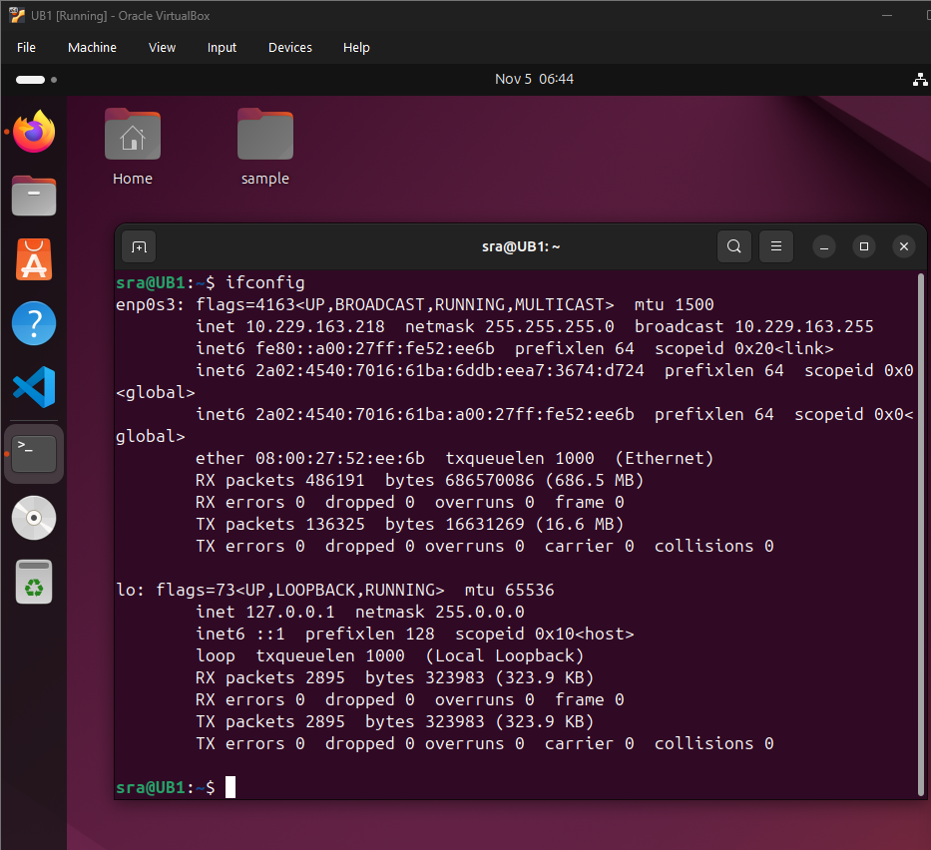
I launched an Ubuntu virtual machine, and its network type is set to bridged.

You can see its IP address in the adjacent image :

IP Address: 10.229.163.218

Both the VM and my laptop (the host) are connected to the internet through my mobile hotspot.

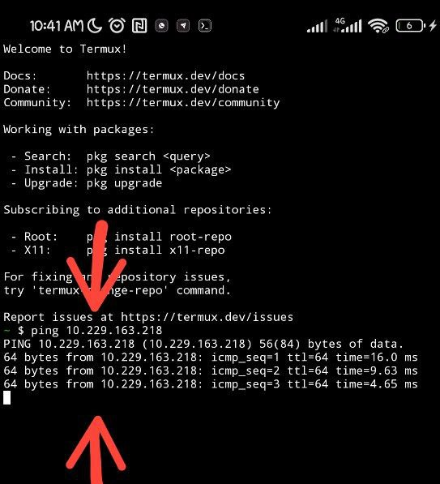

Using Termux on my Android device, I pinged the Ubuntu VM to ensure it was reachable.

The IP address of the mobile device is also shown in the image below :
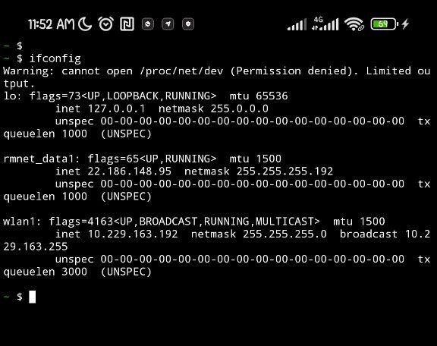
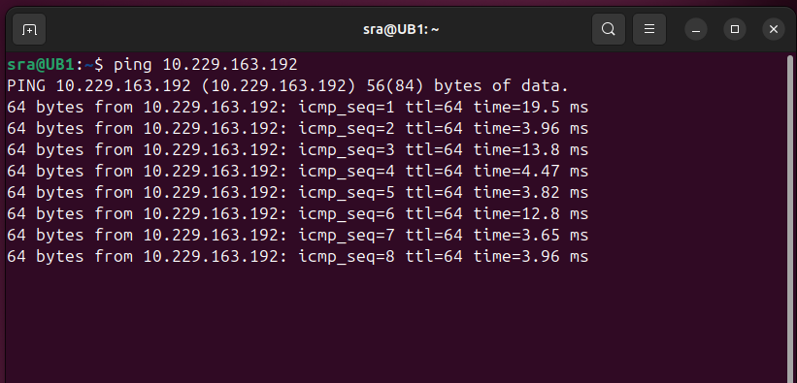
IP : 10.229.263.192

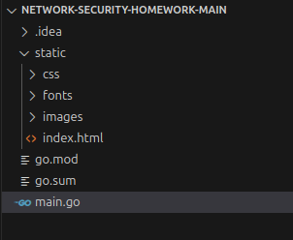
The files related to the server can be seen in the image on the right :

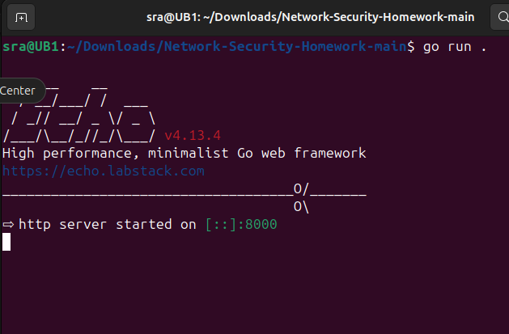
We run the server with the following command:

go run .

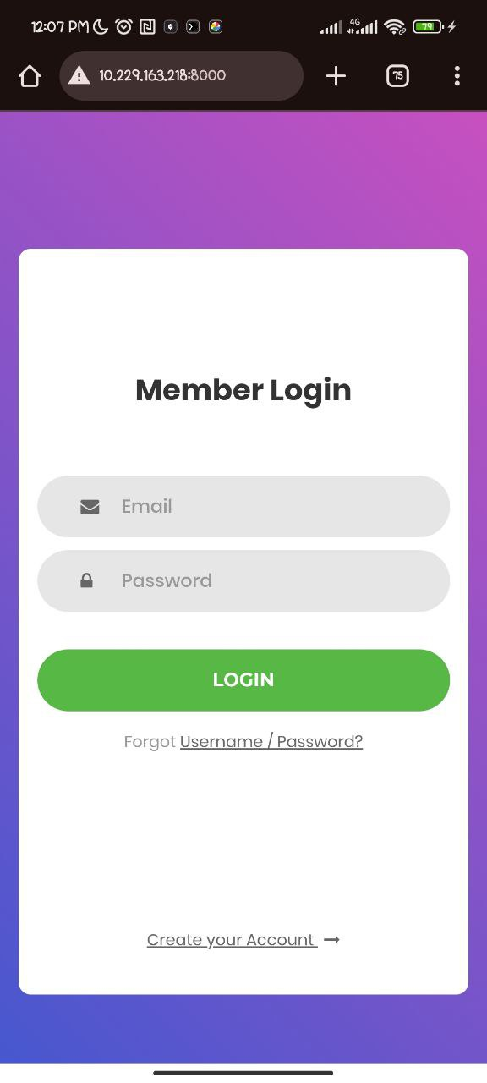
- Client side:

I entered the form’s URL in the mobile browser, but the form hasn’t been submitted yet.

I filled in the form and clicked the login button while Wireshark was capturing the network traffic on my Windows machine.

I used the following filter in Wireshark to capture the relevant packet:
http.request.method == POST
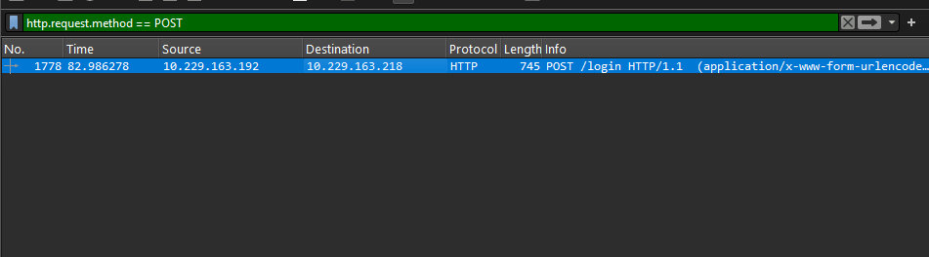

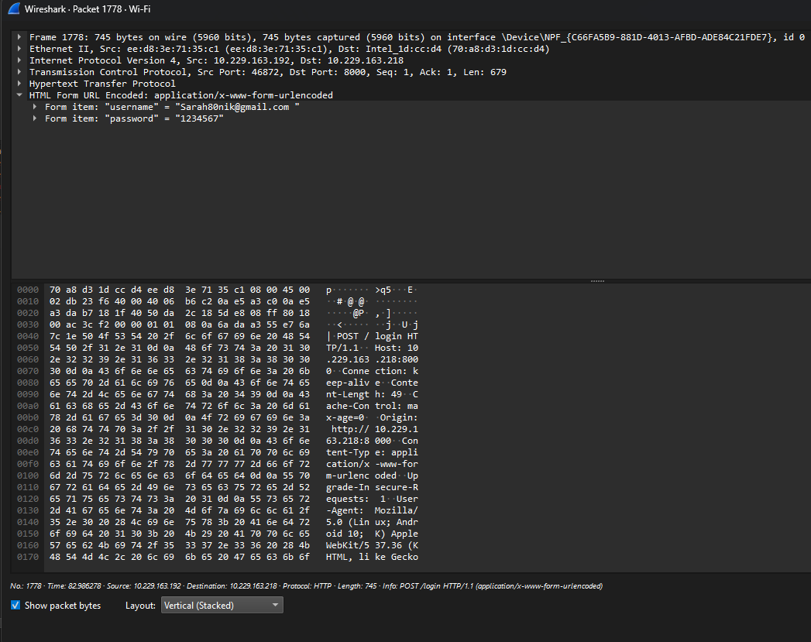

In the HTML Form URL Encoded section, you can see the data that was sent from the mobile device.

Answer for the question :

- Lack of Encryption over HTTP

- If a POST request is sent over HTTP instead of HTTPS , the data is transmitted in plain text.

- This means anyone on the network ( like a hacker on public Wi-FI) can intercept and read the data __ including passwords, credit card numbers, or personal info.

- Server-Side Vulnerabilities

- If the server doesn’t validate input properly, attackers can exploit it using:
  - SQL injection
  - Cross-site scripting (XSS)
  - Remote code execution

- • These attacks can lead to data breaches, account hijacking, or system compromise

- Unlike GET requests, POST data isn’t visible in the URL—but that doesn’t mean it’s secure.
- If the server logs POST bodies or if the frontend exposes them in JavaScript, sensitive data can still leak.

