**Saroj Banjara**

**September 20**

**TASK TWO: OPERATORS AND DECISION MAKING STATEMENT**

1. Write a program in Python to perform the following operation:

* If a number is divisible by 3 it should print “Consultadd” as a string
* If a number is divisible by 5 it should print “Python Training” as a string
* If a number is divisible by both 3 and 5 it should print “Consultadd Python Training” as a string.

num =int(input("Please enter a number: "))

if num % 3 == 0 and num % 5 == 0:

print("Consultadd python training")

elif num % 3 == 0:

print ("Consultadd")

elif num % 5 == 0:

print("Python Training")

else:

print("Please try with another number.")

2. Write a program in Python to perform the following operator based task:

* Ask user to choose the following option first:
  + If User Enter 1 - Addition
  + If User Enter 2 - Subtraction
  + If User Enter 3 - Division
  + If USer Enter 4 - Multiplication
  + If User Enter 5 - Average
* Ask user to enter the 2 numbers in a variable for first and second for the first 4 options mentioned above.
* Ask user to enter two more numbers as first1 and second2 for calculating the average as soon as user choose an option 5.
* At the end if the answer of any operation is Negative print a statement saying “Oops option X(1/2/3/4/5/) is returning the negative number”
* NOTE: At a time user can perform one action at a time.

print("Please select any option from the list below: ")

print("\t\t1 - Addition")

print("\t\t2 - Subtraction")

print("\t\t3 - Division")

print("\t\t4 - Multiplication")

print("\t\t5 - Average")

choice = input("\nEnter your choice 1/2/3/4/5 : ")

first = int(input("Enter your first number: "))

second = int(input("Enter your second number: "))

if choice == '1':

result = first + second

if result < 0:

print("Oops! The Option 1 is returning the negative number")

else:

print('Result: ', first, '+', second, '=', result)

elif choice == '2':

result = first - second

if result < 0:

print("Oops! The Option 2 is returning the negative number")

else:

print('Result: ', first, '-', second, '=', result)

elif choice == '3':

result = first / second

if result < 0:

print("Oops! The Option 3 is returning the negative number")

else:

print('Result: ', first, '/', second, '=', result)

elif choice == '4':

result = first * second

if result < 0:

print("Oops! The Option 4 is returning the negative number")

else:

print('Result: ', first, '*', second, '=', result)

elif choice == '5':

first1 = eval(input("Enter another number: "))

second2 = eval(input("Enter one more number: "))

result = first + second + first1 + second2

if result < 0:

print("Oops! The Option 5 is returning the negative number")

else:

print('Average value: ', result / 4)

else:

print("Invalid input, The choice number has to be either 1/2/3/4/5 ")

3. Write a program in Python to implement the given flowchart:

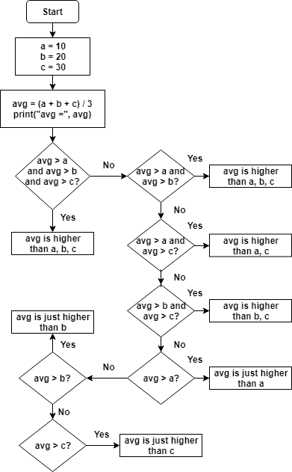

a = 10

b = 20

c = 30

avg = (a + b + c) / 3

print('avg = ', avg)

if avg > a and avg > b and avg > c:

print("avg is higher than a, b, c")

elif avg > a and avg > b:

print("avg is higher than a, b")

elif avg > a and avg > c:

print("avg is higher than a, c")

elif avg > b and avg > c:

print("avg is higher than b, c")

elif avg > a:

print("avg is just higher than a")

elif avg > b:

print("avg is just higher than b")

elif avg > c:

print("avg is just higher than c")

4. Write a program in Python to break and continue if the following cases occurs:

* If user enters a negative number just break the loop and print “It’s Over”
* If user enters a positive number just continue in the loop and print “Good Going”

while True:

num = int(input("Please enter any value: "))

if num > 0:

print("Good going")

if num < 0:

print("It's over")

break

5. Write a program in Python which will find all such numbers which are divisible by 7 but are not a multiple of 5, between 2000 and 3200.

for x in range(2000, 3200):

If (x%7 == 0) and not (x%5 ==0)

print(x)

6. What is the output of the following code examples?

* x=123

for i in x:

print(i)

* Indentation error
* It will still be an error if the indentation is fixed because ‘int’ object is not iterable.
* i = 0

while i < 5:

print(i)

i += 1

if i == 3:

break

else:

print(“error”)

0

1

2

* count = 0

while True:

print(count)

count += 1

if count >= 5:

Break

* nameError at Break
* After fixing, answer will be:

0

1

2

3

4

7. Write a program that prints all the numbers from 0 to 6 except 3 and 6.

Expected output: 0 1 2 4 5

Note: Use ‘continue’ statement

for x in range(0, 6):

If ( x == 3 or x == 6):

continue

print(x, end = ‘ ‘ )

8. Write a program that accepts a string as an input from user and calculate the number of digits and letters.

Expected output:

Letters 6

Digits 2

user = input(“Enter your username: “)

letter = digit = 0

for i in user:

if i.isalpha():

letter = letter + 1

elif i.isdigit():

digit = digit +1

print(“Letters ”, letter)

print(“Digits ”, digit)

9. Read the two parts of the question below:

* Write a program such that it asks users to “guess the lucky number”. If the correct number is guessed the program stops, otherwise it continues forever.

answer = 7

number = 0

while number != answer:

number = int(input(“Guess the number”)

If number == answer:

print(“Bravo! You are lucky”)

break

* Modify the program so that it asks users whether they want to guess again each time. Use two variables, ‘number’ for the number and ‘answer’ for the answer to the question whether they want to continue guessing. The program stops if the user guesses the correct number or answers “no”. ( The program continues as long as a user has not answered “no” and has not guessed the correct number)

answer =7

number = 0

option = ‘yes’

while number != answer and option != ‘no

number = int(input(“Guess the number: ”))

If number != answer:

option = input(“Do you want to continue guessing?”)

If number == answer:

print(“You got it right. Bravo!”)

10. Write a program that asks five times to guess the lucky number. Use a while loop and a counter, such as

counter=1

While counter <= 5:

print(“Type in the”, counter, “number”

counter=counter+1

The program asks for five guesses (no matter whether the correct number was guessed or not). If the correct number is guessed, the program outputs “Good guess!”, otherwise it outputs “Try again!”. After the fifth guess it stops and prints “Game over!”.

answer = 7

counter = 0

number = 0

while number != answer and counter <= 5:

If number != answer:

Counter = counter + 1

print(counter, “number”, “Try again!”)

If counter > 5:

print(“Game over!”)

break

If number == answer:

print(“Good guess!”)

11. In the previous question, insert “break” after the “Good guess!” print statement. “break” will terminate the while loop so that users do not have to continue guessing after they found the number. If the user does not guess the number at all, print “Sorry but that was not very successful”.

answer = 7

counter = 0

number = 0

while number != answer and counter <= 5:

If number != answer:

Counter = counter + 1

print(counter, “number”, “Try again!”)

If counter > 5:

print(“Sorry but that was not successful!”)

break

If number == answer:

print(“Good guess!”)

break