Table of Contents
chapter 1 3
Introduction 3
1.1 Introduction 3
1.2 Problem Statement 4
1.3 Objective 4
1.4 Scope and Limitation 4
1.5 Development Methodology 4
1.6 Report Organization 4
Chapter 2 6
Background Study and Literature Review 6
2.1 Background Study 6
2.2 Literature Review 7
Chapter 3: System Analysis 8
3.1 System Analysis 8
3.1.1 Requirement Analysis 8
3.1.2 Feasibility Analysis 9
3.1.3 Analysis Approach 9
Chapter 4: System Design 11
4.1 Design Approach 11
4.2 Algorithm Details 14
4.3 Diagrams 18
Chapter 5 18
Implementation and Testing 18
5.1 Implementation and Tools used 18
5.2 Testing 19
5.3 Result Analysis 20
Chapter 6 20
Conclusion and Future Recommendations 20
6.1 Conclusion 20
6.2 Future Recommendations 20

chapter 1

introduction

1.1 Introduction
In recent years, the rapid growth of artificial intelligence has led to significant advancements in deepfake technology, particularly in the creation of highly realistic fake audio. Deepfake audio is a type of manipulated audio created using artificial intelligence. It mimics real human speech, making it difficult to detect whether it is real or synthetic voice. This technology can recreate a person’s voice, that copies not just the words said but also their tone and manner of speaking. The dangers of deepfake audio are growing which can be used to mislead people, spread false information, or commit fraud, making it a significant issue in today's digital world.
The Deepfake Audio Detection project aims to build a system that can detect these fake audio clips using a combination of Convolutional Neural Networks (CNNs) and Recurrent Neural Networks (RNNs) with Long Short-Term Memory (LSTM) units. The CNNs will focus on analyzing the spectrograms to detect any irregularities or subtle changes in the audio’s frequency patterns that might indicate manipulation. Meanwhile, the RNNs with LSTM units will process the temporal sequences of the audio by analyzing the Mel frequency cepstral coefficients (MFCCs). LSTMs can learn long-term dependencies in time-series data, making them well-suited to capture the evolution of voice features over time. By tracking how the voice changes from one frame to the next, the LSTM can spot anomalies that deviate from the natural patterns of real human speech.
The project process involves several key stages, starting with data collection from the ASVSpoof2021_LA dataset, which contains real and spoof audio files. The next step is preprocessing these audio files by extracting features such as MFCCs and spectrograms using tools like Librosa. These features are then passed to a hybrid model, combining CNN for feature extraction from spectrograms and LSTM for analyzing temporal patterns in the MFCC data. Through iterative development using the Agile methodology, the model is trained to classify the audio as real or fake. Feedback from each sprint is incorporated to continuously improve the model. Finally, this system will be implemented into an easy-to use platform where users can upload audio files to get real-time feedback on whether the audio is real or fake.

1.2 Problem Statement
As deepfake audio technology becomes more advanced, the ability to detect manipulated audio is critical. Presently, many existing systems struggle with detection accuracy, leading to potential misuse in various domains, including misinformation, fraud, and identity theft. This project endeavors to develop a reliable solution that combines the strengths of CNNs for spatial feature extraction and LSTMs for temporal pattern analysis, thereby improving the detection of deepfake audio clips.

1.3 Objective
• To develop a system for distinguishing between real and deepfake audio.

1.4 Scope and Limitation
This project focuses on detecting deepfake audio using a hybrid CNN-LSTM model. It processes audio files by extracting spectrograms and MFCCs to classify them as real or fake. The system is designed for real-time usage, providing quick and accurate results. It aims to address issues like fraud, misinformation, and identity theft caused by deepfake audio technology.

Limitations:

The system is limited to detecting audio deepfakes and does not handle video deepfakes.
It may struggle with heavily noisy or poor-quality audio.
Performance is dependent on the diversity and quality of the training dataset.

1.5 Development Methodology
The system is developed using the Agile methodology, enabling iterative improvement through short development sprints. Feedback from each sprint is incorporated to refine preprocessing, feature extraction, and model performance.

1.6 Report Organization
The report covers the background study, system analysis, design, implementation, testing, and recommendations for future work.
-Chapter 1 introduces the project, including its purpose, problem statement, objectives, scope, and limitations. It outlines the methodology used for development and provides an overview of how the report is structured.
-Chapter 2 explains fundamental concepts such as spectrograms, MFCCs, CNNs, and LSTMs. It also reviews related work by other researchers, highlighting their methods, results, and limitations.
-Chapter 3 details the functional and non-functional requirements of the system, feasibility analysis, and the analysis approach. It includes diagrams like use case, class, and sequence diagrams to explain the system architecture.
-Chapter 4 focuses on the design of the system, including algorithm details for CNN, LSTM, and their integration for classification. It also includes diagrams, such as flowcharts and block diagrams, to illustrate system workflows.
-Chapter 5 describes the tools, technologies, and methodologies used for implementation. It also includes testing strategies, such as unit and system testing, along with analysis of results.
-The final chapter summarizes the project's findings and performance. It suggests improvements and future directions for enhancing the system's capabilities and addressing emerging challenges.

Chapter 2

Background Study and Literature Review

2.1 Background Study
Key concepts in this project include spectrograms, Mel-frequency cepstral coefficients (MFCCs), and the models we use, which are Convolutional Neural Networks (CNNs) and Long Short-Term Memory (LSTM) networks.
A spectrogram is a visual representation of the time-frequency distribution of audio signals. It displays how the frequency content of an audio signal varies over time. In simpler terms, a spectrogram takes an audio sound and shows how different frequencies are present at different moments. This representation helps us analyze the audio more effectively. Each visual element on the spectrogram indicates the amplitude of a particular frequency at a certain time, allowing us to see patterns that are not easily discernible in the raw audio waveform. Spectrograms are especially useful for deepfake audio detection, as they help identify irregularities in the audio frequency patterns that may suggest manipulation.
Mel-frequency cepstral coefficients, or MFCCs, are a crucial feature used in speech and audio processing. MFCCs capture the essential characteristics of a speech signal by representing its short-term power spectrum. This means that MFCCs provide a compact representation of the audio’s frequency content, focusing on the aspects most relevant to human perception of sound. The Mel scale is designed to mimic the way humans hear, where our perception of frequency is not linear. By converting the audio signal to MFCCs, we can extract meaningful information that can be used to differentiate between real and fake audio.
CNNs are designed to identify spatial features in the data we present to them, such as spectrograms. They work similarly to the way the human visual system processes images. In our context, the CNN analyzes the spectrograms to find patterns that may indicate whether the audio has been manipulated or not. By applying filters to the spectrogram, the CNN learns to recognize distinctive features that are indicative of real or fake audio.

On the other hand, LSTM networks focus on sequential data, which is vital for analyzing MFCCs. LSTMs are a type of Recurrent Neural Network (RNN) specifically designed to learn from sequential information. They are particularly adept at capturing long-term dependencies in data, meaning they can remember important features over time. In our project, the LSTM processes the MFCCs to identify how the audio features change from one moment to the next. This ability enables the model to detect anomalies that deviate from the natural patterns of real human speech.
By combining the strengths of CNNs and LSTMs, our deepfake audio detection system can effectively analyze both the spatial and temporal characteristics of the audio, leading to improved detection accuracy of manipulated audio files.

2.2 Literature Review
Studies reveal the importance of hybrid CNN-LSTM models for detecting temporal and spatial anomalies in audio data. Research highlights limitations of existing methods and emphasizes the need for diverse datasets and robust architectures​.
"Deep Learning Approaches for Audio Signal Analysis," is a journal of Signal Processing
that explored the application of CNNs for feature extraction in audio signals. It
demonstrates how CNNs can be used to extract meaningful patterns from spectrograms,
providing valuable insights into how deep learning models can capture both time and
frequency-based features of audio [4].
The paper titled “A dataset of histograms of original and fake voice recordings” introduces
the H-Voice dataset, which consists of histograms of both original and fake voice
recordings. This dataset is essential for training and testing models that classify real and
fake voices. The histograms help visualize patterns in voice data that makes it easier for
machine learning models to learn and identify fake audio [5].
Another study, “Detecting deepfake audio using CNN and RNN hybrid models”, explores
a more advanced approach that combines CNNs with RNNs. The study focuses on
detecting deepfake audio by analyzing temporal dependencies in the data. By using LSTM
layers to complement the CNN's spatial analysis, this hybrid approach significantly
improves the detection rate for fake voices [6].
Another relevant study is “Exposing deepfakes using a deep multilayer perceptron –
convolutional neural network model” presents a hybrid system that combines a multilayer
perceptron (MLP) and CNN for detecting deepfake videos. What sets this approach apart
is its ability to run on limited computational resources while maintaining fast processing
speeds. The proposed system enhances the efficiency of detecting deepfakes, making it
suitable for real-time applications where computational power might be limited. [7].

Chapter 3: System Analysis

3.1 System Analysis

3.1.1 Requirement Analysis
The requirement analysis identifies the essential features and constraints needed for the deepfake audio detection system. The functional requirements focus on enabling users to upload audio files, extract features like spectrograms and MFCCs, and classify them as real or fake using the CNN-LSTM hybrid model. Non-functional requirements address compatibility, performance, and data security, ensuring the system operates efficiently across different platforms while maintaining user privacy. These requirements serve as the foundation for designing the system's architecture and implementing its core functionalities, supported by diagrams like use case, class, and sequence diagrams for better visualization and validation.
Functional Requirement
Below are the functional requirements for the proposed system.
-The system must allow users to upload audio files for processing.
-The system should preprocess the uploaded audio files by extracting key features such as MFCCs and spectrograms and visualize it.
-The extracted features should be normalized and padded to ensure consistent input for the neural networks.
-The system must classify the audio as either real or fake using a hybrid CNN-LSTM model.
-After processing, the system must provide real-time feedback to the user indicating whether the uploaded audio file is classified as real or fake.
-The result should be displayed with a probability score indicating the confidence of the classification.
Non-Functional Requirements:
Below are some of the nonfunctional requirements for the system.
-The system should be compatible with multiple platforms and run efficiently on standard hardware.
-It must ensure the privacy and security of user-uploaded files.
-Processing and classification should be fast to provide quick results.
-The system should run efficiently on standard hardware, ensuring that it can operate on
typical laptops or desktops without requiring advanced resources like GPUs.

3.1.2 Feasibility Analysis

Technical
The system will be developed using Python, TensorFlow, and Librosa libraries, which are reliable and widely used in audio processing and machine learning. The system will run efficiently on any laptop or desktop with a modern operating system, without requiring advanced hardware such as GPUs.

Operational
The system will be easy to operate, with the only function being the detection of deepfake
audio. The system's functionality is limited to classification, which makes it accessible for
users with minimal technical knowledge too.
Economical
The tools and resources required for the project are freely available, ensuring that it can be
implemented and completed without incurring any costs. The combination of free software
tools, open datasets, and access to cloud-based computational resources makes this project
economically feasible.

3.1.3 Analysis Approach
The object-oriented analysis approach focuses on breaking down the system into objects and their interactions. It emphasizes the use of diagrams to represent various aspects of the system, helping in understanding and designing its structure, behavior, and processes. By using these diagrams, the object-oriented approach provides a structured and visual way to analyze and design the hybrid CNN-LSTM model for deepfake audio detection. This ensures clarity in identifying system components, understanding workflows, and capturing dynamic behaviors essential for accurate implementation.

Class Diagram
Represent the static structure of the system by defining classes, their attributes, methods, and relationships. Classes like AudioFile, FeatureExtractor, and CNN etc can be modeled, showing their attributes (e.g., file name, spectrogram) and methods (e.g., extract_features(), classify()).
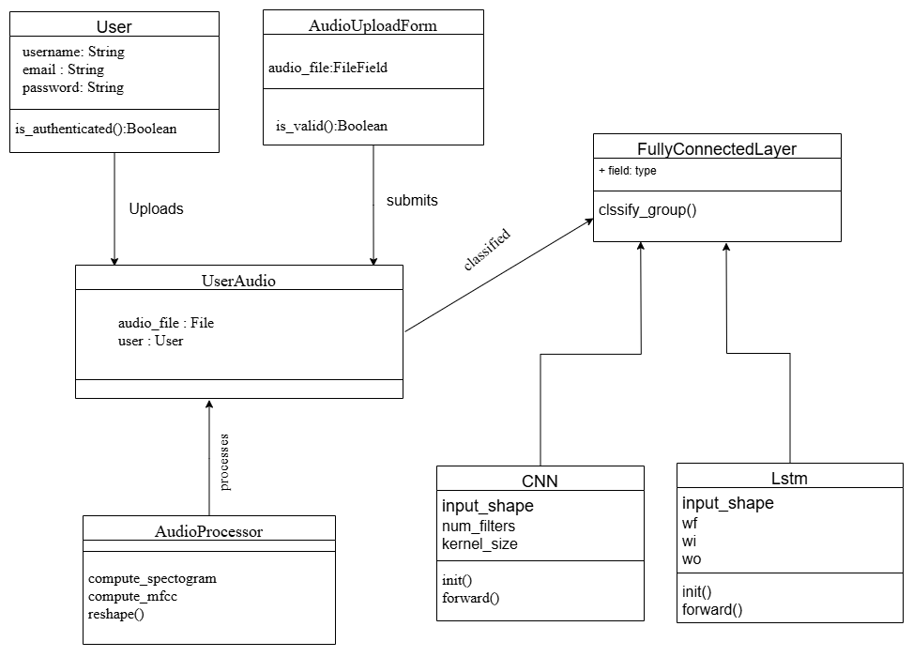
Fig:Class Diagram

Sequence Diagram
It maps the interaction between users, models, and results. It represents the flow of messages and interactions between objects in a specific sequence. For instance, the diagram might show how an AudioFile object sends data to FeatureExtractor, which then forwards processed features to the Classifier for classification.
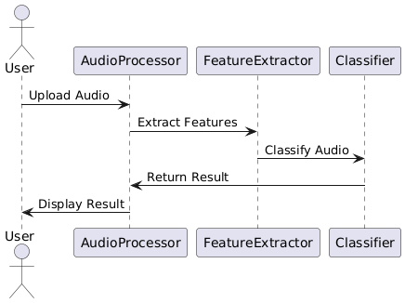
Fig:Sequence Diagram

Chapter 4: System Design

4.1 Design Approach
The hybrid system is designed to combine outputs from CNN and LSTM layers for classification.
1.Refinement of Class, Object, State, Sequence, and Activity Diagrams
Class Diagram: This diagram represents the structure of the system by showing the system's classes, their attributes, methods, and the relationships between them. Each class corresponds to a specific component of the system, such as AudioFile, FeatureExtractor, ModelBuilder, etc. The class diagram is refined by breaking down the primary system components into more specific and manageable classes, detailing attributes, and defining methods that each class will contain.

Object Diagram: The object diagram illustrates the instances of the system's classes at a particular point in time. It shows how objects interact with each other, reflecting the relationships between class instances during the system’s runtime. This is helpful for understanding object states during the execution of the project and validating the interactions between real and fake audio files during feature extraction and model classification.

State Diagram: The state diagram depicts the different states an object or component can be in during the lifecycle of the system. For example, a model training process can have different states such as "Data Loading," "Model Building," "Training in Progress," and "Model Evaluation." These states help visualize how the system reacts to various inputs or events, such as user-triggered actions like starting the training process.

Sequence Diagram: Sequence diagrams demonstrate how objects communicate with one another in a particular order. They show the sequence of function calls and data exchanges that occur during specific operations, such as loading an audio file, extracting features, or training the model. This diagram provides insight into the interactions between objects like the AudioFile, FeatureExtractor, and ModelBuilder.

Activity Diagram: The activity diagram maps out the workflow and business logic of the system, showing the sequence of activities. This diagram is essential for understanding the flow of the system, such as the steps involved in the process of detecting deepfake audio. For instance, it might show steps such as "Loading Audio," "Feature Extraction," "Model Training," and "Prediction," outlining the overall sequence of tasks from start to finish.
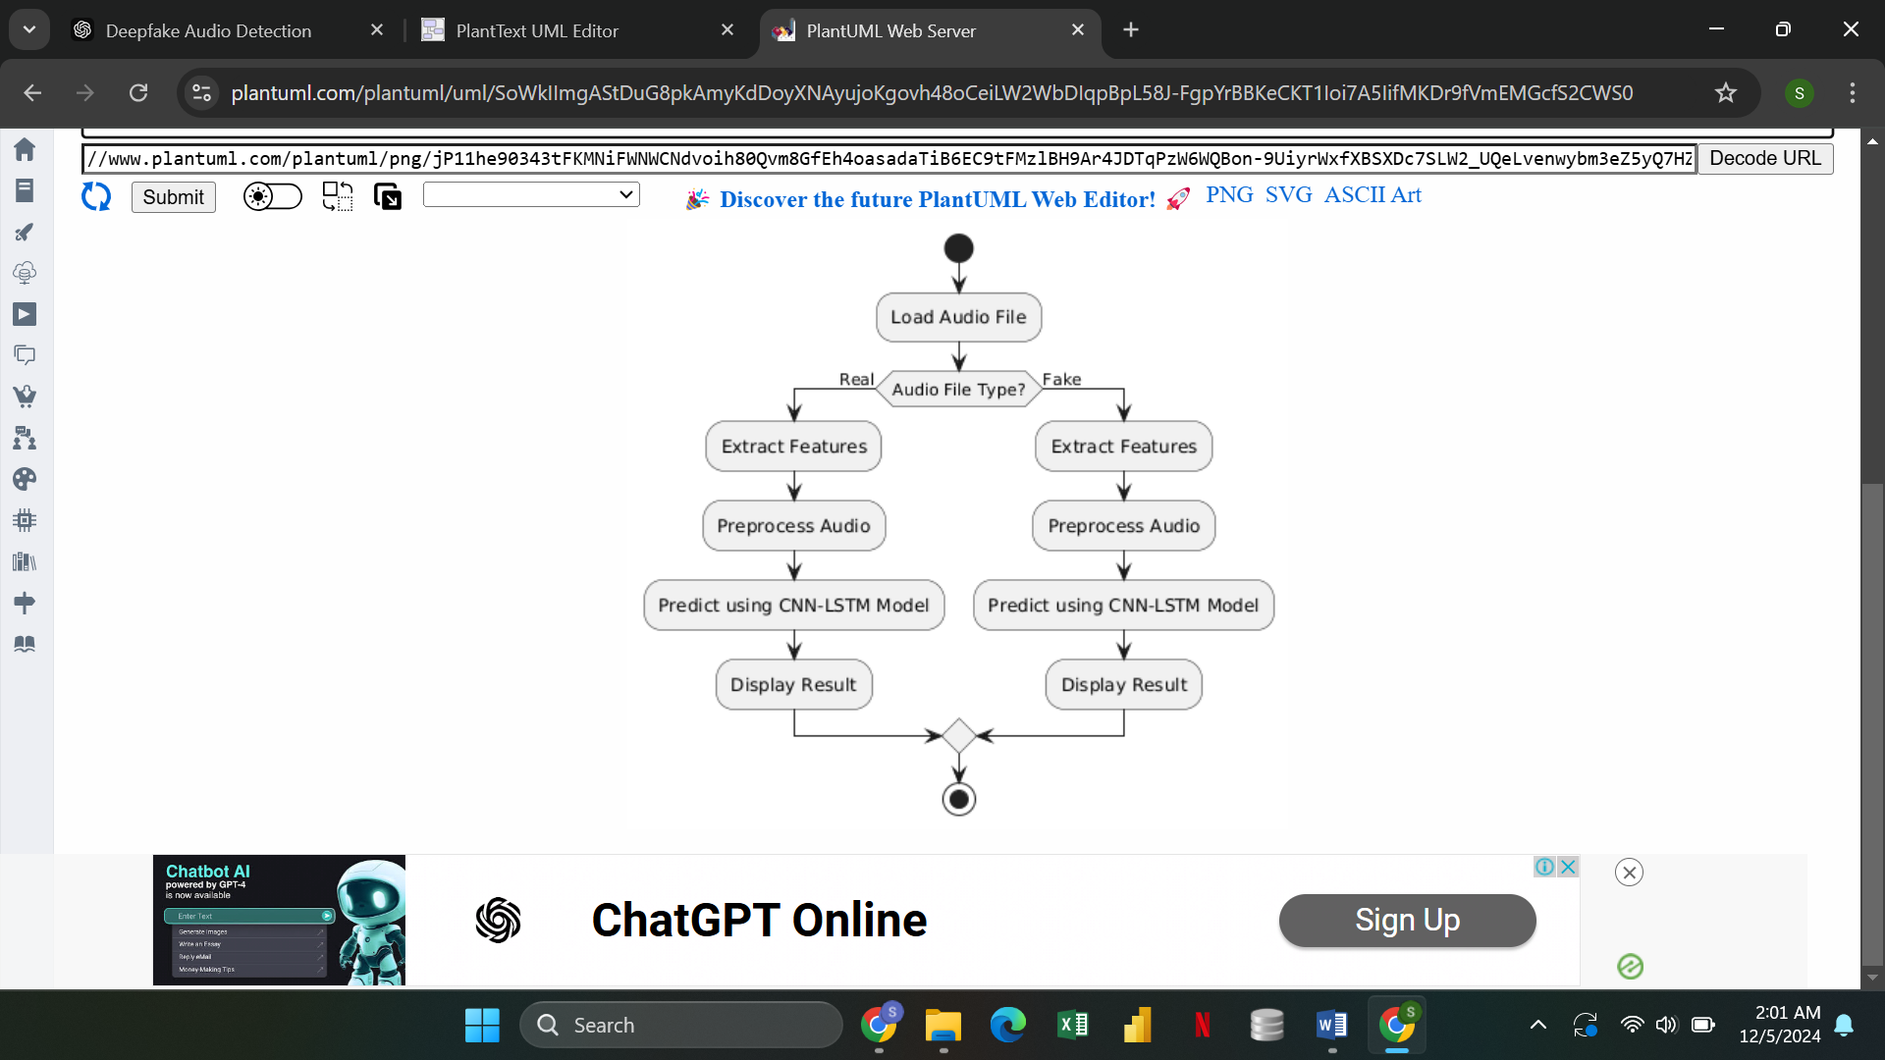
Fig:Activity Diagram
2.Component Diagrams
The Component Diagram illustrates the high-level components of the system and how they interact with each other. In the context of this project, the main components include:

-Feature Extraction Module: Responsible for extracting MFCC and spectrogram features from the audio files.
-Model Training Module: Contains the CNN-LSTM hybrid architecture for training the model.
-Prediction Module: Handles the inference process, where new audio samples are tested using the trained model.
-Visualization Module: Handles the presentation of results, such as plotting confusion matrices and loss graphs.
-The component diagram shows how these modules are connected and how they work together within the system to achieve deepfake detection.
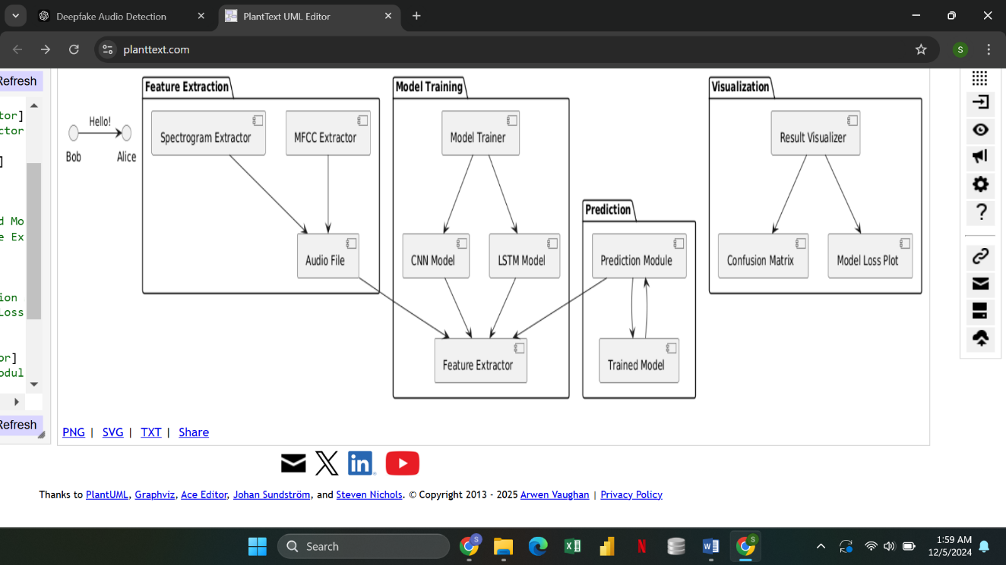
Fig:Component Diagram

3. Deployment Diagrams
A Deployment Diagram illustrates how the system will be deployed in a real-world environment, detailing the hardware and software setup. It shows the system’s physical architecture, including servers, databases, and client-side components. For this project, the deployment diagram may include:

-Client Machine: Where the user interacts with the system, uploading audio files and viewing results.
-Web Server: Where the model is hosted, and training or prediction processes are triggered.
-Database: Stores the audio files, labels (real/fake), and training data.
-Model Server: Hosts the trained CNN-LSTM model, handling predictions and inference.
The deployment diagram helps in visualizing how the system components are physically distributed, ensuring scalability and the efficient operation of the project.

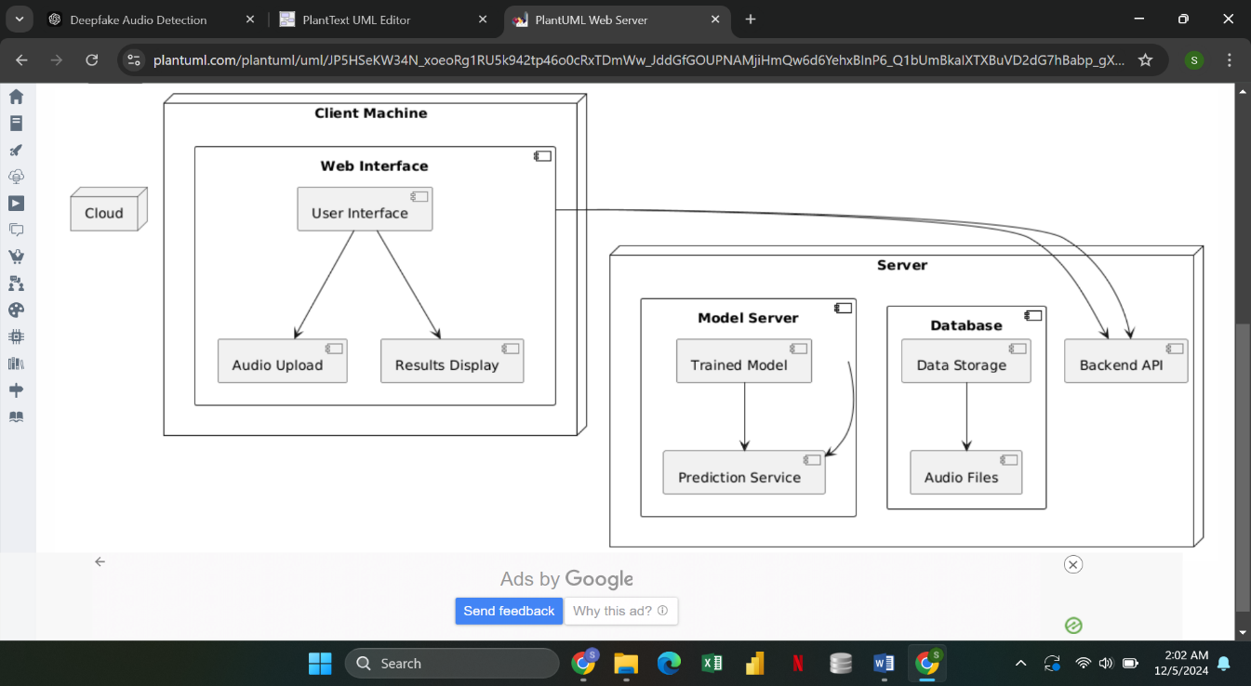
Fig:Deployment Diagram

4.2 Algorithm Details
I.) Convolutional Neural Network (CNN)
CNN is employed to extract spatial features from the spectrogram. A spectrogram is a time
frequency representation of the audio, and CNN treats it like a 2D image, applying filters
to detect various patterns in the frequency-time domain. The key steps are discussed below.
a.) Convolution Layer: The convolution layer applies filters to the input spectrogram to
detect local patterns, such as frequency changes. Each convolutional layer extracts higher-level features, making CNNs ideal for tasks like image and audio processing.
Convolution Operation is defined as:
Where, X is the input spectrogram,
Z=(X*W) +b
-W is the filter/kernel that detects patterns,
-b is the bias term.
This operation creates feature maps that capture different aspects of the spectrogram.
b.) ReLU Activation Function:
After the convolution, the ReLU, Rectified Linear Unit, activation function applies to
introduce non-linearity.
f(Z)=max (0, Z)
This ensures that only positive values pass through, helping the network learn more
complex patterns.
c.) Pooling Layer:
The pooling layer reduces the spatial dimensions of the feature map, making the model
more efficient by retaining the most important information.
In max pooling, the maximum value from each window is retained:
P=max(X)
Pooling helps in reducing the feature map size and prevents overfitting by discarding
irrelevant details.
d.) Flattening:
After multiple convolution and pooling layers, the 2D output is flattened into a 1D vector
before passing it to the fully connected layers.
Backpropagation is used to optimize CNN by adjusting filter weights during training:
Forward Pass:
Input data flows through the network, producing predictions. Loss (error) is calculated by comparing predicted output with the actual label using a loss function, such as cross-entropy.
Backward Pass:
Gradients of the loss with respect to weights (∂L/∂W) are computed layer by layer using the chain rule of calculus.
For the convolution layer, gradients are calculated for each filter based on the error propagated backward.
Weight Update:
Weights and biases are updated using gradient descent or an optimizer like Adam:
Formula: W←W−η⋅ ∂L/∂W
η: Learning rate ,∂L/∂W: Gradient of loss with respect to weights.
This process repeats for multiple iterations (epochs), minimizing the loss and improving accuracy.
Steps of Implementation:
- Define the convolution filters (W) and biases (b) randomly.
- In Feature Extraction, apply convolutional operations to the spectrogram input, use ReLU to retain meaningful patterns and discard irrelevant negative values and downsample the feature maps using pooling to make computations efficient.
- Convert the processed feature maps into a 1D array for input to the classification layer.
- In Training with Backpropagation, perform forward propagation to compute the output, calculate the cross-entropy loss between predictions and actual labels and Use backpropagation to adjust weights and biases for the convolution layers based on the loss gradients.
- Combine CNN-extracted features with LSTM outputs for final classification, ensuring both spatial and temporal patterns are analyzed.

II.) Long Short-Term Memory (LSTM)
LSTM is a specialized type of Recurrent Neural Network (RNN) designed to handle sequential data and capture long-term dependencies. Unlike standard RNNs, LSTM uses gates to control the flow of information, preventing issues like vanishing or exploding gradients. In our project, LSTM is used to analyze MFCCs, which capture the frequency content of audio over time, allowing the system to learn temporal patterns in speech.
LSTM Cell Equations:
a.) Forget Gate:
The forget gate decides how much of the previous cell state to retain.
F_{t}=(W_{f}.[h_{t-1}, x_{t}]+b_{f})
Where:
-h_{t-1} is the previous hidden state,
- x_{t} is the current input (MFCC at time step t),
- W_{f} are the weights for the forget gate,
-b_{f} is the bias term.
b.) Input Gate:
The input gate controls how much new information from the current input is added to the
cell state.
I_{t}= σ (W_{i} .[h_{t-1}, x_{t}] +b_{i})
Where:
- W_{i} and b_{i} are the weights and bias for the input gate.
c.) Cell State Update:
The candidate cell state is created, representing new potential information to be added to
the main cell state.
Č_{t}=tanℎ(𝑊_{c}.[ℎ_{t-1},𝑥_{t}] + 𝑏_{c} )

The new cell state is updated as:
Where:
-C_{t-1} is the previous cell state,
C_{t}=f_{t}.C_{t-1}+i_{t}. Č_{t}
-C_{t} is the updated cell state, which combines both the retained and new information.

d.) Output Gate:
The output gate decides what part of the cell state will be output as the hidden state.
O_{t}= σ (W_{o}. [h_{t-1}, x_{t}]+b_{o})
The final hidden state is:
H_{t}=o_{t}.tanh(C_{t})

The hidden state (h_{t} ) at the last time step is used as the feature representation of the sequence.
Backpropagation Through Time (BPTT) in LSTM
-Forward Pass sequentially process input data through LSTM cells to compute outputs and update cell states.
-Compare the final output with the ground truth label using a loss function, such as cross-entropy.
-Gradients are calculated by propagating the loss backward through the network, including through time for each time step.
-Gradients for gates, weights, and cell states are computed layer by layer using the chain rule.
-Weights are updated using gradient descent or an optimizer.
W←W−η⋅ ∂L/∂W
∂L/∂W: Gradient of the loss with respect to the weights.
Steps of Implementation:
- Define weights (W_{f},W_{i},W_{C},W_{o} ​) and biases (b_{f},b_{i},b_{c},bo) for the forget, input, candidate cell, and output gates.
- For each time step:
-Compute forget gate ( f_{t}) to decide what to retain.
-Compute input gate (i_{t}) to decide what new information to add.
-Update cell state (C_{t}) using retained and new information.
-Compute output gate (o_{t}) to decide what to output.
- Use the hidden state ( h_{t}) from the last time step as the feature representation of the input sequence.
- Concatenate the LSTM’s final hidden state with the CNN’s output to combine spatial and temporal features.
- Use forward propagation to compute outputs and loss. Apply backpropagation through time to update weights and optimize the LSTM.
- Pass MFCCs through the trained LSTM and combine with CNN features for final classification.
The outputs from both models will be concatenated. The combined features are passed
through a fully connected (dense) layer for final classification. The sigmoid activation
function is used in the last layer to output a probability score between 0 and 1, indicating
whether the audio is real or fake.
P(y)= 1/(1+e^{-z})
Where: - z is the output from the fully connected layer.
If the probability P(y) is greater than 0.5, the audio is classified as fake; otherwise, it is
classified as real.

4.3 Diagrams
Diagrams like block diagrams and flowcharts illustrate data flow and system interactions​(Proposal).

Chapter 5

Implementation and Testing

5.1 Implementation and Tools used
-Python is used for implementing the entire system.
-Draw.io is used for creating diagrams such as class diagrams, sequence diagrams, and flowcharts.
-Django Framework implements the web-based interface for the system and allows users to upload audio files and view real-time classification results.
-Google Colab is used as the development environment for writing and running the code.
-Soundfile simplifies audio data loading for preprocessing.
-Pytorch is used or designing, training, and optimizing the CNN and LSTM models.
-NumPy performs matrix operations essential for convolution, pooling, and LSTM.

5.2 Testing

Unit Testing:
This type of testing focuses on validating the functionality of individual modules within the system.
-In Feature Extraction Module, it tests if the spectrogram generation and MFCC extraction produce accurate and consistent outputs for various audio samples. Also it verifies the dimensions and range of features after normalization and padding.
-In CNN and LSTM Modules, it ensures that the CNN processes spectrograms correctly and outputs meaningful spatial features. It confirms that the LSTM captures temporal dependencies in the MFCC features without errors.
By unit testing, each component is checked for its task as expected before integrating them into the system.

System Testing:
This involves testing the entire system as a unified whole to ensure end-to-end functionality.
-In Hybrid Model Testing, it validates that the combined CNN-LSTM model correctly classifies audio files as real or fake. It checks if the model handles diverse inputs, including edge cases like very short or noisy audio.
-For Input and Output Flow, it ensures that the uploaded audio files are preprocessed, classified, and results (real/fake) are displayed accurately.
-And Performance Metrics measures accuracy, precision, recall, and loss to confirm the system meets quality standards.
With System testing, all components are ensured to interact seamlessly, delivering accurate and reliable results to the user.

5.3 Result Analysis
Initial tests revealed the need to adjust learning rates for CNN (0.1) and LSTM (0.001) to improve classification accuracy

Chapter 6

Conclusion and Future Recommendations

6.1 Conclusion
The hybrid CNN-LSTM model developed for deepfake audio detection has shown promising results. By utilizing spectrograms and MFCCs, the system effectively analyzes both spatial and temporal features of audio data. The model has been trained and tested using the ASVspoof2021_LA dataset, ensuring it can handle a variety of real and spoofed audio samples. The system successfully integrates preprocessing, feature extraction, and classification into a streamlined workflow. The use of Python and Pytorch made it possible to build the model without relying on high-level libraries like Keras, adding flexibility and depth to the implementation.

However, challenges remain, particularly in adapting to new deepfake audio generation techniques and noisy audio environments. The system’s performance depends on the diversity and quality of the training dataset, and additional updates are needed to maintain accuracy as deepfake technologies evolve. Despite these limitations, the project demonstrates the potential of combining CNN and LSTM models for addressing critical issues in audio-based deepfake detection.

6.2 Future Recommendations
- Update the system periodically by retraining the model with new datasets that include the latest deepfake generation techniques.
- Optimize model architecture for real-time applications on limited hardware.
- Implement a feedback mechanism where users can label misclassified audio to further improve the system through active learning.
- Enhance the system to perform reliably even with noisy or low-quality audio files by incorporating noise reduction techniques during preprocessing.
- Continue refining the hybrid CNN-LSTM model by experimenting with different architectures, hyperparameters, and optimization techniques to improve accuracy.

