

Information Systems in Business

Title of Assignment | Individual Assignment
Student Name &  Student ID Number | Saron Borak ID: 2303041X
Lecturer | Mr. Sok Dina
Due Date | 1st September 2026
Year – Term | 2026 – Term 3
Word Count | 3560 Words

Student Declaration
I certify that the attached assignment is my own work. Material drawn from other sources has been properly and fully acknowledged as to author/creator, source, and other bibliographic details.
Signature of student: Saron Borak Date: 02/03/2024
Table of Contents
1. Introduction 7
1.1 Background 7
1.2 Problem Statement 7
1.3 Aim and Objectives 7
1.4 Scope 8
1.4.1 In Scope 8
1.4.2 Out of Scope 8
1.5 Structure of this Report 8
2. Software Requirements Specification 9
2.1 Stakeholders 9
2.2 Functional Requirements 9
2.2.1 Authentication and Access Control 9
2.2.2 Administrator Module 9
2.2.3 Lecturer Module 10
2.2.4 Student and Check-in Module 10
2.2.5 Reporting Module 10
2.3 Non-Functional Requirements 11
2.4 Input and Output Specification 11
2.5 Platform and Tools 12
3. System and Database Design 13
3.1 System Architecture 13
3.2 Module Breakdown 13
3.3 Use Cases 14
3.4 User Interface Design 14
3.4.1 Screen Layouts 14
3.5 Database Design 15
3.5.1 Entity Relationship Diagram 15
3.5.2 Table Structures 16
3.5.2.1 users 16
3.5.2.2 faculties 17
3.5.2.3 programs 17
3.5.2.4 semesters 17
3.5.2.5 lecturers 17
3.5.2.6 students 18
3.5.2.7 courses 18
3.5.2.8 class_sections 18
3.5.2.9 class_schedules 19
3.5.2.10 enrollments 19
3.5.2.11 attendance_sessions 19
3.5.2.12 attendance_records 20
3.5.3 Normalisation 20
3.5.4 Integrity Constraints 21
4. Implementation 22
4.1 Project Structure and Size 22
4.2 Authentication 22
4.3 Authorisation: Two Independent Layers 23
4.4 Input Validation and Security 24
4.5 Attendance Capture 25
4.6 QR Self Check-in 26
4.6.1 Token Rotation 26
4.6.2 Check-in Sequence 26
4.6.3 Two Practical Constraints 27
4.7 The Reporting Engine 27
4.8 Reporting Output 29
4.9 Demonstration Data 29
5. Testing 31
5.1 Testing Strategy 31
5.2 Automated Test Suite 31
5.3 Test Cases 32
5.4 Defects Found and Fixed 34
Defect 1: Related counts silently rendering blank 34
Defect 2: Ambiguous column reference 35
Defect 3: Lateness judged against the wrong clock 35
5.5 Manual Verification 36
6. System Walkthrough 37
6.1 Signing In 37
6.2 Administrator Portal 37
6.2.1 Dashboard 37
6.2.2 Managing the Academic Structure 37
6.2.3 Managing People 38
6.2.4 Class Sections and Timetables 38
6.2.5 Roster Management 38
6.2.6 Account Administration 38
6.2.7 Reporting 38
6.3 Lecturer Portal 39
6.3.1 Dashboard 39
6.3.2 Class Detail 39
6.3.3 Generating Sessions 39
6.3.4 Marking the Register 39
6.3.5 The QR Check-in Screen 40
6.4 Student Portal 40
6.4.1 Dashboard 40
6.4.2 Checking In 40
6.4.3 Attendance History 41
6.5 Access Control in Practice 41
6.6 Responsive Layout 41
7. Challenges Faced 42
7.1 No Image Extension for QR Generation 42
7.2 Preventing Proxy Attendance 42
7.3 An Index Name Too Long for MySQL 42
7.4 A Silent Query-Builder Interaction 42
7.5 Timezone Against Timetable 43
7.6 Keeping Three Write Paths Consistent 43
8. Future Scope 44
9. Conclusion 45
References 46
Appendix A: Installation Guide 47
A.1 Create the database 47
A.2 Install and configure 47
A.3 Build the database and run 47
A.4 Run the tests 47
Appendix B: Demonstration Accounts 48
Appendix C: Suggested Demonstration Script 49
Appendix D: Project Structure 50

1. Introduction

1.1 Background
East Asia Management University (EAMU) records class attendance on paper registers. A lecturer carries a printed roster to each class and the sheets are later collected by the faculty office. The sheets are then either filed unprocessed or copied into a spreadsheet at the end of the semester.
The university requires every student to attend at least 90% of the sessions held for each class they are enrolled in. A student who falls below that line may be barred from the final examination. Under a paper system, however, nobody discovers that a student has crossed the threshold until the register sheets are totalled, typically far too late for the student to recover.

1.2 Problem Statement
The existing paper-based process suffers from four specific, related problems:
- Attendance percentages are not visible while they still matter. Totals are computed at the end of the semester, so neither the student nor the lecturer can act on a downward trend during it.
- Marking a register by hand consumes teaching time. In a class of thirty students, calling a roll costs several minutes of every session.
- Paper registers are easy to lose and easy to falsify. A sheet passed around the room can be signed by a classmate on behalf of an absent student, and a mislaid sheet destroys the record for that session entirely.
- There is no single source of truth. The faculty office, the lecturer and the student can each hold a different view of the same attendance record, with no way to reconcile them.
The consequence is that a rule the university actually enforces — the 75% requirement — is administered using data that arrives too late to be useful and cannot be fully trusted.

1.3 Aim and Objectives
The aim of this project is to build a web-based attendance management system that records attendance at the moment a class meets, and makes the resulting percentage continuously visible to everyone who needs it.
The specific objectives are:
- To design a normalised relational database capable of representing the university’s academic structure, its class rosters, and every attendance event.
- To implement three role-specific portals, administrator, lecturer and student, each restricted to the data that role is entitled to see.
- To provide a fast marking interface so a lecturer can complete a register in seconds rather than minutes.
- To provide a self check-in mechanism, using a rotating QR code, that removes roll-calling from the classroom entirely while resisting proxy attendance.
- To calculate attendance percentages automatically against the university’s 75% rule, and to surface at-risk students while intervention is still possible.
- To validate the system through automated tests covering authorisation, data integrity and the correctness of the percentage calculation.

1.4 Scope

1.4.1 In Scope
- Management of the academic structure: faculties, programs, courses, semesters and class sections.
- Management of people: lecturer and student records, each paired with a sign-in account.
- Class rosters, with bulk enrollment.
- Weekly timetables per class section, and bulk generation of a semester of class sessions from them.
- Attendance marking by the lecturer, with four outcomes: present, late, absent and excused.
- Student self check-in by scanning a rotating QR code or typing a short code.
- Attendance reporting at university, class and student level, with CSV download and print support.
- Role-based access control with per-record ownership checks.

1.4.2 Out of Scope
The following were deliberately excluded to keep the project deliverable within the six-week timeframe. They are revisited in Section 8, Future Scope.
- Grade and assessment management — the system records attendance only.
- Timetable clash detection and automated room allocation.
- Outbound email or SMS notification. The system has no mail server dependency; password resets are performed by an administrator in person.
- A native mobile application. The interface is responsive and works in a phone browser, which is sufficient for QR check-in.
- Biometric or location-verified attendance.

1.5 Structure of this Report
Section 2 presents the software requirements specification. Section 3 covers user interface and database design. Section 4 describes the implementation, including the security measures applied. Section 5 reports the testing performed and the defects it uncovered. Section 6 is a screen-by-screen walkthrough of the finished system. Sections 7 and 8 discuss the challenges encountered and the work that could follow, and Section 9 concludes.

2. Software Requirements Specification
This section records the requirements agreed at the start of the project. It corresponds to the Phase 1 deliverable.

2.1 Stakeholders
Three groups interact with the system directly, and one benefits from it indirectly.
Stakeholder | Role in the system | Primary need
Registry / Administrator | Configures the academic structure, creates accounts, manages rosters and reads all reports. | A single trustworthy record of attendance across the university, and early sight of students at risk of exclusion.
Lecturer | Takes the register for their own classes and reviews their own cohort. | To record attendance in seconds without losing teaching time, and to see who is falling behind.
Student | Checks themselves in and monitors their own record. | To know their current percentage in every class, and to be warned before they breach the 75% rule.
Faculty management | Indirect consumer of the reporting output. | Reliable figures for progression and examination-eligibility decisions.
Table 1: Stakeholders and their needs

2.2 Functional Requirements
Requirements are grouped by module and numbered for traceability. Section 5 maps test cases back to these identifiers.

2.2.1 Authentication and Access Control
ID | Requirement
FR-01 | A user shall sign in with an email address and password.
FR-02 | The system shall direct each user to the portal matching their role on sign-in.
FR-03 | The system shall refuse sign-in to an inactive account, even when the password is correct.
FR-04 | The system shall sign out a user whose account is deactivated during an active session.
FR-05 | The system shall limit failed sign-in attempts to five per email address and IP address.
FR-06 | A user shall be able to change their own password and update their own profile.
FR-07 | The system shall deny a user access to any portal or record outside their role and ownership.
Table 2: Authentication and access control requirements

2.2.2 Administrator Module
ID | Requirement
FR-08 | The administrator shall create, read, update and delete faculties, programs, courses and semesters.
FR-09 | The administrator shall create a lecturer, which also creates the matching sign-in account.
FR-10 | The administrator shall create a student, which also creates the matching sign-in account.
FR-11 | The administrator shall create class sections linking a course, a semester and a lecturer.
FR-12 | The administrator shall define a weekly timetable of one or more slots for each class section.
FR-13 | The administrator shall enroll students onto a class roster individually or in bulk.
FR-14 | The system shall prevent a student being enrolled twice on the same roster.
FR-15 | The administrator shall reset any password and activate or deactivate any account.
FR-16 | The system shall prevent an administrator deactivating their own account.
FR-17 | The system shall prevent deletion of a record that still has dependent records.
FR-18 | The system shall permit exactly one semester to be active at a time.
Table 3: Administrator module requirements

2.2.3 Lecturer Module
ID | Requirement
FR-19 | A lecturer shall see only the class sections assigned to them.
FR-20 | A lecturer shall generate a semester of class sessions in bulk from the section timetable.
FR-21 | A lecturer shall create an individual session for a make-up or one-off class.
FR-22 | A lecturer shall mark each student as present, late, absent or excused, with an optional remark.
FR-23 | A lecturer shall open a session for student self check-in and close it again.
FR-24 | The system shall mark every student still unmarked as absent when a session is closed.
FR-25 | A lecturer shall view a live display of the check-in code and of who has checked in.
FR-26 | A lecturer shall view and download an attendance report for their own classes.
Table 4: Lecturer module requirements

2.2.4 Student and Check-in Module
ID | Requirement
FR-27 | A student shall view their attendance percentage for every class they are enrolled in.
FR-28 | The system shall warn a student whose attendance in any class is below the required minimum.
FR-29 | A student shall view their session-by-session history for each class.
FR-30 | A student shall check themselves in by scanning a QR code displayed by the lecturer.
FR-31 | A student shall check themselves in by typing a six-character code, as an alternative to scanning.
FR-32 | The system shall refuse a check-in when the code has expired, the session is not open, the student is not enrolled, or the student has already checked in.
FR-33 | The system shall record a check-in made after a configurable grace period as late rather than present.
Table 5: Student and check-in module requirements

2.2.5 Reporting Module
ID | Requirement
FR-34 | The system shall calculate attendance as attended sessions divided by countable sessions, as a percentage.
FR-35 | The system shall exclude sessions that are not yet closed from the calculation.
FR-36 | The system shall exclude excused absences from the denominator rather than counting them against the student.
FR-37 | The system shall list every student below the required minimum, ordered worst first.
FR-38 | The system shall produce reports at university, class-section and individual-student level.
FR-39 | The system shall allow every report to be downloaded as CSV and printed.
Table 6: Reporting module requirements

2.3 Non-Functional Requirements
ID | Category | Requirement
NFR-01 | Security | Passwords shall be stored using a one-way hash, never in plain text.
NFR-02 | Security | All state-changing requests shall be protected against cross-site request forgery.
NFR-03 | Security | All database access shall use parameter binding, so user input cannot alter a query.
NFR-04 | Security | All user-supplied content shall be escaped on output to prevent script injection.
NFR-05 | Performance | A report shall be produced with a fixed number of queries regardless of the number of students it covers.
NFR-06 | Usability | The interface shall be usable on a mobile phone browser, since students check in on their phones.
NFR-07 | Portability | The system shall run on a standard XAMPP installation with no image-processing extension and no front-end build step.
NFR-08 | Maintainability | The attendance rules shall be defined in one place, so the marking, QR and code paths cannot diverge.
NFR-09 | Integrity | A student shall have at most one attendance outcome per session, enforced by the database.
Table 7: Non-functional requirements

2.4 Input and Output Specification
The table below summarises what each module consumes and produces.
Module | Input | Processing | Output
Sign-in | Email, password | Credential check, active-account check, rate limiting | Authenticated session; redirect to the role portal
Course / section setup | Codes, titles, credit hours, capacity, timetable slots | Validation, uniqueness checks, foreign-key resolution | Stored records; confirmation message
Enrollment | Selected student identifiers | Duplicate filtering, bulk insert | Roster entries; count of students added
Session generation | Date range | Expansion of timetable slots across the range, skipping any that exist | Scheduled sessions; count created
Register marking | Status and remark per student | Roster verification, upsert of records | Attendance records; saved confirmation
QR check-in | Scanned token or typed six-character code | Token validity, session state, enrollment and duplicate checks; late-window evaluation | One attendance record marked present or late
Session close | Confirmation | Bulk insert of absences for unmarked students; credential retirement | Closed session; count auto-marked absent
Reporting | Semester, faculty or date-range filters | Single aggregate query with conditional summation | On-screen tables, percentage bars, CSV file
Table 8: Input, processing and output by module

2.5 Platform and Tools
Component | Version | Purpose and justification
PHP | 8.5.0 | Server language. Backed enumerations are used throughout to model attendance states safely.
Laravel | 13.29 | MVC framework. Supplies routing, the Eloquent ORM, validation, hashing, CSRF protection and a test harness, removing the need to hand-roll security primitives.
MariaDB | 10.4.32 (XAMPP) | Relational database, MySQL-compatible. Chosen because the assignment specifies MySQL and XAMPP is the standard lab environment.
Bootstrap | 5.3.3 (CDN) | Responsive CSS framework, loaded from a content delivery network so the project needs no asset build step.
Bootstrap Icons | 1.11.3 (CDN) | Icon set used for status badges and navigation.
endroid/qr-code | 6.1.3 | QR code generation. Chosen because it emits SVG using pure PHP; the alternatives require the gd or imagick extension, neither of which is installed.
PHPUnit | 12.5 | Automated testing, run against an in-memory SQLite database for speed.
Composer | 2.x | PHP dependency management.
Table 9: Platform and tools
Note that no Node.js, npm or front-end build step is required. Bootstrap is served from a CDN, and the only client-side code is plain browser JavaScript for the QR display and a few form conveniences. The system runs after composer install, a database migration, and php artisan serve.

3. System and Database Design
This section corresponds to the Phase 2 deliverable: the module breakdown, the screen designs, and the database structure.

3.1 System Architecture
The system follows the Model-View-Controller pattern provided by Laravel, with one deliberate addition: a service layer sitting between the controllers and the models.
The reason for that addition is specific. Attendance can be written by three different paths - a lecturer marking the register by hand, a student scanning a QR code, and a student typing a short code. If each path contained its own copy of the rules, they would eventually disagree about what counts as late, or about who is allowed to be marked. Every write therefore passes through a single AttendanceService, and every read passes through a single AttendanceReportService.
Browser
|
v
Routes ----> Middleware ----> Controller ----> Form Request
(92 routes) role / active (thin, 21) (validation, 8)
|
v
Policy check
(ownership, 3)
|
v
AttendanceService | AttendanceReportService
(all writes) | (all reads)
|
v
Eloquent Models (12)
|
v
MySQL / MariaDB (14 tables)
Blade templates render the response. Presentation logic that would otherwise be repeated across views - the colour of a status badge, the label for an enumeration - is defined once on the corresponding PHP enumeration.

3.2 Module Breakdown
Module | Responsibility | Key screens
Authentication | Sign-in, sign-out, session lifecycle, profile and password management. | Login, profile
Academic structure | Faculties, programs, courses and semesters. | Four list screens with create and edit forms
People management | Lecturer and student records, each paired with an account. | Lecturer and student lists, forms, detail pages
Class management | Class sections, weekly timetables and rosters. | Section list, section form with timetable builder, roster manager
Attendance capture | Session lifecycle and register marking. | Session list, session detail, marking register
Self check-in | QR generation, token rotation, student check-in. | QR kiosk, student check-in form
Reporting | Percentage calculation, at-risk detection, CSV export. | University overview, at-risk list, class report, student report
Table 10: System modules

3.3 Use Cases
The system has three actors. The administrator has the widest reach but does not take registers; the lecturer records attendance but only for their own classes; the student can only read their own record and check themselves in.
Actor | Use cases
Administrator | Manage faculties, programs, courses, semesters; manage lecturers and students; create class sections and timetables; manage rosters; reset passwords; deactivate accounts; view and export all reports.
Lecturer | View own classes; generate sessions; open session; display QR code; mark register; close session; view and export own class reports.
Student | View own attendance summary; view per-class history; check in by QR; check in by code; update own profile.
Table 11: Use cases by actor

3.4 User Interface Design
The interface uses Bootstrap 5 with a fixed left sidebar and a top bar. The sidebar contents are generated from the signed-in user’s role, so the three portals share one layout while presenting entirely different navigation.
Three design decisions are worth recording:
- Colour carries meaning consistently. Green indicates present or healthy attendance, amber indicates late or borderline, red indicates absent or below the threshold, and grey indicates excused or inactive. The same palette is used on badges, on percentage bars and on table row highlighting, so a user learns it once.
- The marking register is optimised for speed. Each student occupies one row with four radio buttons rendered as a button group, so a lecturer marks a student with a single click and can mark an entire class with the mark-all shortcuts. Present is pre-selected because it is the common case.
- The QR display is a separate full-screen layout with no navigation. It is designed to be projected onto a classroom screen, so the code and counters are legible from the back of a lecture hall.

3.4.1 Screen Layouts
The wireframes below show the structure of the six most important screens. Screenshots of the implemented versions appear in Section 6.

LOGIN DASHBOARD (any role)
+--------------------------------+ +--------+-------------------------+
| | | EAMU | Heading [ avatar ] |
| [ EAMU crest ] | |--------+-------------------------|
| East Asia Mgmt University | | Nav | [stat] [stat] [stat] |
| | | items | |
| +------------------------+ | | driven | +---------+ +---------+ |
| | Email | | | by | | table | | list | |
| | Password | | | role | | | | | |
| | [ ] Keep me signed in | | | | +---------+ +---------+ |
| | [ Sign in ] | | | | |
| +------------------------+ | | | |
+--------------------------------+ +--------+-------------------------+
MARKING REGISTER QR KIOSK (projected)
+------------------------------------+ +----------------------------+
| 30 students [Mark all: P L A E] | | CLASS - Course title |
|------------------------------------| | |
| # | Student | P L A E | Note | | +------------------+ |
| 1 | Chanda Chea | (o)( )( )( )| | | | | 12 |
| 2 | Chanda Ouk | ( )(o)( )( )| | | | QR CODE | ----|
| 3 | Chanda Tep | (o)( )( )( )| | | | | 30 |
|...| | | | | +------------------+ |
|------------------------------------| | U F V 3 6 5 |
| [Save register] [Save and close] | | refreshes in 45s |
+------------------------------------+ | [ Close session ] |
+----------------------------+
ROSTER MANAGER STUDENT ATTENDANCE
+------------------+-----------------+ +----------------------------+
| Enrolled (24/40) | Add students | | ! Below 75% in 1 class |
|------------------|-----------------| |----------------------------|
| Name [x] | [search......] | | [92%] [5] [97/101] [4] |
| Name [x] | [ ] Name | |----------------------------|
| Name [x] | [ ] Name | | Class Attended Bar |
| Name [x] | [ ] Name | | CS101-B 23 / 25 ####-- |
| | [Enroll selected]| | CS210-A 26 / 26 ###### |
+------------------+-----------------+ +----------------------------+
Figure 1: Wireframes for the six principal screens.

3.5 Database Design
The database holds twelve domain tables plus Laravel’s own supporting tables for sessions, cache and queued jobs. The design separates authentication from role-specific data: every person has exactly one row in users, and lecturers and students each have an additional profile row holding the attributes only that role needs. Administrators have no profile row, because they have no academic attributes.

3.5.1 Entity Relationship Diagram
faculties ----< programs ----< students >---- users
| | |
| | |
+----< courses | lecturers
| | | |
+----< lecturers >-------------|------------+
| |
v v
semesters >--- class_sections ---< enrollments
| |
| +----< class_schedules
v
attendance_sessions ----< attendance_records >---- students

Legend: ----< one-to-many >---- many-to-one
Figure 2: Entity relationship diagram.
The relationships in full:
Parent | Child | Type | Meaning
users | lecturers | 1 : 0..1 | A lecturer account has one staff profile.
users | students | 1 : 0..1 | A student account has one student profile.
faculties | programs | 1 : N | A faculty offers many programs.
faculties | courses | 1 : N | A faculty owns many courses.
faculties | lecturers | 1 : N | A faculty employs many lecturers.
programs | students | 1 : N | A program admits many students.
courses | class_sections | 1 : N | A course runs as several sections.
semesters | class_sections | 1 : N | A semester contains many sections.
lecturers | class_sections | 1 : N | A lecturer teaches several sections.
class_sections | class_schedules | 1 : N | A section meets in one or more weekly slots.
class_sections | enrollments | 1 : N | A section has a roster of students.
class_sections | attendance_sessions | 1 : N | A section holds many class meetings.
students | enrollments | 1 : N | A student is enrolled in several sections.
attendance_sessions | attendance_records | 1 : N | A session produces one record per student.
students | attendance_records | 1 : N | A student accumulates many records.
Table 12: Entity relationships
The many-to-many relationship between students and class sections is resolved through the enrollments table, and the many-to-many between students and sessions through attendance_records. Both junction tables carry their own attributes, so neither is a simple link table.

3.5.2 Table Structures
The tables below were generated from the live database. Types are as MariaDB reports them; the validation column records the rules the application enforces before a write is attempted.

3.5.2.1 users
Authentication and role for every person in the system.
Column | Type | Null | Key | Validation / notes
id | bigint UN | No | PK | Auto-increment
name | varchar(255) | No
email | varchar(255) | No | Unique | Required, valid email, unique
email_verified_at | timestamp | Yes |  | Timestamp
password | varchar(255) | No |  | Required, min 8 chars, bcrypt hashed
role | varchar(20) | No | FK / Index | One of: admin, lecturer, student
phone | varchar(30) | Yes
is_active | tinyint(1) | No | FK / Index | Blocks sign-in when false
remember_token | varchar(100) | Yes
created_at | timestamp | Yes |  | Timestamp
updated_at | timestamp | Yes |  | Timestamp

3.5.2.2 faculties
Top-level academic divisions.
Column | Type | Null | Key | Validation / notes
id | bigint UN | No | PK | Auto-increment
code | varchar(20) | No | Unique | Required, uppercase, unique, max 20
name | varchar(255) | No
created_at | timestamp | Yes |  | Timestamp
updated_at | timestamp | Yes |  | Timestamp

3.5.2.3 programs
Degree programs students are admitted into.
Column | Type | Null | Key | Validation / notes
id | bigint UN | No | PK | Auto-increment
faculty_id | bigint UN | No | FK / Index
code | varchar(20) | No | Unique | Required, uppercase, unique, max 20
name | varchar(255) | No
created_at | timestamp | Yes |  | Timestamp
updated_at | timestamp | Yes |  | Timestamp

3.5.2.4 semesters
Academic periods; exactly one is active.
Column | Type | Null | Key | Validation / notes
id | bigint UN | No | PK | Auto-increment
code | varchar(20) | No | Unique
name | varchar(255) | No
start_date | date | No
end_date | date | No |  | Must be after start_date
is_active | tinyint(1) | No | FK / Index | Only one semester may be true
created_at | timestamp | Yes |  | Timestamp
updated_at | timestamp | Yes |  | Timestamp

3.5.2.5 lecturers
Teaching-staff profile attached to a user account.
Column | Type | Null | Key | Validation / notes
id | bigint UN | No | PK | Auto-increment
user_id | bigint UN | No | Unique
faculty_id | bigint UN | No | FK / Index
staff_no | varchar(30) | No | Unique | Required, unique
title | varchar(30) | Yes
created_at | timestamp | Yes |  | Timestamp
updated_at | timestamp | Yes |  | Timestamp

3.5.2.6 students
Student profile attached to a user account.
Column | Type | Null | Key | Validation / notes
id | bigint UN | No | PK | Auto-increment
user_id | bigint UN | No | Unique
program_id | bigint UN | No | FK / Index
student_no | varchar(30) | No | Unique | Required, unique
intake_year | smallint UN | No |  | Integer, 2000 to current year + 1
status | varchar(20) | No | FK / Index | One of: active, inactive, graduated
created_at | timestamp | Yes |  | Timestamp
updated_at | timestamp | Yes |  | Timestamp

3.5.2.7 courses
The course catalogue.
Column | Type | Null | Key | Validation / notes
id | bigint UN | No | PK | Auto-increment
faculty_id | bigint UN | No | FK / Index
code | varchar(20) | No | Unique | Required, uppercase, unique, max 20
title | varchar(255) | No
credit_hours | tinyint UN | No |  | Integer, 1 to 12
description | text | Yes
created_at | timestamp | Yes |  | Timestamp
updated_at | timestamp | Yes |  | Timestamp

3.5.2.8 class_sections
One offering of a course, in one semester, taught by one lecturer.
Column | Type | Null | Key | Validation / notes
id | bigint UN | No | PK | Auto-increment
course_id | bigint UN | No | FK / Index
semester_id | bigint UN | No | FK / Index
lecturer_id | bigint UN | No | FK / Index
section_code | varchar(10) | No |  | Alphanumeric; unique per course and semester
room | varchar(50) | Yes
capacity | smallint UN | No |  | Integer, 1 to 500
created_at | timestamp | Yes |  | Timestamp
updated_at | timestamp | Yes |  | Timestamp

3.5.2.9 class_schedules
Weekly timetable slots for a class section.
Column | Type | Null | Key | Validation / notes
id | bigint UN | No | PK | Auto-increment
class_section_id | bigint UN | No | FK / Index
day_of_week | tinyint UN | No |  | Integer 1 to 7 (ISO: 1 = Monday)
start_time | time | No
end_time | time | No |  | Must be after start_time
room | varchar(50) | Yes
created_at | timestamp | Yes |  | Timestamp
updated_at | timestamp | Yes |  | Timestamp

3.5.2.10 enrollments
Which students are on which roster.
Column | Type | Null | Key | Validation / notes
id | bigint UN | No | PK | Auto-increment
class_section_id | bigint UN | No | FK / Index
student_id | bigint UN | No | FK / Index
status | varchar(20) | No | FK / Index | One of: enrolled, dropped
enrolled_at | date | No |  | Timestamp
created_at | timestamp | Yes |  | Timestamp
updated_at | timestamp | Yes |  | Timestamp

3.5.2.11 attendance_sessions
A single class meeting.
Column | Type | Null | Key | Validation / notes
id | bigint UN | No | PK | Auto-increment
class_section_id | bigint UN | No | FK / Index
session_date | date | No | FK / Index
start_time | time | No
end_time | time | No
topic | varchar(255) | Yes
status | varchar(20) | No | FK / Index | One of: scheduled, open, closed
late_after_minutes | tinyint UN | No |  | Grace period before a check-in is late
qr_token | varchar(64) | Yes | Unique | Random 64 chars; null unless open
qr_expires_at | timestamp | Yes |  | Timestamp
checkin_code | varchar(6) | Yes | FK / Index | Six chars from a no-ambiguity alphabet
opened_at | timestamp | Yes |  | Timestamp
closed_at | timestamp | Yes |  | Timestamp
created_by | bigint UN | Yes | FK / Index
created_at | timestamp | Yes |  | Timestamp
updated_at | timestamp | Yes |  | Timestamp

3.5.2.12 attendance_records
One student outcome for one session.
Column | Type | Null | Key | Validation / notes
id | bigint UN | No | PK | Auto-increment
attendance_session_id | bigint UN | No | FK / Index
student_id | bigint UN | No | FK / Index
status | varchar(20) | No | FK / Index | One of: present, late, absent, excused
marked_via | varchar(20) | No |  | One of: manual, qr, code, system
marked_at | timestamp | Yes |  | Timestamp
marked_by | bigint UN | Yes | FK / Index
remarks | varchar(255) | Yes |  | Optional, max 255
created_at | timestamp | Yes |  | Timestamp
updated_at | timestamp | Yes |  | Timestamp

3.5.3 Normalisation
The schema is in third normal form.
- First normal form: every column holds a single atomic value. The weekly timetable, which would naturally invite a comma-separated list of days, is instead a separate class_schedules table with one row per slot.
- Second normal form: no non-key column depends on only part of a composite key. The junction tables use a surrogate primary key with a unique constraint over the natural key, so partial dependency cannot arise.
- Third normal form: no non-key column depends on another non-key column. A course title is stored once on courses and referenced by every section rather than repeated on each; a student name lives on users and is never copied onto attendance records.
One denormalisation was considered and rejected: caching each student’s attendance percentage on the enrollments row. It would have made reporting trivial, but the value would need recalculating on every attendance write and would silently drift if any path missed the update. The percentage is therefore always derived, and Section 4.7 explains how it is kept inexpensive.

3.5.4 Integrity Constraints
Correctness that matters is enforced by the database, not only by application code, so a bug or a direct SQL edit cannot corrupt the record.
Constraint | Table | Purpose
UNIQUE (attendance_session_id, student_id) | attendance_records | A student has exactly one outcome per session. This is what makes check-in idempotent: a double scan cannot create a second record.
UNIQUE (class_section_id, student_id) | enrollments | A student cannot appear twice on the same roster.
UNIQUE (course_id, semester_id, section_code) | class_sections | A course cannot run two sections with the same letter in one semester.
UNIQUE (class_section_id, session_date, start_time) | attendance_sessions | A section cannot meet twice at the same moment, which makes session generation safe to re-run.
UNIQUE (qr_token) | attendance_sessions | A check-in token resolves to exactly one session.
UNIQUE (email) | users | One account per email address.
FOREIGN KEY, ON DELETE CASCADE | enrollments, attendance_records, class_schedules | Removing a parent removes its dependent rows, so no orphans remain.
FOREIGN KEY, ON DELETE RESTRICT | courses, lecturers, students | Prevents deleting a faculty, program or lecturer that is still referenced.
Table 13: Integrity constraints and their purpose
A note on index naming: MySQL limits an identifier to 64 characters, and Laravel’s automatically generated name for the session uniqueness constraint exceeded it. These constraints are therefore given explicit short names in the migrations, for example sessions_section_date_time_unique.

4. Implementation
This section corresponds to the Phase 3 deliverable. It describes how the design was realised, with emphasis on the parts that required a decision rather than boilerplate.

4.1 Project Structure and Size
app/
Enums/ 6 backed enumerations (roles, statuses, capture method)
Http/
Controllers/ 21 controllers, grouped Admin / Lecturer / Student
Middleware/ EnsureUserHasRole, EnsureUserIsActive
Requests/ 8 form-request validators
Models/ 12 Eloquent models
Policies/ 3 ownership policies
Services/ AttendanceService, AttendanceReportService
Support/ QrRenderer, CsvExporter
database/
migrations/ 14 migrations
factories/ 12 model factories
seeders/ 5 seeders
resources/views/ 66 Blade templates
routes/ web.php + admin.php + lecturer.php + student.php
tests/Feature/ 8 test classes
Measure | Count
Routes | 92
Database tables | 14 (12 domain + 2 framework groups)
PHP source lines | approximately 7,100
Blade template lines | approximately 3,800
Automated tests | 73 tests, 249 assertions
Table 14: Implementation size

4.2 Authentication
Authentication is hand-built rather than taken from a starter kit, so that every step is explicit and can be explained. Sign-in is handled by a form request that performs three checks in order: rate limiting, credential verification, and an active-account check.
public function authenticate(): void
{
$this->ensureIsNotRateLimited();

if (! Auth::attempt($this->only('email', 'password'), $this->boolean('remember'))) {
RateLimiter::hit($this->throttleKey());

throw ValidationException::withMessages([
'email' => 'These credentials do not match our records.',
]);
}

// A deactivated account must not be able to trade a valid password for
// a session, so this is checked here rather than only in middleware.
if (! Auth::user()->is_active) {
Auth::guard('web')->logout();

throw ValidationException::withMessages([
'email' => 'Your account has been deactivated.',
]);
}

RateLimiter::clear($this->throttleKey());
}
The order matters. Checking the active flag after a successful credential check, rather than folding it into the query, means a deactivated user is told their account is disabled instead of being told their password is wrong - which is the more useful message, and does not leak whether the password was correct to an attacker, because the message is only reached once the password has already been verified.
On success the session identifier is regenerated to defeat session fixation, and the user is redirected to the portal for their role. That destination comes from the role enumeration itself:
enum UserRole: string
{
case Admin = 'admin';
case Lecturer = 'lecturer';
case Student = 'student';

public function homeRoute(): string
{
return match ($this) {
self::Admin => 'admin.dashboard',
self::Lecturer => 'lecturer.dashboard',
self::Student => 'student.dashboard',
};
}
}
Because the enumeration is exhaustive, adding a fourth role would cause the match expression to fail to compile until the new destination is supplied. This is a small example of a principle applied throughout: encode the rule where the compiler can check it.

4.3 Authorisation: Two Independent Layers
Access control is applied twice, because the two layers answer different questions.
The first layer is route middleware, which answers "is this user the right kind of person for this area?" It gates each portal by role.
Route::middleware(['auth', 'active', 'role:lecturer'])
->prefix('lecturer')
->name('lecturer.')
->group(function () { /* ... */ });
That is necessary but not sufficient. It confirms the visitor is a lecturer; it says nothing about which lecturer. Without a second check, any lecturer could edit any other lecturer’s register simply by altering the session identifier in the URL - a horizontal privilege escalation. The second layer is therefore a policy, which answers "is this user the owner of this particular record?"
class AttendanceSessionPolicy
{
public function before(User $user, string $ability): ?bool
{
return $user->isAdmin() ? true : null;
}

// Only the assigned lecturer may open, mark or close a register.
public function manage(User $user, AttendanceSession $session): bool
{
return $user->isLecturer()
&& $user->lecturer?->id === $session->classSection->lecturer_id;
}
}
Every lecturer action calls the policy explicitly before doing any work:
public function mark(AttendanceSession $session): View
{
$this->authorize('manage', $session);
// ...
}
Test cases TC-09 and TC-10 in Section 5 exercise exactly this: a lecturer attempting to open and to mark a session belonging to a colleague. Both are refused with HTTP 403.
A third protection covers the case of an account deactivated while its owner is still signed in. Middleware checks the flag on every request and terminates the session immediately, rather than allowing it to run until it expires.

4.4 Input Validation and Security
Validation is performed by dedicated form-request classes, so a controller never receives unvalidated input. Rules are declared once and apply to both creation and update.
class CourseRequest extends FormRequest
{
public function rules(): array
{
$id = $this->route('course')?->id;

return [
'faculty_id' => ['required', 'exists:faculties,id'],
'code' => ['required', 'string', 'max:20', 'alpha_dash',
Rule::unique('courses', 'code')->ignore($id)],
'title' => ['required', 'string', 'max:255'],
'credit_hours' => ['required', 'integer', 'min:1', 'max:12'],
'description' => ['nullable', 'string', 'max:2000'],
];
}

protected function prepareForValidation(): void
{
if ($this->filled('code')) {
$this->merge(['code' => strtoupper(trim($this->string('code')))]);
}
}
}
Normalising the code to upper case before validation, rather than after, means the uniqueness rule compares like with like: entering "cs210" when "CS210" already exists is correctly rejected as a duplicate.
The measures protecting against the common web vulnerabilities are summarised below.
Threat | Mitigation
SQL injection | All queries are built through the query builder or Eloquent, which bind parameters rather than concatenating them. No user input reaches a raw SQL string anywhere in the codebase.
Cross-site scripting | Blade escapes all interpolated output by default. The only unescaped output in the project is the QR code SVG, which is generated server-side by the application itself and contains no user data. In the QR display, names arriving from the polling endpoint are inserted with textContent rather than innerHTML, so a name could never be interpreted as markup.
Cross-site request forgery | Every state-changing form carries a CSRF token, verified by framework middleware. Requests without a valid token are rejected.
Password disclosure | Passwords are hashed with bcrypt and never stored, logged or returned. The password attribute is on the model hidden list, so it cannot be serialised by accident.
Mass assignment | Models declare an explicit fillable list. The framework is additionally configured to throw an exception when an unlisted attribute is supplied, rather than silently discarding it.
Brute-force sign-in | Attempts are rate limited to five per email address and IP address combination, after which the account is locked out for a period.
Horizontal privilege escalation | Ownership policies, as described in Section 4.3.
Proxy attendance | Check-in tokens rotate every 45 seconds and expire after 60, so a photograph of the projected code stops working almost immediately.
Table 15: Security threats and mitigations

4.5 Attendance Capture
A class session moves through three states. It is created as scheduled, opened when the class begins, and closed when the register is complete. Only closed sessions count towards a percentage, which is what allows a lecturer to open a session without immediately penalising anyone who has not yet arrived.
scheduled --open--> open --close--> closed
^ |
| |
+--------------- reopen ------------+
Closing the register is the operation with the most consequence, because it converts silence into a recorded absence. It runs as a single transaction and marks the unmarked in one statement rather than looping:
public function closeSession(AttendanceSession $session, ?User $by = null): int
{
return DB::transaction(function () use ($session, $by) {
$alreadyMarked = $session->records()->pluck("student_id")->all();

$unmarked = $session->classSection->enrollments()->active()
->whereNotIn("student_id", $alreadyMarked)
->pluck("student_id");

if ($unmarked->isNotEmpty()) {
AttendanceRecord::insert($unmarked->map(fn ($id) => [
"attendance_session_id" => $session->id,
"student_id" => $id,
"status" => AttendanceStatus::Absent->value,
"marked_via" => MarkedVia::System->value,
])->all());
}

$session->forceFill([
"status" => SessionStatus::Closed,
"closed_at" => now(),
// Retiring the credentials stops check-ins after closing.
"qr_token" => null,
"qr_expires_at" => null,
"checkin_code" => null,
])->save();

return $unmarked->count();
});
}
Two details are deliberate. Existing marks are excluded from the insert, so a student who checked in keeps the status they earned. And the check-in credentials are set to null, so the projected code cannot be used after the register closes.
Manual marking uses an upsert keyed on session and student, so re-saving a register corrects existing rows rather than creating duplicates. Submitted marks are first filtered against the roster, so a tampered form cannot create a record for a student in a different class.

4.6 QR Self Check-in
This is the most substantial feature in the system, and the one with the most design tension: it must be quick enough to use at the start of a lecture, yet resistant to a student checking in a friend who is not present.

4.6.1 Token Rotation
The naive implementation issues one code per session. That fails immediately: a student photographs the projected code and sends it to an absent classmate. The system instead issues a token with a 60-second lifetime, and the projected page replaces it every 45 seconds. A photograph is therefore worthless within a minute.
public function rotateQr(AttendanceSession $session): AttendanceSession
{
$session->forceFill([
"qr_token" => Str::random(64),
"checkin_code" => $this->generateCheckInCode(),
"qr_expires_at" => now()->addSeconds(config("attendance.qr_ttl_seconds")),
])->save();

return $session;
}
The six-character code is drawn from an alphabet with the ambiguous characters removed - no zero against letter O, no digit one against letter I - because it is read from a projector at the back of a lecture hall.

4.6.2 Check-in Sequence
Lecturer System Student
| | |
|-- open -------->| |
| |-- mint token + code |
|<-- kiosk -------| |
| | |
| [ QR projected on screen ] |
| |<--- scan /checkin/{token} ---|
| | |
| | check: token current? |
| | session open? |
| | enrolled? |
| | not already in? |
| | decide present or late |
| |---- record + confirm -->|
| | |
|<-- poll (45s) --| rotate token, return |
| live counts | roster state |
| | |
|-- close ------->| unmarked -> absent |
Figure 3: QR check-in sequence.
Four conditions must all hold for a check-in to succeed. Each failure produces a message written for the student rather than a technical error:
Condition | Message shown when it fails
Token exists and has not expired | That check-in code has expired. Scan the code currently on screen.
Session status is open | This class session is not open for check-in.
Student is enrolled in the section | You are not enrolled in this class, so you cannot check in.
Student has no record for this session | You have already been marked present for this session.
Table 16: Check-in refusal conditions
Whether a successful check-in is present or late is decided by comparing the current time with the session start plus a configurable grace period:
public function statusForCheckInAt(?CarbonInterface $moment = null): AttendanceStatus
{
$moment ??= now();

return $moment->greaterThan($this->lateThreshold())
? AttendanceStatus::Late
: AttendanceStatus::Present;
}

4.6.3 Two Practical Constraints
The first is that a QR code is useless if the address inside it cannot be reached. A phone on the campus wireless network cannot resolve localhost, because that address refers to the phone itself. The application therefore inspects its configured base address and displays a prominent warning on the projection screen when it would generate an unreachable code, telling the operator to use the machine network address instead. The six-character code path is unaffected, so the feature can always be demonstrated.
The second is that no image-processing extension is installed. Neither gd nor imagick is available, which rules out PNG output entirely. The QR code is therefore rendered as SVG in pure PHP. This proved to be an advantage rather than a compromise: vector output scales to any projector resolution without blurring, and embeds directly in the page without a second request.

4.7 The Reporting Engine
Reporting is where a naive implementation would quietly fail. The obvious approach is to loop over the students on a roster and calculate each one in turn. For a class of thirty that is thirty queries; for a university report across sixty students and ten sections it is hundreds. The cost grows with enrollment, so the system would work in a demonstration and collapse in use.
Every report in this system is instead a single grouped query using conditional summation. The counters are produced by SQL; only the final division is performed in PHP.
protected function selectExpressions(): array
{
return [
"held" => "COUNT(s.id)",
"recorded" => "COUNT(r.id)",
"attended" => "SUM(CASE WHEN r.status IN (...) THEN 1 ELSE 0 END)",
"present" => "SUM(CASE WHEN r.status = 'present' THEN 1 ELSE 0 END)",
"late" => "SUM(CASE WHEN r.status = 'late' THEN 1 ELSE 0 END)",
"absent" => "SUM(CASE WHEN r.status = 'absent' THEN 1 ELSE 0 END)",
"excused" => "SUM(CASE WHEN r.status = 'excused' THEN 1 ELSE 0 END)",
];
}
The base query joins enrollments to sessions and to whatever record exists for that student in that session. Both joins are left joins, so a student on the roster still appears with zeroes when their class has not met yet.
return DB::table("enrollments as e")
->leftJoin("attendance_sessions as s", function ($join) use ($from, $to) {
$join->on("s.class_section_id", "=", "e.class_section_id")
->where("s.status", "=", SessionStatus::Closed->value);

if ($from) { $join->whereDate("s.session_date", ">=", $from); }
if ($to) { $join->whereDate("s.session_date", "<=", $to); }
})
->leftJoin("attendance_records as r", function ($join) {
$join->on("r.attendance_session_id", "=", "s.id")
->on("r.student_id", "=", "e.student_id");
})
->where("e.status", EnrollmentStatus::Enrolled->value);
One subtlety is worth recording, because it is easy to get wrong. The date filters are placed inside the join condition, not in a WHERE clause. In a WHERE clause they would discard the null rows that a left join exists to produce, silently converting it into an inner join and dropping every student who had no session in the range.
The percentage rule itself is applied in one place:
public function summarise(object $row): array
{
$held = (int) $row->held;
$excused = (int) $row->excused;
$attended = (int) $row->attended;

// Excused absences leave the denominator rather than counting
// against the student.
$countable = max(0, $held - $excused);
$percentage = $countable > 0 ? round($attended / $countable * 100, 1) : 0.0;

return [
// ...
"percentage" => $percentage,
"at_risk" => $countable > 0 && $percentage < config("attendance.min_percentage"),
];
}
Three policy decisions are encoded here. Excused absences leave the denominator, so approved leave does not damage a student. A class that has not yet met produces zero rather than a division by zero, and is not flagged as at risk. And the threshold is read from configuration rather than hard-coded, so the university can change its rule without a code change.
Test case TC-24 asserts that summarising an entire roster costs exactly one query, so this property cannot regress unnoticed.

4.8 Reporting Output
Every report can be printed or downloaded. Print support is provided by a print-specific stylesheet that removes the navigation, the filter controls and the action buttons, so a printed report contains only the data.
CSV export streams rather than assembling the file in memory, so a university-wide export costs the same regardless of size. The file is prefixed with a byte-order mark, without which Microsoft Excel misreads non-ASCII student names.
return response()->stream(function () use ($headings, $rows) {
$handle = fopen("php://output", "w");

// Excel only detects UTF-8 in a CSV when this byte-order mark is
// present; without it, non-ASCII names arrive mangled.
fwrite($handle, "ï»¿");

fputcsv($handle, $headings);

foreach ($rows as $row) {
fputcsv($handle, $row);
}

fclose($handle);
}, 200, [
"Content-Type" => "text/csv; charset=UTF-8",
"Content-Disposition" => "attachment; filename=\"...\"",
]);
Exports are subject to the same authorisation as the on-screen reports: a lecturer can export only their own classes, and a student can export nothing.

4.9 Demonstration Data
A set of seeders populates a complete, believable university so the system can be demonstrated without manual setup. The attendance history is generated with a fixed random seed, so re-seeding reproduces identical figures and the report screenshots in this document remain accurate.
Seeded entity | Quantity
Faculties | 4
Programs | 6
Courses | 10
Semesters | 2 (one active)
Lecturers | 6
Students | 60
Class sections | 10, each with a weekly timetable
Enrollments | 270 (four or five classes per student)
Class sessions | 321 (228 completed, 93 upcoming)
Attendance records | 6,145
Table 17: Seeded demonstration data
Roughly one student in eight is deliberately seeded with poor attendance, which produces seven students below the threshold across twenty-eight enrollments. Without this the at-risk report would be empty on first run and the feature could not be demonstrated. Sessions dated today are left scheduled rather than closed, so a lecturer can immediately open one and take a register.

5. Testing
This section corresponds to the Phase 4 deliverable. Testing was performed at two levels: an automated suite exercising the application through real HTTP requests, and manual verification of the complete demonstration path in a browser.

5.1 Testing Strategy
The automated suite runs against an in-memory SQLite database, rebuilt for each test, so tests are fast and cannot contaminate the demonstration data. Tests exercise the application through its routes rather than calling methods directly, which means routing, middleware, policies, validation, the service layer and the database are all covered by the same assertion.
One configuration choice deserves note. The suite runs with Eloquent lazy loading disabled:
// Catch N+1 queries in the test suite, but stay permissive at runtime so
// a missed eager-load degrades into extra queries rather than a 500.
Model::preventLazyLoading($this->app->runningUnitTests());
With this enabled, any relationship the code forgot to load in advance throws an exception rather than silently issuing an extra query per row. A performance regression therefore fails the build instead of quietly appearing in production.

5.2 Automated Test Suite
The suite comprises 73 tests making 249 assertions, and completes in approximately three seconds.
Test class | Tests | Coverage
AuthenticationTest | 9 | Sign-in, per-role landing pages, wrong password, inactive accounts, mid-session deactivation, sign-out, guest redirection
RoleAccessTest | 9 | Cross-portal refusals in every direction, and the ownership policies for sessions, classes and student records
AdminManagementTest | 10 | CRUD, duplicate rejection, paired account creation, timetable capture, bulk enrollment, semester activation, password reset, self-deactivation guard
AttendanceMarkingTest | 7 | Register saving, re-saving, roster tampering, close-marks-absent, credential retirement, empty-roster guard
QrCheckInTest | 14 | Valid, expired, rotated and unknown tokens; non-enrolled and duplicate check-in; late window; typed-code path; kiosk polling and its authorisation
AttendanceReportTest | 11 | Percentage arithmetic, late policy both ways, excused handling, open-session exclusion, at-risk ordering, single-query assertion
CsvExportTest | 6 | Download headers, byte-order mark, at-risk filtering, per-role export authorisation
PagesRenderTest | 7 | Every screen in all three portals renders with realistic data
Table 18: Automated test suite by class
PS C:UsersRakzeDesktopAssignment> php artisan test

PASS TestsFeatureAdminManagementTest
PASS TestsFeatureAttendanceMarkingTest
PASS TestsFeatureAttendanceReportTest
PASS TestsFeatureAuthenticationTest
PASS TestsFeatureCsvExportTest
PASS TestsFeaturePagesRenderTest
PASS TestsFeatureQrCheckInTest
PASS TestsFeatureRoleAccessTest

Tests: 73 passed (249 assertions)
Duration: 2.90s
Figure 4: Automated test run.

5.3 Test Cases
The table below records the fifty principal test cases, each traced to the requirement it verifies. All were executed against the finished system.
ID | Req. | Test case | Input | Expected result | Status
TC-01 | FR-01 | Sign in with valid credentials | admin@eamu.edu / password | Session created, redirected to admin dashboard | Pass
TC-02 | FR-01 | Sign in with wrong password | admin@eamu.edu / wrong | Rejected with a validation error, no session | Pass
TC-03 | FR-02 | Role-based landing page | Sign in as each of the three roles | Each lands on its own dashboard | Pass
TC-04 | FR-03 | Inactive account sign-in | Correct password, is_active false | Refused with an account-disabled message | Pass
TC-05 | FR-04 | Deactivation mid-session | Deactivate an account with an open session | Next request signs the user out | Pass
TC-06 | FR-07 | Student reaches admin area | GET /admin/students as a student | HTTP 403 | Pass
TC-07 | FR-07 | Lecturer reaches admin area | GET /admin/students as a lecturer | HTTP 403 | Pass
TC-08 | FR-07 | Admin reaches student area | GET /student/dashboard as an admin | HTTP 403 | Pass
TC-09 | FR-07 | Lecturer opens a colleague session | PUT open on another lecturer session | HTTP 403; session unchanged | Pass
TC-10 | FR-07 | Lecturer marks a colleague register | GET mark on another lecturer session | HTTP 403 | Pass
TC-11 | FR-08 | Create a course | Code cs210, title, 3 credits | Stored as CS210; code normalised to upper case | Pass
TC-12 | FR-08 | Duplicate course code | Code CS210 when it already exists | Rejected with a validation error on code | Pass
TC-13 | FR-09 | Create a lecturer | Name, email, password, faculty, staff no. | User row with lecturer role plus lecturer profile | Pass
TC-14 | FR-10 | Create a student | Name, email, password, program, student no. | User row with student role plus student profile | Pass
TC-15 | FR-12 | Section with timetable | Two filled slots and one blank row | Section saved; two schedule rows; blank row discarded | Pass
TC-16 | FR-14 | Bulk enroll with a duplicate | One existing and one new student | Only the new student added; roster total 2 | Pass
TC-17 | FR-16 | Admin deactivates own account | Toggle own account | Refused with an error; account still active | Pass
TC-18 | FR-17 | Delete a faculty holding courses | Delete request | Refused; faculty still present | Pass
TC-19 | FR-18 | Activate a second semester | Create a new semester marked active | Previously active semester stood down | Pass
TC-20 | FR-22 | Save a register | Present for one student, absent for another | One record each, with remark stored | Pass
TC-21 | FR-22 | Re-save a register | Mark absent, then present | One record, updated to present, not duplicated | Pass
TC-22 | FR-22 | Mark a student outside the roster | Post a student id from another class | Entry discarded; only the roster student recorded | Pass
TC-23 | FR-24 | Close a session | One checked in, two unmarked | Two marked absent; the check-in preserved | Pass
TC-24 | FR-23 | Open a session | PUT open | Status open; 64-char token and 6-char code issued | Pass
TC-25 | FR-23 | Open with an empty roster | PUT open on a section with no students | Refused with an error; status unchanged | Pass
TC-26 | FR-30 | Scan a valid code | GET /checkin/{current token} | Recorded present, captured as QR | Pass
TC-27 | FR-31 | Type a valid code | Six-character code, lower case | Recorded present, captured as code | Pass
TC-28 | FR-32 | Expired token | Token past its expiry time | Refused; no record created | Pass
TC-29 | FR-32 | Rotated token | Previous token after a rotation | Refused; no record created | Pass
TC-30 | FR-32 | Unknown token | Fabricated 64-character token | Refused; no record created | Pass
TC-31 | FR-32 | Student not enrolled | Valid token, student not on the roster | Refused; no record created | Pass
TC-32 | FR-32 | Duplicate check-in | Scan the same session twice | Second attempt refused; still one record | Pass
TC-33 | FR-32 | Closed session | Scan after the register was closed | Refused; student remains absent | Pass
TC-34 | FR-33 | Late arrival | Check in 25 minutes after the start | Recorded late rather than present | Pass
TC-35 | FR-30 | Guest scans the code | GET /checkin/{token} while signed out | Sent to login, then returned to the check-in | Pass
TC-36 | FR-25 | Kiosk polling | GET the refresh endpoint | Token rotated; live counts returned | Pass
TC-37 | FR-07 | Kiosk polled by another lecturer | GET refresh on a colleague session | HTTP 403 | Pass
TC-38 | FR-34 | Perfect attendance | Four sessions, all present | 100.0%, not at risk | Pass
TC-39 | FR-34 | Half attendance | Two present, two absent | 50.0%, flagged at risk | Pass
TC-40 | FR-34 | Late counted as attended | One present, two late, one absent | 75.0% under the default policy | Pass
TC-41 | FR-34 | Late excluded by policy | Same input with the policy disabled | 25.0% | Pass
TC-42 | FR-36 | Excused absence | Two present, one excused, one absent | 66.7% from a denominator of three | Pass
TC-43 | FR-35 | Open session excluded | Two closed, one open, one scheduled | Only the two closed counted; 100.0% | Pass
TC-44 | FR-34 | Class not yet met | Enrolled, no sessions held | 0.0% and not flagged at risk | Pass
TC-45 | FR-37 | At-risk ordering | Students at 25% and 50% | Listed worst first | Pass
TC-46 | NFR-05 | Report query count | Roster of ten students | Summarised in exactly one query | Pass
TC-47 | FR-39 | CSV download | Export a class register | text/csv, attachment header, correct rows | Pass
TC-48 | FR-39 | CSV encoding | Inspect the downloaded bytes | Prefixed with a UTF-8 byte-order mark | Pass
TC-49 | FR-07 | Student attempts an export | GET an export URL as a student | HTTP 403 | Pass
TC-50 | FR-27 | Student views another class | GET attendance for a class not enrolled in | HTTP 403 | Pass
Table 19: Test cases, traced to requirements

5.4 Defects Found and Fixed
Manual verification of the demonstration path uncovered three defects that the automated suite had not caught, because each concerned behaviour the tests were not yet asserting. All three were fixed and are now covered by tests.

Defect 1: Related counts silently rendering blank
Aspect | Detail
Symptom | The Classes column on the student list, and the roster and session counts on the lecturer and class-section lists, all rendered as empty cells. No error was raised.
Cause | The queries called withCount to add a counting subquery, then called select to restrict columns for a join used for sorting. In Laravel, select replaces the selected columns rather than adding to them, so the counting subquery was discarded. The view then read a property that did not exist, which Eloquent returns as null, and a null renders as an empty string.
Why it was missed | The page still returned HTTP 200, so a test asserting only that the page renders could not detect it. The defect was visible only by reading the rendered output.
Fix | The join used for sorting was replaced with an ordering subquery, which needs no select and therefore cannot clobber the count. Applied to four controllers.
Prevention | This pattern is now recorded as a project convention, so future code does not reintroduce it.
Table 20: Defect 1
// Before - the count is silently discarded by select()
->withCount(['enrollments'])
->join('users', 'users.id', '=', 'students.user_id')
->orderBy('users.name')
->select('students.*')

// After - ordering by subquery keeps the count intact
->withCount(['enrollments'])
->orderBy(User::select('name')->whereColumn('users.id', 'students.user_id'))

Defect 2: Ambiguous column reference
Aspect | Detail
Symptom | The roster management screen returned HTTP 500 with the database error "ambiguous column name: id".
Cause | The candidate-student query excluded students already enrolled using an unqualified column name. Once the users table was joined for sorting, both tables carried a column of that name and the database could not decide which was meant.
Why it was missed | The screen had no automated test at the time. It was found by a test that walks every screen in the system with realistic data.
Fix | The column reference was qualified with its table name, and the sorting join was removed in favour of an ordering subquery as in Defect 1.
Prevention | The page-rendering test now covers every screen in all three portals.
Table 21: Defect 2

Defect 3: Lateness judged against the wrong clock
Aspect | Detail
Symptom | A check-in made at 10:28 local time for a class starting at 08:00 was recorded as present rather than late.
Cause | The application was running in UTC while the timetable stores local wall-clock times. The server believed the time was 03:28, which is before the class had started, so the check-in was correctly early by its own reckoning but wrong by the clock on the classroom wall.
Why it was missed | Every automated test constructs its times relative to the current moment, so the tests were internally consistent regardless of timezone and could not detect the mismatch. It surfaced only when a check-in was performed against seeded data using fixed timetable times.
Fix | The application timezone was set to the university local time, and the reasoning recorded in configuration so it is not reverted by accident.
Prevention | The timezone is now an explicit environment setting with a comment explaining why it must match the timetable.
Table 22: Defect 3
A fourth issue arose during development rather than testing: MySQL rejected an automatically generated index name for exceeding its 64-character identifier limit. Five constraints were given explicit short names in the migrations.

5.5 Manual Verification
The complete demonstration path was executed in a browser against the seeded database.
- Signed in as administrator. The dashboard reported 60 active students, 6 lecturers, 10 class sections and an overall attendance rate of 91.1% across 5,959 countable marks. The at-risk panel listed seven students, worst first.
- Signed in as a lecturer. The portal showed only that lecturer two assigned classes and the single session scheduled for that day, confirming the scoping works.
- Opened the day session. The system issued a token, redirected to the projection screen, and displayed a scannable QR code, the code UFV365, a live countdown and counters reading 0 of 30.
- Signed in as an enrolled student. The dashboard detected the open session and offered a check-in shortcut.
- Submitted the six-character code. The system confirmed the check-in as present and the record appeared immediately in the student recent-attendance list.
- Returned as the lecturer and opened the marking register. All 30 students were listed, the late threshold was shown as 08:15, and the student who had checked in carried a Code self check-in badge.
- Closed the session. The system reported that 29 students who never checked in were marked absent, and the self check-in was preserved as present.
- Attempted to reach an administrator page while signed in as a lecturer. The custom access-denied page was shown with a route back to the correct dashboard.
- Downloaded the at-risk report as CSV. The file arrived with the correct content type, a dated filename, a UTF-8 byte-order mark and 28 rows ordered worst first.
The behaviour observed matched the expected result in every case.

6. System Walkthrough
This section shows the finished system screen by screen, following the same path used for the demonstration. Every screenshot is taken from the seeded database, so the figures shown match those quoted elsewhere in this report.
To capture these screenshots: start the server with php artisan serve, open http://localhost:8000, and sign in with the accounts listed in Appendix B. Each placeholder below names the exact screen and address to capture.

6.1 Signing In
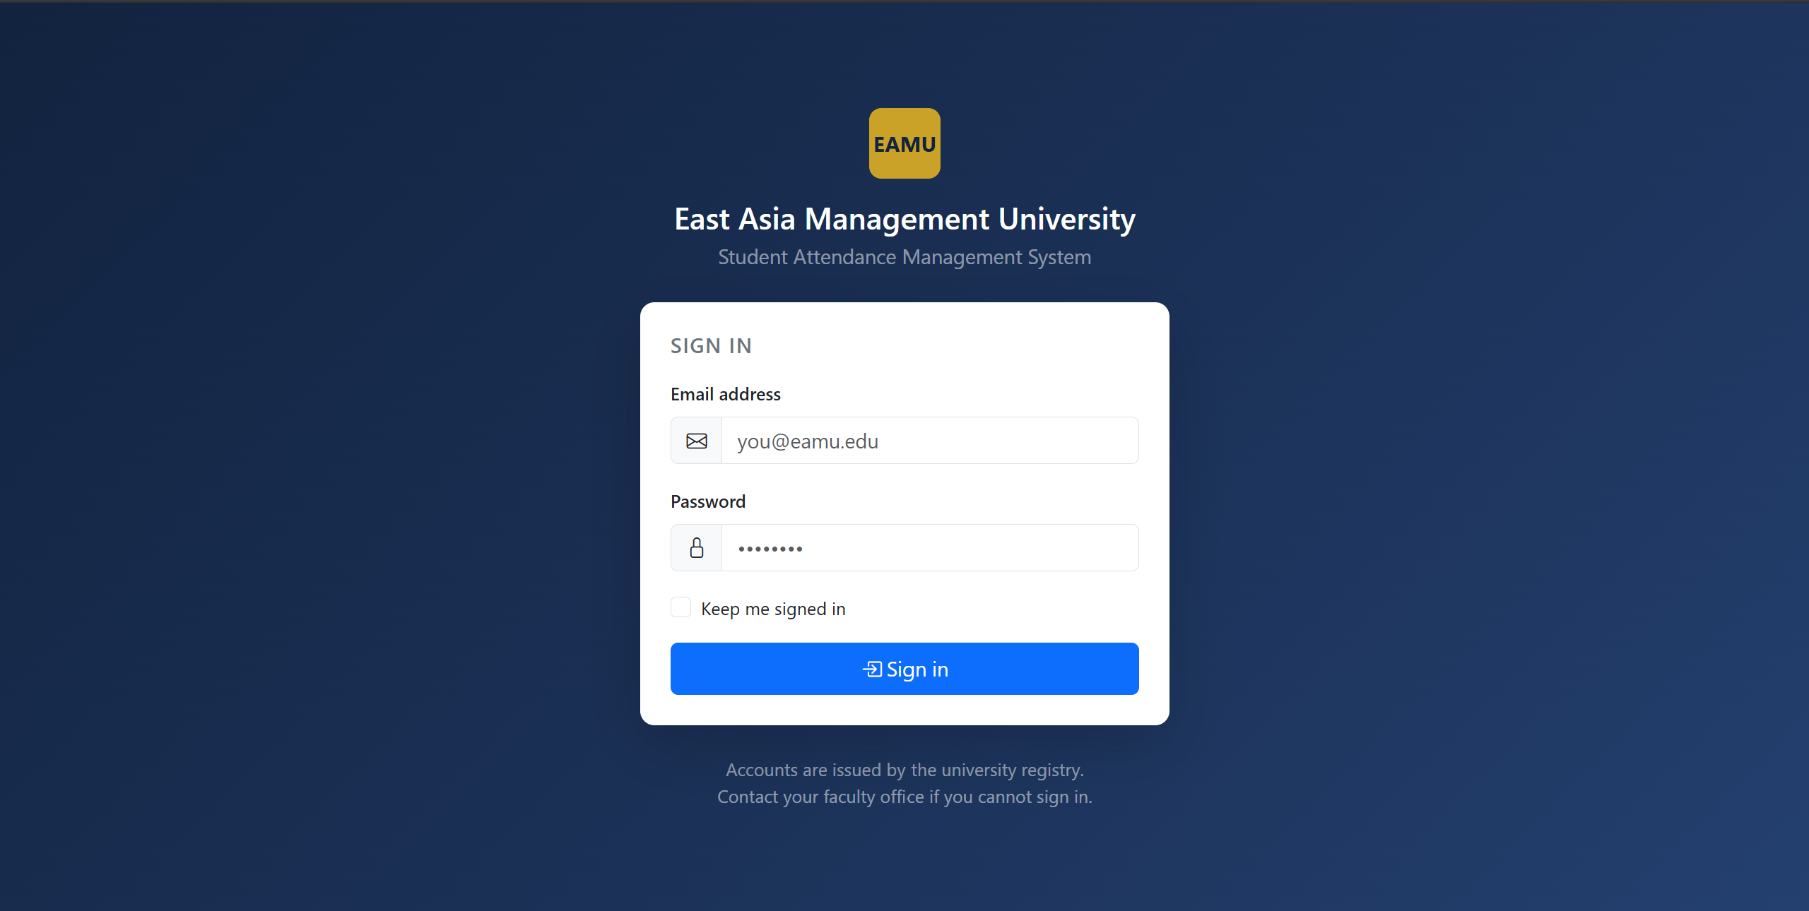
Figure 5: The sign-in screen
Accounts are issued by the registry; there is no public registration, which matches how a university actually admits students. Entering an incorrect password produces the message shown below rather than revealing whether the address exists.
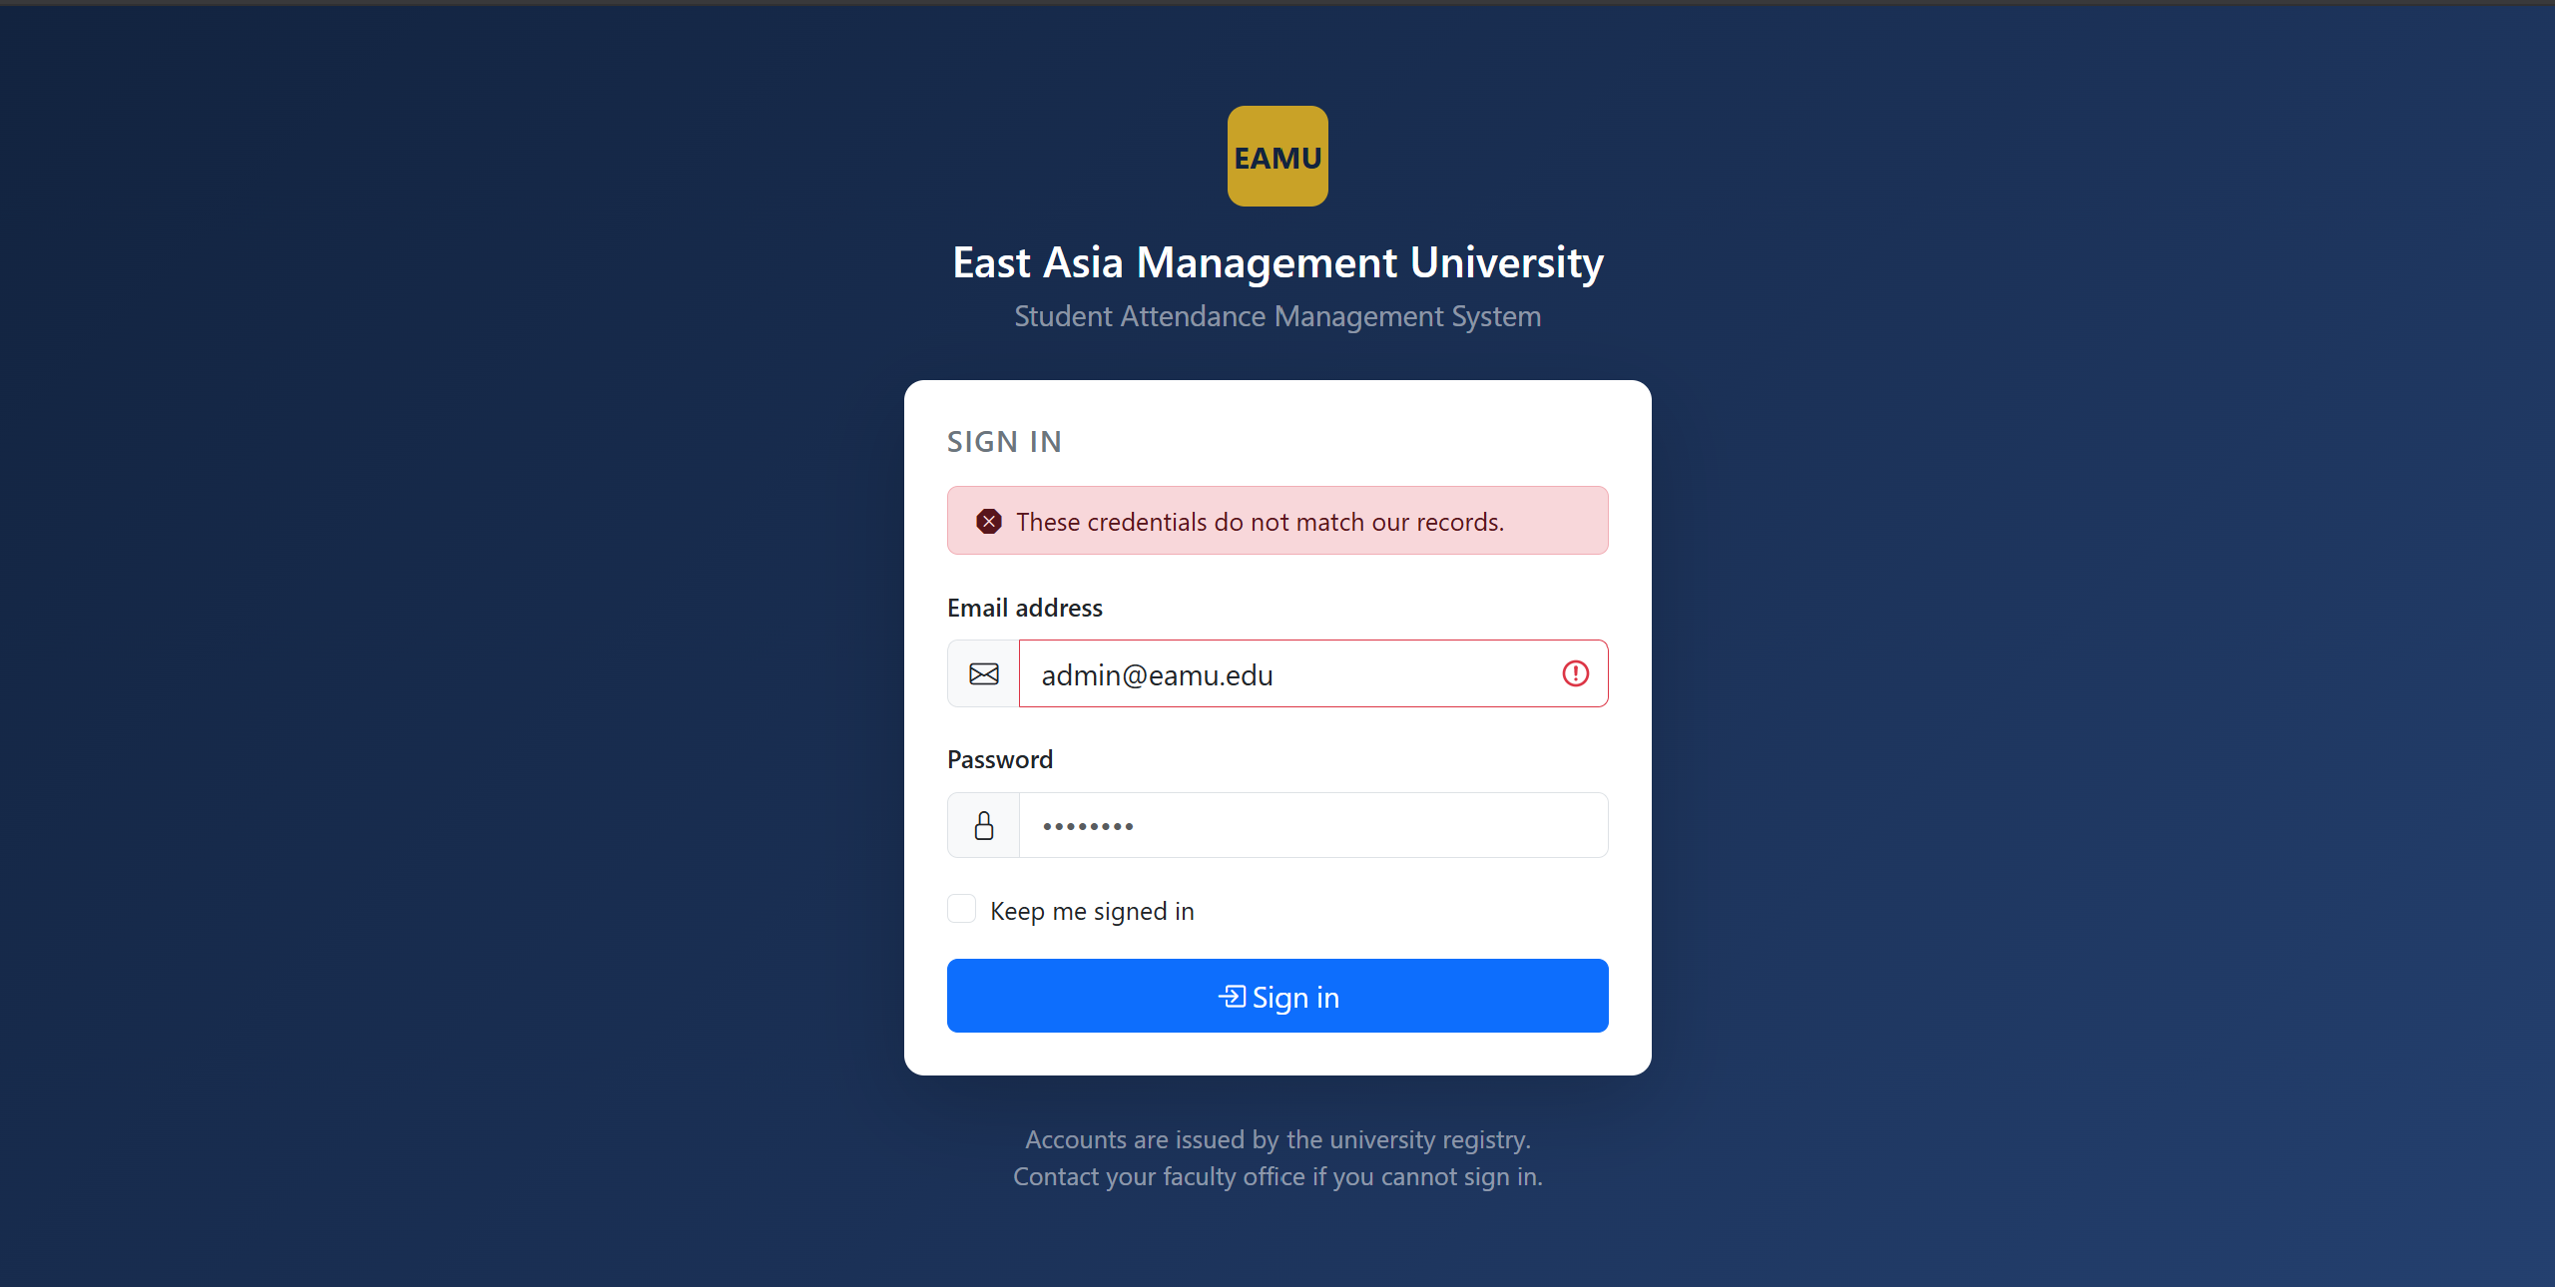
Figure 6: Rejected sign-in attempt

6.2 Administrator Portal

6.2.1 Dashboard
The dashboard opens on four headline figures and two panels: the classes scheduled for today across the whole university, and the students currently below the attendance threshold.
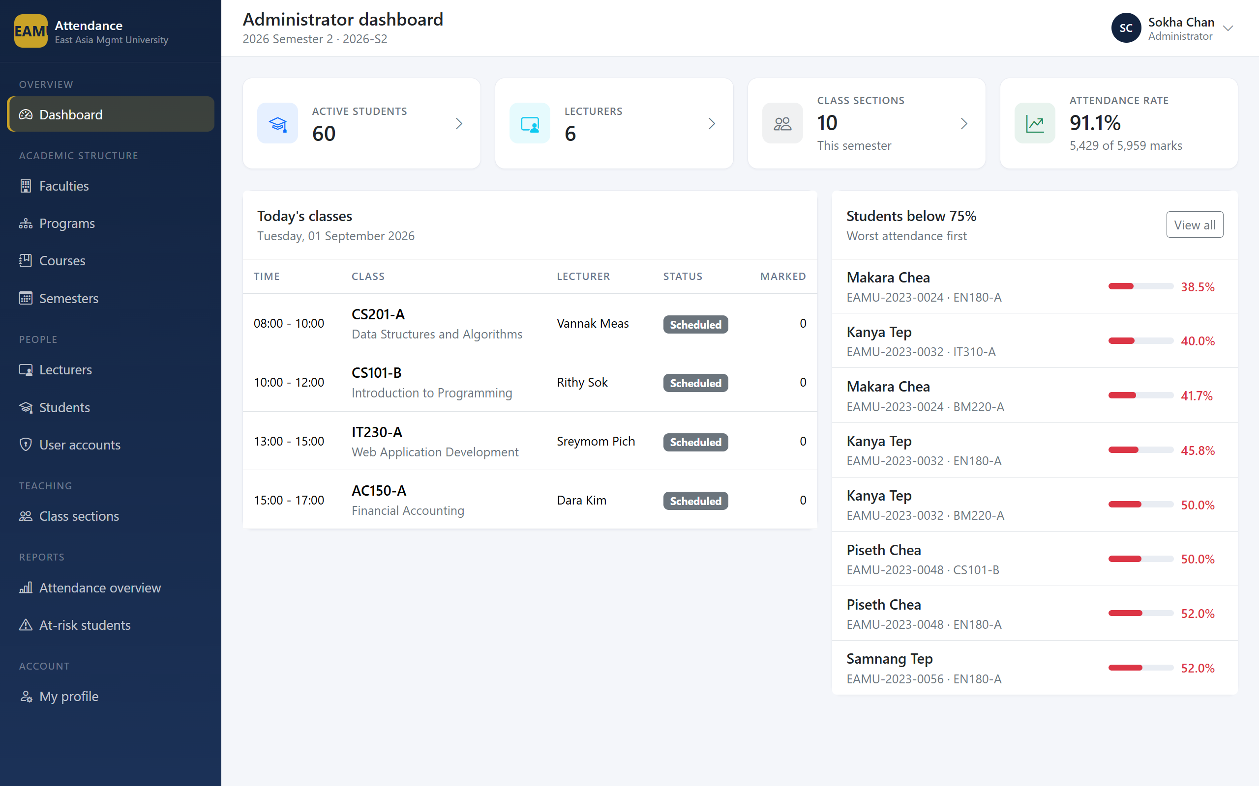Figure 7: Administrator dashboard

6.2.2 Managing the Academic Structure
Faculties, programs, courses and semesters follow a consistent pattern: a searchable list with counts of dependent records, and a form for creating or editing.
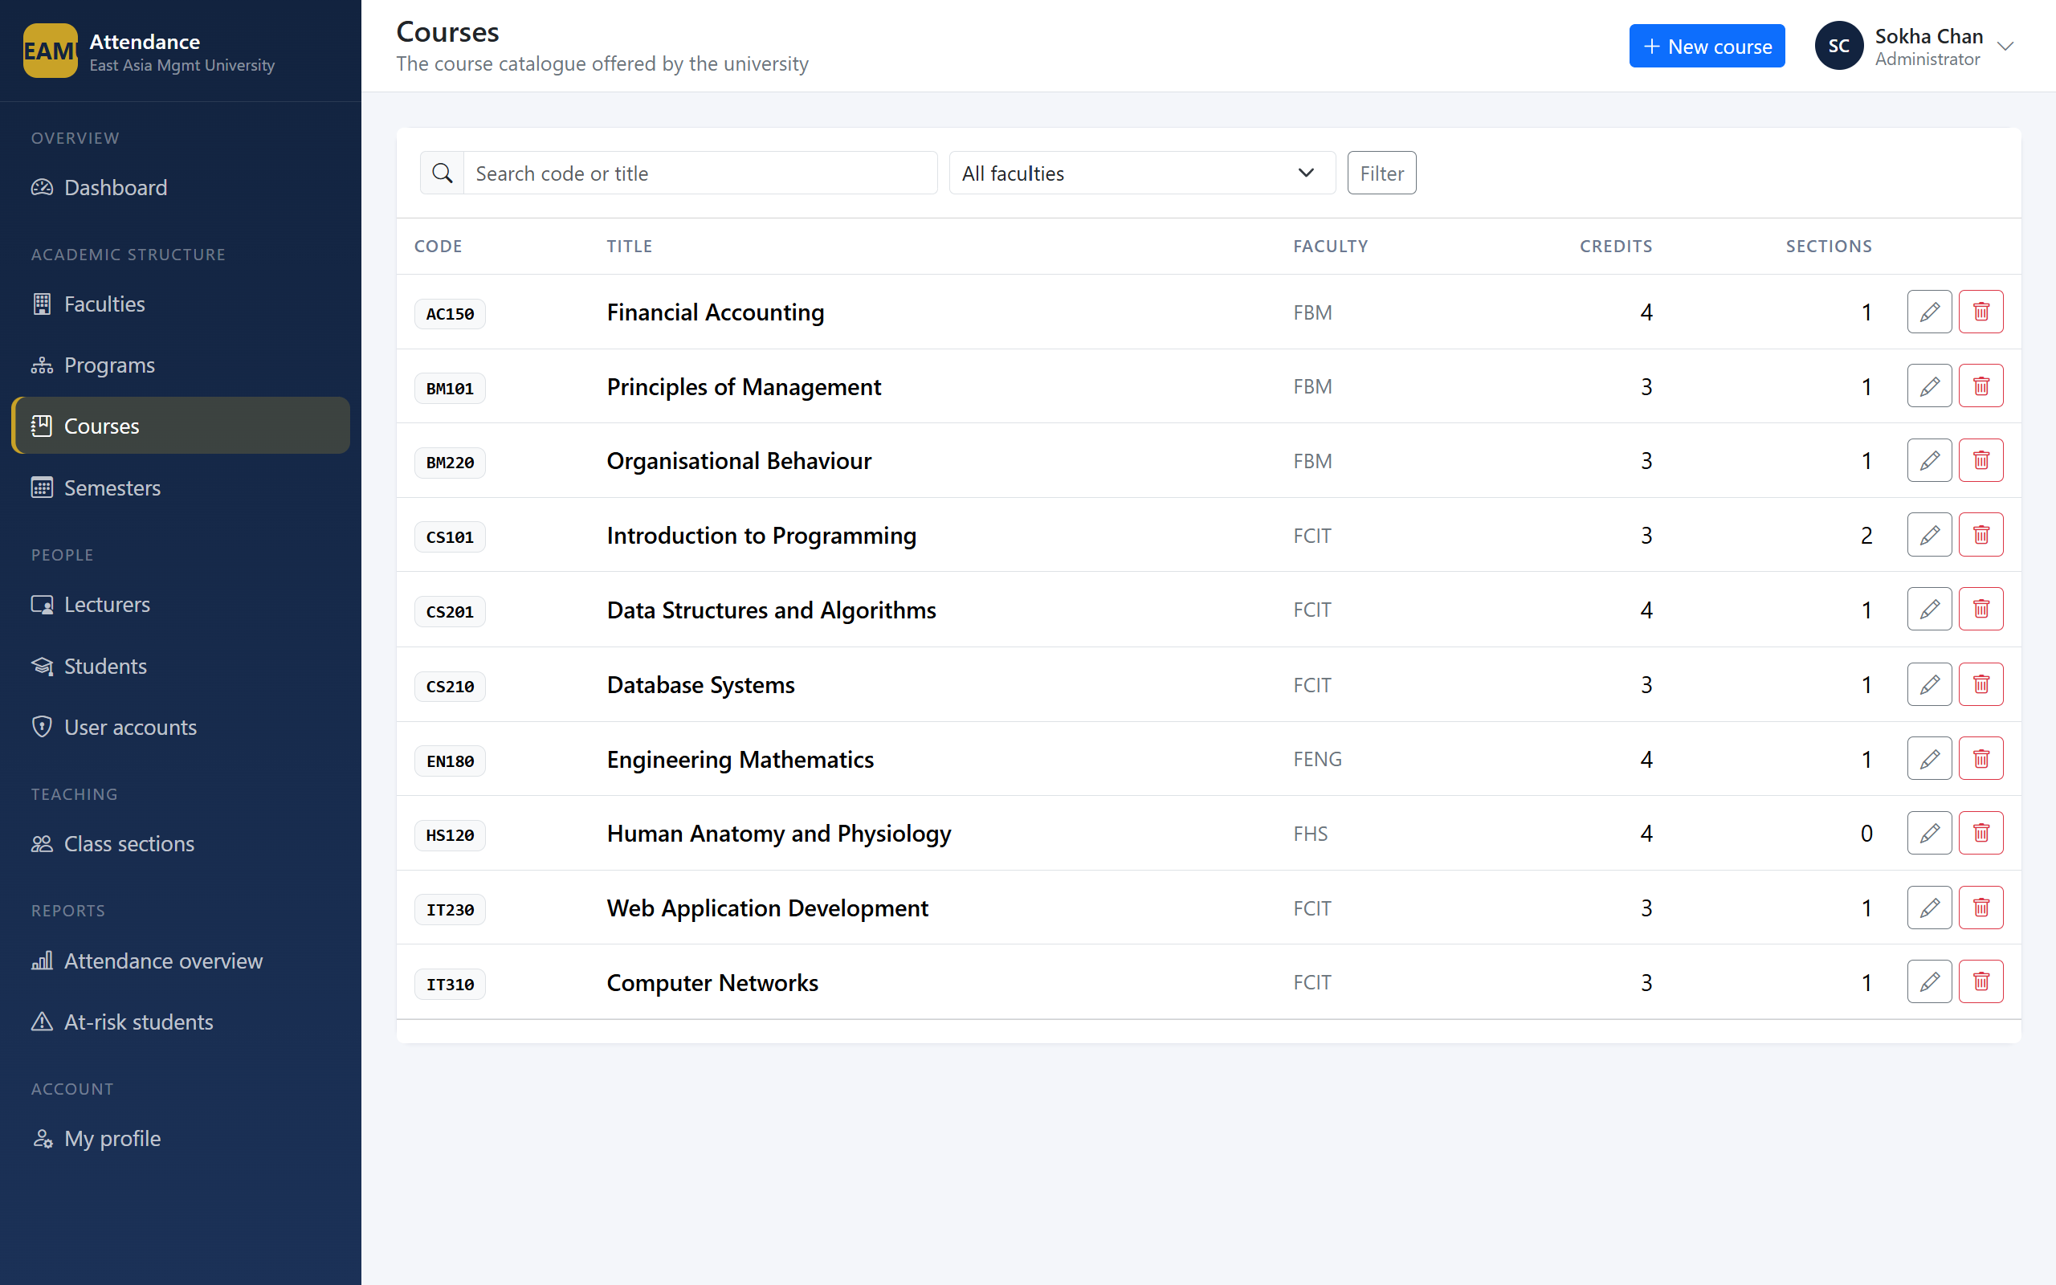
Figure 8: Course catalogue
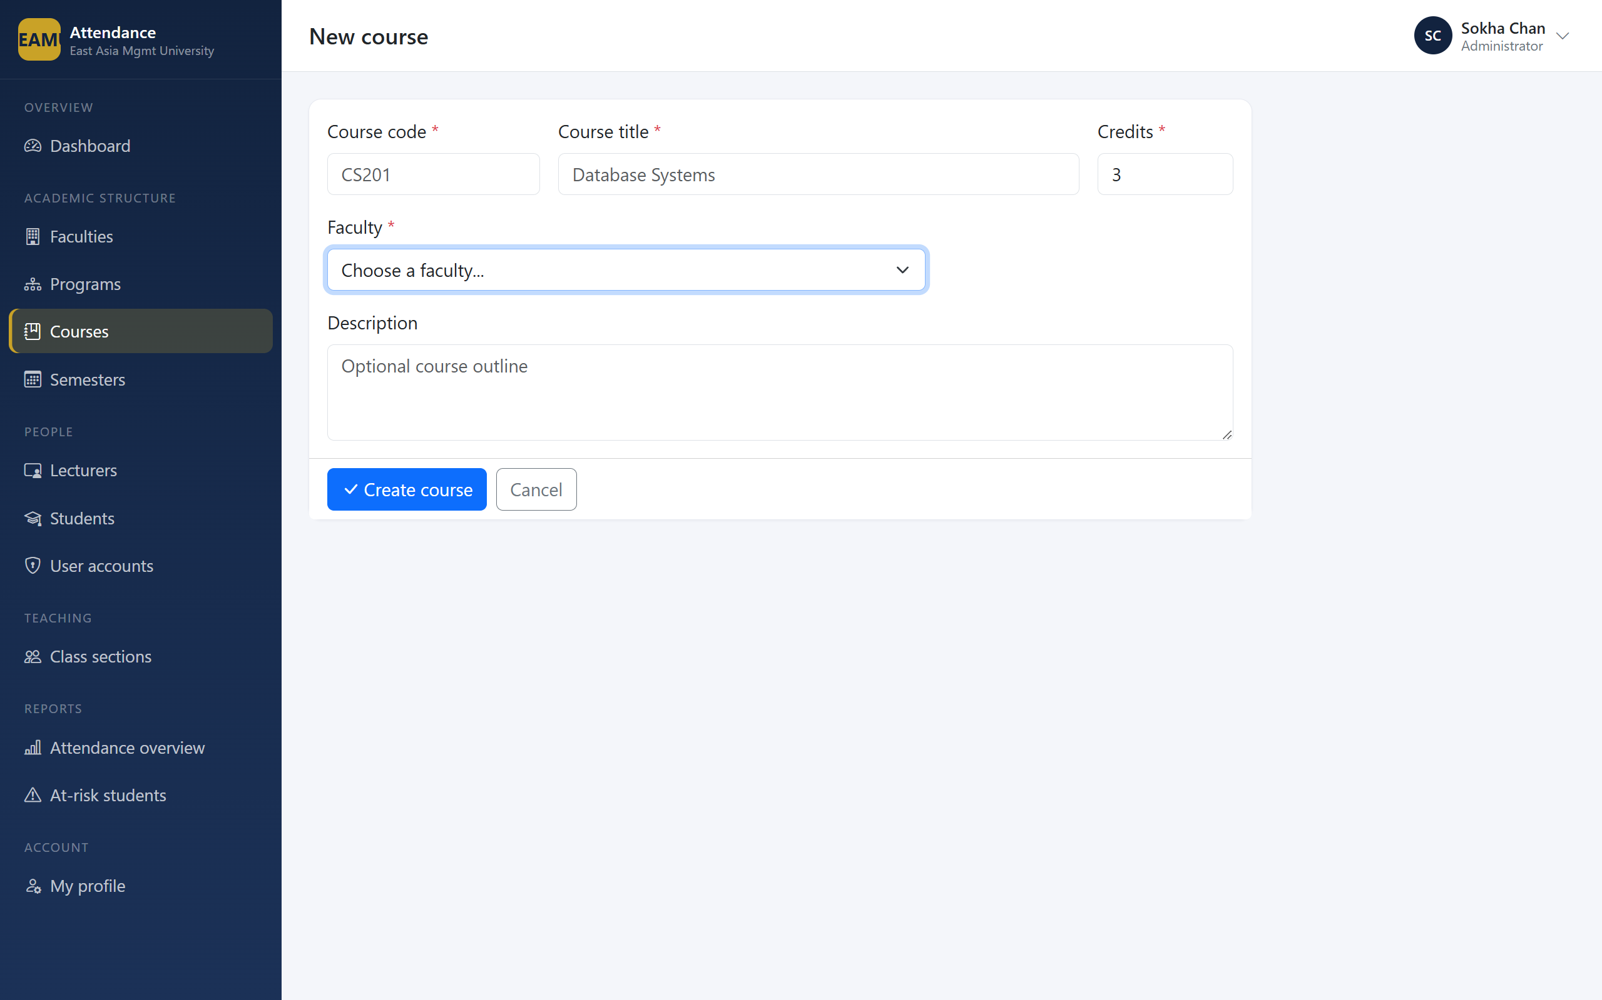
Figure 9: Course entry form
Attempting to delete a record that still has dependents is refused with an explanation rather than cascading silently.
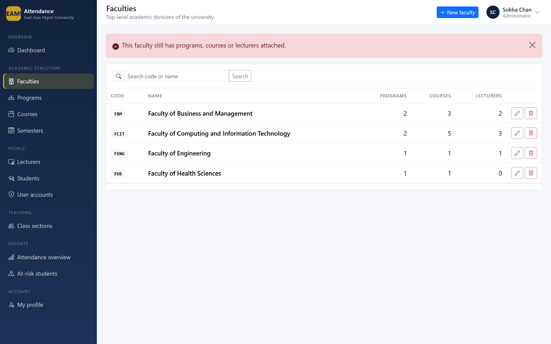
Figure 10: Referential integrity guard

6.2.3 Managing People
Creating a lecturer or a student creates both the academic record and the sign-in account in a single transaction, so the two can never fall out of step.
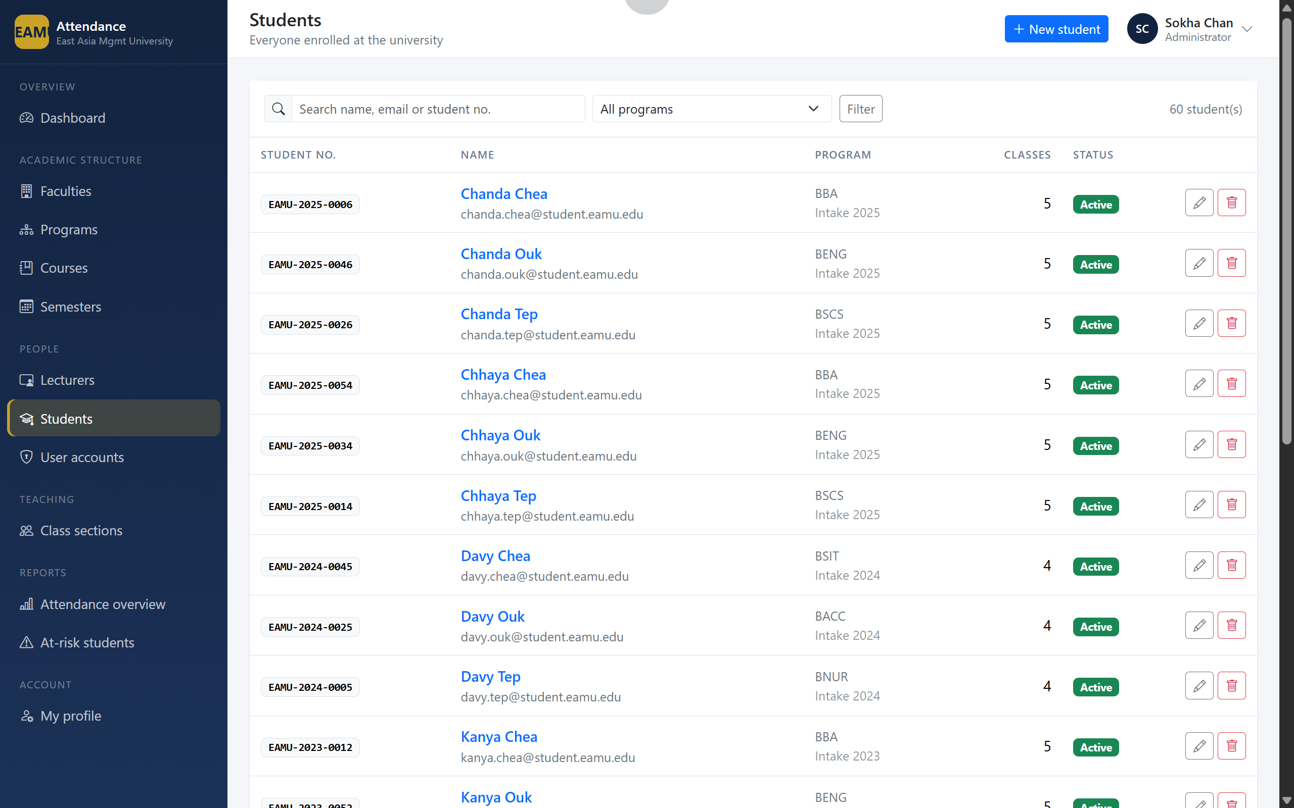
Figure 11: Student list
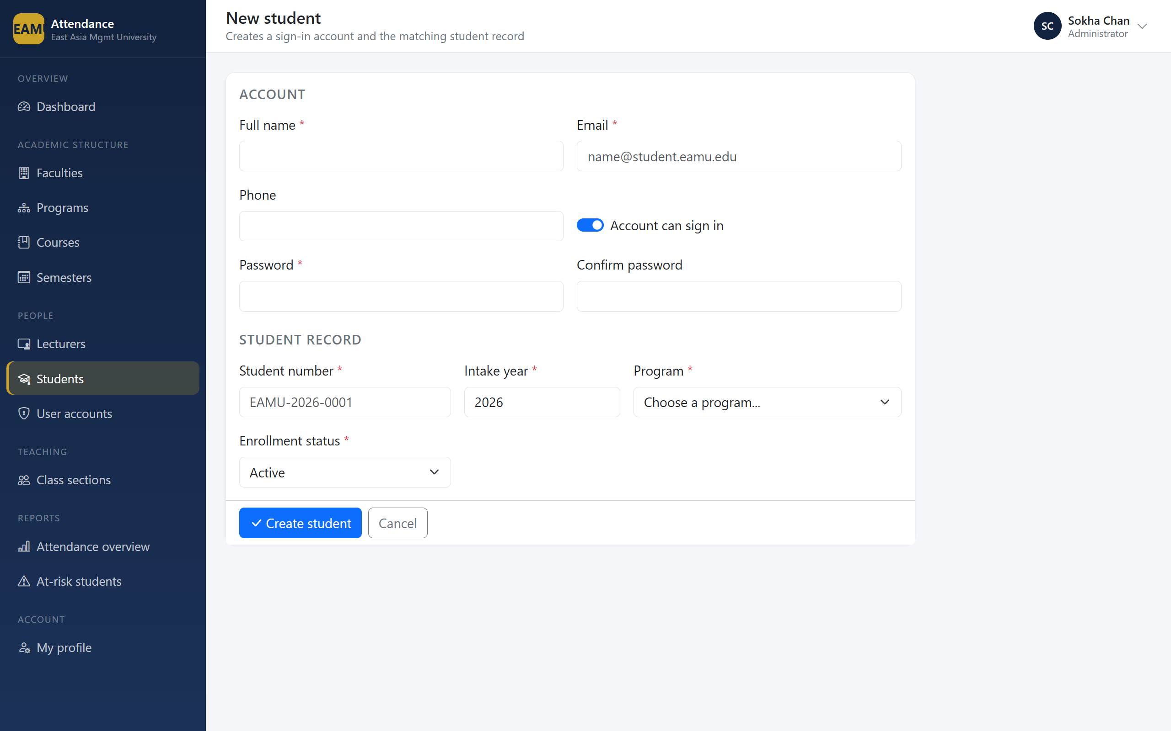
Figure 12: Student entry form

6.2.4 Class Sections and Timetables
A class section binds a course, a semester and a lecturer, and carries the weekly timetable from which a lecturer later generates a term of sessions.
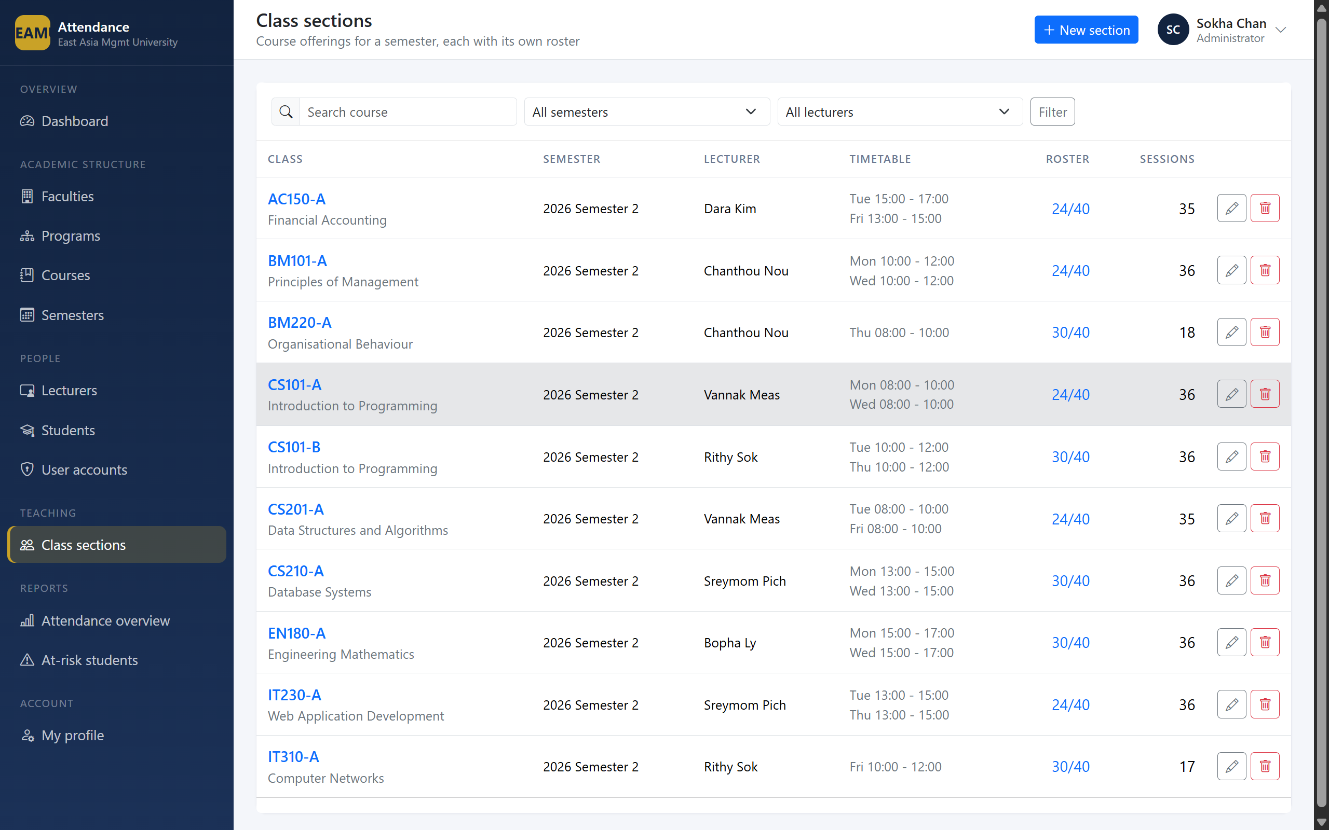
Figure 13: Class section list
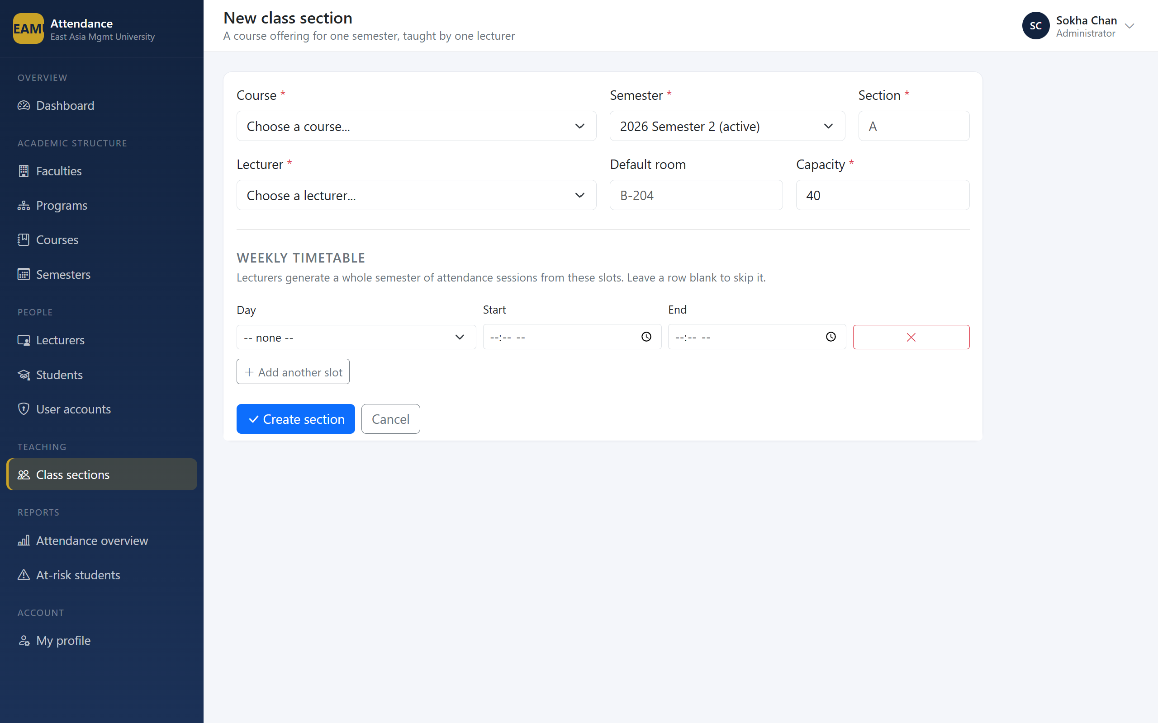
Figure 14: Class section form with timetable builder

6.2.5 Roster Management
The roster manager places the enrolled list beside a searchable pool of candidates. Students already enrolled are excluded from the pool, so a duplicate cannot be created by mistake.
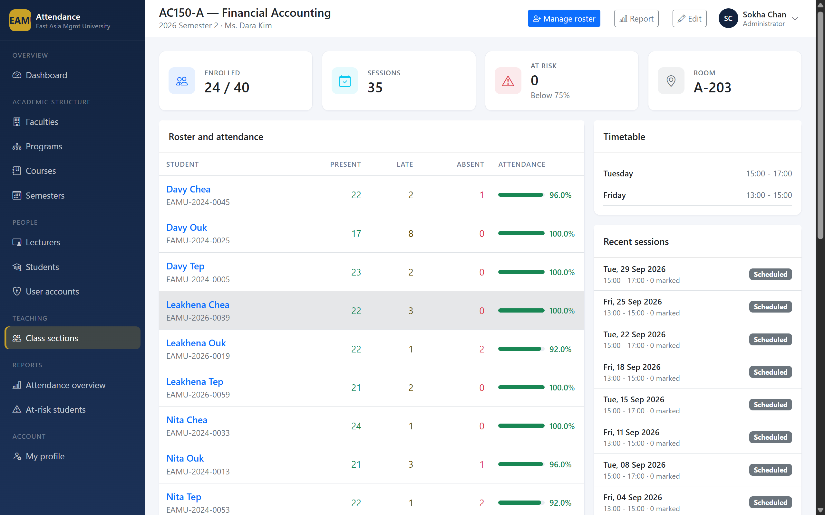
Figure 15: Roster manager

6.2.6 Account Administration
The system sends no email, so password resets are performed by the registry in person. An administrator cannot deactivate their own account.
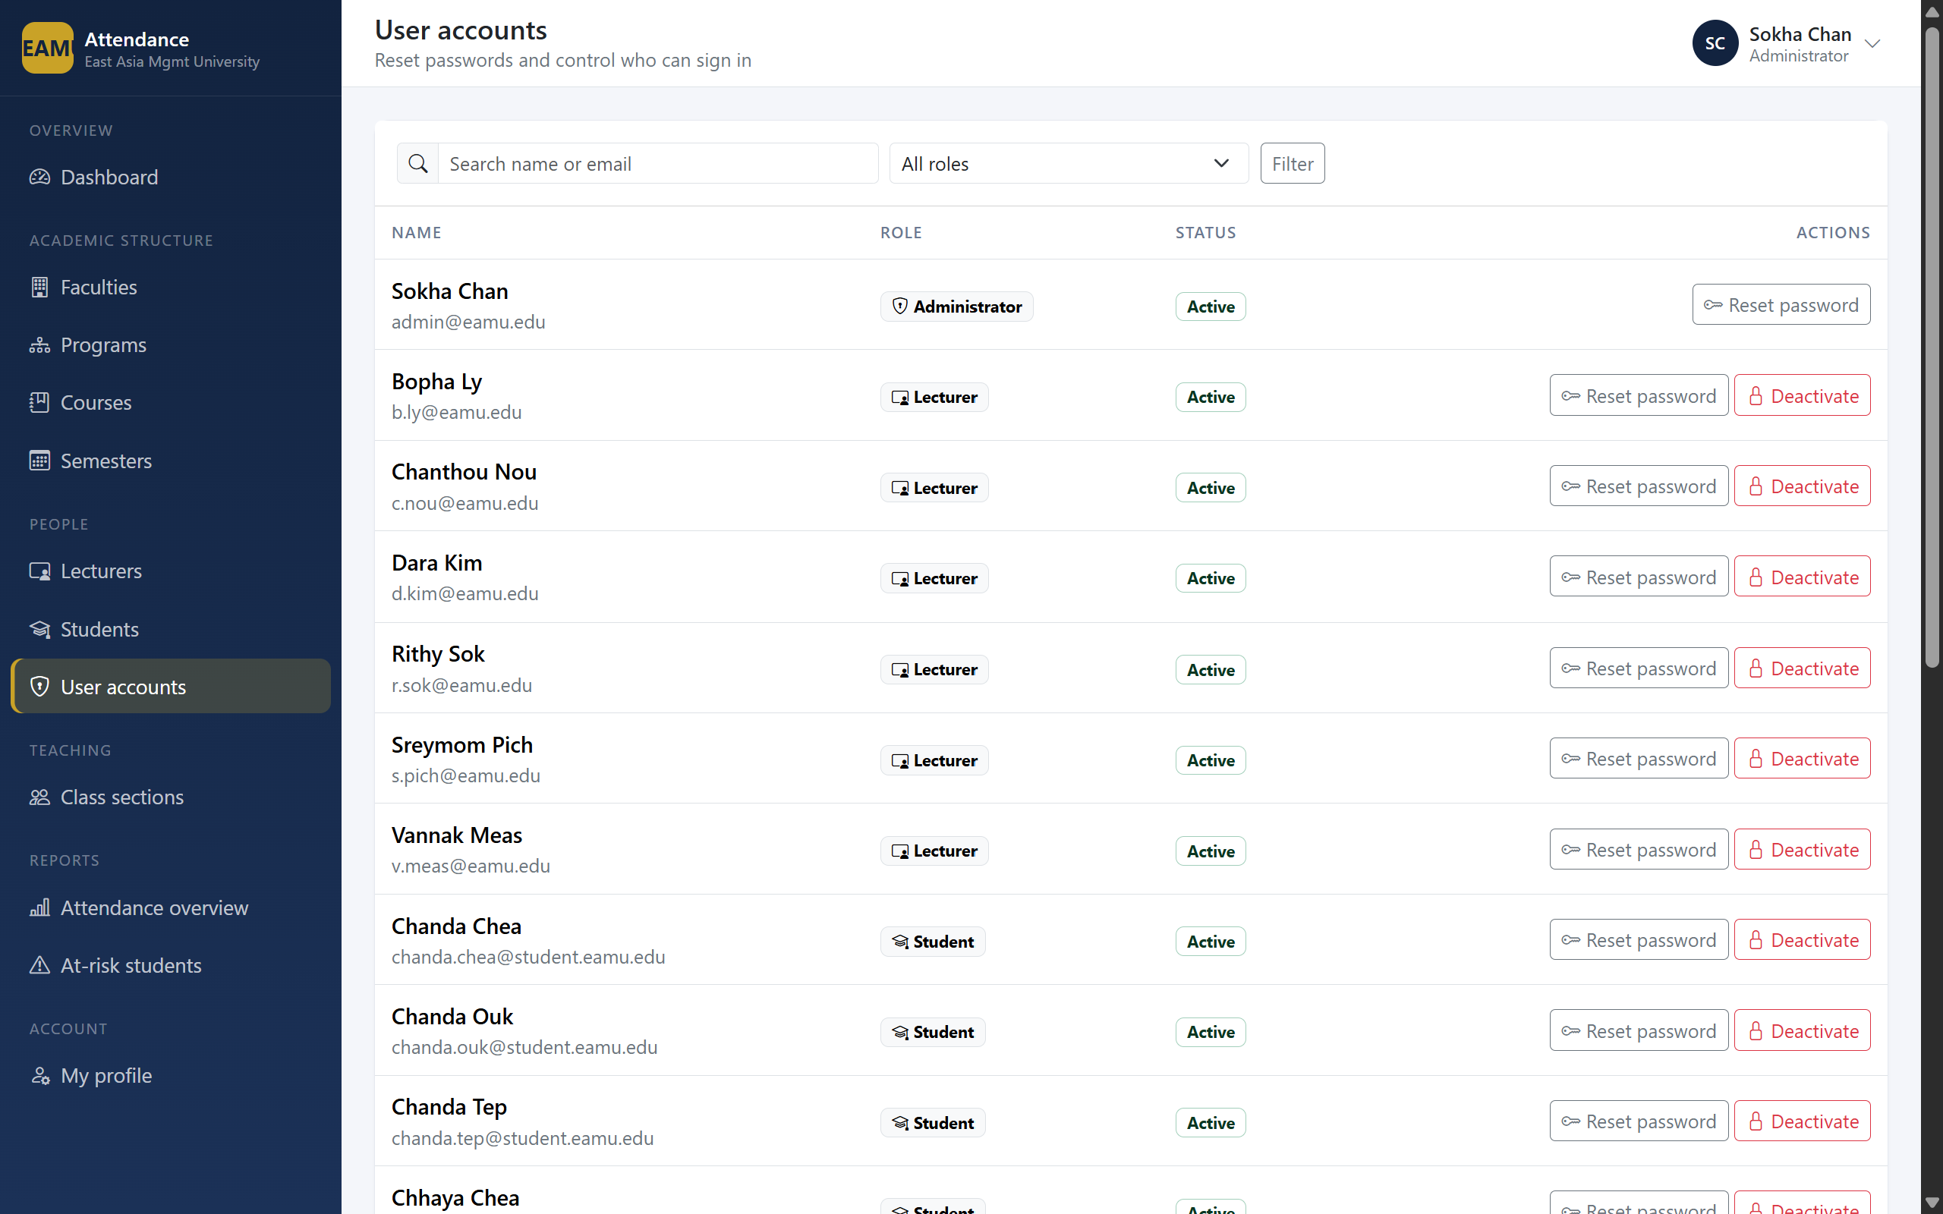
Figure 16: User accounts

6.2.7 Reporting
The overview reports every class section with its cohort attendance. Rows below the threshold are highlighted.
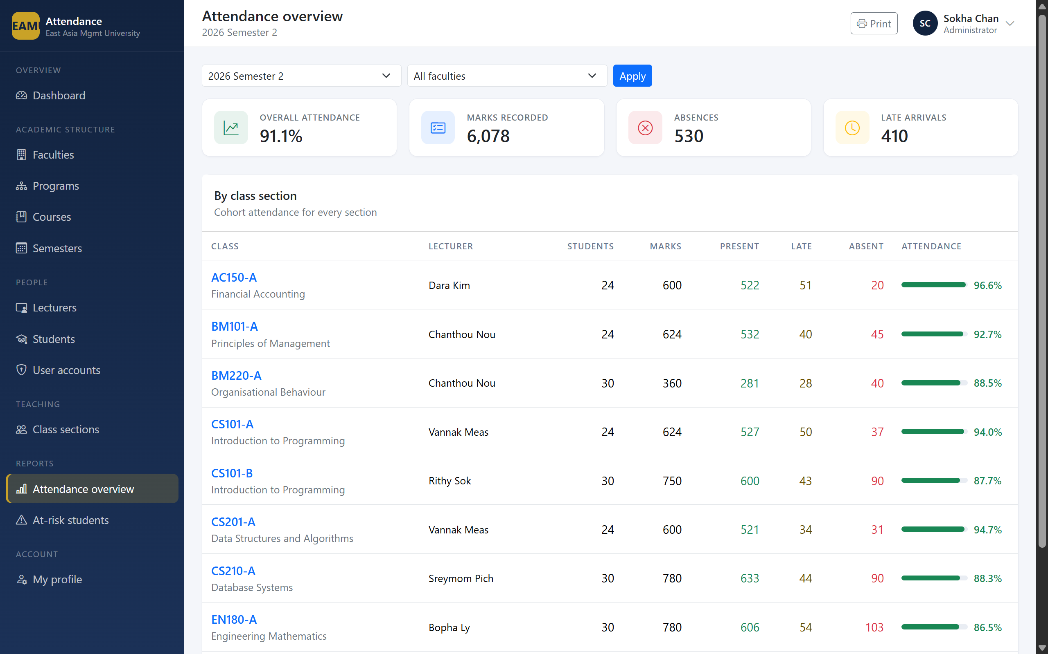
Figure 17: University attendance overview
The at-risk report is the operationally important one: it lists every enrollment below the required minimum, worst first, so the registry can intervene while the semester is still running.
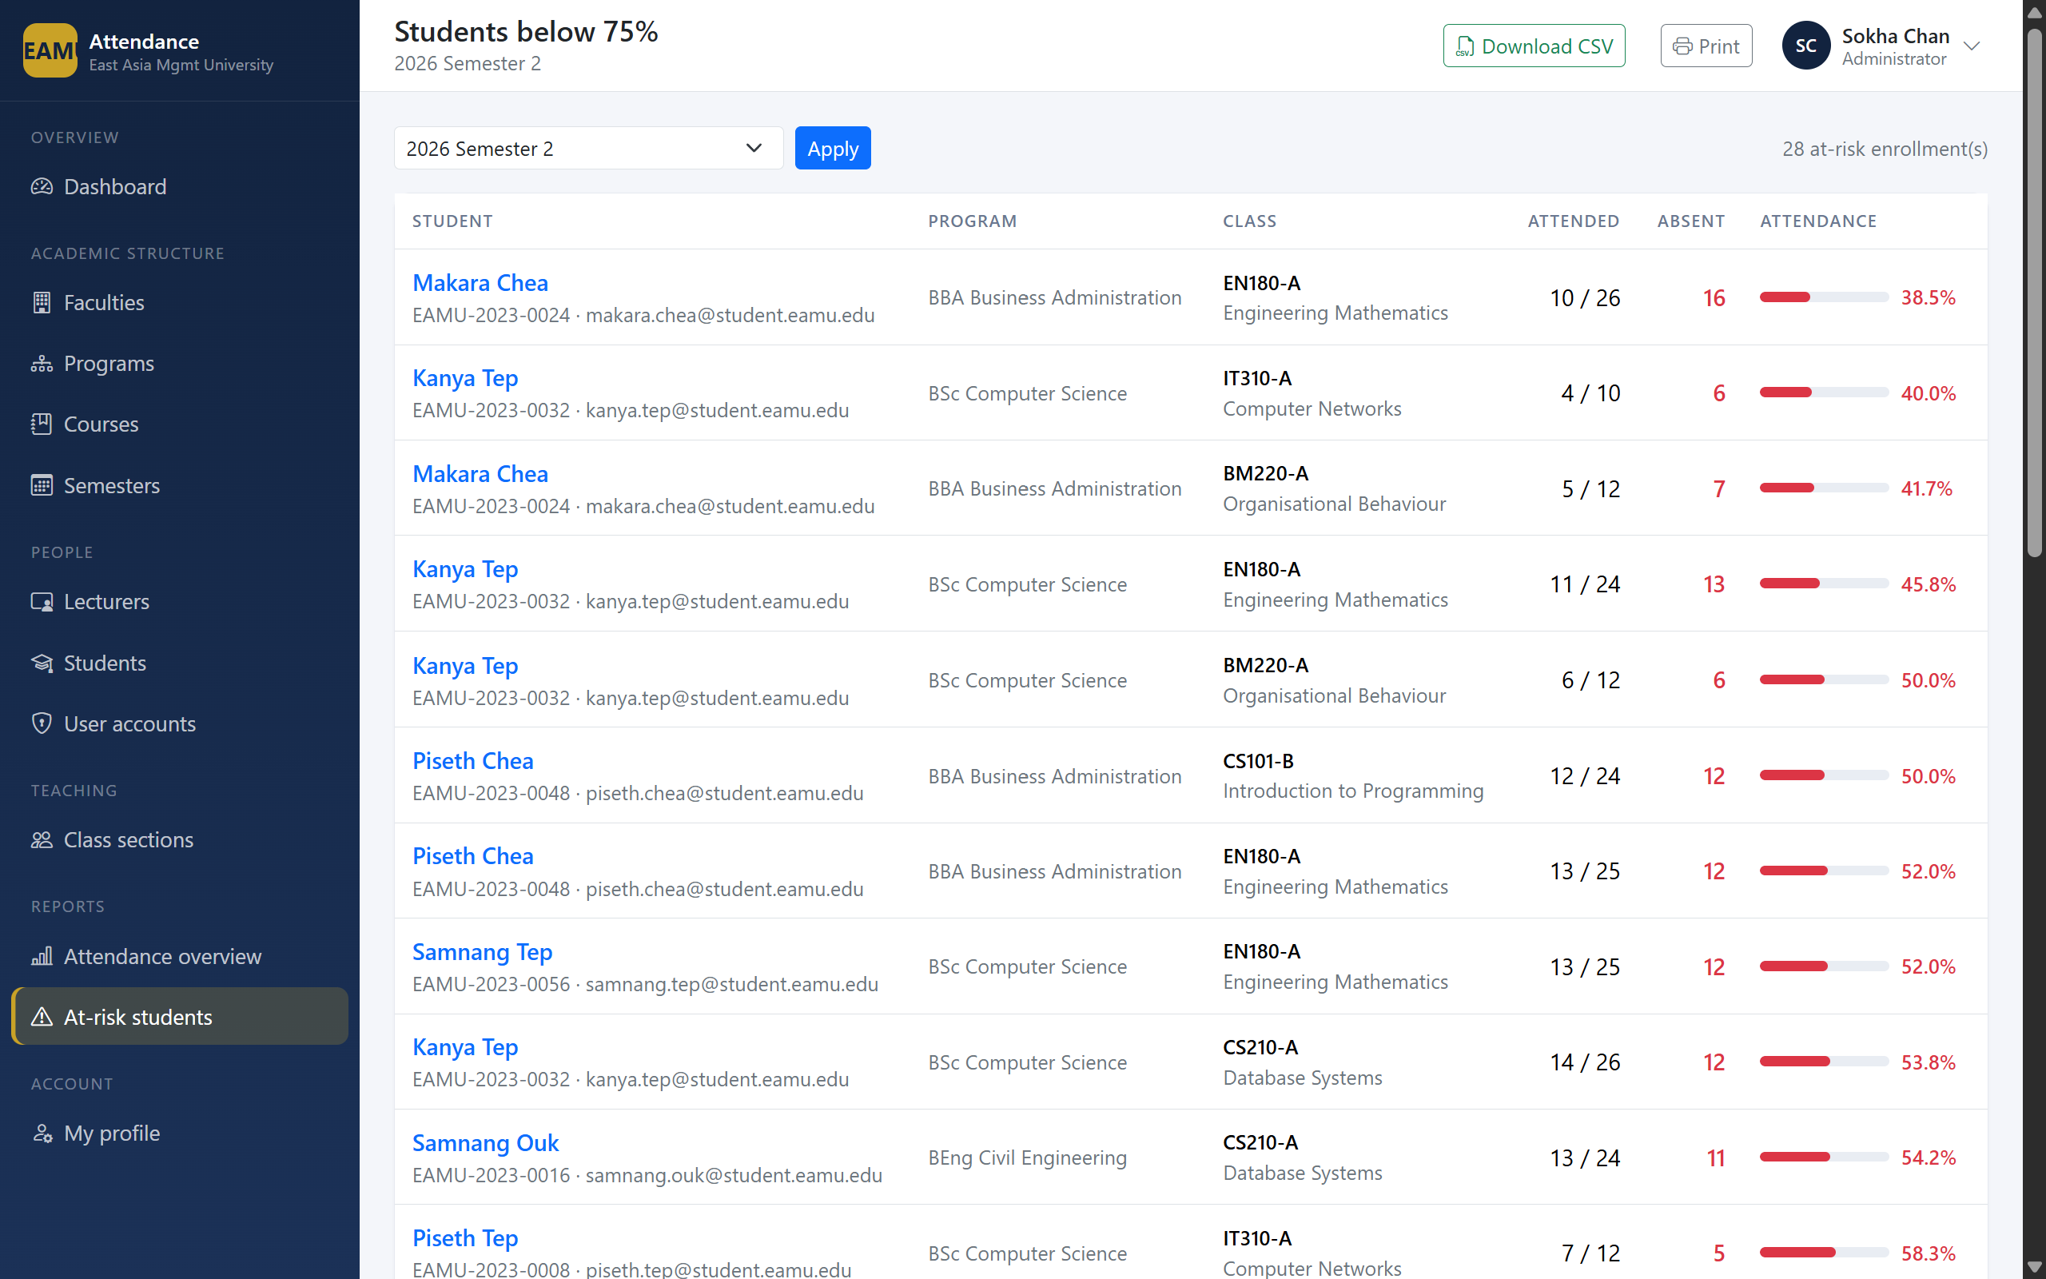
Figure 18: At-risk students report
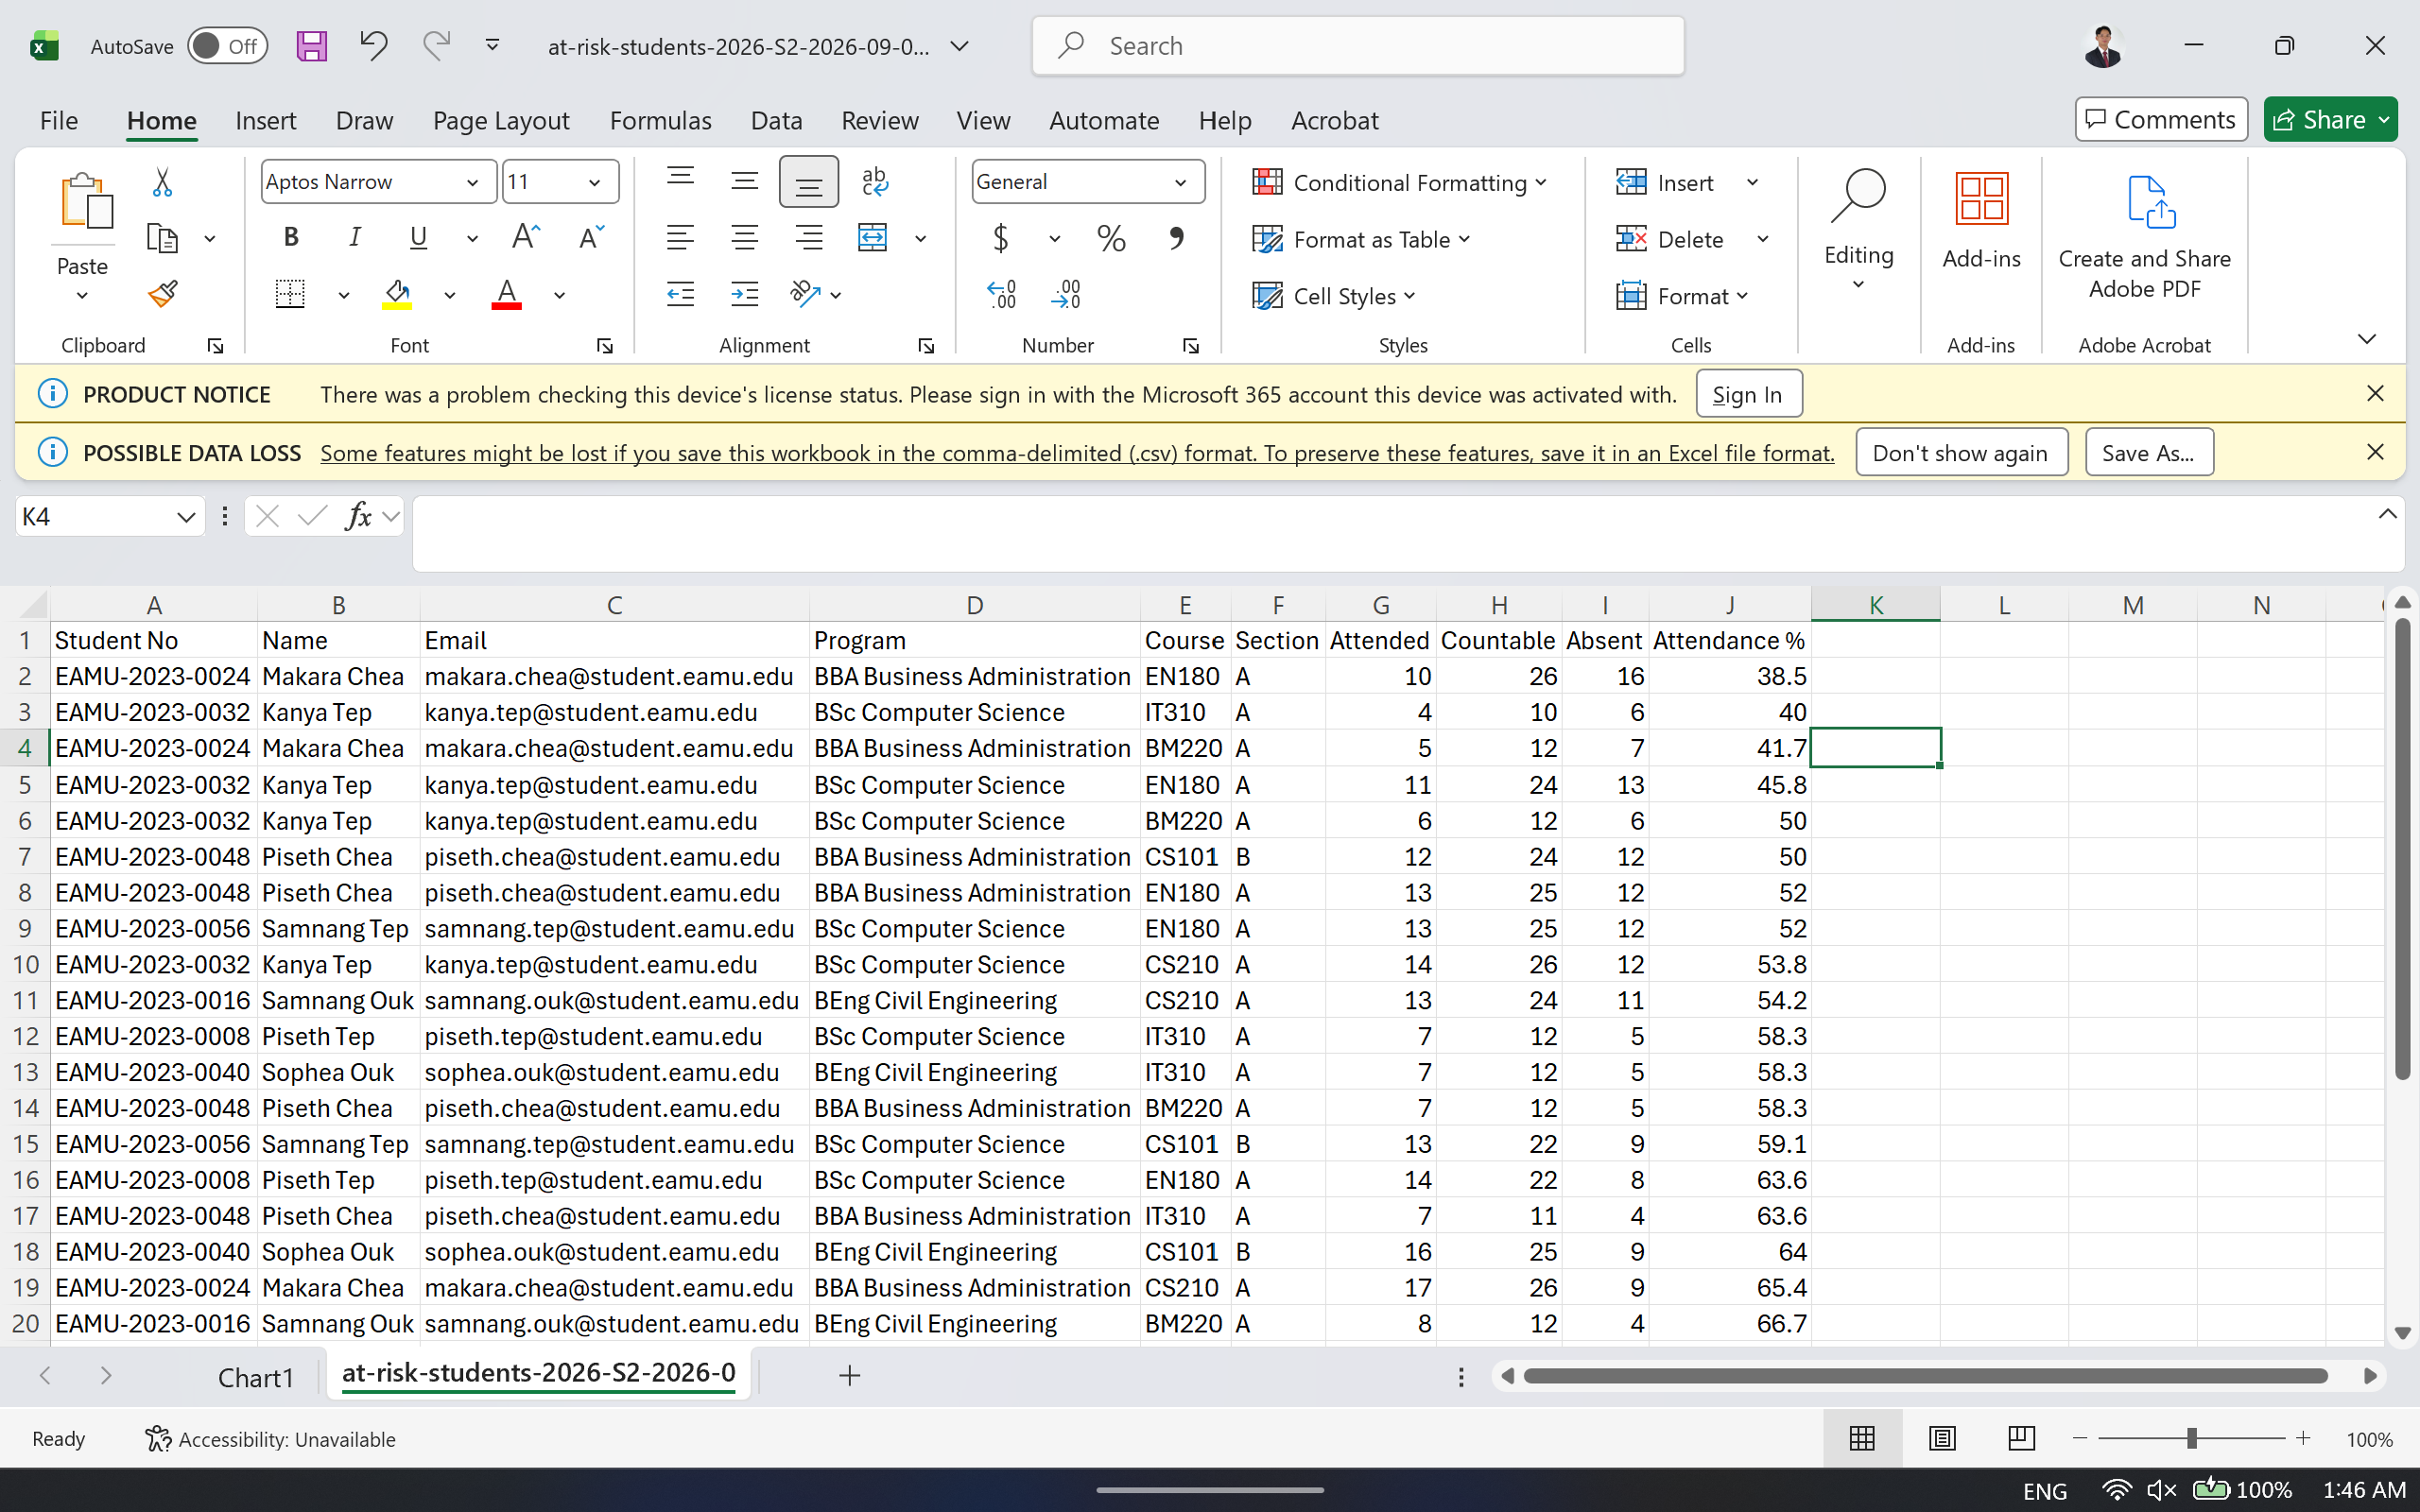
Figure 19: Exported CSV opened in a spreadsheet

6.3 Lecturer Portal

6.3.1 Dashboard
A lecturer sees only the classes assigned to them. The dashboard leads with the sessions scheduled for today, each with a single control to open it for check-in.
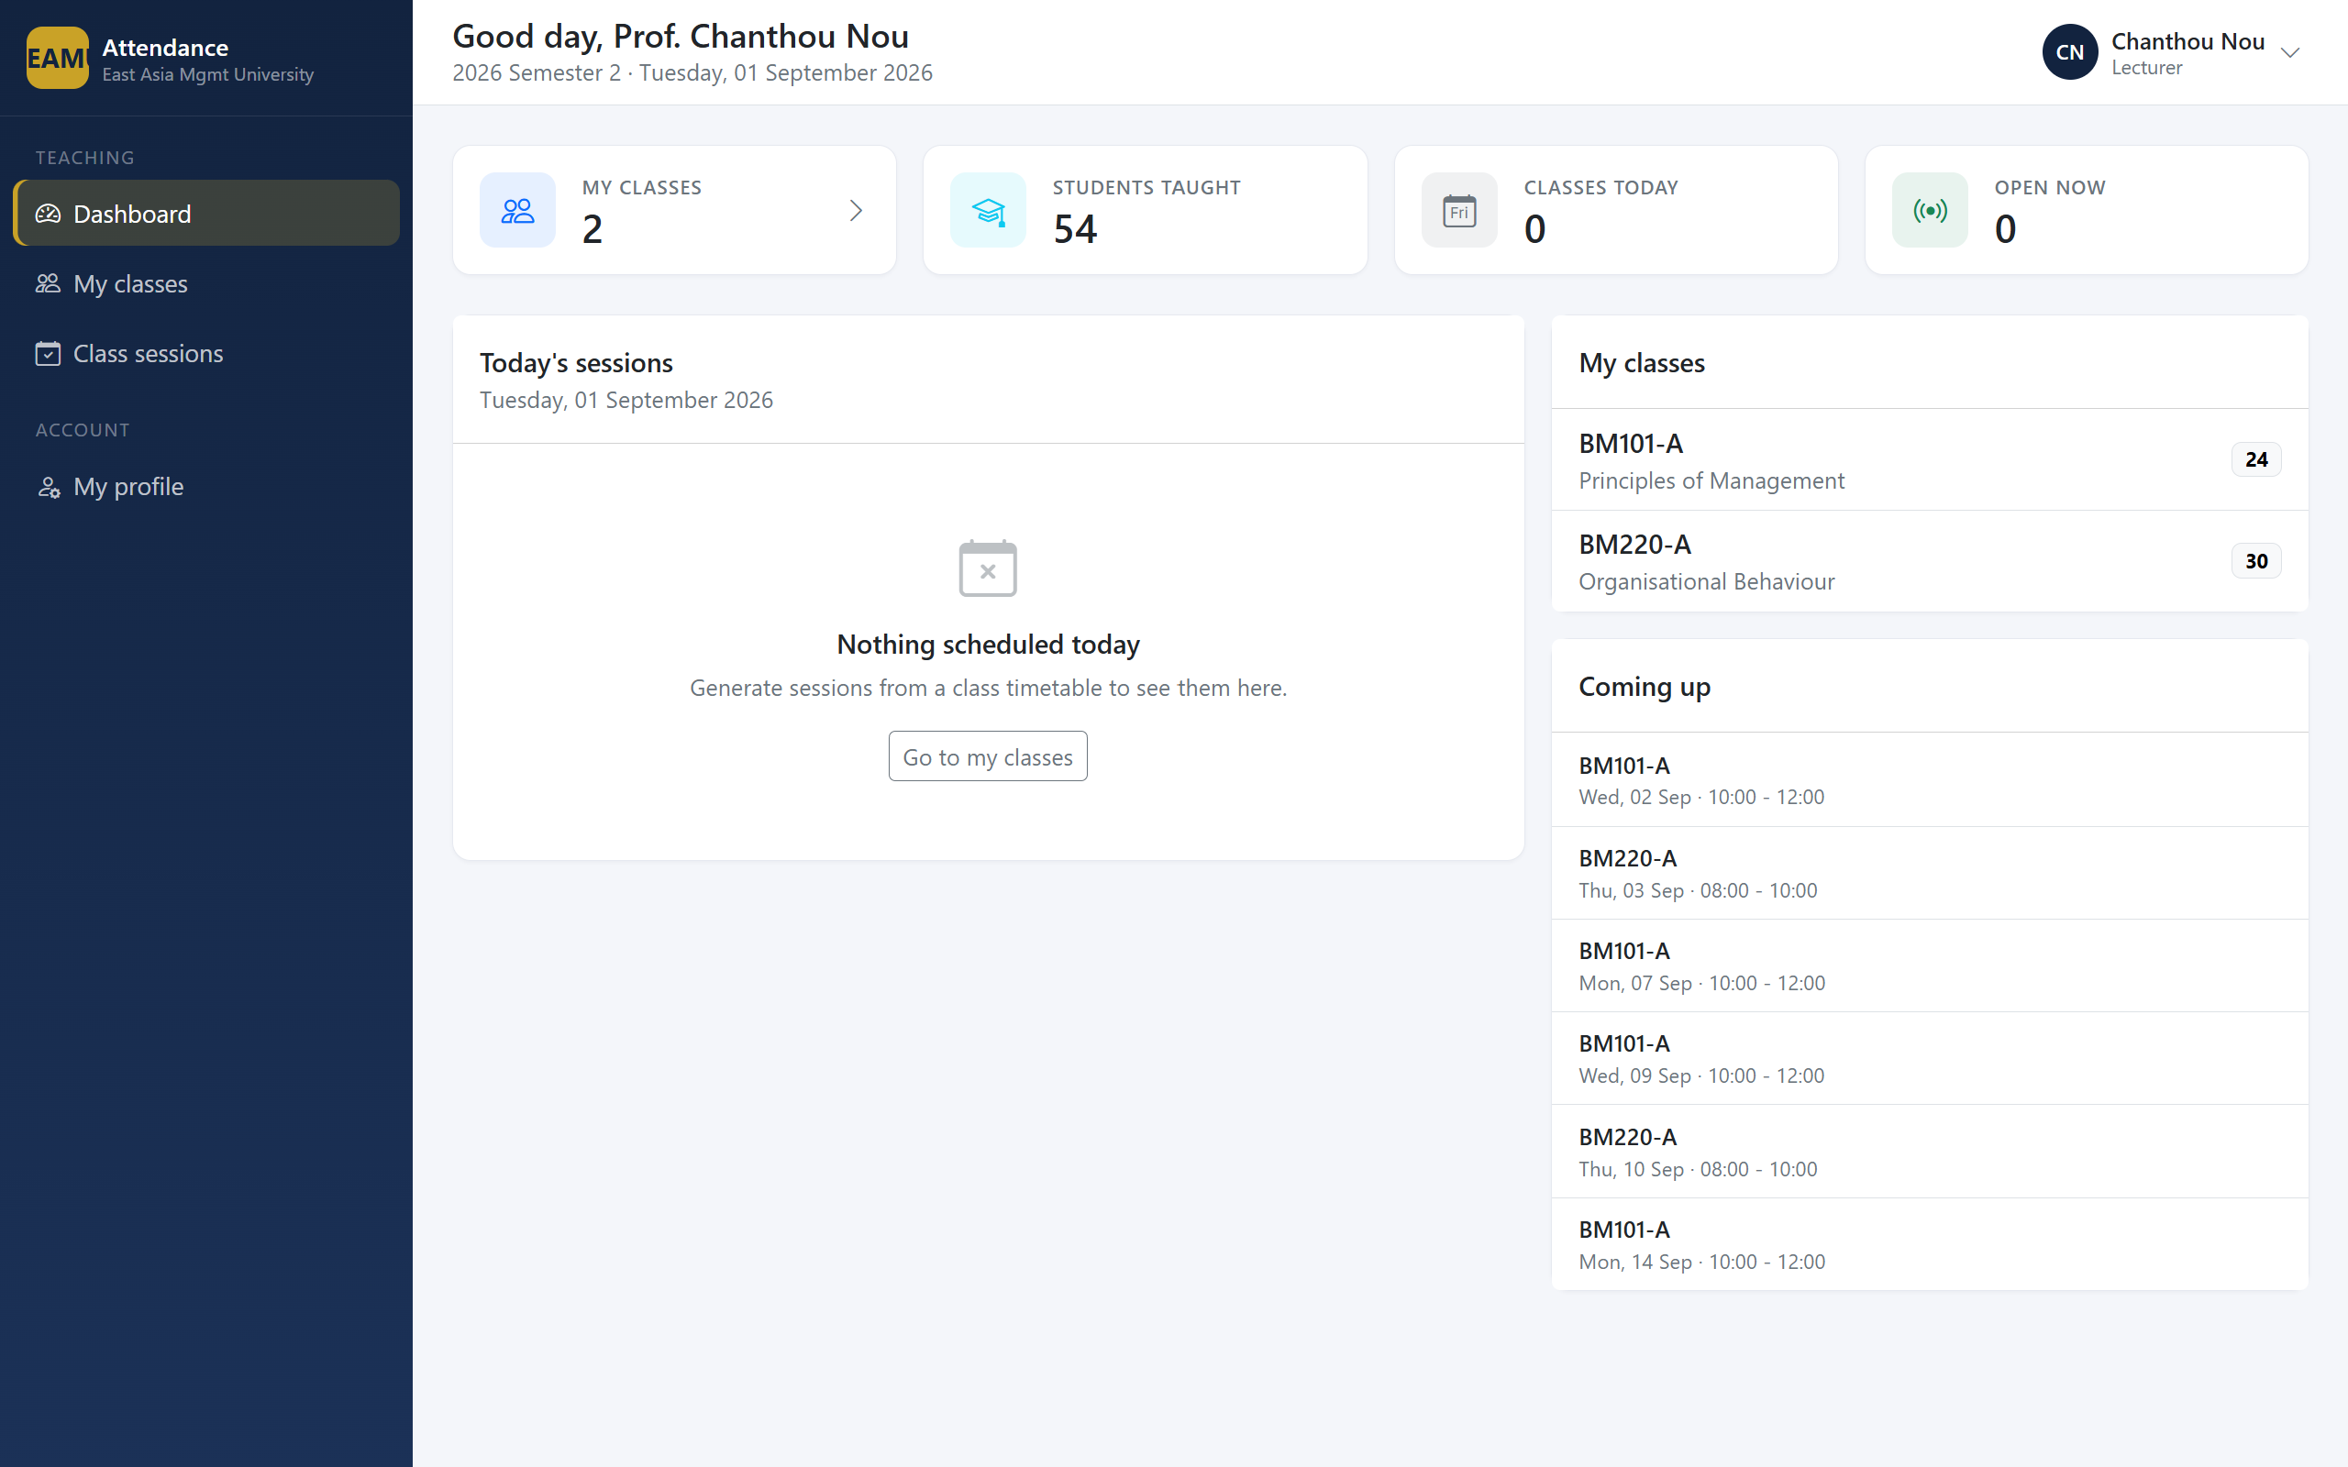
Figure 20: Lecturer dashboard

6.3.2 Class Detail
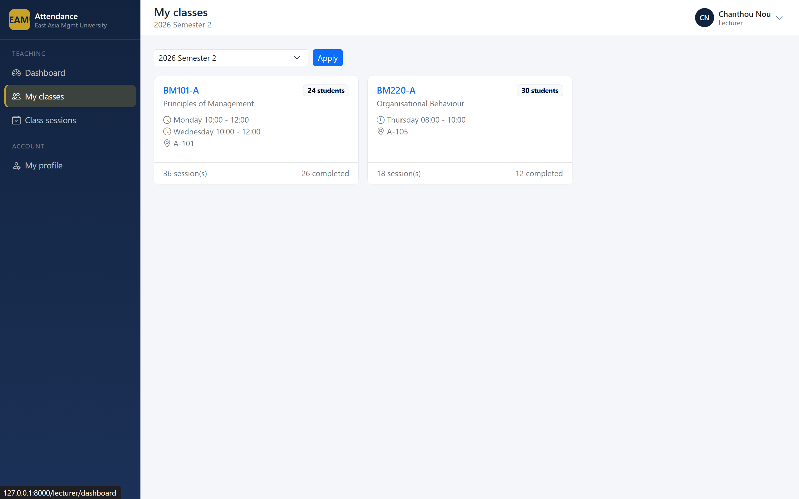
Figure 21: Class detail

6.3.3 Generating Sessions
Rather than creating each class meeting by hand, a lecturer generates the whole term from the timetable in one action. Existing sessions are skipped, so the operation is safe to repeat.
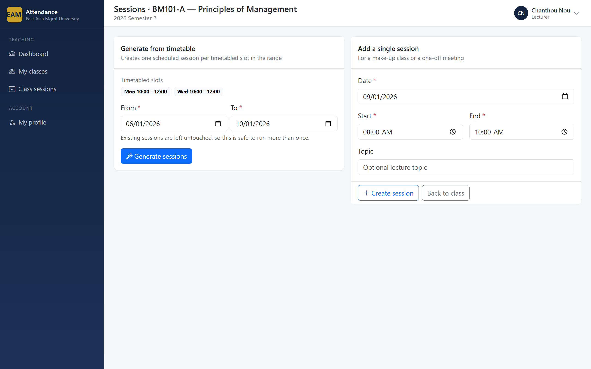
Figure 22: Session generation

6.3.4 Marking the Register
The register is the screen a lecturer uses most. Each student occupies one row with four options, present pre-selected. Students who have already checked in themselves are annotated with how they did so.
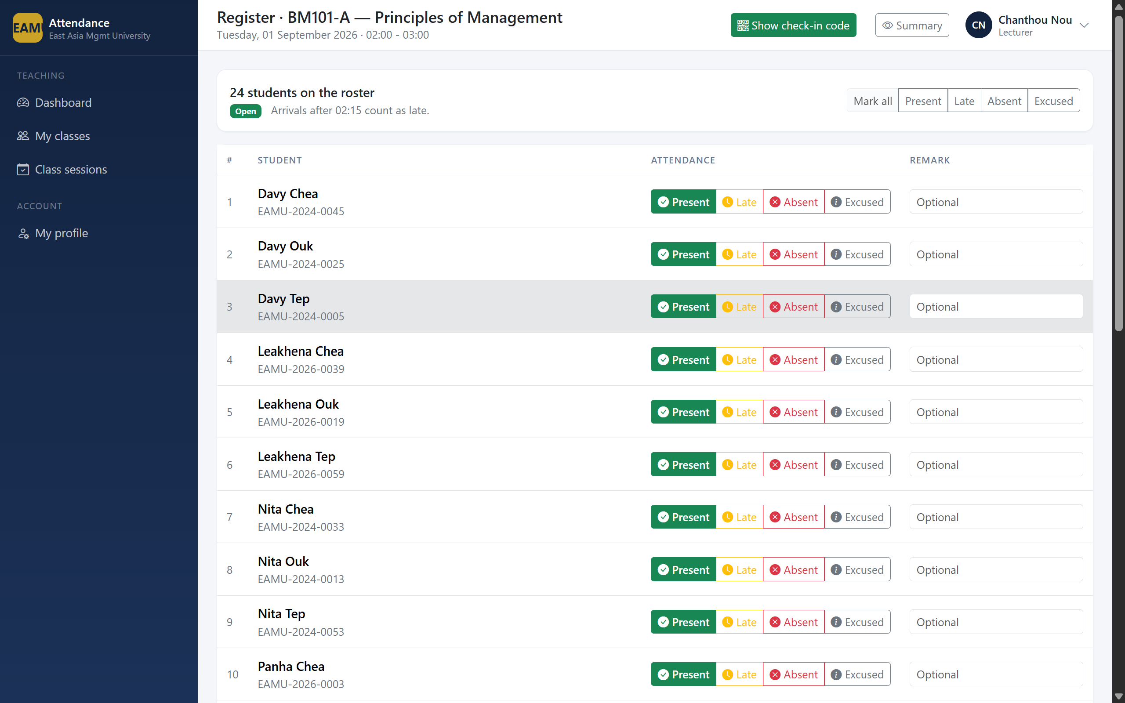
Figure 23: Marking register
Saving and closing in one action records the register and marks any remaining student absent.
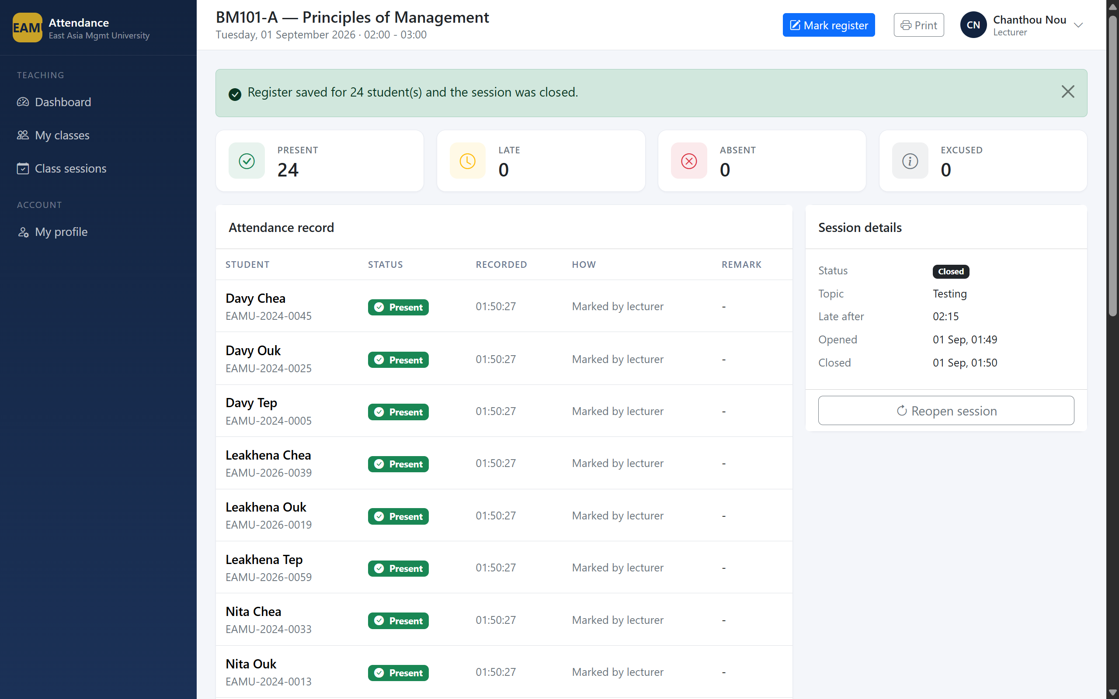
Figure 24: Session closed

6.3.5 The QR Check-in Screen
This screen is designed to be projected. It shows the rotating QR code, the six-character alternative, a countdown to the next rotation, and a live list of students as they check in.
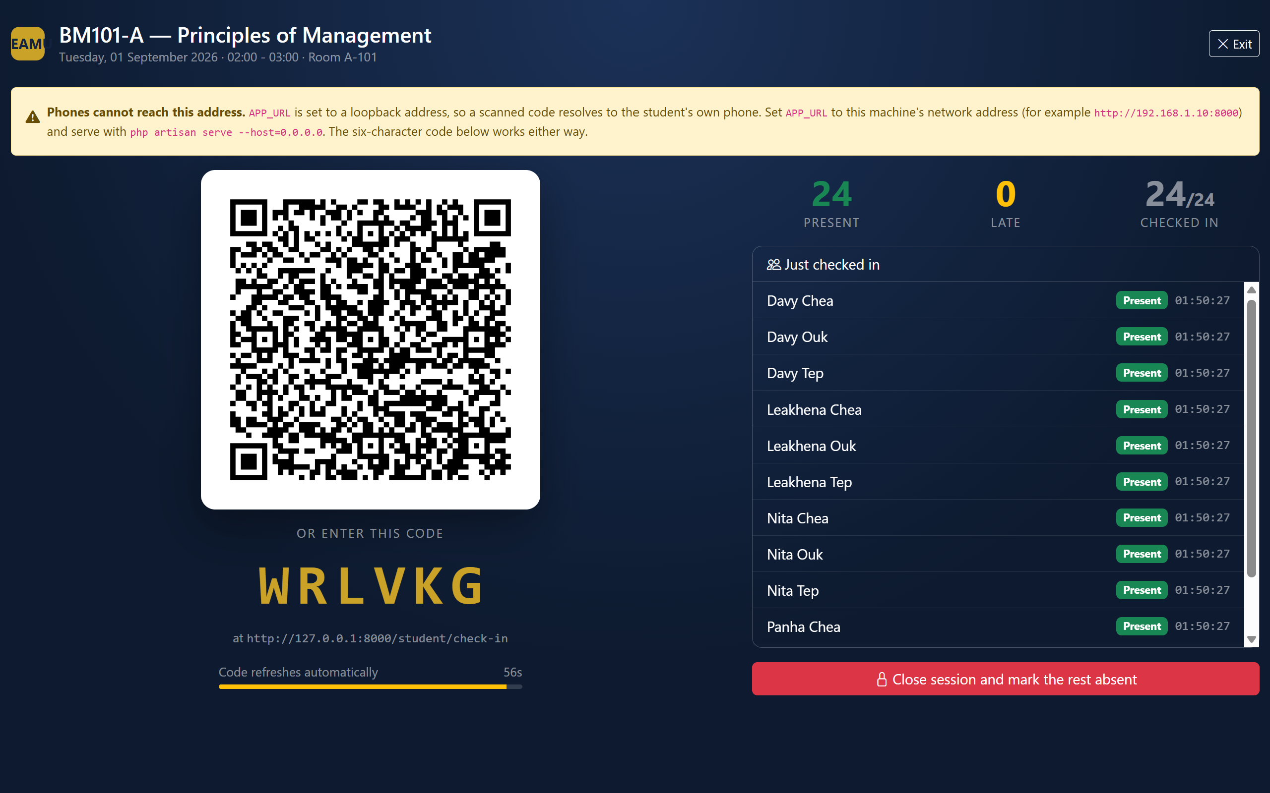
Figure 25: QR check-in screen
Note for the capture: if the application address is still set to localhost, an amber warning appears explaining that phones cannot reach that address. Capturing it is worthwhile, since it demonstrates the system detecting its own misconfiguration.

6.4 Student Portal

6.4.1 Dashboard
A student sees their overall percentage, a per-class breakdown, and a warning naming any class in which they have fallen below the requirement.
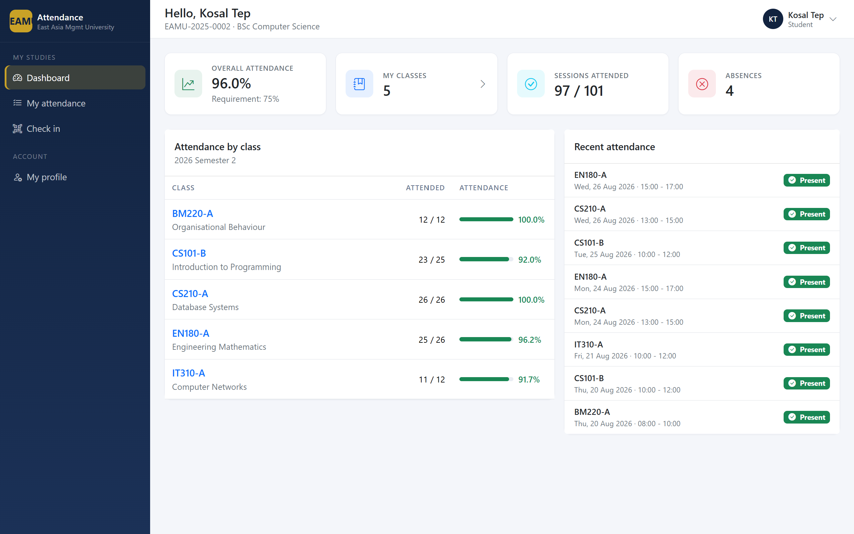 Figure 27: Student dashboard
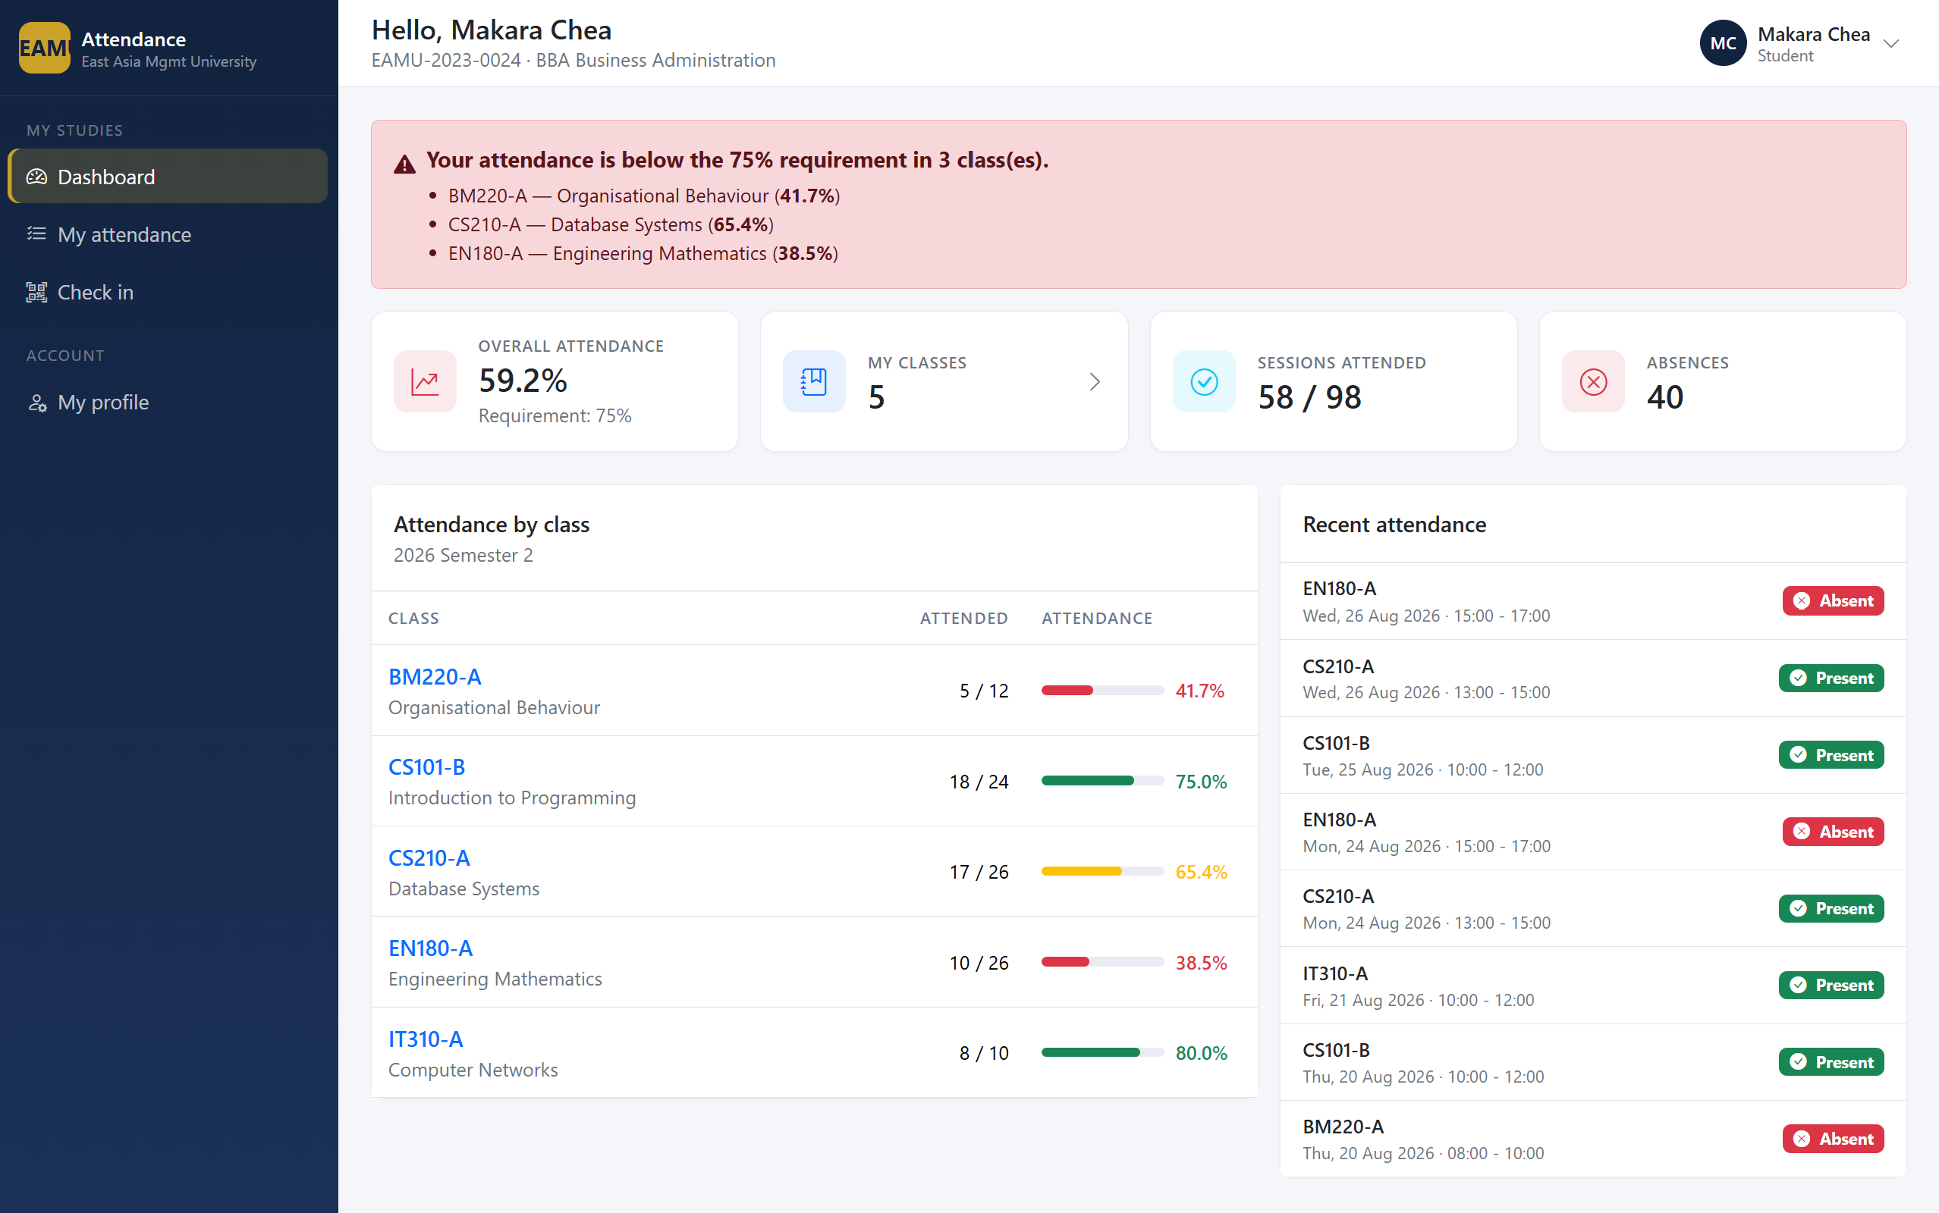
Figure 28: Below-threshold warning

6.4.2 Checking In
When a lecturer has a session open, the student dashboard detects it and offers a shortcut. The check-in screen accepts the six-character code for students without a working camera.
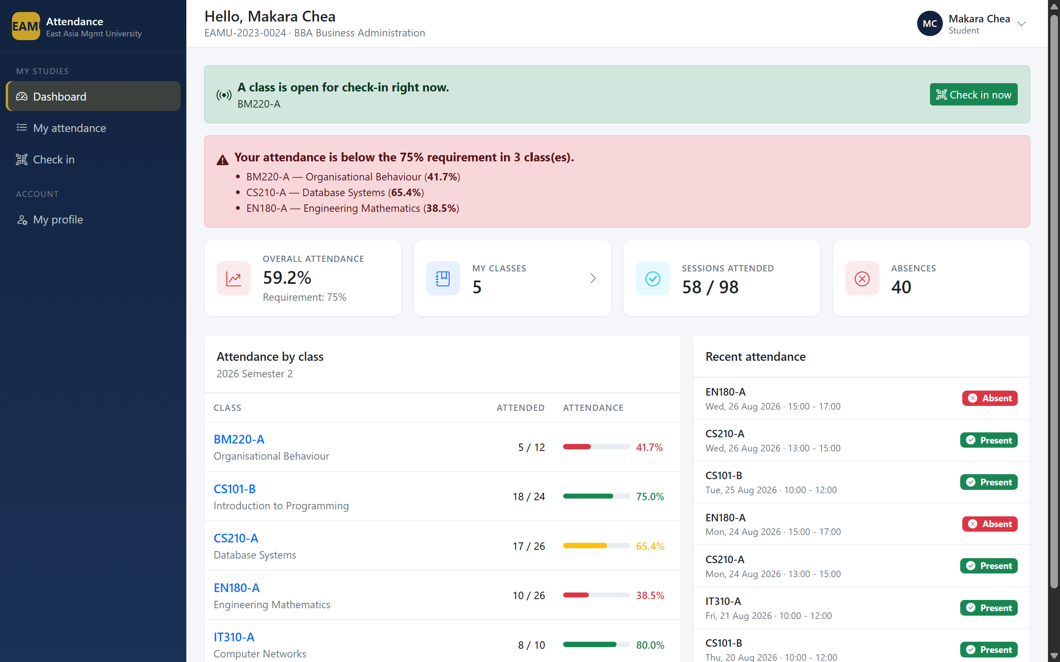
Figure 29: Open session detected
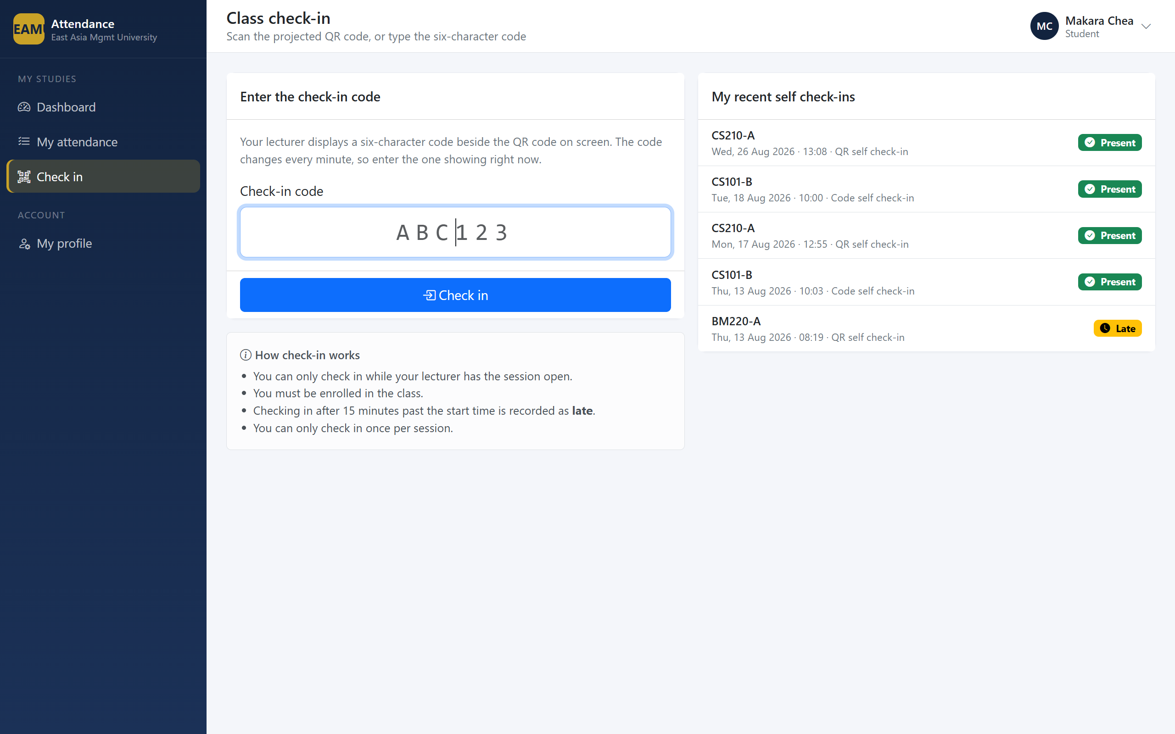
Figure 30: Check-in screen
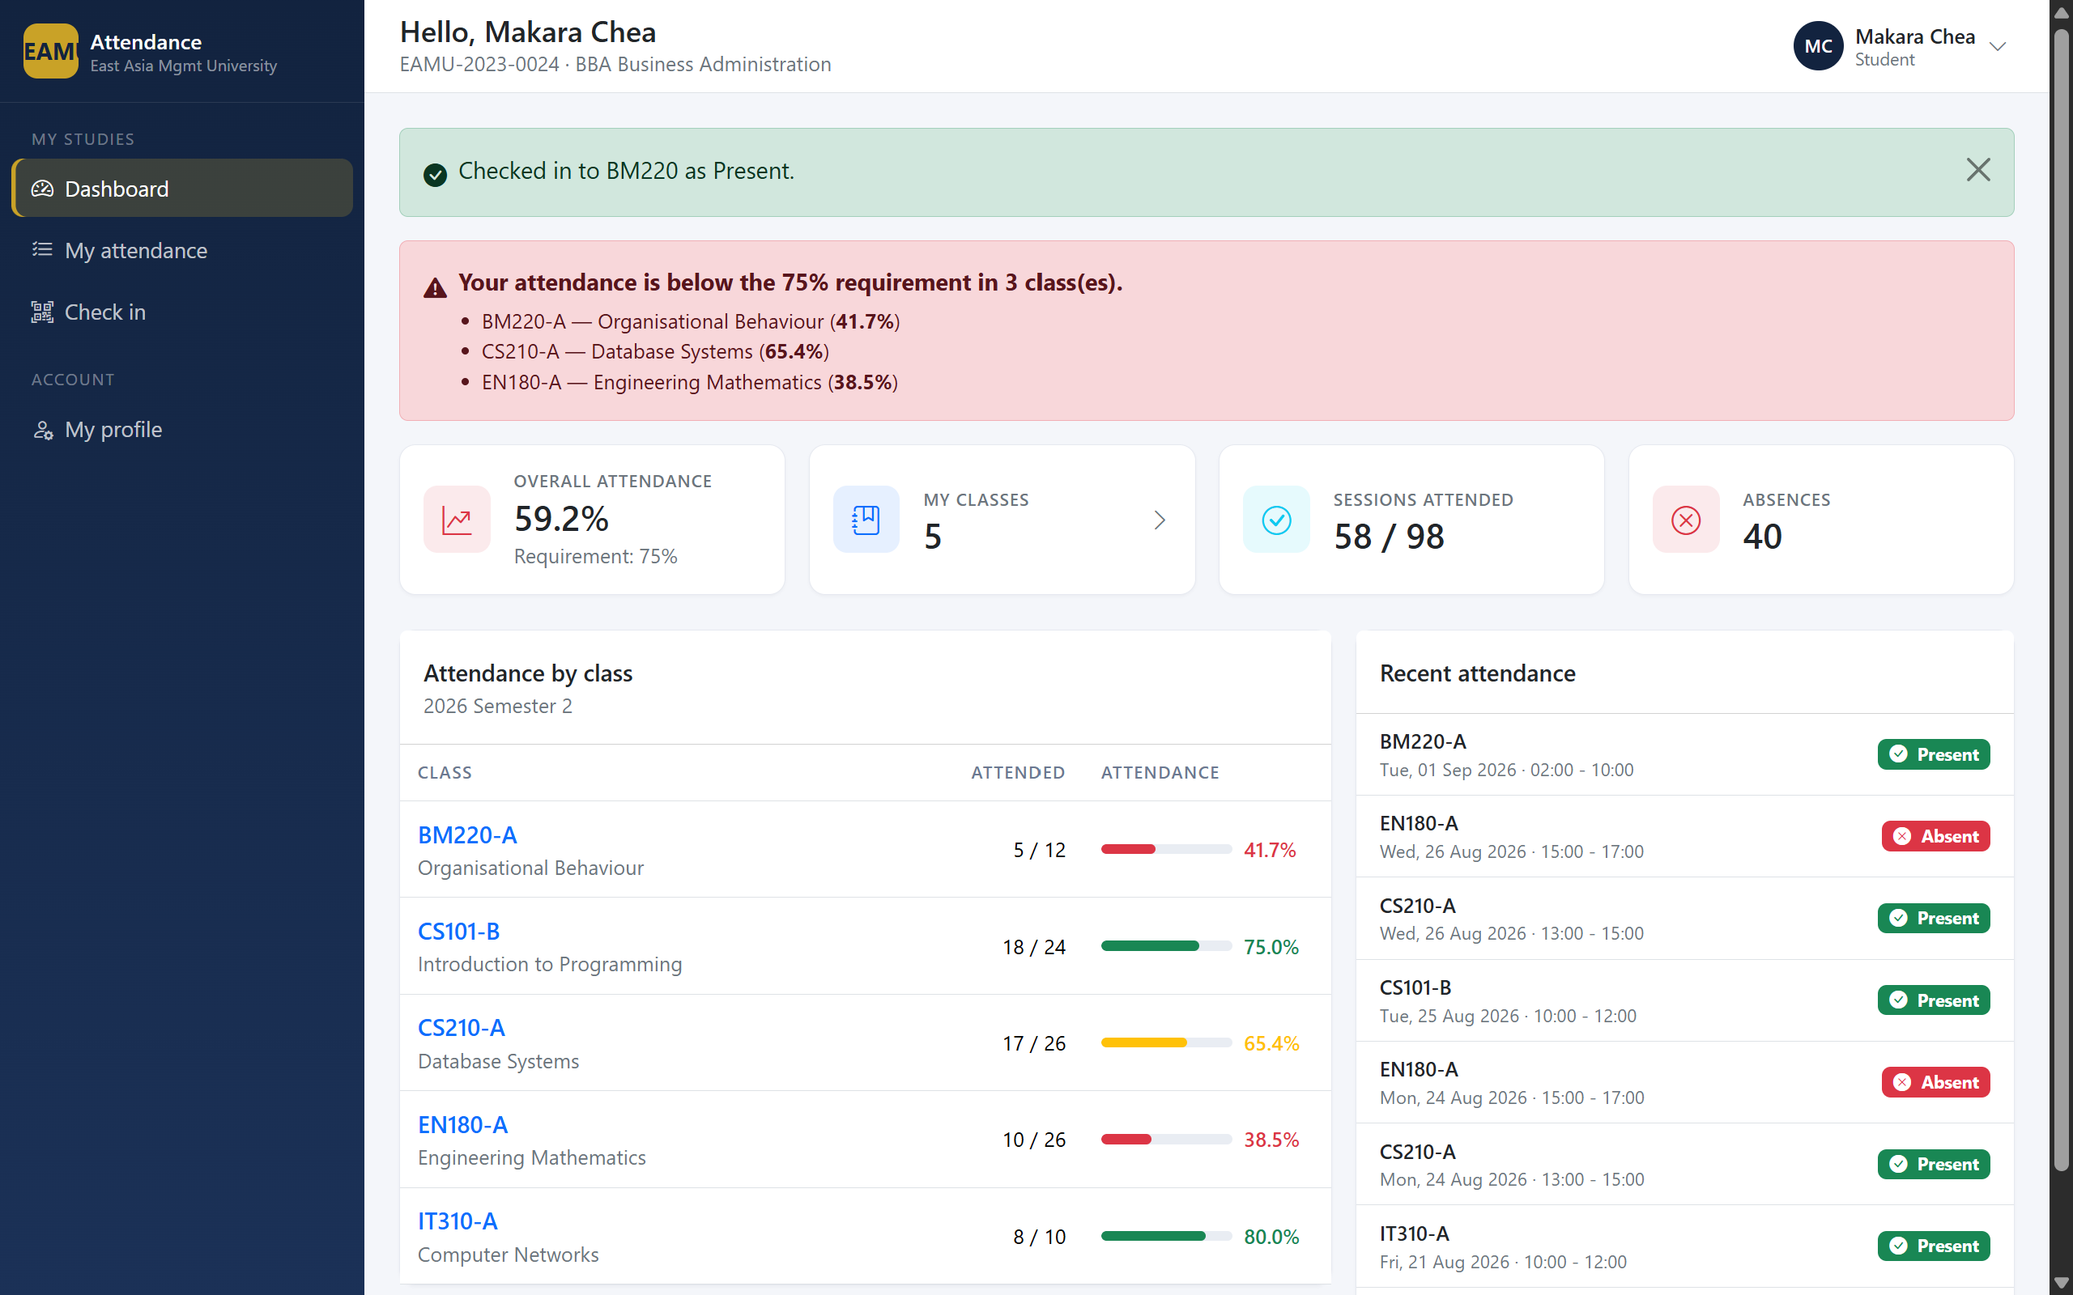
Figure 31: Successful check-in
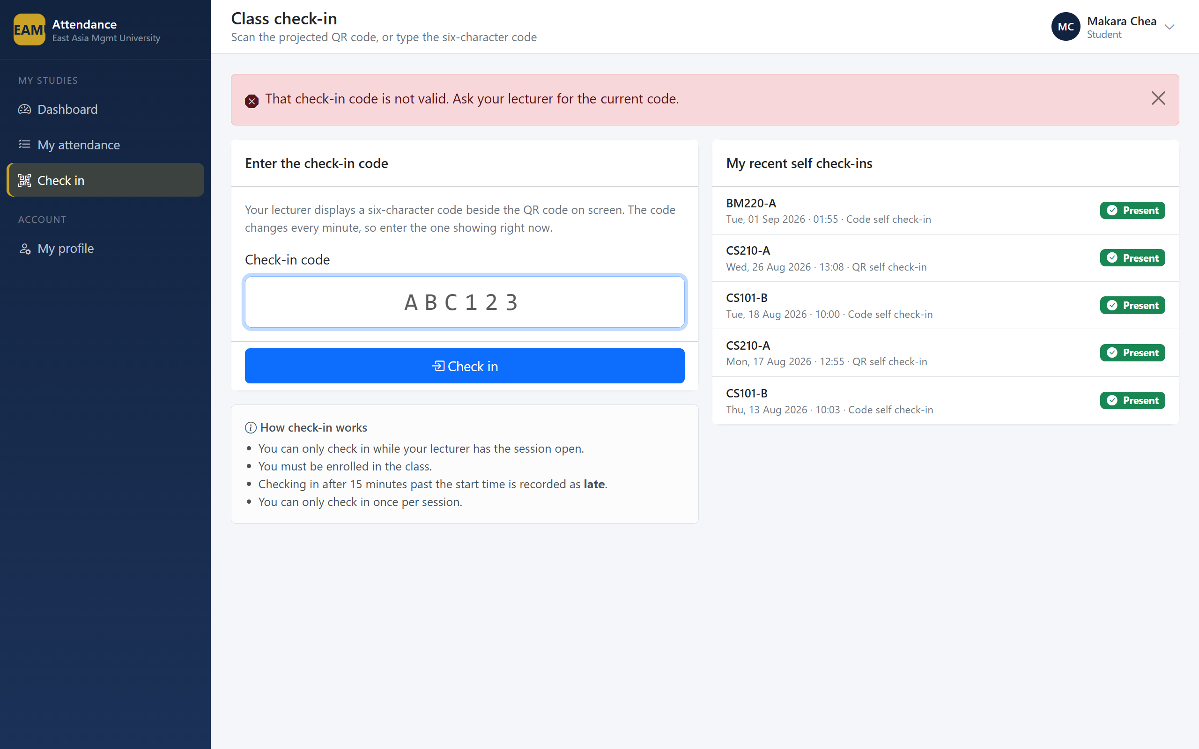
Figure 32: Rejected check-in

6.4.3 Attendance History
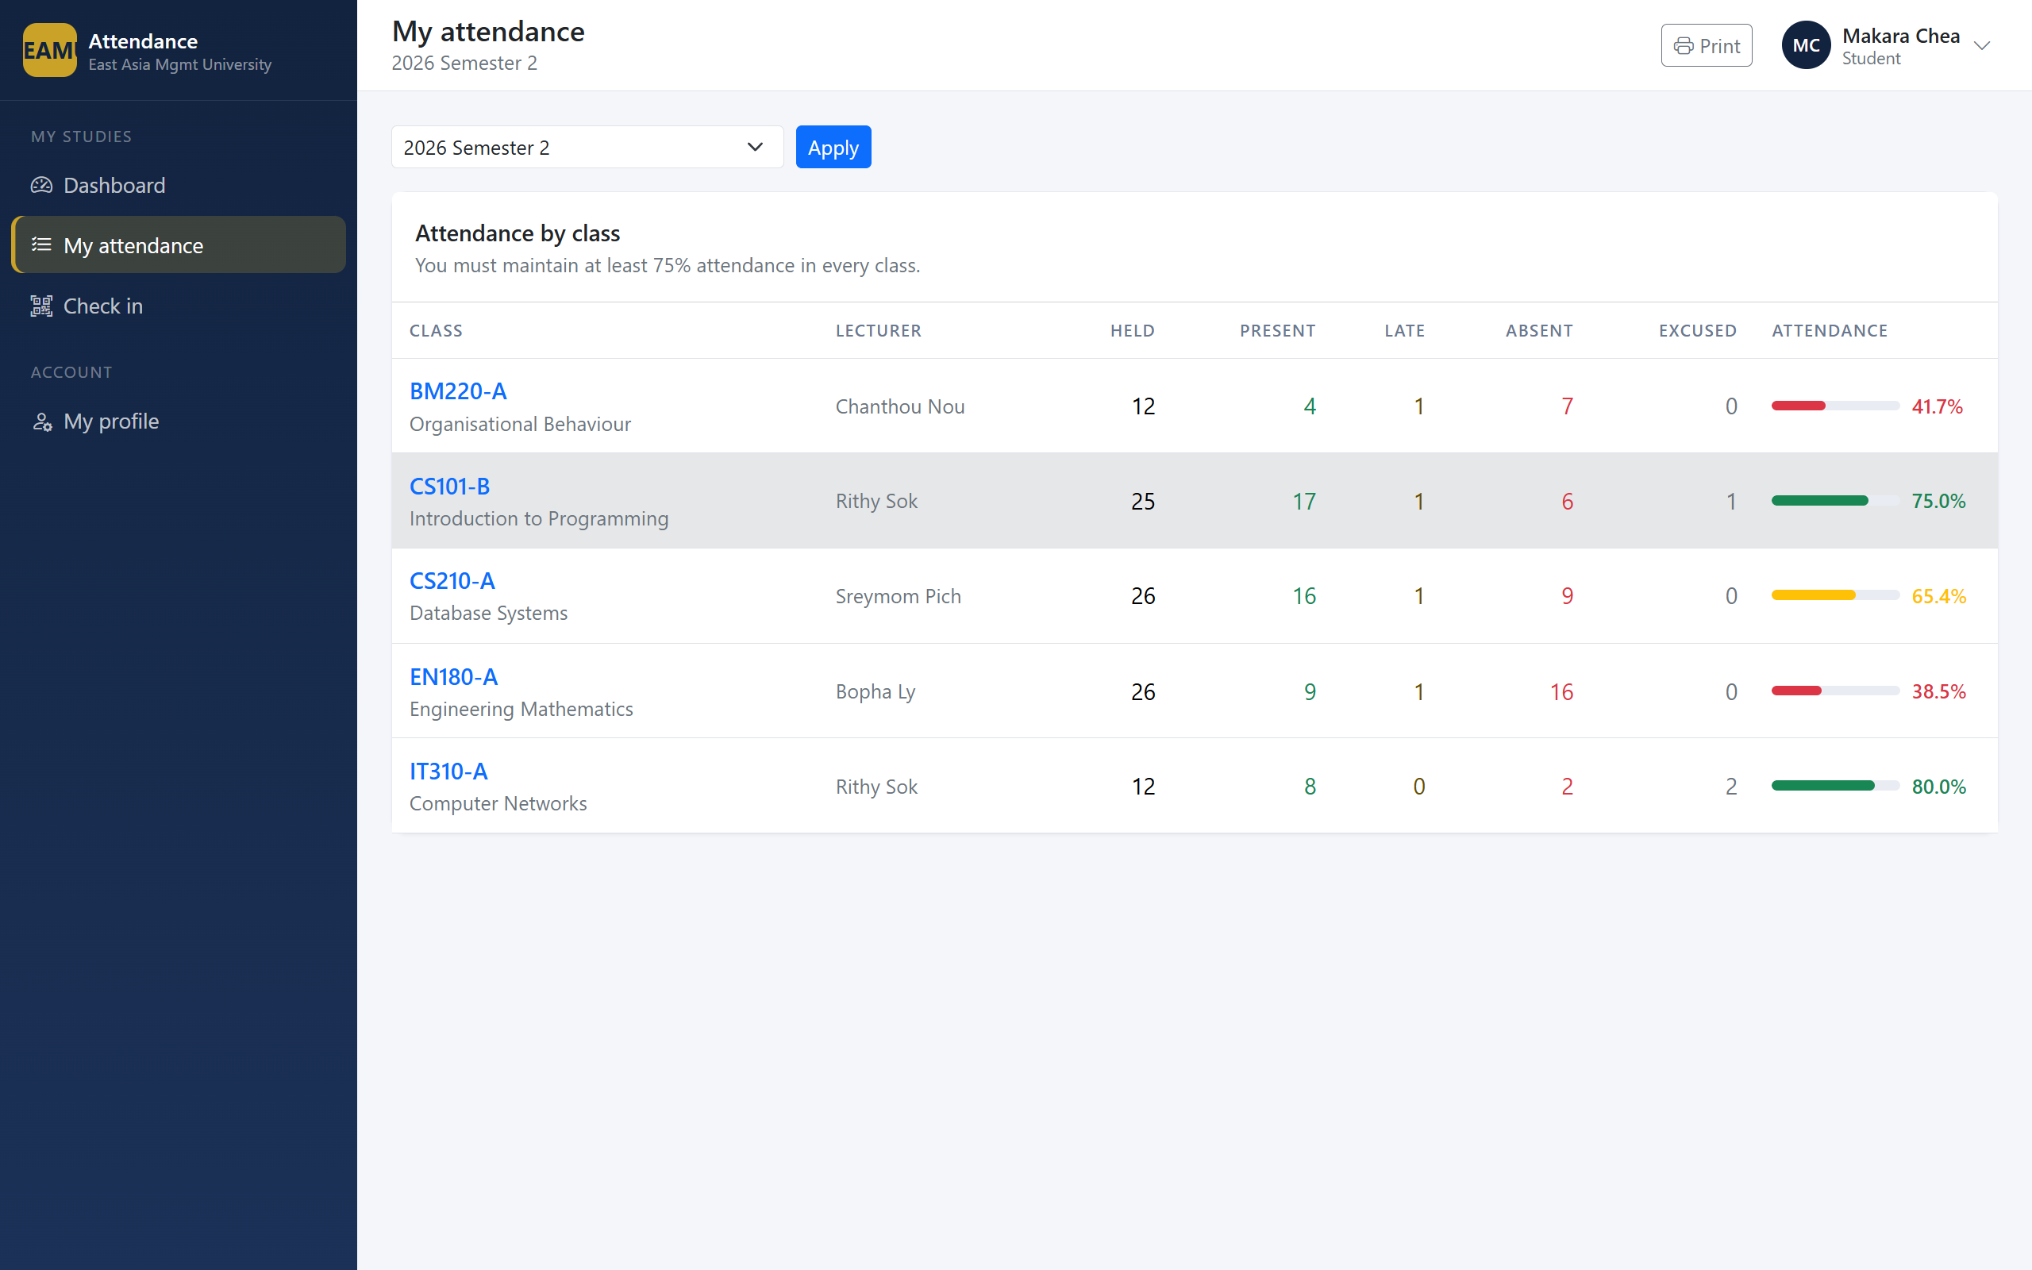
Figure 33: Attendance by class
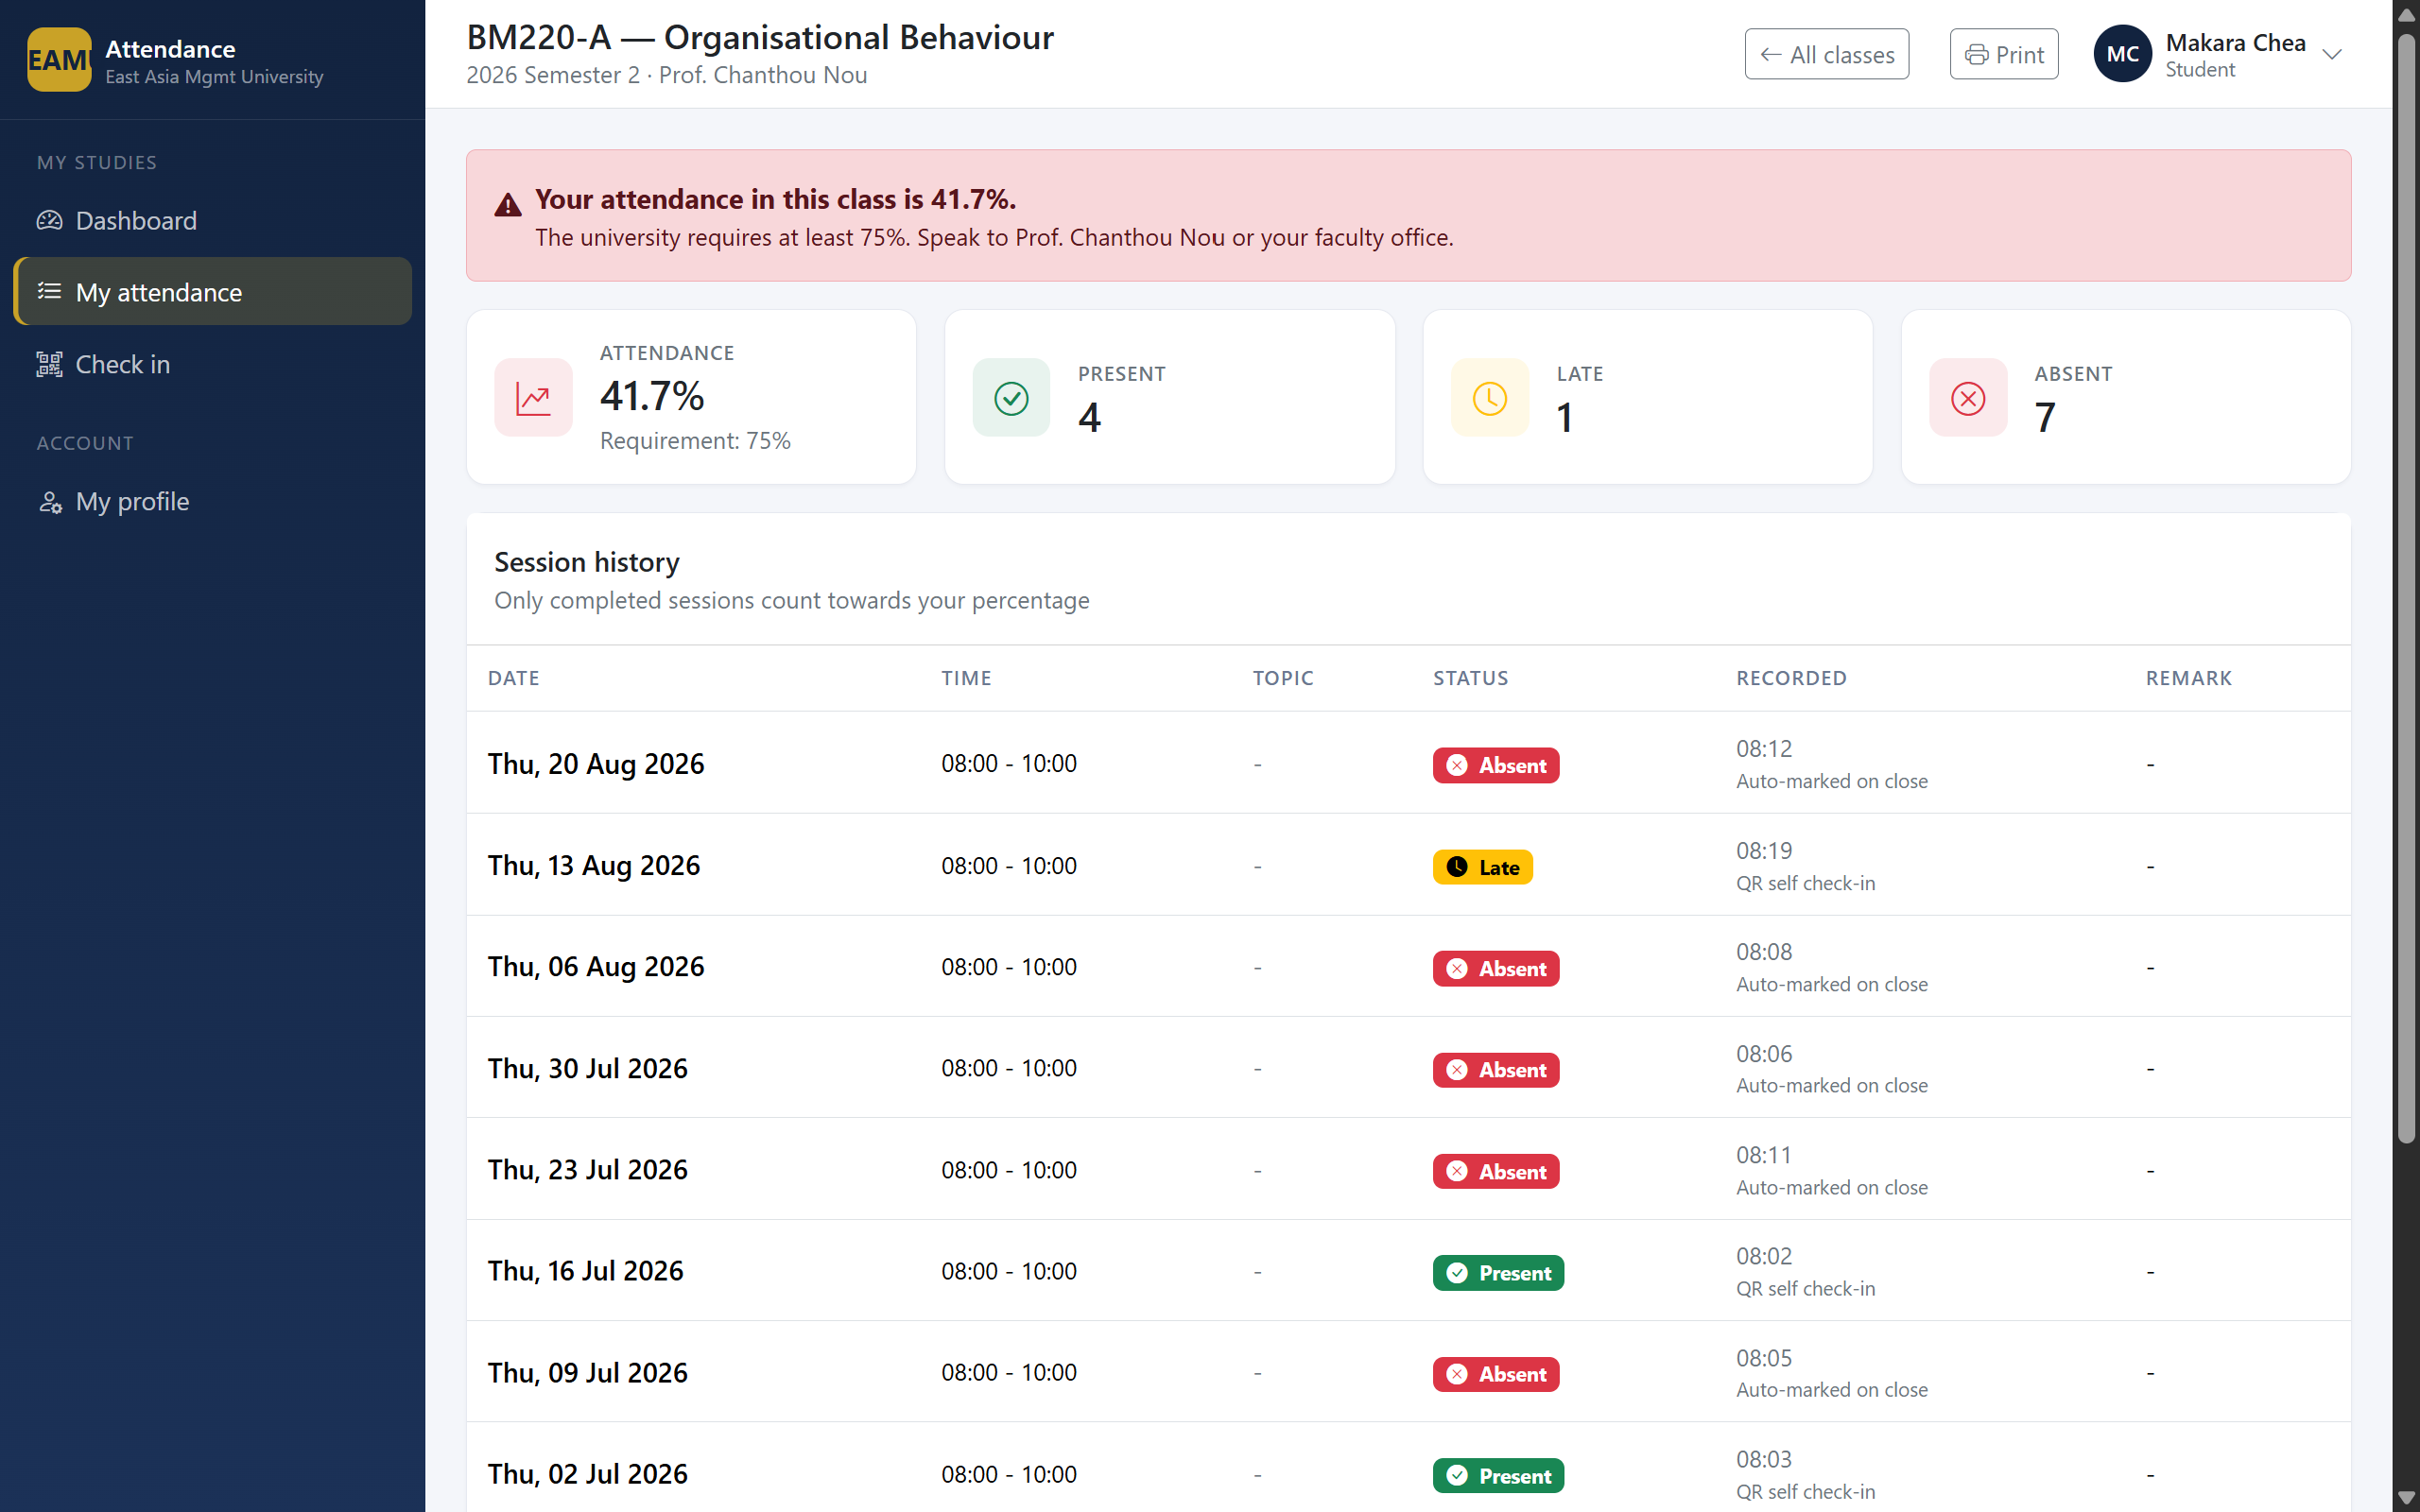
Figure 34: Session-by-session history

6.5 Access Control in Practice
The two-layer authorisation described in Section 4.3 is visible to the user as a clean refusal rather than an error.
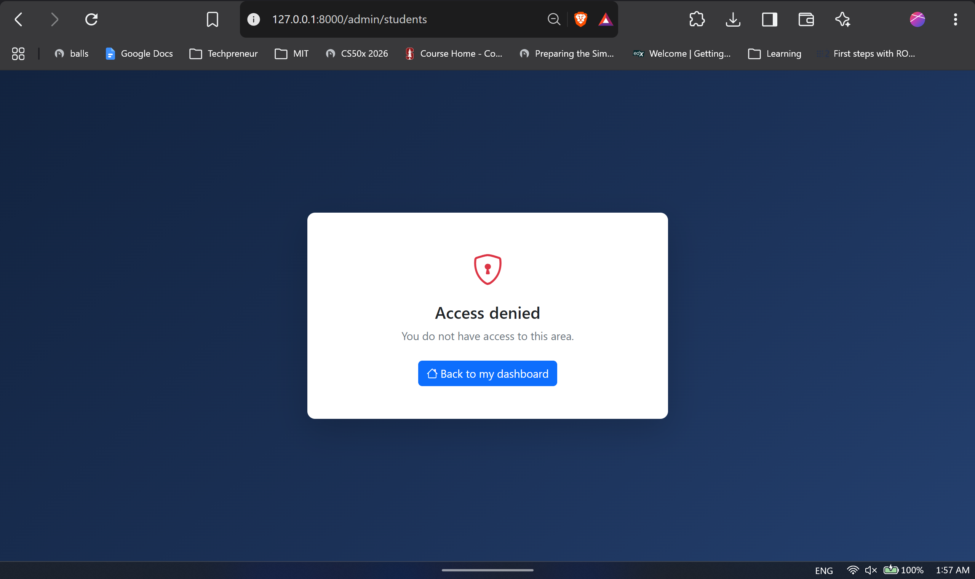
Figure 35: Access denied

6.6 Responsive Layout
Students check in on a phone, so the interface must work at that size. The sidebar collapses behind a menu control and tables scroll horizontally rather than overflowing the page.
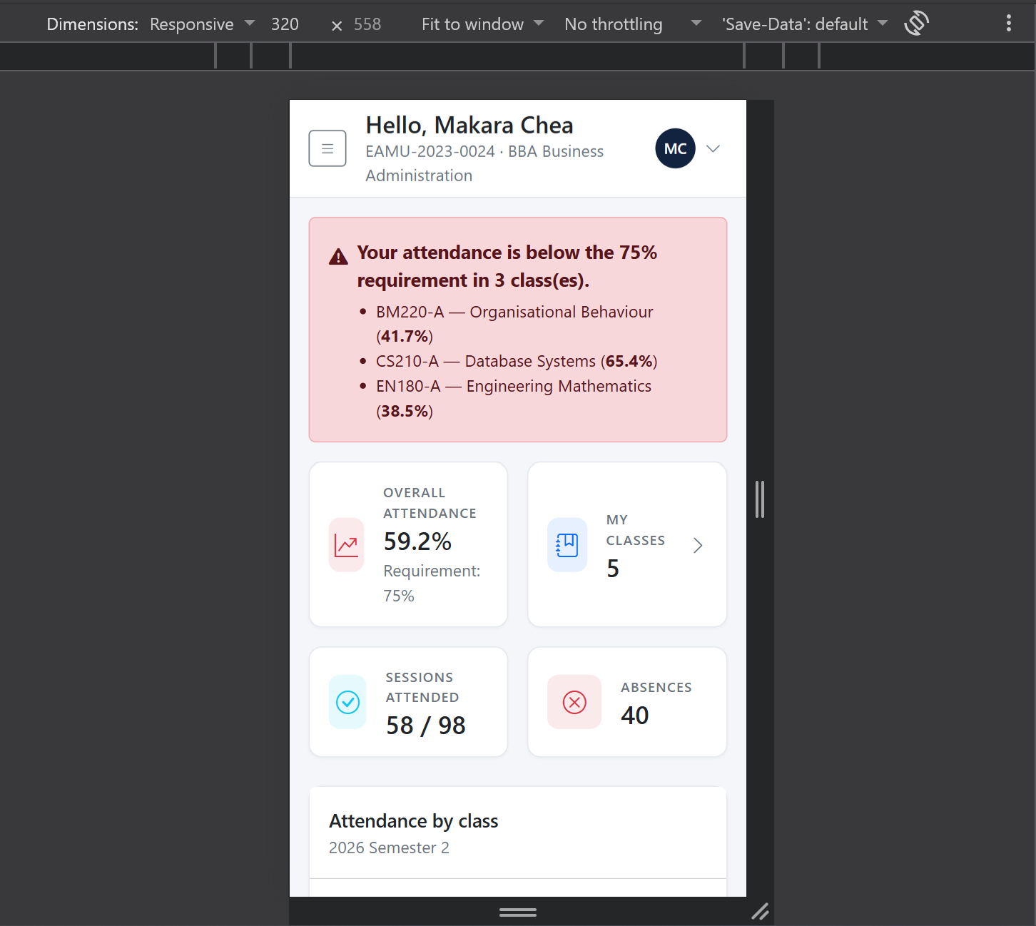
Figure 36: Mobile layout

7. Challenges Faced
Six problems required a design decision rather than a routine fix. Each is recorded with its reasoning, since the reasoning is more transferable than the fix.

7.1 No Image Extension for QR Generation
The obvious way to produce a QR code in PHP is to render a PNG, but that requires the gd or imagick extension and the development machine has neither. Installing an extension was not an acceptable answer: the system has to run on a standard XAMPP installation, and a marker cannot be asked to recompile PHP.
The available libraries were therefore evaluated against this constraint before anything else. The one selected emits SVG using nothing but core PHP, listing the image extension only as an optional suggestion for PNG output. Choosing on the constraint rather than on popularity turned a limitation into an improvement: vector output scales to any projector without blurring, and embeds directly in the page, avoiding a second request per rotation.

7.2 Preventing Proxy Attendance
A static QR code defeats itself. The first student to arrive photographs it and sends it to a friend who is elsewhere, and the system has recorded a lie.
The solution was to give the code a short life and rotate it continuously. Tokens expire after sixty seconds and the projected page replaces them every forty-five, so a photograph is worthless almost at once. This introduced a secondary problem: a scan arriving in the moment between rotations would be rejected. The alternatives were to accept the previous token for a grace period, which needs extra columns and weakens the guarantee, or to keep a single valid token and provide a fallback. The second was chosen, because a rejected scan is recoverable in two seconds by scanning again, whereas a weakened guarantee is permanent. The six-character code covers that edge case and also serves students whose camera does not work.

7.3 An Index Name Too Long for MySQL
The first migration run failed outright. MySQL limits an identifier to 64 characters, and the name the framework generated for the session uniqueness constraint, built by concatenating the table name with all three column names, exceeded it.
Five constraints were given explicit short names. The wider lesson was to run migrations against the real database early, rather than trusting that a schema definition which looks correct will apply cleanly.

7.4 A Silent Query-Builder Interaction
The most instructive defect in the project produced no error at all. Several list screens showed empty cells where a count should have appeared, because a select call placed after a withCount call replaced the counting subquery rather than adding to it.
What makes this worth recording is the failure mode. The page returned HTTP 200, the layout was intact, and only a number was missing, so a test asserting that the page loads could not detect it. It was found by reading the rendered output during manual verification. The remedy removed the need for the select entirely, by ordering through a subquery instead of a join, and the pattern is now written down as a project convention so it cannot be reintroduced.

7.5 Timezone Against Timetable
A check-in made at 10:28 for a class that started at 08:00 was recorded as present rather than late. The application was running in UTC while the timetable stores local wall-clock times, so the server believed the class had not yet begun.
This illustrates a defect the automated tests were structurally unable to find. Every test builds its times relative to the present moment, so they stay internally consistent in any timezone and pass regardless. Only a fixed timetable time compared against a real clock exposes the mismatch. The application timezone is now set explicitly, with the reason recorded in the configuration file so it is not reverted by someone assuming UTC is a safe default.

7.6 Keeping Three Write Paths Consistent
Attendance can be recorded by a lecturer marking a register, by a student scanning a code, or by a student typing one. Three separate implementations of the same rules would eventually disagree about what counts as late or about who may be marked, and that disagreement would surface as data nobody can reconcile.
All three paths therefore call the same service. When the closing rule changed during development, so that closing retires the check-in credentials, the change was made once and applied everywhere. The same reasoning governs the read side: the percentage rule exists in exactly one method, so a screen and its CSV export cannot report different figures for the same student.

8. Future Scope
The following extensions were identified but fell outside the six-week scope. They are ordered by the ratio of value to effort.
Enhancement | Description | Effort
Automatic notification | Email or SMS a student and their advisor when attendance crosses below the threshold, rather than waiting for someone to read the report. The at-risk calculation already exists; only delivery is missing. | Low
Dashboard charts | Attendance trend across the semester and present-versus-absent breakdowns, drawn from data the reporting service already returns. | Low
PDF reports | Server-generated PDF for formal records. Currently covered by print stylesheets, which produce an equivalent document through the browser. | Low
Attendance appeals | Allow a student to request that an absence be reclassified as excused, subject to lecturer approval. The excused status and its exclusion from the denominator already exist; only the workflow is missing. | Medium
Timetable clash detection | Warn when a lecturer or a room is double-booked, or when a student enrolls in two classes that meet at the same time. | Medium
Location-verified check-in | Require the check-in request to originate from the campus network or from within a geofence, closing the remaining gap where a student shares a live code by message. | Medium
Native mobile application | A dedicated scanner app, removing the need to open a browser. The responsive interface already covers this adequately. | High
Biometric attendance | Fingerprint or facial recognition at the classroom door, eliminating proxy attendance entirely but requiring hardware in every room. | High
Multi-campus support | Extend the structure to several campuses with their own calendars and timezones. | High
Table 23: Possible extensions

9. Conclusion
The system meets the objectives set out in Section 1.3. The academic structure, people, class sections and rosters are all managed through the administrator portal; lecturers record attendance either by marking a register or by projecting a rotating QR code; and students see their percentage against the 75% requirement continuously, warned before they breach it. All thirty-nine functional and nine non-functional requirements were implemented and verified.
The problem stated at the outset was that attendance data arrived too late to act on, and could not be fully trusted. Both parts are addressed. Percentages are current from the moment a register closes, which is the same lesson the class was held in. Trust is improved by removing the shared paper sheet, by rotating the check-in code so a photograph cannot be reused, and by enforcing at the database level that a student has exactly one outcome per session.
Three aspects of the work are worth drawing out. The first is that constraints improved the design rather than degrading it: having no image extension forced the SVG route, which proved better than the PNG one would have been. The second is the value of a service layer sitting over three competing write paths, which is what allowed a late change to the closing rule to be made safely in one place. The third is that the defects which mattered most were the silent ones, found by reading output rather than by watching for errors, which is an argument for verifying a system by using it and not only by testing it.
The system is complete, tested and documented, and can be demonstrated end to end against seeded data on any machine with PHP, Composer and MySQL.

References
Laravel. (2026) Laravel 13.x Documentation. Available at: https://laravel.com/docs/13.x
The PHP Group. (2025) PHP Manual, version 8.5. Available at: https://www.php.net/manual/en/
MariaDB Foundation. (2025) MariaDB Server Documentation. Available at: https://mariadb.com/kb/en/documentation/
Bootstrap. (2024) Bootstrap 5.3 Documentation. Available at: https://getbootstrap.com/docs/5.3/
Endroid. (2025) endroid/qr-code, version 6.1. Available at: https://github.com/endroid/qr-code
PHPUnit. (2025) PHPUnit Manual, version 12. Available at: https://docs.phpunit.de/
International Organization for Standardization. (2004) ISO/IEC 18004: Information technology - Automatic identification and data capture techniques - QR Code bar code symbology specification.
OWASP Foundation. (2021) OWASP Top Ten Web Application Security Risks. Available at: https://owasp.org/www-project-top-ten/

Appendix A: Installation Guide
The system requires PHP 8.3 or later, Composer, and MySQL or MariaDB. No Node.js, npm or asset build step is needed.

A.1 Create the database
mysql -u root -e "CREATE DATABASE individualAssignment
CHARACTER SET utf8mb4 COLLATE utf8mb4_unicode_ci;"

# On XAMPP for Windows the client is at:
# C:/xampp/mysql/bin/mysql.exe

A.2 Install and configure
composer install

# Copy .env.example to .env if it does not exist, then confirm:
# DB_CONNECTION=mysql
# DB_HOST=127.0.0.1
# DB_PORT=3306
# DB_DATABASE=individualAssignment
# DB_USERNAME=root
# DB_PASSWORD=

php artisan key:generate

A.3 Build the database and run
php artisan migrate:fresh --seed
php artisan serve

# Then open http://localhost:8000
To allow phones to scan the QR code, set the application address to the machine network address and serve on all interfaces:
# in .env
APP_URL=http://192.168.1.10:8000

php artisan serve --host=0.0.0.0
The six-character check-in code works without this change, so the feature can be demonstrated entirely on one machine.

A.4 Run the tests
php artisan test

Appendix B: Demonstration Accounts
Every seeded account uses the password shown. The seeder prints a current list when it finishes.
Role | Email | Password | Notes
Administrator | admin@eamu.edu | password | Full access to every module and report
Lecturer | v.meas@eamu.edu | password | Teaches three computing sections
Lecturer | c.nou@eamu.edu | password | Teaches two business sections; has a session scheduled today
Lecturer | s.pich@eamu.edu | password | Teaches two computing sections
Student | kosal.tep@student.eamu.edu | password | Enrolled in five classes, healthy attendance
Student | makara.chea@student.eamu.edu | password | Deliberately seeded below the threshold, for the at-risk demonstration
Table 24: Demonstration accounts

Appendix C: Suggested Demonstration Script
A ten-minute demonstration covering every major feature.
- Sign in as the administrator. Show the dashboard figures and the at-risk panel.
- Open the at-risk report. Point out the ordering and download the CSV.
- Create a course, then a class section with a timetable, and enroll students onto the roster.
- Sign out and sign in as c.nou@eamu.edu. Show that only that lecturer classes are visible.
- Open the session scheduled for today. The projection screen appears with the QR code and the six-character code.
- On a second device or browser, sign in as a student and check in using the code. Return to the projection screen and wait for the counter to update.
- Open the marking register. Show the student who checked in, marked with how they did so.
- Close the session. Show that the remaining students were marked absent automatically.
- Sign in as a student below the threshold. Show the warning banner and the per-class breakdown.
- Finally, paste an administrator address into the URL bar while still signed in as the student, to show the access-denied page.

Appendix D: Project Structure
app/
Enums/ AttendanceStatus, SessionStatus, MarkedVia,
UserRole, StudentStatus, EnrollmentStatus
Exceptions/ CheckInException
Http/
Controllers/ Admin/ (11), Lecturer/ (4), Student/ (2),
Auth/ (1), CheckInController, ProfileController
Middleware/ EnsureUserHasRole, EnsureUserIsActive
Requests/ Auth/ and Admin/ form-request validators
Models/ User, Faculty, Program, Semester, Lecturer,
Student, Course, ClassSection, ClassSchedule,
Enrollment, AttendanceSession, AttendanceRecord
Policies/ ClassSectionPolicy, AttendanceSessionPolicy,
StudentPolicy
Services/ AttendanceService, AttendanceReportService
Support/ QrRenderer, CsvExporter
config/attendance.php Threshold, grace period, token lifetimes
database/
migrations/ 14 migrations
factories/ 12 model factories
seeders/ AcademicStructure, People, Teaching,
AttendanceHistory, DatabaseSeeder
public/css/app.css Theme layered over Bootstrap, plus print rules
resources/views/
layouts/ app (portal), guest (login), kiosk (projection)
components/ flash, stat-card, status-badge, percentage-bar,
empty-state, page-card
admin/ lecturer/ student/ Portal screens
routes/ web.php, admin.php, lecturer.php, student.php
tests/Feature/ 8 test classes, 73 tests

