**Question 4**

**Form Description:**

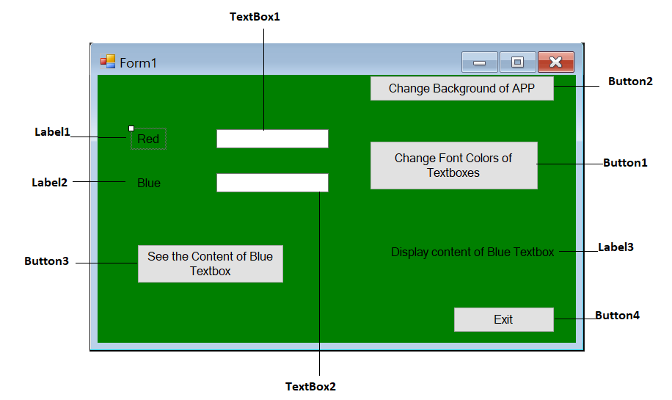

**Code:**

'/--------------------------------------------------------------------

'/ This Program is used to demonstrate the form back color changed -

'/ on button click event, this also allow user to change the font -

'/ font color of textboxes on button click event and this also allow -

'/ user to display the text of one textbox into another label control-

'/ Name: Muhammad Malik -

'/ Date 01/27/2020 -

'/--------------------------------------------------------------------

Public Class Form1

Private Sub Button1_Click(sender As Object, e As EventArgs) Handles Button1.Click

' Font color of textbox1 changed to red.

TextBox1.ForeColor = Color.Red

' Font color of textbox2 changed to blue.

TextBox2.ForeColor = Color.Blue

End Sub

Private Sub Button2_Click(sender As Object, e As EventArgs) Handles Button2.Click

' Check if form background color is green,

' if yes then change the back color of form to Yellow.

If (Me.BackColor = Color.Green) Then

' Change the form back color to Yellow.

Me.BackColor = Color.Yellow

' return the control.

Return

End If

' If above condition is not true then,

' Change the form back color to Green.

Me.BackColor = Color.Green

End Sub

Private Sub Button4_Click(sender As Object, e As EventArgs) Handles Button4.Click

' Close the application on Exit button click.

Me.Close()

End Sub

Private Sub Button3_Click(sender As Object, e As EventArgs) Handles Button3.Click

' copy the text from textbox2 (blue) to the Label3

Label3.Text = TextBox2.Text

End Sub

End Class