**1.1 Assumption**

The main purpose of this task is develop a website for an University with the service of Course offers, Research, News, Alumni, contact information, about us and Enquiries of this as well. For this task we decided to duplicate the design of MIT website. To develop this website at first scrum master describe the product backlog and sprint backlog along with the planning. Then developer will create the burn down chart. After that analyst have to analyses the entire possible outcome that can be done. Analyst will describe the user stories based on the entire feature that will be developed. Then a use case diagram will created to define user and admin access to the system. A workflow diagram, initial class diagram, Activity diagram and an ERD model will be created by the analyst. Then the designer will make some sketches of all the pages and turn those sketches into the wireframe and after that the main website will be design the designer. After finishing the design the developer will develop the website with all the functionality. Lastly the tester will test all the functionality of the website to check there are any error in any functionality and if there are any error developer will resolve those errors a well.

**1.2 User stories**

**User prospective:**

1. As a student I want to visit university offered course / admission aid so that I can select my desire subject.

2. As a student I want to view Research section so that I can know more about MIT much better with that.

3. As a student I want to view all the latest news publishes by the website so that I can get latest information about this as well.

4. As a student I want to see success stories of previous students and alumni section so that I can know about past records and previous result properly.

5. As a student I want to view about information of this website so that I can get to know about this easily.

6. As a student I want to view contact us page so that I can easily able to contact with authorize when needed.

7. As a student I want to able enquire and submit complains of any problem so that I can get present solution of any kind of hassle.

**Admin prospective:**

1. As a staff I want to manage all offered curse / admission aid so that all users can see the latest information about admission.

2. As a staff I want to publish the latest news in the latest news page so that the website can be up to date as well.

3. As a staff I want to manage previous success stories and alumni section so that all users get to know about past records easily.

4. As a staff I want to see user complain. All the user complain that user will give in the enquiries page I want to see those all so that I can give them proper feedback in time.

Use Case Diagram:

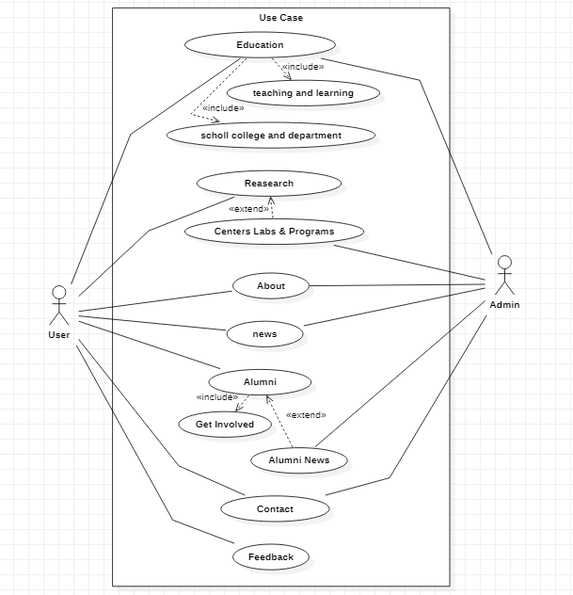

Initial Class Diagram:

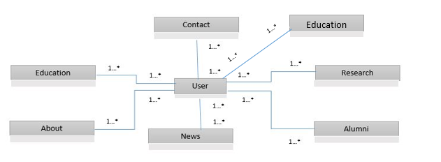

ERD:

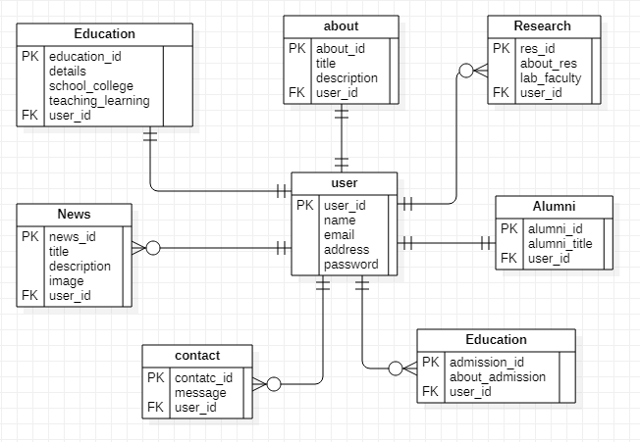

Activity Diagram:

