ICM- Testing Part

Course: COMP1643

Information and Content Management

|  |  |
| --- | --- |
| Submitted to | Submitted by |
| University of Greenwich, UK | Username: mm9258x  Banner Id: 001121804 |

|  |  |
| --- | --- |
| Banner Id | Team Role |
|  | Scrum master and designer |
|  | Analysist |
|  | Developer |
| 001121804 | Tester |

**Introduction:**

From the scenario the content management system offers a course with a teamwork. Our team consists of four members. The role of the team members scrum master and designer, analyst, developer and tester. I work as a tester in this group. Testing is the most valuable part of software development. At the end of the test section, the system is perfect. As a tester I have checked the operation and requirements of the system and identified weaknesses. In this system, I have to test the unit test, integration test, functionality test, usability test, security test, browser test and responsive test.

**Test Plan:**

Before the system is running, a test plan will be developed that describes the name of the test (which area should be inspected), test standard and results. Software context testing tools can be defined as a start of a test plan. A website has design, requirements, performing tests, recording bugs, and analyzing experiments. Different types of tools used for different hypothesis. As, test management tools used for scheduling and there are clear roles and responsibilities for tester to manage and improve quality of the website. Monitoring the performance, response time, reliability and stability that covered by performance testing tools. The conferred module has some features that developed by using a content management system. The level of tasting, that is start with a unit testing then integration test, functional test, usability test, security test, browser test and responsive test. Unit testing isolates a section of code and validity verification. It can be a single function, procedure, module, method or object. The technique thought to use is black box testing. In integration test, it is used in software to determine the flow by connecting two or more modules. Integration testing ensures that communication between different parts of the software can be easily completed. Functional testing is a way to checked to ensure that all the requirements are works properly. Here, thought to use white box testing technique. Usability testing used to design user interactions to evaluate the website through testing. This method of testing the functionality of a website monitored during actual user activity. The goal is to expose ambiguities and improve opportunities for the overall user experience. Security test terms are used to identify errors, defects and safety. Page protection has been developed at the application level and at the service and vision level. The security test is a system that protects IT system data and protects work. System browser compatibility test is for, the system will run in different browser such as, google chrome, Mozilla Firefox, internet explorer. A responsive test for running this system in different devices like mobile and laptop or tablet computer.

**Test Case:**

Once the starting point for the test has been completed and a number of values ​​have been met, the application must be completed at the same time or in the system specified outcome, the results of which may be known and subject to the conditions of implementation. The test case given below

1.unit test

2. integration test

3. functionality test

4. usability test

5.security test

6. browser compatibility test

7. responsive test

**1.Unit test:**

Unit testing is a testing process in which a module tries to determine if there is a problem with its creator. It worries about the value of the type of loneliness. The key, however, is to connect all parts of the system to analyze, distinguish, and resolve differences.

|  |  |  |  |  |  |
| --- | --- | --- | --- | --- | --- |
| Id | Title | Precondition | Test step | Actual result | Expected |
| 1 | Enquiry Submit | Must be accessed in our site | Fill up the requirements | Shows the successful massage. | Except |

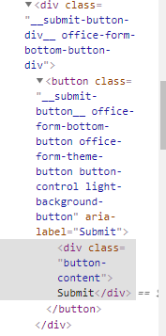

Figure1: shows the unit testing.

2. Integration test:

Integration tests help the components work together and it performed to determine. This is to identify the high and low-level software listed in the Software Device Specification. The Integration testing is defined as a type of program testing performed as part of the installation of the device and the program to ensure the integrity of the entire body.

|  |  |  |  |  |  |
| --- | --- | --- | --- | --- | --- |
| Id | Title | Precondition | Test step | Actual results | Expected |
| 2 | About news page | Must be enter into the page | Must be click the news menu bar | Show the news page. | Except |

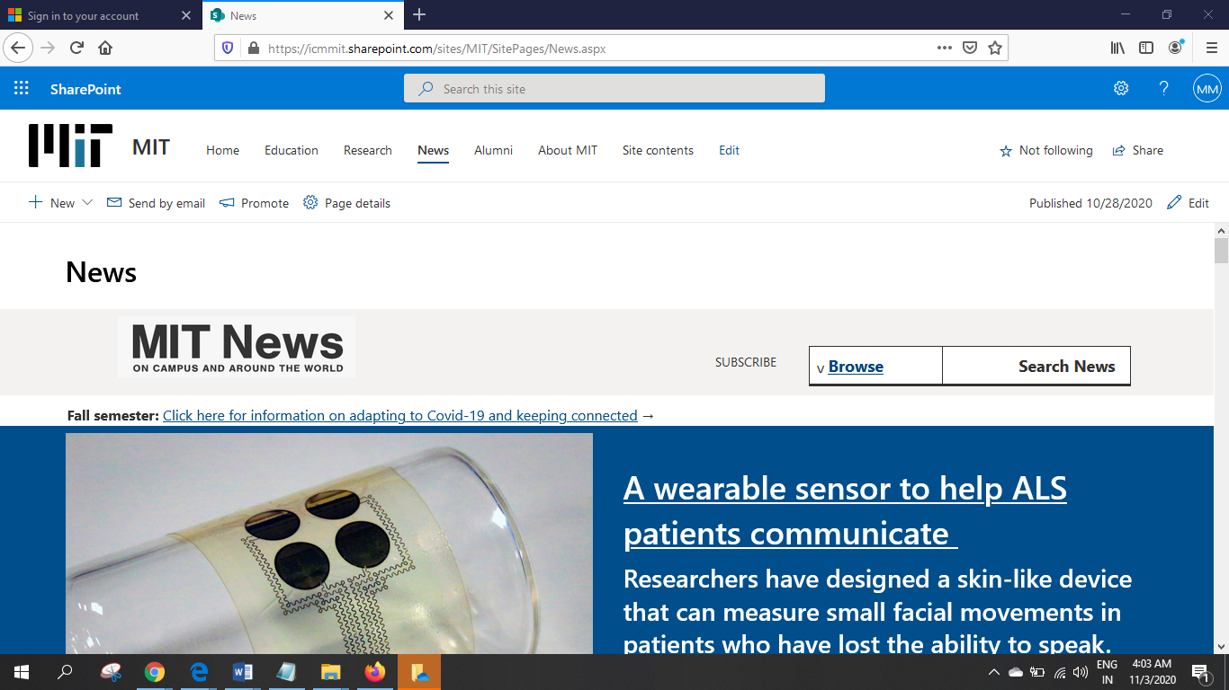

Figure2: Navigation bar shows MIT news.

3 Functional testing:

The functional testing result is the same type of control that can be used to obtain results from previous results. The purpose of the experiment was to measure each aspect of the product implementation as well as to provide data related to the results related to the performance.

|  |  |  |  |  |  |
| --- | --- | --- | --- | --- | --- |
| Id | Title | Precondition | Test step | Actual result | Expected |
| 3 | Enquiry | Must be accessed in our site | Fill up the filed. | Users submits successfully | Except |

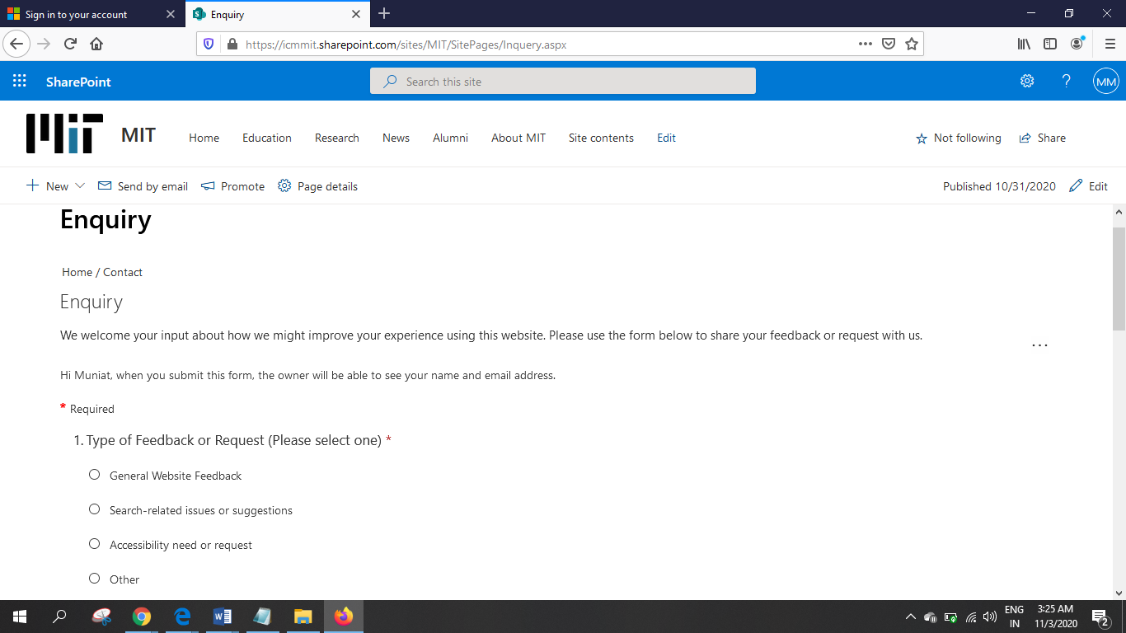

Figure3: Show the Enquiry form.

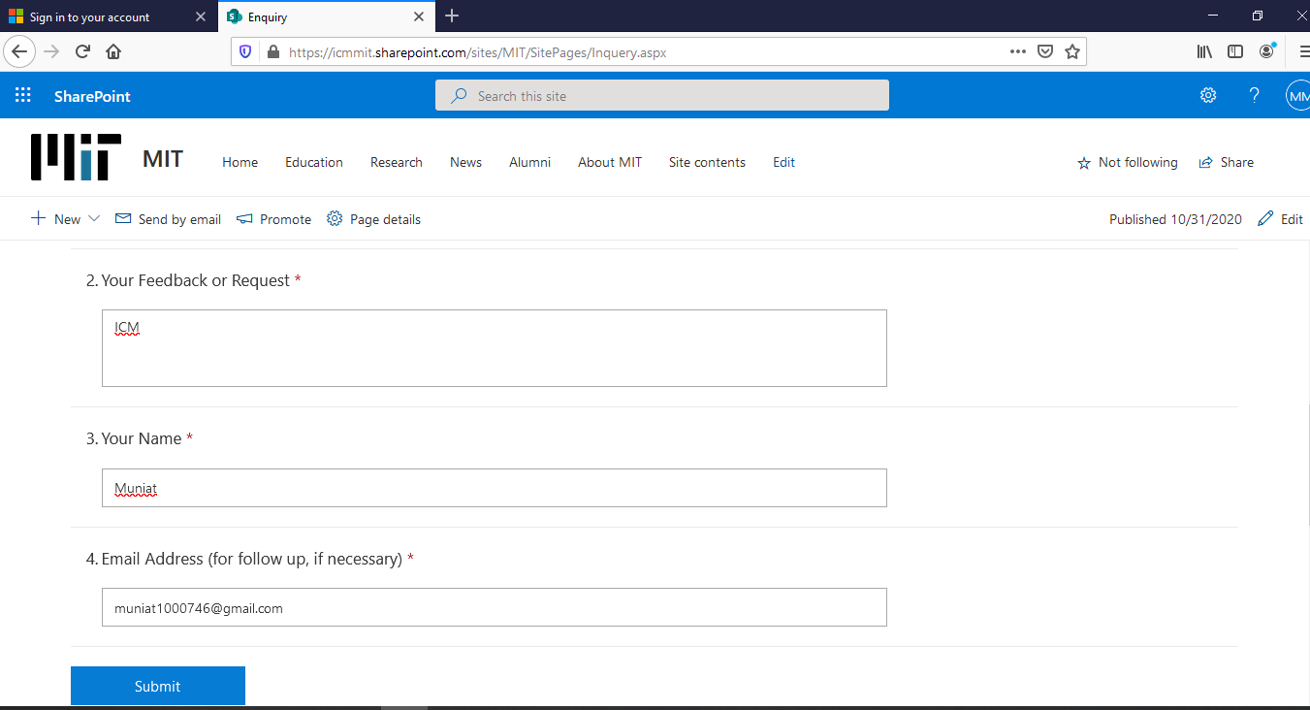

Figure3.1: Fill-up the enquire form.

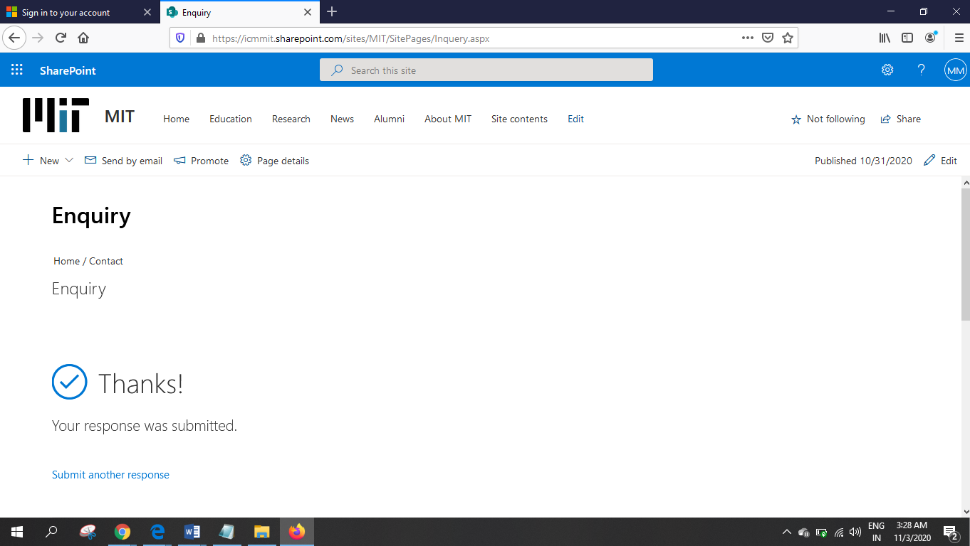

Figure3.2: Show the submission successfully.

4: Usability testing:

An easy test to test is to test the ease of operation and customer safety. Often see the information because they are trying to make a mistake and may be planning. From beginner to subject preparation, it is regularly organized.

|  |  |  |  |  |  |
| --- | --- | --- | --- | --- | --- |
| Id | Title | Precondition | Test step | Actual result | Expected |
| 4 | Search | Must be enter search name | Must be go the website | Show the search result | Except |

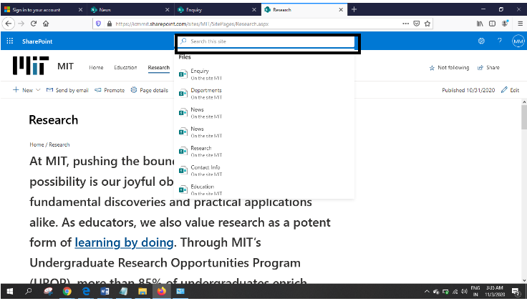

Figure4: show the search bar.

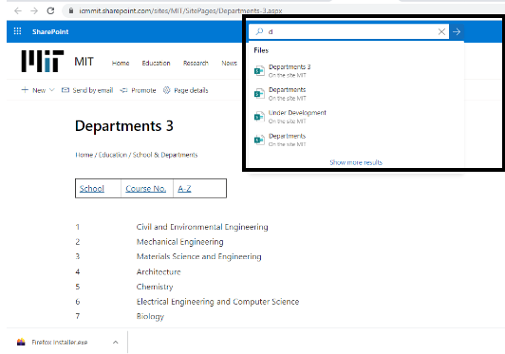

Figure4.1: shows the search result.

5: Browser compatibility testing:

Cross-browser is the functionality to view and disable the functionality of our Website under various software conditions. This is available on our website which provides a great free user experience through friendly apps.

|  |  |  |  |  |  |
| --- | --- | --- | --- | --- | --- |
| Id | Title | Precondition | Test step | Actual result | Expected |
| 5 | Using Firefox | Must be accessed in our site | Must be go the website | Show the home page | Except |

  
Figure5: Check browser compatibility.

6. Security testing:

This is a very important test. During this test, determine the speed of the process and whether the data and equipment are protected from intruders.

|  |  |  |  |  |  |
| --- | --- | --- | --- | --- | --- |
| Id | Title | Precondition | Test step | Actual result | Expected |
| 6 |  |  |  |  | Except |

Figure 6:

7. Responsive testing:

Responsive testing uses URL link where involves the different devices.

|  |  |  |  |  |  |
| --- | --- | --- | --- | --- | --- |
| Id | Title | Precondition | Test step | Actual result | Expected |
| 7 | System responsive | Must be responsive the system with laptop, tab, mobile, pc. | Must be show the screen test | Show the system whole screen | Except |



Figure 7: shows the responsive test (responsive with mobile).

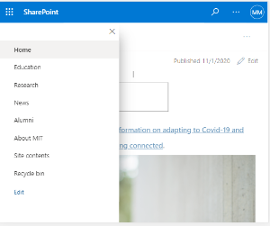

Figure 7.1: Responsive in tablet computer.

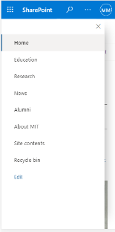

Figure 7.2: Shows navigation bar properly responsively.

Test Log:

|  |  |  |  |  |
| --- | --- | --- | --- | --- |
| Test Number | Test Name | Specification | Outcome | Result |
| 1 | Unit testing | Unit test checks properly | Properly works | Passed |
| 2 | Integration testing | The system has  been checked and  tested properly. | Works Good | Passed |
| 3 | Functional testing | The functional requirements have been checked in proper way. | Successfully works. | Passed |
| 4 | Usability testing | The usability testing in proper way. | Successfully works | Passed |
| 5 | Cross browser testing | Browser works properly | Work well | Passed |
| 6 | Security testing | Check the system security | Properly good | Passed |
| 7 | Responsive testing | Responsive test properly | Works good | Passed |