**04/18/2022**

Report On   
**Movie Review Website**

Project name: Virtualplex*

Submitted by:

**Sarowar Alam (Leader)**

Email: sarowar.alam@northsouth.edu  
ID: 1812669042

**Raihan Hasan Joy** 

Email: raihan.joy@northsouth.edu  
ID: 1712340642

**Sadman Hossain Tonmoy**

Email: saddam.hossain4@northsouth.edu  
ID: 1711096642

**Submitted to:**

**Md. Naqib Imtiaz Hussain**

# Table of Contents

Table of Contents 2

Introduction 3

About Virtualplex 3

Background and Product Context 4

Related Works4

User Story 6

Use Case 1: 7

Use Case 2: 8

Use Case 3: 9

Use Case 4: 10

Limits 10

Solution Description 11

Architecture 11

Front-end plan 12

Back end development 12

Development Plan 13

Use Case Diagram14

Performance Optimization 15

References 21

# Introduction

The project is an online movie review system that distributes and handles a variety of films such as action flicks, comedies, and other genres. The website for the online movie review system is a.net-based system that oversees all sporting activities. It allows ordinary viewers to read the movie's details and leave comments on it. Admin will keep the movie information up to date for users to see. Users can watch movies, rate them, and leave comments about their experiences with them. These websites' online movie reviews assist users in delivering and viewing high-quality films.

## About Virtualplex

Virtualplex is a website where we will be having movie reviews. Users will easily see movie reviews through our website. We will be having two panels. One will be for the user and the other will be for the admin. For the user panel content we will be having Homepage, About, Feedback, Sign up, Sign in, User profile, search bar, payment option etc. For the admin panel we will be having Sign in, Dashboard for add/delete/edit website content etc.

# Background and Product Context

A movie review is published with the primary objective of enlightening viewers about the film and its theme. Although it may appear simple to report on all of the events in the film and express your perspective, this is a common misstep made by many students. While you can convey your thoughts in a film or documentary review, you should do so in a creative and objective manner.

To a large measure, the reader's desire to see the movie is determined by the review. When a teacher assigns a certain video to evaluate, you should take advantage of this ideal occasion to show off your skills as a filmmaker. Imagine that the teacher has never seen the film before (despite the fact that he or she is the one who assigned it in the first place). This will make it easy for you to judge the happenings of the movie.

A film review should provide an in-depth analysis to assist readers in forming an honest judgment on the film and if they would like to see it. This type of assignment is frequent in schools since it allows professors to have a better understanding of their students' objective analysis skills as well as their ability to recount an event in a way that is understandable to others.

In addition, the review helps teachers to assess how students research stories and personalities. After all, a film review is a study of what happened in a documentary or a standard movie. Reviews assess your vocabulary and writing skills, as well as your ability to adapt to various genres and situations they reflect, as well as your ability to summarize and describe significant work in an organized and engaging manner. Students appreciate writing reviews, despite the fact that it entails more responsibility than imagined.

For making a movie review website we need to build a website and that will be discussed in our whole proposal. Before we get into the design or anything else, there's one item we need to finish.

The way people read and interact with text on a website is referred to as visual hierarchy. People usually read from left to right, from top to bottom. When it comes to the internet, though, individuals read in a totally different way.

First, rather than reading a page from top to bottom, most consumers scan it to check if the information is interesting to them before diving in.

People on the internet tend to form a 'F' shape. On a traditional website, they'd begin with the logo, scan the navigation, and then read down the page slowly.

Keep this structure in mind while you design your website so you can place your most crucial pieces where readers will actually see them.

It's also tempting to go overboard with our color and picture choices. However, there is one rule to follow here: less is more.

A small splash of color can draw the eye to it and add some uniqueness to your website, but too much may distract your target audience.

The same is true when it comes to visuals. A few well-placed photographs will breathe new life into your site and aid to convey emotion. However, photos should not be used solely to fill white space. Every image you use on your website should be purposeful.

We’ll want to map out some extra pages for your web development now that we know what kind of site we're constructing and who we're building it for. If we’re creating a huge website, the structure we choose will be critical for both your readers and search engines.

# Related Work

We discovered that there are few existing systems that include all of the applications we want to include throughout our search for similar systems. We learned a lot from looking at a few other initiatives that were similar to ours. We also looked for existing systems and articles on the topic to learn more about how to implement the features we want in our project.

# Problem Statement

Nowadays, people don’t only want to see movie reviews but also they want to keep an eye on their favorite celebrities. Moreover, people are always searching for authentic reviews on which they can rely and have the best experience. Therefore, our website is perfect for within all this combination to give our movie lovers an outstanding experience.

# User Story

| **As a user** | **I want to** | **So that** |
| --- | --- | --- |
| As a user | Sign in/sign up to the website | I have complete control over when and how I use the system. |
| As a registered user | Update my profile information | I am in charge of the information in my profile. |
| As a registered user | Post reviews and rate movies | I am able to share information with others. |
| As a normal user (both  registered/visitors) | Search movies based on my preference:   1. Movie title 2. Director/Actors 3. Top rated 4. Genre | I can read reviews, ratings, and other details about the film. |

## 

## Use Case 1:

**Title:** Create new user account

**Actor:** User

**Description:**

1. Input user id, password, confirm password, name, address, date of birth
2. Check if the user id is unique or not
3. Store user name into database

**Exception:**

1. Required page not found
2. No database connection

**Precondition:**

1. URL of “New user” hyperlink page

**Post condition:**

1. Successful: Create new user account successfully
2. Unsuccessful: Stay in the same page
3. Exception: Stay in the same page if possible

## 

## Use Case 2:

**Title:** Update user account/profile

**Actor:** RegisteredUser

**Description:**

1. Change profile information such as password, name, address, date of birth
2. Add profile picture/avatar
3. Update username into database

**Exception:**

1. Required page not found
2. No database connection

**Precondition:**

1. URL of “My profile” hyperlink page

**Post condition:**

1. Successful: Update user account successfully
2. Unsuccessful: Stay in the same page
3. Exception: Stay in the same page if possible

## 

## Use Case 3:

**Title:** Post a review **Actor:** Registered User

**Description:**

1. Write a movie review
2. Add comments, ratings etc.
3. Post the review on review page
4. Save it on database

**Exception:**

1. Required page not found
2. Posting error

**Precondition:**

1. URL of “Write a review” hyperlink page

**Post condition:**

1. Successful: Post new review successfully, show it in the website
2. Unsuccessful: Stay in the same page
3. Exception: Stay in the same page if possible

## 

## Use Case 4:

**Title:** Search movie review

**Actor:** Normal user

**Description:**

1. User can search movie reviews based on title, producer/actors, popularity (top rated)
2. User can view all the related movie reviews about the searched movie and user can comment and rate the movie

**Exception:**

1. Required page not found
2. No search result found

**Precondition:**

1. URL of “Search” hyperlink page

**Post condition:**

1. Successful: Run a SQL query successfully, show all the reviews from database
2. Unsuccessful: Stay in the same page
3. Exception: Stay in the same page if possible

## Limits

<fill up as the project progresses in the first 2 weeks>

# Solution Description

## Architecture

The way information is structured and prioritized on your website is referred to as website architecture. Search engines can grasp your site structure thanks to navigation, breadcrumbs, URLs, and sitemaps. Customers can quickly find what they're looking for thanks to intuitive navigation features like a giant menu, filters, and faceted search.

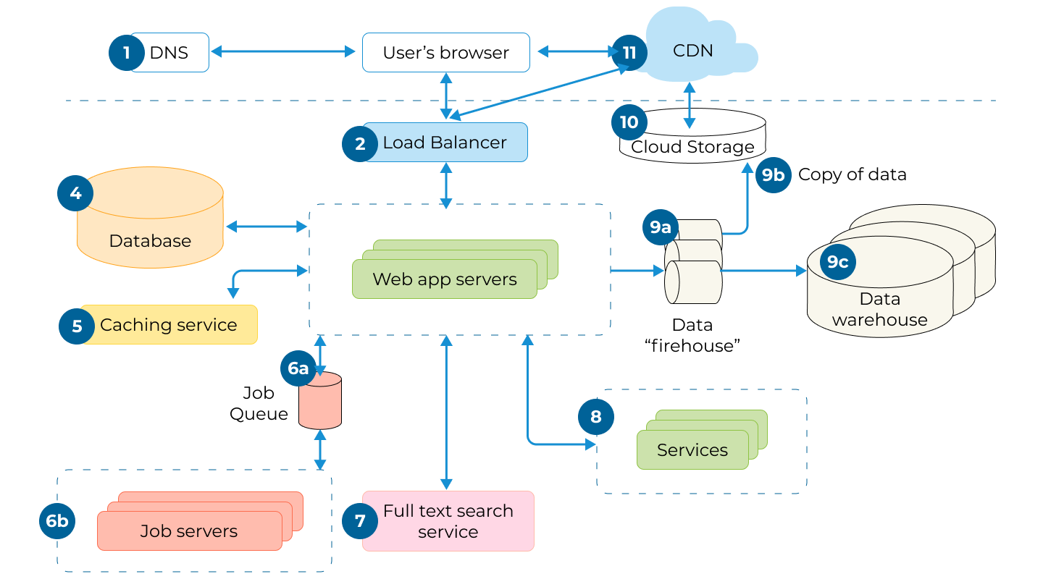

**Figure 1: Architecture plan**



## 

## Front-end plan

A total of 7 page-templates in plan (as of Feb 15, 2022)

1. Main page
2. Search result page
3. Movie details page
4. User details page
5. Review creation page
6. Register/login page
7. User profile creation page

## Back end development

1. Account Creating, Password Recover:
   1. Sign up form, verification by mobile or email.
   2. Login
   3. Facebook login (Phase 2)
   4. Google login (Phase 2)
   5. Forgot Password
   6. MySQL Database
2. Profile Management:
   1. DB plan design
   2. Users Profile
   3. Admin Profile
   4. Movie Review Profile
   5. Others
3. Searching facility:
   1. Movie category based
   2. Genre based
   3. Movie search
   4. Online streaming Search
   5. Genre search

# Development Plan

Planning is the process of selecting among competing communication options in order to establish overarching web goals. To support our web, we'll need to define your intended audience, develop a statement of your web's purpose and mission, and collect and preserve domain information.

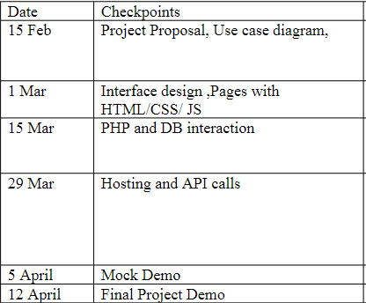

# 

# Use Case Diagram

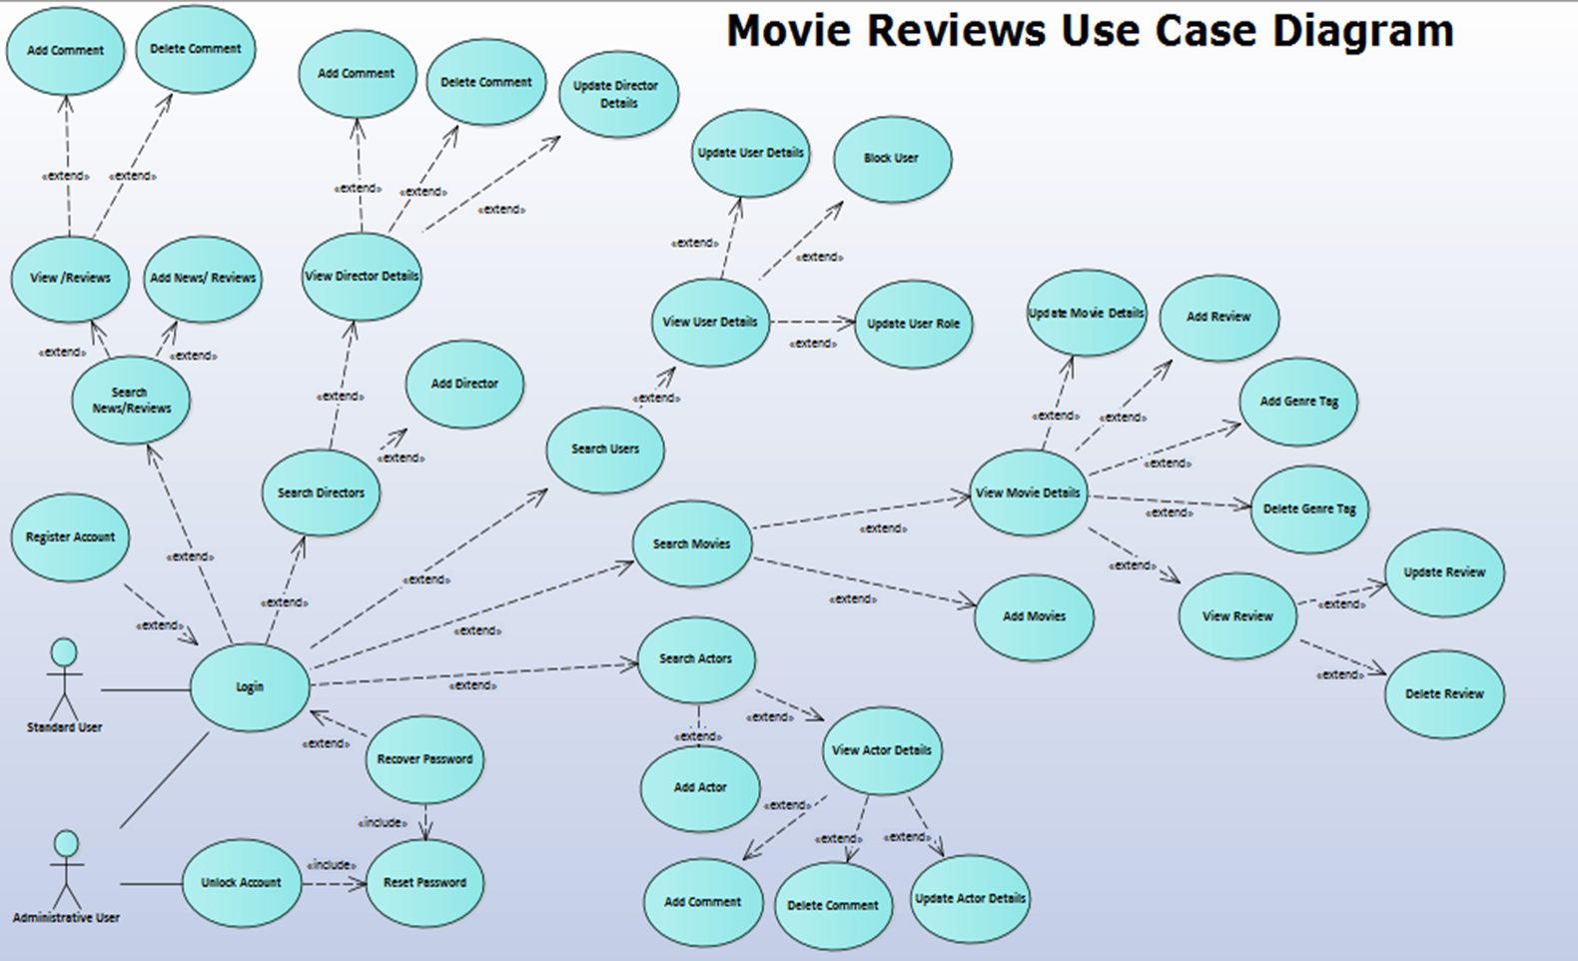

# Performance Optimization

### Login:

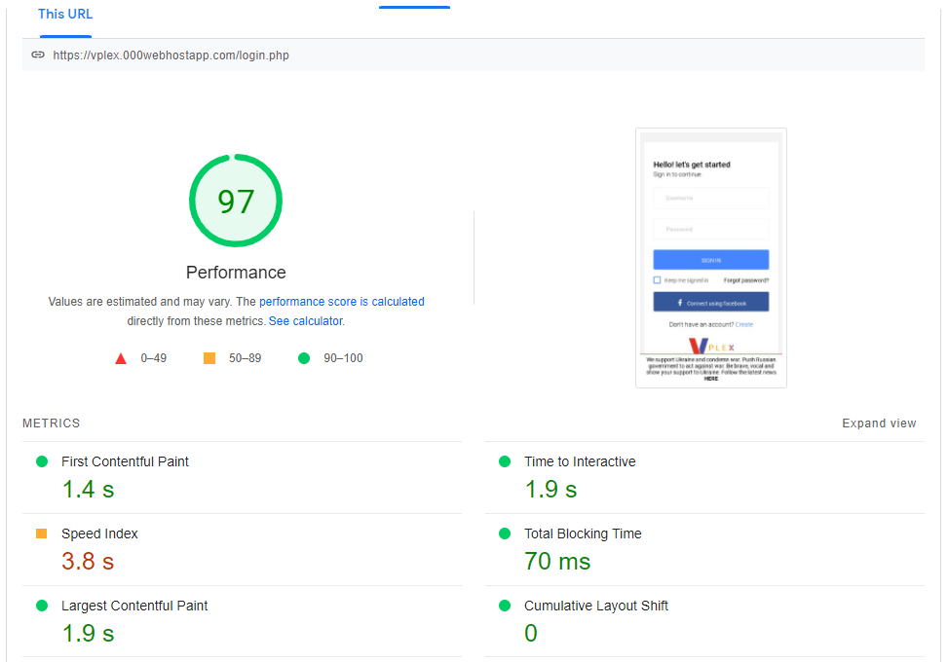

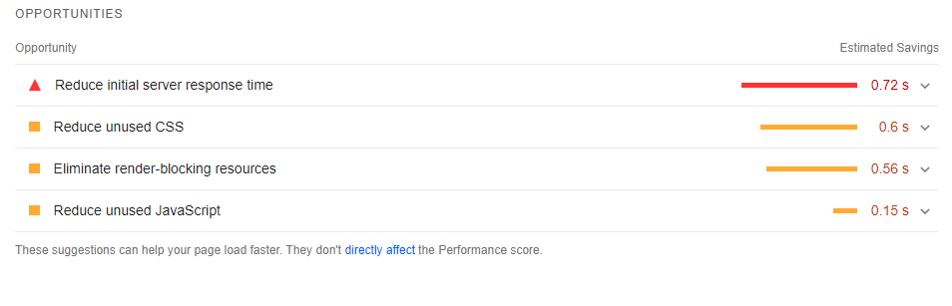

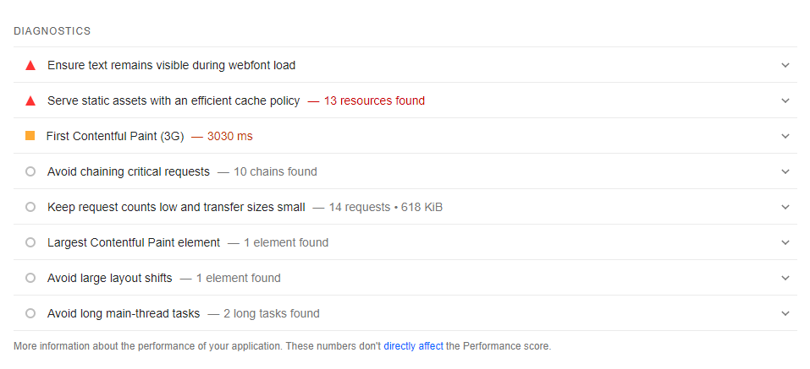

### Register:

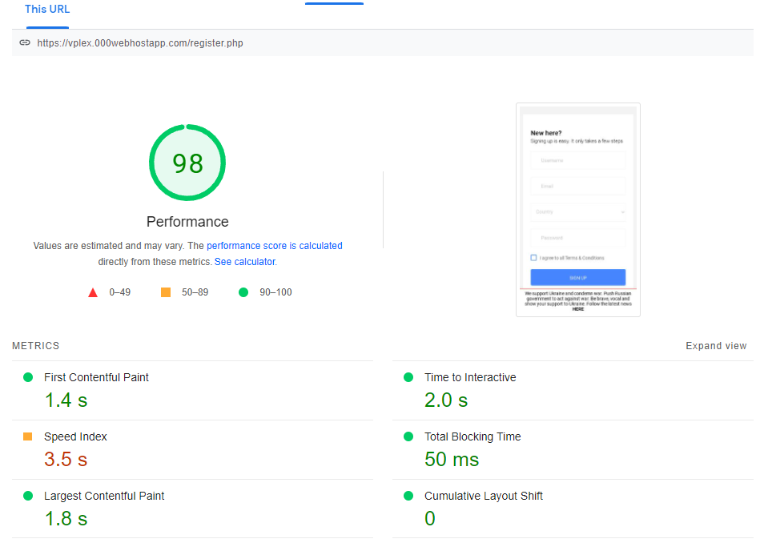

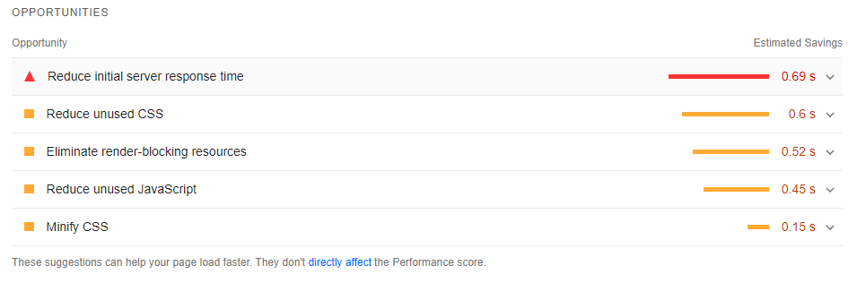

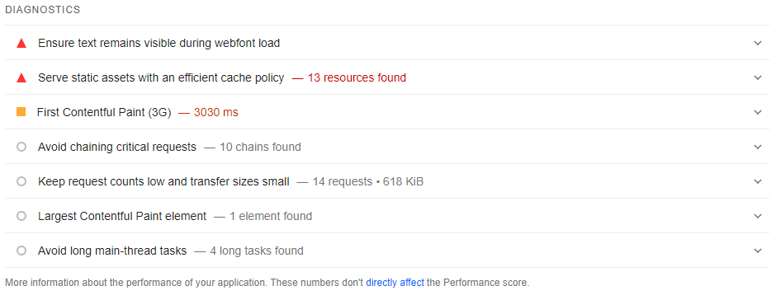

### Index:

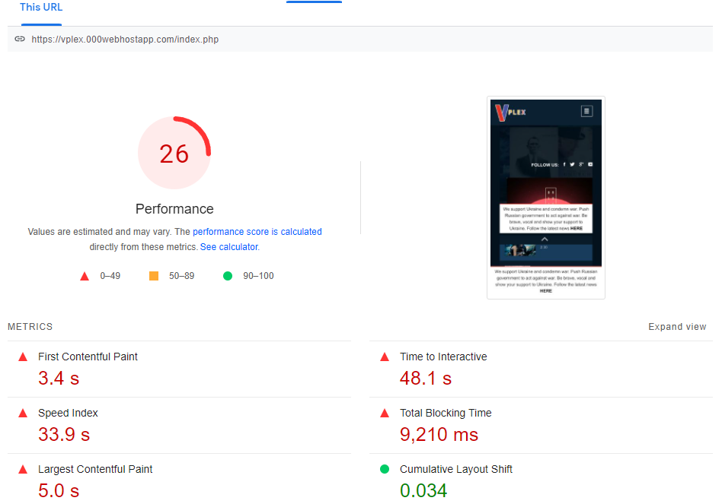

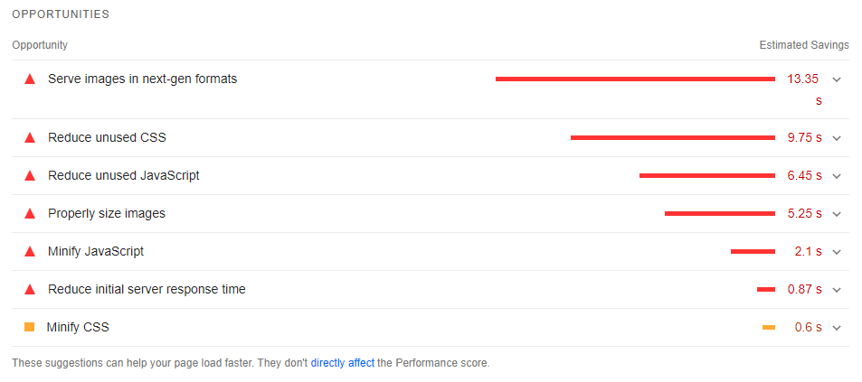

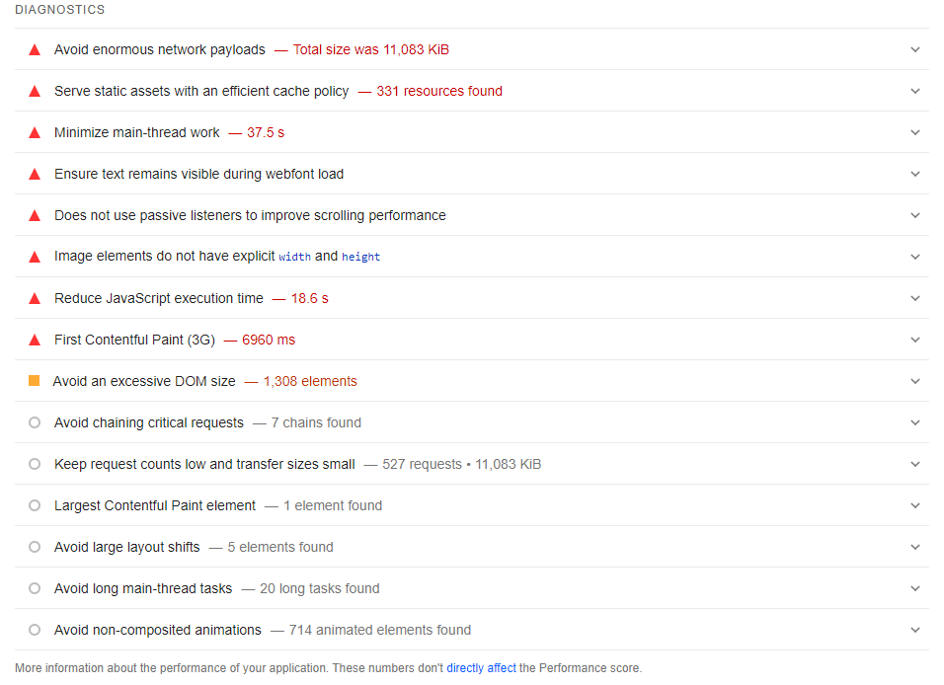

### Dashboard:

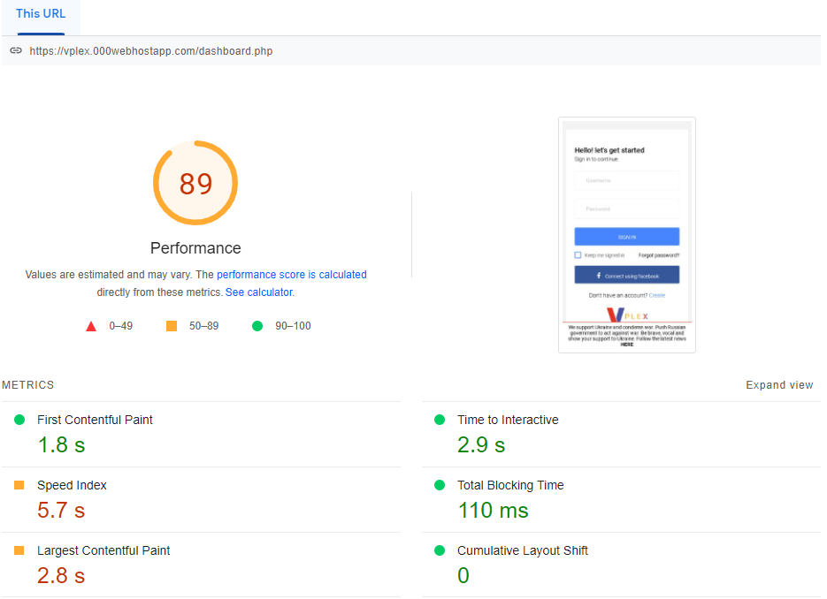

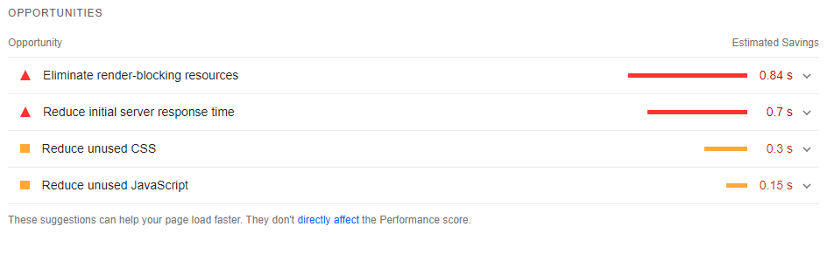

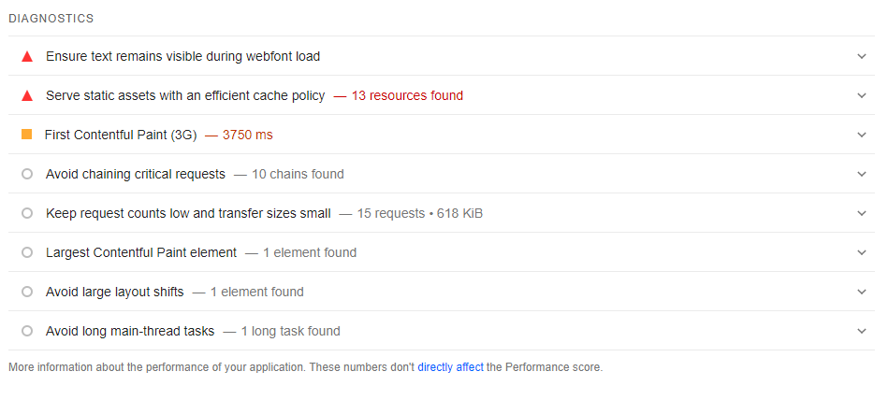

# References:

Fritz, J. (Jan. 04, 2022). Top 10 Best Online Therapy Services 2022. www.top10.com.

Retrieved from <https://www.top10.com/online-therapy/>

Rauch, J. (Jul 24, 2017). The History of Online Therapy. www.talkspace.com.

Retrieved from <https://www.talkspace.com/blog/history-online-therapy/>