

A DIGITAL-TWIN-BASED INTRUSION DETECTION FRAMEWORK FOR CYBERATTACK DETECTION IN LEO SATELLITE NETWORKS

By
SAROWAR RAAJA MANIKANDAN - 6944965
A dissertation submitted in partial fulfilment of the requirements for the award of
MASTER OF SCIENCE IN INFORMATION SECURITY
Department of Computer Science
University of Surrey Guildford, Surrey, GU2 7XH
September 2026
Acknowledgement
I would also like to thank my supervisor who has been of great help with great guidance, constructive feedback and constant support during this doctorate. I also extend my gratitude to both the teaching staff and the university as they ensured that I got the academic resources and learning environment necessary to complete this research. I would like to note with gratitude all those who helped directly or indirectly with the creation and the overall completion of this work. Lastly, I want to also thank my family members and friends who have supported me, been patient and driven through the research process. They have had great assistance in ensuring that this dissertation has been completed successfully.

Declaration
In this thesis, the development and validation of TwinShield - a Digital Twin-based Intrusion Detection Framework for detecting anomalous network activity in the LEO Satellite Networks are carried out. The study surveys the existing literature on the subject area of LEO Satellite Cybersecurity, Intrusion Detection Systems, Machine Learning, and Digital Twin Technology. The CICIDS2017 dataset is employed for analysis of normal and abnormal network traffic, identification of network characteristics with respect to security and development of the proposed framework by using a Random Forest algorithm. The validation of the framework takes place with comparison to a Logistic Regression model by evaluating such metrics as Accuracy, Precision, Recall, F1-score, False Positive Rate and ROC-AUC. The limitation of using a terrestrial dataset instead of real-life LEO Satellite Network traffic is also discussed in the study. Taking into account the supervisor's suggestions, it should be noted that the relevancy of the proposed framework needs to be shown with regard to a certain cyberattack/security incident serving as a case study.
I declare that no Artificial Intelligence (AI) tools or generative AI applications were used in the preparation, writing, analysis, interpretation or completion of this dissertation. All aspects of the research, including the development of the research objectives, literature review, methodology, data analysis, interpretation of findings and conclusions, were completed independently by the author. The information presented in this dissertation has been researched, evaluated and written by the author, with all relevant sources appropriately acknowledged and referenced. The author accepts full responsibility for the originality, accuracy, academic integrity and final content of this dissertation.
Abstract
The intensive growth of satellite systems of Low Earth Orbit (LEO) satellites has made them more significant in communication and digital service delivery but also poses serious security issues in cyberspace. The dynamic, distributed and interconnected nature of LEO networks makes effective intrusion detection increasingly important. In this dissertation, I present TwinShield, a Digital-Twin based Intrusion Detection Framework that aims to provide an opportunity to identify cyberattacks with the use of security-oriented network traffic analysis. This study explores the implementation of Digital Twin concepts in combination with machine-learning based intrusion detection and compares the method with a baseline model. Experimental evaluation based on CICIDS2017 data, which includes normal and abnormal network traffic in various types of attacks, was used. After preprocessing and traffic analysis, 14 security-related network features were identified, which included flow characteristics, a packet statistic, a flow rate, an inter-arrival time, packet-length, a TCP flags and window data. The initial TwinShield classifier was based on a Random Forest and was applied as the primary model (Logistic Regression was utilized as the baseline). The accuracy, precision, recall, F1-score, false-positive rate and ROC-AUC were used as an evaluation of the models. TwinShield achieved 99.77% accuracy, 99.88% precision, 99.84% recall, 99.86% F1-score and an ROC-AUC of 0.9995. The false-positive rate was cut to 0.61 showing a significant improvement as compared to the baseline. The results suggest that the intrusion detection method of combining a focused Digital Twin representation and machine learning is promising. Yet, it must be verified by means of realistic LEO satellite-based traffic before it can be deployed practically.

Table of Contents
Chapter 1: Introduction 10
1.1 Background 10
1.2 Digital Twin and Cybersecurity 10
1.3 Research Problem 11
1.4 Aim 11
1.5 Objectives 12
Chapter 2: Literature Review 13
2.1 Introduction 13
2.2 Cybersecurity Challenges in LEO Satellite Networks 13
2.3 Intrusion Detection Systems 14
2.4 Machine Learning for Intrusion Detection 15
2.5 Digital Twin Technology 16
2.6 Digital Twins and Network Anomaly Detection 17
2.7 Network Traffic Features and Feature Selection 17
2.8 CICIDS2017 Dataset 18
2.9 Research Gap 19
2.10 Chapter Summary 19
Chapter 3: Methodology 21
3.1 Introduction 21
3.2 Research Approach 21
3.3 Dataset Selection 22
3.4 Data Preprocessing 22
3.5 Traffic Analysis and Feature Identification 23
3.6 TwinShield Digital Twin Design 23
3.7 Machine-Learning Model 24
3.8 Baseline Model and Comparison 24
3.9 Training and Testing Procedure 24
3.10 Performance Evaluation 25
3.11 Methodological Limitations 26
3.12 Ethical consideration 26
3.13 Chapter Summary 26
Chapter 4: Results and Analysis 28
4.1 Introduction 28
4.2 Implementation and Evaluation 28
4.3 Key Findings 43
4.3.1 Dataset and Traffic Characteristics 43
4.3.2 Digital Twin and Detection Performance 44
4.3.3 Comparative Model Findings 44
4.4 Critical Analysis 44
4.5 Summary 46
Chapter 5: Conclusion and Recommendations 47
5.1 Conclusion 47
5.2 Recommendations 48
5.2.1 Use LEO-Specific Datasets 48
5.2.2 Expand Attack Scenarios 48
5.2.3 Evaluate Alternative Machine-Learning Models 48
5.2.4 Investigate Real-Time Detection 48
5.2.5 Develop an Adaptive Digital Twin 49
5.3 Final Remarks 49
References 50
Appendix 53

List of Figures
Figure 1: Dataset Structure and Sample Records 24
Figure 2: Dataset Information and Data Types 25
Figure 3: Descriptive Statistics of Network Features 26
Figure 4: Attack Type Frequency Distribution 27
Figure 5: Attack Type Distribution in CICIDS2017 27
Figure 6: Normal and Abnormal Traffic Distribution 28
Figure 7: Traffic Feature Distribution by Class 29
Figure 8: Correlation Heatmap of Digital Twin Features 30
Figure 9: Flow Duration Density by Traffic Class 31
Figure 11: Training and Testing Dataset Split 33
Figure 12: Digital Twin Selected Features 33
Figure 13: Baseline Logistic Regression Model 34
Figure 14: TwinShield Random Forest Model 34
Figure 15: Model Performance Metrics 35
Figure 16: Confusion Matrices — Baseline vs TwinShield 35
Figure 17: TwinShield Classification Report 36
Figure 18: ROC-AUC Comparison — Baseline vs TwinShield 37
Figure 19: Baseline vs TwinShield Performance Comparison 38
Figure 20: TwinShield Performance Improvement 38

List of Tables
Table 1: Major cybersecurity challenges in LEO networks 12
Table 2: Machine-learning approaches relevant to IDS 13
Table 3: Suitability and limitations of CICIDS2017 16
Table 4: Main methodological stages 19
Table 5: Evaluation metrics 23

Chapter 1: Introduction

1.1 Background
Low Earth Obiter (LEO) satellite networks are beginning to gain relevance in contemporary communication and digital infrastructure. They can be applicable in areas like broadband communication, remote connectivity, Earth observation, navigation and emergency services because of their capability to provide connectivity to large geographical regions. Nevertheless, there are also major cybersecurity issues which are brought by the growing reliance on satellite-based communication (Zheng et al. 2022). LEO satellite networks work in complicated and decentralized environments that include satellites, communication paths and internet facilities. The possibility of these components to impact network functioning can open up the potential attack surface and allow malicious actor opportunities, because of their interconnections.
The confidentiality, integrity and availability of the services can be impacted by cyberattacks targeting satellite communication systems. Denial of service, distributed denial of service, scanning of the network, accessing the network without authorisation and other abnormal traffic patterns can potentially disrupt the normal communication (Li et al. 2026). Thus, the efficient Intrusion Detection Systems (IDS) plays a significant role in detecting suspicious behaviours on the network and assisting in safeguarding the satellite-based services. Nevertheless, standard intrusion detection methods may be complicated under the conditions of huge amounts of network traffic and a myriad of network features. Handling a heavy number of features can make systems more complex and improper detection can lead to false-positive notification and decrease the viability of security surveillance.

1.2 Digital Twin and Cybersecurity
One of the potentially valuable ways of tackling some of these challenges is in Digital Twin technology. A digital twin is capable of delivering a digital mirror of a physical system or a functioning environment and its properties and behaviour to be represented, observed and studied. This idea can be used in the cybersecurity field to model the applicable network behaviour and aid in recognising the deviations that could serve as an indicator of malicious behaviour. Past studies have already shown that digital-twin methods can be applied to security surveillance and information about attacks within satellite networks, thus indicating that the technology can be used to create more intelligent security measures (Karim et al. 2026).
The research proposal will discuss an intrusion detector framework involving the application of a digital twin in a specific context of a satellite network of the LEO orbit. The main idea here lies in the fact that rather than treating all network knowledge available as equal, the digital representation can specialise in network properties potential of relevance in detecting abnormal behaviour. The techniques of machine-learning will then be explored as a tool of learning patterns in network traffic and differentiating between legitimate activity and possibly malicious activity.

1.3 Research Problem
Despite the fact that machine learning has been studied extensively in the context of intrusion detection, it is crucial to explore the manner in which it can be brought to bear in conjunction with digital-twin technology in the context of satellite-network cybersecurity (Tasdighi, 2026). One of the main issues is deciding how to use a focused digital representation of network behaviour to achieve the best results in terms of correctly detecting cyberattacks and minimising unwarranted complexity and false-positive warnings. This is especially in the case of LEO satellite networks in which the importance of effective security surveillance is real due to the distributed and dynamic nature of their operations.
The study that is to be proposed will then explore the design of TwinShield, a Digital-Twin-Based Dictionary scheme of Cyberattack Identification of TwinShield in LEO Satellite Systems. The study will investigate literature available, determine suitable security and network attributes, design the proposed framework and implement the study experimentally to determine its detection ability. The research will assume a development research-based study and will be backed by a humongous literature research and practical experimentation hence sticks to its dissertation requirement of using existing technology and concepts to formulate and test a new concept of security.

1.4 Aim
This dissertation has the following aim:
To develop and evaluate a simple Python-based Digital-Twin intrusion detection framework for identifying abnormal network behaviour in a simulated LEO satellite network.

1.5 Objectives
The study will implement this purpose with four key objectives:
- To critically analyze the current literature on LEO satellite cybersecurity, intrusion detection, machine learning and digital-twin technologies with the aim of recognizing current practices and gaps in the literature.
- To determine and compute pertinent network traffic features and attack behaviour which may aid in the modelling of security-related behaviour into a digital-twin-based intrusion detection system.
- To develop and design the proposed TwinShield framework by combing a digital-twin representation with a relevant machine-learning-based intrusion detection method.
- To measure and in the process critically assess the effectiveness of TwinShield in comparison to a relevant baseline based on the use of relevant intrusion-detection performance measures, such as accuracy, precision, recall, F1-score, false-positive rate and ROC-AUC.

Chapter 2: Literature Review

2.1 Introduction
The chapter critically analyses the literature that is pertinent to TwinShield: A Digital-Twin-Based Intrusion Detection Framework in Cyberattack Detection in LEO Satellite Networks. The review will concur with the four research objectives that were put in Chapter 1. It discusses the problem of cybersecurity of Low Earth Orbit (LEO) satellite networks, available Intrusion Detection Systems (IDS), how machine learning is used to detect intrusions, and what Digital Twin technology promises as a new tool to enhance network security. The chapter also takes into account network traffic characteristics and datasets involved in experimental IDS studies prior to establishing the research gap that is filled by TwinShield.

2.2 Cybersecurity Challenges in LEO Satellite Networks
The LEO satellite networks are becoming significant in communications, remote connectivity, Earth observations, navigation and other digital services. LEO satellites can offer relatively low-latency communication, and broad geographical coverage. Nonetheless, there are also great cybersecurity needs associated with the growing reliance on satellite infrastructure. The LEO networks are not the same as the traditional terrestrial networks since they include moving satellites, dynamic links, inter-satellites connections and ground stations (Xu et al. 2025). As a result, network states and communication dynamics may vary dynamically.
These characteristics increase the potential attack surface. Attacks on satellite communications may interfere with the confidentiality, integrity or availability of services. Denial-of-service (DoS), distributed denial-of-service (DDoS), network scanning, unauthorised access and other types of malicious or abnormal traffic are some of the threats (Agnew et al. 2024). Intrusion detection therefore is vital in detecting suspicious activity and aiding in security response in a timely manner.
The big issue is that it is not straightforward to define malicious behaviour and to draw a line between acceptable and malicious changes in network activity. Alterations in communication patterns might also be due to normal movement of satellites or altering network conditions or handovers and not attacks. The IDS implemented by the LEO networks need to be effective in detecting the attack without producing too many false-positive notifications.

Table 1: Major cybersecurity challenges in LEO networks
Challenge | Implication for IDS
Dynamic topology | Normal traffic patterns can change frequently
Distributed architecture | Multiple components require monitoring
Large attack surface | More opportunities for malicious activity
Changing communication conditions | Legitimate behaviour may appear anomalous
Resource constraints | Security mechanisms need to be efficient
False-positive alerts | Excessive alerts can reduce IDS effectiveness
All these challenges show why it is necessary to create security mechanisms that can analyse the behaviour of the network whilst ensuring that the mechanism has a proper balance between the effect of detection and the effectiveness of the functioning.

2.3 Intrusion Detection Systems
Intrusion Detection System is a security tool which checks on the activity of the network or system with the intention of detecting the possible malicious behaviour. Two main types of IDS techniques are signature-based detection and anomaly-based detection. Signature-based IDS compare traffic they observe to known attack patterns (Azar et al. 2022). They are useful in known threats but might be weak in detecting the previously unknown attacks. Instead, anomaly-based IDS aim at detecting violations of the norm and as such have the possibility to offer more potential in detecting new attacks.
The application of anomaly detection is especially applicable to the domain LEO satellite networks due to their dynamic nature. Nonetheless, it also poses a significant difficulty. Well-intended transformations in the behaviour of satellite networks might be registered as attacks (Kaliappan et al. 2026). This is able to boost the false-positive rate and might limit trust in the security system.
Accuracy should, therefore, not be the sole basis in the evaluation of IDS. Precision, recall and F1-score further detail the quality of classification, whereas the false-positive rate is especially interesting to evaluate both whether real usage of a network is treated as malicious.
It has been suggested in the literature that the best satellite IDS must be able to detect abnormal activity with an acceptable rate of false alarms. This offers a significant basis to the proposed TwinShield structure.

2.4 Machine Learning for Intrusion Detection
Machine Learning (ML) is now of significance to intrusion detection since the models can learn about network traffic peculiarities and attack behaviour. The use of supervised learning is specifically helpful in situations where there exist labelled traffic data. The most commonly studied methods are; Logistic Regression, Decision Trees, Random Forest, Support Vector Machines and neural-network methods.
The main advantage of ML-based IDS is that it is possible to detect combinations of network features, which might be hard to define by hand. Nevertheless, model performance varies based on a number of variables, such as the quality of data, distribution of classes, selection of features as well as the appropriateness of training data to the anticipated setting (Yang et al. 2026).
The feature selection is one of the most important issues. The number of characteristics that could be generated in network traffic datasets can be a large amount, although all of them might not have equal importance in attack detection. Unnecessary or redundant features can raise the increased computation needs and make the process more challenging. The choice of meaningful characteristics may possibly result in a more efficient and interpretable model.

Table 2: Machine-learning approaches relevant to IDS
Technique | Strength | Limitation
Logistic Regression | Simple and interpretable | Less effective for complex nonlinear relationships
Decision Tree | Easy to interpret | Can overfit
Random Forest | Handles complex relationships and provides feature importance | Requires multiple trees
Support Vector Machine | Effective for suitable classification problems | Can be computationally expensive with large datasets
Neural Networks | Capable of learning complex patterns | Greater computational and tuning requirements
Random Forest is specifically applicable to the proposed study as it is able to approximate nonlinear correlations among network features and can yield insight to feature significance. However, the choice of an algorithm does not yet solve the problems of satellite intrusion detection. Appropriate data, features and evaluation measures should be used to evaluate the model.

2.5 Digital Twin Technology
A digital Twin technology is the construction of a digital model of a physical thing, system or procedure. The representation can be used to observe, analyse and understand the behaviour of the corresponding physical environment. Digital Twins have seen greater investigations in networking, as they are capable of giving a virtual representation of network components, and behaviour (Sharmin et al. 2025).
The principle can be applied to cybersecurity since the digital representation may help to monitor, analyze and detect. Rather than just direct observations of the functioning environment, network properties can be modelled in a digital environment and be analysed to reveal possible abnormal behaviour.
Digital Twins to satellite cybersecurity is already beginning to appear. An example is Qiao et al. (2023), who suggested a Digital-Twin-based detection and protection infrastructure to satellite-networks to combat sinkhole and grayhole nodes which are related to silent data corruption. Their studies prove that Digital Twin can be implemented in solving security issues in the satellite communication setting.
However, this work focuses on particular routing and node-related threats. The proposed TwinShield research takes another step and explores the application of a Digital Twin to model the network traffic features that are security-related to capture a larger scope of cyberattacks.

2.6 Digital Twins and Network Anomaly Detection
Recent studies have expanded the uses of Digital Twin beyond system representation to include network monitoring and anomaly detection. A Network Digital Twin to monitor traffic and identify anomalies was studied by Sengendo and Granelli (2026). Their efforts show that it is possible to use network representations in conjunction with analytical methods to discover abnormal behaviour.
The significance of this development is that it implies that Digital Twins can be taken as analytical elements instead of being merely visual representations of real-life systems. It is possible to have a Digital Twin which is a structured representation of network behaviour based on which security-relevant patterns can be derived.
However current studies are still disjointed. Optimally, some research concentrates on particular satellite assaults, whereas others look at more generally Digital Twin-oriented network overseeing. Thus, there is a chance to explore a framework in which a security-driven Digital Twin representation is used in tandem with machine-learning-based intrusion detection of a LEO satellite network environment.

2.7 Network Traffic Features and Feature Selection
A large number of characteristics that may offer information on the communication behaviour can be found in network traffic. These can be flow duration, number of packets, packet length, traffic rates, inter-arrival time and TCP flag data. When evil traffic is injected into any network, such characteristics can dramatically alter.
The proposed TwinShield framework is hence important in feature selection. Instead of postulating that all network characteristics available are equally helpful, the study will explore the characteristics that are most helpful in making distinctions between normal and abnormal traffic. Having a reduced representation of the feature may allow computational demands to be reduced without much loss of information on security related behaviour.
According to the current project literature, the security-applicable features may include the flow duration, number of forward packets, flow bytes and packets per second, the inter-arrival-time statistics, packet-length statistics, the number of flags and the cap of initial window-bytes features (Kumar and Sankar, 2025). These classes offer a convenient conceptual framework to explore the manner in which a Digital Twin could be usefully used to model network behaviour as an IDS input.
Interpretability can also be enhanced by feature selection. Should a few network properties consistently play a role in classification, one can gain an insight into the patterns of behaviour that are related to attacks. This comes in especially handy when the suggested framework is critically assessed and not seen as a prediction model alone.

2.8 CICIDS2017 Dataset
CICIDS2017 is a popular dataset to use in network intrusion detection and machine learning research. It harbours both good and bad network traffic and features various types of attack; DoS, DDoS, brute-force, web, infiltration, port scanning and botnet actions (Karim et al. 2026). The data set gives flow-oriented network features which can be smoothly categorized.
The data set will be relevant to the proposed study since it is a labelled traffic that can be used in developing and testing an intrusion detection strategy. It is also able to provide comparative evaluation of a proposed model and a baseline approach.
Nevertheless, a major weakness that needs to be recognized. CICIDS2017 was simulated in a terrestrial network setting and thus, is not reflective of real satellite constellations in space. It ought to, therefore, be considered an experimental IDS data as opposed to an actual reflection of the operational satellite traffic. This difference is critical in the interpretation of the results of the proposed research.

Table 3: Suitability and limitations of CICIDS2017
Dataset characteristic | Relevance | Limitation
Labelled traffic | Supports supervised learning | Labels reflect the dataset environment
Normal and attack traffic | Enables classification | May not represent all satellite behaviours
Multiple attack categories | Supports diverse evaluation | Attack distribution may be imbalanced
Flow-level features | Suitable for feature analysis | Does not capture every satellite-specific factor
Public dataset | Supports reproducibility | Not generated from an actual LEO network
The dataset may thus be used to generate controlled experimental groundwork to test the suggested concept, but the difference between terrestrial and satellite settings should still be included in the subject of critical analysis.

2.9 Research Gap
A clear opportunity in the research is found in the critical review. First, LEO satellite networks demand security systems, which can support dynamic and distributed communication settings. Second, IDS powered by machine learning could offer automatic detection but requires proper traffic features and effective assessment (Burks, 2026). Third, Digital Twin technology offers a framework enabling an online representation of network behaviour that can be studied and analysed digitally. Previous studies have proven the concepts independently and have also delved into particular Digital Twin uses in the area of satellite security. Nonetheless, it is still possible to explore their combination into a specific system of cyberattack identifying.
The main gap that this dissertation will address, thus, is the lack of exploration of a security-oriented Digital Twin paired with machine-learning-based intrusion detection in the environment of LEO satellites networks. TwinShield is suggested to fill this gap by exploring the possibility of using a shrunk and security-pertinent image of network traffic to aid in detecting cyberattacks.

2.10 Chapter Summary
The literature on LEO satellite cybersecurity, intrusion detection, machine learning and Digital Twin technology has been reviewed in this chapter. Issues such as dynamic networks, complexity and false-positive detection were found during the review. It also emphasized the promise of security-oriented features and Digital twins in enhancing IDS features. Nevertheless, the combination of their use to detect LEO satellites cyberattacks is not thoroughly studied. These results combine the four objectives of the research with the basis of the methodology of Chapter 3.

Chapter 3: Methodology

3.1 Introduction
This chapter shows the method applied to create and test the TwinShield: A Digital-Twin-Based Intrusion Detection Framework to Cyberattack Detection in LEO Satellite Networks. The approach directly relates to the four research objectives that were set out in Chapter 1. A quantitative approach is taken which is development based and through which both the design of the proposed framework and an experiment are done. The key steps are the dataset selection, data preprocessing, network-traffic analysis, feature identification, Digital Twin design, machine-learning development, baseline comparison and performance evaluation.

3.2 Research Approach
The study takes the quantitative and developmental approach. The development aspect is about the combination of Digital Twin concepts with machine-based intrusion detection based on machine learning and the quantitative aspect is the evaluation of the developed detection scheme by quantifiable performance measures.
The process involves a sequence of steps, which starts with the preparation and analysis of network-traffic data. Applicable security attributes are then discovered and enlisted in the proposed Digital Twin representation. An abnormal traffic is then detected by a machine-learning classifier. Lastly, the suggested model is contrasted with a model on the baseline.

Table 4: Main methodological stages
Stage | Activity | Purpose
1 | Dataset selection | Obtain suitable network-traffic data
2 | Data preprocessing | Prepare reliable input data
3 | Traffic analysis | Examine normal and abnormal behaviour
4 | Feature identification | Select security-relevant characteristics
5 | Digital Twin design | Develop the TwinShield representation
6 | ML model development | Detect abnormal traffic
7 | Baseline comparison | Establish a reference point
8 | Evaluation | Assess detection effectiveness

3.3 Dataset Selection
This analysis, the cleaned and preprocessed CICIDS2017 dataset from Kaggle is used. This is because the dataset has labelled data with normal and malicious network traffic that can be used for intrusion detection research. The dataset has 53 attributes and 2,520,751 network flow samples with characteristics like flow duration, packets count, packet length, and traffic rates. These include DoS, DDoS, port scanning, brute force, web attacks and bots. Since CICIDS2017 is terrestrial data and not LEO satellite traffic, it serves as experimental data.
The experimental data source is the CICIDS2017 data. It suits intrusion-detection research since it has labelled normal and malicious network traffic, and offers a rich spectrum of network-flow features. Various types of attacks are in the dataset, such as DoS, DDoS, port scanning, brute-force, web attacks and such activity as bots.
The cleaned dataset consists of 2,520,751 network-flow records and 53 columns with variables dependent on the destination ports, duration of the flow, numbers of packets and lengths of packets. These features give an appropriate foundation to explore the correlation between network behaviour and cyberattack detection.
Nonetheless, CICIDS2017 is a system on the ground instead of a functional LEO satellite system. This is a significant methodology weakness. Thus this data is experimentally explored using the proposed concept of detection as opposed to using it as a full bake representation of actual satellite traffic.

3.4 Data Preprocessing
Preprocessing of data is provided before developing machine-learning to make sure that the data set can be analyzed by utilizing credible results. This involves the preparation of network-flow records, elimination of the unsuitable variables and specification of the classification target.
The study involves binary classification whereby traffic is either a normal or abnormal traffic. Predictive feature set excludes variables that explicitly disclose the target classification to avoid the leakage of targets. In particular, Binary Label and Label Encoded, along with Attack Type are not included in the numerical predictors.
This is necessary as the entry of information about the target into the model might artificially boost performance and result in an untrustworthy assessment.

3.5 Traffic Analysis and Feature Identification
After preprocessing, network traffic is mapped in order to detect properties that can be used to distinguish between normal and abnormal behaviour. The features of network flows that are analyzed are flow length, packet performance, flow rate, packet length, inter-arrival times, TCP flags and initial window bytes.
Another significant aspect to the TwinShield methodology is feature selection as the proposed Digital Twin is aimed at offering a narrow representation of security-related network behaviour (Khan et al. 2025). The framework uses 14 security-relevant features encompassing the key traffic characteristics that were discovered during the analysis; instead of including all the possible variables.
The aim of feature selection is to examine whether or not a smaller representation can capture valuable data on cyberattack detection and not introduce any additional complexity. It is also more interpretable as it gives a possibility to study the contribution of individual characteristics of a network.

3.6 TwinShield Digital Twin Design
The design of the TwinShield Digital Twin is the key methodology element. The Digital Twin gives a digitalisation of the use of any set of traffic characteristics of the relevant network as to network-security behaviour.
The suggested solution would not seek to recreate all the existing network variables. Instead, it focuses on features deemed to be pertinent to aiding in identifying abnormal traffic. The representation contains the data of flow behaviour, packet statistics, traffic rates, inter-arrival time, packet length, TCP flags and the window information (Mythili et al. 2025). It includes 14 chosen characteristics in the project design.
The Digital Twin hence gives the bridge between the information in network-traffic and the machine-learning detection procedure. This design is a direct response to the research aim that explores whether a security-centered Digital Twin can aid in detecting cyberattacks.

3.7 Machine-Learning Model
The main machine-learning model of Twin Shield is a Random Forest classifier. Random Forest is suitable since it is able to detect nonlinear associations between the characteristics of the network and classification results. It also may supply information on feature-importance and help with interpretation of the decision of the model.
TwinShield works with reduced Digital Twin feature representation. The configuration that is implemented has 200 trees, balanced classes and parallel processing. The fact that there may be significantly more normal traffic than malicious traffic in network intrusion datasets makes balanced weighting of the classes an issue (Zaidi and Khan, 2026).
Evaluation also takes into account the feature importance to determine which chosen network characteristics have the most significant impacts on classification. This offers another insight on the correlation between network behaviour and intrusion detection.

3.8 Baseline Model and Comparison
The minimum of a baseline model is needed to determine whether the proposed TwinShield representation is benefiting in a meaningful way. The process then becomes Logistic Regression as the baseline model where the full representation of the predictive features are used instead of the reduced Digital Twin representation.
The baseline helps to make a comparison with TwinShield, which can be analyzed relative to the same experimental conditions. The Logistic Regression model implemented has a maximum of 1,000 iterates and a specific random state.
The two techniques compared enable the study to explore whether the Digital Twin and security-oriented feature representation can result in a higher intrusion-detection performance.

3.9 Training and Testing Procedure
The dataset is divided into 75% training data and 25% testing data using stratification. Stratification ensures that distribution of normal and abnormal traffic respectively in the two subsets is maintained.
The training set consists of 1,890,563 records, and the testing set consists of 630,188 records. The training data are trained to generate the machine-learning models, where the testing data remains segregated to be tested.
This separation minimizes the chances of testing the models with previously applied observations and gives a more accurate view of whether or not they will be able to categorize unfamiliar traffic.

3.10 Performance Evaluation
TwinShield is measured to find out its effectiveness based on multiple measures of performance in the form of intrusion-detection, and it is not based on the measure of accuracy alone. The measures chosen are accuracy, precision, recall, F1-score, false-positive rate and ROC-AUC.

Table 5: Evaluation metrics
Metric | Purpose
Accuracy | Measures overall classification correctness
Precision | Measures reliability of abnormal predictions
Recall | Measures detection of actual abnormal traffic
F1-score | Provides a balance between precision and recall
False-positive rate | Measures legitimate traffic incorrectly identified as abnormal
ROC-AUC | Measures the model's ability to distinguish between classes
Accuracy is a general idea of the correct prediction, whereas precision and recall give more information on the identification of attacks. F1-score is an amalgamation of precision and recall. The false positive is a significant metric since a false alarm that legitimate traffic could be detected as harmful might lead to unwarranted security notifications (Edozie et al. 2025). Another test of classification discrimination is found in ROC-AUC.
Confusion matrices will also be reviewed to get an idea of what was correctly classified, and what has been wrongly classified. The outcomes of TwinShield will be subsequently compared to the baseline model to see how effective it is in comparison to the baseline.

3.11 Methodological Limitations
The primary weakness is that it uses CICIDS2017 and not the traffic that has been gathered by an actual LEO satellite network. As a result, the experimental data might not have been comprehensive in quantifying the satellite-specific characteristics. The results have to be thus interpreted in the specified experimental setting.
Another constraint is that the performance of machine-learning can be affected by the properties and distribution of the dataset. The study will therefore not make the research conclusions to be applicable across the board to all LEO satellite networks.

3.12 Ethical consideration
Ethical issues were thoroughly addressed during the process of conducting the research. No data was collected or processed from identifiable users, organisations or individuals in the study; data was simulated. As such, the research involved no personal, sensitive or confidential information. The simulated data was merely for academic or research purposes and is used to test the proposed TwinShield intrusion detection framework. There was no recruiting of participants and no human subjects were involved, so there were no concerns about informed consent or privacy and participant confidentiality. The analysis was done with responsibility and the results were reported accurately, without deliberate manipulation of results. Appropriate acknowledgment of all external academic sources and datasets used in the dissertation have been made to ensure academic integrity and avoid plagiarism.

3.13 Chapter Summary
This chapter laid down the process of developing and trying TwinShield. CICIDS2017 data is used in the research after which preprocessing and feature analysis concerning security are done. Digital Twin going by a choice of network characteristics is incorporated with a Random Forest classifier, and Logistic Regression is the baseline. The stratified 75:25 training/testing division leads to the assessment based on accuracy, precision, recall, F1-score, false positive rate and ROC-AUC. This research approach can offer a systematic foundation to the four research objectives and critical analysis of the proposed research framework, TwinShield.

Chapter 4: Results and Analysis

4.1 Introduction
In this chapter, the author introduces and critically evaluates the outcomes of the creation and testing of the TwinShield framework in respect to the four research objectives. To begin with, the nature and cybersecurity applicability of network traffic are analyzed based on the CICIDS2017 dataset. Second, the analysis recognizes security-relevant characteristics of traffic and creates the 14-feature Digital Twin representation. Third, the TwinShield Random Forest is tested in terms of its capability to identify normal and non-normal traffic. Lastly, its performance is evaluated against Logistic Regression baseline through classification measures and error-related measures. The results are analyzed concerning the purpose of the research to investigate a Digital-Twin-based method of intrusion detection in LEO satellite networks.

4.2 Implementation and Evaluation
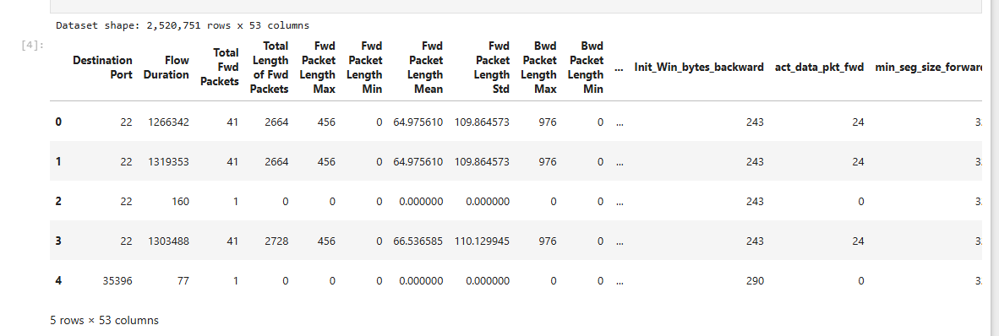

Figure 1: Dataset Structure and Sample Records
The cleaned data structure for CICIDS2017 and initial records is shown in the figure. It includes 53 columns and 2,520,751 rows and has measures for the network-flow variables: Destination Port, Flow Duration, Total Fwd Packets, and packet length. The given records show the structure for the subsequent analysis overall.
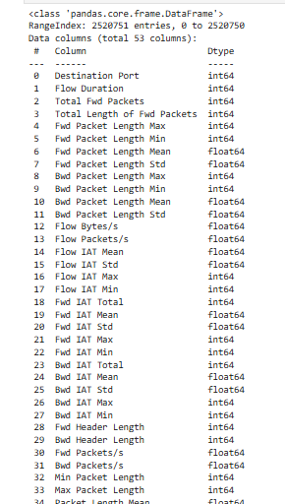

Figure 2: Dataset Information and Data Types
The figure displays information on the data sets, as well as the data types for 53 columns. This data set contains 2,520,751 rows, and the majority of the fields are of type int64 and float64. This structure also implies that most of the attributes in the network flow are numbers; thus, the flow is suitable for statistical analysis and machine learning for network modelling (Qiao et al., 2023).

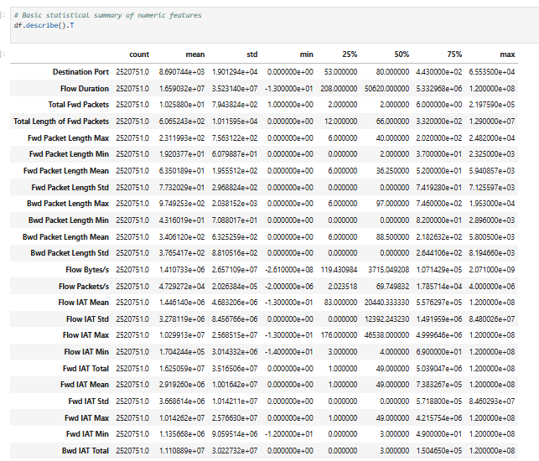

Figure 3: Descriptive Statistics of Network Features
The figure displays descriptive statistics for the numerical network features. The mean of Flow Duration is approximately 1.66×10^7, and the mean of Total Fwd Packets is 2.81. There is also a great range and dispersion, which indicates that characteristics of the network flows vary across the entire network.

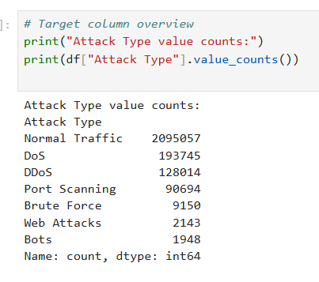

Figure 4: Attack Type Frequency Distribution
The figure displays a frequency distribution for attack categories. Normal Traffic leads with 2,095,057 records, while DoS follows with 193,745, with DDoS coming in third with 128,014. As you can see, port scanning contributes 90,694 records, while Brute Force, Web Attacks and Bots contribute comparatively smaller frequencies in the dataset.
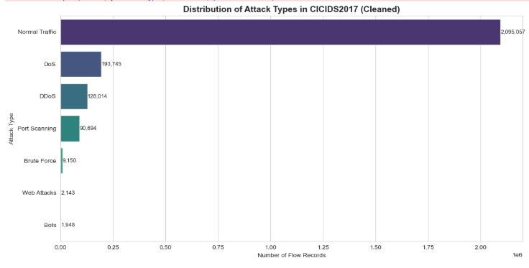

Figure 5: Attack Type Distribution in CICIDS2017
This figure illustrates the distribution of attacks in the cleaned CICIDS2017. In addition to the 2,095,057 flows for Normal Traffic, there are only 1,948 flows for Bots. Overall analysis shows massive multiclass imbalances for DoS (193,745 records) and DDoS (128,014 records) (Sengendo and Granelli, 2026).
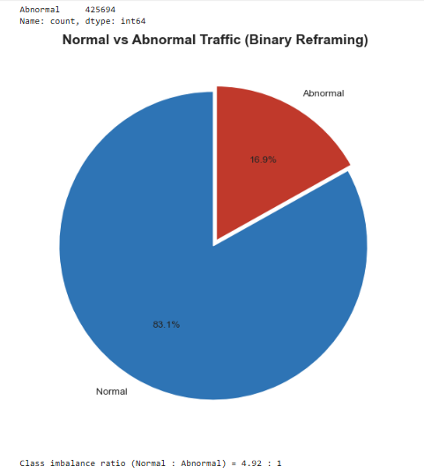

Figure 6: Normal and Abnormal Traffic Distribution
The figure shows the classification of binary traffic after reclassifying the Normal Traffic as Normal and all attacks as Abnormal. Normal traffic is 83.1%, and Abnormal traffic is 16.9%. The class imbalance ratio of the resulting dataset is 4.92:1; that is, there are more data entries of one class compared to the other; hence, stratified splitting and balanced model training with respect to classes are done for modelling and evaluation.

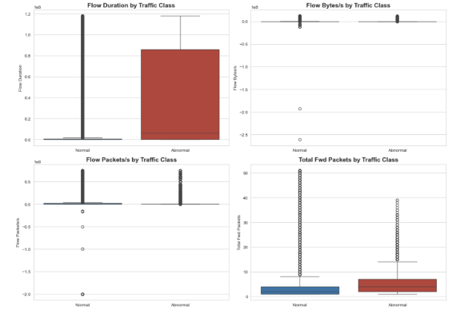

Figure 7: Traffic Feature Distribution by Class
The figure shows a comparison of the Flow Duration, Flow Bytes/s, Flow Packets/s and Total Fwd Packets between Normal and Abnormal traffic. Compared to all traffic classes, there is a significant amount of variability and outliers in the boxplots for Flow Duration and packet-related measures, where traffic classes behave distinctly overall.
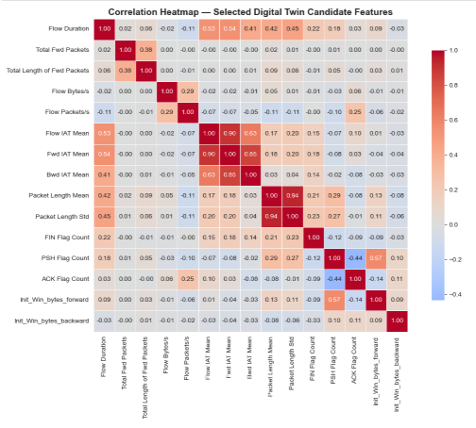

Figure 8: Correlation Heatmap of Digital Twin Features
The figure shows correlations between the selected Digital Twin candidate features. Flow Duration has moderate correlations when compared to Fwd IAT Mean and Fwd IAT Max, around 0.53 and 0.90, respectively. There is also a high correlation (0.94) between Packet Length Mean and Packet Length Std.

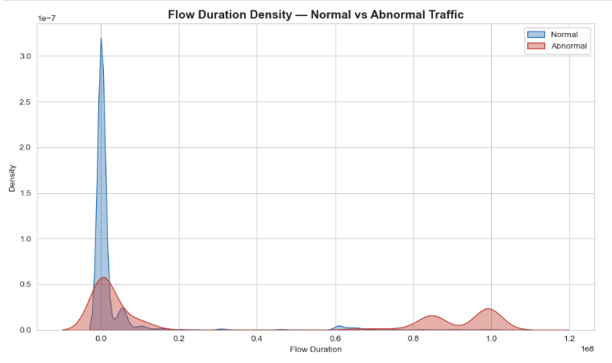

Figure 9: Flow Duration Density by Traffic Class
This is a figure of Flow Duration density of Normal and Abnormal traffic. The distributions of normal flows are well concentrated around lower durations, while Abnormal traffic shows wider distributions with extra peaks at about 0.85*10^8 and 1.0*10^8. This separation suggests that there are different temporal behaviours of the traffic classes in the dataset in general.
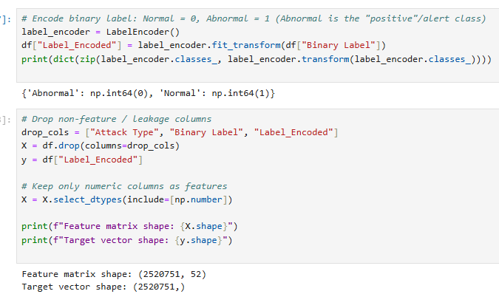
Figure 10: Binary Label Encoding and Feature Matrix
The figure represents the process of binary label encoding and feature preparation. The numbers shown above correspond to: Abnormal = 0, Normal = 1, feature matrix = 2,520,751 observations x 52 numerical features. Therefore, in practice, there is no target leakage when excluding Attack Type, Binary Label, and Label_Encoded.
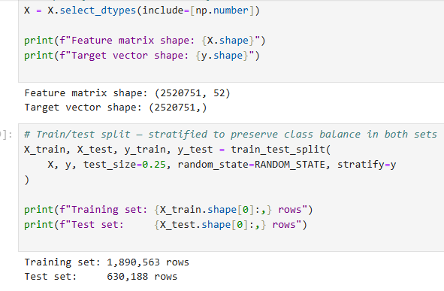

Figure 11: Training and Testing Dataset Split
The figure shows a stratified train-test split of the dataset. The data is split into 75% training and 25% testing w, with the training set containing 1,890,563 rows and the testing set containing 630,188 rows. For reliable evaluation, Stratification is considered to maintain the class proportions of “Normal” and “Abnormal” classes across both datasets appropriately for evaluation (Agnew et al., 2024).
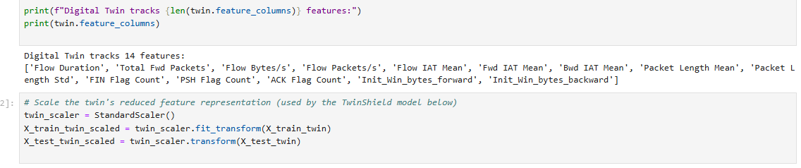

Figure 12: Digital Twin Selected Features
The 14 features monitored and tracked by the Digital Twin are identified. These are Flow Duration, Total Fwd Packets, Flow Bytes/s, Flow Packets/s, IAT measures, packet-length statistics, flag counts and initial window bytes. This reduced representation enables the TwinShield model to focus on the security-relevant traffic behaviour effectively overall.
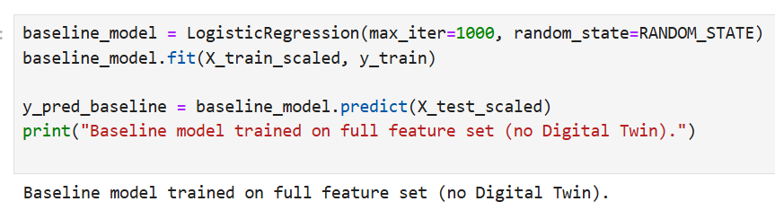

Figure 13: Baseline Logistic Regression Model
The figure shows the Logistic Regression model trained with the complete set of features without the reduction of Digital Twins. The model runs a maximum of 1000 iterations and uses a defined random state. It provides a comparison criterion for the comparative evaluation of the following TwinShield detection approach overall.
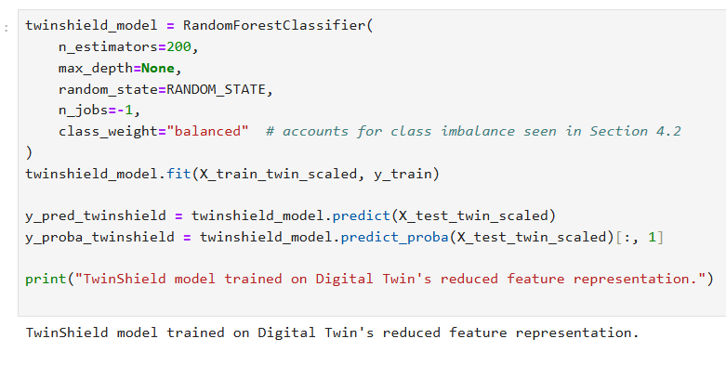

Figure 14: TwinShield Random Forest Model
The figure shows the TwinShield model, which is a Random Forest model with the reduced feature representation in the Digital Twin. It has 200 trees, balanced class weighting and parallel processing. It predicts abnormal traffic with 14 selected features, thus offering the primary detection model for comparative evaluation.
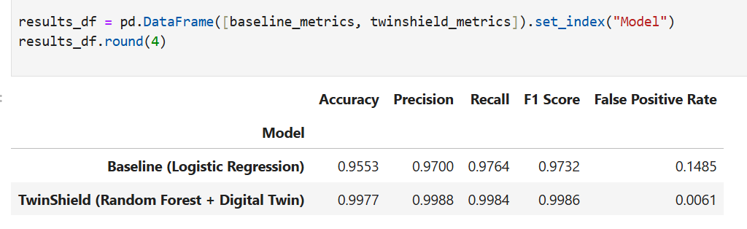

Figure 15: Model Performance Metrics
The figure presents the model performance measures using five measures. Baseline accuracy, precision, recall, and F1 score are 0.9553, 0.9700, 0.9764, and 0.9732. In the comprehensive held-out test evaluation, TwinShield performs with an accuracy of 0.9977, 0.9988 precision, 0.9984 recall and 0.9986 F1 score, and it has a false positive rate of 0.0061.
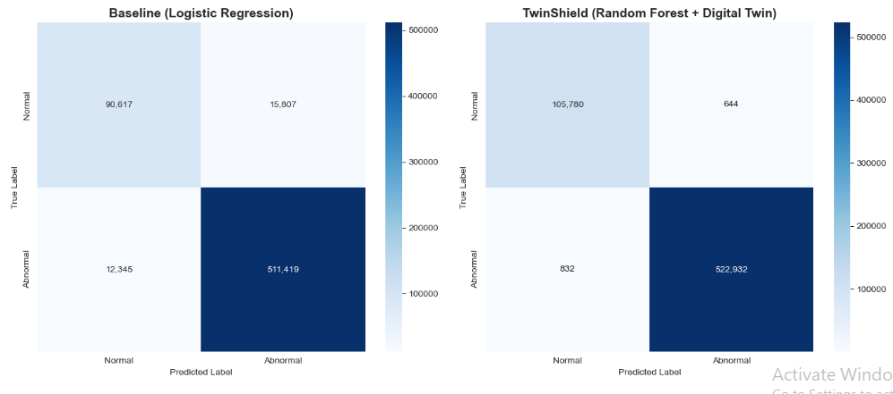

Figure 16: Confusion Matrices — Baseline vs TwinShield
The figure shows the confusion matrices of the two models. The baseline correctly classifies 90,617 cases as Normal and 511,419 as Abnormal, and makes 15,807 errors in each class, respectively. When compared with all cases, the number of errors in TwinShield Normal cases is 105,780 andin Abnormal cases is 522,932.

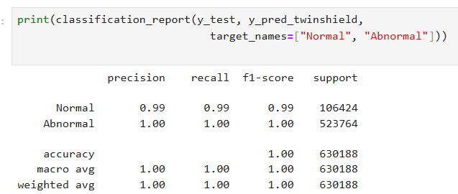

Figure 17: TwinShield Classification Report
The figure shows the report from the TwinShield classification of 630,188 test observations. Normal traffic is able to attain around 0.99 precision, recall and F1 score, while Abnormal traffic is able to attain 1.00 for all. This overall accuracy is around 1.00, indicating very stable binary detection performance for test evaluation overall.

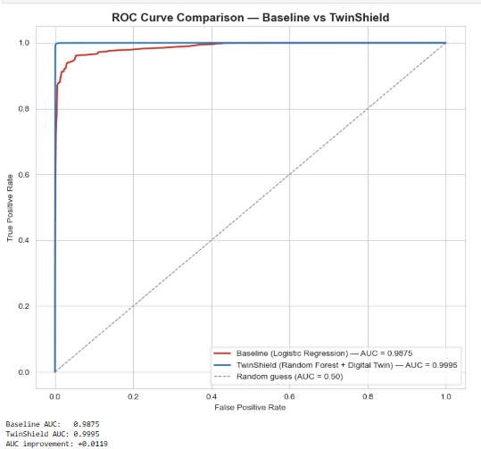

Figure 18: ROC-AUC Comparison — Baseline vs TwinShield
The figure shows the ROC curves of both detection models. Baseline Logistic Regression yields AUC 0.9875 while TwinShield yields AUC 0.9995. The AUC improvement is 0.0119, implying that TwinShield would offer better classification accuracy between Normal traffic and Abnormal traffic as a trade-off for different classification thresholds on the overall test data (Kumar and Arnon, 2024).

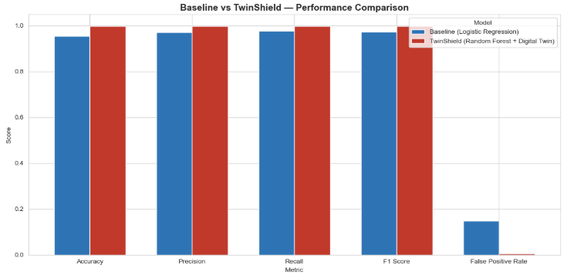

Figure 19: Baseline vs TwinShield Performance Comparison
The accuracy, precision, recall, F1 score, and false positive rate of the baseline and TwinShield are shown. TwinShield consistently outperforms the other classifiers with classification scores of 0.9977 accuracy, 0.9986 F1 score and a false-positive rate of 0.0061 in the held-out test data, compared to the false-positive rate of 0.1485 throughout the held-out test data.
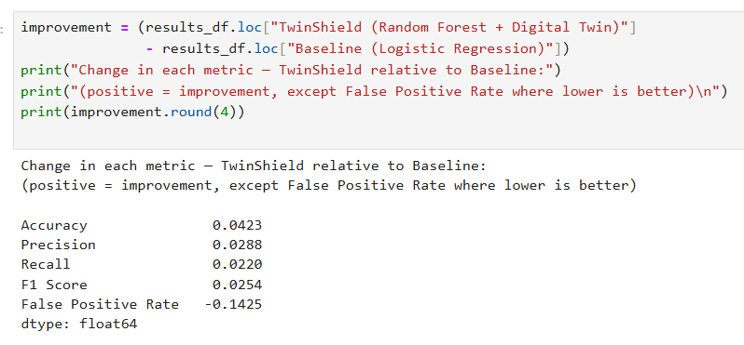

Figure 20: TwinShield Performance Improvement
The figure shows the gains made when TwinShield was compared to the baseline. Accuracy increases by 0.0423, precision by 0.0288, recall by 0.0220, and F1 score by 0.0254. A significant improvement is a reduction in false-positive rate from 0.1425, which means there are significantly fewer false-positive alarms.
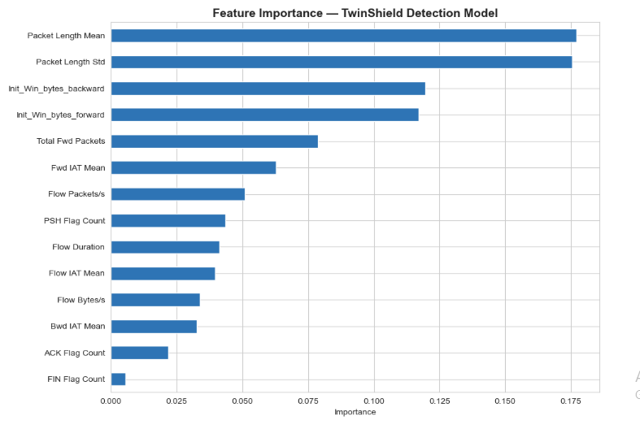
Figure 21: TwinShield Feature Importance
This figure shows the importance of features in the TwinShield Random Forest model. In terms of finding importance, Packet Length Mean has the highest value at 0.178, then comes Packet Length Std at 0.176. Other window bytes, both back and forward, also have a strong importance, while FIN Flag Count has a low importance overall.

4.3 Key Findings

4.3.1 Dataset and Traffic Characteristics
The results indicate that the accuracy of TwinShield has been 99.77% accuracy, 99.88% precision, 99.84% recall, and _99.86% F1-score. Its false-positive rate has been only 0.61%, while ROC-AUC reached 0.9995. The cleaned dataset of CICIDS2017 are of 2520751 network-flow records and 53 columns, and it is found that there is significant diversity and imbalance in the cleaned dataset. Normal Traffic is 2,095,057 (83.1%), and abnormal traffic is 425,694 (16.9%), with an imbalance ratio of 4.92:1. When it comes to attacks, DoS represents 193,745 records, DDoS comes next with 128,014, and Port Scanning with 90,694 (Amodu et al. 2026). Exploratory analysis also reveals considerable packet statistics and traffic rate differences among the instances and in Flow Duration. The association between different candidate Digital Twin features is strong, as can be seen in the correlation analysis, where certain correlations are above 0.90, such as between the features of Fwd IAT Mean and Fwd IAT Max.

4.3.2 Digital Twin and Detection Performance
The Digital Twin reduces this to 14 security-relevant network features including flow duration, packet statistics, traffic rates, initial window bytes, flag counts and IAT measures. This reduced representation is used with the TwinShield Random Forest model, retaining good classification properties. The results indicate that TwinShield provides 0.9977 accuracy, 0.9988 precision, 0.9984 recall and 0.9986 F1 score. That is, it reduces false-positives to a very low level (0.0061) which is significantly lower than the baseline Logistic Regression model's false-positive rate.

4.3.3 Comparative Model Findings
The comparative analysis shows that TwinShield is superior to the baseline on all main assessment parameters. Accuracy increases from 0.9553 to 0.9977, while F1 score improves from 0.9732 to 0.9986. Most significantly, the false-positive rate drops from 0.1485 to 0.0061, or 0.1425 lower. The finding is further reinforced by ROC-AUC analysis, which shows TwinShield to have an AUC of 0.9995, compared to 0.9875 for the baseline, for an improvement of 0.0119.

4.4 Critical Analysis
The results are capable of supplying solid evidence on an experiment to back the four objectives of the research, but the results should be interpreted in the context of the limitations of the chosen dataset. The initial goal was related to getting acquainted with the cybersecurity and traffic specifics concerning intrusion detection in such satellite environments as LEOs. The CICIDS2017 analysis found that there were significant variations between normal and abnormal traffic with the normal traffic constituting 83.1 percent and the abnormal traffic constituting 16.9 percent of the data. The existence of DoS, DDoS, port-scanning, and other types of attacks testifies to the variety of behaviours available to an IDS that should be differentiated. This justifies the rationale of the research that network behaviour analysis should be performed to provide effective detection and positive outcome, as opposed to a single characteristic of traffic.
The second goal which intended to find the characteristics of the relevant traffic and create an appropriate Digital Twin representation was achieved with the help of feature analysis and correlation evaluation. Based on the relevance to the security features, fourteen security-related features were picked up, including flow duration, packet statistics, traffic rates, inter-arrival times, packet lengths, flags, and window nature. The results of the feature-importance also indicate that the characteristics have interesting information to detect, with the highest importance of Packet Length Mean and Packet Length Standard Deviation. This is to say that the reduced representation has retained meaningful behavioural information despite the much fewer features used.
The third goal was to come up with the TwinShield intrusion detection methodology. The Random Forest model achieved 99.77% accuracy, 99.88% precision, 99.84% recall and 99.86% F1-score. These findings indicate very stable binary classification performance on the test data set that has been held-out. The results can also be compared with broader studies indicating that AI-based security solutions can be utilized to empower LEO satellite networks. Recent studies have also explored Digital Twin-aided AI security of LEO networks, with the promise of integrating virtual representations of networks with smart anomaly detection.
The fourth goal, which is related to assessment of the proposed framework in relation to a baseline, is well endorsed by the results of comparisons. TwinShield improved accuracy from 95.53% to 99.77% and F1-score from 97.32% to 99.86%. More to the point, the rate of false-positives was significantly lowered to 0.61% which means that there were fewer legitimate traffic cases that were inaccurately recognized as attacks. ROC-AUC also increased from 0.9875 to 0.9995. These findings indicate that the suggested reduced Digital Twin representation and Random Forest have better experimental discrimination compared to the baseline.
Nevertheless, the findings are not to be seen as reliable indicators of operational preparedness to actual use of LEO satellites. CICIDS2017 is not a satellite-oriented (satellite-specific) dataset, that is, we cannot fully reproduce characteristics like satellite mobility, evolving inter-satellite links and resource limitations. These environmental issues have been identified as key by recent LEO IDS research. Thus, the outcomes prove the possibility and experimental efficiency of TwinShield instead of its performance in actual conditions of satellites. External validity would be reinforced by further validation with satellite-specific or simulated LEO traffic.
All in all, the findings are consistent with the study objective: they show that a security-centered Digital Twin architecture with machine learning can deliver very effective experimental intrusion detection, and it also reveals that additional satellite-specific validation is needed.

4.5 Summary
In this chapter, TwinShield was compared to the four research objectives. The analysis revealed applicable attack and traffic features, substantiated the choice of 14 Digital Twin features, and affirmed that it detects well with the support of Random Forest. TwinShield had an accuracy of 99.77, F1-score of 99.86 with a false-positive rate of 0.61, which was higher than the Logistic Regression baseline. The results thus corroborate the purpose of the research, but the utilization of CICIDS2017 indicates that their application should be further confirmed with the help of the realistic LEO satellite traffic.

Chapter 5: Conclusion and Recommendations

5.1 Conclusion
In this dissertation, TwinShield: A Digital-Twin-Based Intrusion Detection Framework to Detect Cyberattacks in LEO Satellite Networks was examined. The study sought to address the question of whether a security-oriented Digital Twin representation used together with machine-learning-driven intrusion detection can be a promising solution to detecting abnormal network traffic.
The literature review fulfilled the first goal by analyzing the cybersecurity issues related to LEO satellite networks, the current IDS solutions, the use of machine learning and Digital Twin technology. The review identified LEO networks to possess unique features, such as dynamic connectivity, distributed infrastructure and evolving traffic behaviour. These attributes pose difficulties to traditional intrusion detection as well as they indicate the necessity of methods that can be used to analyse network behaviour.
The second goal was to find the features of network-traffic that could be used to detect cyberattacks. The results of the analysis of CICIDS2017 data revealed the significant differences between normal and abnormal traffic. The study picked 14 security-relevant features, such as flow duration, packet statistics, traffic rates, inter-arrival time, packet-length features, TCP flags and initial window details. The analysis of the feature importance also indicated that Packet Length Mean and Packet Length Standard Deviation were the most significant features in the TwinShields model.
The third goal was to create the TwinShield framework with the chosen Digital Twin representation and a Random Forest classifier. The results of the experiment showed good performance improved with TwinShield having 99.77% accuracy and 99.88% precision, 99.84 recall and 99.86 F1-score on the withheld-out test. This model also had ROC-AUC of 0.9995, which indicates that the model was effective in discriminating between normal and abnormal traffic.
The fourth aim was to compare TwinShield and Logistics Regression baseline. The comparison revealed that TwinShield is superior in the key evaluation measures. Accuracy increased from 95.53% to 99.77%, while F1-score increased from 97.32% to 99.86%. The biggest positive difference was that the rate of false-positives dropped to 0.61, indicating that there are significantly fewer cases of valid traffic being reported as attacks. These results obtain solid experimental data on the suggested framework.
In general, the study shows that the combination of a dedicated Digital Twin representation with machine learning will offer an excellent solution to intrusion detection. Findings reflect the study purpose and indicate that the four objectives were met with the help of the literature review, feature analysis, framework development and comparative evaluation.
The results should be, however, under the constraints of the experimental setting. CICIDS2017 is not a dataset taken out of a real-life LEO satellite network. Hence, the high performance in detection cannot be assumed to define the performance in the real satellite environments. Issues like mobility of the satellite, altering network topology, inter-satellite communication and resource constraints demand additional research studies.

5.2 Recommendations

5.2.1 Use LEO-Specific Datasets
Future work ought to assess the TwinShield with simulated or real LEO satellite network traffic. It would enable the validation of the chosen features and detection model with the conditions of the communication with the satellite and would enhance the validity of the results.

5.2.2 Expand Attack Scenarios
Future research should explore more diverse attacks applicable to satellite networks, such as those that target communication channels, routing, inter-satellite interactions and ground stations (Siddique, 2024). This would determine whether TwinShield is capable of identifying varied categories of satellite-specific threats.

5.2.3 Evaluate Alternative Machine-Learning Models
Even though TwinShield has demonstrated great accuracy as proven by Random Forest, it can be recommended in future studies that TwinShield be compared to other machine-learning and deep-learning algorithms (Reis, 2025). This may motivate the identification of alternative models that can enhance detection performance, model adaptability or model efficiency.

5.2.4 Investigate Real-Time Detection
Further work must look into the possibility of designing TwinShield to be used in real-time as an intrusion-detection mechanism. The evaluation of factors like processing time, computational resources, detection latency and memory requirements should be considered since such factors are especially crucial in satellite environments that are resource-constrained (Verma, 2025).

5.2.5 Develop an Adaptive Digital Twin
The Digital Twin could also be made dynamic whereby as legitimate LEO network behaviour changes; it is automatically updated. A more flexible representation would perhaps enhance the capacity to differentiate real shifts in the situation of the satellite-networks and bad deviations, which would further decrease the number of false alarms (Kumar and Sankar, 2025).

5.3 Final Remarks
TwinShield offers a good experimental base to Digital-Twin-based intrusion detection in cybersecurity in LEO satellites. The potential of the proposed approach is evidenced by its good classification performance and performance improvement relative to the baseline. However, additional confirmation with a real satellite traffic and operating conditions is needed before the framework will be deemed suitable to practice deployment.

References
Agnew, D., Del Aguila, A. and McNair, J., 2024. Enhanced network metric prediction for machine learning-based cyber security of a software-defined UAV relay network. IEEE Access, 12, pp.54202-54219.
Amodu, O.A., Hanapi, Z.M., Jarray, C., Althumali, H., Saif, F.A., Mahmood, R.A.R., Adam, M.S. and Abdullah, N.F., 2026. Machine Learning for NTN-Assisted IoT: A Bibliometric-Assisted Survey of Opti-mization across Trajectory, Resource, Energy, and Security Aspects. Computer Modeling in Engineering & Sciences, pp.1-68.
Azar, A.T., Shehab, E., Mattar, A.M., Hameed, I.A. and Elsaid, S.A., 2023. Deep learning based hybrid intrusion detection systems to protect satellite networks. Journal of Network and Systems Management, 31(4), p.82.
Burks, T.M., 2026. A Reproducible Satellite Constellation Testbed for Cyber Attack Experimentation, Dataset Generation, and Machine Learning Based Detection (Doctoral dissertation, Tennessee Technological University).
Edozie, E., Shuaibu, A.N., Sadiq, B.O. and John, U.K., 2025. Artificial intelligence advances in anomaly detection for telecom networks: E. Edozie et al. Artificial Intelligence Review, 58(4), p.100.
Kaliappan, M., Vimal, S., Karpagavalli, C., Ramnath, M., Walia, K. and Dhiman, G., 2026. Digital-Twin-Enabled Satellite–UAV–RIS Cooperative Networks: A Reinforcement-Learning Framework for Joint Trajectory and Passive Beamforming Optimization. Journal of Animal Environment, pp.190-196.
Karim, M., Hassan, M.Z. and Rahman, M.A., 2026. Digital Twin for Context Awareness, Security, and Resilience in Vehicular Networks for 5G and Beyond: A Comprehensive Survey. IEEE Open Journal of the Communications Society.
Khan, S., Sumra, I.A. and Abdin, M.Z.U., 2025. AI-Driven Cybersecurity for Satellite Systems: A Survey of Threats, Applications, Challenges and Future Directions. International Journal of Emerging Engineering and Technology, 4(2), pp.44-51.
Kumar, G.K. and Sankar, P., 2025. Artificial intelligence powered satellite communications and Sentinel satellite constellations: An overview and future perspectives. SN Computer Science, 6(6), p.735.
Kumar, R. and Arnon, S., 2024. Review of physical layer security in integrated satellite–terrestrial networks. Electronics, 13(22), p.4414.
Li, Y.T., Chen, S.H., Feng, K.T., Shen, L.H., Ding, Z. and Wu, J.M., 2026. AI-Enabled Digital Twin-Driven Handover and Resource Allocation in Multi-LEO Satellite Networks. IEEE Internet of Things Journal.
Mythili, S., Nidhya, R. and Ramamoorthy, A.K., 2025. AI-Driven Security Framework for Enhanced Threat Detection in Mobile Satellite Networks. ICTACT Journal on Communication Technology, 16(01), pp.3443-3448.
Qiao, G., Zhuang, Y., Ye, T. and Qiao, Y., 2023. A digital-twin-based detection and protection framework for SDC-induced sinkhole and grayhole nodes in satellite networks. Aerospace, 10(9), p.788.
Reis, M.J., 2025. AI-driven anomaly detection for securing IoT devices in 5G-enabled smart cities. Electronics, 14(12), p.2492.
Sengendo, J. and Granelli, F., 2026. From Prediction to Protection: A Network Digital Twin framework for Traffic Monitoring and Anomaly Detection. Computer Networks, p.112250.
Sharmin, A., Mahmud, B.U., Nabi, N., Shaima, M. and Faruk, M.J.H., 2025. Cyber attacks on space information networks: vulnerabilities, threats, and countermeasures for satellite security. Journal of Cybersecurity and Privacy, 5(3), p.76.
Siddique, I., 2024. Detection and analysis of anomalous behavior in on-orbit satellites using AI algorithms. Journal of Firewall Software‎ and Networking, 2(2), pp.10-48001.
Tasdighi, A., 2026. Mission-Centric Cybersecurity for Space Systems: A Quantitative, Simulation-Driven Framework for Lifecycle Resilience. Simulation-Driven Framework for Lifecycle Resilience (February 20, 2026).
Verma, A.R.K., 2025. Cybersecurity in satellite communication networks: Key threats and neutralization measures. IEEE Open Journal of the Communications Society, 6, pp.5667-5692.
Xu, M., Fan, J., Huang, X., Zhou, C., Kang, J., Niyato, D., Mao, S., Han, Z. and Lam, K.Y., 2025. Forewarned is forearmed: A survey on large language model-based agents in autonomous cyberattacks. arXiv preprint arXiv:2505.12786.
Yang, G., Ni, L., Geng, J. and Peng, X., 2026. FedLTN-CubeSat: neuro-symbolic federated learning for intrusion detection in LEO CubeSat constellations. Mathematics, 14(6), p.1047.
Zaidi, S.M.A. and Khan, S.M., 2026. AI-Powered Cybersecurity: Graph-Based Anomaly Detection in Network Traffic. Journal of Engineering and Computational Intelligence Review, 4(1), pp.91-100.
Zheng, T., Yi, P. and Wu, Y., 2022. Smart grid: Cyber attacks, critical defense approaches, and digital twin. arXiv preprint arXiv:2205.11783.

Appendix
Dataset link:
https://www.kaggle.com/datasets/ericanacletoribeiro/cicids2017-cleaned-and-preprocessed

